10pearlsAQI – Karachi Air Quality Index Prediction System

Live Application: https://karachi-aqi-predictor-zec4fardmlwwrfmxcnkqqo.streamlit.app/
Author: Izma Wara Khan
Organization: 10Pearls

Table of Contents:
NO. | Content
1 | Introduction
2 | Project Overview
3 | System Architecture
4 | Technology Stack
5 | Data Pipeline & Feature Engineering
6 | Machine Learning Models & Performance
7 | Model Interpretability (SHAP Analysis)
8 | Dashboard
9 | Troubleshooting & Challenges
10 | Conclusion

1. Introduction:
Air Quality Index (AQI) is a standardized indicator used to measure air pollution levels and their impact on human health. Karachi frequently experiences unhealthy AQI conditions due to high traffic density, industrial activity, and seasonal weather changes. This project develops an end-to-end AQI prediction system to forecast air quality for the next three days using historical AQI and weather variables.

2. Project Overview:
10pearlsAQI is an end-to-end Air Quality Index (AQI) prediction system engineered for Karachi, Pakistan. The system forecasts air quality for the next 3 days by analyzing atmospheric pollutants (PM2.5/AQI) and weather variables (temperature, humidity, wind speed, and pressure).

Objectives Achieved:
• Automated Data Pipeline: Real-time hourly data collection from Open-Meteo and OpenWeather APIs.
• Feature Engineering Mastery: Implementation of 24+ engineered features, including temporal lags and rolling statistics to capture AQI trends and variations.
• Best Model Selection (Benchmarking): Multiple machine learning models were evaluated, and the Random Forest Regressor was selected as the best-performing model based on RMSE and R², making it the deployed model for AQI prediction.
• Model Explainability: Integration of SHAP (SHapley Additive exPlanations) to provide transparency into AI decision-making and feature impact.
• Dashboard Deployment: Development of a Streamlit-based dashboard for real-time AQI prediction and visualization
• CI/CD Excellence: Fully automated workflows using GitHub Actions for scheduled data fetching and model training.

3. System Architecture:
The system follows a decoupled, data-driven architecture consisting of three layers:
- Data Layer: MongoDB Atlas serves as the centralized feature store.
- Pipeline Layer: GitHub Actions triggers two pipelines (Hourly Features & Daily Training).
- Service Layer: A Streamlit dashboard consumes the production-ready model for real-time inference.
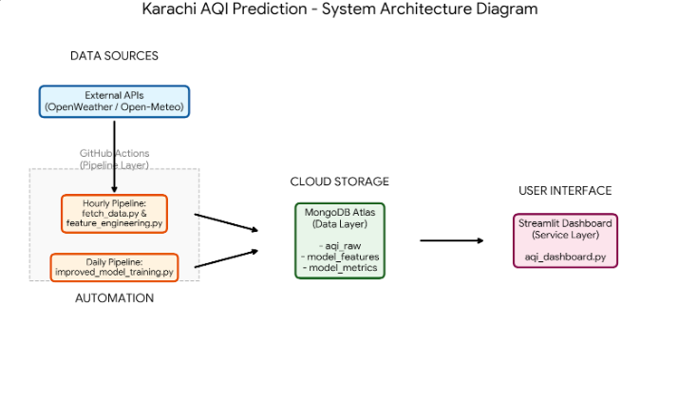

4. Technology Stack:
Category | Tools/Technologies
Language | Python
Dashboard | Streamlit
Machine Learning Model | Random Forest
Data Processing | Pandas
Visualization | Plotly
Automation | GitHub Actions
Feature Store | MongoDB Atlas

5. Data Pipeline & Feature Engineering:
The system collects real-time hourly data from Open-Meteo and OpenWeather APIs. After preprocessing, feature engineering is applied to capture historical patterns and temporal behavior.

Feature Engineering
- Lag Features: AQI(t-1), AQI(t-6), AQI(t-24) to capture persistence.
- Rolling Statistics: Mean and standard deviation over 6h, 12h, and 24h windows.
- Temporal Context: Hour and day-of-week encoding for daily traffic patterns.

6. Machine Learning Models & Performance:
Multiple regression models were benchmarked using RMSE and R² metrics. Random Forest performed best and was deployed.
Model | Accuracy (R² %) | RMSE | Status
Random Forest | ~69.18% | 7.22 | Best (Deployed)
Ridge Regression | ~40.5% | 10.12 | Baseline
Linear Regression | ~40.2% | 10.15 | Baseline
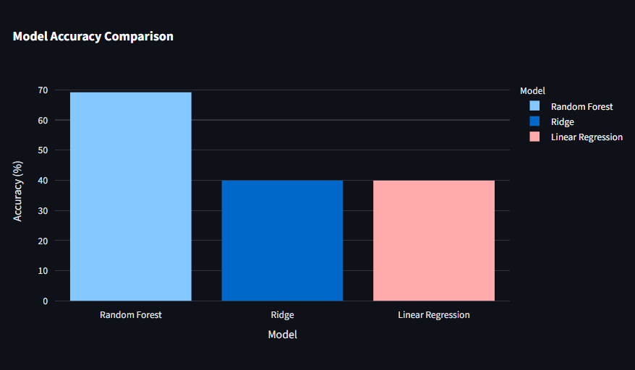
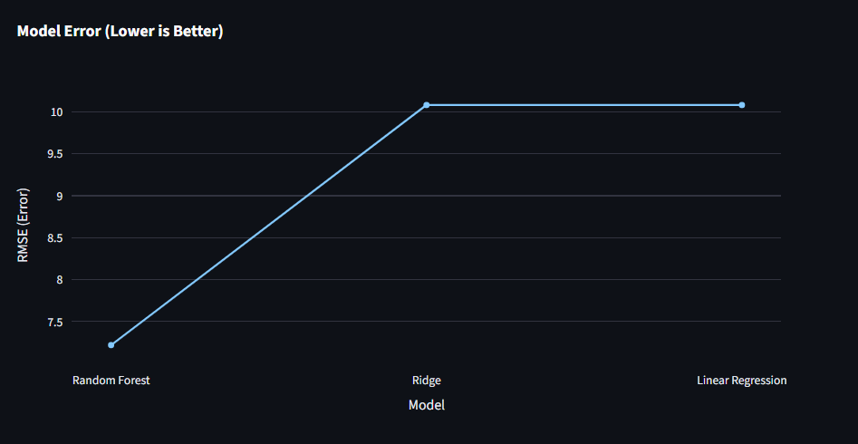

7. Model Interpretability (SHAP Analysis):
SHAP (SHapley Additive exPlanations) was integrated to interpret the model predictions and explain feature contributions.

Key Insights
- Current AQI value is the strongest predictor of future AQI.
- Temperature and AQI lag-24h are among the top influential features.
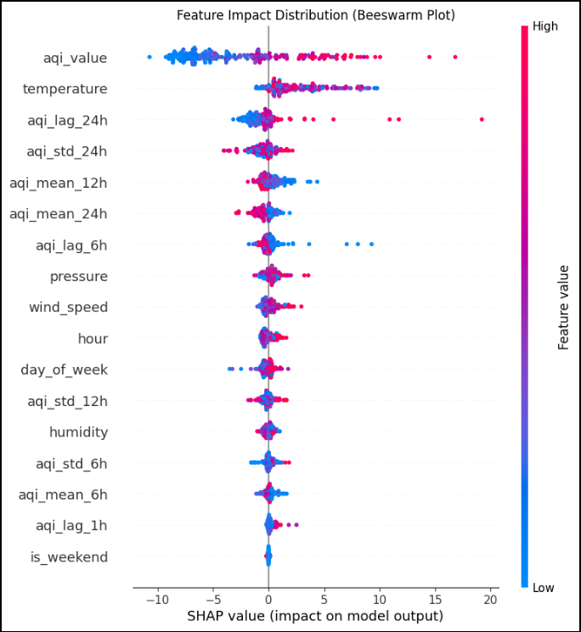
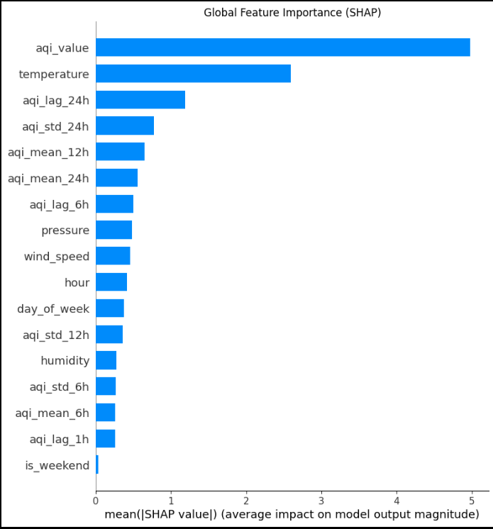
8. Dashboard:
An interactive Streamlit dashboard was developed to serve as the system’s primary interface for real-time inference and data visualization. The dashboard connects directly to the MongoDB Feature Store to display the most recent air quality insights for Karachi.

Core Functionalities
- Model Performance Analytics: The interface features dynamic Plotly charts that compare the Accuracy (%) and RMSE of the deployed Random Forest model against other baseline models, ensuring transparency in prediction quality.
- Atmospheric Status: Provides a live view of Karachi's current AQI and weather parameters, synchronized with the latest hourly data fetch.
- 3-Day Smart Forecast: Users can trigger the Random Forest engine via a "Generate Forecast" button. The system then processes the latest features through the production model to output a detailed 3-day AQI prediction table.
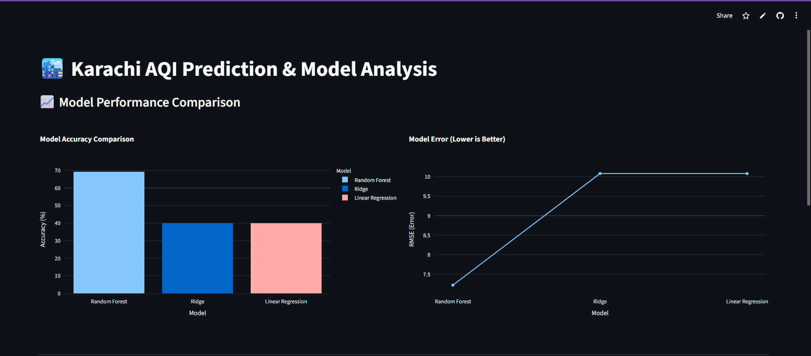
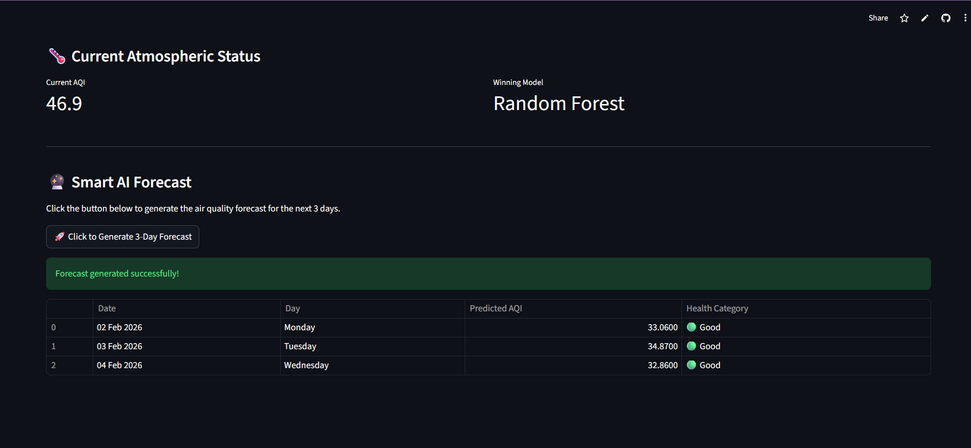

9. Troubleshooting & Challenges:

API Data Fetching Issues
Inconsistent API responses were observed, including missing values, slow responses, and occasional invalid data. APIs also provided data in different formats and time zones. Timestamp normalization, strict merging, retries, null handling, and logging were implemented to ensure reliable hourly data collection.

Feature Store Challenges (Hopsworks Trial + MongoDB)
Hopsworks Feature Store was tested but faced connection/authentication errors and free-tier limitations. MongoDB Atlas was finalized as the feature store for stability. Credentials were secured using GitHub Secrets.

Model Training & Performance Issues
Karachi AQI contains frequent spikes, leading to weak performance of linear models and higher error rates. Random Forest was adopted for non-linear learning and improved robustness. Scaling and tuning improved stability.

CI/CD Pipeline & Deployment Issues
GitHub Actions workflows occasionally failed due to API timeouts, missing environment variables, and database connectivity restrictions. Improved error handling, logging, and secrets management were applied to increase pipeline reliability.

10. Conclusion:
10pearlsAQI successfully delivers an automated AQI forecasting system for Karachi. With advanced feature engineering, Random Forest modeling, SHAP explainability, and CI/CD automation, the system provides reliable short-term AQI predictions and health advisories.

