**Recipes :** C# .NET Windows Forms application for example of handling one-to-many relationships, many-to-many relationships and validations using advanced user interfaces. Handles SQL Server or Oracle Database connections with SAP Crystal Reports. Created in Visual Studio 2017.

1. **Introduction: Database**

Recipes description: one recipe (Recept) have multiple steps (Korak) and one step belongs to one single recipe. So, relationship between these two entities is one-to-many. Recipe ID is foreign key in table Step. Table Step have one unique key - ID_koraka, which identifies one and only one unique step.

One recipe is having multiple ingredients and one ingredient can be present at multiple recipes. The relation between entities Recipe and Ingredient is many-to-many. This relation requires involvement of additional table, which consists of information about which recipe have which ingredient. Table name is Recipe_Ingredient (Recept_sestavina). Primary key of this table consist of two parts: Recipe ID (ID_Recepta) and Ingredient ID (ID_sestavine) with relation to tables Recipe (Recept) and Ingredient (Sestavina).

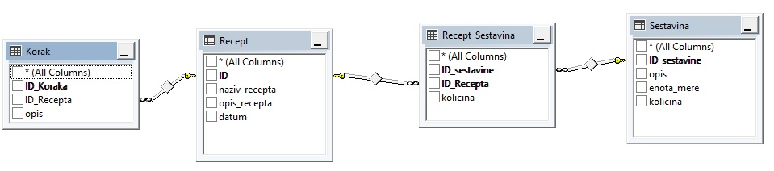

Picture 1: Database diagram

1. **System**

System is built by three parts:

1. **List of recipes** - adding, update and delete recipes and adding, update and delete their steps and ingredients,
2. **List of ingredients** - with possibility of add ingredient, change amount of ingredient or delete ingredient,
3. **Select working database** – we choose between SQL Server or Oracle database.

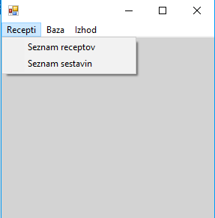

Picture 2: Main menu – first selecton

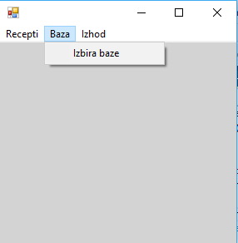

Picture 3: Main menu – second selection

* 1. **List of recipes (Seznam receptov)**

In List of recipes we can manage recipes, their steps and their ingredients.

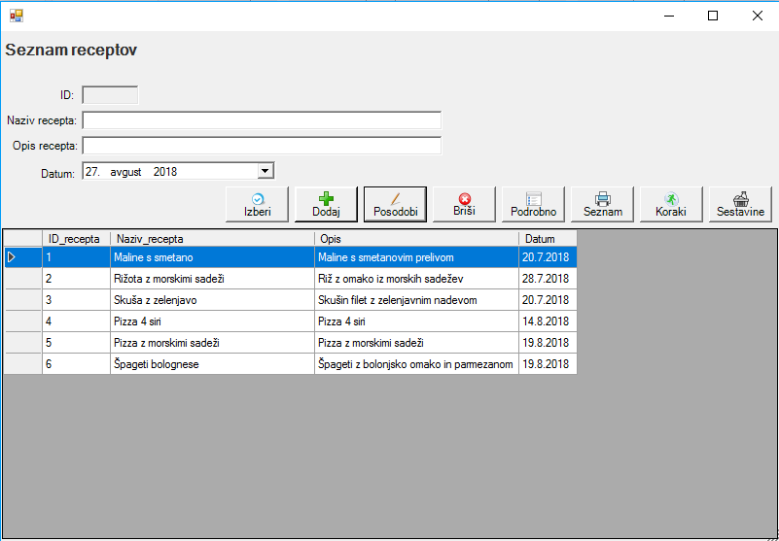

Picture 4: List of recipes

We are able to:

1. Select recipe to edit (button Izberi),
2. Add new recipe to list (button Dodaj),
3. Update existing selected recipe (button Posodobi),
4. Delete recipe (button Briši),
5. Preview and print recipe with steps and ingredients (button Podrobnosti),
6. Preview and print list of recipes (button Seznam),
7. Manage steps (button Koraki),
8. Manage belonged ingredients (button Sestavine).
   * 1. **Managing steps**

First, we must select recipe from list and then click button Steps (Koraki). After that, we can:

1. Select step for edit (button Izberi),
2. Add new step to recipe (button Dodaj),
3. Update existing step (button Posodobi) or
4. Delete selected step (button Briši).

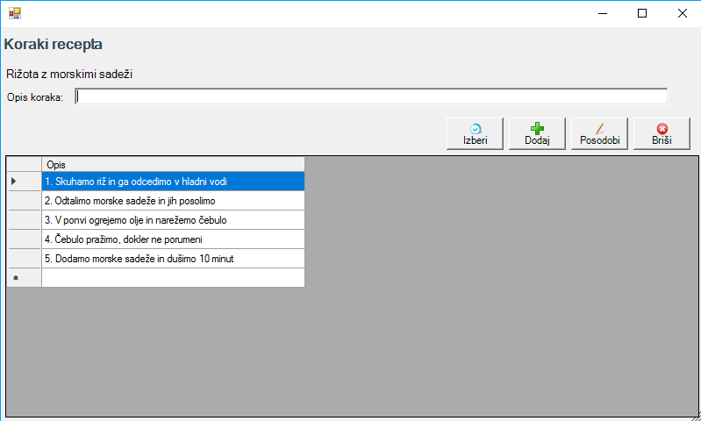

Picture 5: Managing steps (Koraki recepta)

With this tasks we manage one-to-many relationship between entities Recipe and Step.

* + 1. **Managing recipe ingredients**

After clicking button Ingredients (Sestavine), we get possibility of choosing an ingredient to recipe with amount with click of the button. If inputted amount is bigger than available amount, we must repeat that task with smaller amount.

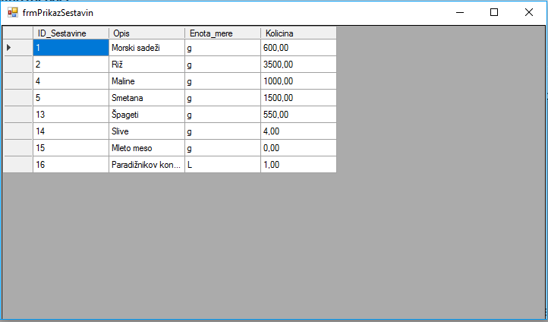Picture 6: Selecting ingredient

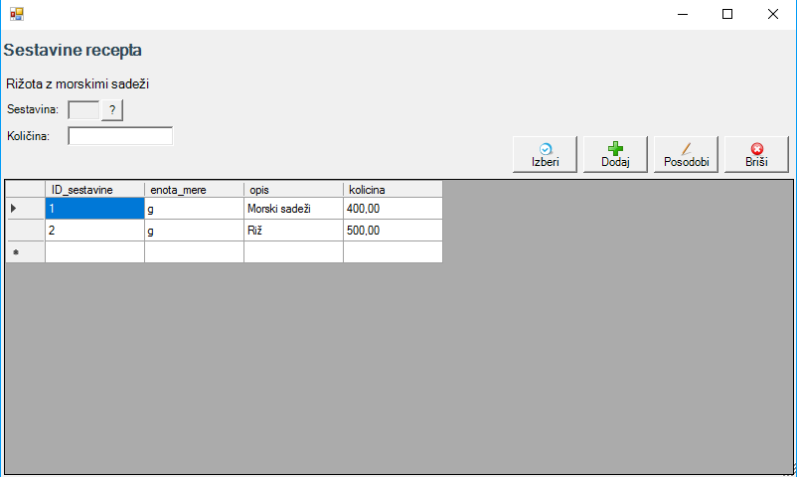

Picture 7: Managing recipe ingredients (Sestavine recepta)

We can:

1. Select ingredient from list of available ingredients (click on button ) and add to recipe (button Dodaj) with input of amount (Količina),
2. Select (button Izberi), change and update amount of existing ingredient (button Posodobi) with consideration of available amount and
3. Delete recipe ingredient (button Briši).

With this sequence of tasks we handle many-to-many relationship between entities Recipe and Ingredient.

* 1. **Handling list of available ingredients and amounts**

With click on option List of Ingredients (Seznam sestavin) in main menu we can manage available ingredients and amounts. Amount drops consequently when we add ingredient to recipe. We specify measure unit (Enota mere) of ingredient. We choose between g (gram), L (liter) and kom. (piece).

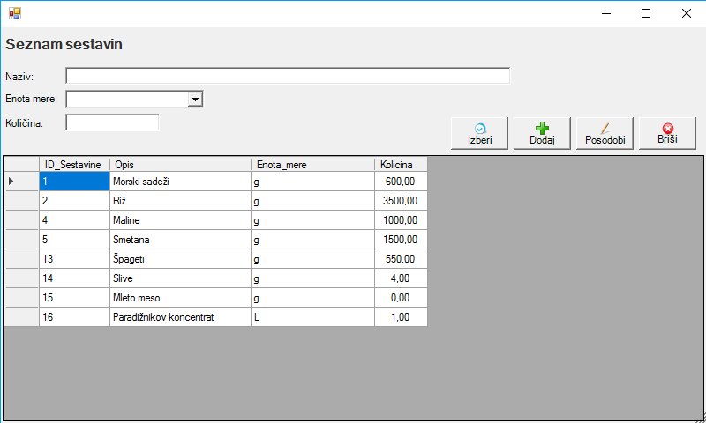

Picture 8: Managing list of available ingredients and amounts

* 1. **Database selection**

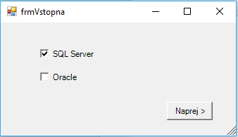

Picture 9: Database selection

Database backups are available on Git Hub repository (SQL Server backup) and DropBox (Oracle backup).