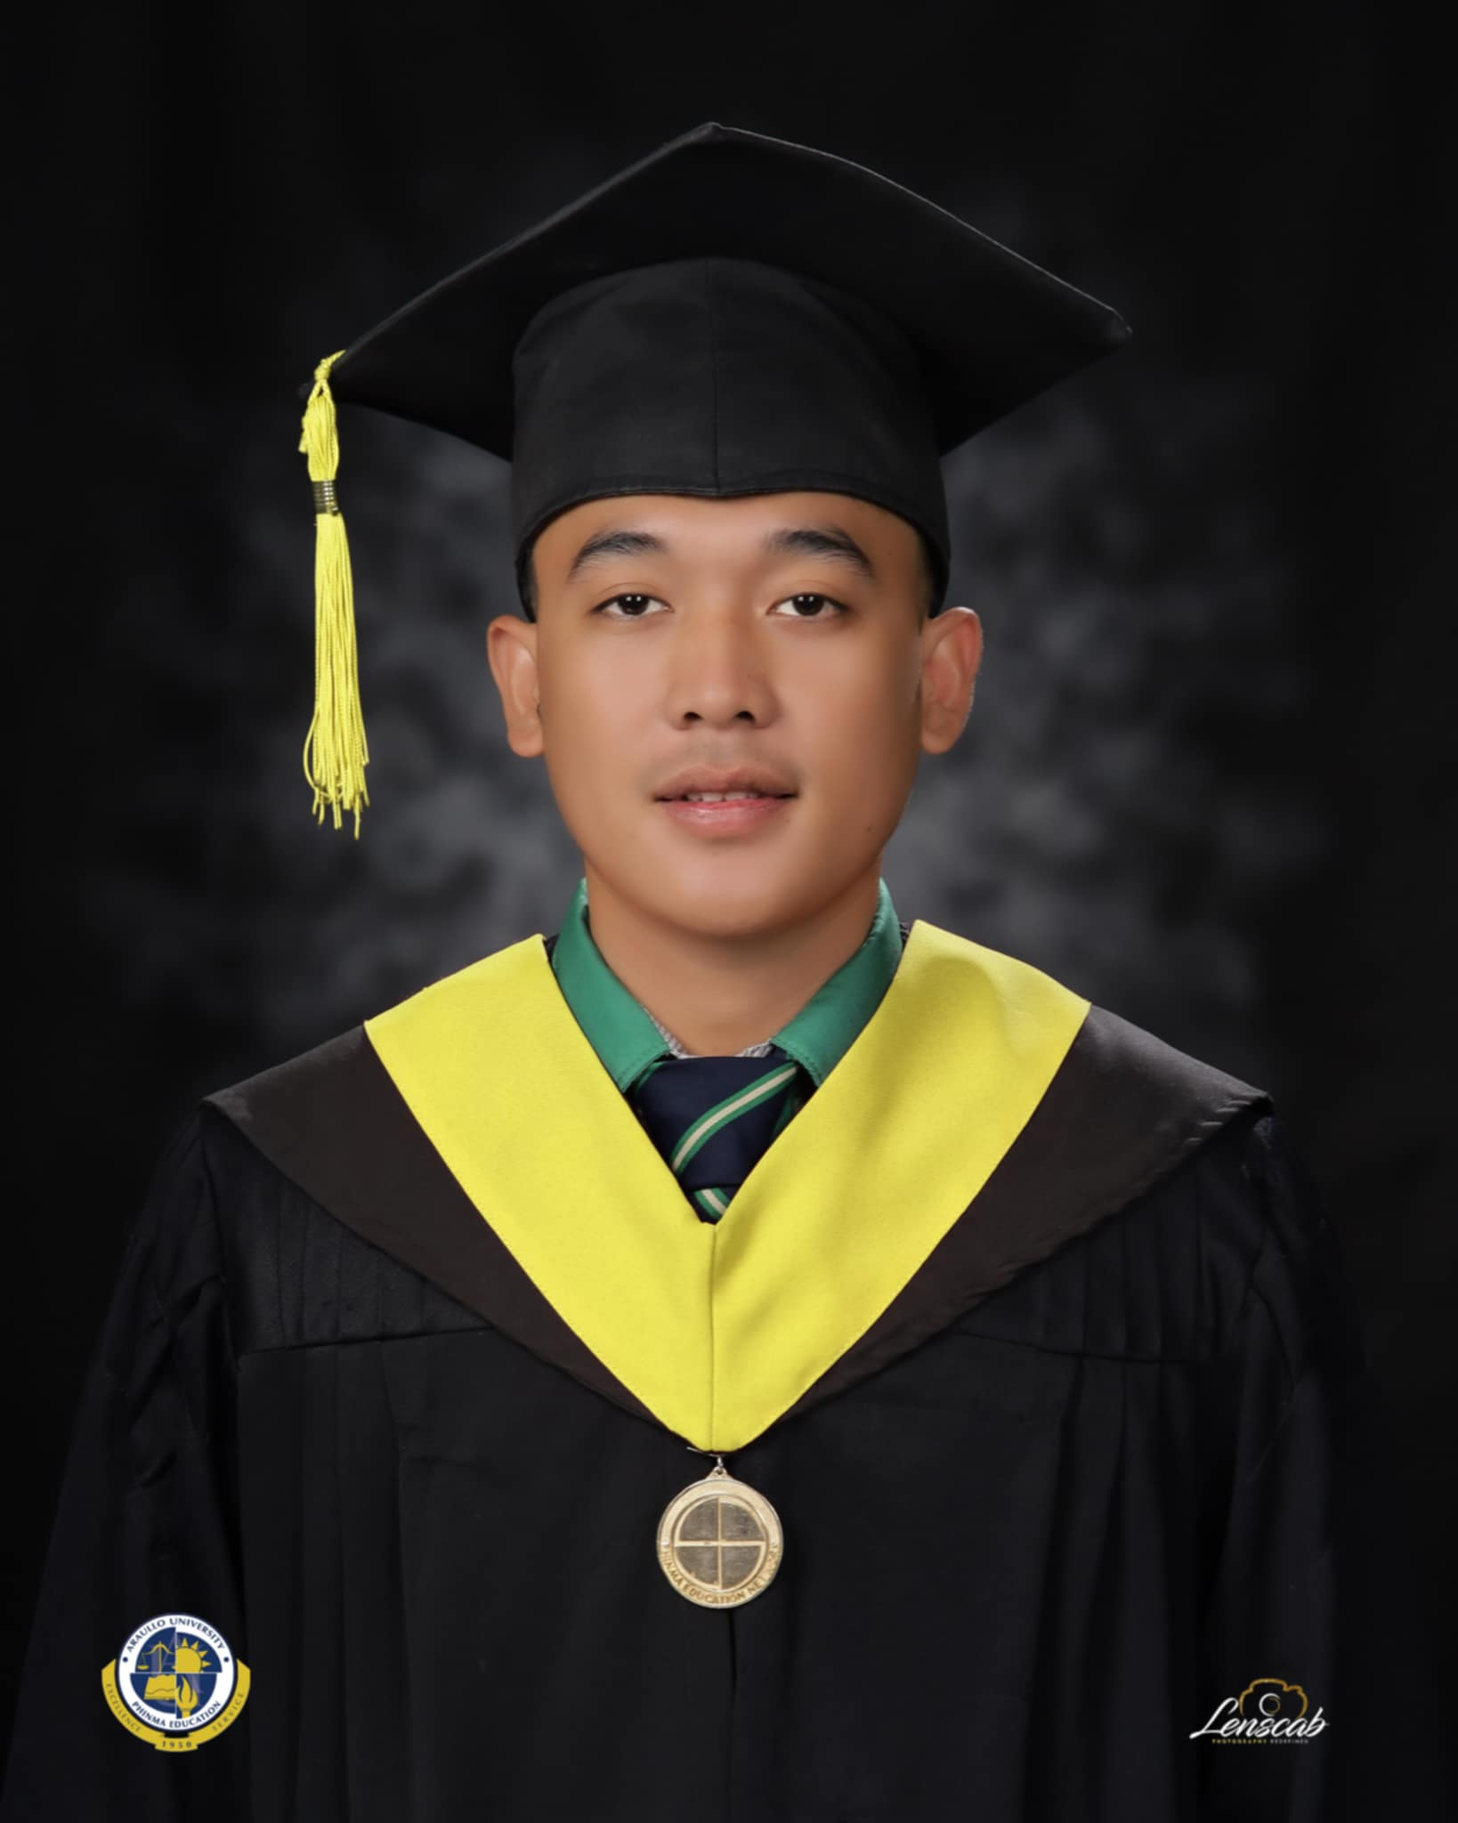**AERON PAUL SALIPSIP**

 +639951147459  aeronsalipsip@gmail.com  [www.aeron-portfolio.com](https://www.aeron-portfolio.com)

**EDUCATION**

**Bachelor of Information Technology**

**Phinma Araullo University**

2021 - 2025

**Zaragoza National High School**

**ICT - SENIOR HIGH SCHOOL**

2012 - 2018

**EXPERTISE**

 Fullstack Python Flask Framework

 MySQL Database Management

 Web version control using Github

 Printer Troubleshooting

 PC Troubleshooting including server

mapping

**PROFILE**

I’ m a Fullstack developer s killed in Python Flask, MySQL database management, and G itHub version control. I also have hands-on

experience troubleshooting printers and PCs, including server

mapping. Passionate about problem-solving, I ensure efficient

systems and seamless collaboration, always striving for optimized performance in both software and hardware environments.

**WORK EXPERIENCE**

**THE FOREST LODGE (5 STAR HOTEL)**

**2024-2025**

Dece m be r - Fe b

Management Information System (MIS)

Student Intern (500 Hours)

. Developing a Guest Feedback System (GFS) using Python, Flask Framework and MySQL Database

. Printer and PC Troubleshooting and server mapping . Updating TV Signage Daily

. Room Lockset Configuration

|  |  |
| --- | --- |
| **PHINMAARAULLO UNIVERSITY(MAIN CAMPUS)** PRE-OJT  Student Intern (200 Hours)  . Developing a Registrar Management System (RMS) Front End Dev using PHP  **FREELANCING**  . Oauth Script Fixing Using Python . Web scraping  . Admin Side Apartment Listing  **CAPSTONE RESEARCH**  . Developing Student Portal in Asia Pacific College Of  Business And Arts (APCBA) Using Python Flask Framework and PostgresSQL Database Management | **2024**  A ug ust- Oct  **2 0 2 3 - 2 0 2 4**  Dece m be r - Ja n  **2 0 2 3 - 2 0 2 4**  Ma rc h- J u ne |

**MINI PROJECT**

. Sign Language Detector

. Voice Assisted News AI

. Guitar Store

. Paraphrasing Tool

**CERTIFICATION**

. Oracle Academy

. Database Foundation Learning May 23, 2024

. AWS Academy Introduction To Cloud Semester 1 May 30, 2024

. Python Crash Course Feb 11, 2024

**SALESFORCE BADGE**

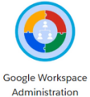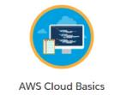

July 6, 2024

Feb 2, 2024

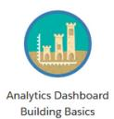

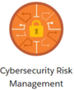March 25, 2024

July 7, 2024

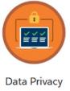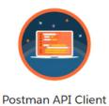

June 12, 2024

April 3, 2024

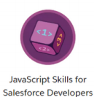

May 23, 2024

July 20, 2024