Quantum-Assisted Optimization of Mobile Medical Team Deployment During Disasters
Team Gliders
Izza Fatima & Anum Ibrahim
FAST NUCES, Islamabad
Qiskit Fall Fest 2026 hackathon - domain: Disaster Response.
Repository: https://github.com/Izza-cpp/qiskit-optimization-hackathon

1. Summary
We select which 3 of 10 disaster-affected locations receive a mobile medical team, trading off patients in need, outbreak risk and travel time, and we penalise teams whose service areas overlap. The problem is written as a constrained binary quadratic problem, converted to a QUBO and an Ising Hamiltonian on 10 qubits, and solved with QAOA in Qiskit on the Aer simulator. Everything is checked against an independent exact classical solver (120 candidate deployments) and against random-sampling and classical-heuristic baselines.
- The constraint-preserving XY-ring QAOA with a Dicke start state returns 100% feasible samples and puts 6.7% of its probability on the exact optimum at depth p=5, about 8.2x more than random feasible sampling (0.82%). The penalty-based X-mixer reaches 1.2% with only 40% feasible samples.
- We do NOT claim quantum advantage. With 10 qubits the exact answer is found instantly by enumeration, and a simple classical heuristic (greedy, local search, simulated annealing) solves the instance reliably.
- We report where the method is weak: the optimum of model C is sensitive to the input data, the XY circuit with a generic Dicke state is very deep once transpiled, and the circuit cost grows steeply with problem size.

2. Problem and context
After a flood or earthquake, health coordinators must decide quickly where to send a limited number of mobile medical teams. We model the core allocation decision: three interchangeable teams start at one depot; each of ten locations has an estimated number of patients, an outbreak-risk score (0-100, e.g. cholera or dengue) and a travel time. At most one team goes to a location. The model is decision support only: there is no routing, scheduling, capacity or traffic model, and all data are synthetic (no real disaster was observed).
Problem statement. How should a limited number of mobile medical teams be placed across disaster-affected locations when patient need, outbreak risk, travel time and service-area overlap compete? This is a resource-allocation problem in the Disaster Response domain. Our small test instance has 10 locations and 3 teams, so there are C(10,3)=120 feasible deployments.
Who it serves. Health coordinators and emergency operations centres who must assign teams within hours, and through them the affected population: patients waiting for care and communities at risk of outbreaks such as cholera or dengue. The model supports their decision; it does not replace it.
Three formulations use the same data and constraint:
Model | Meaning | Weights
A | patients + travel only | w_P=0.5, w_T=0.2
B | outbreak-aware | w_P=0.5, w_R=0.3, w_T=0.2
C | B + pairwise service-area overlap (our extension) | as B, w_O=0.3

Objective (maximise): F(x) = sum_i s_i x_i - w_O sum_{i<j} O_ij x_i x_j, subject to sum_i x_i = 3, with s_i = w_P P_i/max(P) + w_R R_i/100 - w_T T_i/max(T) and O_ij = max(0, 1 - d_ij/15 km).

3. Quantum formulation
Energy to minimise: H(x) = -F(x) + lambda (sum x_i - 3)^2. With x_i = (1 - Z_i)/2 this is an Ising Hamiltonian with fields h_i and couplings J_ij. The penalty lambda is not arbitrary: we compute the exact threshold lambda* = max over infeasible x of (F(x)-F*)/(m-K)^2 (0.436 for model B, 0.356 for model C) and use 1.25 lambda*. Unit tests verify that the QUBO energies and the Hamiltonian diagonal equal the classical energies for all 1024 bitstrings (error ~1e-14), and that below lambda* an infeasible state becomes the ground state.

Architecture
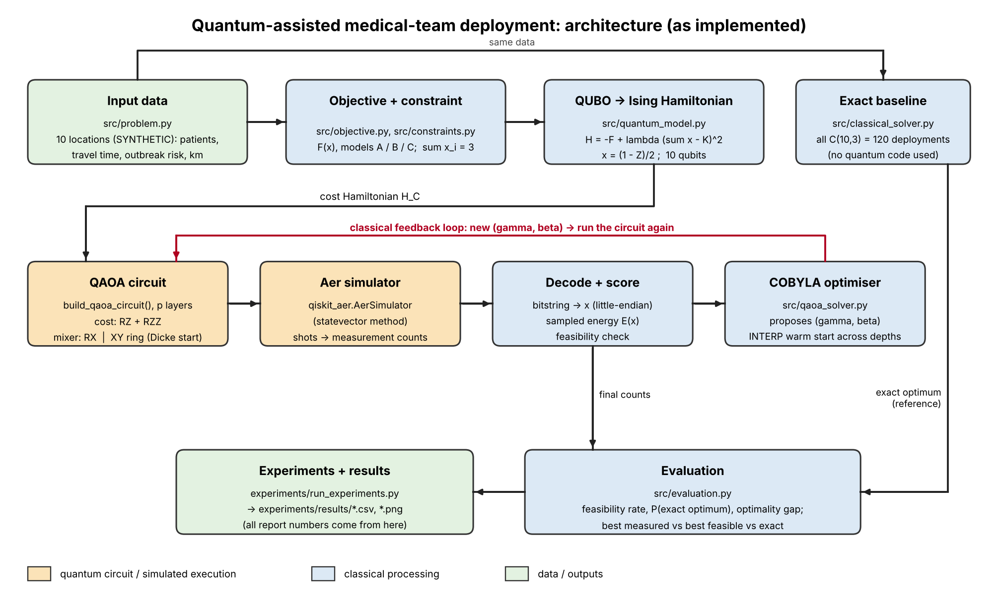
Figure 1. Pipeline: data, QUBO/Ising, QAOA circuit (quantum), classical optimiser, evaluation against the exact solver.
Quantum part (simulated by Aer): state preparation, cost/mixer layers, measurement. Classical part: decoding, sampled expected energy, COBYLA parameter updates, evaluation. The exact solver is never used inside the loop.
 | X mixer | XY mixer (default)
Start state | uniform superposition | Dicke state |D(10,3)>
Mixer | RX on every qubit | XX+YY ring (keeps Hamming weight)
Constraint | penalty only | enforced by construction
Logical circuit depth (p=3) | 59 | ~2090 (Dicke preparation dominates)

Parameters are initialised by INTERP warm starts across depths (Zhou et al., 2020) and optimised by COBYLA from sampled energies (2048 shots). Seeds fix the start points and the simulator sampling.

Why QAOA for this problem
The deployment decision is a constrained binary quadratic problem: one binary variable per location, a linear score, a pairwise overlap penalty and a cardinality constraint (exactly 3 teams). It maps directly onto an Ising Hamiltonian, the native input of QAOA (Farhi et al., 2014), so the quantum circuit encodes the real objective rather than a toy stand-in.
We considered the alternatives. Grover search needs an oracle and offers at most a quadratic speed-up over only 120 candidates, which enumeration handles instantly. VQE needs a hand-designed ansatz with no built-in link to the constraint. Quantum annealing needs annealing hardware outside the Qiskit workflow required here. QAOA's alternating-operator form also lets us enforce the cardinality constraint inside the mixer (XY ring with a Dicke start state, Hadfield et al., 2019) instead of relying on a penalty alone.
Where the quantum part does real work. In the quantum pipeline, the QAOA circuit is the only source of candidate deployments. Its measured samples are decoded, scored and used to update the parameters (gamma, beta); the exact solver is used only for evaluation. The measured benefit is enrichment over random feasible sampling (8.2x at p=5 on the 10-location instance, Section 5), not an advantage over classical heuristics (Section 4).

4. Classical baselines
Exact solver: enumerates all C(10,3)=120 deployments with an objective implementation independent of the quantum code.
Model | Exact optimum | F*
A | L1, L3, L7 | 0.8848
B | L1, L3, L5 | 1.6152
C | L1, L3, L9 | 1.5207

Ignoring outbreak risk (A's deployment scored under B) costs 0.115, i.e. 7.1% of F*; ignoring overlap (B's deployment scored under C) costs 0.113, i.e. 7.4%. Without the overlap term the problem is linear and is solved by sorting; on our weight grid sorting is wrong in 40 of 66 cells (it requires an outbreak weight of at least 0.2). Only model C is a genuine quadratic problem.
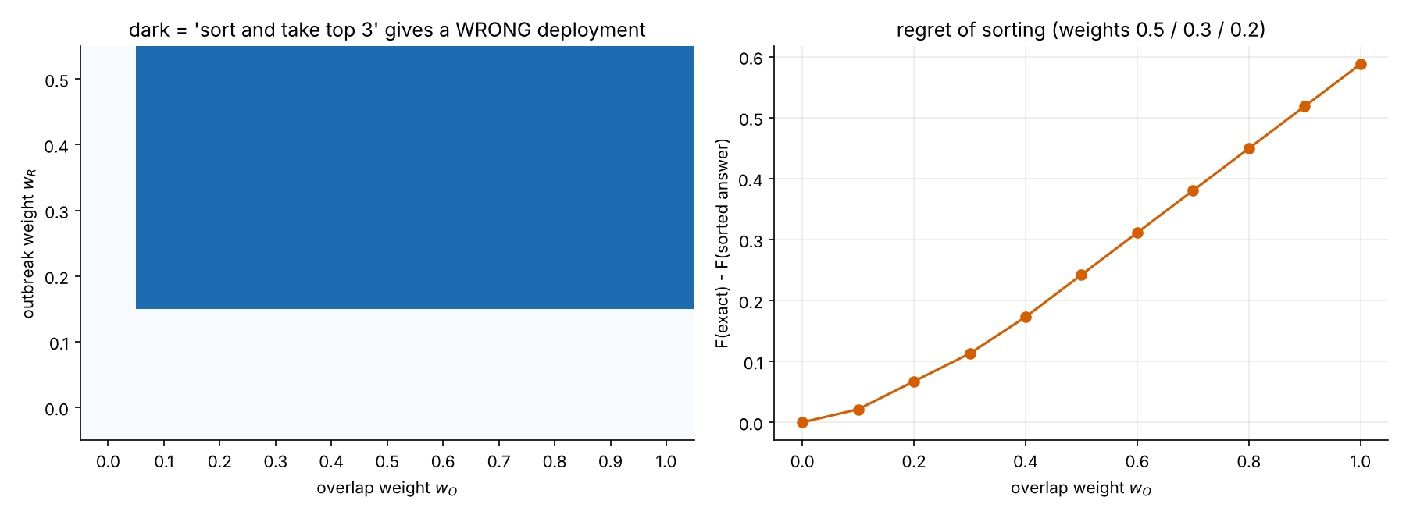
Figure 2. Where sorting by score fails (E7).

Classical heuristics (E8)
Probability of returning the exact model-C optimum (300 repetitions per cell; budget = number of objective evaluations). Greedy (marginal-gain) construction returns the optimum with 27 evaluations.
Method | 10 evals | 25 evals | 27 evals | 50 evals | 100 evals
Greedy | - | - | 1 | - | -
Local search | 0.127 | 0.48 | - | 0.933 | 1
Random search | 0.077 | 0.197 | - | 0.363 | 0.54
Simulated annealing | 0.193 | 0.483 | - | 0.847 | 0.973

Classical heuristics solve this 10-location instance with a few dozen evaluations. QAOA is therefore not competitive on this instance; its value here is as a verified formulation and a scaling testbed.

5. QAOA results
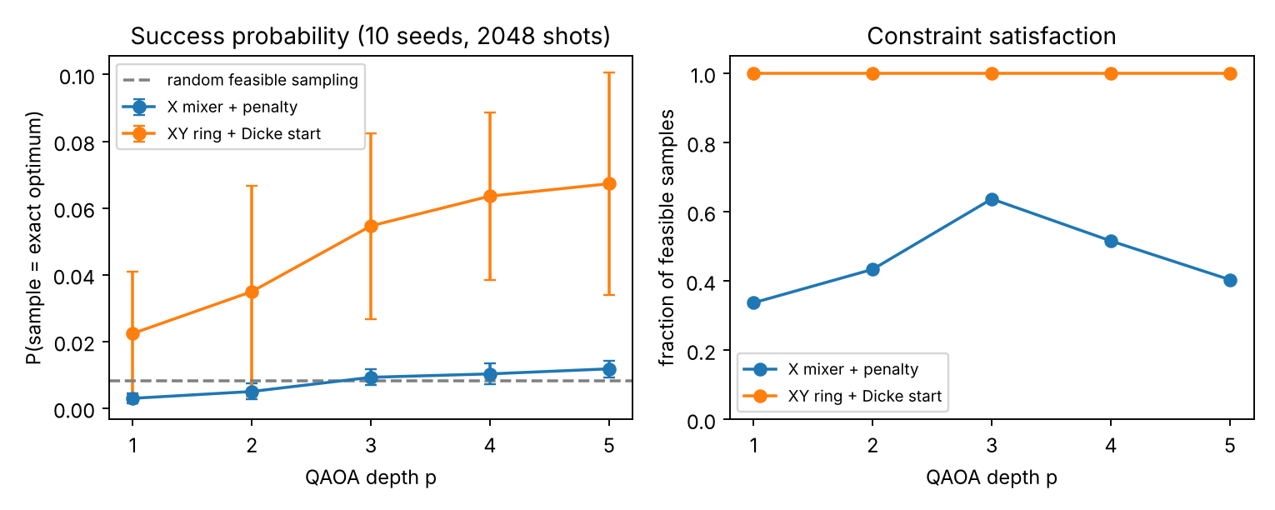
Figure 3. Depth study, model C, 10 seeds.
Mixer | p | P(exact optimum) | Feasible samples | Runtime (s) | Logical depth
X + penalty | 1 | 0.0030 +/- 0.0014 | 34% | 1.9 | 21
X + penalty | 2 | 0.0050 +/- 0.0024 | 43% | 4.1 | 40
X + penalty | 3 | 0.0093 +/- 0.0024 | 64% | 7.0 | 59
X + penalty | 4 | 0.0103 +/- 0.0031 | 52% | 11.0 | 78
X + penalty | 5 | 0.0118 +/- 0.0025 | 40% | 16.3 | 97
XY + Dicke | 1 | 0.0224 +/- 0.0185 | 100% | 6.7 | 2045
XY + Dicke | 2 | 0.0350 +/- 0.0316 | 100% | 14.5 | 2067
XY + Dicke | 3 | 0.0546 +/- 0.0278 | 100% | 24.6 | 2089
XY + Dicke | 4 | 0.0636 +/- 0.0251 | 100% | 36.9 | 2111
XY + Dicke | 5 | 0.0673 +/- 0.0333 | 100% | 49.4 | 2133

Controls: random feasible sampling finds the optimum with probability 0.0082 (theory 1/120 = 0.0083); random 10-bit strings give 0.0010 with 12% feasible samples. The best sampled feasible deployment equals the exact optimum in all runs, but that is not evidence of skill: with 2048 shots random feasible sampling finds it too. We therefore report enrichment over random sampling as the meaningful metric.
QAOA recovers a different exact optimum for each model (XY, p=4, 5 seeds each): model A: L1, L3, L7 (P=0.085); model B: L1, L3, L5 (P=0.060); model C: L1, L3, L9 (P=0.067).
Penalty study (X mixer): below lambda* the QUBO ground state is infeasible; above it the ground state is feasible.
lambda / lambda* | QUBO ground state feasible | Feasible samples | P(exact optimum)
0.25 | False | 8% | 0.0018
0.5 | False | 27% | 0.0163
0.8 | False | 50% | 0.0112
1 | True | 66% | 0.0133
1.25 | True | 73% | 0.0088
2 | True | 72% | 0.0091
4 | True | 67% | 0.0069

6. Robustness of the model-C optimum
Model C's best and second-best deployments differ by only 0.009 in F, so the exact optimum is nearly degenerate. We perturbed patients, risk and travel times with log-normal noise (3000 draws per level) and recomputed the exact optimum.
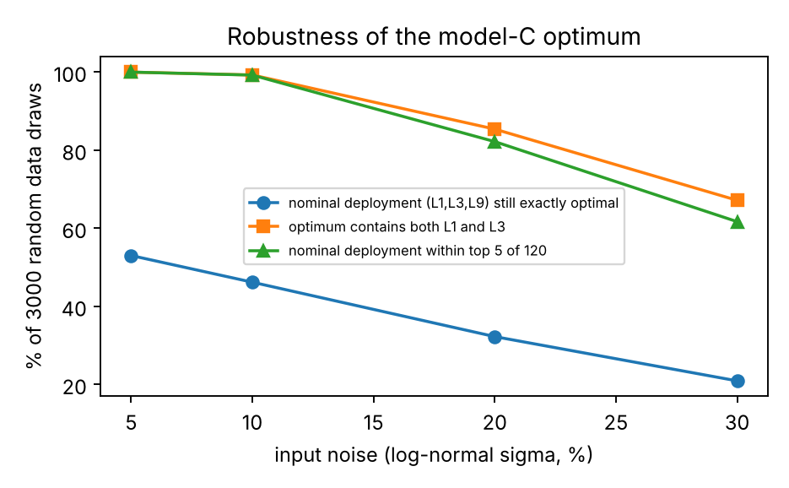
Figure 4. Stability of the optimum under input noise.
Noise sigma | Draws | Nominal still optimal | Nominal in top 5 | Optimum contains L1 and L3 | Mean relative regret of nominal | P95 relative regret
0.05 | 3000 | 0.53 | 1 | 1 | 0.006 | 0.025
0.1 | 3000 | 0.462 | 0.992 | 0.993 | 0.015 | 0.055
0.2 | 3000 | 0.323 | 0.822 | 0.854 | 0.039 | 0.125
0.3 | 3000 | 0.209 | 0.617 | 0.672 | 0.075 | 0.218

Interpretation: the decision 'send teams to L1 and L3' is robust; the choice of the third location is not. Reporting the single nominal optimum without this caveat would overstate its certainty.
Probability mass of XY-QAOA (p=5, 3 seeds, 2048 shots) on near-optimal deployments, compared with random feasible sampling:
Deployments | How many (of 120) | QAOA mass | Random feasible mass
within 0% of F* | 1 | 8.5% | 0.8%
within 1% of F* | 2 | 15.6% | 1.7%
within 5% of F* | 3 | 23.0% | 2.5%
within 10% of F* | 8 | 35.9% | 6.7%

Note on seeds: the 8.5% above (3 seeds, p=5) and the 6.7% in Section 5 (10 seeds, p=5) come from different seed sets of the same experiment. They differ by less than one standard deviation (0.033), so they are consistent.

7. Scaling study (E9)
Synthetic random instances (seeded) with n = 8 ... 14 locations, model C, XY-QAOA p=3, 2-3 seeds per size. Random feasible sampling has success probability 1/C(n,K).
n | K | Candidates | Runs | QAOA P(opt) | Random P(opt) | Enrichment (x random) | Logical depth | 2-qubit gates | Wall time (s)
8 | 3 | 56 | 3 | 0.0671 | 0.0179 | 3.7552 | 550 | 379 | 4
10 | 3 | 120 | 3 | 0.0389 | 0.0083 | 4.668 | 2089 | 1208 | 11
12 | 4 | 495 | 3 | 0.0285 | 0.002 | 14.0991 | 8246 | 4353 | 47
14 | 4 | 1001 | 2 | 0.0056 | 0.001 | 5.6208 | 32830 | 16726 | 408

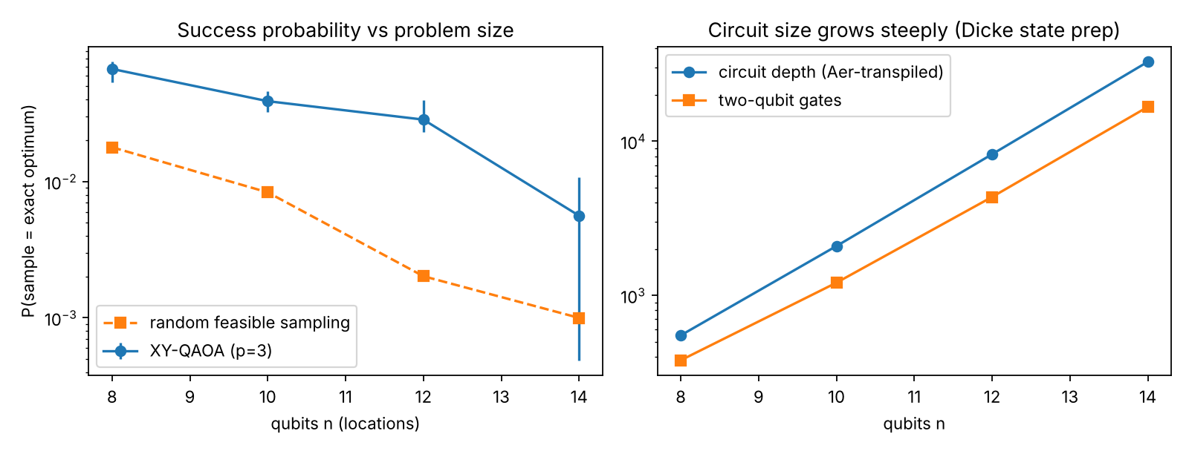
Figure 5. Success probability and circuit size versus n.
Honest note: at n=14 seed 1 QAOA reached P=0.0005, below random sampling (0.0010). With a fixed budget of 150 optimiser iterations the optimiser has not converged at the largest size, and the single-seed spread is large.
Reading: QAOA's success probability falls as n grows (0.067 at n=8 to 0.0056 at n=14) but stays above random sampling on average (3.8x to 14.1x enrichment, highest at n=12). Circuit cost grows far faster than the instance: logical depth rises from 550 to 32,830, two-qubit gates from 379 to 16,726 and wall time from 4 s to 408 s. With only 2-3 seeds per size, the non-monotone enrichment should not be over-interpreted; the results are indicative, not statistically conclusive. The n=10 value here (0.0389, 3 seeds) differs from the p=3 value in Section 5 (0.0546, 10 seeds) because the seed sets differ; the two means are within one standard deviation (about 0.028) of each other. The generic Dicke-state synthesis grows quickly with n and is the practical limit of this implementation (a linear-depth Dicke circuit is future work).

8. Hardware readiness (no hardware run)
We did not run on a quantum device. To quantify what a device would face we transpiled the circuits to a heavy-hex coupling map with basis gates ECR/RZ/SX/X (noise-free; Qiskit generic backend, optimisation level 1).
p | circuit | transpiled depth | ECR gates | total gates | qubits used
1 | X mixer (H start) | 338 | 195 | 996 | 10
1 | XY ring + Dicke start | 7471 | 2821 | 12818 | 10
1 | XY ring + basis start | 334 | 242 | 1208 | 11
3 | X mixer (H start) | 1152 | 645 | 3101 | 10
3 | XY ring + Dicke start | 8249 | 3410 | 15483 | 10
3 | XY ring + basis start | 997 | 753 | 3690 | 10
5 | X mixer (H start) | 1625 | 1113 | 5258 | 10
5 | XY ring + Dicke start | 9416 | 4146 | 18725 | 10
5 | XY ring + basis start | 1793 | 1288 | 6251 | 10

The XY circuit with the generic Dicke start has thousands of two-qubit gates even at p=1, far beyond what current noisy hardware can run coherently. A shallow alternative (a single basis state |1110000000> instead of the Dicke state) is cheap but failed in our test: 0 of 3 runs sampled the optimum (P=0.0). We kept it as a documented negative result.

9. Limitations (honest)
- No quantum advantage: 120 candidates are enumerated instantly and classical heuristics succeed with a few dozen evaluations.
- Noiseless simulation only; no hardware run; transpiled circuits are too deep for current devices.
- Synthetic data; weights, the 0.5 km/min speed and the overlap model are our assumptions; model C is our own extension.
- Success probabilities stay below 10% at p <= 5 (local COBYLA optimiser, 5-10 seeds); results are indicative.
- The model-C optimum is nearly degenerate and sensitive to the data (Section 6).
- Scaling study covers n <= 14, 2-3 seeds per size.

10. Reproducibility
Python 3.12, Qiskit 2.6.2, Qiskit Aer 0.18.2. 110 unit tests (python -m pytest -q). python experiments/run_experiments.py runs the main study; python -m experiments.run_extra runs E8-E10. All random seeds are fixed; results are written as CSV to experiments/results/. Setup and run instructions for judges are in README.md in the repository. Experiment IDs used in this report (E7 sorting failure, E8 classical heuristics, E9 scaling study) refer to the scripts in the experiments/ folder.

11. Originality and credits
The problem formulation (models A, B and C, including the overlap extension), the QUBO/Ising conversion, the QAOA implementation, the classical baselines and the experiments were written by our team for this hackathon. No code was copied from tutorials or other teams.
Ideas and methods taken from the literature are credited: QAOA (Farhi et al.), the XY-ring alternating-operator mixer for Hamming-weight constraints (Hadfield et al.), INTERP parameter warm starts across depths (Zhou et al.) and Dicke states (Baertschi and Eidenbenz; we use generic amplitude loading, not their circuit). Library code used: Qiskit, Qiskit Aer and standard Python scientific packages, as listed in the repository.

12. References
- Farhi, Goldstone, Gutmann. A Quantum Approximate Optimization Algorithm. arXiv:1411.4028 (2014).
- Hadfield et al. From the QAOA to a Quantum Alternating Operator Ansatz. Algorithms 12(2):34 (2019).
- Zhou et al. QAOA: Performance, Mechanism, and Implementation on Near-Term Devices. Phys. Rev. X 10, 021067 (2020).
- Baertschi, Eidenbenz. Deterministic Preparation of Dicke States. FCT 2019 (we use generic amplitude loading, not their circuit).
- Qiskit and Qiskit Aer documentation (IBM Quantum).

