

**UNIVERSITI MALAYSIA TERENGGANU**



**CSM3103 FRONT-END PROGRAMMING**

**BACHELOR OF COMPUTER SCIENCE (MOBILE COMPUTING) WITH HONORS**

**LAB 2**

**SEMESTER II 2023/2024**



**Prepared for:**

DR RABIEI BIN MAMAT

**Prepared by:**

MUHAMMAD IZZUL WAFIY BIN IZAM (S65466)

# Task 1 – Setup and configure Apache cordova on your desktop/laptop

Create cordova Task 1 :

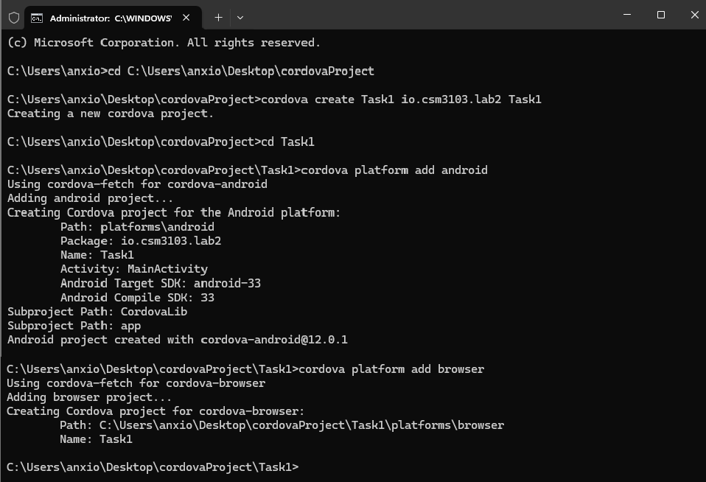

Output :

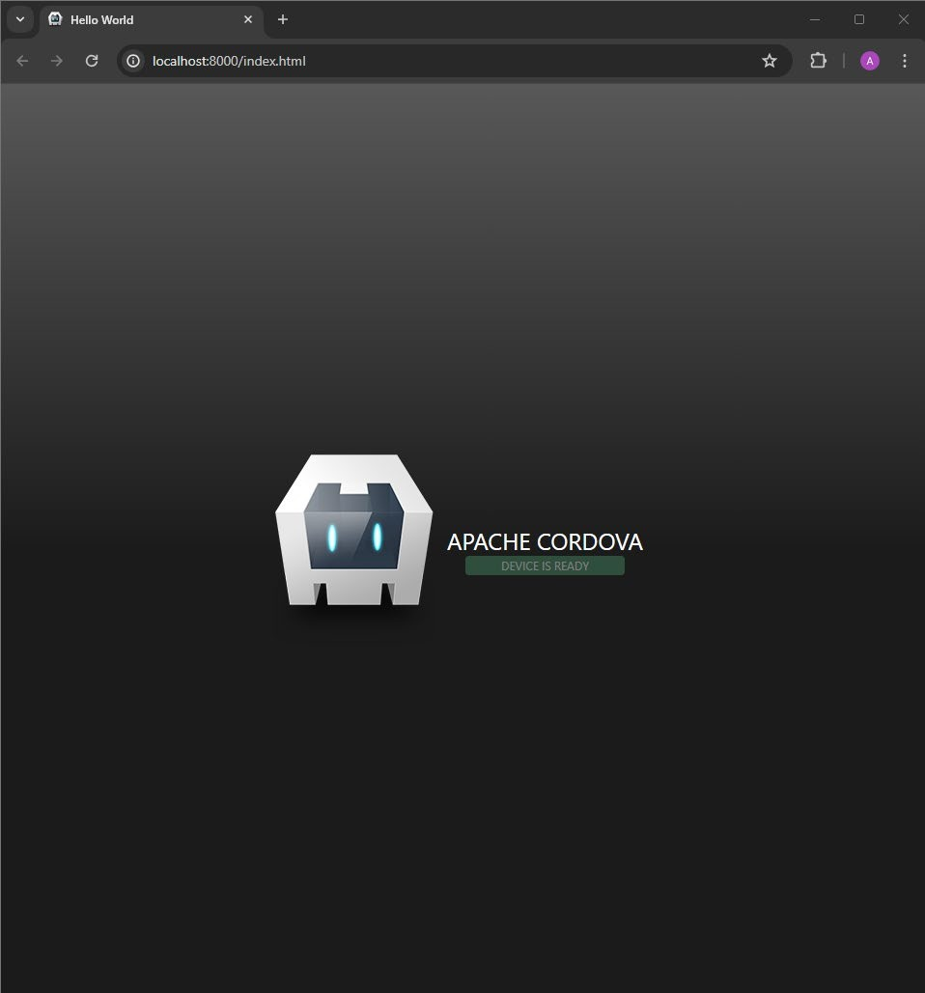

Update Path :

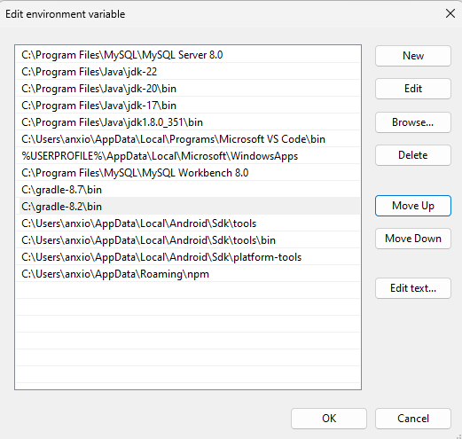

# Task 2 – Your First Apache Cordova Application

Create cordova Task 2 :

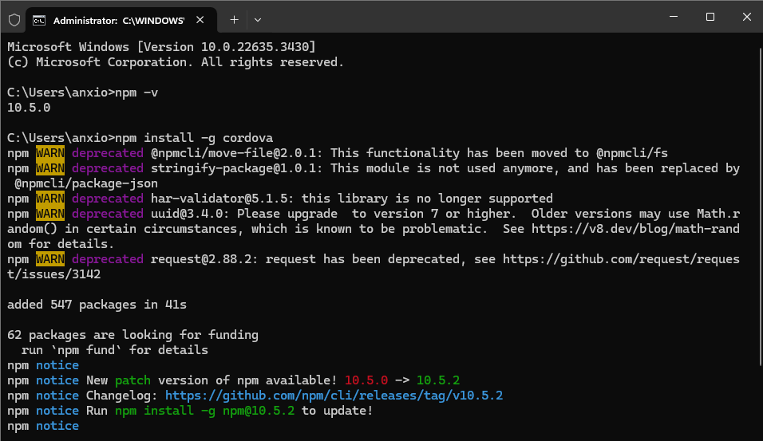

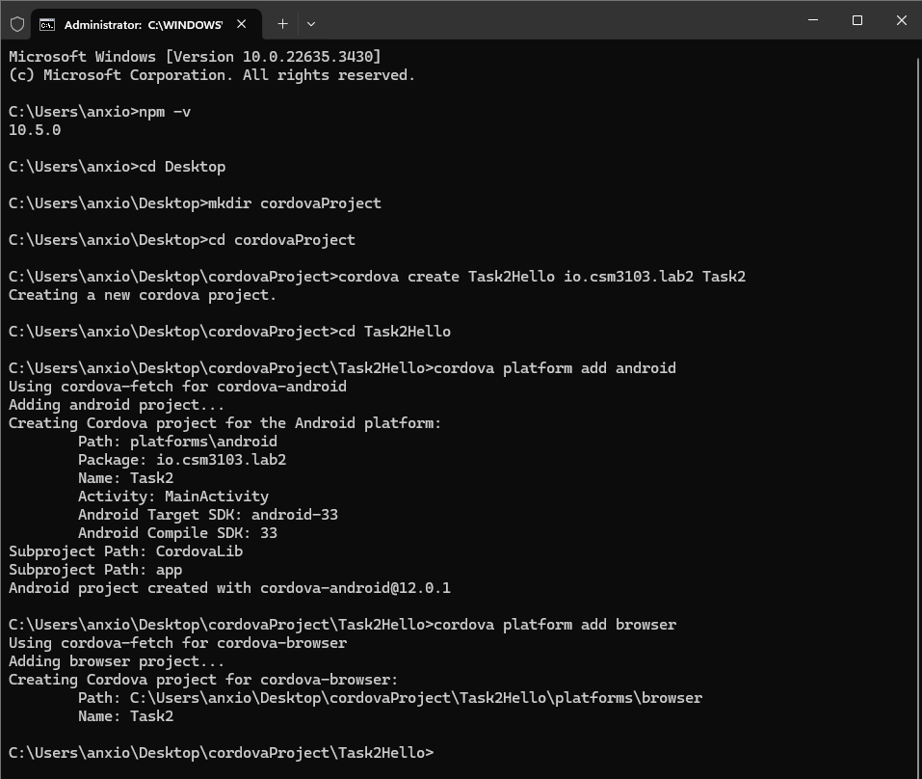

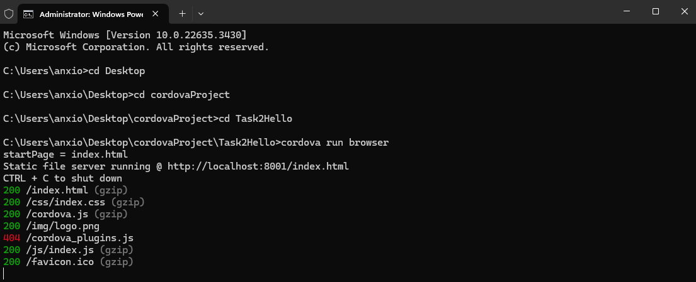

Cordova run browser :

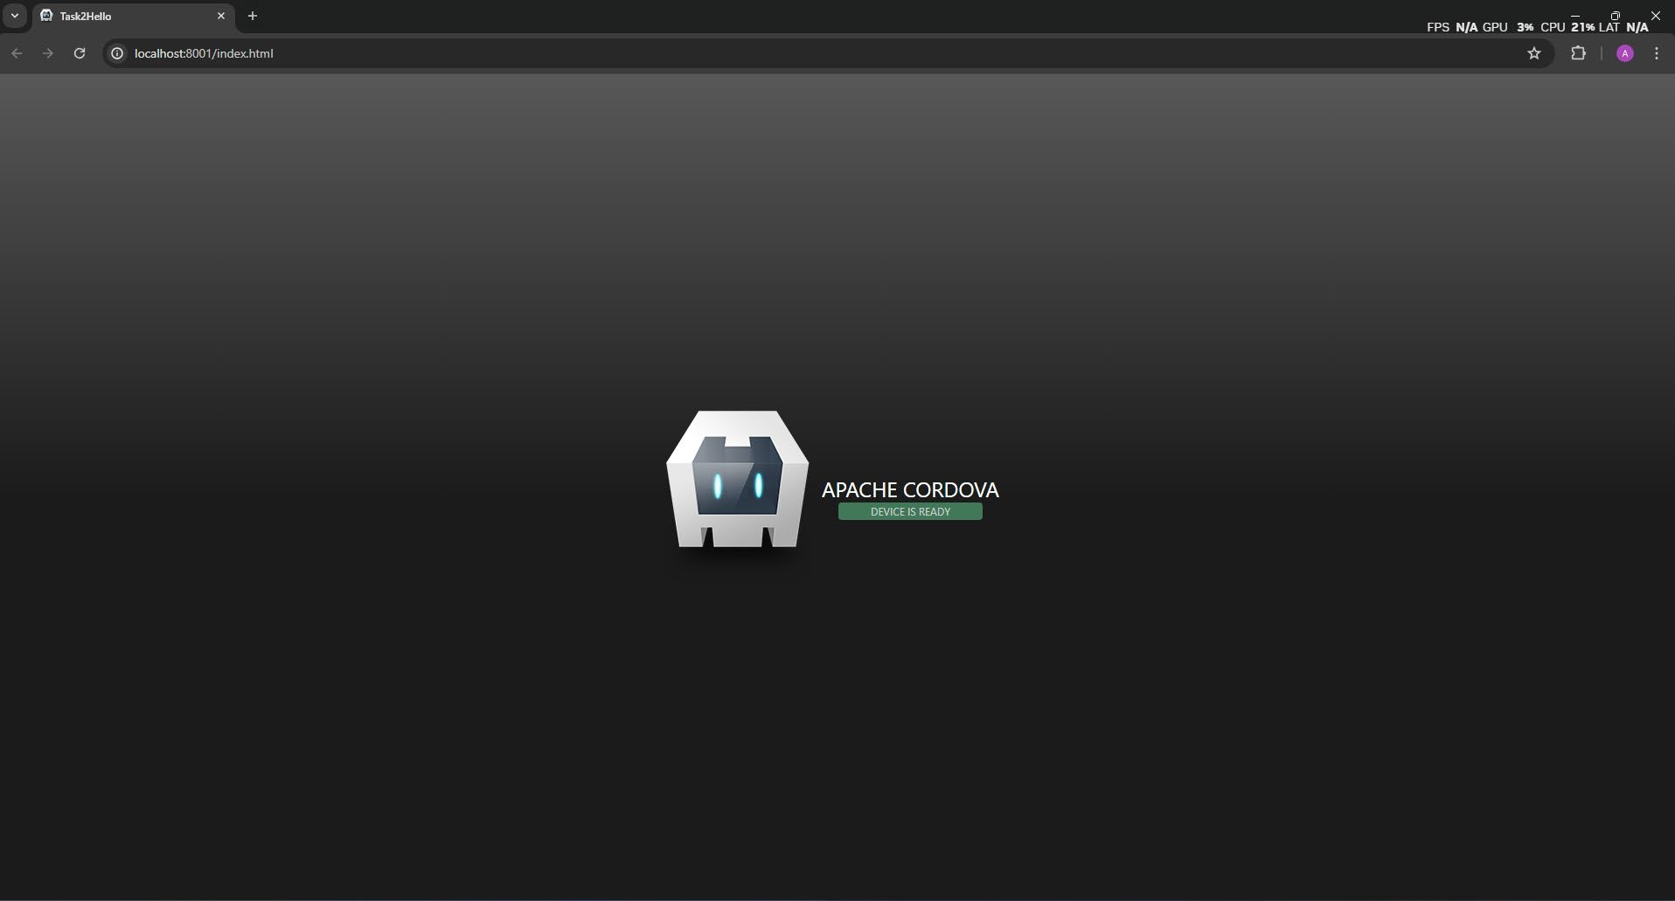

# Task3 – Simple eventListener in Cordova Project

Create cordova Task 3 :

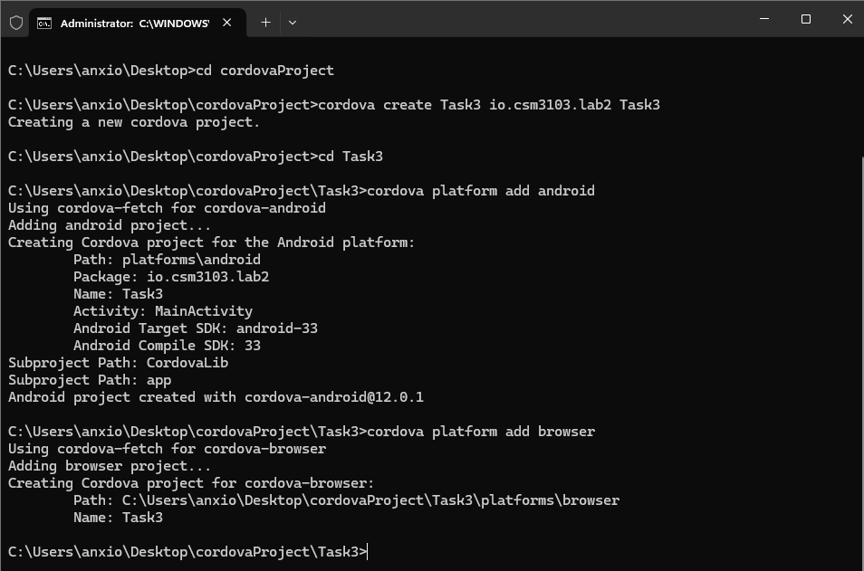

Add Js

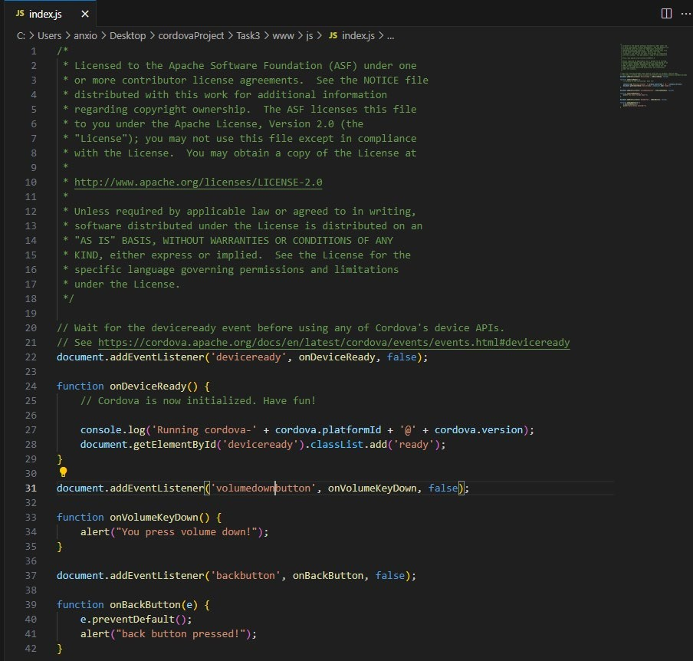

Add device

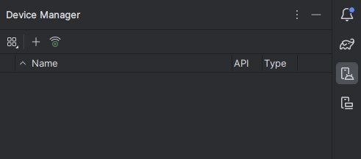

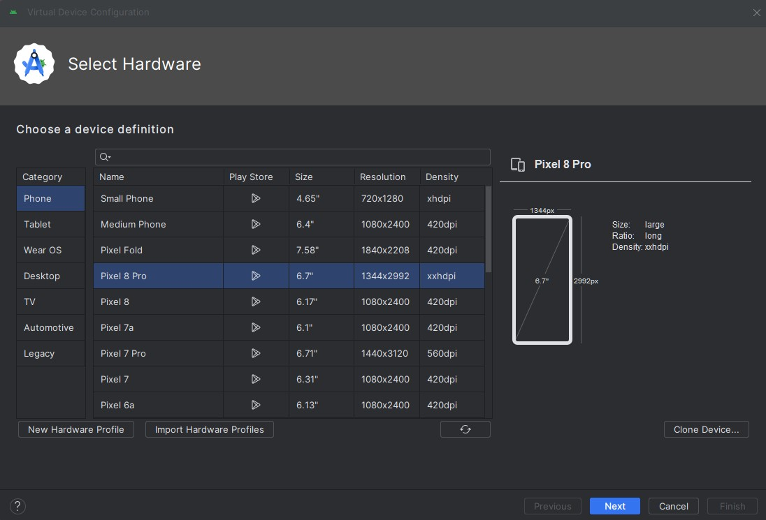

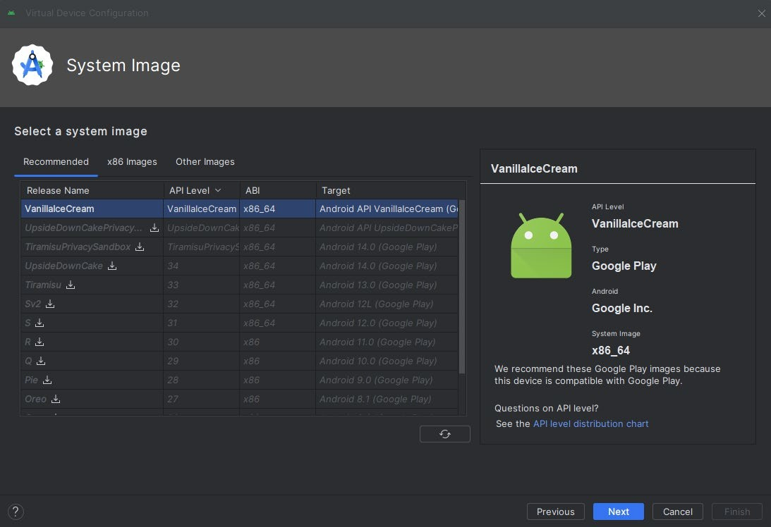

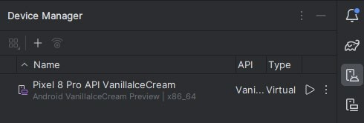

Cordova run android

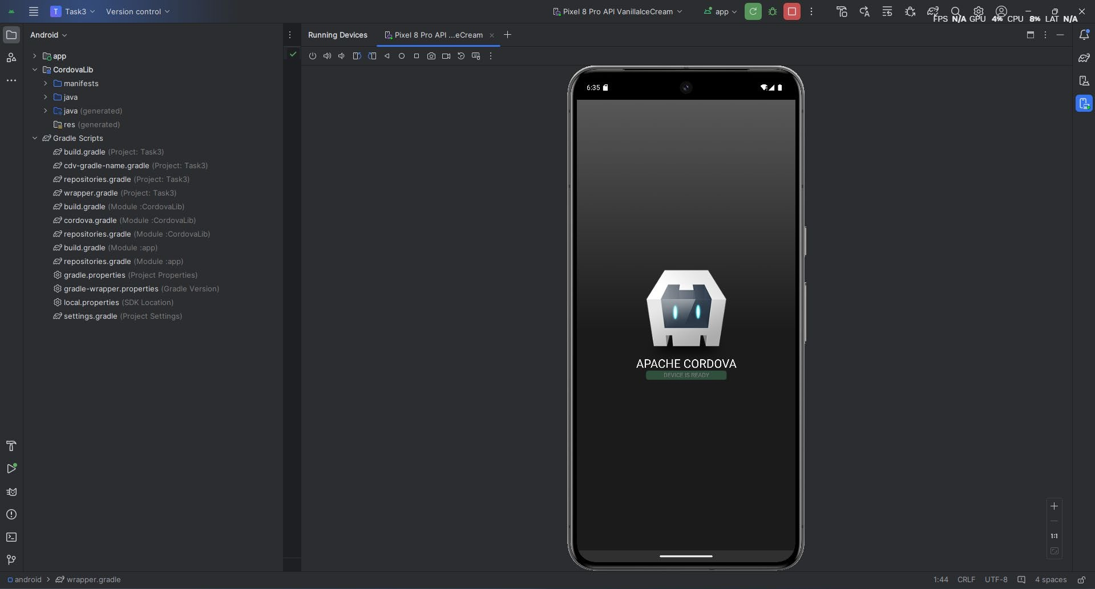

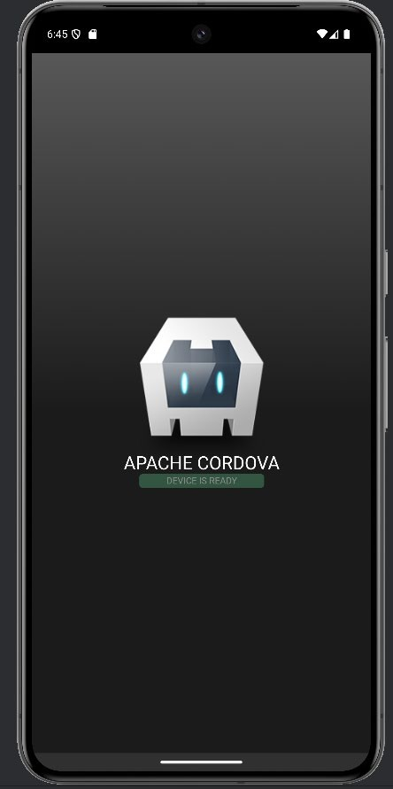

Volume Up :

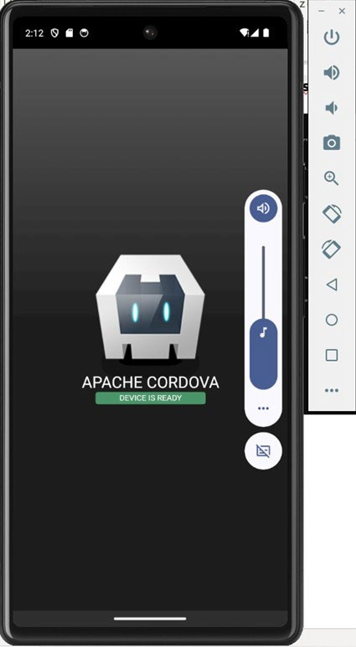

Volume Down :

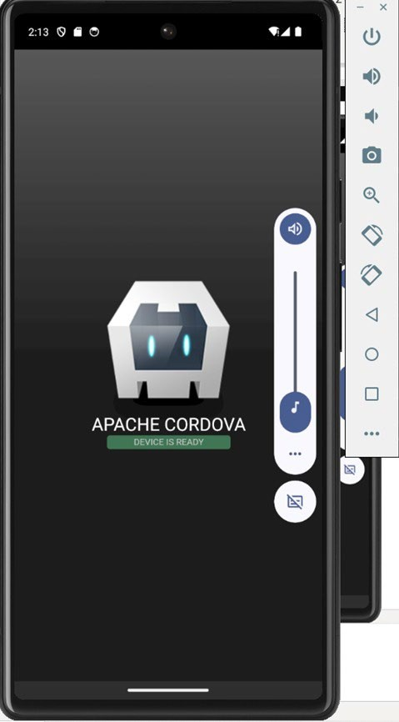

# Question

1. **What is the purpose of e.preventDefault()**

e.preventDefault() will prevent the page from refreshing.

# 8.

* 1. Handle volume up button document.addEventListener('volumeupbutton', onVolumeKeyUp, false);

function onVolumeKeyUp(){ alert("You press volume down!");

}

document.addEventListener('Upbutton', onUpButton, false);

function onUpButton(e){ e.preventDefault(); alert("back button pressed!");

* 1. Handle menu button document.addEventListener('backbutton', onBackButton, false);

function onBackButton() {

// add custom logic

}

In android, menu button can used same as back button but it can be different based on their function.

# Task 4 – Cordova Plugin use case (Simple Geolocation)

Create cordova Task4 :

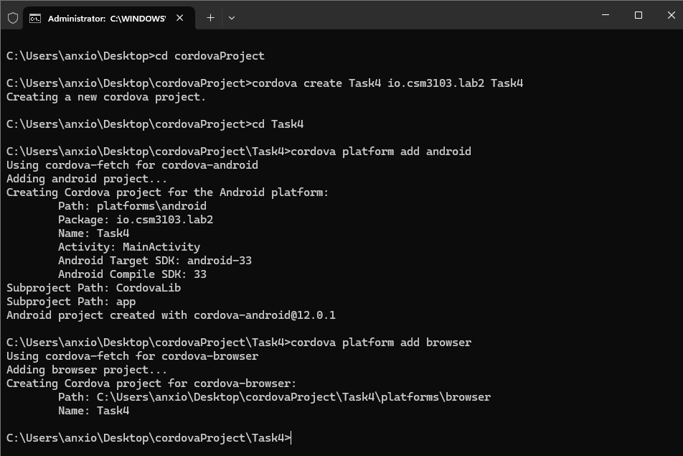

Add Js

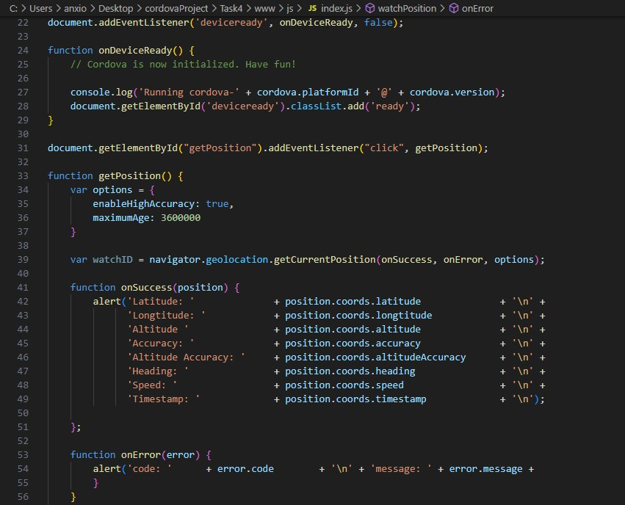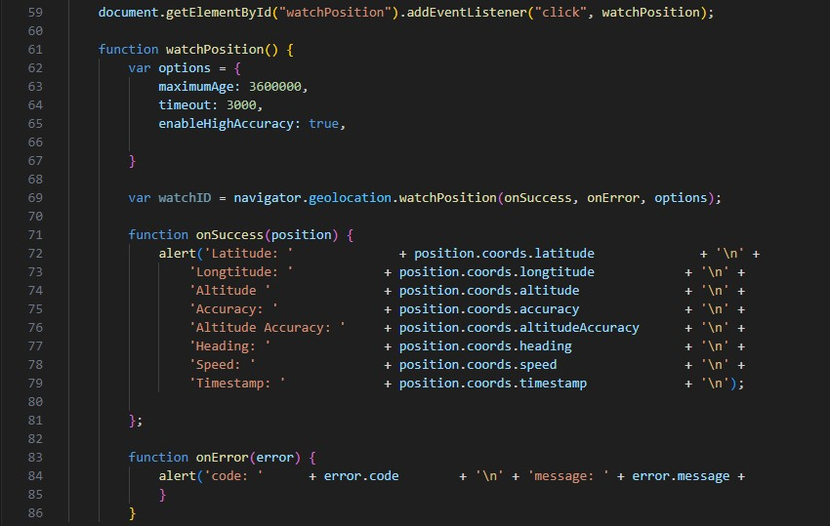

Add HTML

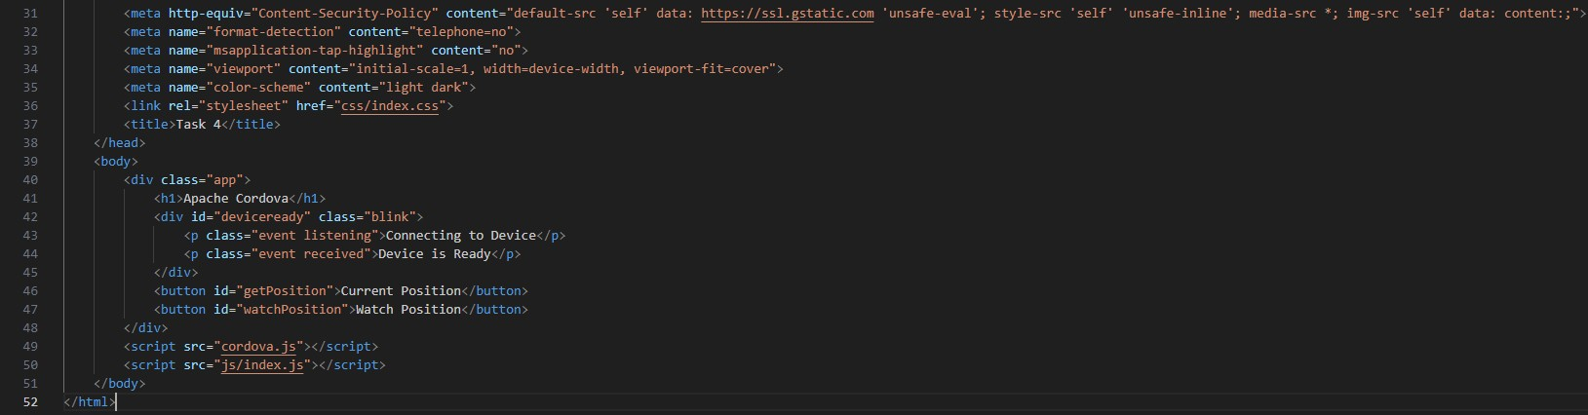

Cordova run browser :

