

**UNIVERSITI MALAYSIA TERENGGANU**

**CSM3103 – FRONT-END PROGRAMMING**

**BACHELOR OF COMPUTER SCIENCE (MOBILE COMPUTING) WITH HONORS**

**LAB 4**

**SEMESTER II 2023/2024**

**Prepared for:**

DR RABIEI BIN MAMAT

**Prepared by:**

MUHAMMAD IZZUL WAFIY BIN IZAM (S65466)

**Link Github :**

[**htps://github.com/arifhaikal2001/CSM3103-LAB-4.git**](https://github.com/arifhaikal2001/CSM3103-LAB-4.git)

# Task 1 – JavaScript Function

Code :

Html

<!DOCTYPE html>

<html lang="en">

<head>

<meta charset="UTF-8">

<meta name="viewport" content="width=device-width, initial-scale=1.0">

<title>Task 1</title>

<script src="Task 1.js" defer></script>

</head>

<body>

<h1> JavaScript Function</h1>

<div id="output"></div>

<button onclick="findSquare()">Find Square</button>

<button onclick="sumOfCubes()">Sum of Cubes</button>

<button onclick="reverseNumber()">Reverse Number</button>

<button onclick="divisibleByZ(parseInt(prompt('Enter a number to find divisible numbers between 1 and 100:')))">Divisible Numbers</button>

</body>

</html>

Js

function findSquare() {

let number = parseInt(prompt("Enter a number to find its square:")); let square = number * number;

document.getElementById("output").innerText = `Square of ${number} is: ${square}`;

}

function sumOfCubes() {

let num1 = parseInt(prompt("Enter the first number:"));

let num2 = parseInt(prompt("Enter the second number:")); let sum = Math.pow(num1, 3) + Math.pow(num2, 3);

document.getElementById("output").innerText = `Sum of cubes of ${num1} and ${num2} is: ${sum}`;

}

function reverseNumber() {

let number = parseInt(prompt("Enter a number to reverse:")); let reversed = 0;

while (number > 0) {

reversed = (reversed * 10) + (number % 10); number = Math.floor(number / 10);

}

document.getElementById("output").innerText = `Reversed number is: ${reversed}`;

}

function divisibleByZ(z) { let output = "";

for (let i = 1; i <= 100; i++) { if (i % z === 0) {

output += i + ", ";

}

}

document.getElementById("output").innerText = `Numbers between 1 and 100 divisible by ${z} are: ${output}`;

}

Output :

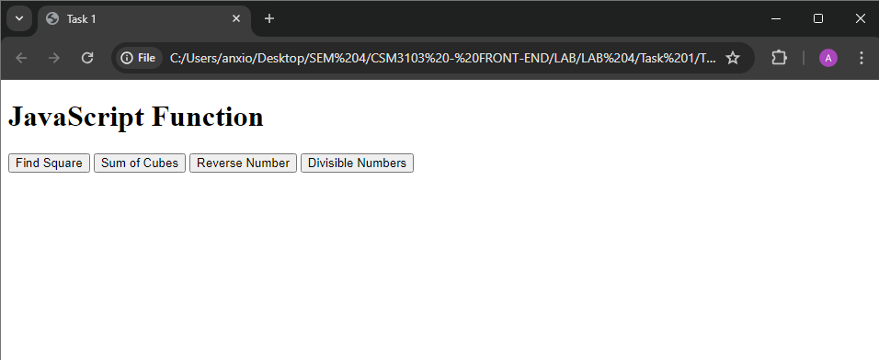

* Find Square

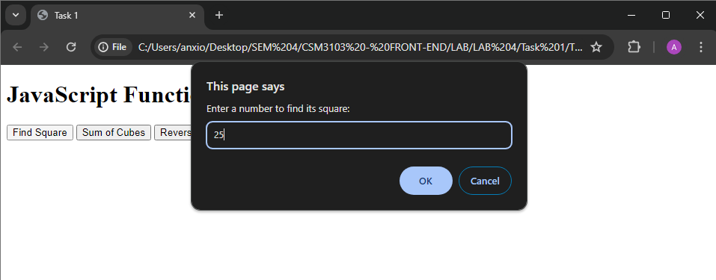

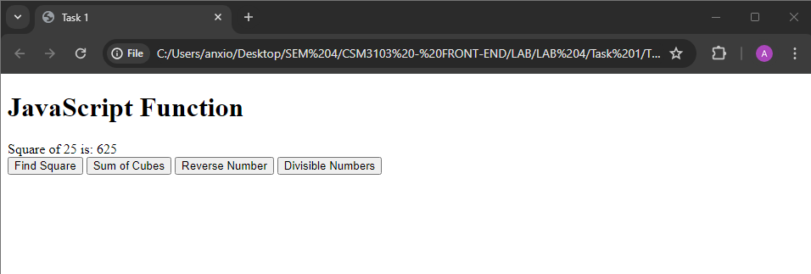

* Sum of Cubes

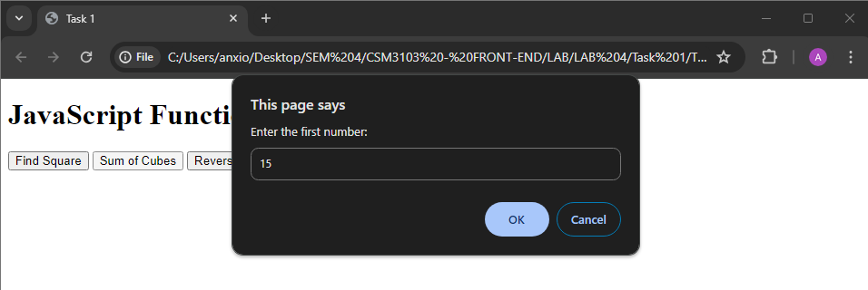

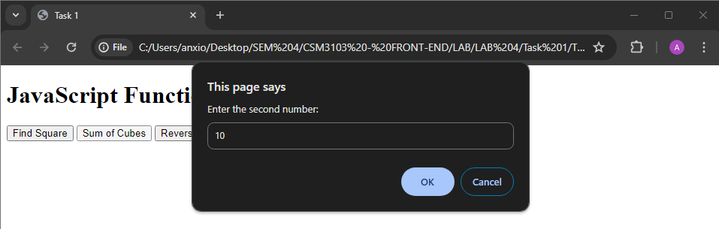

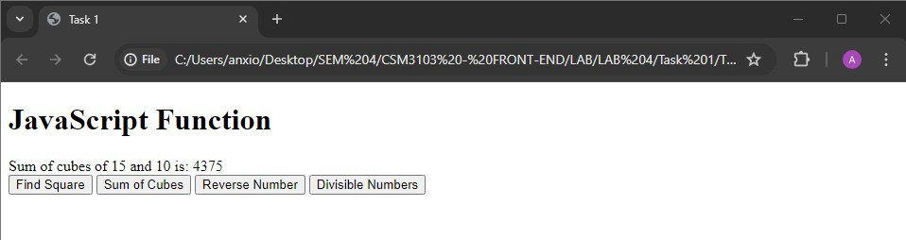

* Reverse Number

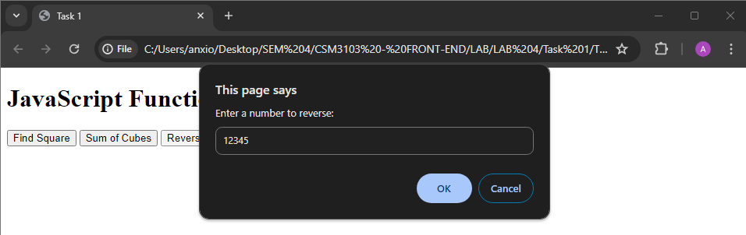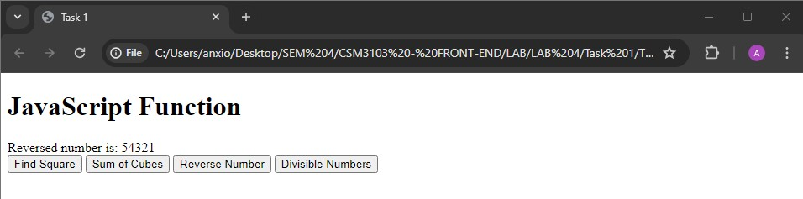

* Divisible Numbers

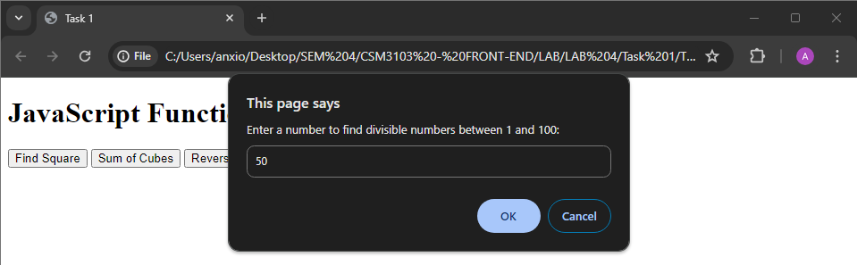

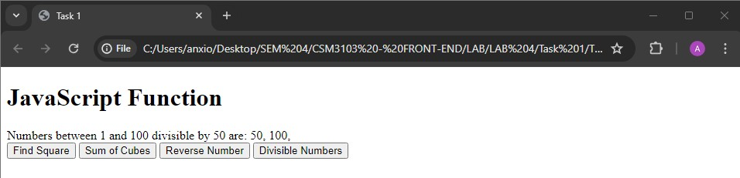

# Task 2 - JavaScript Recursion Function

Code :

Html

<!DOCTYPE html>

<html lang="en">

<head>

<meta charset="UTF-8">

<meta name="viewport" content="width=device-width, initial-scale=1.0">

<title>Task 2</title>

<script src="Task 2.js" defer></script>

</head>

<body>

<h1>Recursion Functions</h1>

<div id="output"></div>

<button onclick="sumOfDigits()">Sum of Digits</button>

<button onclick="power(parseInt(prompt('Enter base:')), parseInt(prompt('Enter exponent:')))">Power</button>

</body>

</html>

Js

function sumOfDigits() {

let number = parseInt(prompt("Enter a number to find sum of its digits:")); let sum = calculateSumOfDigits(number);

document.getElementById("output").innerText = `Sum of digits of ${number} is: ${sum}`;

}

function calculateSumOfDigits(number) { if (number === 0) {

return 0;

} else {

return (number % 10) + calculateSumOfDigits(Math.floor(number / 10));

}

}

function power(x, y) {

let result = calculatePower(x, y);

document.getElementById("output").innerText = `${x} raised to the power ${y} is:

${result}`;

}

function calculatePower(x, y) { if (y === 0) {

return 1;

} else if (y > 0) {

return x * calculatePower(x, y - 1);

} else {

return 1 / calculatePower(x, -y);

}

}

Output :

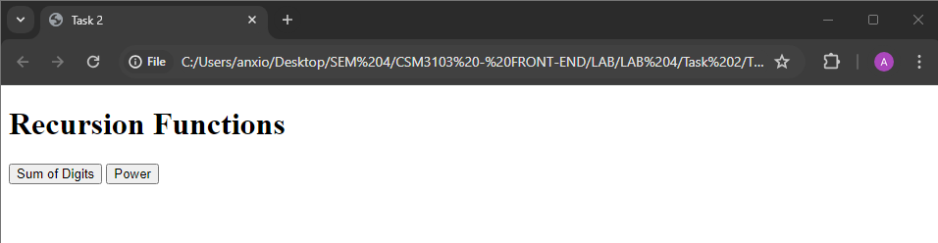

* Sum of digits

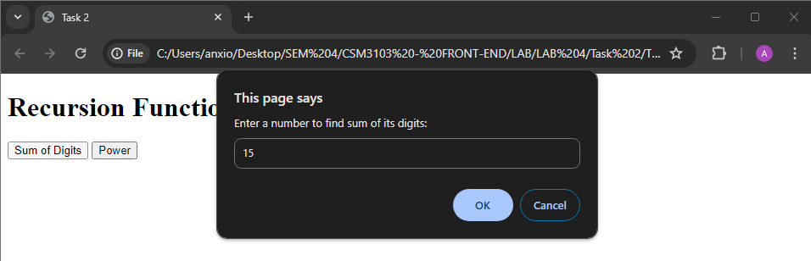

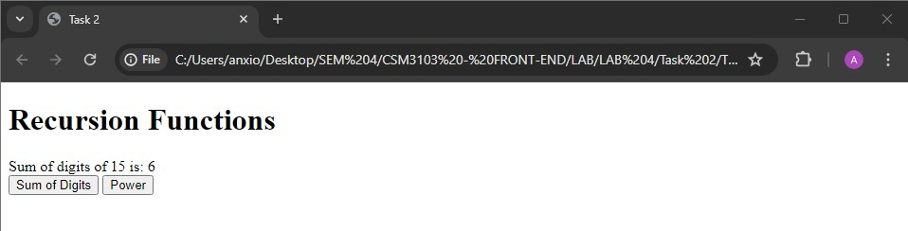

* Power

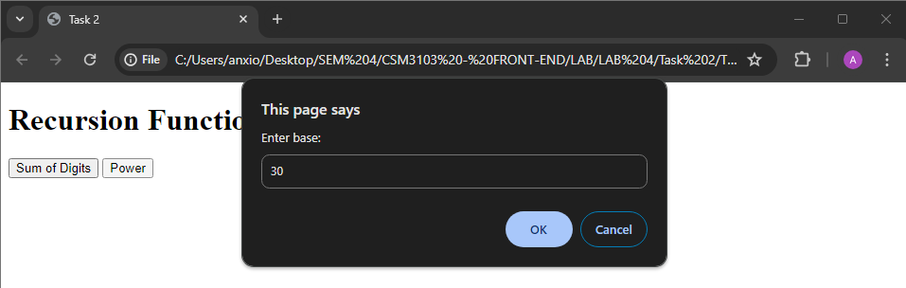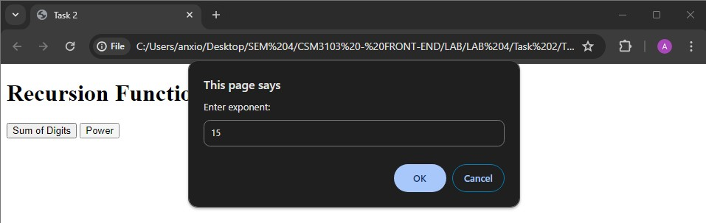

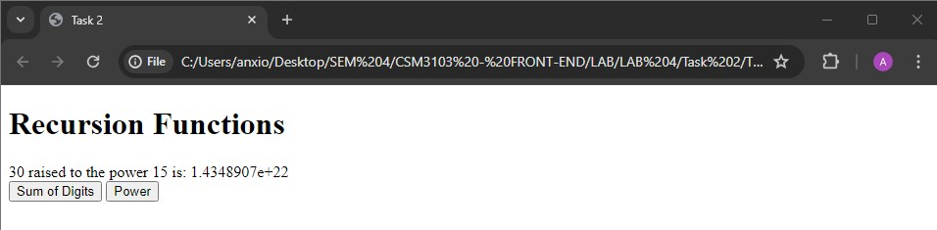

# Task 3 – JavaScript Object and Prototype

Code :

Html

<!DOCTYPE html>

<html lang="en">

<head>

<meta charset="UTF-8">

<meta name="viewport" content="width=device-width, initial-scale=1.0">

<title>Task 3</title>

</head>

<body>

<h2>Product Details</h2>

<form id="productForm">

<label for="productName">Product Name:</label>

<input type="text" id="productName" required><br><br>

<label for="quantity">Quantity:</label>

<input type="number" id="quantity" required><br><br>

<label for="price">Price:</label>

<input type="number" id="price" required><br><br>

<button type="button" onclick="addProduct()">Add Product</button>

</form>

<h2>Book Details</h2>

<form id="bookForm">

<label for="bookName">Book Name:</label>

<input type="text" id="bookName" required><br><br>

<label for="authorName">Author Name:</label>

<input type="text" id="authorName" required><br><br>

<label for="bookPrice">Price:</label>

<input type="number" id="bookPrice" required><br><br>

<button type="button" onclick="addBook()">Add Book</button>

</form>

<h2>Output</h2>

<div id="output"></div>

<script src="Task 3.js"></script>

</body>

</html>

Js

function Product(name, quantity, price) { this.name = name;

this.quantity = quantity; this.price = price;

}

function addProduct() {

const productName = document.getElementById('productName').value; const quantity = parseInt(document.getElementById('quantity').value); const price = parseFloat(document.getElementById('price').value);

const product = new Product(productName, quantity, price);

displayOutput(product);

}

function Book(bookName, authorName) { this.bookName = bookName; this.authorName = authorName;

}

Book.prototype.price = null; function addBook() {

const bookName = document.getElementById('bookName').value; const authorName = document.getElementById('authorName').value;

const bookPrice = parseFloat(document.getElementById('bookPrice').value);

const book = new Book(bookName, authorName); book.price = bookPrice;

displayOutput(book);

}

function displayOutput(obj) {

let outputDiv = document.getElementById('output'); let outputHTML = '';

for (let prop in obj) {

if (obj.hasOwnProperty(prop)) {

outputHTML += `<strong>${prop}:</strong> ${obj[prop]}<br>`;

}

}

outputDiv.innerHTML += outputHTML + '<br>';

}

Output :

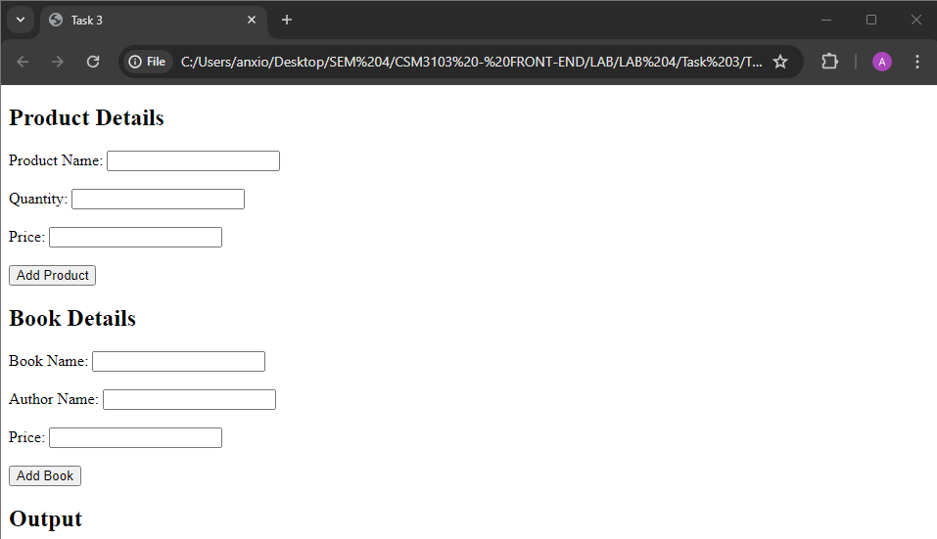

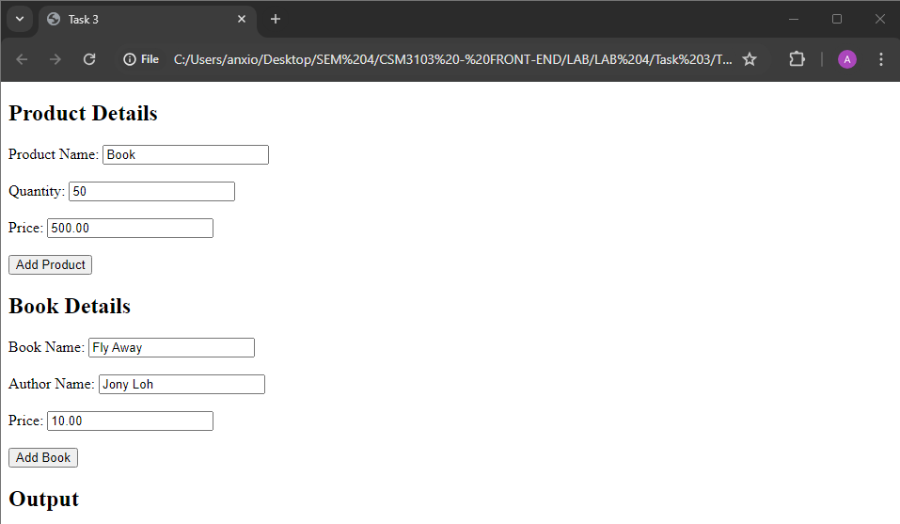

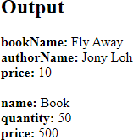

# Task 4 – Event Manager

Code :

Html

<!DOCTYPE html>

<html lang="en">

<head>

<meta charset="UTF-8">

<meta name="viewport" content="width=device-width, initial-scale=1.0">

<title>Task 4</title>

<style>

#paragraph { padding: 20px;

border: 1px solid black; cursor: pointer;

}

#textfield { padding: 10px; font-size: 16px;

transition: all 0.3s ease;

}

</style>

</head>

<body>

<h1>Number 1 - Change the paragraph color</h1>

<p id="paragraph">Click me!</p>

<h1>Number 2 - Text Field Events</h1>

<input type="text" id="textfield" placeholder="Type something...">

<script src="eventmanager.js"></script>

<script src="textfield.js"></script>

</body>

</html>

Js (eventmanager)

const paragraph = document.getElementById('paragraph');

paragraph.onclick = function() { paragraph.style.backgroundColor = 'yellow';

};

paragraph.ondblclick = function() { paragraph.style.backgroundColor = 'blue';

};

paragraph.onmouseover = function() { paragraph.style.backgroundColor = 'red';

};

paragraph.onmouseout = function() { paragraph.style.backgroundColor = 'green';

};

Js (textfield)

const textfield = document.getElementById('textfield');

textfield.onchange = function() { textfield.style.border = '2px solid blue';

};

textfield.onfocus = function() { textfield.style.backgroundColor = '#f0f0f0';

};

textfield.onblur = function() { textfield.style.backgroundColor = 'white';

};

Output :

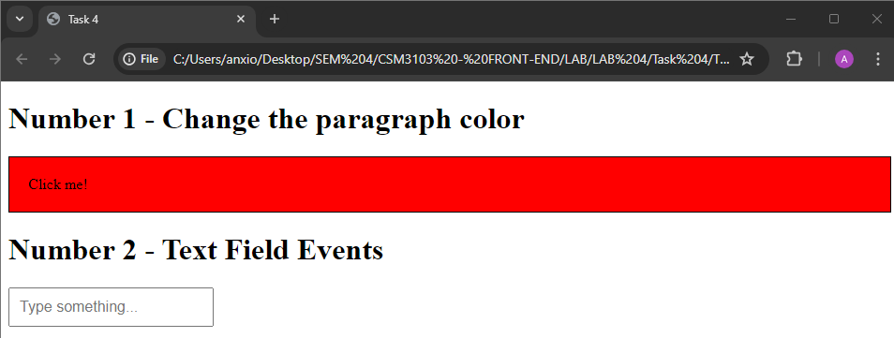

# Task 5

Code :

Html

<!DOCTYPE html>

<html lang="en">

<head>

<meta charset="UTF-8">

<meta name="viewport" content="width=device-width, initial-scale=1.0">

<title>Task 5</title>

</head>

<body>

<h2>Dynamic Table</h2>

<table id="myTable" border="1">

<thead>

<tr>

<th>#</th>

<th>Name</th>

<th>Email</th>

<th>Phone</th>

</tr>

</thead>

<tbody>

</tbody>

</table>

<br>

<input type="text" id="name" placeholder="Enter Name">

<input type="text" id="email" placeholder="Enter Email">

<input type="text" id="phone" placeholder="Enter Phone">

<button onclick="addRow()">Add Record</button>

<script src="Task 5.js"></script>

</body>

</html>

Js

function addRow() {

var table = document.getElementById("myTable").getElementsByTagName('tbody')[0]; var newRow = table.insertRow(table.rows.length);

var cells = [];

for (var i = 0; i < 4; i++) { cells.push(newRow.insertCell(i));

}

cells[0].innerHTML = table.rows.length;

cells[1].innerHTML = document.getElementById("name").value; cells[2].innerHTML = document.getElementById("email").value; cells[3].innerHTML = document.getElementById("phone").value;

document.getElementById("name").value = ""; document.getElementById("email").value = ""; document.getElementById("phone").value = "";

}

window.onload = function() {

var table = document.getElementById("myTable"); var header = table.createTHead();

var row = header.insertRow(0); var headerCells = [];

for (var i = 0; i < headerCells.length; i++) { var cell = row.insertCell(i); cell.innerHTML = headerCells[i];

}

}

document.addEventListener('DOMContentLoaded', function() { var table = document.getElementById("myTable"); table.onclick = function(e) {

if (e.target.tagName.toLowerCase() === 'td') { var index = e.target.parentNode.rowIndex; table.deleteRow(index);

}

};

});

Output :

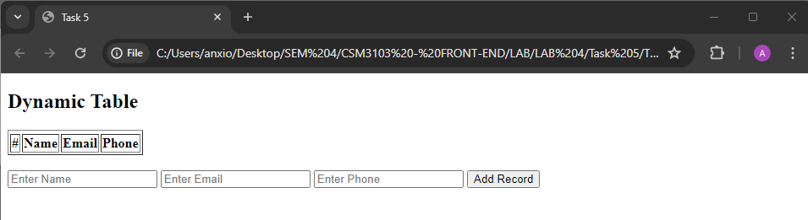

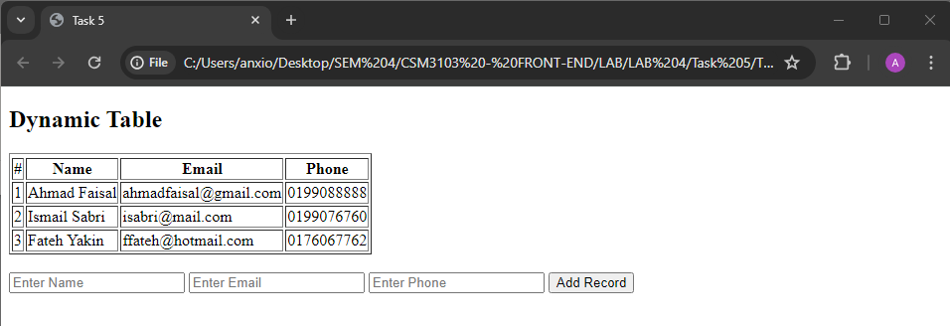

# Task 6

Code :

Html

<!DOCTYPE html>

<html lang="en">

<head>

<meta charset="UTF-8">

<meta name="viewport" content="width=device-width, initial-scale=1.0">

<title>Task 6</title>

<style>

#container { position: relative; width: 400px; height: 400px;

border: 2px solid black;

}

.small-square { position: absolute; width: 20px; height: 20px;

background-color: red;

}

</style>

</head>

<body>

<div id="container">

<div id="square1" class="small-square"></div>

<div id="square2" class="small-square"></div>

</div>

<button id="startBtn">Start Animation</button>

<button id="stopBtn">Stop Animation</button>

<script src="Task 6.js"></script>

</body>

</html>

Js

let intervalId;

function moveSquares() {

const container = document.getElementById('container'); const square1 = document.getElementById('square1'); const square2 = document.getElementById('square2'); const containerWidth = container.clientWidth;

const containerHeight = container.clientHeight; const squareWidth = square1.clientWidth;

const squareHeight = square1.clientHeight;

intervalId = setInterval(() => {

const randomX1 = Math.floor(Math.random() * (containerWidth - squareWidth)); const randomY1 = Math.floor(Math.random() * (containerHeight - squareHeight)); const randomX2 = Math.floor(Math.random() * (containerWidth - squareWidth)); const randomY2 = Math.floor(Math.random() * (containerHeight - squareHeight));

square1.style.left = randomX1 + 'px'; square1.style.top = randomY1 + 'px'; square2.style.left = randomX2 + 'px'; square2.style.top = randomY2 + 'px';

}, 1000);

}

function stopAnimation() { clearInterval(intervalId);

}

document.getElementById('startBtn').addEventListener('click', moveSquares); document.getElementById('stopBtn').addEventListener('click', stopAnimation);

Output :

