

**UNIVERSITI MALAYSIA TERENGGANU**

**CSM3103 – FRONT-END PROGRAMMING**

**BACHELOR OF COMPUTER SCIENCE (MOBILE COMPUTING) WITH HONORS**

**LAB 5**

**SEMESTER II 2023/2024**

**Prepared for:**

DR RABIEI BIN MAMAT

**Prepared by:**

MUHAMMAD IZZUL WAFIY BIN IZAM (S65466)

**Link Github :**

# Task 1

Code :

<html>

<head>

<title>Lab 5 : Task 1</title>

<meta charset="utf-8">

<script

src="https://code.jquery.com/jquery-3.1.1.js"

integrity="sha256-16cdPddA6VdVInumRGo6IbivbERE8p7CQR3HzTBuELA=" crossorigin="anonymous"></script>

<link rel="stylesheet" href= "https://cdnjs.cloudflare.com/ajax/libs/mini.css/2.0.2/mini-default.css">

<style>

body { margin: 20px; } #color_change { border: 1px solid; }

.cow_color { font-weight: bold; }

</style>

<script>

$(document).ready(function() {

var button = $('#button_change');

$(button).click(function(){

var input_color = $('#input_color'); var input_value = $(input_color).val(); var element = $('.door_color');

$(element).html(input_value);

$('body').css('color', input_value);

});

});

</script>

</head>

<body>

<h2> Paint it <span class="door_color">Black</span> by The Rolling Stones(1966)</h2>

<p>I see a red door and I want it painted <span class="door_color">Black</span>

</p>

<p>My Wanted Color is :

<input id="input_color" value="Purple"></input>

<button id="button_change"> Change!

</button>

</p>

</body>

</html>

Output:

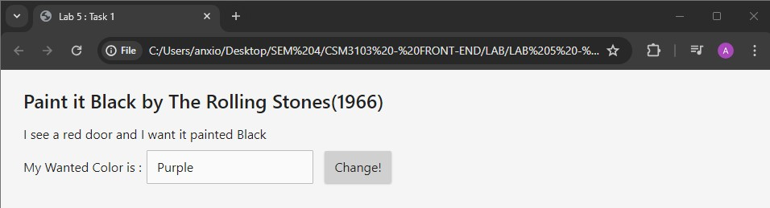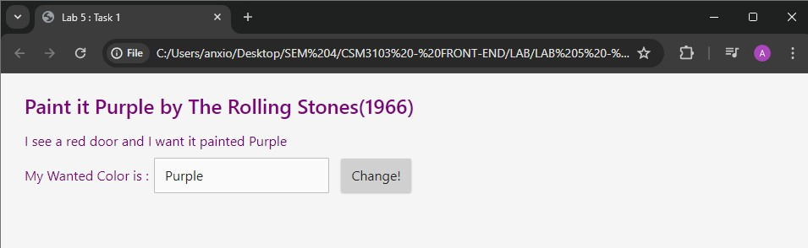

For selected colour

Code :

<html>

<head>

<title>Lab 5 : Task 1 - select colour</title>

<meta charset="utf-8">

<script

src="https://code.jquery.com/jquery-3.1.1.js"

integrity="sha256-16cdPddA6VdVInumRGo6IbivbERE8p7CQR3HzTBuELA=" crossorigin="anonymous"></script>

<link rel="stylesheet" href= "https://cdnjs.cloudflare.com/ajax/libs/mini.css/2.0.2/mini-default.css">

<style>

body { margin: 20px; } #color_change { border: 1px solid; }

.cow_color { font-weight: bold; }

</style>

<script>

$(document).ready(function() {

$('#button_change').click(function(){

var selectedColor = $('#select_color').val();

$('.door_color').html(selectedColor);

$('.door_color').css('color', selectedColor);

});

});

</script>

</head>

<body>

<h2> Paint it <span class="door_color">Black</span> by The Rolling Stones(1966)</h2>

<p>I see a red door and I want it painted <span class="door_color">Black</span>

</p>

<p>My Wanted Color is :

<select id = "select_color">

<option value ="black">Black</option>

<option value ="red">Red</option>

<option value ="green">Green</option>

<option value ="blue">Blue</option>

<option value ="purple">Purple</option>

</select>

<button id="button_change"> Change!

</button>

</p>

</body>

</html>

Output :

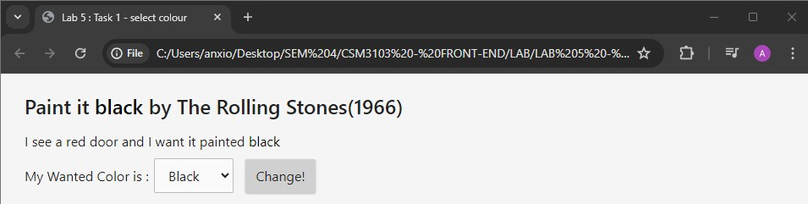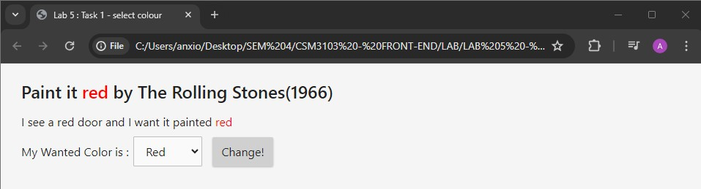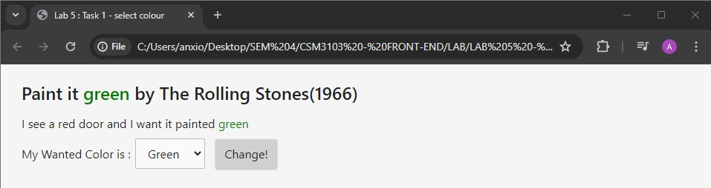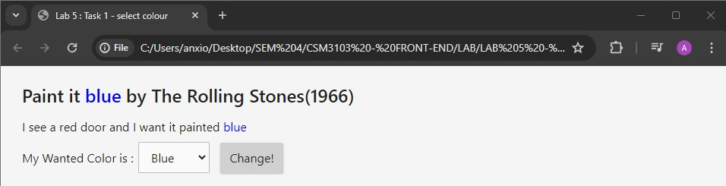

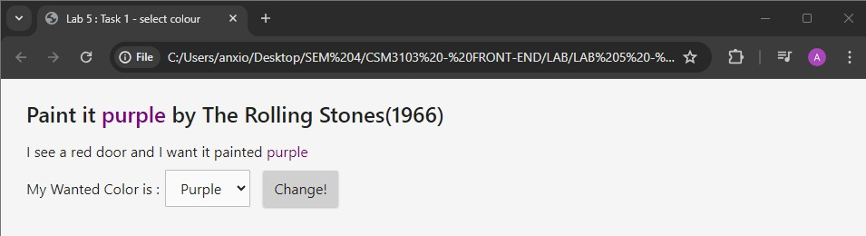

# Task 2

Code :

<!doctype html>

<html>

<head>

<title>Lab 5: Task 2</title>

<meta charset="utf-8">

<link rel="stylesheet" href= "https://maxcdn.bootstrapcdn.com/bootstrap/3.3.7/css/bootstrap.min.css">

<style>

#boxes { margin-top: 50px; float: left; width: 100%; } #toggles { float: left; width: 100%; margin-top: 10px; } #info { float: left; margin-top: 5px; }

.box { width: 50px; height: 50px; float: left; }

.outlined { border: 2px solid black; }

.round-edge { border-radius: 15px; }

.teal { background-color: teal; }

</style>

<script

src="https://code.jquery.com/jquery-3.1.1.js"

integrity="sha256-16cdPddA6VdVInumRGo6IbivbERE8p7CQR3HzTBuELA=" crossorigin="anonymous"></script>

<script>

var colorTeal = "rgb(57, 204, 204)";

$(document).ready(function(){

var colorTeal = "rgb(57, 204, 204)"; var originalBackgroundColor = "";

$('#button_toggle_colors').click(function(){

// Check the background color of the first box to determine the current state var box1 = $('#box1');

if (originalBackgroundColor === "") {

// Save the original background color if it hasn't been saved yet originalBackgroundColor = $(box1).css('background-color');

}

// Toggle background color of all boxes

$('.box').each(function(){

if ($(this).css('background-color') === colorTeal) {

$(this).css('background-color', originalBackgroundColor);

} else {

$(this).css('background-color', colorTeal);

});

}

});

$('#button_toggle_roundedges').click(function(){

$(".box").toggleClass('round-edge');

});

$('#button_add_box').click(function(){

// Create a new box and append it to the boxes container var newBox = $('<div class="box outlined"></div>');

$('#boxes').append(newBox);

});

});

var new_box = document.createElement('div'); var existingBoxes = $(".box").length;

var nextBoxId = existingBoxes+1;

$(new_box).attr("id","box"+nextBoxId);

$(new_box).addClass("box");

$(new_box).addClass("outlined");

$("#boxes").append(new_box);

</script>

</head>

<body>

<div class="container">

<div id="boxes">

<div id="box1" class="box outlined"></div>

<div id="box2" class="box outlined"></div>

<div id="box3" class="box outlined"></div>

</div>

<div id="toggles">

<h2>Toggles</h2>

<button class="btn" id="button_toggle_colors"

>Toggle Colors</button>

<button class="btn" id="button_toggle_roundedges"

>Toggle Rounded Borders</button>

<button class="btn" id="button_add_box"

>Add a New Box</button>

</div>

</div>

</body>

</html>

Output :

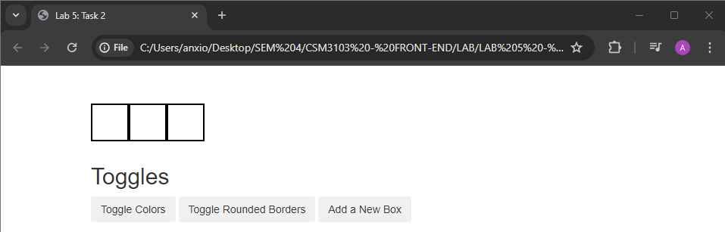

Toggle colour

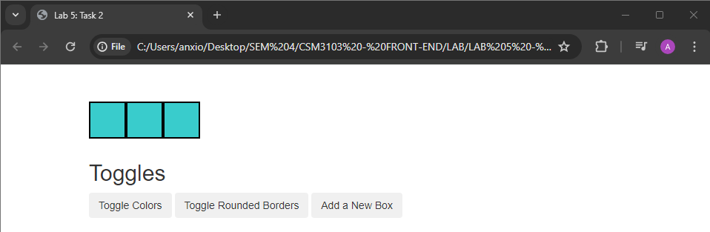

Toggle Rounded Borders

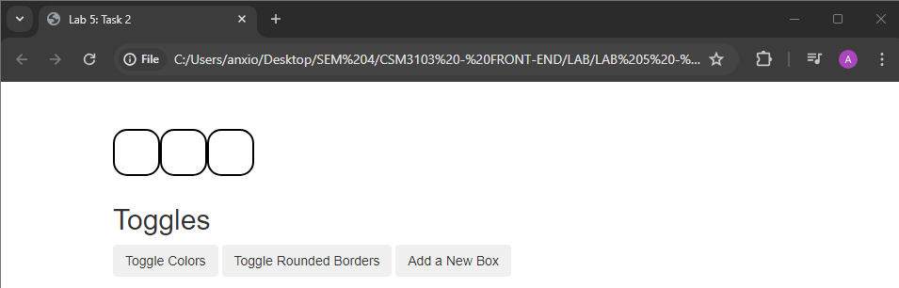

Add a New Box

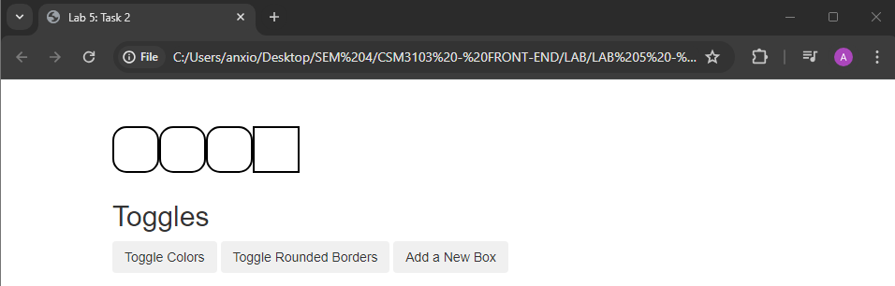

Modify

Code :

<!doctype html>

<html>

<head>

<title>Lab 5: Task 2 - Modify</title>

<meta charset="utf-8">

<link rel="stylesheet" href="https://maxcdn.bootstrapcdn.com/bootstrap/3.3.7/css/bootstrap.min.css">

<style>

#boxes { margin-top: 50px; float: left; width: 100%; } #toggles { float: left; width: 100%; margin-top: 10px; } #info { float: left; margin-top: 5px; }

.box { width: 50px; height: 50px; float: left; }

.outlined { border: 2px solid black; }

.round-edge { border-radius: 15px; }

.teal { background-color: teal; }

</style>

<script src="https://code.jquery.com/jquery-3.1.1.js" integrity="sha256- 16cdPddA6VdVInumRGo6IbivbERE8p7CQR3HzTBuELA=" crossorigin="anonymous"></script>

<script>

$(document).ready(function(){

var colorTeal = "rgb(57, 204, 204)"; var originalBackgroundColor = "";

$('#button_toggle_colors').click(function(){

// Check the background color of the first box to determine the current state var box1 = $('#box1');

if (originalBackgroundColor === "") {

// Save the original background color if it hasn't been saved yet originalBackgroundColor = $(box1).css('background-color');

}

// Toggle background color of all boxes

$('.box').each(function(){

if ($(this).css('background-color') === colorTeal) {

$(this).css('background-color', originalBackgroundColor);

} else {

$(this).css('background-color', colorTeal);

});

}

});

$('#button_toggle_roundedges').click(function(){

$(".box").toggleClass('round-edge');

});

$('#button_add_box').click(function(){

// Hide all existing boxes

$(".box").hide();

// Randomly select one box to show

var randomBoxIndex = Math.floor(Math.random() * $(".box").length);

$(".box").eq(randomBoxIndex).show();

});

});

</script>

</head>

<body>

<div class="container">

<div id="boxes">

<div id="box1" class="box outlined"></div>

<div id="box2" class="box outlined"></div>

<div id="box3" class="box outlined"></div>

</div>

<div id="toggles">

<h2>Toggles</h2>

<button class="btn" id="button_toggle_colors">Toggle Colors</button>

<button class="btn" id="button_toggle_roundedges">Toggle Rounded Borders</button>

<button class="btn" id="button_add_box">Add a New Box</button>

</div>

</div>

</body>

</html>

Output :

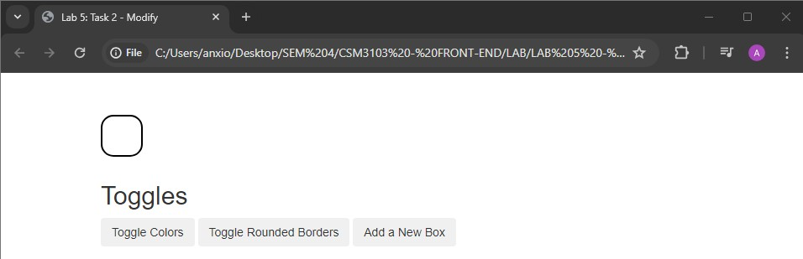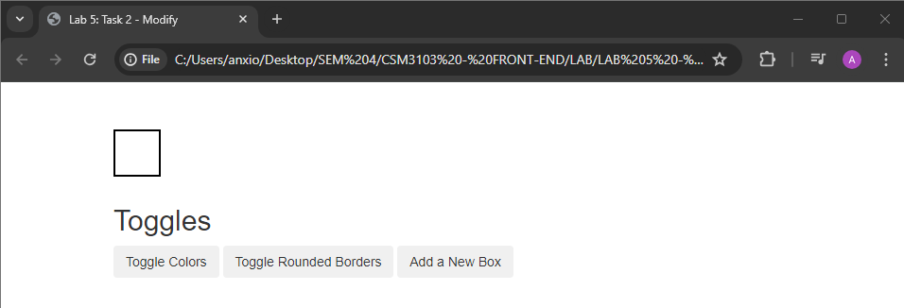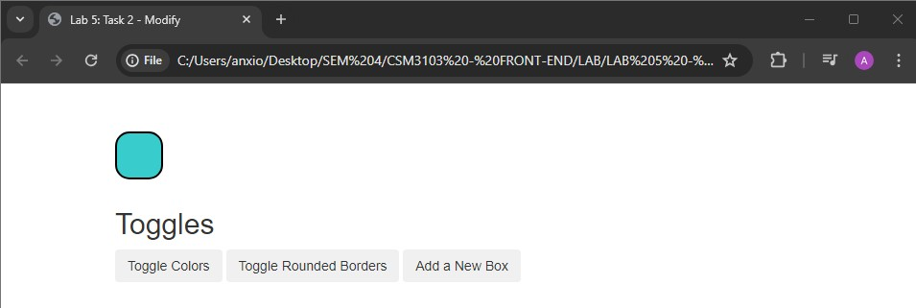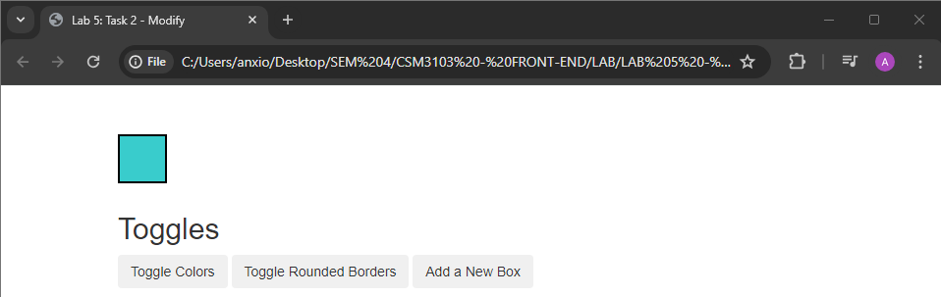

# Task 3

Code :

<!doctype html>

<html>

<head>

<title>Lab 5: Task 3</title>

<meta charset="utf-8">

<script

src="https://code.jquery.com/jquery-3.1.1.js"

integrity="sha256-16cdPddA6VdVInumRGo6IbivbERE8p7CQR3HzTBuELA=" crossorigin="anonymous"></script>

<script src="https://code.jquery.com/ui/1.12.1/jquery-ui.js"

integrity="sha256-T0Vest3yCU7pafRw9r+settMBX6JkKN06dqBnpQ8d30=" crossorigin="anonymous"></script>

<link rel="stylesheet" href= "https://cdnjs.cloudflare.com/ajax/libs/normalize/5.0.0/normalize.css">

<link rel="stylesheet" href= "https://code.jquery.com/ui/1.12.1/themes/ui-lightness/jquery-ui.css">

<style> body {

margin: 20px;

}

#name_input { float: left;

margin-bottom: 20px; margin-right: 20px;

}

#date_input { float: left;

margin-bottom: 20px;

}

#year_input { clear:both;

}

.rank_color { width: 20px; margin-top: 2px;

}

#selectable .ui-selecting{ background: #FECA40;

}

#selectable .ui-selecting{ background: #F39814; color: white;

}

#selectable li:before{ content: "\2713"; color:transparent;

}

#selectable li.ui-selecting:before{ content: "\2713";

color:black;

}

#selectable li.ui-selected:before{ content: "\2713";

color:white;

}

#selectable{

list-style-type: none; margin: 0;

padding: 0; width: 3px; cursor: pointer;

}

#selectable li{ margin: 3px; padding: 0.4em; font-size: 1.0em; height: 16px;

}

#sortable{

list-style-type: none; margin: 0;

padding: 0; width: 150px;

}

#sortable li{

margin: 0 3px 3px 3px; padding: 0.4em; padding-left: 1.5em; font-size: 1.0em; height: 12px;

}

</style>

<script>

$(document).ready(function() {

$('#date').datepicker();

$("#selectable").selectable();

$("#sortable").sortable();

$("#sortable").disableSelection();

$(document).tooltip({ item: '[title], [class]',

position: {my: "left center", at: "right center"}, content: function(){

var element = $(this); if(element.is('[title]')){ return element.attr('title');

}

if (element.is('[class]')){ console.log('class', element);

if (element.hasClass('ui-state-default')){ var text = element.text();

return '<div class="color_switch" style="background:' + text +'"></div>'

}

}

}

})

});

</script>

</head>

<body>

<h2>jQuery UI-Survey</h2>

<h3>General Information</h3>

<div id="name_input">

<label for="name">Name:</label>

<input type="text" id="name">

</div>

<div id="date_input">

<label for="date">Date:</label>

<input type="text" id="date">

</div>

<div id="year_input">

<h3>Are you enrolled as an undergraduate or a graduate?</h3>

<input type="radio" name="enroll_year" id="ugrad" value="ugrad">

<label for="ugrad">Undergraduate (taking 6.813)</label><br>

<input type="radio" name="enroll_year" id="grad" value="grad">

<label for="grad">Graduate (taking 6.831)</label>

<!-- Step 2: Your HTML here -->

<ol id="selectable">

<li class="ui-widget-content" title="taking 6.813">Undergraduate</lI>

<li class="ui-widget-content" title="taking 6.813">Graduate</li>

</ol>

</div>

<div id="color_input">

<!-- Comment out instruction when you finish step 3 -->

<h3>Rank the colors listed from your most favorite (1)

to your least favorite (5). Be sure to only use each ranking once.</h3>

<!-- Comment this part of the form out after step 3 -->

<input type="text" class="rank_color" id="red">

<label for="red">#ff0000</label><br/>

<input type="text" class="rank_color" id="blue">

<label for="blue">#0000ff</label><br/>

<input type="text" class="rank_color" id="hot_pink">

<label for="hot_pink">#ff00b3</label><br/>

<input type="text" class="rank_color" id="mustard">

<label for="mustard">#ded447</label><br/>

<input type="text" class="rank_color" id="dark_green">

<label for="dark_green">#125e18</label><br/>

<!-- Step 3: Your HTML here -->

<span class="ui-icon ui-icon-arrowthick-2-n-s"></span>

<ul id = "sortable">

<li class = "ui-state-default">#ff0000</li>

<li class = "ui-state-default">#0000ff</li>

<li class = "ui-state-default">#ff00b3</li>

<li class = "ui-state-default">#ded447</li>

<li class = "ui-state-default">#125e18</li>

</ul>

</div>

</body>

</html>

Output :

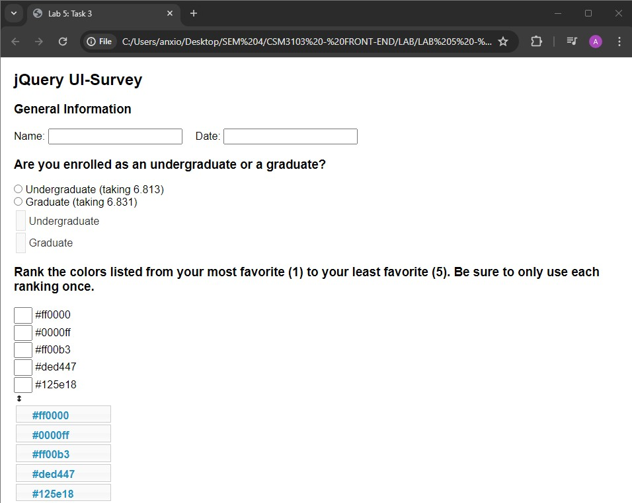

# Task 4

Code :

<!doctype html>

<html>

<head>

<title>Lab 5: Task 4</title>

<meta charset="utf-8">

<script

src="https://code.jquery.com/jquery-3.1.1.js"

integrity="sha256-16cdPddA6VdVInumRGo6IbivbERE8p7CQR3HzTBuELA=" crossorigin="anonymous"></script>

<script src="https://code.jquery.com/ui/1.12.1/jquery-ui.js"

integrity="sha256-T0Vest3yCU7pafRw9r+settMBX6JkKN06dqBnpQ8d30=" crossorigin="anonymous"></script>

<link rel="stylesheet" href= "https://cdnjs.cloudflare.com/ajax/libs/normalize/5.0.0/normalize.css">

<link rel="stylesheet" href= "https://code.jquery.com/ui/1.12.1/themes/ui-lightness/jquery-ui.css">

<style>

body { margin: 20px; } #container { display: block; }

#draw_buttons { float: left; width: 100%; margin-top: 10px; }

</style>

<script>

$(document).ready(function() {

/* Step 1: Your code goes here */

var canvas = document.getElementById("myCanvas"); var ctxt = canvas.getContext('2d');

/* Step 2: Your js code goes here */

$("#button_draw_triangle").click(function() { ctxt.fillStyle = '#f00';

ctxt.strokeStyle = '#000';

ctxt.lineWidth = 3;

ctxt.beginPath(); ctxt.moveTo(60, 240);

ctxt.lineTo(240, 240);

ctxt.lineTo(150, 60); ctxt.closePath(); ctxt.fill(); ctxt.stroke();

});

/* Step 3: Your js code goes here */

$("#button_draw_rotated_triangle").click(function() { ctxt.translate(canvas.width / 2, canvas.height / 2);

ctxt.rotate(Math.PI / 4);

ctxt.beginPath();

ctxt.moveTo(-90, 90);

ctxt.lineTo(90, 90);

ctxt.lineTo(0, -90);

ctxt.closePath(); ctxt.fill(); ctxt.stroke();

});

/* Step 4: Your js code goes here */

$("#button_clear_canvas").click(function() {

/* Clear canvas and reset transformations */ ctxt.clearRect(0, 0, canvas.width, canvas.height);

ctxt.setTransform(1, 0, 0, 1, 0, 0); // Reset transformation matrix

});

});

</script>

</head>

<body>

<h2>Manipulate the Canvas</h2>

<canvas id="myCanvas" width="300" height="300"

style="border:1px solid #000000;"></canvas>

<div id="draw_buttons">

<button id="button_draw_triangle">Draw Triangle</button>

<button id="button_draw_rotated_triangle">Draw Rotated Triangle</button>

<button id="button_clear_canvas">Clear Canvas</button>

</div>

</body>

</html>

Output :

Draw Triangle

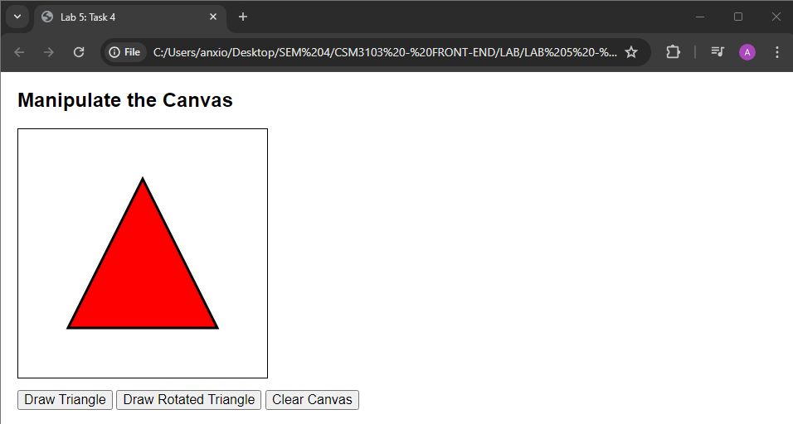

Draw Rotated Triangle

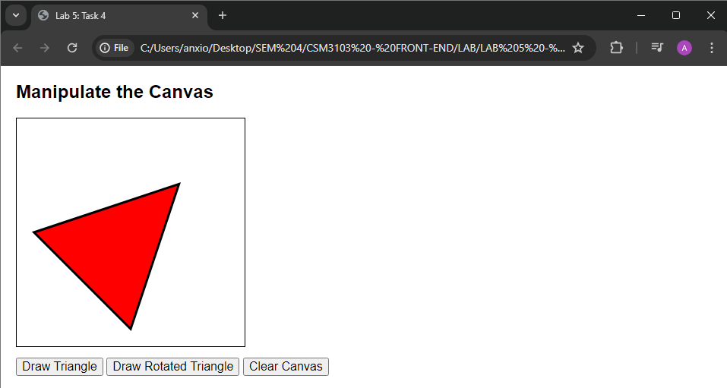

Clear Canvas

