HW_12

izd3

## Problem #01 - Chapter 44 Exercise #2A

# Show your work here  
library(tidyverse)

## Warning: package 'tidyverse' was built under R version 4.2.3

## Warning: package 'ggplot2' was built under R version 4.2.3

## Warning: package 'tibble' was built under R version 4.2.3

## Warning: package 'purrr' was built under R version 4.2.3

## Warning: package 'dplyr' was built under R version 4.2.3

## Warning: package 'stringr' was built under R version 4.2.3

## Warning: package 'forcats' was built under R version 4.2.3

## Warning: package 'lubridate' was built under R version 4.2.3

## ── Attaching core tidyverse packages ──────────────────────── tidyverse 2.0.0 ──  
## ✔ dplyr 1.1.2 ✔ readr 2.1.4  
## ✔ forcats 1.0.0 ✔ stringr 1.5.0  
## ✔ ggplot2 3.4.3 ✔ tibble 3.2.1  
## ✔ lubridate 1.9.3 ✔ tidyr 1.3.0  
## ✔ purrr 1.0.2   
## ── Conflicts ────────────────────────────────────────── tidyverse_conflicts() ──  
## ✖ dplyr::filter() masks stats::filter()  
## ✖ dplyr::lag() masks stats::lag()  
## ℹ Use the conflicted package (<http://conflicted.r-lib.org/>) to force all conflicts to become errors

Joins002.tib$FIRSTNAME=tolower(Joins002.tib$FIRSTNAME)  
Joins002.tib$LASTNAME=tolower(Joins002.tib$LASTNAME)  
  
Joins003.dat$firstname=tolower(Joins003.dat$firstname)  
Joins003.dat$lastname=tolower(Joins003.dat$lastname)  
  
inner_join(Joins002.tib,Joins003.dat,by=join_by(FIRSTNAME=="firstname",  
 LASTNAME=="lastname"))

## # A tibble: 1 × 4  
## LASTNAME FIRSTNAME `Favorite Color` favoritecolor  
## <chr> <chr> <chr> <chr>   
## 1 deherrera jacob honeydew4 navajowhite1

## Problem #02 - Chapter 44 Exercise #02A

# Show your work here  
Joins004.tib

## # A tibble: 20 × 4  
## LastNames firstNames registrationCode dataStuff  
## <chr> <chr> <chr> <dbl>  
## 1 al-Azad Jessica 282 99.1  
## 2 Morett Matthew 244 86.8  
## 3 Nelson Tasneem 371 86.7  
## 4 Hallam Robert 174 85.8  
## 5 Munoz Torres Wesley 469 93.8  
## 6 Joel Draven 696 94.0  
## 7 el-Tariq Taariq 683 92.0  
## 8 Nelson Tasneem 328 92.0  
## 9 el-Tariq Taariq 260 84.5  
## 10 Deherrera Jacob 392 84.9  
## 11 Vogt Chantelle 175 87.4  
## 12 Morett Matthew 357 94.6  
## 13 Nelson Tasneem 029 82.5  
## 14 Hallam Robert 525 88.1  
## 15 Morett Matthew 310 99.8  
## 16 Morett Matthew 182 81.0  
## 17 Williams Sanders Albert 737 94.3  
## 18 al-Azer Noel 783 86.9  
## 19 Conner Deshaun 975 94.7  
## 20 Nelson Tasneem 206 97.1

Joins005.tib

## # A tibble: 21 × 5  
## LastNames firstNames ID_NUMBER dataThings coloredThings   
## <chr> <chr> <chr> <dbl> <chr>   
## 1 Morett Matthew 182 81.0 grey71   
## 2 Conner Deshaun 975 94.7 steelblue4   
## 3 el-Tariq Taariq 683 92.0 sienna1   
## 4 Williams Sanders Albert 737 94.3 grey40   
## 5 al-Azad Jessica 282 99.1 goldenrod4   
## 6 Munoz Torres Wesley 161 98.0 cornsilk2   
## 7 Munoz Torres Wesley 469 93.8 darkslategray4  
## 8 Villamil Buenfil Renita 525 85.0 navajowhite   
## 9 Vogt Chantelle 175 87.4 hotpink2   
## 10 Deherrera Jacob 169 85.7 slategray3   
## # ℹ 11 more rows

inner_join(Joins004.tib,Joins005.tib,  
 by=join_by("registrationCode"=="ID_NUMBER",  
 "LastNames"=="LastNames",  
 "firstNames"=="firstNames"))

## # A tibble: 14 × 6  
## LastNames firstNames registrationCode dataStuff dataThings coloredThings  
## <chr> <chr> <chr> <dbl> <dbl> <chr>   
## 1 al-Azad Jessica 282 99.1 99.1 goldenrod4   
## 2 Morett Matthew 244 86.8 86.8 green1   
## 3 Munoz Torres Wesley 469 93.8 93.8 darkslategra…  
## 4 Joel Draven 696 94.0 94.0 cornflowerbl…  
## 5 el-Tariq Taariq 683 92.0 92.0 sienna1   
## 6 el-Tariq Taariq 260 84.5 84.5 bisque3   
## 7 Deherrera Jacob 392 84.9 84.9 grey8   
## 8 Vogt Chantelle 175 87.4 87.4 hotpink2   
## 9 Morett Matthew 357 94.6 94.6 thistle   
## 10 Nelson Tasneem 029 82.5 82.5 palevioletre…  
## 11 Morett Matthew 182 81.0 81.0 grey71   
## 12 Williams Sand… Albert 737 94.3 94.3 grey40   
## 13 Conner Deshaun 975 94.7 94.7 steelblue4   
## 14 Nelson Tasneem 206 97.1 97.1 hotpink1

## Problem #03 - Chapter 45 Exercise #04

# Show your work here  
joined<-full_join(Joins006.tib,Joins008.tib,by=c('X3','X1','X2'))  
  
joined<-full_join(joined,Joins007.tib,  
 by=join_by('X2'=="shape",'X3'=='calendar',  
 'X1'=='length'))  
mean_vals<-joined|>  
 group_by(X3)|>  
 summarise(  
 mean_len=mean(X1)  
 )  
mean_vals$X3=mdy(mean_vals$X3)  
  
joined$X3=mdy(joined$X3)  
joined<-joined|>  
 full_join(mean_vals,by='X3')  
joined|>  
 ggplot(aes(x=X3,y=X1,color=X2))+geom_point()+  
 scale_x_date(breaks = make_date(month = 10,day = c(9,16),year = 2023),  
 date_labels = "%b %d")+  
 labs(  
 x='calendar',  
 y='length',  
 color='shape'  
 )+  
 geom_point(aes(x=X3,y=mean_len),size=6,shape=4,color='black')+  
 geom_text(aes(x=X3,y=mean_len),  
 label="mean",color="black",nudge_x = 0.8)

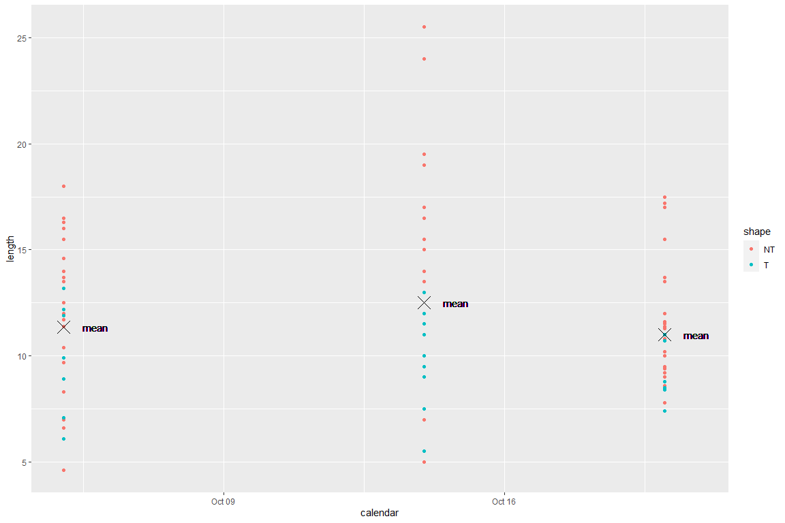

## Problem #04 - Chapter 48 Exercise #2

# Show your work here  
Long001b.tib

## # A tibble: 6 × 3  
## COLOUR TYPE alphabet  
## <chr> <int> <chr>   
## 1 mediumturquoise 1 E   
## 2 mediumturquoise 2 P   
## 3 mediumturquoise 3 G   
## 4 peru 1 C   
## 5 peru 2 N   
## 6 peru 3 U

MyLongTibble<-Wide001.tib|>  
 pivot_longer(  
 cols = !COLOUR,  
 names_to=c("Discard","TYPE"),  
 names_sep = "e",  
 values_to = c("alphabet")  
 )|>  
 select(!Discard)|>  
 mutate(TYPE=as.integer(TYPE))  
  
MyLongTibble

## # A tibble: 6 × 3  
## COLOUR TYPE alphabet  
## <chr> <int> <chr>   
## 1 mediumturquoise 1 E   
## 2 mediumturquoise 2 P   
## 3 mediumturquoise 3 G   
## 4 peru 1 C   
## 5 peru 2 N   
## 6 peru 3 U

## Problem #05 - Chapter 48 Exercise #06

# Show your work here  
newtib<-Wide003.tib|>  
 pivot_longer(cols = !NAME,  
 names_to = c("Discard","AGE"),  
 names_sep = "E",  
 values_to = "VALUES")|>  
 select(!Discard)|>  
 mutate(AGE=as.integer(AGE))  
  
newtib|>  
 ggplot(aes(x=AGE,y=VALUES,color=NAME))+geom_line()+geom_point()

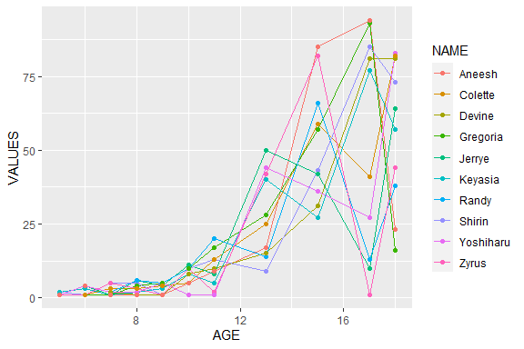

## Problem #06 - Chapter 49 Exercise #2

# Show your work here  
Wide001.tib

## # A tibble: 2 × 4  
## COLOUR type1 type2 type3  
## <chr> <chr> <chr> <chr>  
## 1 mediumturquoise E P G   
## 2 peru C N U

MyWideTibble<-Long001a.tib|>  
 pivot_wider(id_cols = COLOUR,names_from = TYPE,values_from = alphabet)  
  
MyWideTibble

## # A tibble: 2 × 4  
## COLOUR type1 type2 type3  
## <chr> <chr> <chr> <chr>  
## 1 mediumturquoise E P G   
## 2 peru C N U

## Problem #07 - Chapter 50 Exercise #01

# Show your work here  
MyLongTibble<-Split001.tib|>  
 separate(col = stuff,  
 into = c("NUMBER","UPPER","LOWER","LOGICAL"),sep = "-",convert = T)  
MyLongTibble

## # A tibble: 10 × 4  
## NUMBER UPPER LOWER LOGICAL  
## <int> <chr> <chr> <lgl>   
## 1 26 C d FALSE   
## 2 37 J m FALSE   
## 3 9 K v FALSE   
## 4 55 A r TRUE   
## 5 41 N p TRUE   
## 6 62 X x TRUE   
## 7 59 Z o TRUE   
## 8 1 R c FALSE   
## 9 20 O s TRUE   
## 10 87 F z TRUE

Separated001.tib

## # A tibble: 10 × 4  
## NUMBER UPPER LOWER LOGICAL  
## <chr> <chr> <chr> <chr>   
## 1 26 C d FALSE   
## 2 37 J m FALSE   
## 3 9 K v FALSE   
## 4 55 A r TRUE   
## 5 41 N p TRUE   
## 6 62 X x TRUE   
## 7 59 Z o TRUE   
## 8 1 R c FALSE   
## 9 20 O s TRUE   
## 10 87 F z TRUE

## Problem #08 - Chapter 50 Exercise #03

# Show your work here  
Split002.tib|>  
 separate(col = LotsOfData,into = c("Discard","LOCATION"),sep ="LEAF_" )|>  
 select(!Discard)|>  
 separate(col = LOCATION,into = c("DISCARD","LOCATION"),  
 sep ="[0-9][0-9][0-9]_[0-9][0-9][0-9][0-9]_" )|>  
 select(!DISCARD)|>  
 separate(col = LOCATION,into = c("LOCATION","RID"))|>  
 select(!RID)|>  
 ggplot(aes(x=shapes,fill=LOCATION))+geom_bar()+  
 scale_fill_manual(breaks = c("AGRI","ARTS"),  
 labels=c("Ag Quad","Arts Quad"),  
 values = c("red","white"),  
 name="location")+  
 labs(  
 title="This is the title"  
 )

