HW_07

izd3

Use only commands & functions that are shown in the indicated chapter or prior chapters.

## Problem #01 - Chapter 29 Exercise #01D

# Show your work here  
library(scales)  
library(ggplot2)

## Warning: package 'ggplot2' was built under R version 4.2.3

coordGraph002+coord_fixed(ratio=8/7)

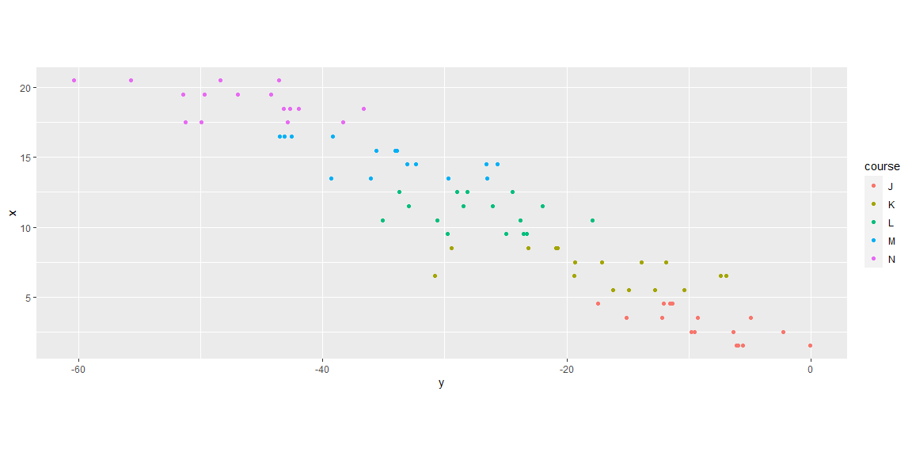

## Problem #02 - Chapter 29 Exercise #03D

# Show your work here  
  
coordGraph002+coord_trans(y=sqrt_trans(),x=reverse_trans())

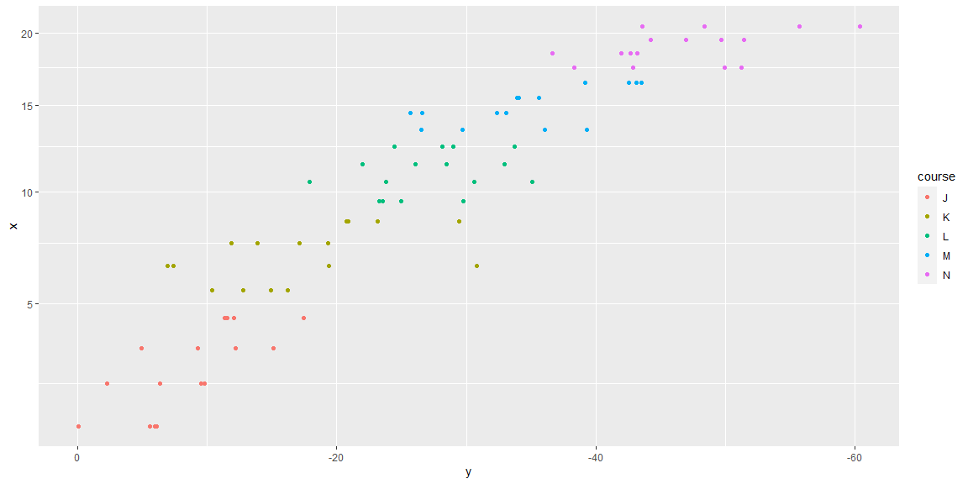

## Problem #03 - Chapter 30 Exercise #01D

# Show your work here  
facetPlot004+facet_wrap(~ggplot005.dat$var.3)

## `stat_bin()` using `bins = 30`. Pick better value with `binwidth`.

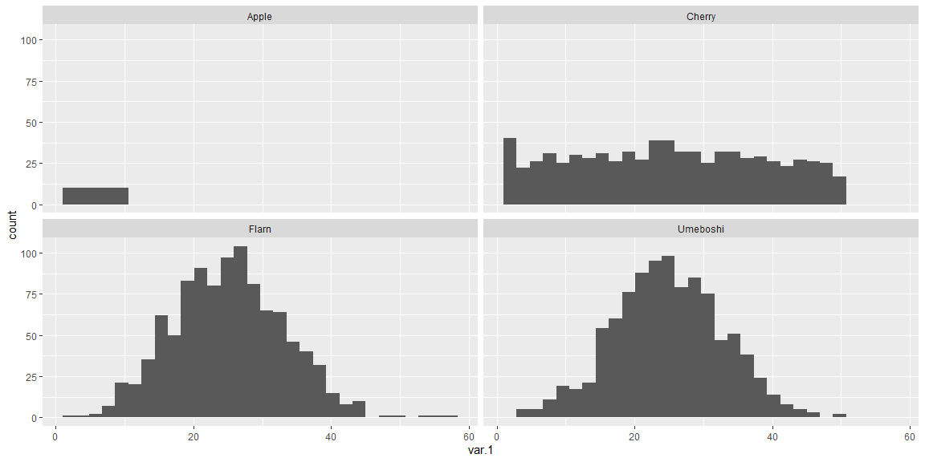

## Problem #04 - Chapter 30 Exercise #03D

# Show your work here  
facetPlot006+facet_grid(ggplot006.dat$var.3~ggplot006.dat$var.4)

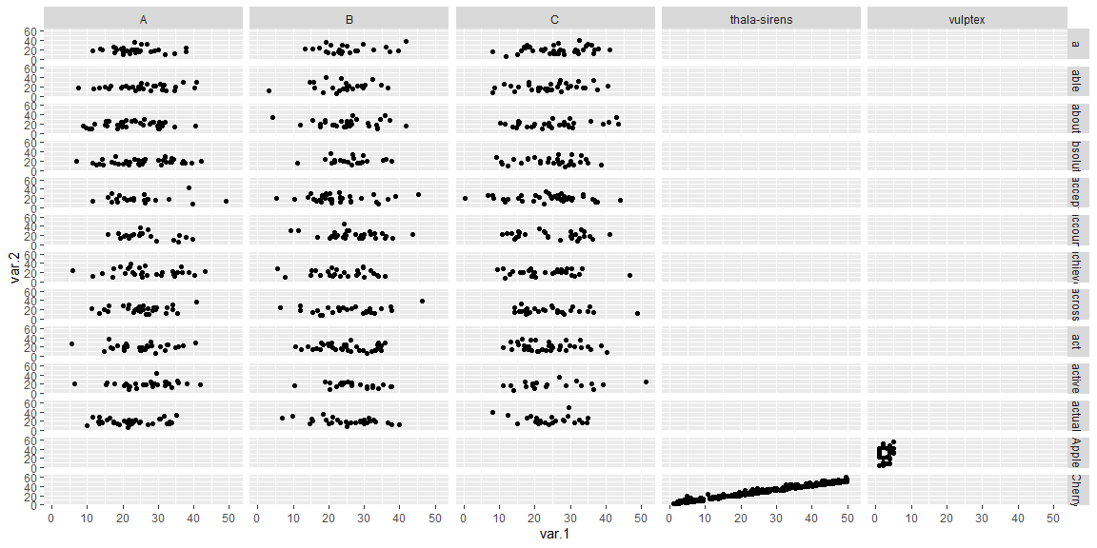

## Problem #05 - Chapter 30 Exercise #04A

# Show your work here  
ggplot005.dat|>  
 ggplot(aes(x=var.1,y=var.2,color=var.3))+  
 geom_point(shape=3,size=4)+  
 facet_wrap(~ggplot005.dat$var.4)

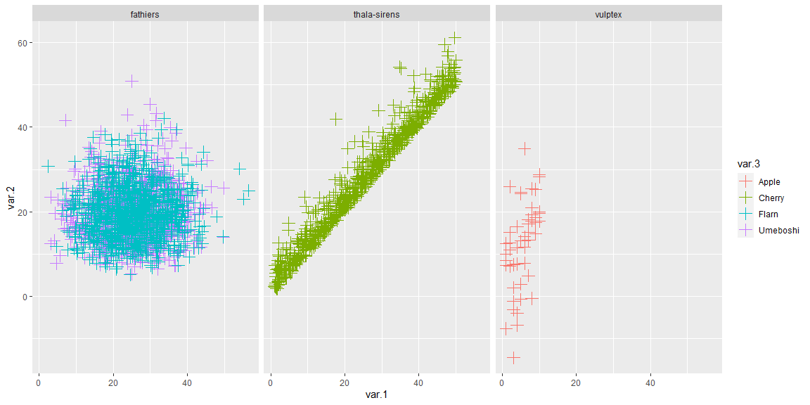

## Problem #06 - Chapter 31 Exercise #03A

# Show your work here  
ggplot009.tib|>  
 ggplot(aes(x=x.values,y=y.values))+geom_line()

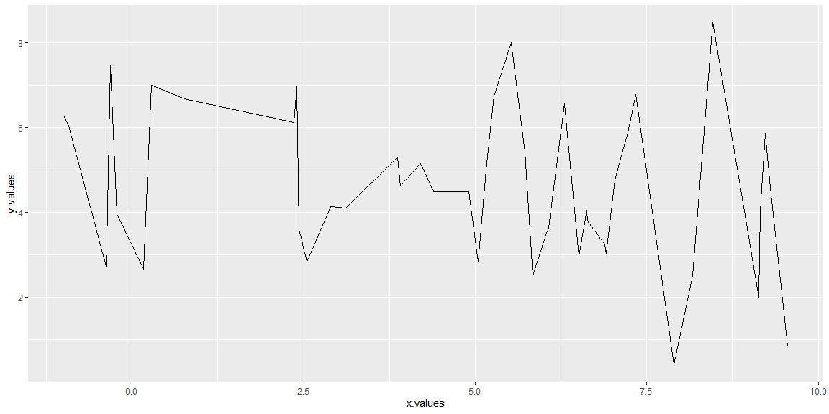

## Problem #07 - Chapter 31 Exercise #04D

# Show your work here  
ggplot010.tib|>  
 ggplot(aes(x=u.values,y=t.values,color=z.values))+geom_line()

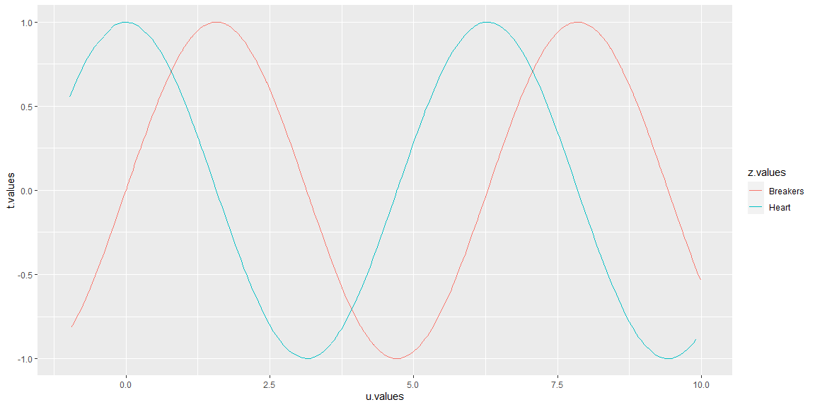

## Problem #08 - Chapter 31 Exercise #06

# Show your work here  
x<-c(-1,0,1,2,0,-2)  
y<-c(0,0,0,1,1,1)  
x_head<-c(0,0.29,0,-.29)  
y_head<-c(4,4.5,5,4.5)  
head_data<-data.frame(x.boat=x_head,y.boat=y_head)  
boat_data<-data.frame(x.boat=x,y.boat=y)  
  
  
  
x_values <- seq(-5, 2, length.out = 1000) # 100  
  
y_values<-c(sinpi(x_values)/2,sinpi(x_values)/2.7,sinpi(x_values)/6,sinpi(x_values)/3,  
 sinpi(x_values)/7)  
  
x_values<-rep.int(x_values,times = 5)  
z_values<-rep(c('A','B','C','D','E'),each=1000)  
  
 wavy<-data.frame(x.boat=x_values,y.boat=y_values,z.wave=z_values)  
  
  
  
  
ggplot()+geom_polygon(data=boat_data,mapping = aes(x=x.boat,y=y.boat),  
 color='red',fill='red')+  
 geom_line(mapping = aes(x=0,y=2:4))+  
 geom_line(mapping = aes(x=c(0,1),y=c(2,1)))+  
 geom_line(mapping = aes(x=c(0,-1),y=c(2,1)))+  
 geom_line(mapping = aes(x=c(0,1.5),y=c(3.98,3)))+  
 geom_line(mapping = aes(x=c(0,-1.5),y=c(3.98,3)))+  
 geom_point(aes(x=0,y=4.28),size=20)+  
 geom_line(data=wavy,mapping = aes(x=x.boat,y=y.boat,color=z.wave))+  
 geom_hline(yintercept = 5,color='white')

