HW_08

izd3

Use only commands & functions that are shown in the indicated chapter or prior chapters.

## Problem #01 - Chapter 32 Exercise #01D

# Show your work here  
library(ggplot2)

## Warning: package 'ggplot2' was built under R version 4.2.3

oneVariable001.dat|>  
 ggplot(mapping = aes(x=values))+geom_freqpoly(stat = 'bin',binwidth=0.5,color='red')

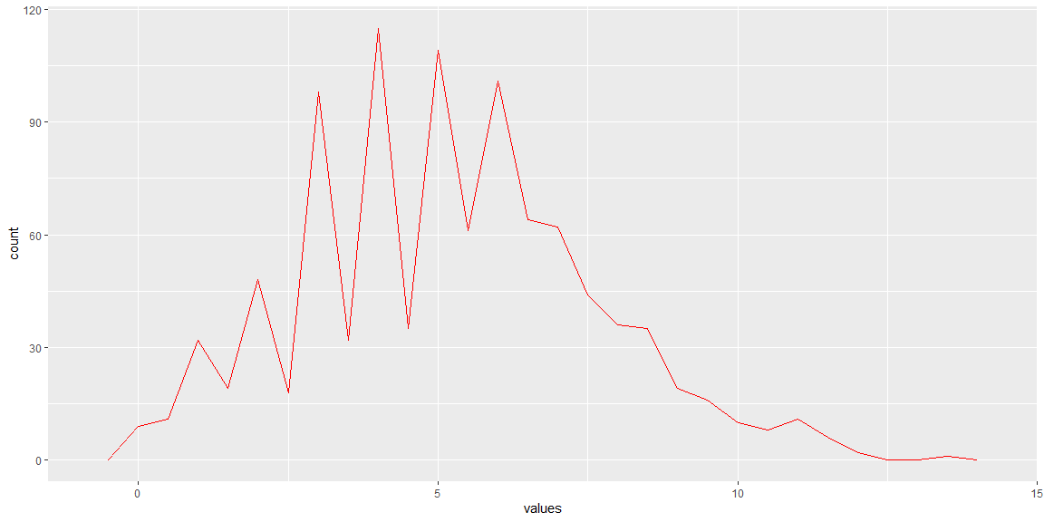

## Problem #02 - Chapter 32 Exercise #02A

# Show your work here  
oneVariable001.dat|>  
 ggplot(mapping = aes(x=values,fill=animals))+geom_histogram(binwidth = 0.5,position = 'stack')

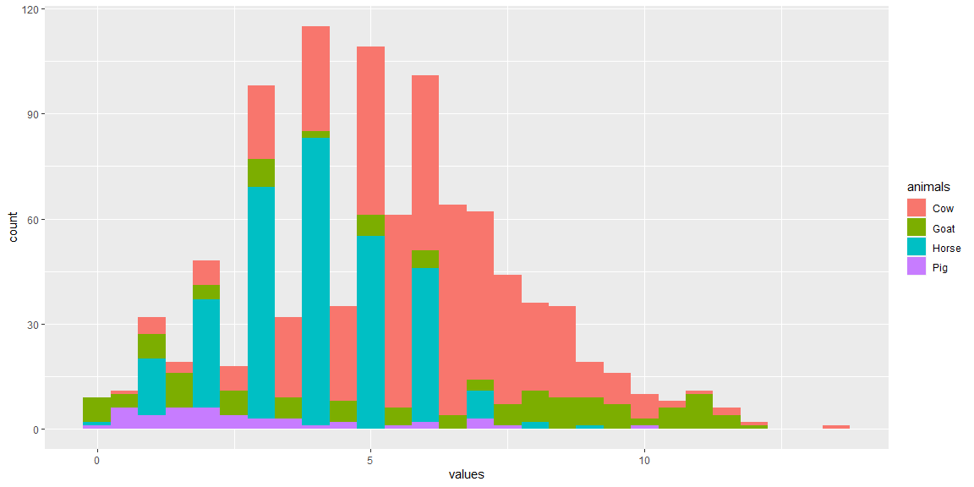

## Problem #03 - Chapter 32 Exercise #03A

# Show your work here  
oneVariable001.dat|>  
 ggplot(mapping = aes(x=values,fill=animals))+  
 geom_histogram(binwidth = 0.5,position = 'dodge')

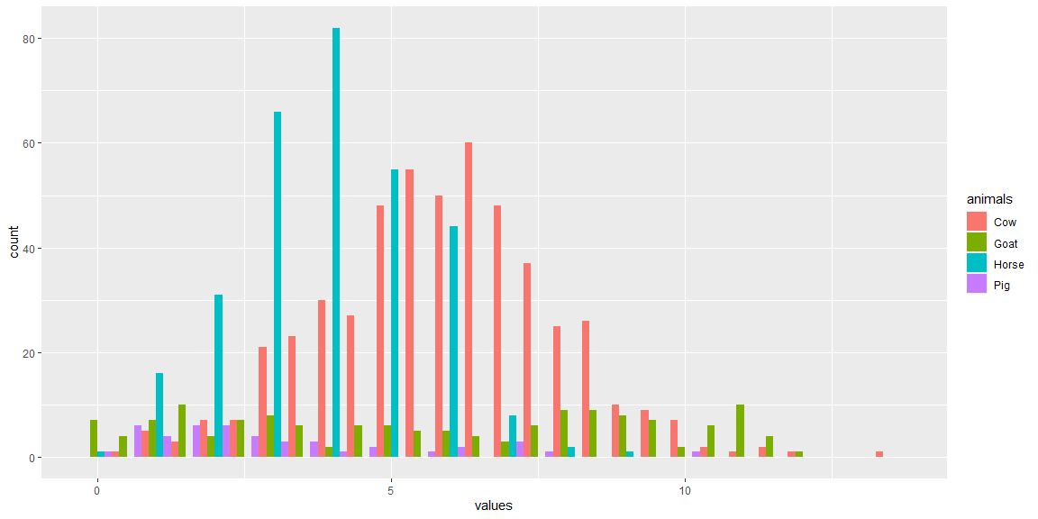

## Problem #04 - Chapter 32 Exercise #04B

# Show your work here  
oneVariable001.dat|>  
 ggplot(mapping = aes(x=animals,y=values,fill=animals))+geom_violin()+  
 geom_boxplot(alpha=0.5)

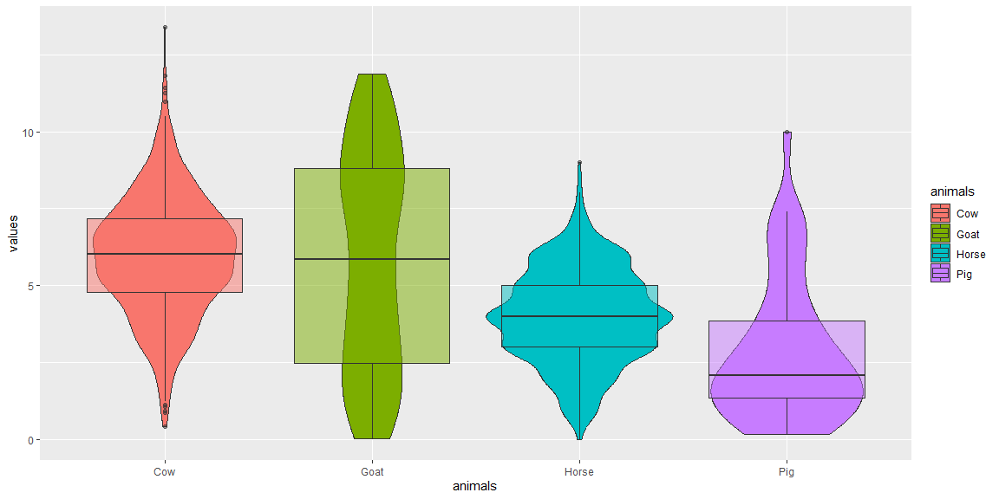

## Problem #05 - Chapter 32 Exercise #04C

# Show your work here  
oneVariable001.dat|>  
 ggplot(mapping = aes(x=drive,fill=animals))+  
 geom_histogram(position = 'identity',alpha=0.5)+  
 facet_wrap(~flops)

## `stat_bin()` using `bins = 30`. Pick better value with `binwidth`.

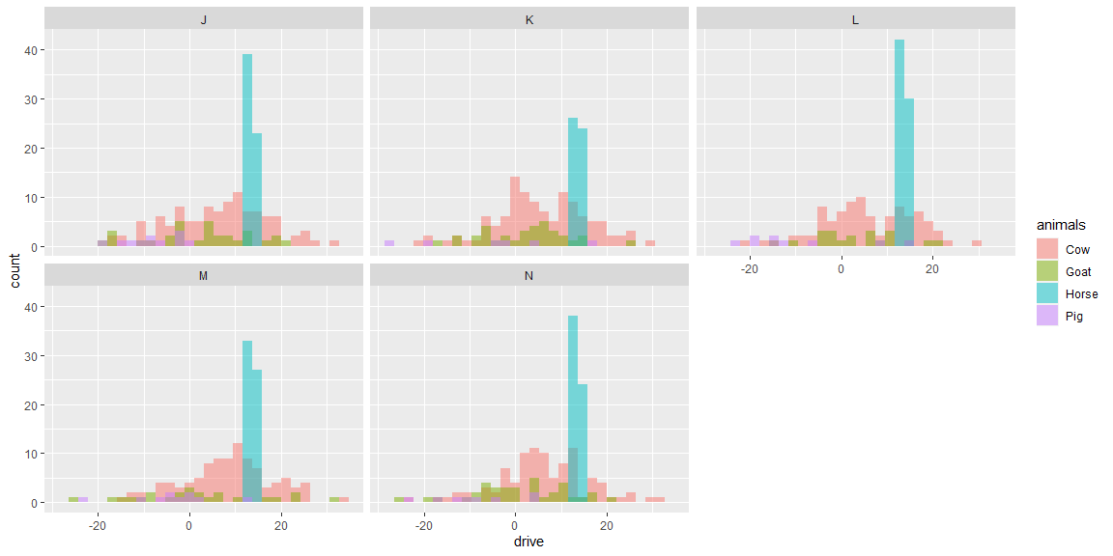

## Problem #06 - Chapter 33 Exercise #01A

# Show your work here  
oneVariable001.dat|>  
 ggplot(mapping = aes(x=values,y=drive))+geom_point()

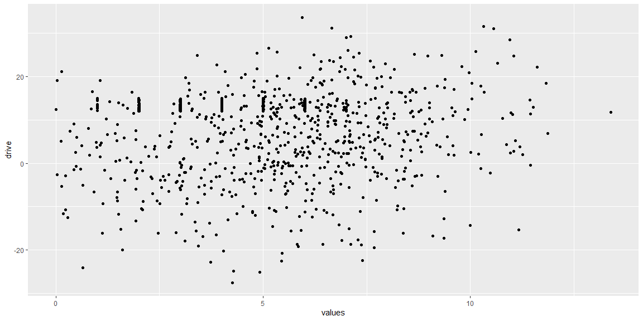

## Problem #07 - Chapter 33 Exercise #02AC ( Displayed Side-by-Side)

# Show your work here  
oneVariable002.dat|>  
 ggplot(mapping = aes(x=values,y=drive))+geom_point()+  
 geom_rug(aes(color=animals),sides = 'r')

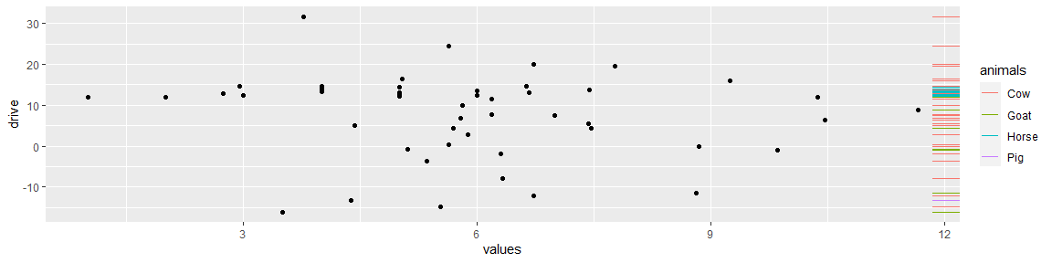

oneVariable001.dat|>  
 ggplot(mapping = aes(x=values,y=drive,color=flops))+geom_point()+  
 geom_smooth(aes(linetype=animals),se=F,color='black')

## `geom_smooth()` using method = 'loess' and formula = 'y ~ x'

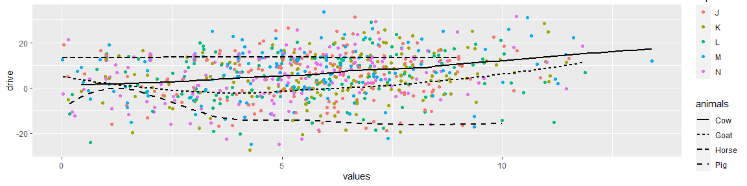

## Problem #08 - Chapter 33 Exercise #04 (Use Minard dataframes in HistData package)

# Show your work here  
library(HistData)

## Warning: package 'HistData' was built under R version 4.2.3

Minard.cities|>  
 ggplot(mapping = aes(x=lat,y=long))+geom_point()+  
 geom_text(aes(label=city),nudge_y =-1 )+  
 geom_ribbon(data = Minard.troops,  
 mapping =aes(x=lat,y=long,  
 ymin=long-survivors/max(survivors),  
 ymax=long+survivors/max(survivors),fill=direction))

