HW_09

izd3

Use only commands & functions that are shown in the indicated chapter or prior chapters.

## Problem #01 - Chapter 34 Exercise #01B

# Show your work here  
library(ggplot2)

## Warning: package 'ggplot2' was built under R version 4.2.3

library(scales)  
scalesGraph000+scale_x_discrete(name='Flavors',labels=c('chocolate',  
 'raspberry'  
 ,'strawberry',  
 'vanilla'))+  
 scale_fill_manual(values=c('red','white','black'),breaks = c('c','n','s'),  
 labels=c('chips','nuts','sprinkles'),name='Toppings')+  
 scale_y_continuous(name='Frequency',breaks = NULL)

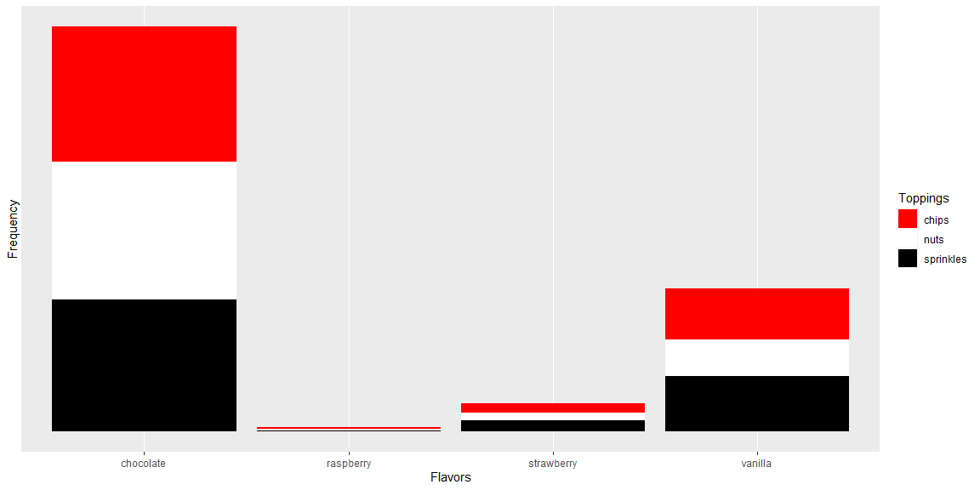

## Problem #02 - Chapter 34 Exercise #02B

# Show your work here  
scalesGraph001+scale_size_manual(name='Flavor',  
 labels=c('chocolate','strawberry',   
 'raspberry','vanilla'),  
 values = c(4,3,2,1))

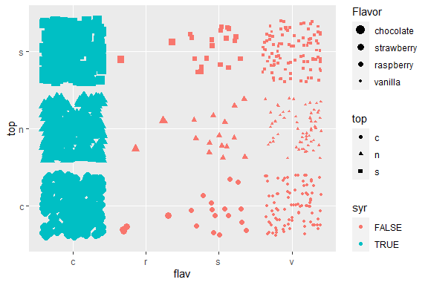

## Problem #03 - Chapter 34 Exercise #04A ( top left )

# Show your work here  
scaled001.dat|>  
 ggplot(mapping = aes(x=weight,y=top,color=flav))+geom_jitter(shape=10)+  
 scale_color_manual(name='Flavor',breaks = c('c','s','r','v'),  
 labels=c('Chocolate','Strawberry','Raspberry','Vanilla'),  
 values = c('blue','red','black','white'))

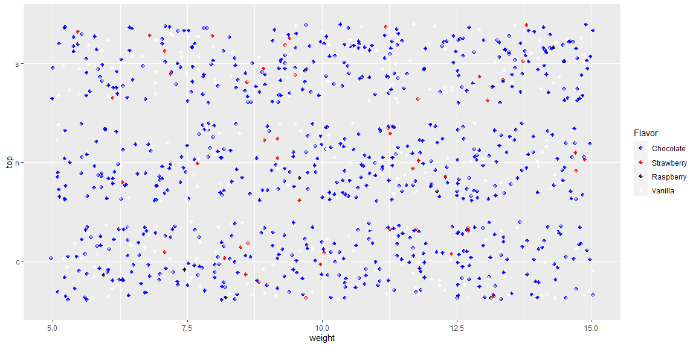

## Problem #04 - Chapter 35 Exercise #01D

# Show your work here  
scalesGraph002+scale_color_gradient(name='Red to Blue',  
 low = 'red',high = 'blue')

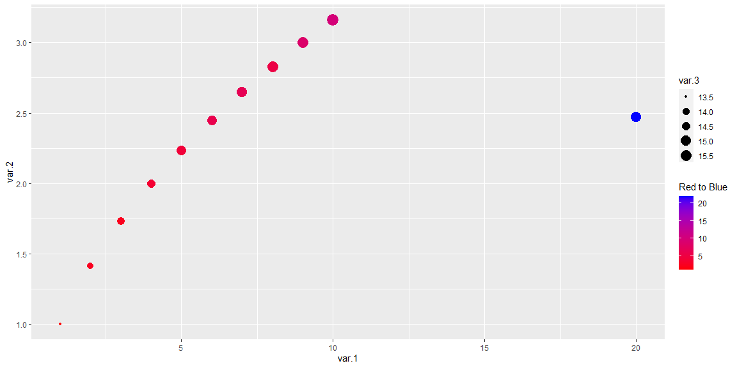

## Problem #05 - Chapter 35 Exercise #03A (red - blue)

# Show your work here  
scaled002.tib|>  
 ggplot(mapping = aes(x=var.1,y=var.5,color=var.3))+geom_violin(fill='grey')+  
 geom_point()+  
 scale_x_log10(name='Log 10 Variable 1',breaks=c(1,5,10,15))+  
 scale_color_gradient(name='VAR 3',low = 'red',high = 'blue')

## Warning: The following aesthetics were dropped during statistical transformation: colour  
## ℹ This can happen when ggplot fails to infer the correct grouping structure in  
## the data.  
## ℹ Did you forget to specify a `group` aesthetic or to convert a numerical  
## variable into a factor?

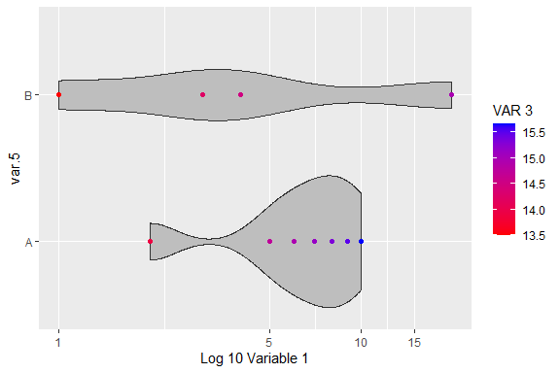

## Problem #06 - Chapter 37 Exercise #03B

# Show your work here  
library(forcats)

## Warning: package 'forcats' was built under R version 4.2.3

fact<-factor(factorData005.fact,levels = c('four star','three star'  
 ,'two star','one star','zero star'))  
table(fact)

## fact  
## four star three star two star one star zero star   
## 0 0 0 7 38

unclass(fact)

## [1] 4 NA 5 NA NA NA 5 NA 4 5 NA NA NA 5 NA NA 4 4 NA NA NA 5 NA NA NA  
## [26] 5 4 5 5 NA 5 NA 5 5 5 NA NA 5 NA 5 5 5 5 NA 5 NA NA 5 NA 5  
## [51] NA 5 NA NA NA NA 5 NA 5 NA NA 4 NA NA 5 NA 5 5 5 5 NA NA NA NA 5  
## [76] NA 5 NA NA 5 5 5 NA NA NA NA 5 NA NA NA 4 NA NA 5 NA NA 5 5 NA 5  
## attr(,"levels")  
## [1] "four star" "three star" "two star" "one star" "zero star"

## Problem #07 - Chapter 37 Exercise #04B

# Show your work here  
table(factorData005.fact)

## factorData005.fact  
## four stars one star three stars zero star   
## 19 7 36 38

factorData005.fact<-fct_recode(factorData005.fact,`no stars`="zero stars",  
 `one,two, or three stars`='one star',  
 `one,two, or three stars`='two stars',  
 `one,two, or three stars`='three stars')

## Warning: Unknown levels in `f`: zero stars, two stars

table(factorData005.fact)

## factorData005.fact  
## four stars one,two, or three stars zero star   
## 19 43 38

## Problem #08 - Chapter 33 Exercise #05E

# Show your work here  
 test<-data.frame(factorData006.fact=fct_infreq(factorData006.fact),  
 factorData004.fact =factorData004.fact)  
test$factorData004.fact=factor(test$factorData004.fact,levels = LETTERS[11:20])  
test|>  
 ggplot(mapping = aes(x=factorData006.fact,fill=factorData004.fact))+  
 geom_bar()+  
 scale_fill_manual(breaks = LETTERS[11:20],  
 labels=LETTERS[11:20],  
 values = c('red','white','red','white','red','white',  
 'red','white','red','white'),drop=FALSE)+  
 scale_x_discrete(breaks=c('reference','gnat','pig'),labels=c('REFERENCE',  
 'GNAT',  
 'PIG'))

