Lab_06

izd3

Use only commands & functions that are shown in the indicated chapter or prior chapters.

## Problem #01 - Chapter 25 Exercise #7

# Show your work here  
first_10<-LETTERS[1:10]  
sample(first_10, 3, replace = TRUE)

## [1] "E" "B" "J"

## Problem #02 - Chapter 27 Exercise #3

# Show your work here  
library('patchwork')  
(patchwork01|patchwork02)/(patchwork01|patchwork03|patchwork04)

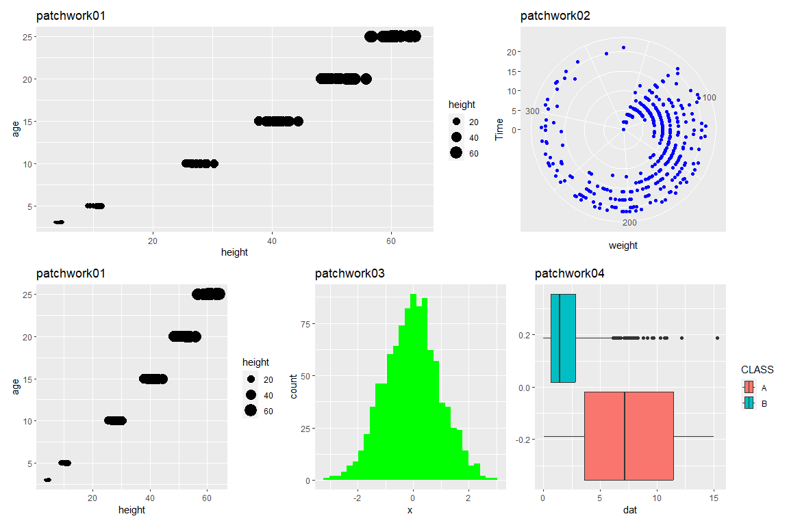

## Problem #03 - Chapter 28 Exercise #2A

# Show your work here  
library('ggplot2')

## Warning: package 'ggplot2' was built under R version 4.2.3

plot_1<-ggplot(x=ggplot001.tib,mapping = aes(x=ggplot001.tib$var.1,y=ggplot001.tib$var.2,color=ggplot001.tib$group.var.1))+  
 geom_point(size=4)  
plot_1

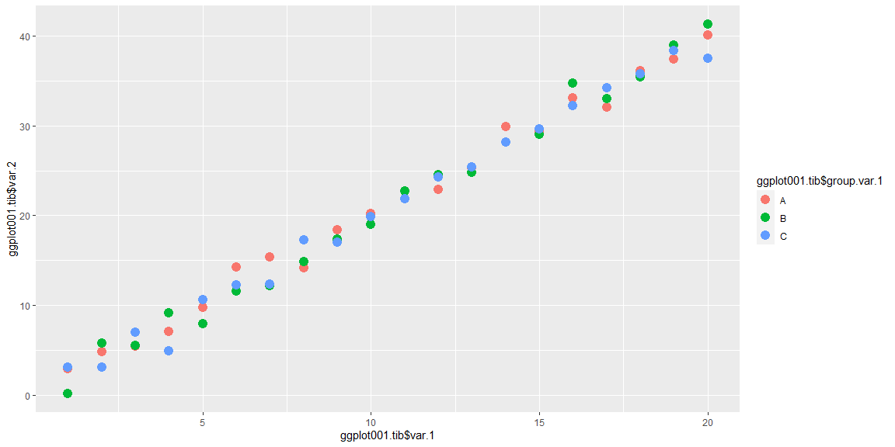

## Problem #0v4 - Chapter 28 Exercise #4A ( look at the legends to help determine the datasets used.)

# Show your work here  
plot_1<-ggplot(x=ggplot001.tib,mapping = aes(x=ggplot001.tib$var.1,y=ggplot001.tib$var.2,color=ggplot001.tib$group.var.1))+  
 geom_point(size=0)  
  
plot_1+geom_point(data = ggplot001.tib,size=4,shape=6)

## Warning: Use of `ggplot001.tib$var.1` is discouraged.  
## ℹ Use `var.1` instead.

## Warning: Use of `ggplot001.tib$var.2` is discouraged.  
## ℹ Use `var.2` instead.

## Warning: Use of `ggplot001.tib$group.var.1` is discouraged.  
## ℹ Use `group.var.1` instead.

