Lab_07

izd3

Use only commands & functions that are shown in the indicated chapter or prior chapters.

## Problem #01 - Chapter 28 Exercise #5C ( look at the legends to help determine the datasets used.)

# Show your work here  
library(ggplot2)

## Warning: package 'ggplot2' was built under R version 4.2.3

ggplot001.tib|>  
 ggplot(aes(x=var.1,y=var.2,size=var.2))+geom_point(fill=NA)

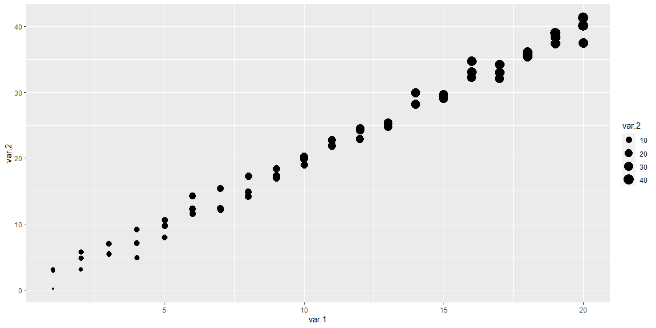

## Problem #02 - Chapter 29 Exercise #1A

# Show your work here  
coordGraph001+coord_fixed(ratio = 2)

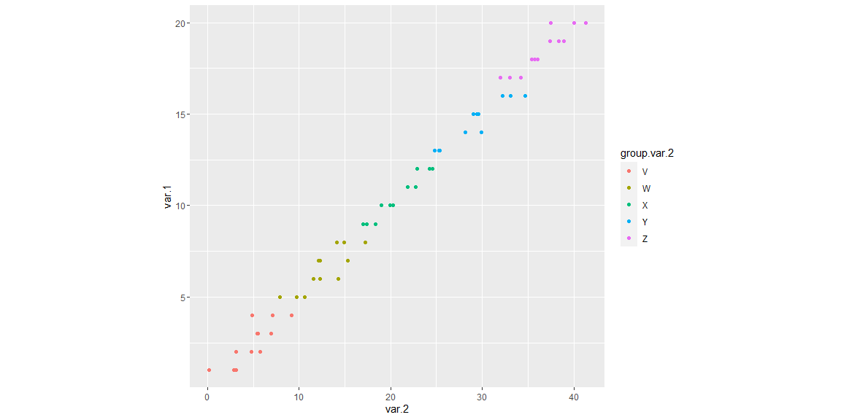

## Problem #03 - Chapter 30 Exercise #1B

# Show your work here  
ggplot005.dat|>  
 ggplot(aes(x=var.2))+geom_histogram()+facet_wrap(~var.4)

## `stat_bin()` using `bins = 30`. Pick better value with `binwidth`.

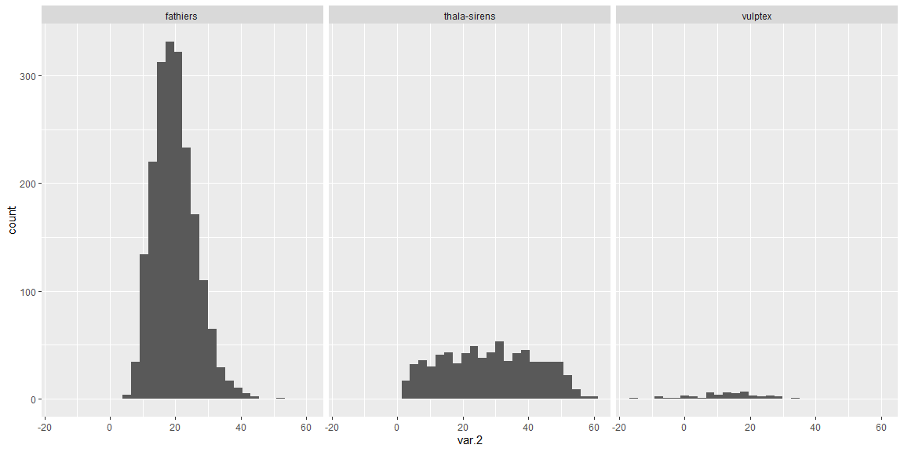

## Problem #04 - Chapter 31 Exercise #1A

# Show your work here  
ggplot008.tib|>  
 ggplot(aes(x=x.values,y=y.values,color=t.values))+geom_line()+  
 geom_vline(xintercept = 0,color='red')+  
 geom_hline(yintercept = 0.75,color='lightblue')

