Lab_08

izd3

Use only commands & functions that are shown in the indicated chapter or prior chapters.

## Problem #01 - Chapter 32 Excercise 1A

# Show your work here  
library(ggplot2)

## Warning: package 'ggplot2' was built under R version 4.2.3

oneVariable001.dat|>  
 ggplot(aes(x=values))+geom_histogram()

## `stat_bin()` using `bins = 30`. Pick better value with `binwidth`.

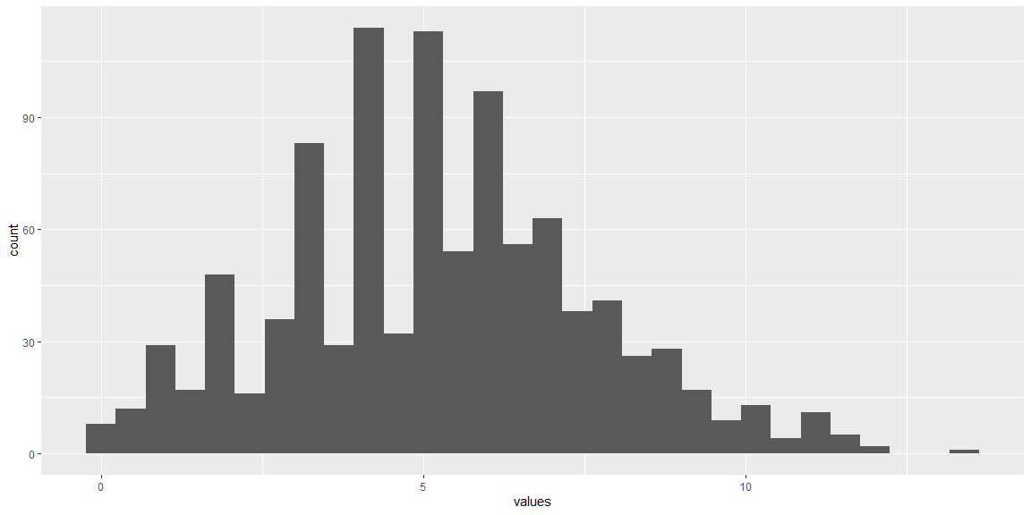

## Problem #02 - Chapter 32 Exercise #2D

# Show your work here  
oneVariable001.dat|>  
 ggplot(aes(x=values,color=animals))+geom_freqpoly()

## `stat_bin()` using `bins = 30`. Pick better value with `binwidth`.

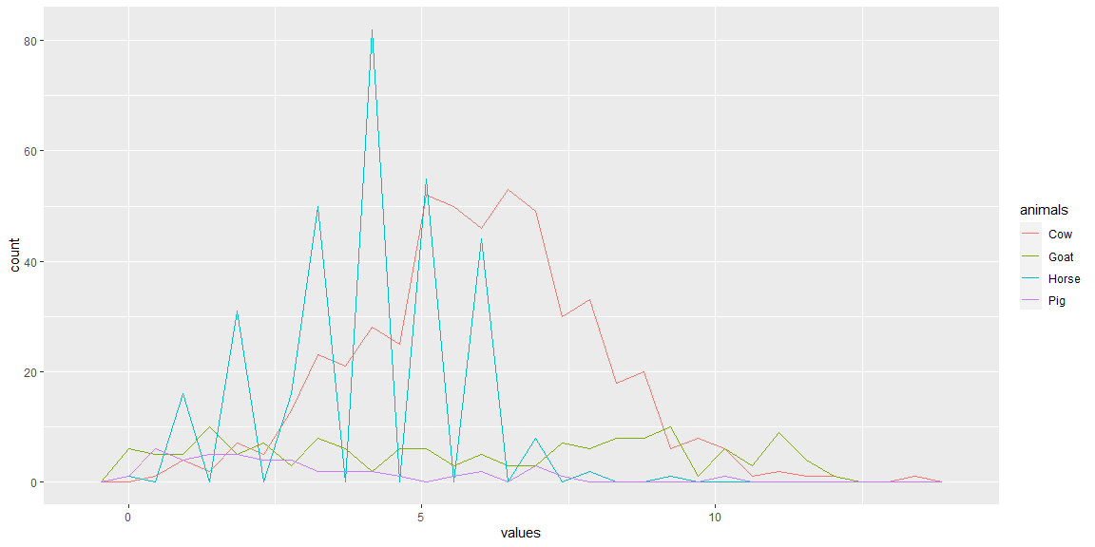

## Problem #03 - Chapter 32 Exercise #3C

# Show your work here  
oneVariable001.dat|>  
 ggplot(aes(x=flops,y=values,fill=flops))+geom_violin()

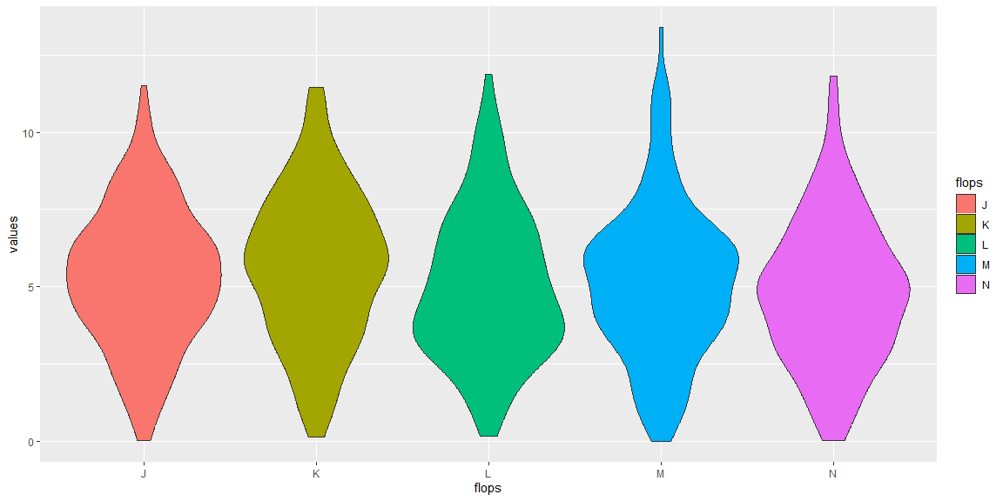

## Problem #04 - Chapter 33 Exercise #2C

# Show your work here  
oneVariable001.dat|>  
 ggplot(aes(x=values,y=drive))+  
 geom_point(aes(color=flops))+  
 geom_smooth(aes(linetype=animals),se=F,color='black')

## `geom_smooth()` using method = 'loess' and formula = 'y ~ x'

