Lab_09

izd3

Use only commands & functions that are shown in the indicated chapter or prior chapters.

## Problem #01 - Chapter 34 Exercise 1A

# Show your work here  
library(scales)  
library(ggplot2)

## Warning: package 'ggplot2' was built under R version 4.2.3

scalesGraph000+scale_fill_manual(values=c('red','white','black'),breaks = c('n','c','s'),  
 labels=c('chips','nuts','sprinkles'),name='toppings')

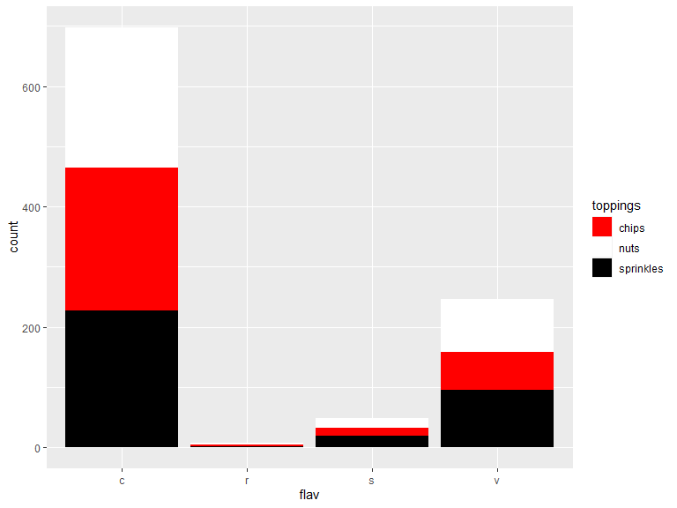

## Problem #02 - Chapter 35 Exercise #1A

# Show your work here  
scalesGraph002+scale_x_sqrt(name='X-Axis',breaks=c(1:10,20))

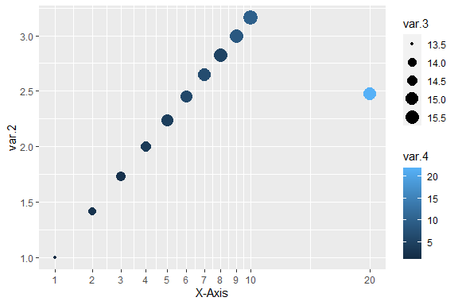

## Problem #03 - Chapter 37 Exercise #1A

# Show your work here  
library(forcats)

## Warning: package 'forcats' was built under R version 4.2.3

facts<-factor(factorData001)  
unclass(facts)

## [1] 1 1 1 2 9 1 3 5 5 5 4 1 3 4 2 3 2 6 8 1 3 9 2 6 2 7 2 4 1 1 9 5 8 5 6 2 3 1  
## [39] 6 6 1 5 3 4 5 2 4 6 1 9  
## attr(,"levels")  
## [1] "a" "c" "d" "e" "f" "g" "h" "i" "j"

table(facts)

## facts  
## a c d e f g h i j   
## 11 8 6 5 7 6 1 2 4

## Problem #04 - Chapter 37 Exercise #5A

# Show your work here  
  
starfact<-data.frame(fact=fct_infreq(factorData005.fact))  
  
starfact|>  
 ggplot(mapping = aes(x=fact,fill=fact))+geom_bar()

