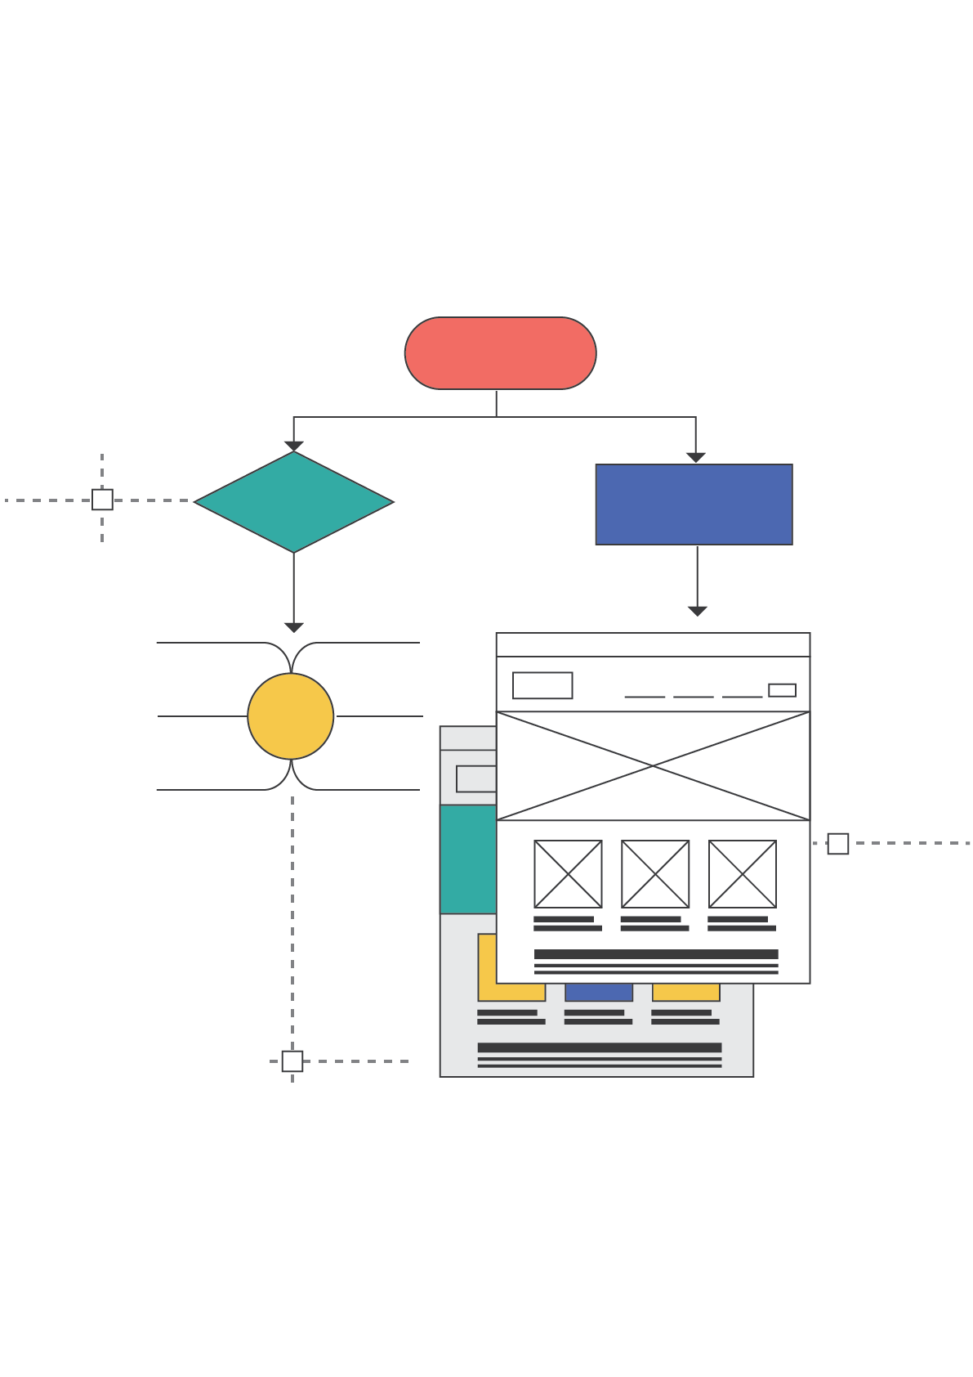

**Website Planning Template for ABC.com**

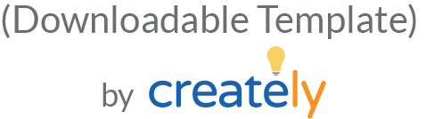

**HOW TO USE THIS TEMPLATE**

This website template contains steps you need to follow during a website planning project.

How to use the diagrams

The diagram examples provided are editable. Use the link provided with them to open them in the Creately editor and modify them as suits your needs. Once opened in the editor you can change colors, styles, fonts, images etc. and export them as images or PDFs.

How to use the image placeholders

Once you open the wireframe or UI mockup templates on the Creately editor, you can replace the image placeholders with images imported directly from your computer or browsed from the Internet.

**PHASE 1: PRE – PLANNING**

**WEBSITE OBJECTIVES**

*<What are you trying to achieve with your website? Defining your website objectives prior to building is important to clarify what you need to focus on>*

|  |  |
| --- | --- |
| Generate more traffic | Yes/No |
| Maintain search engine rankings |  |
| Improve lead conversion rates |  |
| Increase brand awareness |  |
| Improve user satisfaction |  |
| Increase ecommerce sales |  |
| Improve sales support |  |
| Engage potential and existing customers |  |
| Become an authoritative resource |  |
| Retain customers |  |
| Promote content online |  |
| Get more email subscribers |  |
| Get your eBook downloaded |  |

**ANALYSIS OF TOP COMPETITORS AND THE MARKET**

*<Before you jump in head on, you need to know what you are getting into. A thorough analysis of your competitors and the market can give you a heads up for what you need to prepare for >*

**Key Competitors:**

<List down the top 5 competitors here>

**Keywords:**

<List down keywords related to your industry/ market/ audience here>

*Use the following mind map to organize and share the information you collect on the websites of your top competitors and market trends

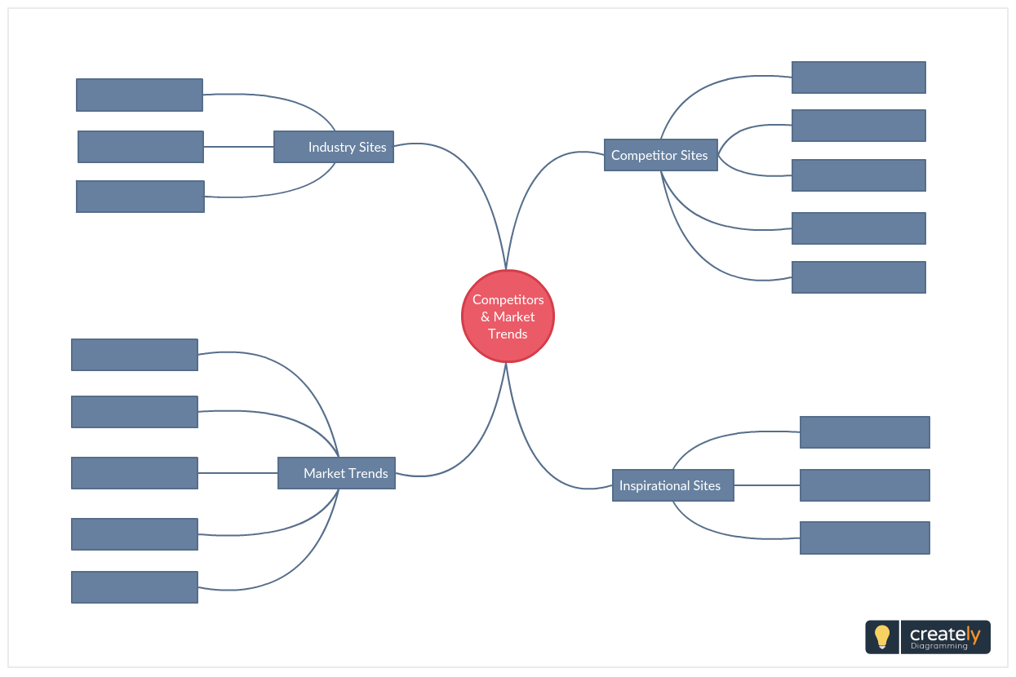<http://creately.com/creately-start?tempID=jfaov2qc2>

**PHASE 2: INFORMATION ARCHITECTURE AND USER FLOWS**

### WEBSITE STRUCTURE

### *<You can highlight the key areas of your site using a site map. This initial map will help you when developing your site’s wireframe later>*

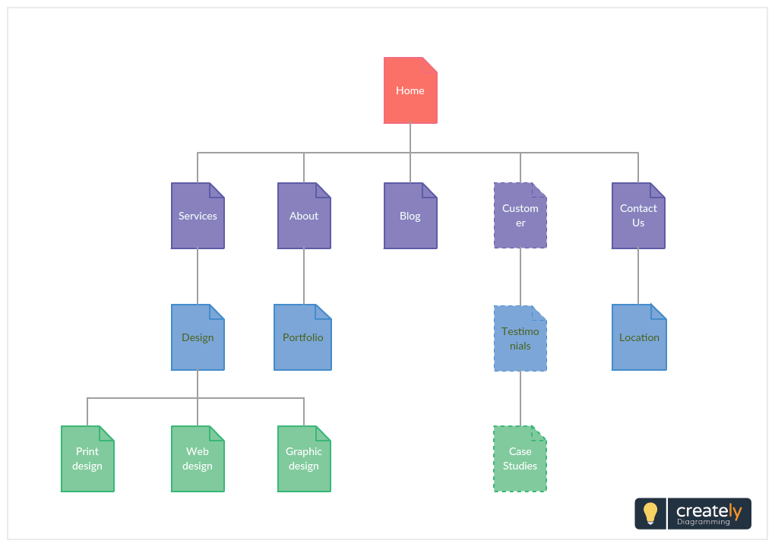<http://creately.com/creately-start?tempID=jfaqp9br1>

**NAVIGATION FLOW**

*<****Using a flowchart, you can map how your visitor would navigate through your site. Identifying this will help you decide on the key phrases, key paragraphs, key images etc. you should place on each page>***

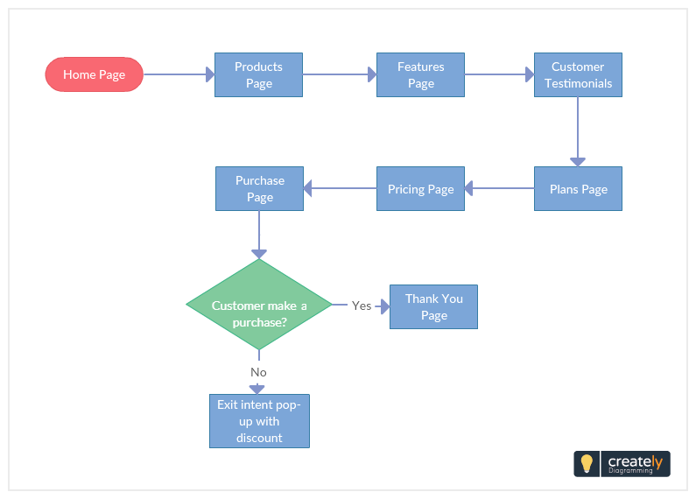

<http://creately.com/creately-start?tempID=jfareluk1>

Want to create your own user flow? Draw it quickly with [Creately flowchart software](https://creately.com/Flowcharts-and-Workflow-Diagrams-Online).

**PHASE 3: DESIGN LAYOUTS AND SITE INFRASTRUCTURE**

### KEY COLORS, ELEMENTS AND STYLES

### *<Mood boards are a great way to document the inspirational instances you find while you are doing research for your website design. You can use them to come up with your own style guide for your website>*

<http://creately.com/creately-start?tempID=jfareluk2>

**WEBSITE WIREFRAMES**

*<With wireframes you can create a blueprint of your website. This will help demonstrate how key interface elements should be placed on pages for a better user experience>*

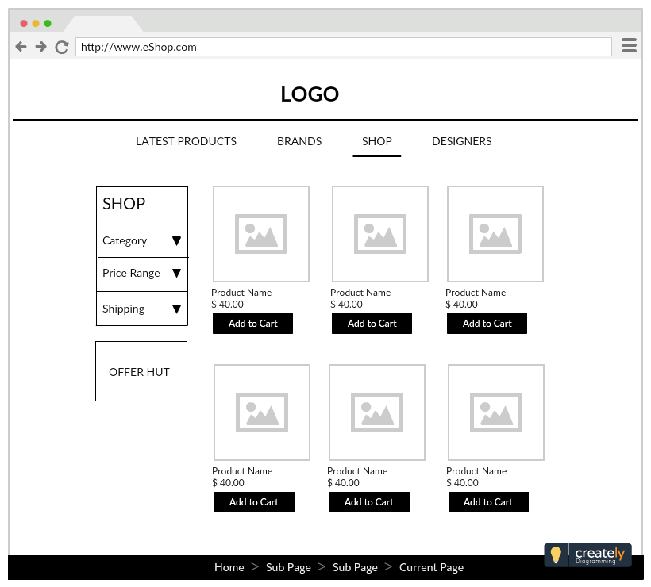

<http://creately.com/creately-start?tempID=gsy8pdq41>

**WEBSITE UI MOCKUPS**

*<Revise the design choices for color themes, typography, iconography, layouts, and visuals of navigation with UI mockups. They can help you detect any faults before you go ahead with the final design>*

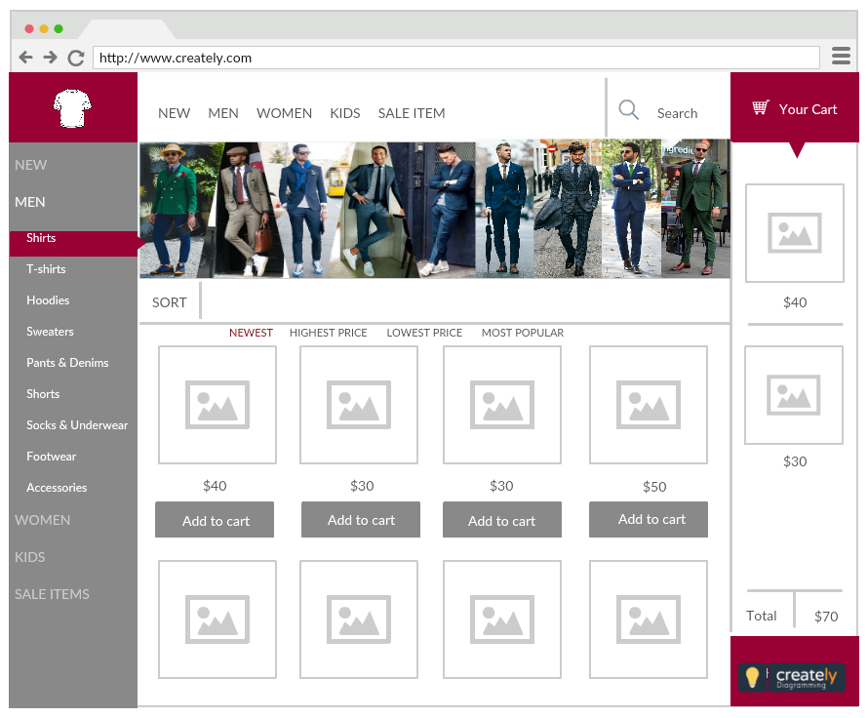

<http://creately.com/creately-start?tempID=ipt6bcpc1>

**PHASE 4: PROMOTION AND MARKETING**

### WEBSITE PROMOTION AND MARKETING

### *<Building your website is just the initial phase of it all. Then comes marketing. There are several ways you can promote and drive traffic to your website. Get your team together and sketch out a step by step plan on how to get your website in front of an interested audience >*

### 

<http://creately.com/creately-start?tempID=jfaw7i0a1>