Candidate Number: Centre Number: 12990

CONJURE

DIGITAL ART SOFTWARE

Jessie Guo

Qualification Code:

Contents

1 Analysis 3

1.1 Background 3

1.1.1 Software 3

1.1.2 Hardware 3

1.1.3 References and Models 3

1.2 End User 4

1.3 Problem 4

1.3.1 Lack of Features 4

1.3.2 Lack of Portability 5

1.3.3 Inefficiency 5

1.3.4 Ease of Use 5

1.4 Research on Existing Products 5

1.4.1 Basic Art Program Example: Microsoft Paint 5

1.4.2 Advanced Art Program Example: Clip Studio Paint 10

1.4.3 Doodle Recognition Example: Quick Draw 15

1.4.4 Image Recognition Example: Google Search by Images 15

1.5 Description 16

1.6 Prototyping 16

1.7 Modelling 16

1.8 Objectives 16

1.8.1 Overview 16

1.9 Execution 17

1.9.1 Icons 17

1.9.2 Brush Tools 18

1.9.3 Modification Tools 18

1.9.4 Functionality Tools 19

1.9.5 Management Tools 20

1.9.6 Advanced Features 20

2 References 21

3 Notes 21

4 End User Transcripts 22

4.1 End User A 22

4.1.1 User interface and Complexity 22

4.1.2 Traditional Art Experience 22

4.2 End User B 22

4.2.1 User Interface and Complexity 22

4.2.2 Traditional Art Experience 23

# Analysis

## Background

One of the many art forms that exist is digital art. The term digital art software refers to programs that facilitate illustration (and occasionally animation) through technology, and often consist of a main drawing canvas centred on the screen with a selection of tools situated at the edges.

What separates digital from traditional art forms is its versatility and convenience. Despite using a pen, one is no longer confined to the constraints of the specific tool they are using, nor must they hassle with acquiring and relying on additional supplies to achieve basic functionality. Instead, they are automatically equipped with a multitude of digitalised mediums, tools, functions, and shortcuts that are immediately available to them within a single device.

### Software

Basic software will provide the essential tools for an illustration program, and typically contains the following features:

* Paintbrush
* Eraser
* Selection tool
* Fill
* Text insert
* Save/upload

More sophisticated art software will typically have a broader range of customisation options and advanced tools, such as layering or image distortion. These types of art software are used by both recreational and professional creators.

### Hardware

Art software commonly caters to devices specialized for drawing; a graphics tablet paired with a pen is the main device used for digital art. These devices are specialized for illustration due to the intuitive input method and additional functionality of pen pressure, as well as extra buttons to increase ease of use.

### References and Models

To aid with their illustration, artists will often have a collection of reference images to act as a model or inspiration for their art. These can consist of models, general images of scenery of objects, colour pallets, and possibly examples of other art styles that they may want to incorporate into their art. To find these references, artists are frequently required to browse the internet to find images suitable for their work.

3D models are also used to aid in sketching people or objects at different angles. Artists can either use integrated 3D modelling or an external piece of software to create their desired models.

## End User

My product will be targeted towards digital artists and traditional artists that are transitioning into digital art. The intended end user includes commissioners, hobbyists, new, and veteran artists. To achieve this, I will need to include a wide range of features to accommodate the needs of experienced and more advanced users, while keeping a clear and friendly UI to cater to newer users.

To aid in the development of my program, I will be communicating with a friend who will be referred to as End User A. They are an experienced digital artist who also has 1 year of experience in digital art (specifically in Clip Studio Paint) and 6 years in traditional art. Since their transition to digital art, it has been their preferred medium. They have done traditional art academically throughout their secondary school education and previously indulged in traditional art as a pastime. In terms of their experience in digital art, they are familiar with many of the integrated features in Clip Studio related to illustration but lack experience in its other specialised tools such as animation. As my program will be mainly catered towards illustration, their opinions will be seen as from an advanced user’s view.

I will also be communicating with another friend who prefers traditional art, and will refer to them as End User B. Though they have (scarcely) used digital software before, they prefer to use traditional mediums, varying from watercolours to oil paint. Similarly to End User A, they do art recreationally though less frequently than End User A. Though their experience in digital art is limited (specifically in ibis Paint), I believe their opinions will be valuable in creating software friendly to newer and inexperienced users. Their opinions will be seen as from a newer user’s view.

## Problem

I aim to create an advanced art program with new integrated features as well as the traditional tools expected from an advanced art program. Automatic reference generation and integrated 3D modelling are two new features that I would like to include in my art program and will be the main focus of this project, along with having the basic tools accompanying general art software. I will create it to accommodate tablet and mouse input methods.

After researching different art programs and their disadvantages, I have compiled four categories in which current art programs seem to fail at.

### Lack of Features

Upon researching the pros and cons of art software online, I have encountered a lack of features as a common disadvantage. However, these features vary between art programs, but I will outline some that I may integrate into my program.

This article [reference https://www.creativebloq.com/advice/the-best-software-for-digital-artists] states Photoshop lacks vector support. This may simply be due to its speciality in raster graphics, but I would like my program to serve as a general-purpose art application.

The article also mentions that MediBang Paint lacks a variety of brush options. While this is a specific example, a survey I conducted also suggested that brush variety was an issue in art programs. Out of the 16 participants in my survey that used digital art software, 4 stated that there was a lack in brush variety.

Several other features that participants stated current art applications were lacking were a lack of exportation formatting, ability to remove backgrounds, and add pixel borders. Another participant also stated that while they thought a variety of features exists, “all the good features aren’t in one program”. Though the features were not specified, I will analyse existing art programs to extract useful features that I could include in my program to increase its general applications.

### Lack of Portability

The second issue I will discuss is limited platform support as well as portability of created artworks. Despite my art program being catered towards PC users, I would like to increase flexibility in my program by creating a supported program whereby created art can be synced across devices and downloaded. As someone who has indulged in digital art before, I believe it is an inconvenience when transferring files between devices. Furthermore, a portable gallery of all projects would make accessing and compiling portfolios easier for any artist.

### Inefficiency

Performance issues or lag was also a common issue identified in the survey; 50% of those who used art software had issues with performance. A factor of this could be the available canvas sizes, as with a higher DPI canvas, more computing power is needed to update and display the image. Furthermore, with the use of image distortion or other editing features, a large amount of information must be processed at a time, possibly causing lag. I will aim to prevent these issues, though performance issues will be inevitable if they are caused by hardware constraints.

### Ease of Use

In this article (reference https://www.creativebloq.com/advice/the-best-software-for-digital-artists), 3 of the 13 pieces of software mentioned had complicated interfaces as a disadvantage. In my survey, 2 out of 4 of those who didn’t use digital art software but instead did traditional art claimed that current digital art programs were too intimidating or complex. Furthermore, out of the 16 people that did digital art, 50% also agreed that current art programs are complicated and difficult to use. One person mentioned that in the specific example of Photoshop, they noticed that there was a steep learning curve for many people.

As one of the most prominent and reoccurring disadvantage of current art, I will aim to create an intuitive and clear interface to accommodate old and new users alike.

## Research on Existing Products

To assess the basic needs of my program, I researched two widely used art programs that were accessible to me. As I intend to create a program compatible with PC, I analysed two popular PC art programs to identify the key features required.

### Basic Art Program Example: Microsoft Paint

Microsoft Paint [reference Microsoft Paint <https://www.microsoft.com/en-gb/p/paint/9wzdncrfhx97?activetab=pivot:overviewtab> , 14/09/2022] is a simple graphics program that gives the user the ability to draw on a canvas using different brushes with a variety of colours, shapes, and tools.

I chose to analyse Microsoft Paint due to its barebones approach to providing the basic artistic tools for a simple art program. The features extracted from this program will act as the base of my program, ensuring there is sufficient functionality provided at the minimum level.

#### GUI

Microsoft Paint’s UI is minimalistic, and simple. The canvas sits in the centre of the screen with the toolbar situated at the top.

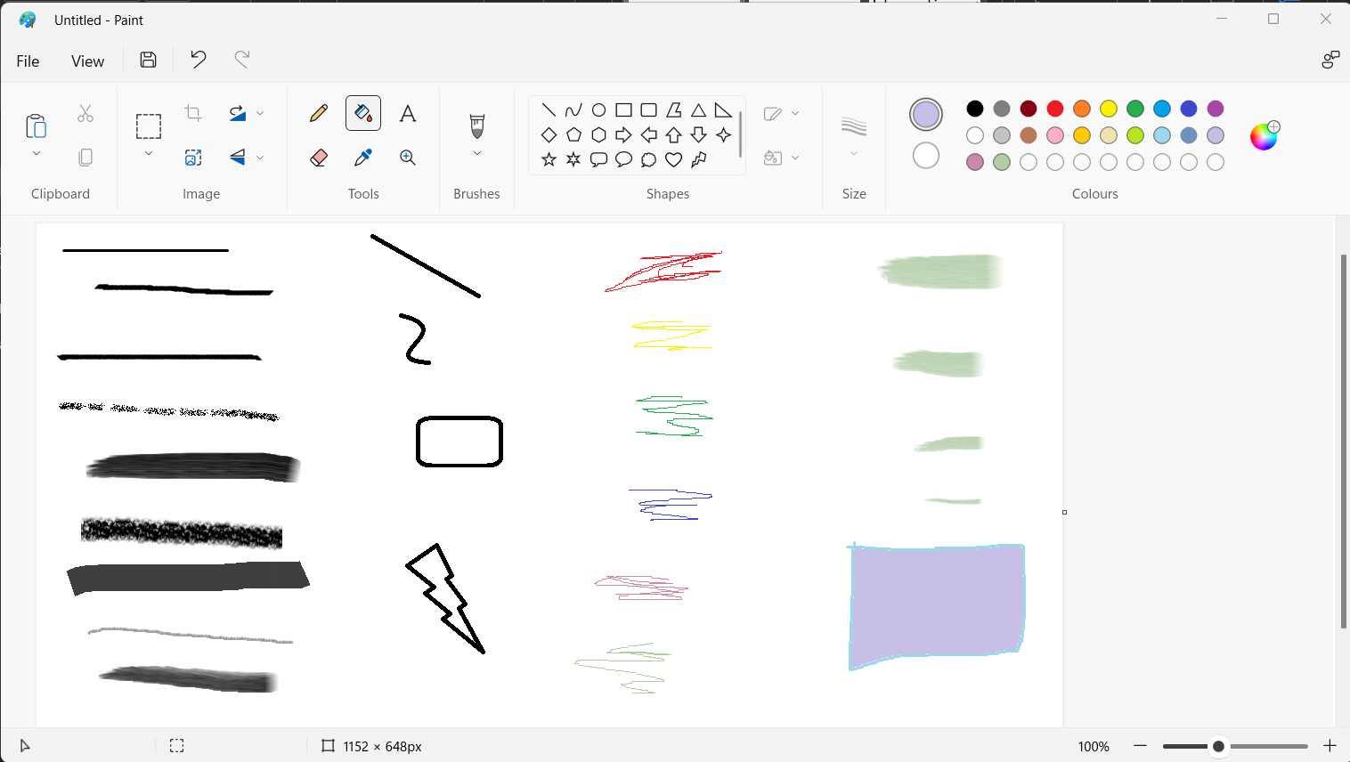

Figure . MS Paint sample displaying the usage of different tools provided by the program.

##### Tool Categorisation and Icons

The GUI of Microsoft Paint includes a variety of tools that are separated into distinct categories, as seen in figure 1. Inside each category contains icons representing selectable tools. The categories are clear and concise, and laid out with minimal detail. The GUI design is greatly simplified by the usage of icons and straightforward categorisation. Furthermore, the icons are minimalistic, providing the user a strong, clear suggestion of its use. For tools with additional functionality or customisation options, a dropdown arrow is situated next to the icon, abstracting the GUI to only show additional selectors when the tool is to be used by the user.

##### Extra Tools

At the top of the window, icons for file management, viewing options, and undo/redo steps are shown. The placement of these essential functions is optimal for familiarity; it is a standard for most programs. The save icon is also conveniently placed for easy access.

*Summary of the key features of the GUI:*

* Categorised tools
* Simplified design
* Minimalistic icons
* Abstraction of additional settings
* Intuitive icon placement

#### Features

Microsoft paint is designed for simple drawing and image editing, and caters to those with less experience in digital art. This can be seen through their collections of basic but essential features that populate most of the toolbar.

##### General Tools

The main features consist of the pencil, fill tool, eraser, brush selection, selector tool. The pencil works as a simple pen that changes the colour of the pixel the cursor interacts with. This is a useful tool to be able to edit individual pixels for drawing refinement or image editing.

##### Bucket Tool

The bucket tool is also a simple autofill tool which changes the pixels in a body of equally coloured pixels. Upon experimenting with the bucket tool, it performs to standard with solid pens, but lacks the ability to fill transparent or textured lines.

Figure . MS Paint bucket tool testing. The fill tool sometimes struggles with filling circles, especially those outlined using “airbrush” and “watercolour” brushes.

##### Eraser

As with the fill bucket, the eraser also lacks some functionality. The eraser can erase pixels accurately, but it is strictly limited to solid erasure. This could result in unnatural strokes when using the eraser with a textured paintbrush. Furthermore, the size options for the eraser are limiting; there are only four size options of 4 pixels, 6 pixels, 8 pixels, and 10 pixels (where the pixel number stated acts as the length of a square shaped erasure area).

Figure . MS Paint eraser tool size and sample shown with the default size of the canvas.

As shown in figure 3, this limited set of sizes may not be ideal, and the lack of selection of textures for the eraser does not compliment the availability of brush textures.

##### Brushes

The variety of brush textures is satisfactory; there are a total of nine brush types available, with an additional one (the pencil) available as a default pen. Though there is a lack of customisation in parameters of the brush textures, the variety of brush types is already sufficient for a simple graphics program.

##### Selection Tool

The final feature I will discuss is the selector tool. There are two shapes of selection that the user can choose from: free-form or rectangular. Though the selection tool can perform the task of selecting and transferring pixels, the selection box for free-form selections was unclear; the original selection outline would be lost and replaced with a rectangle as shown in figure 4, though the pixels selected to move would retain the original shape.

Figure . MS Paint selection tool in use.

Another issue that arose was the removed pixels would take on the colour of the currently selected secondary colour. Though this may be convenient for simple art programs that lack multilayering, it would not be suitable for my program.

##### Summary

In the summary I will omit some features that I judge to be unnecessary for my software, such as importing an image from a scanner.

*Summary of features provided by the software:*

* Basic drawing tools
  + Pencil
  + Fill bucket
  + Text box insertion
  + Eraser
  + Eyedropper
  + Magnifier
* Image editing tools
  + Select
  + Crop
  + Rotation
  + Resizing
  + Flip
* Clipboard
  + Paste
  + Import
  + Copy
  + Cut
* Brush selection
* Shape drawer selection
  + Outline colour selection
  + Fill colour selection
* Brush size selection
* Colour selection
  + Default pallet colours
  + Custom added colours
  + Colour wheel
* File tab
  + New drawing
  + Open existing drawing/image
  + See recently edited files
  + Save drawing
  + Save drawing as a different file
  + Print
  + Send drawing
  + Set drawing as desktop background
  + View Image Properties
* View tab
  + View zoom size
  + Show ruler
  + Show gridlines
  + Show status bar
    - Contains:
      * Cursor coordinates (relative to the canvas)
      * Selection area dimensions
      * Canvas size
      * Zoom slider
  + Enlarge to full screen
* Save icon
* Undo/Redo

### Advanced Art Program Example: Clip Studio Paint

An advanced program I looked at was Clip Studio Paint [reference Clip Studio Paint, <https://www.clipstudio.net/en/>, 14/09/2022]. This application caters illustration, animation, and comics. I will only be analysing the tools associated with illustration.

#### GUI

Compared to Microsoft Paint, Clip Studio Paint immediately shows to have a more cluttered GUI. Figure 5 shows an example of what a Clip Studio Paint program may look like.

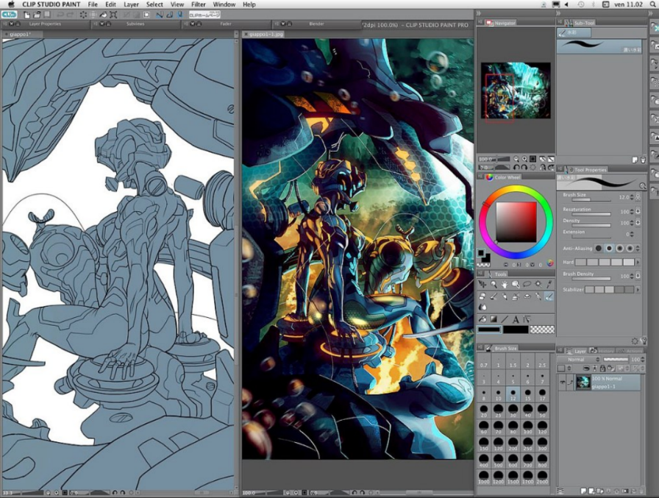

Figure . Example of Clip Studio Paint in use. [reference Clip Studio Paint example sample, https://i1.wp.com/kalicrack.com/wp-content/uploads/2020/08/Clip-Studio-Paint-Crack.jpg?resize=1024%2C768&ssl=1, 14/09/2022]

##### Windows and Tabs

There is a significantly larger number of windows/tabs than MS Paint, and an increased variety of icons, as well as additional hidden tabs located on the side. Despite Clip Studio Paint’s overwhelming number of features, it can abstract its UI; Clip Studio Paint allows the user to customise which windows are shown, as well as its location on the screen.

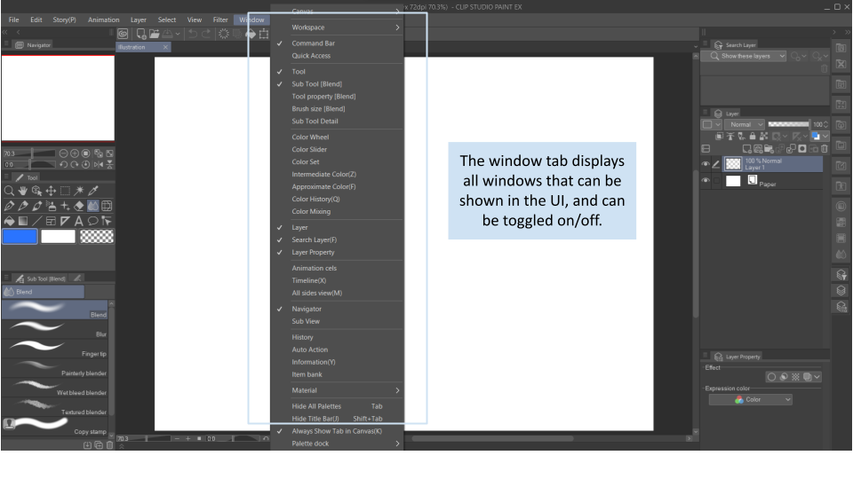

Figure . All tools can be accessed, shown, and hidden here.

This minimalises the clutter on the screen and gives the user freedom to decide which features are visible. Furthermore, the ability to customise the organisation of the windows provides much flexibility in personalising one’s UI.

Despite the partition of each tool into individual windows, the number of icons and windows available can be seen as overwhelming, and many of them are not as intuitive as the basic icons shown in figure 1. End User A also agrees with this, stating that the large number of windows can be overwhelming. Perhaps the categories that the windows are separated into could be labelled to clarify their usage and provide the user with an idea of what they can ignore.

##### Icons

Like MS Paint and other art programs, Clip Studio Paint uses icons to denote different tools and functions.

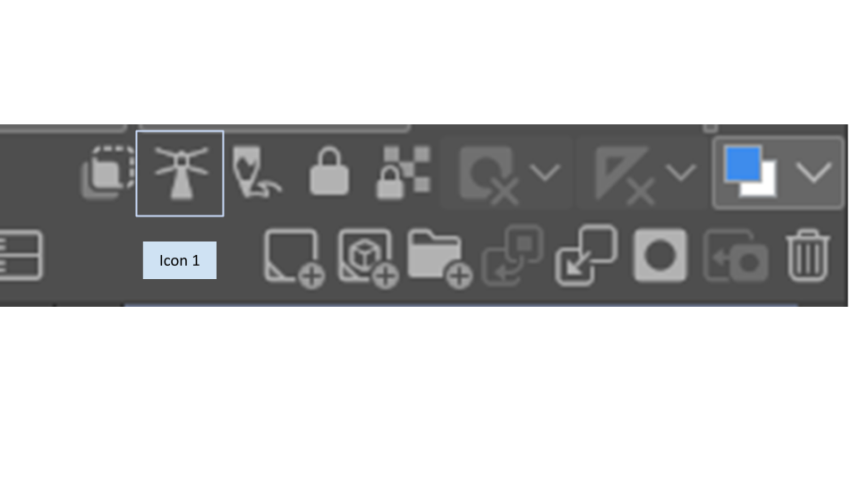

Figure . An assortment of icons denoting layer functions in Clip Studio Paint

The icons shown in figure 3 are concise and minimalistic – ideal for experienced users - but may not be suitable for newer users. Many of these functions are unique to digital art (for example, layer masks), and some are not very intuitive; icon 1 is vague and does not resemble anything familiar. Furthermore, upon asking End User B on their confidence in exploring the tools in Clip Studio Paint, they rated their confidence 3 out of 10. This may be expected from a user unfamiliar with digital art software in general, but I would like my software to be easy to navigate to all users.

From my judgement, this unclarity is due to the lack of information provided in the software itself. The most amount of information that Clip Studio Paint provides within the software is the tool description.

Figure . Hovering over an icon displays its function.

As shown in figure 8, a brief description is provided as the cursor hovers over the icon. Though this may be satisfactory to experienced artists who have used different art programs before, novice users will struggle to understand the function behind each icon. Referring to the example in figure 8, the user is left to infer what a reference layer is with no further detail. While there are many tutorials online to explain each tool, a small, integrated tutorial on each icon could help newer users familiarise themselves with the mountain of tools the program provides.

##### Themes

Another characteristic of the UI was also criticised by End User A. They commented on the dull, grey theme of the UI, suggesting there should be more themes available rather than simply light and dark mode. This led to the proposal of custom themes, where users could design their own themes which could be shared between users. Though this is not a significant feature crucial to art software, it will improve the user experience and personalisation.

*Summary of Key Features of the GUI:*

* Abstraction of UI though windowed tabs
* Personalised UI based on the user’s preference
  + Lack of themes
* Simplified icons
  + Lack of information about tools

#### Features

As an advanced art program, Clip Studio Paint contains a significantly greater selection of features than MS Paint. I will cover the features that I aim to include in my program.

##### Brushes and Customisation

Clip Studio Paint has a wide selection of default brushes mimicking traditional art forms.

Figure . A selection of default brushes provided by Clip Studio Paint.

Increasing the flexibility of brush options, Clip Studio Paint allows the user to customise their brushes thoroughly and allows users to create their own custom brushes entirely.

Figure . Clip Studio Paint's brush customisation windows and tabs.

Users can draw their own brush shapes or textures and change brush parameters such as thickness or opacity, but more intricately than the base parameters; setting dynamic input methods allows users to control what attributes of the input affect the parameters of the brush and how. To elaborate, the attributes of the input method consist of pressure, tilt, and velocity. A graph is provided to aid the user in altering their preferences in altering the dynamics of the brush. Furthermore, any custom brushes create can be exported and shared with others, essentially creating an infinite selection of brushes for Clip Studio Paint Users.

### Doodle Recognition Example: Quick Draw

One of the features I would like to include in my program is reference generation. This will act similar to Google’s Quick Draw [reference Google’s Quick Draw <https://quickdraw.withgoogle.com/>, 30/10/2022] where the program will analyse the user’s drawing and identify what it is that they intend to draw.

Figure . A display of the images that Quick Draw compared to my drawing. [reference Quick Draw, <https://quickdraw.withgoogle.com/>, 30/10/2022]

As shown in figure 11, Quick Draw uses a large database of images consisting of doodles drawn by other players. These images are then compared to the user’s image and used to guess what the intended image was to be.

When starting the game, the player is given a prompt to draw. While drawing the image, the AI will continuously attempt to identify the object in the image until the object is correctly guessed.

In my experience in testing the AI, it is very consistent in guessing doodles which is likely to be due to its extremely large dataset. According to their website [reference Quick Draw Data, <https://quickdraw.withgoogle.com/datak>, 30/10/2022], they currently have 50 million drawings in their dataset. This means their AI has been trained with a large variety of data samples, significantly increasing the accuracy of their model. Furthermore, their website states that their dataset has been contributed by over 15 million players, reducing bias in their model. This makes it extremely ideal and efficient for analysing doodles.

### Image Recognition Example: Google Search by Images

Google’s Reverse Image Search is an application that takes an image as an input and outputs images that look similar to the input, as well as information about the image. Figure 12 shows an example of Reverse Image Search in use.

Figure . Using Google Search by Image on an image of an apple. [reference Apple Image, <https://www.publicdomainpictures.net/en/view-image.php?image=29048&picture=red-apple-isolated>, 30/10/2022]

## Description

See objectives

## Prototyping

[continue]

## Modelling

[continue]

## Objectives

[continue]

### Overview

Drawing tools:

* Freehand brush tool
* Eraser tool
* Bucket tool
* Free-hand selector tools
* Move tool
* Cut tool
* Colour wheel
* Shape tools
* Blend tool
* Customisable brushes

Functionality

* Undo/redo (last 50 actions)
* Clear layers

Management:

* Upload files
  + JPEG/PNG
* Download work
  + JPEG/PNG
* Autosave
* Save in a format allowing layers to be saved individually

Ambitious features:

* Reference generation tool
  + Process users drawing with machine learning API
* Importing images
* 3D model generation for references
* Line-art extraction
* Accounts
  + Enables sharing and publishing of art on an integrated platform

## Execution

Note: None of these solutions are final, more research is needed to clearly specify what will be done and if that is the most convenient, applicable solution.

For my program I will be using Python’s Pygame Library. This library will allow me to have a customisable window in which I can implement a UI for my art program.

### Icons

To implement interactable icons/buttons, I will store the shape (coordinate boundaries) of each button in a tuple which can then be tested against the position of the cursor. If the cursor is within these boundaries then a text prompt will pop up to reveal its function and details. If the user is familiar with icons and their uses, they will have the option to turn this feature off. I will then use Pygame’s event module to detect mouse presses indicating tool selection.

For icons that contain dropdowns, I would create a layer variable which isolates each set of selectable icons. For example, if the dropdown “covered” another icon, checking which value the layer variable holds will prevent the covered icon from activating.

If necessary, buttons will be a standard shape to prevent the calculations of complicated coordinate boundaries.

### Brush Tools

#### Freehand Brush Tool

The freehand brush tool will use Pygame’s mouse module to detect the location of the mouse. This value will then be used to draw a circle (or other shape depending on the brush type) onto the screen. The circle will be constantly drawn onto the screen as long as the left-mouse-button is held in the downward position. The pixels within the shape of the brush will be added to a set which can then be added to the overall layer of the current layer. To prevent the repetition of already existing pixels, a set will be used rather than a list.

#### Eraser Tool

The eraser will remove the pixels within a certain radius of the cursor. This will be done by recording the position of the pixels within the radius of the cursor and storing them into a set. The pixels in the set can then be individually removed from the layer the user is currently using.

#### Bucket Tool

A bucket tool can be implemented by using a recursive algorithm to check if there is a closed body of neighbouring pixels of the same colour. If there is, the bucket will change the colour of every pixel within the body to the selected colour.

#### Free – Hand Selector Tool

This tool will use similar algorithms with the brush tool, except storing the value of pixels encountered into a set. [Determine how all the pixels within the selection will be found]

During the selection process, there will always be a straight line connecting the start of the selection to where the cursor is currently at. This is to ensure that the selected area will always be an enclosed space.

The selector tool will always work on a separate “selection layer” which allows selections to be modified with further selections, and for the selections to be used on different layers.

### Modification Tools

#### Move Tool

This tool will simply shift the pixels within a layer or a selected layer in respect to the movement of the user’s cursor. This is simply done by adding the changes to the mouse cursor in relation to its original position to the position of each pixel in the layer.

#### Cut Tool

This tool will be heavily reliant on the selector tool, allowing selected pixels values to be copied onto a temporary list, and also removed from the current layer. This list of pixels can then be stored until the contents of the clipboard are pasted or replaced.

#### Colour Wheel

[Do more research]

[Completely theoretical] A colour wheel could be generated using hex values which can be shown on the screen with their respective colours. The colour can be chosen by the user by detecting the location of the mouse and performing a calculation to determine the colour. This may not be reliable with different sized windows.

#### Shape Tools

[Possibly solution, need to research more] A function will be made to output the position of pixels denoting a certain shape through calculations on the radius of the shape. Upon the user clicking down and dragging the mouse, the displacement of the cursor from when their first LMB down action was performed would act as a parameter for the function. The values the function outputs would then be used to discolour the pixels on the screen, effectively producing a shape.

A dynamic shape tool could be implemented by creating a temporary layer in which the pixels will be constantly updated until the user releases the LMB. The resultant pixels can then be saved onto the current layer.

#### Blend Tools

[Needs more research] The colours of the pixels within a certain radius of the cursor will be “averaged” with different weightings depending on the proximity of each pixel from the centre of the cursor where the “blend” will be stronger.

#### Customisable Brushes

This can be implemented by allowing the user to change values regarding the coordinate boundaries of the brush. Hopefully, more customisations and features of the brush can be added, such as fading or point-tip which the user can then customise.

### Functionality Tools

#### Undo/Redo Action

[Needs more research and detail] Each action could have an associated ID or code which an algorithm can then be decoded to determine its function. These IDs would then be stored in a list. Each action could have an “un-action” counterpart which will ease the processing of each undo.

Alternatively, copies of the whole art piece can be saved which can be loaded to “undo” an action. This will be easier to implement but will cause a strain on memory.

#### Clear Layers

This will simply remove all pixels in a current layer.

### Management Tools

#### Download files

To download the art created on the program, I will use the surface module to capture the art. This image can then be saved to a file specified by the user.

To allow the capture of just the art (not including the toolbars, etc), I could crop the image to fit the canvas, or enlarge the canvas to fit the full screen, where the whole window can be captured without any obstruction.

#### Upload files

Pygame’s image loading function will serve fine.

#### Save files

[Unsure]

[Research saving files in custom/suitable formats]

#### Autosave

Dependent on save files

### Advanced Features

#### Reference Generation Tool

[Unsure] Process users drawing using a machine learning API.

#### Importing Images from the Web

[Unsure]

#### 3D Model Generation Tool

[Unsure]

#### Line-Art Extraction Tool

[Unsure]

#### Accounts

[Unsure]

# References

# Notes

Statistics:

Out of the 4 who do traditional art:

* They don’t use digital art software because:
  + (1) Not aware of digital software
  + (2) Digital software looks too intimidating/complex
  + (2) Traditional mediums are more convenient
  + (2) Lack the necessary hardware
  + (1) "I am an artisanal gunsmith, no such thing as digital software for my trade."
* They would be interesting in trying digital software with the following features:
  + (3) Customisable user interface
  + (3) Automatic reference generation
  + (3) Integrated 3d modelling feature
  + (1) Simply not interested in using digital software
  + (1) “Easy to use tools”

Out of the 16 who does digital art:

* They use digital software for:
  + (4) Commissions
  + (13) Pastime
  + (5) School
  + (1) "Making Art (and shitposts) and modding game assets (eg, texturepack)"
  + (1) ,"And slod pastime. And also work. "
  + (1) "Editing screenshots or scans, scribbles"
* Features they think current programs lack:
  + (4) Brush variety
  + (1) Lack of exportation formatting
  + (7) Limited platform support
  + (8) Performance issues or lag
  + (8) Complicated and difficult to use
  + (1) None
  + (3) “Paywalled features”, "Non subscription", “Expensive”
  + (1) "Like ALL art programs? Every one that exists? I think every feature is present somewhere. The problem is all the good features aren't in one program."
  + (1) “I use photoshop. It has meny fatures, but it i noticed for people it has a steep learning curve. "
  + (1) "The ability to easily cut out objects/remove backgrounds and add pixel borders"
* Features desired
  + (9) Customisable UI
  + (7) Automatic reference generation
  + (7) Integrated 3d modelling
  + (1) None
  + (1) “autosave”
  + (1) “brush variety”
  + (1) “Downloadable add-ons, e.g. brushes, fonts, clip arts"
  + (1) “Animation features”
  + (1) “Filters”
  + (1) "To not pay $30 a month to use"

# End User Transcripts

## End User A

### User interface and Complexity

J: What makes Clip Studio Paint Complicated – how it looks or the lack of information about the functionality of tools?

A: There is a lot of features and tools that I do not know how to use; I agree there is a lack of information about the use of features.

A: The abundance of windows can be overwhelming, and brushes are not organised well.

J: How would you prefer the brushes to be laid out?

A: Using a layout like Procreate – its UI is clean.

### Traditional Art Experience

J: Do you think having experience with traditional art helped you understand how to use digital more?

A: Nope.

A: It helped with art in general of course, but not the skills of digital art.

## End User B

### User Interface and Complexity

J: On a scale of 1 to 10, how confident do you think you would be able to use Clip Studio Paint?

B: 7, maybe 8

B: I could draw what I wanted but if I did anything complex, I would give up.

J: On a scale of 1 to 10, how confident would you be exploring the tools they have?

B: 3

B: I would stick to what I know.

### Traditional Art Experience

J: Do you think having experience with traditional art helped you understand how to use digital more?

B: It does not help with understanding features.

J: Did previously doing traditional art set any expectations in digital art?

B: I expected for its features to be realistic – for example mixing colours which in my experience was not reliable.