**CS6308 – JAVA PROGRAMMING**

**LAB ASSIGNMENT - 1**

**INTRODUCTION TO JAVA PROGRAMMING**

1. Hello World

**Code:**

public class HelloWorld {  
 public static void main(String[] args){  
 System.*out*.println("Hello World!");  
 }  
}

**Output:**

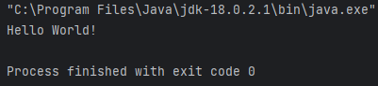

1. Displaying name and register number

**Code:**

import java.util.*;  
public class Main {  
 public static void main(String[] args) {  
 Scanner in = new Scanner(System.*in*);  
 System.*out*.printf("Enter your name: ");  
 String name = in.nextLine();  
 System.*out*.printf("\nEnter your reg num: ");  
 int regnum = in.nextInt();  
 System.*out*.printf("\nI am %s. My register number is %d\n", name, regnum);  
  
 in.close();  
 }  
}

**Output:**

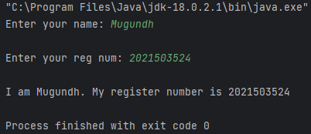

1. Displaying person details

**Code:**

import java.util.*;  
public class MyDetails{  
 public static void main(String[] args) {  
 Scanner in = new Scanner(System.*in*);  
 System.*out*.printf("Enter your name: ");  
 String name = in.nextLine();  
 System.*out*.printf("\nEnter your reg num: ");  
 long regnum = in.nextLong();  
 String dummy = in.nextLine(); // to clear the buffer  
 System.*out*.printf("\nEnter your address: ");  
 String addr = in.nextLine();  
 System.*out*.printf("\nEnter your phone number: ");  
 long ph_no = in.nextLong();  
 System.*out*.printf("\nI am %s. My register number is %d\nI am from %s. Contact me @ +91 %d", name, regnum, addr, ph_no);  
  
 in.close();  
 }  
}

**Output:**

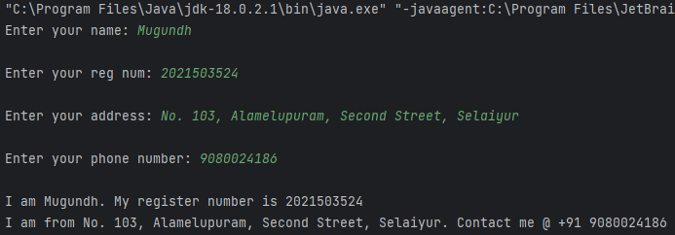

1. Add two numbers

**Code:**

import java.util.*;  
public class Add {  
 public static void main(String[] args){  
 Scanner in = new Scanner(System.*in*);  
 System.*out*.printf("Enter number 1: ");  
 int n1 = in.nextInt();  
 System.*out*.printf("\nEnter number 2: ");  
 int n2 = in.nextInt();  
 System.*out*.printf("\n%d + %d = %d", n1, n2, n1 + n2);  
  
 in.close();Add  
 }  
}

**Output:**

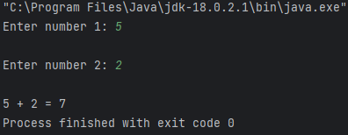

1. Implementing a basic Chat application

**Code:**

import java.util.*;  
public class MyChat {  
  
 public static void main(String[] args) {  
 Scanner in = new Scanner(System.*in*);  
 String s1 = "", s2 = "";  
 System.*out*.println("Start your conversation!");  
  
 while (!s1.*equals*("Bye") && !s2.*equals*("Bye")) {  
 System.*out*.printf("User 1: ");  
 s1 = in.nextLine();  
 if(Objects.*equals*(s1, "Bye"))  
 break;  
 System.*out*.printf("User 2: ");  
 s2 = in.nextLine();  
 }  
 System.*out*.println("Conversation Ended!");  
 in.close();  
 }  
}

**Output:**

