|  |
| --- |
| **Ex.No: 2 DATE: 09-08-23**  **BASICS OF JAVA PROGRAMMING** |

1. Write the program and compile the code @ command line to execute

**Code:**

public class helloWorld3524 {  
 public static void main(String[] args) { // The main method that executes when the program is run.  
 System.*out*.println("2021503524 - Mugundh J B - 09/09/23 - 1.30 pm");  
 System.*out*.print("\nHello, ");  
 System.*out*.print(args[0]); // args[0] => first argument given in command line  
 System.*out*.println("\nGood morning! ");  
 }  
}

**Output:**

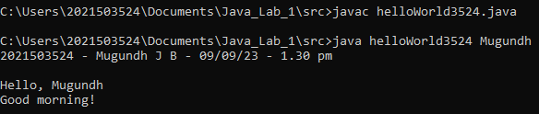

1. Write the program to print current date and time

**Code:**

import java.time.LocalDateTime;  
import java.time.format.DateTimeFormatter;  
  
public class dateTime3524 {  
 public static void main(String[] args) {  
 System.*out*.println("2021503524 - Mugundh J B \n");  
 LocalDateTime current = LocalDateTime.*now*(); //"LocalDateTime" is the class  
 //"now()" is a method, represent the current date and time  
 DateTimeFormatter dateformat = DateTimeFormatter.*ofPattern*("yyyy-MM-dd HH:mm:ss");  
 // ofPattern() is used to format the date in a particular pattern  
 String formattedTime = current.format(dateformat);  
 System.*out*.println("Current Date and Time is: " + formattedTime);  
 }  
}

**Output:**

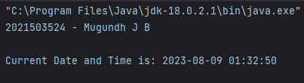

1. Find the maximum Compile time and Runtime error messages of simple one line output message.

* Delete any of the semicolons.



* Misspell the word public, static, void, main

public:



static:



void:



main:



* omit the word public, static, void, main, arg,

public:



static:



main:



arg:

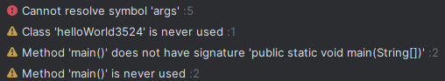

* Remove the quotation marks around string

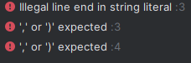

* Change the main method argument data type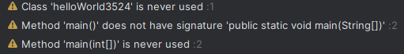
* Omit the argument



* Change the argument variable name

**No error**

* Remove the curly braces



* Same variable name redeclared



1. Copy the program and compile it. Find the error messages that the compiler finds out. Correct it out and repeat the process until the code runs

**Code:**

public class Bug3524 {  
 public static int main(int param) {

// Create a Scanner object to read input from the console.  
 string name Scanner in=new Scanner(System.*in*);  
 System.*out*.println("Hello. Please type your name:);  
 name = in.readline();  
 system.out.println("Hello"+name);  
 System.*out*.println ("Have a, nice day!)  
 }  
}

**Errors: (All errors summarized after making changes at each line)**

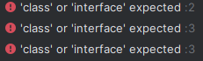

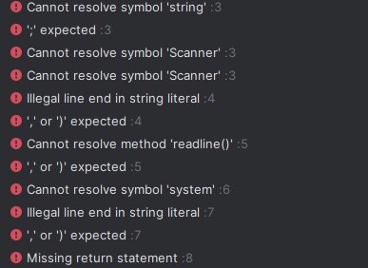









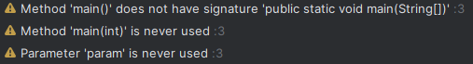

**Corrected code:**

import java.util.Scanner;

public class Bug3524 {

public static void main(String[] param) {

// Create a Scanner object to read input from the console.

Scanner in = new Scanner(System.in);

System.out.println("2021503524 - Mugundh J B - 09/09/23 - 2.20 pm");

// Ask the user to input their name.

System.out.println("Hello. Please type your name:");

String name = in.nextLine(); // Read the user's input as a String.

// Display a personalized greeting using the provided name.

System.out.println("Hello " + name);

// Display a farewell message to the user.

System.out.println("Have a nice day!");

}

}

**Output:**

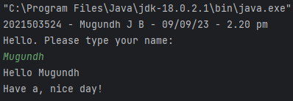

1. Write a program to learn the different Java data types and their correct / incorrect values.

**Code: (Added other data types in addition to given data types)**

public class dataType3524 {  
 // Integer data types  
 byte byteValue = 127; // Correct  
 // byte byteValue = 128; // Incorrect: Value exceeds the valid range (-128 to 127)  
 long longValue = 9223372036854775807; // Incorrect, require L at the end  
 long longValue = 9223372036854775807L; // Correct  
 long longValue = 9223372036854775807; // Incorrect, require L at the end  
 long longValue = 9223372036854775808L; // Incorrect: Value exceeds the valid range  
 // Floating-point data types  
 float floatValue = 3.14f; // Correct  
 float floatValue = 3.14; // Incorrect: Floating-point literals need 'f' or 'F' suffix  
 // Boolean data type  
 double doubleValue = 3.14159; // Correct  
 // Character data type  
 char charValue = 'A'; // Correct  
 char charValue = "A"; // Incorrect: Use single quotes for characters

// Boolean data type  
 boolean booleanValue = true; // Correct  
 boolean booleanValue = 0; // Incorrect: Use 'true' or 'false' for boolean values  
}

**Output:**

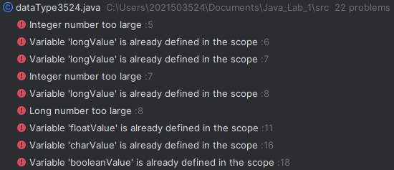

1. Write a program that takes as input Fahrenheit temperature. It converts the input temperature to Celsius and prints out the converted temperature as shown in the example. The formula for conversion between the two is: C=5/9(F−32), Where C is the temperature in Celsius and F is the temperature in Fahrenheit.

**Code:**

import java.util.Scanner;  
import java.text.DecimalFormat;  
public class Temp3524 {  
 public static void main(String[] args){

// Create a Scanner object to read input from the console.  
 Scanner in = new Scanner(System.*in*);

System.*out*.println("2021503524 - Mugundh J B - 09/09/23 - 2.40 pm");  
 System.*out*.print("Enter temperature in Fahrenheit: ");   
 float fah = in.nextFloat(); // Input the Fahrenheit from user  
 float c = (fah - 32) * 5 / 9;  
 DecimalFormat df = new DecimalFormat("0.00"); // Used to format the decimal value in form of required pattern  
 System.*out*.printf("Fahrenheit temperature " + df.format(fah) +  
 " is the same \nas " + df.format(c) + " degrees Celsius.");  
 }  
}

**Output:**

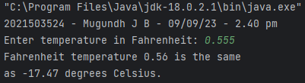

1. Write a program that accepts the three numbers u, a, and t as input. Here, u denotes the starting speed, a the acceleration, and t the amount of time. The program outputs the displacement covered (d) in time (t). The program prints the final velocity (v). v=u+at. Since velocity and acceleration are continuous vectors (in physics), u and a can have any real value. Only non-negative real values, or 0 t, can be assigned to time t, i.e., 0 ≤ t.

**Code:**

import java.util.Scanner;  
public class finalVelocity3524 {  
 public static void main(String[] args){  
 Scanner in = new Scanner(System.*in*);  
 System.*out*.println("2021503524 - Mugundh J B - 09/09/23 - 3 pm");  
 System.*out*.print("Enter the starting speed: ");  
 float u = in.nextFloat(); // Read starting speed from user  
 System.*out*.print("Enter the acceleration: ");  
 float a = in.nextFloat(); // Read acceleration from user  
 System.*out*.print("Enter the time: ");  
 float t = in.nextFloat(); // Read time from user  
  
 float d = (float) (u * t + (0.5 * a * t * t)); // Formula to calc displacement  
 System.*out*.printf("The displacement is %.2f", d);  
 float v = u + a * t; // Formula to calc final velocity  
 System.*out*.printf("\nThe final velocity is %.2f", v);  
 }  
}

**Output:**

