|  |
| --- |
| **Ex.No: 3 DATE: 09-08-23**  **CONTROL STRUCTURES** |

1. Write a program to determine the custom grade of the marks given. If the marks go beyond 100 or lower than 0 then state the input is invalid. 90 to 100 : Grade O 80 TO 89 : Grade A+ 70 TO 79 : Grade A 60 TO 69 : Grade B+ 50 to 59 : Grade B 0 TO 49 : Grade U Hint: use If statement

Code:

import java.time.LocalDate;  
import java.time.LocalTime;  
import java.util.*;  
  
public class studentGrade3524 {  
 public static void main(String[] args) {  
 System.*out*.println("2021503524 - Mugundh J B");  
 System.*out*.println("Date: " + LocalDate.*now*() + " Time: " + LocalTime.*now*());  
 // Create a Scanner to read user input  
 Scanner in = new Scanner(System.*in*);  
 // Prompt the user for the number of subjects  
 System.*out*.print("Enter no of subjects: ");  
 int n = in.nextInt();  
 // Consume newline character left in buffer  
 String buff = in.nextLine();  
 // Initialize an array to store marks for each subject  
 int[] arr = new int[n];  
 // Prompt the user to enter marks for each subject and validate input  
 System.*out*.println("Enter the marks: ");  
 for (int i = 0; i < n; i++) {  
 arr[i] = in.nextInt();  
 if (arr[i] < 0 || arr[i] > 100) {  
 System.*out*.println("Invalid input! Enter again: ");  
 arr[i] = in.nextInt();  
 }  
 }  
 // Determine the grade for each subject based on marks and display it  
 for (int i = 0; i < n; i++) {  
 if (arr[i] >= 90 && arr[i] <= 100)  
 System.*out*.printf("Grade of subject %d = %s\n", i + 1, "O");  
 else if (arr[i] >= 80 && arr[i] <= 89)  
 System.*out*.printf("Grade of subject %d = %s\n", i + 1, "A+");  
 else if (arr[i] >= 70 && arr[i] <= 79)  
 System.*out*.printf("Grade of subject %d = %s\n", i + 1, "A");  
 else if (arr[i] >= 60 && arr[i] <= 69)  
 System.*out*.printf("Grade of subject %d = %s\n", i + 1, "B+");  
 else if (arr[i] >= 50 && arr[i] <= 59)  
 System.*out*.printf("Grade of subject %d = %s\n", i + 1, "B");  
 else  
 System.*out*.printf("Grade of subject %d = %s", i + 1, "U");  
 }  
 }  
}

Output:

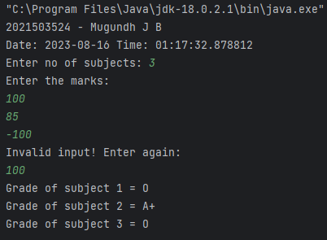

1. Write a program that simulates the coin toss as head or tail. Use Random number 0 0r 1 to determine the system input. The program should print the result as head if it one and tail if it is zero. Read the input from the user as a character ‘h’ or ‘t’ or ‘H’ or ‘T’ and tell the user whether he or she has predicted the coin toss correctly . Declare the result as Won the toss! Or lose! (Hint: Use Random class to get the random input 0 to 1).

Code:

import java.time.LocalDate;  
import java.time.LocalTime;  
import java.util.*;  
  
public class headsTails3524 {  
 public static void main(String[] args) {  
 System.*out*.println("2021503524 - Mugundh J B");  
  
 System.*out*.println("Date: " + LocalDate.*now*() + " Time: " + LocalTime.*now*());  
  
 // Create a random number generator  
 Random rand = new Random();  
  
 // Generate a random number (0 or 1)  
 int num = rand.nextInt(2);  
  
 // Create a Scanner to read user input  
 Scanner in = new Scanner(System.*in*);  
  
 // Prompt the user for their choice  
 System.*out*.print("Enter your choice (h / H / t / T): ");  
 char choice = in.next().charAt(0);  
  
 // Validate user's choice  
 while (choice != 'h' && choice != 'H' && choice != 't' && choice != 'T') {  
 System.*out*.printf("Invalid choice. Enter your choice (h / H / t / T): ");  
 choice = in.next().charAt(0);  
 }  
  
 // Display the random value generated  
 System.*out*.printf("Random value = %d\n", num);  
  
 // Check if the user won or lost based on their choice and the random value  
 if (((choice == 'h' || choice == 'H') && num == 1) || ((choice == 't' || choice == 'T') && num == 0))  
 System.*out*.print("You won!");  
 else  
 System.*out*.print("You lose!");  
  
 }  
}

Output:

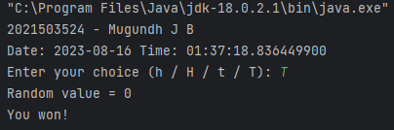

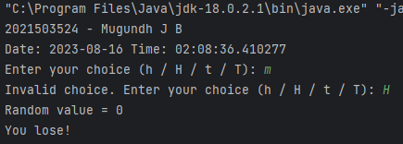

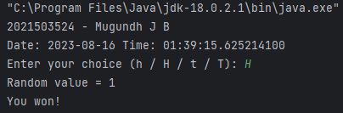

1. Write a program to output the number of days of the month(1 to 12) in the given year. The value of the month February is 28 or 20 based on the leap year. Give warning for invalid input that is of digit less than 4 or greater than 5. Hint: Use Switch statement.

Code:

import java.time.LocalDate;  
import java.time.LocalTime;  
import java.util.Scanner;  
  
public class monthDays3524 {  
 public static void main(String[] args) {  
 System.*out*.println("2021503524 - Mugundh J B");  
 System.*out*.println("Date: " + LocalDate.*now*() + " Time: " + LocalTime.*now*());  
 Scanner scanner = new Scanner(System.*in*);  
  
 System.*out*.print("Enter the year: ");  
 int year = scanner.nextInt(); // Getting the year as input  
  
 while (year < 1000 || year > 9999) { // Checking if the entered year is valid  
 System.*out*.printf("Invalid input for the year!\nEnter the year again: ");  
 year = scanner.nextInt(); // Getting input again if input is invalid  
 }  
 System.*out*.print("Enter the month (1 to 12): ");  
 int month = scanner.nextInt(); // Getting the month as input  
  
 int daysInMonth = 0; // Variable to store no of days in that month  
 switch(month){  
 case 1: case 3: case 5: case 7: case 8: case 10: case 12:  
 daysInMonth = 31;  
 break;  
 case 4: case 6: case 9: case 11:  
 daysInMonth = 30;  
 break;  
 case 2:  
 if ((year % 4 == 0 && year % 100 != 0) || (year % 400 == 0)) {  
 daysInMonth = 29; // Leap year  
 } else {  
 daysInMonth = 28; // Non-leap year  
 }  
 break;  
 default:  
 System.*out*.println("Invalid month!");  
 return;  
 }  
 System.*out*.printf("Number of days in %d th month: %d", month, daysInMonth);  
 }  
}

Output:

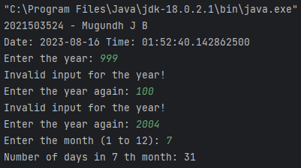

1. Write a program that verbalize the user inputs between 1 and 9999 number. For example

Input number : 852 => Output: Eight hundred and fifty two.

Code:

import java.time.LocalDate;  
import java.time.LocalTime;  
import java.util.Scanner;  
public class Verbalize3524{  
 // Arrays to store the verbal representations of units and tens  
 private static final String[] *units* = {  
 "", "One", "Two", "Three", "Four", "Five", "Six", "Seven", "Eight", "Nine", "Ten",  
 "Eleven", "Twelve", "Thirteen", "Fourteen", "Fifteen", "Sixteen", "Seventeen", "Eighteen", "Nineteen"  
 };  
 private static final String[] *tens* = {  
 "", "", "Twenty", "Thirty", "Forty", "Fifty", "Sixty", "Seventy", "Eighty", "Ninety"  
 };  
 public static void main(String[] args) {  
 System.*out*.println("2021503524 - Mugundh J B");  
 System.*out*.println("Date: " + LocalDate.*now*() + " Time: " + LocalTime.*now*());  
 Scanner scanner = new Scanner(System.*in*);  
 System.*out*.print("Enter a number between 1 and 9999: ");  
 int number = scanner.nextInt();  
 // Check for invalid input  
 while (number < 1 || number > 9999) {  
 System.*out*.print("Invalid input. Please enter a number between 1 and 9999: ");  
 number = scanner.nextInt();  
 }  
 // Convert the number to its verbal representation  
 String verbalized = *convertToWords*(number);  
 System.*out*.printf("Verbalized form:\n" + verbalized);  
 }  
 // Convert a number to its verbal representation  
 public static String convertToWords(int number) {  
 if (number < 20) {  
 return *units*[number]; // Directly use the units array  
 } else if (number < 100) {  
 return *tens*[number / 10] + " " + *units*[number % 10]; // Combine tens and units  
 } else if (number < 1000) {  
 return *units*[number / 100] + " Hundred and " + *convertToWords*(number % 100); // Handling hundreds by recursion  
 } else {  
 return *units*[number / 1000] + " Thousand and " + *convertToWords*(number % 1000); // Handling thousands by recursion  
 }  
 }  
}

Output:

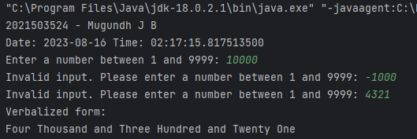

1. Write a program to create 24-hour digital watch. Get the input from the user for the day(Mon, Tue, Wed, Thu, Fri, Sat, Sun) , hour (24-hour) , minute and seconds . The input of the user is valid then the digital clock should advance the input by one second and display the new day, hour, minute and second. Sample input: Input day : Mon Input hour : 23 Input minute : 59 Input second : 59 Sample output Tue 0 0 0 Hint: Use for statement

Code:

import java.time.LocalDate;  
import java.time.LocalTime;  
import java.util.Scanner;  
public class digitalWatch3524 {  
 public static void main(String[] args) {  
 System.*out*.println("2021503524 - Mugundh J B");  
 System.*out*.println("Date: " + LocalDate.*now*() + " Time: " + LocalTime.*now*());  
 Scanner scanner = new Scanner(System.*in*);  
 // Prompt the user for input  
 System.*out*.print("Input day (Mon, Tue, Wed, Thu, Fri, Sat, Sun): ");  
 String day = scanner.nextLine();  
 System.*out*.print("Input hour (24-hour): ");  
 int hour = scanner.nextInt();  
 System.*out*.print("Input minute: ");  
 int minute = scanner.nextInt();  
 System.*out*.print("Input second: ");  
 int second = scanner.nextInt();  
 // Validating day input  
 if (!*isValidDay*(day)) {  
 System.*out*.println("Invalid day input!");  
 } else if (hour < 0 || hour > 23 || minute < 0 || minute > 59 || second < 0 || second > 59) {  
 System.*out*.println("Invalid time input!");  
 } else {  
 // Advancing time by one second  
 second++;  
 if (second == 60) {  
 second = 0;  
 minute++;  
 if (minute == 60) {  
 minute = 0;  
 hour++;  
 if (hour == 24) {  
 hour = 0;  
 day = *getNextDay*(day);  
 }  
 }  
 }  
 // Displaying the new time  
 System.*out*.println("New time: " + day + " " + hour + " " + minute + " " + second);  
 }  
 }  
 // Checking if the given day is valid  
 public static boolean isValidDay(String day) {  
 return day.equals("Mon") || day.equals("Tue") || day.equals("Wed") ||  
 day.equals("Thu") || day.equals("Fri") || day.equals("Sat") || day.equals("Sun");  
 }  
 // Getting the next day  
 public static String getNextDay(String day) {  
 if (day.equals("Sun")) return "Mon";  
 if (day.equals("Mon")) return "Tue";  
 if (day.equals("Tue")) return "Wed";  
 if (day.equals("Wed")) return "Thu";  
 if (day.equals("Thu")) return "Fri";  
 if (day.equals("Fri")) return "Sat";  
 if (day.equals("Sat")) return "Sun";  
 return "";  
 }  
}

Output:

