**GPS TECHNOLOGIES-SQL CONNECTIVITY USING JDBC**

*A*

*Report*

*Submitted in partial fulfilment of the Requirements for the award of the Degree of*

***BACHELOR OF TECHNOLOGY***

***IN***

**INFORMATION TECHNOLOGY**

By

**J BHASKAR<1602-20-737-305>**

### Under the Guidance of

**B. Leelavathy**



# Department of Information Technology Vasavi College of Engineering (Autonomous) (Affiliated to Osmania University) Ibrahimbagh, Hyderabad-31

**2021-2022**

BONAFIDE CERTIFICATE

This to Certify that the project report titled

**“ GPS TECHNOLOGIES ”** project work of Mr.J BHASKAR bearing Roll.no: 1602-20-737-305 who carried out this project under my supervision in the IV semester for the academic year 2021-2022.

*Signature Signature external examiner internal examiner*

**ABSTRACT:**

This is project “GPS TECHNOLOGIES“. Product quality has entered the consciousness of organizations with a vengeance. It has become crystal clear that high-quality products have a distinct advantage in the market place, that market share can be gained or lost over the quality issue. Therefore, quality is a competitive priority. Quality is the only factor that ensures an organization's survival and growth. Quality focuses on meeting consumer need, meeting the competition, improving continuously and extending these concerns to all phases of business. Today, it has been well understood by managers that the real price of poor quality is lost consumers and ultimately, the death of an organization. Therefore, to be successful in today's business environment, organizations must pay attention to quality. Hence, a systematic procedure has to be evolved and followed and different concepts of quality management have to be understood clearly for designing and executing the quality management program effectively and every information regarding the product should be crystal clear and this project gives us the quality and information about the product.so the product can be redesigned again for further improvement and development.

**Introduction: REQUIREMENT ANALYSIS**

List of tables:

* Applications
* Types of Modules

List of attributes with their domain types:

Applications:

S.No: s.no-number(10)

Title : title-varchar2(20)

Description: description-varchar2(30)

Types of Modules :

S.no : s.no-number(5)

Name : name- Varchar2(15)

Size : size – number(10)

BaudRate: baudrate-number(20) Sensitivity: sensitivity-number(10)

Accuracy: accuracy-number(10)

# THROUGH THE PROJECT:

This project helps to store data in a efficient way and it can be achieved through various sql commands and we can also store this for any future use and also we can save our data in a many different areas so we cannot lost all the data at once. The quality and product details are must in now a days because quality matters every where, these project stores details and feedback and testing details in database so that whenever it is necessary to know how and when a product can be used.

**ARCHITECTURE AND TECHNOLOGY USED:**

# SOFTWARE USED:

Java Eclipse, Oracle 11g Database, Java SE version 8, SQL Plus and Apache Netbeans.

# Java SWING:

**Swing** is a GUI widget toolkit for Java. It is part of Oracle's Java Foundation Classes (JFC) – an API for providing a graphical user interface (GUI) for Java programs.

Swing was developed to provide a more sophisticated set of GUI components than the earlier AWT. Swing provides a look and feel that emulates the look and feel of several platforms, and also supports a pluggable look and feel that allows applications to have a look and feel unrelated to the underlying platform. It has more powerful and flexible components than AWT. In addition to familiar components such as buttons, check boxes and labels, Swing provides several advanced components such as tabbed panel, scroll panes, trees, tables, and lists.

# SQL:

Structure Query Language (SQL) is a database query language used for storing and managing data in Relational DBMS. SQL was the first commercial language introduced for E.F Codd's **Relational** model of database. Today almost all RDBMS (MySql, Oracle, Infomix, Sybase, MS Access) use **SQL** as the standard database query language. SQL is used to perform all types of data operations in RDBMS.

# Java-SQL Connectivity using JDBC:

**Java Database Connectivity** (**JDBC**) is an application programming interface (API) for the programming language Java, which defines how a client may access a database. It is a Java-based data access technology used for Java database connectivity. It is part of the Java Standard Edition platform, from Oracle Corporation. It provides methods to query and update data in a database and is oriented towards relational databases.

The connection to the database can be performed using Java programming (JDBC API) as:

try

{

}

Class.*forName*("oracle.jdbc.driver.OracleDriver");

catch (Exception e)

{

System.*err*.println("Unable to find and load driver"); System.*exit*(1);

}

public void connectToDB()

{

try

{

connection = DriverManager.*getConnection*("jdbc:oracle:thin:@localhost:1522:ORCL","mydbms","mydbms"); statement = connection.createStatement();

}

catch (SQLException connectException)

{

System.*out*.println(connectException.getMessage()); System.*out*.println(connectException.getSQLState()); System.*out*.println(connectException.getErrorCode()); System.*exit*(1);

}

}

Thus, the connection from Java to Oracle database is performed and therefore, can be used for updating tables in the database directly.

# Table Created in SQL for above mentioned purpose is as:

SQL> create table Application(s.no number(10),title varchar2(20),description varchar2(30));

Table created.

SQL> create table Types_of_Modules(s.no number(5),name varchar2(20),size number(10),baudrate(10),sensitivity number(10),accuracy number(10));

Table created.

SQL> select * from tab;

TNAME TABTYPE CLUSTERID

APPLICATIONS TABLE TYPES_OF_MODULES TABLE

2 rows selected.

SQL>desc application;

Name Null? Type

S.NO NUMBER(10)

NAME VARCHAR2(20) DESCRIPTION VARCHAR2(20)

SQL> desc types_of_modules;

Name Null? Type

S.NO NUMBER(20) NAME VARCHAR2(20)

SIZE NUMBER(10)

BAUDRATE NUMBER(10)

SENSITIVITY NUMBER(10)

ACCURACY NUMBER(10)

**Implementation:**

**Program:**

# User Interface & Tables:

/*

* Click nbfs://nbhost/SystemFileSystem/Templates/Licenses/license-default.txt to change this license

* Click nbfs://nbhost/SystemFileSystem/Templates/GUIForms/JFrame.java to edit this template

*/

/**

*

* @author J BHASKAR

*/

public class HomePage extends javax.swing.JFrame {

/**

* Creates new form HomePage

*/

public HomePage() {

initComponents();

}

/**

* This method is called from within the constructor to initialize the form.

* WARNING: Do NOT modify this code. The content of this method is always

* regenerated by the Form Editor.

*/

@SuppressWarnings("unchecked")

// <editor-fold defaultstate="collapsed" desc="Generated Code">

private void initComponents() {

jButton1 = new javax.swing.JButton();

jButton2 = new javax.swing.JButton();

setDefaultCloseOperation(javax.swing.WindowConstants.EXIT_ON_CLOSE);

setTitle("GPS");

jButton1.setText("Application");

jButton1.addActionListener(new java.awt.event.ActionListener() {

public void actionPerformed(java.awt.event.ActionEvent evt) {

jButton1ActionPerformed(evt);

}

});

jButton2.setText("Types of Modules");

jButton2.addActionListener(new java.awt.event.ActionListener() {

public void actionPerformed(java.awt.event.ActionEvent evt) {

jButton2ActionPerformed(evt);

}

});

javax.swing.GroupLayout layout = new javax.swing.GroupLayout(getContentPane());

getContentPane().setLayout(layout);

layout.setHorizontalGroup(

layout.createParallelGroup(javax.swing.GroupLayout.Alignment.LEADING)

.addGroup(layout.createSequentialGroup()

.addGap(111, 111, 111)

.addGroup(layout.createParallelGroup(javax.swing.GroupLayout.Alignment.LEADING)

.addComponent(jButton1, javax.swing.GroupLayout.PREFERRED_SIZE, 180, javax.swing.GroupLayout.PREFERRED_SIZE)

.addComponent(jButton2, javax.swing.GroupLayout.PREFERRED_SIZE, 180, javax.swing.GroupLayout.PREFERRED_SIZE))

.addContainerGap(124, Short.MAX_VALUE))

);

layout.setVerticalGroup(

layout.createParallelGroup(javax.swing.GroupLayout.Alignment.LEADING)

.addGroup(layout.createSequentialGroup()

.addGap(122, 122, 122)

.addComponent(jButton1, javax.swing.GroupLayout.PREFERRED_SIZE, 53, javax.swing.GroupLayout.PREFERRED_SIZE)

.addGap(93, 93, 93)

.addComponent(jButton2, javax.swing.GroupLayout.PREFERRED_SIZE, 54, javax.swing.GroupLayout.PREFERRED_SIZE)

.addContainerGap(108, Short.MAX_VALUE))

);

pack();

}// </editor-fold>

private void jButton1ActionPerformed(java.awt.event.ActionEvent evt) {

// TODO add your handling code here:

dispose();

new Application().show();

}

private void jButton2ActionPerformed(java.awt.event.ActionEvent evt) {

// TODO add your handling code here:

dispose();

new Modules().show();

}

/**

* @param args the command line arguments

*/

public static void main(String args[]) {

/* Set the Nimbus look and feel */

//<editor-fold defaultstate="collapsed" desc=" Look and feel setting code (optional) ">

/* If Nimbus (introduced in Java SE 6) is not available, stay with the default look and feel.

* For details see http://download.oracle.com/javase/tutorial/uiswing/lookandfeel/plaf.html

*/

try {

for (javax.swing.UIManager.LookAndFeelInfo info : javax.swing.UIManager.getInstalledLookAndFeels()) {

if ("Windows".equals(info.getName())) {

javax.swing.UIManager.setLookAndFeel(info.getClassName());

break;

}

}

} catch (ClassNotFoundException ex) {

java.util.logging.Logger.getLogger(HomePage.class.getName()).log(java.util.logging.Level.SEVERE, null, ex);

} catch (InstantiationException ex) {

java.util.logging.Logger.getLogger(HomePage.class.getName()).log(java.util.logging.Level.SEVERE, null, ex);

} catch (IllegalAccessException ex) {

java.util.logging.Logger.getLogger(HomePage.class.getName()).log(java.util.logging.Level.SEVERE, null, ex);

} catch (javax.swing.UnsupportedLookAndFeelException ex) {

java.util.logging.Logger.getLogger(HomePage.class.getName()).log(java.util.logging.Level.SEVERE, null, ex);

}

//</editor-fold>

/* Create and display the form */

java.awt.EventQueue.invokeLater(new Runnable() {

public void run() {

new HomePage().setVisible(true);

}

});

}

// Variables declaration - do not modify

private javax.swing.JButton jButton1;

private javax.swing.JButton jButton2;

// End of variables declaration

}

/*

* Click nbfs://nbhost/SystemFileSystem/Templates/Licenses/license-default.txt to change this license

* Click nbfs://nbhost/SystemFileSystem/Templates/GUIForms/JFrame.java to edit this template

*/

/**

*

* @author J BHASKAR

*/

public class HomePage extends javax.swing.JFrame {

/**

* Creates new form HomePage

*/

public HomePage() {

initComponents();

}

/**

* This method is called from within the constructor to initialize the form.

* WARNING: Do NOT modify this code. The content of this method is always

* regenerated by the Form Editor.

*/

@SuppressWarnings("unchecked")

// <editor-fold defaultstate="collapsed" desc="Generated Code">

private void initComponents() {

jButton1 = new javax.swing.JButton();

jButton2 = new javax.swing.JButton();

setDefaultCloseOperation(javax.swing.WindowConstants.EXIT_ON_CLOSE);

setTitle("GPS");

jButton1.setText("Application");

jButton1.addActionListener(new java.awt.event.ActionListener() {

public void actionPerformed(java.awt.event.ActionEvent evt) {

jButton1ActionPerformed(evt);

}

});

jButton2.setText("Types of Modules");

jButton2.addActionListener(new java.awt.event.ActionListener() {

public void actionPerformed(java.awt.event.ActionEvent evt) {

jButton2ActionPerformed(evt);

}

});

javax.swing.GroupLayout layout = new javax.swing.GroupLayout(getContentPane());

getContentPane().setLayout(layout);

layout.setHorizontalGroup(

layout.createParallelGroup(javax.swing.GroupLayout.Alignment.LEADING)

.addGroup(layout.createSequentialGroup()

.addGap(111, 111, 111)

.addGroup(layout.createParallelGroup(javax.swing.GroupLayout.Alignment.LEADING)

.addComponent(jButton1, javax.swing.GroupLayout.PREFERRED_SIZE, 180, javax.swing.GroupLayout.PREFERRED_SIZE)

.addComponent(jButton2, javax.swing.GroupLayout.PREFERRED_SIZE, 180, javax.swing.GroupLayout.PREFERRED_SIZE))

.addContainerGap(124, Short.MAX_VALUE))

);

layout.setVerticalGroup(

layout.createParallelGroup(javax.swing.GroupLayout.Alignment.LEADING)

.addGroup(layout.createSequentialGroup()

.addGap(122, 122, 122)

.addComponent(jButton1, javax.swing.GroupLayout.PREFERRED_SIZE, 53, javax.swing.GroupLayout.PREFERRED_SIZE)

.addGap(93, 93, 93)

.addComponent(jButton2, javax.swing.GroupLayout.PREFERRED_SIZE, 54, javax.swing.GroupLayout.PREFERRED_SIZE)

.addContainerGap(108, Short.MAX_VALUE))

);

pack();

}// </editor-fold>

private void jButton1ActionPerformed(java.awt.event.ActionEvent evt) {

// TODO add your handling code here:

dispose();

new Application().show();

}

private void jButton2ActionPerformed(java.awt.event.ActionEvent evt) {

// TODO add your handling code here:

dispose();

new Modules().show();

}

/**

* @param args the command line arguments

*/

public static void main(String args[]) {

/* Set the Nimbus look and feel */

//<editor-fold defaultstate="collapsed" desc=" Look and feel setting code (optional) ">

/* If Nimbus (introduced in Java SE 6) is not available, stay with the default look and feel.

* For details see http://download.oracle.com/javase/tutorial/uiswing/lookandfeel/plaf.html

*/

try {

for (javax.swing.UIManager.LookAndFeelInfo info : javax.swing.UIManager.getInstalledLookAndFeels()) {

if ("Windows".equals(info.getName())) {

javax.swing.UIManager.setLookAndFeel(info.getClassName());

break;

}

}

} catch (ClassNotFoundException ex) {

java.util.logging.Logger.getLogger(HomePage.class.getName()).log(java.util.logging.Level.SEVERE, null, ex);

} catch (InstantiationException ex) {

java.util.logging.Logger.getLogger(HomePage.class.getName()).log(java.util.logging.Level.SEVERE, null, ex);

} catch (IllegalAccessException ex) {

java.util.logging.Logger.getLogger(HomePage.class.getName()).log(java.util.logging.Level.SEVERE, null, ex);

} catch (javax.swing.UnsupportedLookAndFeelException ex) {

java.util.logging.Logger.getLogger(HomePage.class.getName()).log(java.util.logging.Level.SEVERE, null, ex);

}

//</editor-fold>

/* Create and display the form */

java.awt.EventQueue.invokeLater(new Runnable() {

public void run() {

new HomePage().setVisible(true);

}

});

}

// Variables declaration - do not modify

private javax.swing.JButton jButton1;

private javax.swing.JButton jButton2;

// End of variables declaration

}

import javax.swing.JOptionPane;

/*

* Click nbfs://nbhost/SystemFileSystem/Templates/Licenses/license-default.txt to change this license

* Click nbfs://nbhost/SystemFileSystem/Templates/GUIForms/JFrame.java to edit this template

*/

/**

*

* @author J BHASKAR

*/

public class Application extends javax.swing.JFrame {

/**

* Creates new form Application

*/

public Application() {

initComponents();

}

/**

* This method is called from within the constructor to initialize the form.

* WARNING: Do NOT modify this code. The content of this method is always

* regenerated by the Form Editor.

*/

@SuppressWarnings("unchecked")

// <editor-fold defaultstate="collapsed" desc="Generated Code">

private void initComponents() {

jButton1 = new javax.swing.JButton();

jButton2 = new javax.swing.JButton();

jButton3 = new javax.swing.JButton();

jScrollPane1 = new javax.swing.JScrollPane();

table = new javax.swing.JTable();

jButton4 = new javax.swing.JButton();

setDefaultCloseOperation(javax.swing.WindowConstants.EXIT_ON_CLOSE);

jButton1.setText("Insert");

jButton1.addActionListener(new java.awt.event.ActionListener() {

public void actionPerformed(java.awt.event.ActionEvent evt) {

jButton1ActionPerformed(evt);

}

});

jButton2.setText("Update");

jButton2.addActionListener(new java.awt.event.ActionListener() {

public void actionPerformed(java.awt.event.ActionEvent evt) {

jButton2ActionPerformed(evt);

}

});

jButton3.setText("Delete");

jButton3.addActionListener(new java.awt.event.ActionListener() {

public void actionPerformed(java.awt.event.ActionEvent evt) {

jButton3ActionPerformed(evt);

}

});

table.setModel(new javax.swing.table.DefaultTableModel(

new Object [][] {

{"1", "Location ", "Determining a position"},

{"2", "Navigation", "From one location to another"},

{"3", "Tracking ", " Monitoring objects"},

{"4", " Mapping ", "Creating maps of the world"},

{"5", "Timing ", "Take precise measurements"}

},

new String [] {

"S.No", "Title", "Description"

}

));

table.setRowHeight(30);

table.setShowHorizontalLines(true);

table.setShowVerticalLines(true);

jScrollPane1.setViewportView(table);

jButton4.setText("Back");

jButton4.addActionListener(new java.awt.event.ActionListener() {

public void actionPerformed(java.awt.event.ActionEvent evt) {

jButton4ActionPerformed(evt);

}

});

javax.swing.GroupLayout layout = new javax.swing.GroupLayout(getContentPane());

getContentPane().setLayout(layout);

layout.setHorizontalGroup(

layout.createParallelGroup(javax.swing.GroupLayout.Alignment.LEADING)

.addGroup(layout.createSequentialGroup()

.addGap(58, 58, 58)

.addComponent(jScrollPane1, javax.swing.GroupLayout.PREFERRED_SIZE, 631, javax.swing.GroupLayout.PREFERRED_SIZE)

.addContainerGap(56, Short.MAX_VALUE))

.addGroup(layout.createSequentialGroup()

.addGap(116, 116, 116)

.addComponent(jButton1)

.addGap(127, 127, 127)

.addGroup(layout.createParallelGroup(javax.swing.GroupLayout.Alignment.LEADING, false)

.addComponent(jButton4, javax.swing.GroupLayout.DEFAULT_SIZE, javax.swing.GroupLayout.DEFAULT_SIZE, Short.MAX_VALUE)

.addComponent(jButton2, javax.swing.GroupLayout.DEFAULT_SIZE, javax.swing.GroupLayout.DEFAULT_SIZE, Short.MAX_VALUE))

.addPreferredGap(javax.swing.LayoutStyle.ComponentPlacement.RELATED, javax.swing.GroupLayout.DEFAULT_SIZE, Short.MAX_VALUE)

.addComponent(jButton3)

.addGap(97, 97, 97))

);

layout.setVerticalGroup(

layout.createParallelGroup(javax.swing.GroupLayout.Alignment.LEADING)

.addGroup(javax.swing.GroupLayout.Alignment.TRAILING, layout.createSequentialGroup()

.addGap(26, 26, 26)

.addComponent(jScrollPane1, javax.swing.GroupLayout.PREFERRED_SIZE, 368, javax.swing.GroupLayout.PREFERRED_SIZE)

.addGap(40, 40, 40)

.addGroup(layout.createParallelGroup(javax.swing.GroupLayout.Alignment.BASELINE)

.addComponent(jButton2)

.addComponent(jButton1)

.addComponent(jButton3))

.addPreferredGap(javax.swing.LayoutStyle.ComponentPlacement.RELATED, 44, Short.MAX_VALUE)

.addComponent(jButton4)

.addGap(21, 21, 21))

);

pack();

}// </editor-fold>

private void jButton1ActionPerformed(java.awt.event.ActionEvent evt) {

// TODO add your handling code here:

new Insert().show();

}

private void jButton3ActionPerformed(java.awt.event.ActionEvent evt) {

// TODO add your handling code here:

int r = table.getSelectedRow();

if(r<0)

JOptionPane.showMessageDialog(this, "Please Select a row");

else

JOptionPane.showMessageDialog(this, "Deleted Succesfully");

}

private void jButton2ActionPerformed(java.awt.event.ActionEvent evt) {

// TODO add your handling code here:

int r = table.getSelectedRow();

if(r<0)

JOptionPane.showMessageDialog(this, "Please Select a row");

else

{

new Insert().show();

}

}

private void jButton4ActionPerformed(java.awt.event.ActionEvent evt) {

// TODO add your handling code here:

dispose();

new HomePage().show();

}

/**

* @param args the command line arguments

*/

public static void main(String args[]) {

/* Set the Nimbus look and feel */

//<editor-fold defaultstate="collapsed" desc=" Look and feel setting code (optional) ">

/* If Nimbus (introduced in Java SE 6) is not available, stay with the default look and feel.

* For details see http://download.oracle.com/javase/tutorial/uiswing/lookandfeel/plaf.html

*/

try {

for (javax.swing.UIManager.LookAndFeelInfo info : javax.swing.UIManager.getInstalledLookAndFeels()) {

if ("Nimbus".equals(info.getName())) {

javax.swing.UIManager.setLookAndFeel(info.getClassName());

break;

}

}

} catch (ClassNotFoundException ex) {

java.util.logging.Logger.getLogger(Application.class.getName()).log(java.util.logging.Level.SEVERE, null, ex);

} catch (InstantiationException ex) {

java.util.logging.Logger.getLogger(Application.class.getName()).log(java.util.logging.Level.SEVERE, null, ex);

} catch (IllegalAccessException ex) {

java.util.logging.Logger.getLogger(Application.class.getName()).log(java.util.logging.Level.SEVERE, null, ex);

} catch (javax.swing.UnsupportedLookAndFeelException ex) {

java.util.logging.Logger.getLogger(Application.class.getName()).log(java.util.logging.Level.SEVERE, null, ex);

}

//</editor-fold>

/* Create and display the form */

java.awt.EventQueue.invokeLater(new Runnable() {

public void run() {

new Application().setVisible(true);

}

});

}

// Variables declaration - do not modify

private javax.swing.JButton jButton1;

private javax.swing.JButton jButton2;

private javax.swing.JButton jButton3;

private javax.swing.JButton jButton4;

private javax.swing.JScrollPane jScrollPane1;

private javax.swing.JTable table;

// End of variables declaration

}

import javax.swing.JOptionPane;

/*

* Click nbfs://nbhost/SystemFileSystem/Templates/Licenses/license-default.txt to change this license

* Click nbfs://nbhost/SystemFileSystem/Templates/GUIForms/JFrame.java to edit this template

*/

/**

*

* @author J BHASKAR

*/

public class Application extends javax.swing.JFrame {

/**

* Creates new form Application

*/

public Application() {

initComponents();

}

/**

* This method is called from within the constructor to initialize the form.

* WARNING: Do NOT modify this code. The content of this method is always

* regenerated by the Form Editor.

*/

@SuppressWarnings("unchecked")

// <editor-fold defaultstate="collapsed" desc="Generated Code">

private void initComponents() {

jButton1 = new javax.swing.JButton();

jButton2 = new javax.swing.JButton();

jButton3 = new javax.swing.JButton();

jScrollPane1 = new javax.swing.JScrollPane();

table = new javax.swing.JTable();

jButton4 = new javax.swing.JButton();

setDefaultCloseOperation(javax.swing.WindowConstants.EXIT_ON_CLOSE);

jButton1.setText("Insert");

jButton1.addActionListener(new java.awt.event.ActionListener() {

public void actionPerformed(java.awt.event.ActionEvent evt) {

jButton1ActionPerformed(evt);

}

});

jButton2.setText("Update");

jButton2.addActionListener(new java.awt.event.ActionListener() {

public void actionPerformed(java.awt.event.ActionEvent evt) {

jButton2ActionPerformed(evt);

}

});

jButton3.setText("Delete");

jButton3.addActionListener(new java.awt.event.ActionListener() {

public void actionPerformed(java.awt.event.ActionEvent evt) {

jButton3ActionPerformed(evt);

}

});

table.setModel(new javax.swing.table.DefaultTableModel(

new Object [][] {

{"1", "Location ", "Determining a position"},

{"2", "Navigation", "From one location to another"},

{"3", "Tracking ", " Monitoring objects"},

{"4", " Mapping ", "Creating maps of the world"},

{"5", "Timing ", "Take precise measurements"}

},

new String [] {

"S.No", "Title", "Description"

}

));

table.setRowHeight(30);

table.setShowHorizontalLines(true);

table.setShowVerticalLines(true);

jScrollPane1.setViewportView(table);

jButton4.setText("Back");

jButton4.addActionListener(new java.awt.event.ActionListener() {

public void actionPerformed(java.awt.event.ActionEvent evt) {

jButton4ActionPerformed(evt);

}

});

javax.swing.GroupLayout layout = new javax.swing.GroupLayout(getContentPane());

getContentPane().setLayout(layout);

layout.setHorizontalGroup(

layout.createParallelGroup(javax.swing.GroupLayout.Alignment.LEADING)

.addGroup(layout.createSequentialGroup()

.addGap(58, 58, 58)

.addComponent(jScrollPane1, javax.swing.GroupLayout.PREFERRED_SIZE, 631, javax.swing.GroupLayout.PREFERRED_SIZE)

.addContainerGap(56, Short.MAX_VALUE))

.addGroup(layout.createSequentialGroup()

.addGap(116, 116, 116)

.addComponent(jButton1)

.addGap(127, 127, 127)

.addGroup(layout.createParallelGroup(javax.swing.GroupLayout.Alignment.LEADING, false)

.addComponent(jButton4, javax.swing.GroupLayout.DEFAULT_SIZE, javax.swing.GroupLayout.DEFAULT_SIZE, Short.MAX_VALUE)

.addComponent(jButton2, javax.swing.GroupLayout.DEFAULT_SIZE, javax.swing.GroupLayout.DEFAULT_SIZE, Short.MAX_VALUE))

.addPreferredGap(javax.swing.LayoutStyle.ComponentPlacement.RELATED, javax.swing.GroupLayout.DEFAULT_SIZE, Short.MAX_VALUE)

.addComponent(jButton3)

.addGap(97, 97, 97))

);

layout.setVerticalGroup(

layout.createParallelGroup(javax.swing.GroupLayout.Alignment.LEADING)

.addGroup(javax.swing.GroupLayout.Alignment.TRAILING, layout.createSequentialGroup()

.addGap(26, 26, 26)

.addComponent(jScrollPane1, javax.swing.GroupLayout.PREFERRED_SIZE, 368, javax.swing.GroupLayout.PREFERRED_SIZE)

.addGap(40, 40, 40)

.addGroup(layout.createParallelGroup(javax.swing.GroupLayout.Alignment.BASELINE)

.addComponent(jButton2)

.addComponent(jButton1)

.addComponent(jButton3))

.addPreferredGap(javax.swing.LayoutStyle.ComponentPlacement.RELATED, 44, Short.MAX_VALUE)

.addComponent(jButton4)

.addGap(21, 21, 21))

);

pack();

}// </editor-fold>

private void jButton1ActionPerformed(java.awt.event.ActionEvent evt) {

// TODO add your handling code here:

new Insert().show();

}

private void jButton3ActionPerformed(java.awt.event.ActionEvent evt) {

// TODO add your handling code here:

int r = table.getSelectedRow();

if(r<0)

JOptionPane.showMessageDialog(this, "Please Select a row");

else

JOptionPane.showMessageDialog(this, "Deleted Succesfully");

}

private void jButton2ActionPerformed(java.awt.event.ActionEvent evt) {

// TODO add your handling code here:

int r = table.getSelectedRow();

if(r<0)

JOptionPane.showMessageDialog(this, "Please Select a row");

else

{

new Insert().show();

}

}

private void jButton4ActionPerformed(java.awt.event.ActionEvent evt) {

// TODO add your handling code here:

dispose();

new HomePage().show();

}

/**

* @param args the command line arguments

*/

public static void main(String args[]) {

/* Set the Nimbus look and feel */

//<editor-fold defaultstate="collapsed" desc=" Look and feel setting code (optional) ">

/* If Nimbus (introduced in Java SE 6) is not available, stay with the default look and feel.

* For details see http://download.oracle.com/javase/tutorial/uiswing/lookandfeel/plaf.html

*/

try {

for (javax.swing.UIManager.LookAndFeelInfo info : javax.swing.UIManager.getInstalledLookAndFeels()) {

if ("Nimbus".equals(info.getName())) {

javax.swing.UIManager.setLookAndFeel(info.getClassName());

break;

}

}

} catch (ClassNotFoundException ex) {

java.util.logging.Logger.getLogger(Application.class.getName()).log(java.util.logging.Level.SEVERE, null, ex);

} catch (InstantiationException ex) {

java.util.logging.Logger.getLogger(Application.class.getName()).log(java.util.logging.Level.SEVERE, null, ex);

} catch (IllegalAccessException ex) {

java.util.logging.Logger.getLogger(Application.class.getName()).log(java.util.logging.Level.SEVERE, null, ex);

} catch (javax.swing.UnsupportedLookAndFeelException ex) {

java.util.logging.Logger.getLogger(Application.class.getName()).log(java.util.logging.Level.SEVERE, null, ex);

}

//</editor-fold>

/* Create and display the form */

java.awt.EventQueue.invokeLater(new Runnable() {

public void run() {

new Application().setVisible(true);

}

});

}

// Variables declaration - do not modify

private javax.swing.JButton jButton1;

private javax.swing.JButton jButton2;

private javax.swing.JButton jButton3;

private javax.swing.JButton jButton4;

private javax.swing.JScrollPane jScrollPane1;

private javax.swing.JTable table;

// End of variables declaration

}

import javax.swing.JOptionPane;

/*

* Click nbfs://nbhost/SystemFileSystem/Templates/Licenses/license-default.txt to change this license

* Click nbfs://nbhost/SystemFileSystem/Templates/GUIForms/JFrame.java to edit this template

*/

/**

*

* @author J BHASKAR

*/

public class Application extends javax.swing.JFrame {

/**

* Creates new form Application

*/

public Application() {

initComponents();

}

/**

* This method is called from within the constructor to initialize the form.

* WARNING: Do NOT modify this code. The content of this method is always

* regenerated by the Form Editor.

*/

@SuppressWarnings("unchecked")

// <editor-fold defaultstate="collapsed" desc="Generated Code">

private void initComponents() {

jButton1 = new javax.swing.JButton();

jButton2 = new javax.swing.JButton();

jButton3 = new javax.swing.JButton();

jScrollPane1 = new javax.swing.JScrollPane();

table = new javax.swing.JTable();

jButton4 = new javax.swing.JButton();

setDefaultCloseOperation(javax.swing.WindowConstants.EXIT_ON_CLOSE);

jButton1.setText("Insert");

jButton1.addActionListener(new java.awt.event.ActionListener() {

public void actionPerformed(java.awt.event.ActionEvent evt) {

jButton1ActionPerformed(evt);

}

});

jButton2.setText("Update");

jButton2.addActionListener(new java.awt.event.ActionListener() {

public void actionPerformed(java.awt.event.ActionEvent evt) {

jButton2ActionPerformed(evt);

}

});

jButton3.setText("Delete");

jButton3.addActionListener(new java.awt.event.ActionListener() {

public void actionPerformed(java.awt.event.ActionEvent evt) {

jButton3ActionPerformed(evt);

}

});

table.setModel(new javax.swing.table.DefaultTableModel(

new Object [][] {

{"1", "Location ", "Determining a position"},

{"2", "Navigation", "From one location to another"},

{"3", "Tracking ", " Monitoring objects"},

{"4", " Mapping ", "Creating maps of the world"},

{"5", "Timing ", "Take precise measurements"}

},

new String [] {

"S.No", "Title", "Description"

}

));

table.setRowHeight(30);

table.setShowHorizontalLines(true);

table.setShowVerticalLines(true);

jScrollPane1.setViewportView(table);

jButton4.setText("Back");

jButton4.addActionListener(new java.awt.event.ActionListener() {

public void actionPerformed(java.awt.event.ActionEvent evt) {

jButton4ActionPerformed(evt);

}

});

javax.swing.GroupLayout layout = new javax.swing.GroupLayout(getContentPane());

getContentPane().setLayout(layout);

layout.setHorizontalGroup(

layout.createParallelGroup(javax.swing.GroupLayout.Alignment.LEADING)

.addGroup(layout.createSequentialGroup()

.addGap(58, 58, 58)

.addComponent(jScrollPane1, javax.swing.GroupLayout.PREFERRED_SIZE, 631, javax.swing.GroupLayout.PREFERRED_SIZE)

.addContainerGap(56, Short.MAX_VALUE))

.addGroup(layout.createSequentialGroup()

.addGap(116, 116, 116)

.addComponent(jButton1)

.addGap(127, 127, 127)

.addGroup(layout.createParallelGroup(javax.swing.GroupLayout.Alignment.LEADING, false)

.addComponent(jButton4, javax.swing.GroupLayout.DEFAULT_SIZE, javax.swing.GroupLayout.DEFAULT_SIZE, Short.MAX_VALUE)

.addComponent(jButton2, javax.swing.GroupLayout.DEFAULT_SIZE, javax.swing.GroupLayout.DEFAULT_SIZE, Short.MAX_VALUE))

.addPreferredGap(javax.swing.LayoutStyle.ComponentPlacement.RELATED, javax.swing.GroupLayout.DEFAULT_SIZE, Short.MAX_VALUE)

.addComponent(jButton3)

.addGap(97, 97, 97))

);

layout.setVerticalGroup(

layout.createParallelGroup(javax.swing.GroupLayout.Alignment.LEADING)

.addGroup(javax.swing.GroupLayout.Alignment.TRAILING, layout.createSequentialGroup()

.addGap(26, 26, 26)

.addComponent(jScrollPane1, javax.swing.GroupLayout.PREFERRED_SIZE, 368, javax.swing.GroupLayout.PREFERRED_SIZE)

.addGap(40, 40, 40)

.addGroup(layout.createParallelGroup(javax.swing.GroupLayout.Alignment.BASELINE)

.addComponent(jButton2)

.addComponent(jButton1)

.addComponent(jButton3))

.addPreferredGap(javax.swing.LayoutStyle.ComponentPlacement.RELATED, 44, Short.MAX_VALUE)

.addComponent(jButton4)

.addGap(21, 21, 21))

);

pack();

}// </editor-fold>

private void jButton1ActionPerformed(java.awt.event.ActionEvent evt) {

// TODO add your handling code here:

new Insert().show();

}

private void jButton3ActionPerformed(java.awt.event.ActionEvent evt) {

// TODO add your handling code here:

int r = table.getSelectedRow();

if(r<0)

JOptionPane.showMessageDialog(this, "Please Select a row");

else

JOptionPane.showMessageDialog(this, "Deleted Succesfully");

}

private void jButton2ActionPerformed(java.awt.event.ActionEvent evt) {

// TODO add your handling code here:

int r = table.getSelectedRow();

if(r<0)

JOptionPane.showMessageDialog(this, "Please Select a row");

else

{

new Insert().show();

}

}

private void jButton4ActionPerformed(java.awt.event.ActionEvent evt) {

// TODO add your handling code here:

dispose();

new HomePage().show();

}

/**

* @param args the command line arguments

*/

public static void main(String args[]) {

/* Set the Nimbus look and feel */

//<editor-fold defaultstate="collapsed" desc=" Look and feel setting code (optional) ">

/* If Nimbus (introduced in Java SE 6) is not available, stay with the default look and feel.

* For details see http://download.oracle.com/javase/tutorial/uiswing/lookandfeel/plaf.html

*/

try {

for (javax.swing.UIManager.LookAndFeelInfo info : javax.swing.UIManager.getInstalledLookAndFeels()) {

if ("Nimbus".equals(info.getName())) {

javax.swing.UIManager.setLookAndFeel(info.getClassName());

break;

}

}

} catch (ClassNotFoundException ex) {

java.util.logging.Logger.getLogger(Application.class.getName()).log(java.util.logging.Level.SEVERE, null, ex);

} catch (InstantiationException ex) {

java.util.logging.Logger.getLogger(Application.class.getName()).log(java.util.logging.Level.SEVERE, null, ex);

} catch (IllegalAccessException ex) {

java.util.logging.Logger.getLogger(Application.class.getName()).log(java.util.logging.Level.SEVERE, null, ex);

} catch (javax.swing.UnsupportedLookAndFeelException ex) {

java.util.logging.Logger.getLogger(Application.class.getName()).log(java.util.logging.Level.SEVERE, null, ex);

}

//</editor-fold>

/* Create and display the form */

java.awt.EventQueue.invokeLater(new Runnable() {

public void run() {

new Application().setVisible(true);

}

});

}

// Variables declaration - do not modify

private javax.swing.JButton jButton1;

private javax.swing.JButton jButton2;

private javax.swing.JButton jButton3;

private javax.swing.JButton jButton4;

private javax.swing.JScrollPane jScrollPane1;

private javax.swing.JTable table;

// End of variables declaration

}

import javax.swing.JOptionPane;

/*

* Click nbfs://nbhost/SystemFileSystem/Templates/Licenses/license-default.txt to change this license

* Click nbfs://nbhost/SystemFileSystem/Templates/GUIForms/JFrame.java to edit this template

*/

/**

*

* @author J BHASKAR

*/

public class Application extends javax.swing.JFrame {

/**

* Creates new form Application

*/

public Application() {

initComponents();

}

/**

* This method is called from within the constructor to initialize the form.

* WARNING: Do NOT modify this code. The content of this method is always

* regenerated by the Form Editor.

*/

@SuppressWarnings("unchecked")

// <editor-fold defaultstate="collapsed" desc="Generated Code">

private void initComponents() {

jButton1 = new javax.swing.JButton();

jButton2 = new javax.swing.JButton();

jButton3 = new javax.swing.JButton();

jScrollPane1 = new javax.swing.JScrollPane();

table = new javax.swing.JTable();

jButton4 = new javax.swing.JButton();

setDefaultCloseOperation(javax.swing.WindowConstants.EXIT_ON_CLOSE);

jButton1.setText("Insert");

jButton1.addActionListener(new java.awt.event.ActionListener() {

public void actionPerformed(java.awt.event.ActionEvent evt) {

jButton1ActionPerformed(evt);

}

});

jButton2.setText("Update");

jButton2.addActionListener(new java.awt.event.ActionListener() {

public void actionPerformed(java.awt.event.ActionEvent evt) {

jButton2ActionPerformed(evt);

}

});

jButton3.setText("Delete");

jButton3.addActionListener(new java.awt.event.ActionListener() {

public void actionPerformed(java.awt.event.ActionEvent evt) {

jButton3ActionPerformed(evt);

}

});

table.setModel(new javax.swing.table.DefaultTableModel(

new Object [][] {

{"1", "Location ", "Determining a position"},

{"2", "Navigation", "From one location to another"},

{"3", "Tracking ", " Monitoring objects"},

{"4", " Mapping ", "Creating maps of the world"},

{"5", "Timing ", "Take precise measurements"}

},

new String [] {

"S.No", "Title", "Description"

}

));

table.setRowHeight(30);

table.setShowHorizontalLines(true);

table.setShowVerticalLines(true);

jScrollPane1.setViewportView(table);

jButton4.setText("Back");

jButton4.addActionListener(new java.awt.event.ActionListener() {

public void actionPerformed(java.awt.event.ActionEvent evt) {

jButton4ActionPerformed(evt);

}

});

javax.swing.GroupLayout layout = new javax.swing.GroupLayout(getContentPane());

getContentPane().setLayout(layout);

layout.setHorizontalGroup(

layout.createParallelGroup(javax.swing.GroupLayout.Alignment.LEADING)

.addGroup(layout.createSequentialGroup()

.addGap(58, 58, 58)

.addComponent(jScrollPane1, javax.swing.GroupLayout.PREFERRED_SIZE, 631, javax.swing.GroupLayout.PREFERRED_SIZE)

.addContainerGap(56, Short.MAX_VALUE))

.addGroup(layout.createSequentialGroup()

.addGap(116, 116, 116)

.addComponent(jButton1)

.addGap(127, 127, 127)

.addGroup(layout.createParallelGroup(javax.swing.GroupLayout.Alignment.LEADING, false)

.addComponent(jButton4, javax.swing.GroupLayout.DEFAULT_SIZE, javax.swing.GroupLayout.DEFAULT_SIZE, Short.MAX_VALUE)

.addComponent(jButton2, javax.swing.GroupLayout.DEFAULT_SIZE, javax.swing.GroupLayout.DEFAULT_SIZE, Short.MAX_VALUE))

.addPreferredGap(javax.swing.LayoutStyle.ComponentPlacement.RELATED, javax.swing.GroupLayout.DEFAULT_SIZE, Short.MAX_VALUE)

.addComponent(jButton3)

.addGap(97, 97, 97))

);

layout.setVerticalGroup(

layout.createParallelGroup(javax.swing.GroupLayout.Alignment.LEADING)

.addGroup(javax.swing.GroupLayout.Alignment.TRAILING, layout.createSequentialGroup()

.addGap(26, 26, 26)

.addComponent(jScrollPane1, javax.swing.GroupLayout.PREFERRED_SIZE, 368, javax.swing.GroupLayout.PREFERRED_SIZE)

.addGap(40, 40, 40)

.addGroup(layout.createParallelGroup(javax.swing.GroupLayout.Alignment.BASELINE)

.addComponent(jButton2)

.addComponent(jButton1)

.addComponent(jButton3))

.addPreferredGap(javax.swing.LayoutStyle.ComponentPlacement.RELATED, 44, Short.MAX_VALUE)

.addComponent(jButton4)

.addGap(21, 21, 21))

);

pack();

}// </editor-fold>

private void jButton1ActionPerformed(java.awt.event.ActionEvent evt) {

// TODO add your handling code here:

new Insert().show();

}

private void jButton3ActionPerformed(java.awt.event.ActionEvent evt) {

// TODO add your handling code here:

int r = table.getSelectedRow();

if(r<0)

JOptionPane.showMessageDialog(this, "Please Select a row");

else

JOptionPane.showMessageDialog(this, "Deleted Succesfully");

}

private void jButton2ActionPerformed(java.awt.event.ActionEvent evt) {

// TODO add your handling code here:

int r = table.getSelectedRow();

if(r<0)

JOptionPane.showMessageDialog(this, "Please Select a row");

else

{

new Insert().show();

}

}

private void jButton4ActionPerformed(java.awt.event.ActionEvent evt) {

// TODO add your handling code here:

dispose();

new HomePage().show();

}

/**

* @param args the command line arguments

*/

public static void main(String args[]) {

/* Set the Nimbus look and feel */

//<editor-fold defaultstate="collapsed" desc=" Look and feel setting code (optional) ">

/* If Nimbus (introduced in Java SE 6) is not available, stay with the default look and feel.

* For details see http://download.oracle.com/javase/tutorial/uiswing/lookandfeel/plaf.html

*/

try {

for (javax.swing.UIManager.LookAndFeelInfo info : javax.swing.UIManager.getInstalledLookAndFeels()) {

if ("Nimbus".equals(info.getName())) {

javax.swing.UIManager.setLookAndFeel(info.getClassName());

break;

}

}

} catch (ClassNotFoundException ex) {

java.util.logging.Logger.getLogger(Application.class.getName()).log(java.util.logging.Level.SEVERE, null, ex);

} catch (InstantiationException ex) {

java.util.logging.Logger.getLogger(Application.class.getName()).log(java.util.logging.Level.SEVERE, null, ex);

} catch (IllegalAccessException ex) {

java.util.logging.Logger.getLogger(Application.class.getName()).log(java.util.logging.Level.SEVERE, null, ex);

} catch (javax.swing.UnsupportedLookAndFeelException ex) {

java.util.logging.Logger.getLogger(Application.class.getName()).log(java.util.logging.Level.SEVERE, null, ex);

}

//</editor-fold>

/* Create and display the form */

java.awt.EventQueue.invokeLater(new Runnable() {

public void run() {

new Application().setVisible(true);

}

});

}

// Variables declaration - do not modify

private javax.swing.JButton jButton1;

private javax.swing.JButton jButton2;

private javax.swing.JButton jButton3;

private javax.swing.JButton jButton4;

private javax.swing.JScrollPane jScrollPane1;

private javax.swing.JTable table;

// End of variables declaration

}

import javax.swing.JOptionPane;

/*

* Click nbfs://nbhost/SystemFileSystem/Templates/Licenses/license-default.txt to change this license

* Click nbfs://nbhost/SystemFileSystem/Templates/GUIForms/JFrame.java to edit this template

*/

/**

*

* @author J BHASKAR

*/

public class Insert extends javax.swing.JFrame {

/**

* Creates new form Insert

*/

public Insert() {

initComponents();

}

/**

* This method is called from within the constructor to initialize the form.

* WARNING: Do NOT modify this code. The content of this method is always

* regenerated by the Form Editor.

*/

@SuppressWarnings("unchecked")

// <editor-fold defaultstate="collapsed" desc="Generated Code">

private void initComponents() {

jLabel1 = new javax.swing.JLabel();

jLabel2 = new javax.swing.JLabel();

jTextField1 = new javax.swing.JTextField();

jTextField2 = new javax.swing.JTextField();

jButton1 = new javax.swing.JButton();

setDefaultCloseOperation(javax.swing.WindowConstants.DISPOSE_ON_CLOSE);

jLabel1.setText("Title");

jLabel2.setText("Description");

jTextField1.addActionListener(new java.awt.event.ActionListener() {

public void actionPerformed(java.awt.event.ActionEvent evt) {

jTextField1ActionPerformed(evt);

}

});

jTextField2.addActionListener(new java.awt.event.ActionListener() {

public void actionPerformed(java.awt.event.ActionEvent evt) {

jTextField2ActionPerformed(evt);

}

});

jButton1.setText("Submit");

jButton1.addActionListener(new java.awt.event.ActionListener() {

public void actionPerformed(java.awt.event.ActionEvent evt) {

jButton1ActionPerformed(evt);

}

});

javax.swing.GroupLayout layout = new javax.swing.GroupLayout(getContentPane());

getContentPane().setLayout(layout);

layout.setHorizontalGroup(

layout.createParallelGroup(javax.swing.GroupLayout.Alignment.LEADING)

.addGroup(layout.createSequentialGroup()

.addGap(63, 63, 63)

.addGroup(layout.createParallelGroup(javax.swing.GroupLayout.Alignment.LEADING)

.addComponent(jLabel2)

.addComponent(jLabel1))

.addPreferredGap(javax.swing.LayoutStyle.ComponentPlacement.RELATED, javax.swing.GroupLayout.DEFAULT_SIZE, Short.MAX_VALUE)

.addGroup(layout.createParallelGroup(javax.swing.GroupLayout.Alignment.LEADING, false)

.addComponent(jTextField2, javax.swing.GroupLayout.DEFAULT_SIZE, 240, Short.MAX_VALUE)

.addComponent(jTextField1))

.addContainerGap(javax.swing.GroupLayout.DEFAULT_SIZE, Short.MAX_VALUE))

.addGroup(layout.createSequentialGroup()

.addGap(185, 185, 185)

.addComponent(jButton1)

.addContainerGap(233, Short.MAX_VALUE))

);

layout.setVerticalGroup(

layout.createParallelGroup(javax.swing.GroupLayout.Alignment.LEADING)

.addGroup(layout.createSequentialGroup()

.addGap(56, 56, 56)

.addGroup(layout.createParallelGroup(javax.swing.GroupLayout.Alignment.BASELINE)

.addComponent(jTextField1, javax.swing.GroupLayout.PREFERRED_SIZE, javax.swing.GroupLayout.DEFAULT_SIZE, javax.swing.GroupLayout.PREFERRED_SIZE)

.addComponent(jLabel1))

.addGap(72, 72, 72)

.addGroup(layout.createParallelGroup(javax.swing.GroupLayout.Alignment.BASELINE)

.addComponent(jLabel2)

.addComponent(jTextField2, javax.swing.GroupLayout.PREFERRED_SIZE, javax.swing.GroupLayout.DEFAULT_SIZE, javax.swing.GroupLayout.PREFERRED_SIZE))

.addPreferredGap(javax.swing.LayoutStyle.ComponentPlacement.RELATED, 51, Short.MAX_VALUE)

.addComponent(jButton1)

.addGap(32, 32, 32))

);

pack();

}// </editor-fold>

private void jButton1ActionPerformed(java.awt.event.ActionEvent evt) {

// TODO add your handling code here:

JOptionPane.showMessageDialog(this,"Inserted Succesfully");

}

private void jTextField2ActionPerformed(java.awt.event.ActionEvent evt) {

// TODO add your handling code here:

}

private void jTextField1ActionPerformed(java.awt.event.ActionEvent evt) {

// TODO add your handling code here:

}

/**

* @param args the command line arguments

*/

public static void main(String args[]) {

/* Set the Nimbus look and feel */

//<editor-fold defaultstate="collapsed" desc=" Look and feel setting code (optional) ">

/* If Nimbus (introduced in Java SE 6) is not available, stay with the default look and feel.

* For details see http://download.oracle.com/javase/tutorial/uiswing/lookandfeel/plaf.html

*/

try {

for (javax.swing.UIManager.LookAndFeelInfo info : javax.swing.UIManager.getInstalledLookAndFeels()) {

if ("Nimbus".equals(info.getName())) {

javax.swing.UIManager.setLookAndFeel(info.getClassName());

break;

}

}

} catch (ClassNotFoundException ex) {

java.util.logging.Logger.getLogger(Insert.class.getName()).log(java.util.logging.Level.SEVERE, null, ex);

} catch (InstantiationException ex) {

java.util.logging.Logger.getLogger(Insert.class.getName()).log(java.util.logging.Level.SEVERE, null, ex);

} catch (IllegalAccessException ex) {

java.util.logging.Logger.getLogger(Insert.class.getName()).log(java.util.logging.Level.SEVERE, null, ex);

} catch (javax.swing.UnsupportedLookAndFeelException ex) {

java.util.logging.Logger.getLogger(Insert.class.getName()).log(java.util.logging.Level.SEVERE, null, ex);

}

//</editor-fold>

/* Create and display the form */

java.awt.EventQueue.invokeLater(new Runnable() {

public void run() {

new Insert().setVisible(true);

}

});

}

// Variables declaration - do not modify

private javax.swing.JButton jButton1;

private javax.swing.JLabel jLabel1;

private javax.swing.JLabel jLabel2;

private javax.swing.JTextField jTextField1;

private javax.swing.JTextField jTextField2;

// End of variables declaration

}

import javax.swing.JOptionPane;

/*

* Click nbfs://nbhost/SystemFileSystem/Templates/Licenses/license-default.txt to change this license

* Click nbfs://nbhost/SystemFileSystem/Templates/GUIForms/JFrame.java to edit this template

*/

/**

*

* @author J BHASKAR

*/

public class Insert extends javax.swing.JFrame {

/**

* Creates new form Insert

*/

public Insert() {

initComponents();

}

/**

* This method is called from within the constructor to initialize the form.

* WARNING: Do NOT modify this code. The content of this method is always

* regenerated by the Form Editor.

*/

@SuppressWarnings("unchecked")

// <editor-fold defaultstate="collapsed" desc="Generated Code">

private void initComponents() {

jLabel1 = new javax.swing.JLabel();

jLabel2 = new javax.swing.JLabel();

jTextField1 = new javax.swing.JTextField();

jTextField2 = new javax.swing.JTextField();

jButton1 = new javax.swing.JButton();

setDefaultCloseOperation(javax.swing.WindowConstants.DISPOSE_ON_CLOSE);

jLabel1.setText("Title");

jLabel2.setText("Description");

jTextField1.addActionListener(new java.awt.event.ActionListener() {

public void actionPerformed(java.awt.event.ActionEvent evt) {

jTextField1ActionPerformed(evt);

}

});

jTextField2.addActionListener(new java.awt.event.ActionListener() {

public void actionPerformed(java.awt.event.ActionEvent evt) {

jTextField2ActionPerformed(evt);

}

});

jButton1.setText("Submit");

jButton1.addActionListener(new java.awt.event.ActionListener() {

public void actionPerformed(java.awt.event.ActionEvent evt) {

jButton1ActionPerformed(evt);

}

});

javax.swing.GroupLayout layout = new javax.swing.GroupLayout(getContentPane());

getContentPane().setLayout(layout);

layout.setHorizontalGroup(

layout.createParallelGroup(javax.swing.GroupLayout.Alignment.LEADING)

.addGroup(layout.createSequentialGroup()

.addGap(63, 63, 63)

.addGroup(layout.createParallelGroup(javax.swing.GroupLayout.Alignment.LEADING)

.addComponent(jLabel2)

.addComponent(jLabel1))

.addPreferredGap(javax.swing.LayoutStyle.ComponentPlacement.RELATED, javax.swing.GroupLayout.DEFAULT_SIZE, Short.MAX_VALUE)

.addGroup(layout.createParallelGroup(javax.swing.GroupLayout.Alignment.LEADING, false)

.addComponent(jTextField2, javax.swing.GroupLayout.DEFAULT_SIZE, 240, Short.MAX_VALUE)

.addComponent(jTextField1))

.addContainerGap(javax.swing.GroupLayout.DEFAULT_SIZE, Short.MAX_VALUE))

.addGroup(layout.createSequentialGroup()

.addGap(185, 185, 185)

.addComponent(jButton1)

.addContainerGap(233, Short.MAX_VALUE))

);

layout.setVerticalGroup(

layout.createParallelGroup(javax.swing.GroupLayout.Alignment.LEADING)

.addGroup(layout.createSequentialGroup()

.addGap(56, 56, 56)

.addGroup(layout.createParallelGroup(javax.swing.GroupLayout.Alignment.BASELINE)

.addComponent(jTextField1, javax.swing.GroupLayout.PREFERRED_SIZE, javax.swing.GroupLayout.DEFAULT_SIZE, javax.swing.GroupLayout.PREFERRED_SIZE)

.addComponent(jLabel1))

.addGap(72, 72, 72)

.addGroup(layout.createParallelGroup(javax.swing.GroupLayout.Alignment.BASELINE)

.addComponent(jLabel2)

.addComponent(jTextField2, javax.swing.GroupLayout.PREFERRED_SIZE, javax.swing.GroupLayout.DEFAULT_SIZE, javax.swing.GroupLayout.PREFERRED_SIZE))

.addPreferredGap(javax.swing.LayoutStyle.ComponentPlacement.RELATED, 51, Short.MAX_VALUE)

.addComponent(jButton1)

.addGap(32, 32, 32))

);

pack();

}// </editor-fold>

private void jButton1ActionPerformed(java.awt.event.ActionEvent evt) {

// TODO add your handling code here:

JOptionPane.showMessageDialog(this,"Inserted Succesfully");

}

private void jTextField2ActionPerformed(java.awt.event.ActionEvent evt) {

// TODO add your handling code here:

}

private void jTextField1ActionPerformed(java.awt.event.ActionEvent evt) {

// TODO add your handling code here:

}

/**

* @param args the command line arguments

*/

public static void main(String args[]) {

/* Set the Nimbus look and feel */

//<editor-fold defaultstate="collapsed" desc=" Look and feel setting code (optional) ">

/* If Nimbus (introduced in Java SE 6) is not available, stay with the default look and feel.

* For details see http://download.oracle.com/javase/tutorial/uiswing/lookandfeel/plaf.html

*/

try {

for (javax.swing.UIManager.LookAndFeelInfo info : javax.swing.UIManager.getInstalledLookAndFeels()) {

if ("Nimbus".equals(info.getName())) {

javax.swing.UIManager.setLookAndFeel(info.getClassName());

break;

}

}

} catch (ClassNotFoundException ex) {

java.util.logging.Logger.getLogger(Insert.class.getName()).log(java.util.logging.Level.SEVERE, null, ex);

} catch (InstantiationException ex) {

java.util.logging.Logger.getLogger(Insert.class.getName()).log(java.util.logging.Level.SEVERE, null, ex);

} catch (IllegalAccessException ex) {

java.util.logging.Logger.getLogger(Insert.class.getName()).log(java.util.logging.Level.SEVERE, null, ex);

} catch (javax.swing.UnsupportedLookAndFeelException ex) {

java.util.logging.Logger.getLogger(Insert.class.getName()).log(java.util.logging.Level.SEVERE, null, ex);

}

//</editor-fold>

import javax.swing.JOptionPane;

/*

* Click nbfs://nbhost/SystemFileSystem/Templates/Licenses/license-default.txt to change this license

* Click nbfs://nbhost/SystemFileSystem/Templates/GUIForms/JFrame.java to edit this template

*/

/**

*

* @author J BHASKAR

*/

public class Insert extends javax.swing.JFrame {

/**

* Creates new form Insert

*/

public Insert() {

initComponents();

}

/**

* This method is called from within the constructor to initialize the form.

* WARNING: Do NOT modify this code. The content of this method is always

* regenerated by the Form Editor.

*/

@SuppressWarnings("unchecked")

// <editor-fold defaultstate="collapsed" desc="Generated Code">

private void initComponents() {

jLabel1 = new javax.swing.JLabel();

jLabel2 = new javax.swing.JLabel();

jTextField1 = new javax.swing.JTextField();

jTextField2 = new javax.swing.JTextField();

jButton1 = new javax.swing.JButton();

setDefaultCloseOperation(javax.swing.WindowConstants.DISPOSE_ON_CLOSE);

jLabel1.setText("Title");

jLabel2.setText("Description");

jTextField1.addActionListener(new java.awt.event.ActionListener() {

public void actionPerformed(java.awt.event.ActionEvent evt) {

jTextField1ActionPerformed(evt);

}

});

jTextField2.addActionListener(new java.awt.event.ActionListener() {

public void actionPerformed(java.awt.event.ActionEvent evt) {

jTextField2ActionPerformed(evt);

}

});

jButton1.setText("Submit");

jButton1.addActionListener(new java.awt.event.ActionListener() {

public void actionPerformed(java.awt.event.ActionEvent evt) {

jButton1ActionPerformed(evt);

}

});

javax.swing.GroupLayout layout = new javax.swing.GroupLayout(getContentPane());

getContentPane().setLayout(layout);

layout.setHorizontalGroup(

layout.createParallelGroup(javax.swing.GroupLayout.Alignment.LEADING)

.addGroup(layout.createSequentialGroup()

.addGap(63, 63, 63)

.addGroup(layout.createParallelGroup(javax.swing.GroupLayout.Alignment.LEADING)

.addComponent(jLabel2)

.addComponent(jLabel1))

.addPreferredGap(javax.swing.LayoutStyle.ComponentPlacement.RELATED, javax.swing.GroupLayout.DEFAULT_SIZE, Short.MAX_VALUE)

.addGroup(layout.createParallelGroup(javax.swing.GroupLayout.Alignment.LEADING, false)

.addComponent(jTextField2, javax.swing.GroupLayout.DEFAULT_SIZE, 240, Short.MAX_VALUE)

.addComponent(jTextField1))

.addContainerGap(javax.swing.GroupLayout.DEFAULT_SIZE, Short.MAX_VALUE))

.addGroup(layout.createSequentialGroup()

.addGap(185, 185, 185)

.addComponent(jButton1)

.addContainerGap(233, Short.MAX_VALUE))

);

layout.setVerticalGroup(

layout.createParallelGroup(javax.swing.GroupLayout.Alignment.LEADING)

.addGroup(layout.createSequentialGroup()

.addGap(56, 56, 56)

.addGroup(layout.createParallelGroup(javax.swing.GroupLayout.Alignment.BASELINE)

.addComponent(jTextField1, javax.swing.GroupLayout.PREFERRED_SIZE, javax.swing.GroupLayout.DEFAULT_SIZE, javax.swing.GroupLayout.PREFERRED_SIZE)

.addComponent(jLabel1))

.addGap(72, 72, 72)

.addGroup(layout.createParallelGroup(javax.swing.GroupLayout.Alignment.BASELINE)

.addComponent(jLabel2)

.addComponent(jTextField2, javax.swing.GroupLayout.PREFERRED_SIZE, javax.swing.GroupLayout.DEFAULT_SIZE, javax.swing.GroupLayout.PREFERRED_SIZE))

.addPreferredGap(javax.swing.LayoutStyle.ComponentPlacement.RELATED, 51, Short.MAX_VALUE)

.addComponent(jButton1)

.addGap(32, 32, 32))

);

pack();

}// </editor-fold>

private void jButton1ActionPerformed(java.awt.event.ActionEvent evt) {

// TODO add your handling code here:

JOptionPane.showMessageDialog(this,"Inserted Succesfully");

}

private void jTextField2ActionPerformed(java.awt.event.ActionEvent evt) {

// TODO add your handling code here:

}

private void jTextField1ActionPerformed(java.awt.event.ActionEvent evt) {

// TODO add your handling code here:

}

/**

* @param args the command line arguments

*/

public static void main(String args[]) {

/* Set the Nimbus look and feel */

//<editor-fold defaultstate="collapsed" desc=" Look and feel setting code (optional) ">

/* If Nimbus (introduced in Java SE 6) is not available, stay with the default look and feel.

* For details see http://download.oracle.com/javase/tutorial/uiswing/lookandfeel/plaf.html

*/

try {

for (javax.swing.UIManager.LookAndFeelInfo info : javax.swing.UIManager.getInstalledLookAndFeels()) {

if ("Nimbus".equals(info.getName())) {

javax.swing.UIManager.setLookAndFeel(info.getClassName());

break;

}

}

} catch (ClassNotFoundException ex) {

java.util.logging.Logger.getLogger(Insert.class.getName()).log(java.util.logging.Level.SEVERE, null, ex);

} catch (InstantiationException ex) {

java.util.logging.Logger.getLogger(Insert.class.getName()).log(java.util.logging.Level.SEVERE, null, ex);

} catch (IllegalAccessException ex) {

java.util.logging.Logger.getLogger(Insert.class.getName()).log(java.util.logging.Level.SEVERE, null, ex);

} catch (javax.swing.UnsupportedLookAndFeelException ex) {

java.util.logging.Logger.getLogger(Insert.class.getName()).log(java.util.logging.Level.SEVERE, null, ex);

}

//</editor-fold>

/* Create and display the form */

java.awt.EventQueue.invokeLater(new Runnable() {

public void run() {

new Insert().setVisible(true);

}

});

}

// Variables declaration - do not modify

private javax.swing.JButton jButton1;

private javax.swing.JLabel jLabel1;

private javax.swing.JLabel jLabel2;

private javax.swing.JTextField jTextField1;

private javax.swing.JTextField jTextField2;

// End of variables declaration

}

/* Create and display the form */

java.awt.EventQueue.invokeLater(new Runnable() {

public void run() {

new Insert().setVisible(true);

}

});

}

// Variables declaration - do not modify

private javax.swing.JButton jButton1;

private javax.swing.JLabel jLabel1;

private javax.swing.JLabel jLabel2;

private javax.swing.JTextField jTextField1;

private javax.swing.JTextField jTextField2;

// End of variables declaration

}

import javax.swing.JOptionPane;

/*

* Click nbfs://nbhost/SystemFileSystem/Templates/Licenses/license-default.txt to change this license

* Click nbfs://nbhost/SystemFileSystem/Templates/GUIForms/JFrame.java to edit this template

*/

/**

*

* @author J BHASKAR

*/

public class ModuleInsert extends javax.swing.JFrame {

/**

* Creates new form ModuleInsert

*/

public ModuleInsert() {

initComponents();

}

/**

* This method is called from within the constructor to initialize the form.

* WARNING: Do NOT modify this code. The content of this method is always

* regenerated by the Form Editor.

*/

@SuppressWarnings("unchecked")

// <editor-fold defaultstate="collapsed" desc="Generated Code">

private void initComponents() {

jLabel1 = new javax.swing.JLabel();

jLabel2 = new javax.swing.JLabel();

jLabel3 = new javax.swing.JLabel();

jLabel4 = new javax.swing.JLabel();

jLabel5 = new javax.swing.JLabel();

jTextField1 = new javax.swing.JTextField();

jTextField2 = new javax.swing.JTextField();

jTextField3 = new javax.swing.JTextField();

jTextField4 = new javax.swing.JTextField();

jTextField5 = new javax.swing.JTextField();

jButton1 = new javax.swing.JButton();

setDefaultCloseOperation(javax.swing.WindowConstants.EXIT_ON_CLOSE);

jLabel1.setText("Name");

jLabel2.setText("Size");

jLabel3.setText("Baud Rate");

jLabel4.setText("Sensitivity");

jLabel5.setText("Accuracy");

jTextField1.addActionListener(new java.awt.event.ActionListener() {

public void actionPerformed(java.awt.event.ActionEvent evt) {

jTextField1ActionPerformed(evt);

}

});

jTextField2.addActionListener(new java.awt.event.ActionListener() {

public void actionPerformed(java.awt.event.ActionEvent evt) {

jTextField2ActionPerformed(evt);

}

});

jTextField3.addActionListener(new java.awt.event.ActionListener() {

public void actionPerformed(java.awt.event.ActionEvent evt) {

jTextField3ActionPerformed(evt);

}

});

jTextField5.addActionListener(new java.awt.event.ActionListener() {

public void actionPerformed(java.awt.event.ActionEvent evt) {

jTextField5ActionPerformed(evt);

}

});

jButton1.setText("Submit");

jButton1.addActionListener(new java.awt.event.ActionListener() {

public void actionPerformed(java.awt.event.ActionEvent evt) {

jButton1ActionPerformed(evt);

}

});

javax.swing.GroupLayout layout = new javax.swing.GroupLayout(getContentPane());

getContentPane().setLayout(layout);

layout.setHorizontalGroup(

layout.createParallelGroup(javax.swing.GroupLayout.Alignment.LEADING)

.addGroup(layout.createSequentialGroup()

.addGroup(layout.createParallelGroup(javax.swing.GroupLayout.Alignment.LEADING)

.addGroup(layout.createSequentialGroup()

.addGap(67, 67, 67)

.addGroup(layout.createParallelGroup(javax.swing.GroupLayout.Alignment.LEADING)

.addComponent(jLabel1)

.addComponent(jLabel2)

.addComponent(jLabel3)

.addGroup(layout.createParallelGroup(javax.swing.GroupLayout.Alignment.TRAILING)

.addComponent(jLabel5)

.addComponent(jLabel4)))

.addGap(113, 113, 113)

.addGroup(layout.createParallelGroup(javax.swing.GroupLayout.Alignment.LEADING, false)

.addComponent(jTextField1, javax.swing.GroupLayout.DEFAULT_SIZE, 202, Short.MAX_VALUE)

.addComponent(jTextField2)

.addComponent(jTextField3)

.addComponent(jTextField5)

.addComponent(jTextField4)))

.addGroup(layout.createSequentialGroup()

.addGap(193, 193, 193)

.addComponent(jButton1)))

.addContainerGap(101, Short.MAX_VALUE))

);

layout.setVerticalGroup(

layout.createParallelGroup(javax.swing.GroupLayout.Alignment.LEADING)

.addGroup(layout.createSequentialGroup()

.addGap(68, 68, 68)

.addGroup(layout.createParallelGroup(javax.swing.GroupLayout.Alignment.BASELINE)

.addComponent(jTextField1, javax.swing.GroupLayout.PREFERRED_SIZE, javax.swing.GroupLayout.DEFAULT_SIZE, javax.swing.GroupLayout.PREFERRED_SIZE)

.addComponent(jLabel1))

.addGap(49, 49, 49)

.addGroup(layout.createParallelGroup(javax.swing.GroupLayout.Alignment.BASELINE)

.addComponent(jTextField2, javax.swing.GroupLayout.PREFERRED_SIZE, javax.swing.GroupLayout.DEFAULT_SIZE, javax.swing.GroupLayout.PREFERRED_SIZE)

.addComponent(jLabel2))

.addGap(50, 50, 50)

.addGroup(layout.createParallelGroup(javax.swing.GroupLayout.Alignment.BASELINE)

.addComponent(jTextField3, javax.swing.GroupLayout.PREFERRED_SIZE, javax.swing.GroupLayout.DEFAULT_SIZE, javax.swing.GroupLayout.PREFERRED_SIZE)

.addComponent(jLabel3))

.addGap(62, 62, 62)

.addGroup(layout.createParallelGroup(javax.swing.GroupLayout.Alignment.BASELINE)

.addComponent(jLabel4)

.addComponent(jTextField5, javax.swing.GroupLayout.PREFERRED_SIZE, javax.swing.GroupLayout.DEFAULT_SIZE, javax.swing.GroupLayout.PREFERRED_SIZE))

.addGap(55, 55, 55)

.addGroup(layout.createParallelGroup(javax.swing.GroupLayout.Alignment.BASELINE)

.addComponent(jTextField4, javax.swing.GroupLayout.PREFERRED_SIZE, javax.swing.GroupLayout.DEFAULT_SIZE, javax.swing.GroupLayout.PREFERRED_SIZE)

.addComponent(jLabel5))

.addGap(45, 45, 45)

.addComponent(jButton1)

.addContainerGap(42, Short.MAX_VALUE))

);

pack();

}// </editor-fold>

private void jButton1ActionPerformed(java.awt.event.ActionEvent evt) {

// TODO add your handling code here:

JOptionPane.showMessageDialog(this,"Inserted Succesfully");

}

private void jTextField1ActionPerformed(java.awt.event.ActionEvent evt) {

// TODO add your handling code here:

}

private void jTextField2ActionPerformed(java.awt.event.ActionEvent evt) {

// TODO add your handling code here:

}

private void jTextField3ActionPerformed(java.awt.event.ActionEvent evt) {

// TODO add your handling code here:

}

private void jTextField5ActionPerformed(java.awt.event.ActionEvent evt) {

// TODO add your handling code here:

}

/**

* @param args the command line arguments

*/

public static void main(String args[]) {

/* Set the Nimbus look and feel */

//<editor-fold defaultstate="collapsed" desc=" Look and feel setting code (optional) ">

/* If Nimbus (introduced in Java SE 6) is not available, stay with the default look and feel.

* For details see http://download.oracle.com/javase/tutorial/uiswing/lookandfeel/plaf.html

*/

try {

for (javax.swing.UIManager.LookAndFeelInfo info : javax.swing.UIManager.getInstalledLookAndFeels()) {

if ("Nimbus".equals(info.getName())) {

javax.swing.UIManager.setLookAndFeel(info.getClassName());

break;

}

}

} catch (ClassNotFoundException ex) {

java.util.logging.Logger.getLogger(ModuleInsert.class.getName()).log(java.util.logging.Level.SEVERE, null, ex);

} catch (InstantiationException ex) {

java.util.logging.Logger.getLogger(ModuleInsert.class.getName()).log(java.util.logging.Level.SEVERE, null, ex);

} catch (IllegalAccessException ex) {

java.util.logging.Logger.getLogger(ModuleInsert.class.getName()).log(java.util.logging.Level.SEVERE, null, ex);

} catch (javax.swing.UnsupportedLookAndFeelException ex) {

java.util.logging.Logger.getLogger(ModuleInsert.class.getName()).log(java.util.logging.Level.SEVERE, null, ex);

}

//</editor-fold>

/* Create and display the form */

java.awt.EventQueue.invokeLater(new Runnable() {

public void run() {

new ModuleInsert().setVisible(true);

}

});

}

// Variables declaration - do not modify

private javax.swing.JButton jButton1;

private javax.swing.JLabel jLabel1;

private javax.swing.JLabel jLabel2;

private javax.swing.JLabel jLabel3;

private javax.swing.JLabel jLabel4;

private javax.swing.JLabel jLabel5;

private javax.swing.JTextField jTextField1;

private javax.swing.JTextField jTextField2;

private javax.swing.JTextField jTextField3;

private javax.swing.JTextField jTextField4;

private javax.swing.JTextField jTextField5;

// End of variables declaration

}

import javax.swing.JOptionPane;

/*

* Click nbfs://nbhost/SystemFileSystem/Templates/Licenses/license-default.txt to change this license

* Click nbfs://nbhost/SystemFileSystem/Templates/GUIForms/JFrame.java to edit this template

*/

/**

*

* @author J BHASKAR

*/

public class ModuleInsert extends javax.swing.JFrame {

/**

* Creates new form ModuleInsert

*/

public ModuleInsert() {

initComponents();

}

/**

* This method is called from within the constructor to initialize the form.

* WARNING: Do NOT modify this code. The content of this method is always

* regenerated by the Form Editor.

*/

@SuppressWarnings("unchecked")

// <editor-fold defaultstate="collapsed" desc="Generated Code">

private void initComponents() {

jLabel1 = new javax.swing.JLabel();

jLabel2 = new javax.swing.JLabel();

jLabel3 = new javax.swing.JLabel();

jLabel4 = new javax.swing.JLabel();

jLabel5 = new javax.swing.JLabel();

jTextField1 = new javax.swing.JTextField();

jTextField2 = new javax.swing.JTextField();

jTextField3 = new javax.swing.JTextField();

jTextField4 = new javax.swing.JTextField();

jTextField5 = new javax.swing.JTextField();

jButton1 = new javax.swing.JButton();

setDefaultCloseOperation(javax.swing.WindowConstants.EXIT_ON_CLOSE);

jLabel1.setText("Name");

jLabel2.setText("Size");

jLabel3.setText("Baud Rate");

jLabel4.setText("Sensitivity");

jLabel5.setText("Accuracy");

jTextField1.addActionListener(new java.awt.event.ActionListener() {

public void actionPerformed(java.awt.event.ActionEvent evt) {

jTextField1ActionPerformed(evt);

}

});

jTextField2.addActionListener(new java.awt.event.ActionListener() {

public void actionPerformed(java.awt.event.ActionEvent evt) {

jTextField2ActionPerformed(evt);

}

});

jTextField3.addActionListener(new java.awt.event.ActionListener() {

public void actionPerformed(java.awt.event.ActionEvent evt) {

jTextField3ActionPerformed(evt);

}

});

jTextField5.addActionListener(new java.awt.event.ActionListener() {

public void actionPerformed(java.awt.event.ActionEvent evt) {

jTextField5ActionPerformed(evt);

}

});

jButton1.setText("Submit");

jButton1.addActionListener(new java.awt.event.ActionListener() {

public void actionPerformed(java.awt.event.ActionEvent evt) {

jButton1ActionPerformed(evt);

}

});

javax.swing.GroupLayout layout = new javax.swing.GroupLayout(getContentPane());

getContentPane().setLayout(layout);

layout.setHorizontalGroup(

layout.createParallelGroup(javax.swing.GroupLayout.Alignment.LEADING)

.addGroup(layout.createSequentialGroup()

.addGroup(layout.createParallelGroup(javax.swing.GroupLayout.Alignment.LEADING)

.addGroup(layout.createSequentialGroup()

.addGap(67, 67, 67)

.addGroup(layout.createParallelGroup(javax.swing.GroupLayout.Alignment.LEADING)

.addComponent(jLabel1)

.addComponent(jLabel2)

.addComponent(jLabel3)

.addGroup(layout.createParallelGroup(javax.swing.GroupLayout.Alignment.TRAILING)

.addComponent(jLabel5)

.addComponent(jLabel4)))

.addGap(113, 113, 113)

.addGroup(layout.createParallelGroup(javax.swing.GroupLayout.Alignment.LEADING, false)

.addComponent(jTextField1, javax.swing.GroupLayout.DEFAULT_SIZE, 202, Short.MAX_VALUE)

.addComponent(jTextField2)

.addComponent(jTextField3)

.addComponent(jTextField5)

.addComponent(jTextField4)))

.addGroup(layout.createSequentialGroup()

.addGap(193, 193, 193)

.addComponent(jButton1)))

.addContainerGap(101, Short.MAX_VALUE))

);

layout.setVerticalGroup(

layout.createParallelGroup(javax.swing.GroupLayout.Alignment.LEADING)

.addGroup(layout.createSequentialGroup()

.addGap(68, 68, 68)

.addGroup(layout.createParallelGroup(javax.swing.GroupLayout.Alignment.BASELINE)

.addComponent(jTextField1, javax.swing.GroupLayout.PREFERRED_SIZE, javax.swing.GroupLayout.DEFAULT_SIZE, javax.swing.GroupLayout.PREFERRED_SIZE)

.addComponent(jLabel1))

.addGap(49, 49, 49)

.addGroup(layout.createParallelGroup(javax.swing.GroupLayout.Alignment.BASELINE)

.addComponent(jTextField2, javax.swing.GroupLayout.PREFERRED_SIZE, javax.swing.GroupLayout.DEFAULT_SIZE, javax.swing.GroupLayout.PREFERRED_SIZE)

.addComponent(jLabel2))

.addGap(50, 50, 50)

.addGroup(layout.createParallelGroup(javax.swing.GroupLayout.Alignment.BASELINE)

.addComponent(jTextField3, javax.swing.GroupLayout.PREFERRED_SIZE, javax.swing.GroupLayout.DEFAULT_SIZE, javax.swing.GroupLayout.PREFERRED_SIZE)

.addComponent(jLabel3))

.addGap(62, 62, 62)

.addGroup(layout.createParallelGroup(javax.swing.GroupLayout.Alignment.BASELINE)

.addComponent(jLabel4)

.addComponent(jTextField5, javax.swing.GroupLayout.PREFERRED_SIZE, javax.swing.GroupLayout.DEFAULT_SIZE, javax.swing.GroupLayout.PREFERRED_SIZE))

.addGap(55, 55, 55)

.addGroup(layout.createParallelGroup(javax.swing.GroupLayout.Alignment.BASELINE)

.addComponent(jTextField4, javax.swing.GroupLayout.PREFERRED_SIZE, javax.swing.GroupLayout.DEFAULT_SIZE, javax.swing.GroupLayout.PREFERRED_SIZE)

.addComponent(jLabel5))

.addGap(45, 45, 45)

.addComponent(jButton1)

.addContainerGap(42, Short.MAX_VALUE))

);

pack();

}// </editor-fold>

private void jButton1ActionPerformed(java.awt.event.ActionEvent evt) {

// TODO add your handling code here:

JOptionPane.showMessageDialog(this,"Inserted Succesfully");

}

private void jTextField1ActionPerformed(java.awt.event.ActionEvent evt) {

// TODO add your handling code here:

}

private void jTextField2ActionPerformed(java.awt.event.ActionEvent evt) {

// TODO add your handling code here:

}

private void jTextField3ActionPerformed(java.awt.event.ActionEvent evt) {

// TODO add your handling code here:

}

private void jTextField5ActionPerformed(java.awt.event.ActionEvent evt) {

// TODO add your handling code here:

}

/**

* @param args the command line arguments

*/

public static void main(String args[]) {

/* Set the Nimbus look and feel */

//<editor-fold defaultstate="collapsed" desc=" Look and feel setting code (optional) ">

/* If Nimbus (introduced in Java SE 6) is not available, stay with the default look and feel.

* For details see http://download.oracle.com/javase/tutorial/uiswing/lookandfeel/plaf.html

*/

try {

for (javax.swing.UIManager.LookAndFeelInfo info : javax.swing.UIManager.getInstalledLookAndFeels()) {

if ("Nimbus".equals(info.getName())) {

javax.swing.UIManager.setLookAndFeel(info.getClassName());

break;

}

}

} catch (ClassNotFoundException ex) {

java.util.logging.Logger.getLogger(ModuleInsert.class.getName()).log(java.util.logging.Level.SEVERE, null, ex);

} catch (InstantiationException ex) {

java.util.logging.Logger.getLogger(ModuleInsert.class.getName()).log(java.util.logging.Level.SEVERE, null, ex);

} catch (IllegalAccessException ex) {

java.util.logging.Logger.getLogger(ModuleInsert.class.getName()).log(java.util.logging.Level.SEVERE, null, ex);

} catch (javax.swing.UnsupportedLookAndFeelException ex) {

java.util.logging.Logger.getLogger(ModuleInsert.class.getName()).log(java.util.logging.Level.SEVERE, null, ex);

}

//</editor-fold>

/* Create and display the form */

java.awt.EventQueue.invokeLater(new Runnable() {

public void run() {

new ModuleInsert().setVisible(true);

}

});

}

// Variables declaration - do not modify

private javax.swing.JButton jButton1;

private javax.swing.JLabel jLabel1;

private javax.swing.JLabel jLabel2;

private javax.swing.JLabel jLabel3;

private javax.swing.JLabel jLabel4;

private javax.swing.JLabel jLabel5;

private javax.swing.JTextField jTextField1;

private javax.swing.JTextField jTextField2;

private javax.swing.JTextField jTextField3;

private javax.swing.JTextField jTextField4;

private javax.swing.JTextField jTextField5;

// End of variables declaration

}

**Testing:**

## Java GUI Testing:

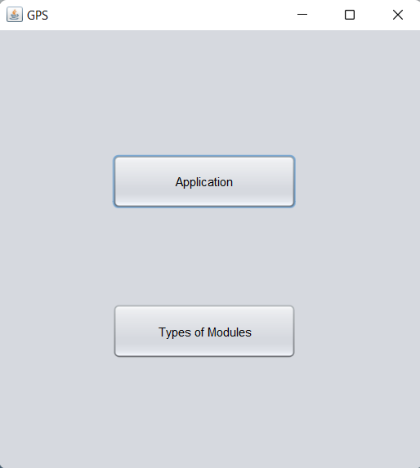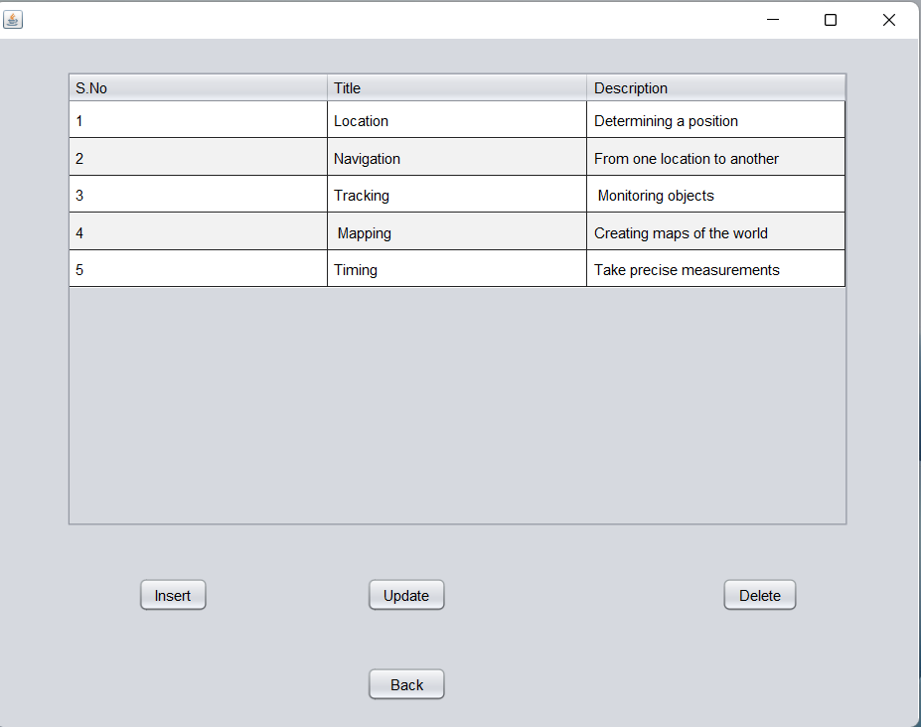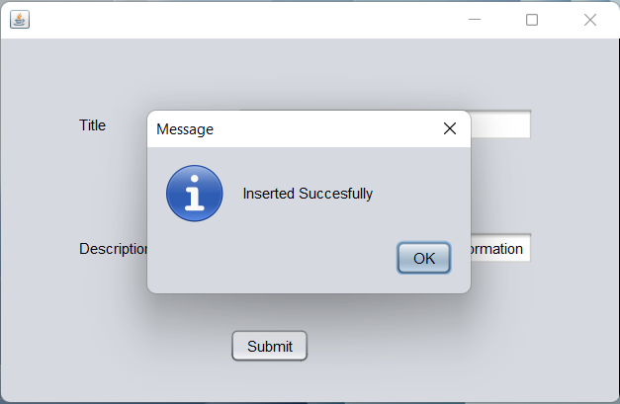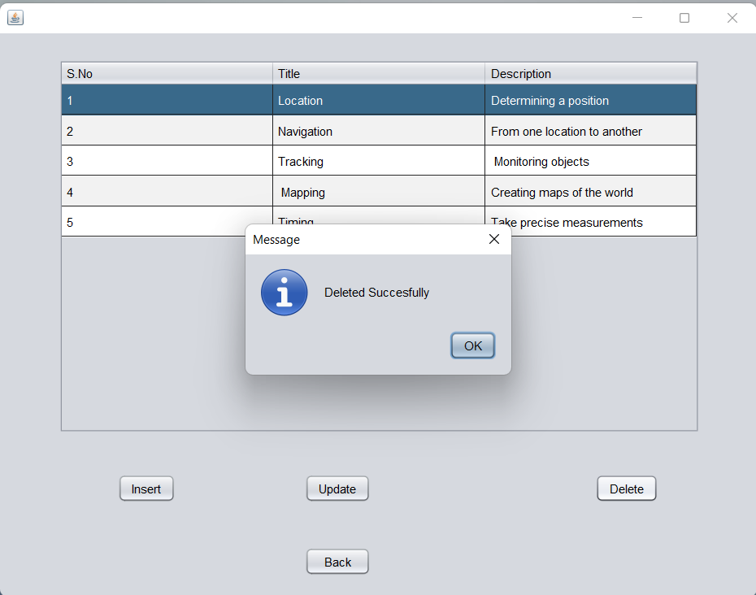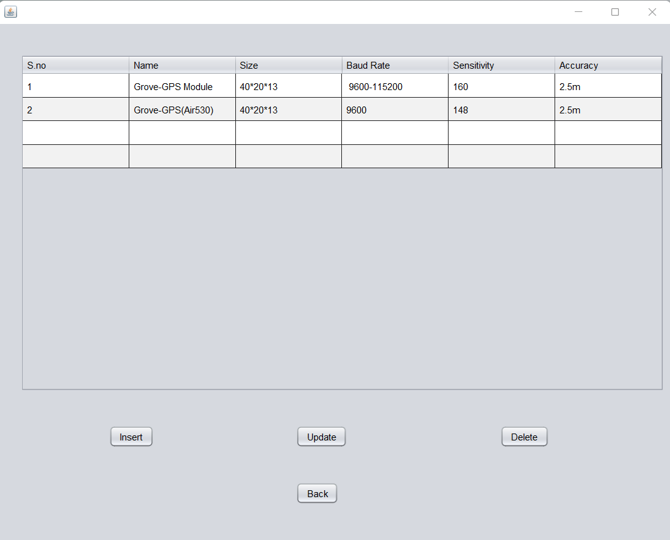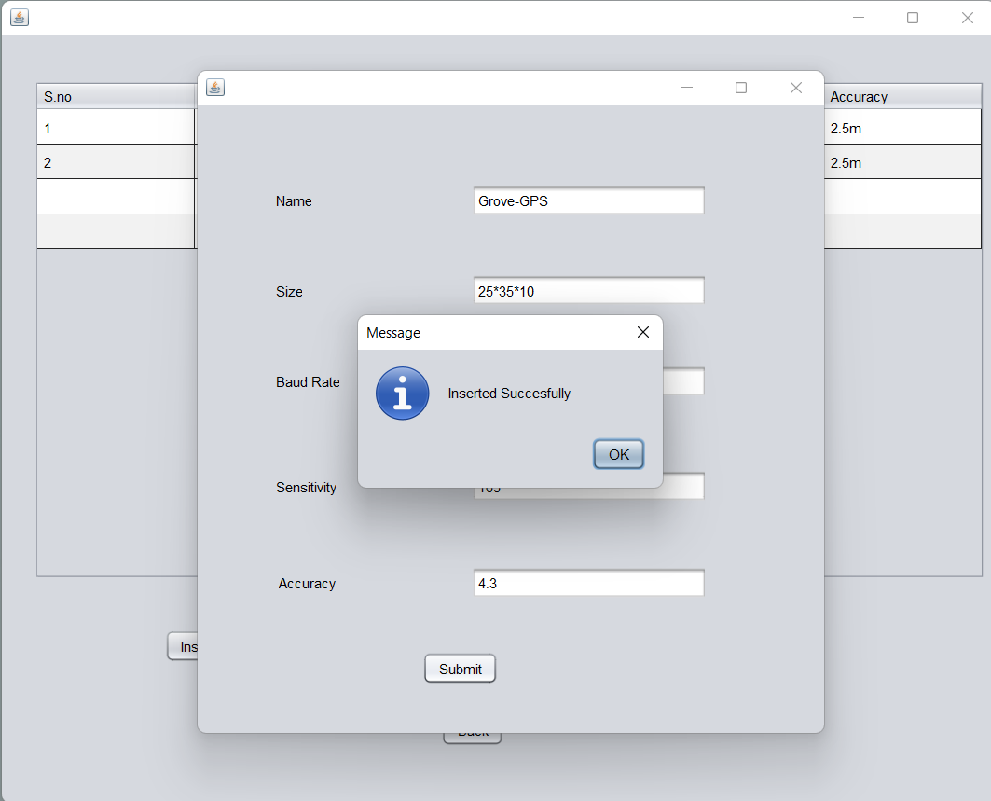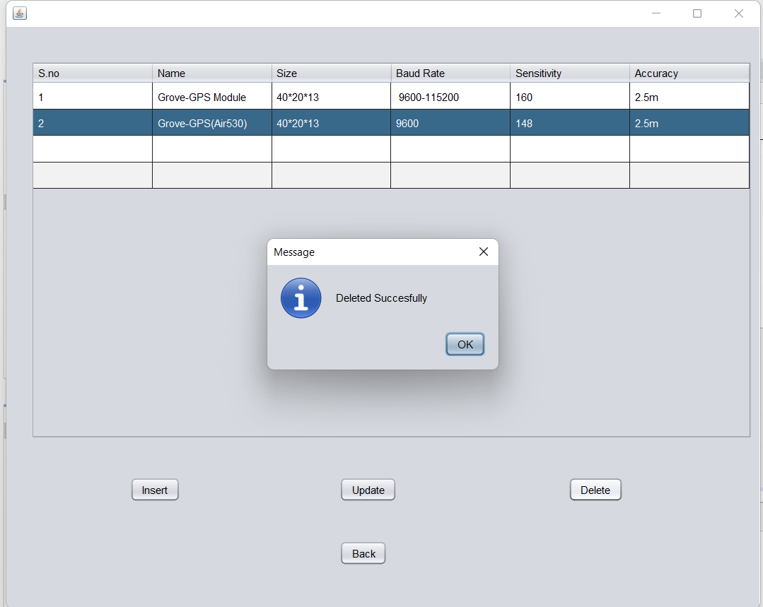

**The data entered in the above form is updated in the “Applications and Type_of_Modules” table of the Oracle database 11g as:**

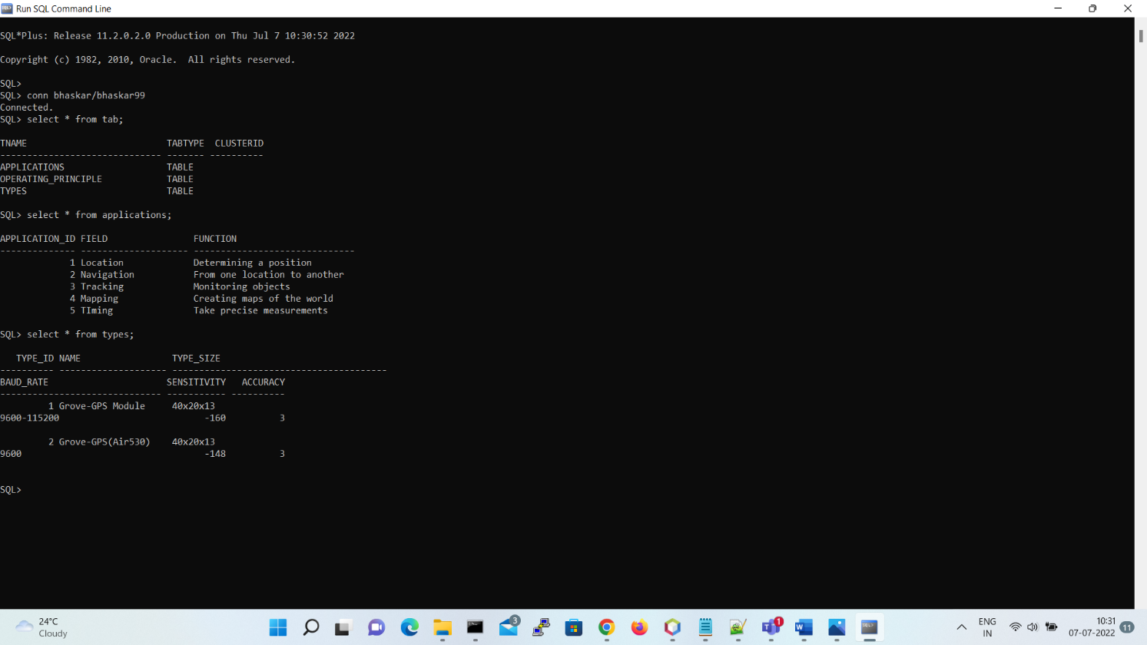

**Results:**

I successfully completed this DBMS PROJECT “GPS TECHNOLOGIES”.

# Discussion and Future work

While doing this project I got new ideas I understood how to work on projects. Now to further extend this project I want to create a android app by which I can control my project on my hand and connect to it.

# References:

* [https://www.academia.edu/36893248/Ramakrishnan_-](https://www.academia.edu/36893248/Ramakrishnan_-_Database_Management_Systems_3rd_Edition)

[_Database_Management_Systems_3rd_Edition](https://www.academia.edu/36893248/Ramakrishnan_-_Database_Management_Systems_3rd_Edition)

* <https://docs.oracle.com/javase/7/docs/index.html>
* <https://www.javatpoint.com/dbms-tutorial>
* <http://www.sqlines.com/articles/java/sql_server_jdbc_connection>
* <https://netbeans.apache.org/>