Splunk for SAP
version 1.02
by Jim Cooke

Installation Manual
4 September 2011

The latest version of this document can be found at
http://code.google.com/p/sapninja/source/browse/trunk/splunk/SplunkForSAP.doc

© 2011 by Cooke Computing Pty Ltd
PO BOX 712
RANDWICK, NSW 2031
AUSTRALIA
sapslunk@gmail.com

Table of Contents
Amendments 4
Background 4
Section 1 – Build Collector Framework 6
Development Objects 6
Development Package 6
Function Group 7
Data Types 8
Tables 9
ZPLUNK_CCMS_A 9
ZPLUNK_CCMS_C 10
ZPLUNK_CCMS_MTES 11
ZPLUNK_PARAMS 12
ZPLUNK_SM04MEM 13
ZPLUNK_SM04USR 14
ZPLUNK_SM20 15
ZPLUNK_SM21 16
ZPLUNK_SM50 17
ZPLUNK_SPOOL 18
ZPLUNK_ST03N 19
ZPLUNK_ST03N_FE 21
ZPLUNK_ST03N_TRN 22
ABAP Classes 23
KEYPAIRT method 23
CHECKLOCK method 24
LOCK method 25
UNLOCK method 26
TIMESTAMP method 27
CCMS_MTE_TOUCH method 28
CCMS_MTE_GETTIME method 29
CONV_SECS_SINCE_EPOCH method 30
Function Modules 31
ZPLUNK_GET function module 31
ZFORMAT_SIGN function module 33
Include Programs 34
ZPLUNK0001 include program 34
ZPLUNK0002 include program 35
ZPLUNK0003 include program 36
ZPLUNK0004 include program 37
ZPLUNK0005 include program 38
ZPLUNK0006 include program 39
ZPLUNK0007 include program 40
ZPLUNK0008 include program 41
ZPLUNK0009 include program 42
ZPLUNK0010 include program 43
ZPLUNK0011 include program 44
Main Programs 45
ZPLUNK_CAPTURE 45
ZPLUNKSAPMSM21 47
Section 2 – Propagate Collector Framework 48
Create variants 48
Configure ZPLUNK_CCMS_MTES 52
Create transport 54
Schedule collectors 55
Section 3 – Deploy Perl Extractor 56
Security for the Extractors 57
Pre-prepared RFC Role 57
Security Technical Details 57
Perl extractors on Linux 58
Install C Compiler 58
Acquire SAP NW RFC SDK libraries 58
INSTALL ADDITIONAL PERL MODULES 59
Acquire CPAN module for perl and sap 59
Compiling the extractor 60
Create YAML connection file 60
Perl extractors on Windows 61
Install C++ 61
Install Microsoft Platform SDK 61
Install perl 61
Acquire SAP NW RFC SDK libraries 61
Acquire CPAN module for perl and sap 62
INSTALL ADDITIONAL PERL MODULES 62
Compiling the extractor 62
Create YAML connection file 63

Amendments

Vers | Date | Description
1.01 | 27.08.2011 | Add a new dataset for SM20 audit logs  Modify ZPLUNKSAPMSM21_700 to work for all versions of SAP_BASIS
1.02 | 04.09.2011 | Add missing function module ZFORMAT_SIGN  Add “Reason” to ZPLUNK_SM50 table

Background
I rely on the scrutiny of the user community to ensure that errors and omissions are corrected. Please advise sapsplunk@gmail.com with any such errors or omissions.
Roadmap
In terms of the roadmap to setting up information collectors for Splunk, this document is broken up into three sections, corresponding to the first three sections of the roadmap. The final two sections involve the setup of your reporting solution and are beyond the scope of this document (and of the http://www.sapninja.com website for that matter).
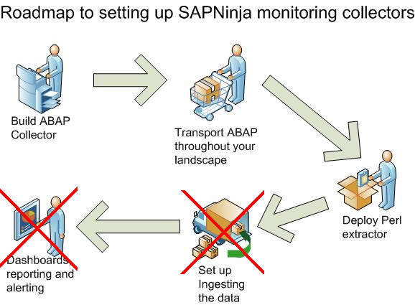

Section 1 – Build Collector Framework
The ABAP components consist of the following:
- Staging tables to hold data that has not yet been ingested by Splunk
- A collector program to gather data and populate the staging tables
- A remote-enabled function which can be called by Splunk to supply data that has not yet been ingested.

Development Objects
These tasks can be assigned to any ABAP programmer, who will be familiar with the concepts.

Development Package
All objects created from now on should be assigned to package ZPLUNK, if prompted. Start by creating this development package.

Start transaction SE80

From the top drop-down on the left-hand pane, choose

Object type = Package
Enter Object Name = ZPLUNK

Click Enter

Answer Yes to create the object

Enter the following values for the object properties:

Property | Value
Package | ZPLUNK
Short Description | Splunk Collector - Development Package
Application Component | BC
Software Component | HOME
Transport Layer | <Your Choice>
Package Type | Not a main package

Click Enter

Function Group
There will be a few functions created for the Splunk collector, including the main extraction function as well as maintenance screen functions. They need to belong to a function group. We will create a new function group called ZPLUNK_FGRP.
Start transaction SE80

Open Package ZPLUNK

Right-click on ZPLUNK and choose Create → Function Group

Function Group = ZPLUNK_FGRP
Short Text = Splunk Collector – Function Group

Click Save

Assign to package ZPLUNK when prompted

Data Types
There are many “standard” SAP data types that could fill this function, but it is better to create a set of custom data types so that we can be sure they will exist on all types of systems that we wish to use our collector on. For example some of the “standard” types might exist in an ERP installation, but not Solution Manager or, vice versa.

For each data type listed in the table below, repeat the following steps:
- Start transaction SE11
- Click on the Data Type radio button
- Enter the name from the “name” column below and Click Create
- Select the Data Element radio button and Click Enter
- At the next screen, always select the Predefined Type radio button
- Assign to the ZPLUNK package as mentioned before

Name | Type | Short  Description | Data  Type | Len | Label  Name
ZPLUNK_TXT1 | data element | Text - 1 character | CHAR | 1 | TEXT1
ZPLUNK_TXT2 | data element | Text - 2 characters | CHAR | 2 | TEXT2
ZPLUNK_TXT3 | data element | Text - 3 characters | CHAR | 3 | TEXT3
ZPLUNK_TXT4 | data element | Text - 4 characters | CHAR | 4 | TEXT4
ZPLUNK_TXT12 | data element | Text - 12 characters | CHAR | 12 | TEXT4
ZPLUNK_TXT20 | data element | Text - 20 characters | CHAR | 20 | TEXT20
ZPLUNK_TXT40 | data element | Text - 40 characters | CHAR | 40 | TEXT40
ZPLUNK_TXT60 | data element | Text - 60 characters | CHAR | 60 | TEXT60
ZPLUNK_TXT120 | data element | Text - 120 characters | CHAR | 120 | TEXT120
ZPLUNK_TXT255 | data element | Text - 255 characters | CHAR | 255 | TEXT255
ZPLUNK_DATE | data element | Date | DATS | 8 | DATE
ZPLUNK_TIME | data element | Time | TIMS | 6 | TIME
ZPLUNK_DEC24 | data element | Decimal | DEC | 24 | DEC24

Tables
The collector relies on several staging tables to store the data, as well as tables which control collector activities.

For each data type listed in the table below, repeat the following steps:
- Start transaction SE11
- Click on the Database Table radio button
- Enter the name from each sub-section below and Click Create

ZPLUNK_CCMS_A

ATTRIBUTES
Short Description = Splunk Collector - CCMS Alerts

DELIVERY AND MAINTENANCE
Delivery Class = L
Data Browser/Table View Maint = Display/Maintenance Allowed

Fields
Name | Key | Data Element
SAMPLEDATE | X | ZPLUNK_DATE
SAMPLETIME | X | ZPLUNK_TIME
HOST | X | ZPLUNK_TXT40
SYSNAME | X | ZPLUNK_TXT3
SYSNR | X | ZPLUNK_TXT2
MTECLASS | X | ZPLUNK_TXT120
SENT |  | ZPLUNK_TXT1
MSG |  | ZPLUNK_TXT255
SEVERITY |  | ZPLUNK_TXT1

Extras → Enhancement category
Category = Cannot be enhanced

technical settings
Data Class = USER
Size Category = 2
Buffering = Buffering not allowed

ZPLUNK_CCMS_C

ATTRIBUTES
Short Description = Splunk Collector - CCMS MTE Status

DELIVERY AND MAINTENANCE
Delivery Class = L
Data Browser/Table View Maint = Display/Maintenance Allowed

Fields
Name | Key | Data Element
SAMPLEDATE | X | ZPLUNK_DATE
SAMPLETIME | X | ZPLUNK_TIME
HOST | X | ZPLUNK_TXT40
SYSNAME | X | ZPLUNK_TXT3
SYSNR | X | ZPLUNK_TXT2
MTECLASS | X | ZPLUNK_TXT120
SENT |  | ZPLUNK_TXT120
MSG |  | ZPLUNK_TXT255
SEVERITY |  | ZPLUNK_TXT1
OBSERVATION |  | INT4
OBSERVATION_UOM |  | ZPLUNK_TXT4

Extras → Enhancement category
Category = Cannot be enhanced

technical settings
Data Class = USER
Size Category = 3
Buffering = Buffering not allowed

ZPLUNK_CCMS_MTES

ATTRIBUTES
Short Description = Splunk Collector - CCMS MTE classes for current status

DELIVERY AND MAINTENANCE
Delivery Class = L
Data Browser/Table View Maint = Display/Maintenance Allowed

Fields
Name | Key | Data Element
MTECLASS | X | ZPLUNK_TXT40
COLL_FREQ_MINS |  | INT4
THRESHOLD_ACTIVE |  | ZPLUNK_TXT1

Extras → Enhancement category
Category = Cannot be enhanced

technical settings
Data Class = USER
Size Category = 0
Buffering = Buffering switched on
Buffering Type = Fully Buffered

ZPLUNK_PARAMS

ATTRIBUTES
Short Description = Splunk Collector – Application Parameters

DELIVERY AND MAINTENANCE
Delivery Class = L
Data Browser/Table View Maint = Display/Maintenance Allowed

Fields
Name | Key | Data Element
PARAM | X | ZPLUNK_TXT60
VALUE |  | ZPLUNK_TXT60

Extras → Enhancement category
Category = Cannot be enhanced

technical settings
Data Class = USER
Size Category = 0
Buffering = Buffering switched on
Buffering Type = Fully Buffered

TABLE MAINTENANCE
You generate a table maintenance program for this table. From SE11:
- Utilities → Table Maintenance Generator

Authorization Group | &NC&
Maintenance Type | One step
Function group | ZPLUNK_FGRP

- Click on Find Scr. Number(s) button
- Select Propose screen number(s) radio button
- Click Enter
- Click Create

ZPLUNK_SM04MEM

ATTRIBUTES
Short Description = Splunk Collector – SM04 Memory Usage

DELIVERY AND MAINTENANCE
Delivery Class = L
Data Browser/Table View Maint = Display/Maintenance Allowed

Fields
Name | Key | Data Element
SAMPLEDATE | X | ZPLUNK_DATE
SAMPLETIME | X | ZPLUNK_TIME
HOST | X | ZPLUNK_TXT40
SYSNAME | X | ZPLUNK_TXT3
SYSNR | X | ZPLUNK_TXT2
IDX | X | INT2
SENT |  | ZPLUNK_TXT1
MANDT |  | ZPLUNK_TXT3
BNAME |  | ZPLUNK_TXT12
TCODE |  | ZPLUNK_TXT20
PAGEMEM |  | ZPLUNK_DEC24
ROLLMEM |  | ZPLUNK_DEC24
EXTENDEDMEM |  | ZPLUNK_DEC24
PRIVMEM |  | ZPLUNK_DEC24

Extras → Enhancement category
Category = Cannot be enhanced

technical settings
Data Class = USER
Size Category = 3
Buffering = Buffering not allowed

ZPLUNK_SM04USR

ATTRIBUTES
Short Description = Splunk Collector – SM04 User List

DELIVERY AND MAINTENANCE
Delivery Class = L
Data Browser/Table View Maint = Display/Maintenance Allowed

Fields
Name | Key | Data Element
SAMPLEDATE | X | ZPLUNK_DATE
SAMPLETIME | X | ZPLUNK_TIME
HOST | X | ZPLUNK_TXT40
SYSNAME | X | ZPLUNK_TXT3
SYSNR | X | ZPLUNK_TXT2
IDX | X | INT2
SENT |  | ZPLUNK_TXT1
MANDT |  | ZPLUNK_TXT3
BNAME |  | ZPLUNK_TXT12
USTYP |  | ZPLUNK_TXT12
TCODE |  | ZPLUNK_TXT20
LASTACTION |  | ZPLUNK_TIME
TERM |  | ZPLUNK_TXT40
IPADDR |  | ZPLUNK_TXT40

Extras → Enhancement category
Category = Cannot be enhanced

technical settings
Data Class = USER
Size Category = 3
Buffering = Buffering not allowed

ZPLUNK_SM20

ATTRIBUTES
Short Description = Splunk Collector – SM20 Security Audit Log

DELIVERY AND MAINTENANCE
Delivery Class = L
Data Browser/Table View Maint = Display/Maintenance Allowed

Fields
Name | Key | Data Element
SAMPLEDATE | X | ZPLUNK_DATE
SAMPLETIME | X | ZPLUNK_TIME
HOST | X | ZPLUNK_TXT40
SYSNAME | X | ZPLUNK_TXT3
SYSNR | X | ZPLUNK_TXT2
MANDT | X | ZPLUNK_TXT3
BNAME | X | ZPLUNK_TXT12
TERM | X | ZPLUNK_TXT12
TCODE | X | ZPLUNK_TXT20
REPNAME | X | ZPLUNK_TXT60
SENT |  | ZPLUNK_TXT1
MSG |  | ZPLUNK_TXT255

Extras → Enhancement category
Category = Cannot be enhanced

technical settings
Data Class = USER
Size Category = 5
Buffering = Buffering not allowed

ZPLUNK_SM21

ATTRIBUTES
Short Description = Splunk Collector – SM21 System Log

DELIVERY AND MAINTENANCE
Delivery Class = L
Data Browser/Table View Maint = Display/Maintenance Allowed

Fields
Name | Key | Data Element
SAMPLEDATE | X | ZPLUNK_DATE
SAMPLETIME | X | ZPLUNK_TIME
HOST | X | ZPLUNK_TXT40
SYSNAME | X | ZPLUNK_TXT3
SYSNR | X | ZPLUNK_TXT2
ENTRY | X | ZPLUNK_TXT12
SENT |  | ZPLUNK_TXT1
ENTRYTYPE |  | ZPLUNK_TXT1
MSGNO |  | ZPLUNK_TXT3
MANDT |  | ZPLUNK_TXT3
BNAME |  | ZPLUNK_TXT12
TERM |  | ZPLUNK_TXT12
MODE |  | ZPLUNK_TXT1
PID |  | ZPLUNK_TXT12
TASKNO |  | ZPLUNK_TXT12
TASKTYPE |  | ZPLUNK_TXT2
TCODE |  | ZPLUNK_TXT20
REPNAME |  | ZPLUNK_TXT60
MSGNO |  | ZPLUNK_TXT120

Extras → Enhancement category
Category = Cannot be enhanced

technical settings
Data Class = USER
Size Category = 3
Buffering = Buffering not allowed

ZPLUNK_SM50

ATTRIBUTES
Short Description = Splunk Collector – SM50 Work Processes

DELIVERY AND MAINTENANCE
Delivery Class = L
Data Browser/Table View Maint = Display/Maintenance Allowed

Fields
Name | Key | Data Element
SAMPLEDATE | X | ZPLUNK_DATE
SAMPLETIME | X | ZPLUNK_TIME
HOST | X | ZPLUNK_TXT40
SYSNAME | X | ZPLUNK_TXT3
SYSNR | X | ZPLUNK_TXT2
WP_NO | X | ZPLUNK_TXT2
SENT |  | ZPLUNK_TXT1
WP_TYPE |  | ZPLUNK_TXT3
WP_PID |  | ZPLUNK_TXT12
WP_STATUS |  | ZPLUNK_TXT12
WP_WAITING |  | ZPLUNK_TXT12
WP_DUMPS |  | ZPLUNK_TXT2
WP_MANDT |  | ZPLUNK_TXT3
WP_BNAME |  | ZPLUNK_TXT12
WP_REPORT |  | ZPLUNK_TXT40
WP_ELTIME |  | ZPLUNK_TXT12
WP_ACTION |  | ZPLUNK_TXT40
WP_TABLE |  | ZPLUNK_TXT40

Extras → Enhancement category
Category = Cannot be enhanced

technical settings
Data Class = USER
Size Category = 3
Buffering = Buffering not allowed

ZPLUNK_SPOOL

ATTRIBUTES
Short Description = Splunk Collector – SP01 Successful Print Jobs

DELIVERY AND MAINTENANCE
Delivery Class = L
Data Browser/Table View Maint = Display/Maintenance Allowed

Fields
Name | Key | Data Element
SAMPLEDATE | X | ZPLUNK_DATE
SAMPLETIME | X | ZPLUNK_TIME
HOST | X | ZPLUNK_TXT40
SYSNAME | X | ZPLUNK_TXT3
SYSNR | X | ZPLUNK_TXT2
SPOOLID | X | INT4
SENT |  | ZPLUNK_TXT1
MANDT |  | ZPLUNK_TXT3
BNAME |  | ZPLUNK_TXT12
PADEST |  | ZPLUNK_TXT4
LNAME |  | ZPLUNK_TXT40
PAGESPRINTED |  | INT2
BYTESOUT |  | INT4
OUTPUTTYPE |  | ZPLUNK_TXT12

Extras → Enhancement category
Category = Cannot be enhanced

technical settings
Data Class = USER
Size Category = 3
Buffering = Buffering not allowed

ZPLUNK_ST03N

ATTRIBUTES
Short Description = Splunk Collector – ST03N Workload Overview

DELIVERY AND MAINTENANCE
Delivery Class = L
Data Browser/Table View Maint = Display/Maintenance Allowed

Fields
Name | Key | Data Element
SAMPLEDATE | X | ZPLUNK_DATE
SAMPLETIME | X | ZPLUNK_TIME
HOST | X | ZPLUNK_TXT40
SYSNAME | X | ZPLUNK_TXT3
SYSNR | X | ZPLUNK_TXT2
TASKTYPE | X | ZPLUNK_TXT60
SENT |  | ZPLUNK_TXT1
STEPS |  | ZPLUNK_DEC24
RESPTI |  | ZPLUNK_DEC24
PROCTI |  | ZPLUNK_DEC24
CPUTI |  | ZPLUNK_DEC24
DBTI |  | ZPLUNK_DEC24
QUEUETI |  | ZPLUNK_DEC24
LOADGENTI |  | ZPLUNK_DEC24
LOCKTI |  | ZPLUNK_DEC24
CPICTI |  | ZPLUNK_DEC24
GUINETTIME |  | ZPLUNK_DEC24
GUITIME |  | ZPLUNK_DEC24
GUICNT |  | ZPLUNK_DEC24
BYTES |  | ZPLUNK_DEC24
ROLLINSTEP |  | ZPLUNK_DEC24
ROLLINTI |  | ZPLUNK_DEC24
ROLLOUTTI |  | ZPLUNK_DEC24
ROLLOUTCNT |  | ZPLUNK_DEC24
ROLLWAITTI |  | ZPLUNK_DEC24
ROLLSTEP |  | ZPLUNK_DEC24
VMC_CALL_COUNT |  | ZPLUNK_DEC24
VMC_CPU_TIME |  | ZPLUNK_DEC24
VMC_ELAP_TIME |  | ZPLUNK_DEC24
PHYREADCNT |  | ZPLUNK_DEC24
CHNGCNT |  | ZPLUNK_DEC24
READDIRBUF |  | ZPLUNK_DEC24
PHYCHNGREC |  | ZPLUNK_DEC24
READSEQCNT |  | ZPLUNK_DEC24

Extras → Enhancement category
Category = Cannot be enhanced

technical settings
Data Class = USER
Size Category = 3
Buffering = Buffering not allowed

ZPLUNK_ST03N_FE

ATTRIBUTES
Short Description = Splunk Collector – ST03N Frontend Usage

DELIVERY AND MAINTENANCE
Delivery Class = L
Data Browser/Table View Maint = Display/Maintenance Allowed

Fields
Name | Key | Data Element
SAMPLEDATE | X | ZPLUNK_DATE
SAMPLETIME | X | ZPLUNK_TIME
HOST | X | ZPLUNK_TXT40
SYSNAME | X | ZPLUNK_TXT3
SYSNR | X | ZPLUNK_TXT2
PHOST | X | ZPLUNK_TXT60
IPADDR |  | ZPLUNK_TXT20
SENT |  | ZPLUNK_TXT1
STEPS |  | ZPLUNK_DEC24
BYTESIN |  | ZPLUNK_DEC24
BYTESOUT |  | ZPLUNK_DEC24
GUITIME |  | ZPLUNK_DEC24
GUICNT |  | ZPLUNK_DEC24
GUINETTIME |  | ZPLUNK_DEC24

Extras → Enhancement category
Category = Cannot be enhanced

technical settings
Data Class = USER
Size Category = 3
Buffering = Buffering not allowed

ZPLUNK_ST03N_TRN

ATTRIBUTES
Short Description = Splunk Collector – ST03N User Transactions

DELIVERY AND MAINTENANCE
Delivery Class = L
Data Browser/Table View Maint = Display/Maintenance Allowed

Fields
Name | Key | Data Element
SAMPLEDATE | X | ZPLUNK_DATE
SAMPLETIME | X | ZPLUNK_TIME
HOST | X | ZPLUNK_TXT40
SYSNAME | X | ZPLUNK_TXT3
SYSNR | X | ZPLUNK_TXT2
TASKTYPE | X | ZPLUNK_TXT60
BNAME | X | ZPLUNK_TXT12
EXECUTED |  | ZPLUNK_TXT120
SENT |  | ZPLUNK_TXT1
CALLTYPE |  | ZPLUNK_TXT1
STEPS |  | ZPLUNK_DEC24
RESPTI |  | ZPLUNK_DEC24
PROCTI |  | ZPLUNK_DEC24
CPUTI |  | ZPLUNK_DEC24
QUEUETI |  | ZPLUNK_DEC24
ROLLWAITTI |  | ZPLUNK_DEC24
GUITIME |  | ZPLUNK_DEC24
GUICNT |  | ZPLUNK_DEC24
GUINETTIME |  | ZPLUNK_DEC24
DBTI |  | ZPLUNK_DEC24
READDIRTI |  | ZPLUNK_DEC24
READSEQTI |  | ZPLUNK_DEC24
CHNGTI |  | ZPLUNK_DEC24

Extras → Enhancement category
Category = Cannot be enhanced

technical settings
Data Class = USER
Size Category = 3
Buffering = Buffering not allowed

ABAP Classes
The following ABAP class is used by the Splunk collector to perform some generic functions and formatting.

- Execute transaction SE24
- Enter Object type = ZPLUNK_COMMON
- Click Create
- Choose the Class radio button and Click Enter
- Set Instantiation = Public
- Click Enter
- Set Package = ZPLUNK
- Click Enter
- Open up the Methods tab and perform the actions listed below for each method

KEYPAIRT method

Method descriptor
Method | Level | Visibility | Description
KEYPAIRT | Static | Public | Generate a text keypair with text input

Method parameters
Click the Parameters button to define these

Parameter | Type | Pass  Val | Method | Type | Description
KEY | Importing | X | Type | ZPLUNK_TXT255 | Key name
VALUE | Importing | X | Type | ZPLUNK_TXT255 | Key value
RESULT | Exporting | X | Type | ZPLUNK_TXT255 | Keypair

Method Code
- Click Save
- Click Back (green arrow)
- Double-click KEYPAIRT
- From menu Utilities → More Utilities → Upload/Download → Upload
- Import code from meth_keypairt.txt at the link

http://code.google.com/p/sapninja/source/browse/trunk/splunk/meth_keypairt.txt

- Click Save

CHECKLOCK method

Method descriptor
Method | Level | Visibility | Description
CHECKLOCK | Static | Public | Check dataset lock record

Method parameters
Click the Parameters button to define these

Parameter | Type | Pass  Val | Method | Type | Description
DATASET | Importing | X | Type | ZPLUNK_TXT255 | Splunk Dataset
EXPIRY_DAET | Importing | X | Type | ZPLUNK_DATE | Lock expiry date
EXPIRY_TIME | Importing | X | Type | ZPLUNK_TIME | Lock expiry time
RESULT | Exporting | X | Type | ZPLUNK_TXT255 | Result String

Method Code
Click Save

Click Back (green arrow)

Double-click KEYPAIRT

From menu Utilities → More Utilities → Upload/Download → Upload
Import code from meth_checklock.txt at the link

http://code.google.com/p/sapninja/source/browse/trunk/splunk/meth_checklock.txt

Click Save

LOCK method

Method descriptor
Method | Level | Visibility | Description
LOCK | Static | Public | Write dataset lock entry

Method parameters
Click the Parameters button to define these

Parameter | Type | Pass  Val | Method | Type | Description
DATASET | Importing | X | Type | ZPLUNK_TXT255 | Splunk Dataset
RESULT | Exporting | X | Type | ZPLUNK_TXT255 | Result String

Method Code
Click Save

Click Back (green arrow)

Double-click KEYPAIRT

From menu Utilities → More Utilities → Upload/Download → Upload
Import code from meth_lock.txt at the link

http://code.google.com/p/sapninja/source/browse/trunk/splunk/meth_lock.txt

Click Save

UNLOCK method

Method descriptor
Method | Level | Visibility | Description
UNLOCK | Static | Public | Remove dataset lock entry

Method parameters
Click the Parameters button to define these

Parameter | Type | Pass  Val | Method | Type | Description
DATASET | Importing | X | Type | ZPLUNK_TXT255 | Splunk Dataset
RESULT | Exporting | X | Type | ZPLUNK_TXT255 | Result String

Method Code
Click Save

Click Back (green arrow)

Double-click KEYPAIRT

From menu Utilities → More Utilities → Upload/Download → Upload
Import code from meth_unlock.txt at the link

http://code.google.com/p/sapninja/source/browse/trunk/splunk/meth_unlock.txt

Click Save

TIMESTAMP method

Method descriptor
Method | Level | Visibility | Description
TIMESTAMP | Static | Public | Return timestamp in Splunk log format

Method parameters
Click the Parameters button to define these

Parameter | Type | Pass  Val | Method | Type | Description
RAWDATE | Importing | X | Type | ZPLUNK_DATE | Raw date
RAWTIME | Importing | X | Type | ZPLUNK_TIME | Raw time
RESULT | Exporting | X | Type | ZPLUNK_TXT255 | Formatted Timestamp

Method Code
Click Save

Click Back (green arrow)

Double-click KEYPAIRT

From menu Utilities → More Utilities → Upload/Download → Upload
Import code from meth_timestamp.txt at the link

http://code.google.com/p/sapninja/source/browse/trunk/splunk/meth_timestamp.txt

Click Save

CCMS_MTE_TOUCH method

Method descriptor
Method | Level | Visibility | Description
CCMS_MTE_TOUCH | Static | Public | Record MTE collection timestamp for this host

Method parameters
Click the Parameters button to define these

Parameter | Type | Pass  Val | Method | Type | Description
MTE | Importing | X | Type | ZPLUNK_TXT255 | MTE Class
RESULT | Exporting | X | Type | ZPLUNK_TXT255 | Result String

Method Code
Click Save

Click Back (green arrow)

Double-click KEYPAIRT

From menu Utilities → More Utilities → Upload/Download → Upload
Import code from meth_ccms_mte_touch.txt at the link

http://code.google.com/p/sapninja/source/browse/trunk/splunk/meth_ccms_mte_touch.txt

Click Save

CCMS_MTE_GETTIME method

Method descriptor
Method | Level | Visibility | Description
CCMS_MTE_GETTIME | Static | Public | Retrieve MTE collection timestamp for this host

Method parameters
Click the Parameters button to define these

Parameter | Type | Pass  Val | Method | Type | Description
MTE | Importing | X | Type | ZPLUNK_TXT255 | MTE Class
RESULT | Exporting | X | Type | ZPLUNK_TXT255 | Result String

Method Code
Click Save

Click Back (green arrow)

Double-click KEYPAIRT

From menu Utilities → More Utilities → Upload/Download → Upload
Import code from meth_ccms_mte_gettime.txt at the link

http://code.google.com/p/sapninja/source/browse/trunk/splunk/meth_ccms_mte_gettime.txt

Click Save

CONV_SECS_SINCE_EPOCH method

Method descriptor
Method | Level | Visibility | Description
CONV_SECS_SINCE_EPOCH | Static | Public | Convert seconds since epoch to timestamp

Method parameters
Click the Parameters button to define these

Parameter | Type | Pass  Val | Method | Type | Description
SECS_SINCE_EPOCH | Changing | X | Type | TIMESTAMP | UTC Time Stamp in Short Form

Method Code
Click Save
Click Back (green arrow)
Double-click KEYPAIRT
From menu Utilities → More Utilities → Upload/Download → Upload
Import code from meth_conv_secs_since_epoch.txt at the link

http://code.google.com/p/sapninja/source/browse/trunk/splunk/meth_conv_secs_since_epoch.txt

Click Save

Activate the Class

Start transaction SE24

Enter Object type = ZPLUNK_COMMON

Click Activate or (CTRL+F3)

Function Modules

ZPLUNK_GET function module

Start transaction SE37

Enter Function Module = ZPLUNK_GET

Click Create

Function Module | ZPLUNK_GET
Function Group | ZPLUNK_FGRP
Short Text | RFC for Splunk record retrieval

Go to Source Code tab

From menu Utilities → More Utilities → Upload/Download → Upload

Import code from fm_zplunk_get.txt at the link

http://code.google.com/p/sapninja/source/browse/trunk/splunk/fm_zplunk_get.txt

From menu Goto -> Text Elements -> Text Symbols

Click Yes to save the function module code when prompted

Create the following symbol

Sym | Text
001 | ;

Click Save

Click Back (green arrow)

Attributes tab
Choose or set the radio button Processing Type = Remote-Enabled Module

IMPORT TAB

Parameter Name | Typing | Optional | Pass  Value | Associated Type
DATASET | TYPE |  | X | ZPLUNK_TXT255

EXPORT TAB
Parameter Name | Typing | Pass  Value | Associated Type
RESULT | TYPE | X | STRINGTAB

Click Save

Click Activate

ZPLUNK_FORMAT_SIGN function module

Start transaction SE37

Enter Function Module = ZPLUNK_FORMAT_SIGN

Click Create

Function Module | ZPLUNK_FORMAT_SIGN
Function Group | ZPLUNK_FGRP
Short Text | Format numeric sign to front of number

Go to Source Code tab

From menu Utilities → More Utilities → Upload/Download → Upload

Import code from fm_zplunk_get.txt at the link

http://code.google.com/p/sapninja/source/browse/trunk/splunk/fm_zplunk_format_sign.txt

CHANGING TAB

Parameter Name | Typing | Optional | Pass  Value | Associated Type
VALUE | TYPE |  |  | CLIKE

Click Save

Click Activate

ZPLUNK_NSLOOKUP function module

Start transaction SE37

Enter Function Module = ZPLUNK_NSLOOKUP

Click Create

Function Module | ZPLUNK_NSLOOKUP
Function Group | ZPLUNK_FGRP
Short Text | Find an IP Address from a hostname

Go to Source Code tab

From menu Utilities → More Utilities → Upload/Download → Upload

Import code from fm_zplunk_get.txt at the link

http://code.google.com/p/sapninja/source/browse/trunk/splunk/fm_zplunk_nslookup.txt

IMPORTING TAB

Parameter Name | Typing | Optional | Pass  Value | Associated Type
HOSTNAME | TYPE |  | X | SXPGCOLIST-PARAMETERS

EXPORTING TAB

Parameter Name | Typing | Optional | Pass  Value | Associated Type
IPADDRESS | TYPE |  |  | ZPLUNK_TXT255

Click Save

Click Activate

Include Programs

ZPLUNK0001 include program
Start transaction SE38

Enter Program = ZPLUNK0001

Click Create

Title | ZPLUNK_CAPTURE - global variables
Type | Include Program
Status | Customer Production Program
Application | Basis

Click Enter

Set Package = ZPLUNK

Click Enter

From menu Utilities → More Utilities → Upload/Download → Upload

Import code from inc_zplunk0001.txt at the link

http://code.google.com/p/sapninja/source/browse/trunk/splunk/inc_zplunk0001.txt

ZPLUNK0002 include program
Start transaction SE38

Enter Program = ZPLUNK0002

Click Create

Title | ZPLUNK_CAPTURE - time functions
Type | Include Program
Status | Customer Production Program
Application | Basis

Click Enter

Set Package = ZPLUNK

Click Enter

From menu Utilities → More Utilities → Upload/Download → Upload

Import code from inc_zplunk0002.txt at the link

http://code.google.com/p/sapninja/source/browse/trunk/splunk/inc_zplunk0002.txt

ZPLUNK0003 include program
Start transaction SE38

Enter Program = ZPLUNK0003

Click Create

Title | ZPLUNK_CAPTURE - SM04 User List
Type | Include Program
Status | Customer Production Program
Application | Basis

Click Enter

Set Package = ZPLUNK

Click Enter

From menu Utilities → More Utilities → Upload/Download → Upload

Import code from inc_zplunk0003.txt at the link

http://code.google.com/p/sapninja/source/browse/trunk/splunk/inc_zplunk0003.txt

ZPLUNK0004 include program
Start transaction SE38

Enter Program = ZPLUNK0004

Click Create

Title | ZPLUNK_CAPTURE - SM04 Memory Use
Type | Include Program
Status | Customer Production Program
Application | Basis

Click Enter

Set Package = ZPLUNK

Click Enter

From menu Utilities → More Utilities → Upload/Download → Upload

Import code from inc_zplunk0004.txt at the link

http://code.google.com/p/sapninja/source/browse/trunk/splunk/inc_zplunk0004.txt

ZPLUNK0005 include program
Start transaction SE38

Enter Program = ZPLUNK0005

Click Create

Title | ZPLUNK_CAPTURE - ST03N save results
Type | Include Program
Status | Customer Production Program
Application | Basis

Click Enter

Set Package = ZPLUNK

Click Enter

From menu Utilities → More Utilities → Upload/Download → Upload

Import code from inc_zplunk0005.txt at the link

http://code.google.com/p/sapninja/source/browse/trunk/splunk/inc_zplunk0005.txt

ZPLUNK0006 include program
Start transaction SE38

Enter Program = ZPLUNK0006

Click Create

Title | ZPLUNK_CAPTURE - ST03N collect data
Type | Include Program
Status | Customer Production Program
Application | Basis

Click Enter

Set Package = ZPLUNK

Click Enter

From menu Utilities → More Utilities → Upload/Download → Upload
Import code from inc_zplunk0006.txt at the link

http://code.google.com/p/sapninja/source/browse/trunk/splunk/inc_zplunk0006.txt

ZPLUNK0007 include program
Start transaction SE38

Enter Program = ZPLUNK0007

Click Create

Title | ZPLUNK_CAPTURE - SM21 system log
Type | Include Program
Status | Customer Production Program
Application | Basis

Click Enter

Set Package = ZPLUNK

Click Enter

From menu Utilities → More Utilities → Upload/Download → Upload
Import code from inc_zplunk0007.txt at the link

http://code.google.com/p/sapninja/source/browse/trunk/splunk/inc_zplunk0007.txt

ZPLUNK0008 include program
Start transaction SE38

Enter Program = ZPLUNK0008

Click Create

Title | ZPLUNK_CAPTURE - CCMS alerts
Type | Include Program
Status | Customer Production Program
Application | Basis

Click Enter

Set Package = ZPLUNK

Click Enter

From menu Utilities → More Utilities → Upload/Download → Upload
Import code from inc_zplunk0008.txt at the link

http://code.google.com/p/sapninja/source/browse/trunk/splunk/inc_zplunk0008.txt

ZPLUNK0009 include program
Start transaction SE38

Enter Program = ZPLUNK0009

Click Create

Title | ZPLUNK_CAPTURE - SM50 workload
Type | Include Program
Status | Customer Production Program
Application | Basis

Click Enter

Set Package = ZPLUNK

Click Enter

From menu Utilities → More Utilities → Upload/Download → Upload
Import code from inc_zplunk0009.txt at the link

http://code.google.com/p/sapninja/source/browse/trunk/splunk/inc_zplunk0009.txt

ZPLUNK0010 include program
Start transaction SE38

Enter Program = ZPLUNK0010

Click Create

Title | ZPLUNK_CAPTURE - SP01 print jobs
Type | Include Program
Status | Customer Production Program
Application | Basis

Click Enter

Set Package = ZPLUNK

Click Enter

From menu Utilities → More Utilities → Upload/Download → Upload

Import code from inc_zplunk0010.txt at the link

http://code.google.com/p/sapninja/source/browse/trunk/splunk/inc_zplunk00010.txt

ZPLUNK0011 include program
Start transaction SE38

Enter Program = ZPLUNK0011

Click Create

Title | ZPLUNK_CAPTURE - SM20 Security Audit Logs
Type | Include Program
Status | Customer Production Program
Application | Basis

Click Enter

Set Package = ZPLUNK

Click Enter

From menu Utilities → More Utilities → Upload/Download → Upload

Import code from inc_zplunk0011.txt at the link

http://code.google.com/p/sapninja/source/browse/trunk/splunk/inc_zplunk00011.txt

Main Programs

ZPLUNK_CAPTURE
Start transaction SE38

Enter Program = ZPLUNK_CAPTURE

Click Create

Title | Splunk Collector Data Capture
Type | Executable Program
Status | Customer Production Program
Application | Basis

Click Enter

Set Package = ZPLUNK

Click Enter

From menu Utilities → More Utilities → Upload/Download → Upload
Import code from prg_zplunk_capture.txt at the link

http://code.google.com/p/sapninja/source/browse/trunk/splunk/prg_zplunk_capture.txt

From menu Goto -> Text Elements -> Text Symbols
Click Yes to save the function module code when prompted
Create the following symbols

Sym | Text
431 | Time Zone
432 | Purge data by age
433 | Data retention days
434 | Purge extracted data
500 | General Parameters
530 | Log entry time
531 | Last round hour
532 | Last round 30 mins
533 | Last round 15 mins
534 | Last round 10 mins
535 | Last round 5 mins
536 | Last round minute
537 | Actual time
540 | ST03N Workload
541 | SM21 System Log
543 | CCMS Alerts
544 | ST03N User Txns
545 | ST03N Frontend
546 | Print Jobs
547 | SM20 Audit Logs
550 | Measurement period
551 | Previous 1 minute
552 | Previous 5 mins
553 | Previous 10 mins
554 | Previous 15 mins
555 | Previous 30 mins
556 | Previous hour
557 | Previous 8 hours
558 | Previous 12 hours
559 | Previous 24 hours
560 | SM04 User List
561 | SM04 Memory List
562 | CCMS Current
563 | SM50 Work Processes
600 | Time Range Data
630 | Point-in-Time Data

Click Save
Click Back (green arrow)
Activate the program

ZPLUNKSAPMSM21
Start transaction SE38

Enter Program = ZPLUNKSAPMSM21

Click Create

Title | Customised SAPMSM21 for splunk collector
Type | Executable Program
Status | Customer Production Program
Application | Basis

Click Enter

Set Package = ZPLUNK
Click Enter

From menu Utilities → More Utilities → Upload/Download → Upload
Import code from prg_zplunksapmsm21.txt at the link

http://code.google.com/p/sapninja/source/browse/trunk/splunk/prg_zplunksapmsm21.txt

Activate the program

Section 2 – Propagate Collector Framework

Create variants
The collector is very easy to configure with regards to what time span it collects for. Some measures are transitory point-in-time snapshots (like SM50 views), while others collect a time range of information like ST03N or SM21. The collector for ST03N uses standard SAP function modules, but it is still reasonably CPU intensive. If your system is heavily loaded and close to capacity, I recommend scheduling ST03N hourly instead of every 15 minutes as proposed here. Some metrics are system-wide, like CCMS alerts and print jobs and should therefore only be scheduled on the central instance. I suggest the following variants for most customers.

When you set up the variants, you choose whether the collector will delete data by age, or by whether it has been harvested by the ZPLUNK_GET function. I recommend doing it by age and keeping it for 7 days until you get used to the tools.

The variants below need to be created with transaction SE38 with the variants radio button ticked and program ZPLUNK_CAPTURE selected.

Long cycle on central instance

Variant | 15-MIN-CI
Description | 15 minute cycle for Central Instance

This variant will timestamp the data with the last round multiple of 15 minutes. For example,if it is 15:24, then the timestamp will be 15:15. The measurement span will be for 15 minutes, for the same example, then it would measure 15:00 to 15:15. Finally, only the ST03N monitors are selected.
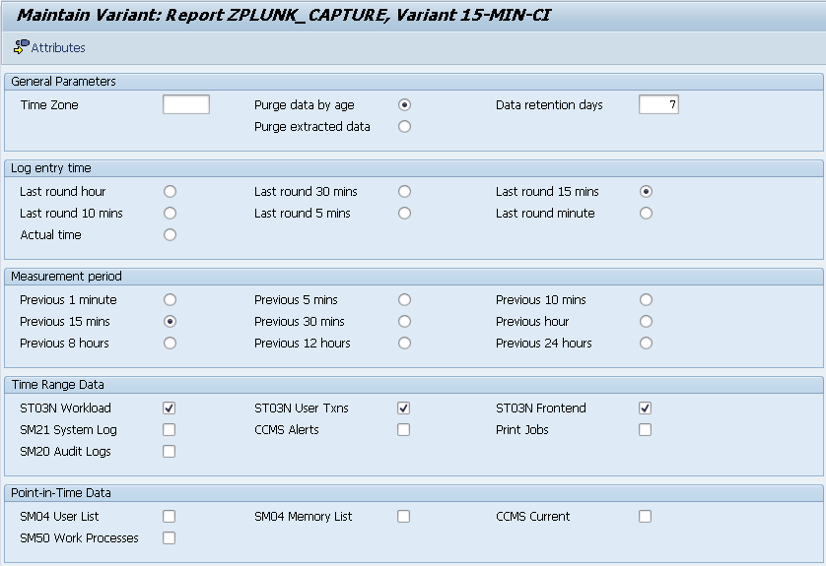

short cycle on central instance

Variant | 5-MIN-CI
Description | 5 minute cycle for Central Instance

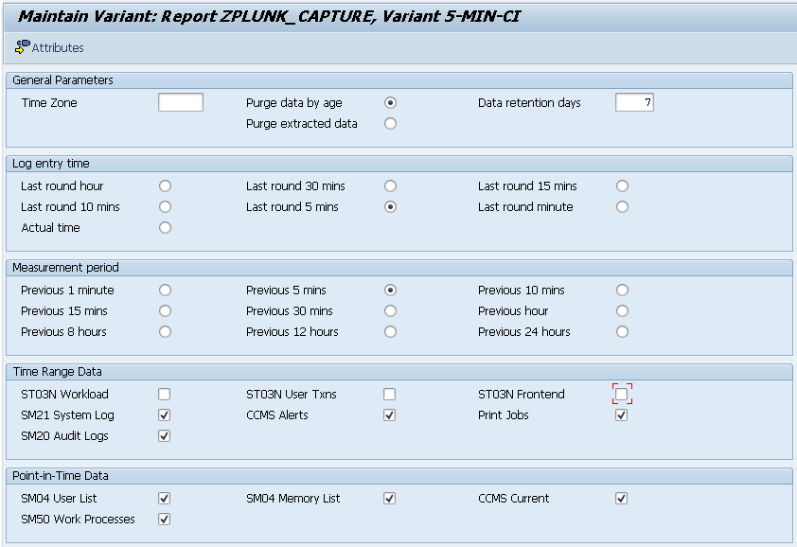

short cycle on application servers
The application server variant excludes CCMS Alerts and Print Jobs. Print jobs are system-wide so it makes sense to execute from the central instance variant. CCMS alerts are taken from the ALALERTS file, which is located centrally on the GLOBAL file system directory.

Variant | 5-MIN-APPSVR
Description | 5 minute cycle for Application Servers

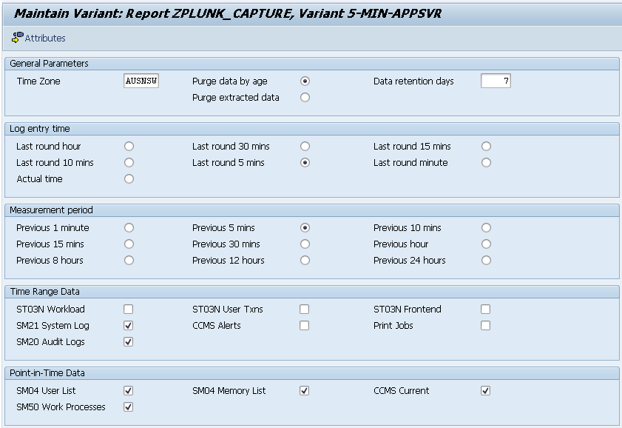

Configure ZPLUNK_CCMS_MTES
Give a man a fish, and you feed him for a day. Teach a man to fish and you feed him for life.

This section is not going to tell you what MTE’s to monitor. It will only explain how to add MTE’s to be collected with the “CCMS Current” option ticked.

By way of example, if you wanted to collect the CCMS for space used by the Initial Records buffer, this is what you would do. First, find the MTE in transaction RZ20.

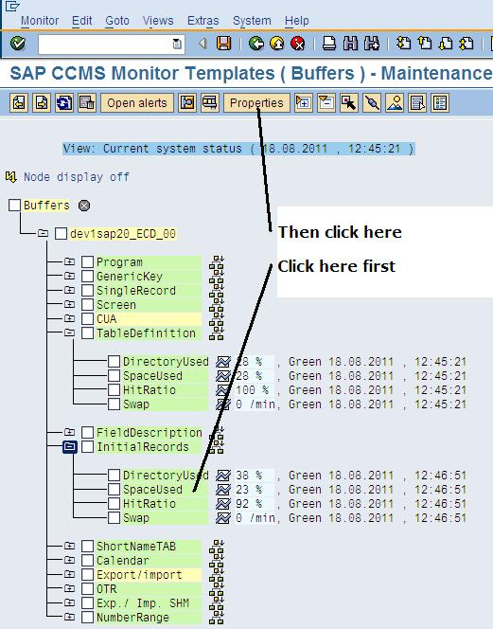
This will bring you to the money screen. Grab hold of the highlighted value.

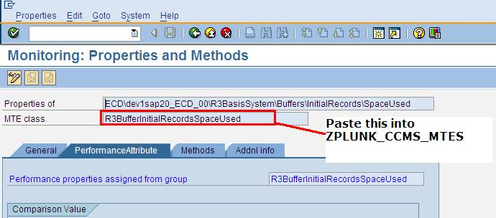

Start transaction SM30 and edit the table ZPLUNK_CCMS_MTES. Paste in this MTE name as a new value. Repeat for every MTE that you want to capture a current value snapshot for.

Note It is not necessary to do this for alerts. All CCMS alerts will be fetched regardless of what is in this table

Create transport
As you have been following the steps in this document, you have probably already assigned these objects to a transport request which you can use to push the collector to downstream systems.

To create a new complete transport, with everything you have just set up:

Start transaction SE80

Select the object type Package

Enter ZPLUNK

Click on the Glasses to display the package

Right-click on ZPLUNK and choose Write transport entry. When prompted, choose All Objects

To transport the variants, start transaction SA38 and execute report RSTRANSP. Enter ZPLUNK_CAPTURE as the program name and leave the variant name blank. Click execute and tick all the variants displayed. Assign them to your package transport.

To include the values that you coded into table ZPLUNK_CCMS_MTES, execute transaction SE10, find your transport, double-click on it to edit the objects and manually add and object entry

R3TR | TABU | ZPLUNK_CCMS_MTES

Enter a key value of “*” to select all keys. If this freaks you out a bit, you can edit that table manually in each of your downstream systems with transaction SM30.

Schedule collectors
Now you have all the ingredients to schedule the collectors. I am not going to cover what security the user account needs, as I typically execute these jobs with a privileged system user.
It is important to schedule a collector on each ABAP application server by specifying the execution host when creating the job from transaction SM36.
I recommend scheduling the following jobs

ZPLUNK_CAPTURE_15MINS_<Central Instance Host>
Execution host = <Central Instance Host>
Report = ZPLUNK_CAPTURE
Variant = 15-MIN-CI
Frequency = 15 minutes
Start at = 00:03

ZPLUNK_CAPTURE_15MINS_<Application Server>
Execution host = <Each application server>
Report = ZPLUNK_CAPTURE
Variant = 15-MIN-CI (not a mistake)
Frequency = 15 minutes
Start at = 00:03

ZPLUNK_CAPTURE_5MINS_<Central Instance Host >
Execution host = <Central Instance Host>
Report = ZPLUNK_CAPTURE
Variant = 5-MIN-CI
Frequency = 5 minutes
Start at = 00:01

ZPLUNK_CAPTURE_5MINS_<Application Server>
Execution host = <Each application server>
Report = ZPLUNK_CAPTURE
Variant = 5-MIN-APPSVR
Frequency = 5 minutes
Start at = 00:01

Section 3 – Deploy Perl Extractor
Once you get to this point on your journey of installation, you should have
- Installed all of the necessary SAP code
- Created job variants
- Set up users and security required
- Scheduled the collector jobs

In simple terms, you should have some ABAP systems which have harvested lots of useful data. Now you are ready to ingest this data into a tool like Splunk (or Excel, SQL Server or whatever analytical tools you use).

The best way to extract captured information remotely from SAP is to use Perl to make remote function calls to the SAP system. This requires the use of the SAP Netweaver RFC Software Development Kit (NWRFCSDK). Ordinarily, one would need C/Perl sofware development skills to achieve this, but Piers Harding is to be acknowledged and thanked for his contributions in making this reachable by members of the general community. This site will endeavour to simplify the instructions even further, so they become basic instructions that any Windows or LINUX administrator can follow. If you wish to explore this area further, please visit Piers' site at http://search.cpan.org/dist/sapnwrfc/sapnwrfc.pm.
I have supplied instructions of how to perform this for Linux or Windows systems. This will hopefully give you enough clues if you need to do it for a different operating system like AIX or HP-UX. Of course, if you have to do this, please share the instructions with sapsplunk@gmail.com and we will incorporate it into the documentation for the community.

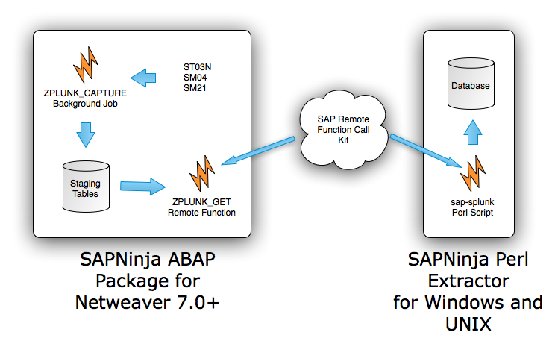

Security for the Extractors

Pre-prepared RFC Role

In this section, you will prepare the system to respond to external RFC calls by creating a user account with the appropriate access.

Use transaction PFCG in the SAP system to import the role ZSAPNINJA_RFC.SAP. Choose Role → Upload from the menu. You can download this file from the link http://code.google.com/p/sapninja/source/browse/trunk/splunk/ZSAPNINJA_RFC.SAP

From SAP transaction SU01, create a user (say SPLUNKRFC) of type Communications user and assign it the role of ZSAPNINJA_RFC

Security Technical Details
For data to be successfully extracted by the SAPninja perl script, you will need a user account in the target SAP system you are querying. The user only needs very minimal security. The account should be set up as a Communications User type so that the password never expires and nobody can log in interactively. The exact security required is as follows:
Auth Object | RFC Type | RFC Name | Activity
S_RFC | FUGR | SYST | 16
S_RFC | FUGR | RFC1 | 16
S_RFC | FUGR | SDIFRUNTIME | 16
S_RFC | FUGR | ZPLUNK_GET | 16
NB: The security above is sufficient for the account to perform the extractions, but not enough to pass the perl module installation tests. This will not prevent your installation working successfully, but will throw up error messages that you probably don't want to see at the time. The following security should be temporarily enabled for the purposes of SAPNW::Rfc perl module installation and then immediately removed.
Auth Object | ACTVT | DICBERCLS
S_TABU_DIS | 03 | SS

Auth Object | DEVCLASS | OBJTYPE | OBJNAME | P_GROUP | ACTVT
S_DEVELOP | SRCX | FUGR | GRFC |  | 03

Perl extractors on Linux
These instructions were developed on Red Hat Linux.

Install C Compiler

To install the module, you will need a gcc compiler on the system.

sudo yum install gcc

Acquire SAP NW RFC SDK libraries
You will need a valid SAP Marketplace account to download the nwrfcsdk libraries from SAP. At the time of writing, there were two versions available, 7.10 and 7.11. SAP indicate that the SDK libraries are backward-compatible, so it is a good idea to obtain the latest version. Be very sure to choose the version that matches your operating system architecture exactly.

The package is delivered as a *.SAR file, which is the SAP equivalent of tar in UNIX. To unpack it, you need the SAPCAR executable, which is also available from http://service.sap.com/patches. The navigation path will depend on your version but will be similar to this "Support Packages and Patches -> Entry by Application Group -> SAP NetWeaver and complementary products -> SAP NETWEAVER -> SAP NETWEAVER 7.0 -> Entry by Component" Application Server ABAP -> SAP KERNEL 7.00 64-BIT UNICODE -> Linux on x86_64 64bit -> #Database independent". You may need to rename the SAPCAR executable to remove any version information that forms part of its name, so that the file is called SAPCAR (or SAPCAR.exe if you use Windows).

Open http://service.sap.com/patches

Navigate to Entry by application group → Additional Components → SAP NWRFCSDK → SAP NW RFC SDK 7.10 → Linux on x86_64 64bit (or whatever you are using)

Download the SAR file

Unpack the SAR file with SAPCAR and save as c:\nwrfcsdk. To unpack the archive, the command will look similar to this
SAPCAR -xvf NWRFC_8-20004549.SAR

Copy the unpacked directory nwrfcsdk to a permanent location, say, /usr/sap/nwrfcsdk

INSTALL ADDITIONAL PERL MODULES
You need to have ActiveState Perl installed before doing these steps. Install the Perl prerequisite packages:
Open a windows command prompt and type the commands below

cpan ExtUtils::MakeMaker
cpan YAML

Acquire CPAN module for perl and sap
All prerequisites are now in place for the compilation and installation of the SAPNW::Rfc perl module. Obtain the sapnwrfc-0.31.tar.gz gzipped tarball from CPAN (http://search.cpan.org/CPAN/authors/id/P/PI/PIERS/sapnwrfc-0.31.tar.gz).
Unpack the tarball

tar -xvzf sapnwrfc-0.31.tar.gz

Change directory to the unpacked directory.

cd sapnwrfc-0.31

Edit the file sap.yml and customize the following parameters to match your own installation. This is required for perl module compilations tests to work.

ashost: <your sap server host>
sysnr: "<your sap system number>"
client: "<your sap client>"
user: SPLUNKRFC
passwd: <password of SPLUNKRFC>
lcheck: 1
lang: EN
trace: 0
debug: 0

Compiling the extractor
It is now time to compile and install the SAPNW::Rfc perl module. This can be done with the following commands. Note: the user on the SAP target system will need to have slightly elevated privileges to allow the successful completion of the tests in the make test command below.

export LD_LIBRARY_PATH=$LD_LIBRARY_PATH:/usr/sap/nwrfcsdk/lib
echo "/usr/sap/nwrfcsdk/lib" > /etc/ld.so.conf.d/sapnwrfcsdk.conf
/sbin/ldconfig
perl Makefile.PL
make
# For the next command, ignore the failures from test 06 onwards.
make test
make install

Create YAML connection file
SAPninja Perl Script - Deploy the splunk-sap.pl perl script on your Splunk server. It should be placed where your other scripted input scripts are located. Create a yml connection file called sap.yml. The contents need to look like this, but with the correct values for host, user, password, etc.

ashost: <your sap server host>
sysnr: "<your sap system number>"
client: "<your sap client>"
user: SPLUNKRFC
passwd: <password of SPLUNKRFC>
lcheck: 1
lang: EN
trace: 0
debug: 0

The splunk-sap.pl script can be executed as follows. Ensure that your LD_LIBRARY_PATH variable has been populated with the location of the SAP Netweaver libraries (i.e. /usr/sap/nwrfcsdk/lib). Download the sample perl script splunk-sap.pl. You can download this file from the link
http://code.google.com/p/sapninja/source/browse/trunk/splunk/splunk-sap.pl

export LD_LIBRARY_PATH=$LD_LIBRARY_PATH:/usr/sap/nwrfcsdk/lib
./splunk-sap.pl ./sap.yml ZPLUNK_SM50

Perl extractors on Windows
It is more difficult to set up the Perl extractors to Splunk on Windows than it is on LINUX due to peculiarities of the Windows C++ compilers and the environment generally. The instructions on this page will hopefully give you a sure-fire way to get one started before you try and use later versions of Visual C++ , Perl, or other components. I know for sure that these instructions will work with Visual C++ ExClick on Windows XP or Server 2003. If you manage to get the extractor working with later versions, we would appreciate you sharing the instructions so we can add them to this document.

Install C++
Install Visual C++ 2005 ExClick (Download from http://www.softpedia.com/progDownload/Microsoft-Visual-C-Toolkit-Download-11595.html)

Install Microsoft Platform SDK
Install MS Platform SDK for Windows XP/Server 2003 (Download from http://download.cnet.com/Windows-Server-2003-SP1-Platform-SDK-ISO-Install/3000-2070_4-10731571.html and rename from *.img to *.iso)

Install perl
Install ActiveState Perl (http://www.perl.org) . Navigate to the download page. Download and install ActivePerl version 5.10

Acquire SAP NW RFC SDK libraries
You will need a valid SAP Marketplace account to download the nwrfcsdk libraries from SAP. Proceed as follows

Navigate to http://service.sap.com/patches

Navigate to Entry by application group → Additional Components → SAP NW RFCSDK → SAP NW RFC SDK 7.10 → Windows Server on IA32 32bit (or whatever you are using)

Download the SAR file

Unpack the SAR file with SAPCAR and save as c:\nwrfcsdk. If you cannot find SAPCAR, please read the section that corresponds to this one within the section “Perl extractors on Linux”.

Acquire CPAN module for perl and sap
Download the CPAN Perl module for NWRFCSDK. Proceed as follows:

Navigate to http://search.cpan.org/dist/sapnwrfc/

Click the Download button to download sapnwrfc-0.31.tar.tar

Use winrar or similar to unpack the file to c:\sapnwrfc-0.31

INSTALL ADDITIONAL PERL MODULES
You need to have ActiveState Perl installed before doing these steps. Install the Perl prerequisite packages. Open a windows command prompt and type the commands below

cpan ExtUtils::MakeMaker
cpan YAML

Compiling the extractor
This activity can sort out the men from the boys. Proceed as follows:

Start → All Programs → Microsoft Platform SDK for Windows Server 2003 SP1

Choose Open build environment window

Choose Windows XP 32bit Build Environment (or Server 2003 if that is what you are using)

Choose Set Windows XP 32bit Build Environment (Retail) (or the corresponding W2K3 server option)

This will open up a command prompt which has all sorts of compiler-centric settings ready on it. Set up your environment variables by typing in the command shown on the next bullet points

"C:\Program Files\Microsoft Visual Studio 8\VC\vcvarsall.bat" x86
cd C:\sapnwrfc-0.31
perl Makefile.PL --addlibs ' -lm -ldl -lpthread '
/*Enter [c:/nwrfcsdk] if prompted*/

There will be a file called Makefile in your directory which was created by the command above. Edit this file to get compiler and linker to use options from SAP Note 1056696. You need to find the lines CCFLAGS and LDLOADLIBS and replace them with the following:

OSS_CCFLAGS = -DBCDASM -nologo -Od -Ob1 -fp:strict -Gy -GF -EHs -Z7 -W3 -Wp64 -D_X86_ -DWIN32 -DSAPwithUNICODE -DUNICODE -D_UNICODE -MD -D_AFXDLL -FR -J -RTC1 -D_CRT_NON_CONFORMING_SWPRINTFS -D_CRT_SECURE_NO_DEPRECATE -D_CRT_NONSTDC_NO_DEPRECATE -DSAPonNT -c /EHc- /TP
CCFLAGS = $(CCFLAGS) $(OSS_CCFLAGS)
OSS_LDLOADLIBS = -nologo /NXCOMPAT -STACK:0x800000 ole32.lib rpcrt4.lib oleaut32.lib oledb.lib uuid.lib kernel32.lib advapi32.lib user32.lib gdi32.lib winspool.lib ws2_32.lib Iphlpapi.lib netapi32.lib comdlg32.lib shell32.lib dbghelp.lib version.lib mpr.lib secur32.lib -OPT:REF -LARGEADDRESSAWARE -subsystem:console -out:*.exe *.obj sapnwrfc.lib libsapucum.lib sapdecfICUlib.lib
LDLOADLIBS = $(LDLOADLIBS) $(OSS_LDLOADLIBS)

Compile the libraries by executing the command

nmake

Create YAML connection file

Edit the file sap.yml(which is a connection file) so it is configured for your system

ashost: <your sap server host>
sysnr: "<your sap system number>"
client: "<your sap client>"
user: SPLUNKRFC
passwd: <password of SPLUNKRFC>
lcheck: 1
lang: EN
trace: 0
debug: 0

Test your installation by executing

nmake test

This will have some failures, but none should be due to failed RFC connections or authentication problems.

Install your Perl module so it is ready for use by executing

nmake install

Download the sample perl script splunk-sap.pl. You can download this file from the link http://code.google.com/p/sapninja/source/browse/trunk/splunk/splunk-sap.pl . Modify the contents of this script to meet your needs, in particular which dataset you want to extract. A good one to start with is ZPLUNK_SM50.
Perform a test execution of your splunk extractor

Open a windows command prompt

cd /d c:\sapnwrfc-0.31
perl splunk-sap.pl sap.yml ZPLUNK_SM04USR

Note You need to have scheduled the ZPLUNK_CAPTURE data gathering jobs on the SAP system to collect information that can be returned by this call.

Note If you execute this command for a second time, it will not return any data that you have extracted already. You will never get the same information twice if you retrieve the data using the ZPLUNK_GET function module. If you are testing, you will need to re-execute ZPLUNK_CAPTURE on the server for the relevant data set to get some more data.

Note You can pipe the output of the command file to a text file by suffixing a "> file.txt" at the end of the example perl statement above.

