SAP Ninja

Mass Activation of SAP Ninja

Data Dictionary Objects

Prepared by

Jim Cooke

[www.sapninja.com](http://www.sapninja.com)

[sapsplunk@gmail.com](mailto:sapsplunk@gmail.com)

# Instructions

The SAP Ninja nugget for Splunk delivers dozens of data dictionary objects, which would be tedious to activate manually. The following screenshots show how to perform a mass activation of these objects. Start transaction *SA38* and execute program *RADMASG0.*

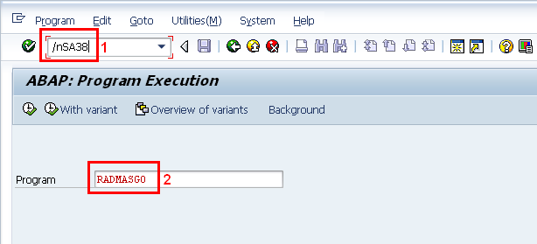

Click on the *Direct Objects* button at the selection screen.

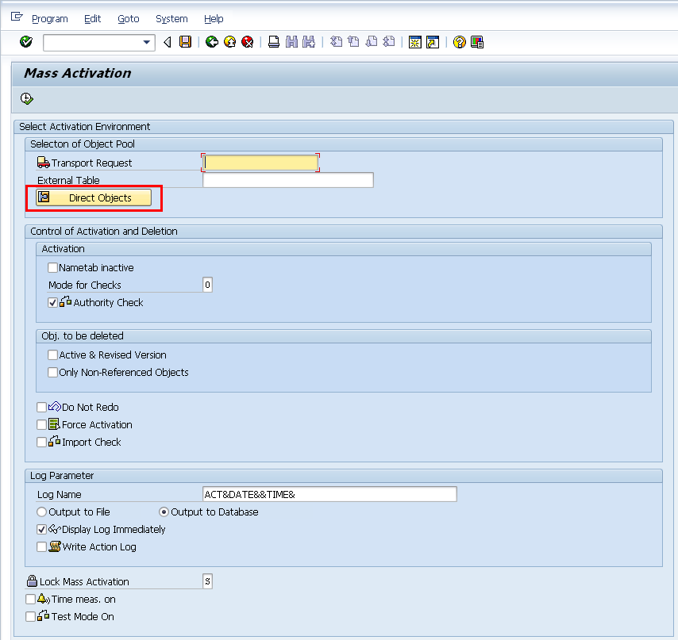

Enter *ZSAPNINJA\** as the selection for *Domains, Data Elements* and *Tables*. Press the *Execute* button.

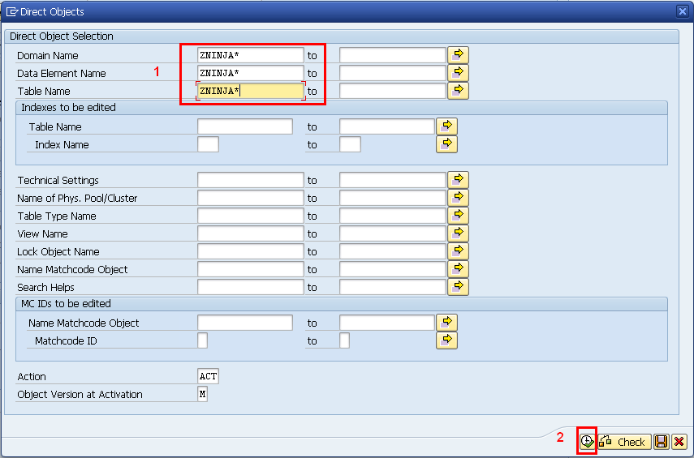

You will return to the selection screen. Press the *Execute* button and all the SAP Ninja DDIC objects will be activated in one swoop.

