Arithmetic Logic Unit Specification

Description:

The ALU controls all of the arithmetic, logic and check functions of the system, it takes in a function select, a request signal and one or two 32-bit words and outputs a 32-bit result and 4 flags; the carry flag, negative flag, zero flag and the overflow flag. Upon completion of a function it returns an ALU acknowledge signal to let the instruction decoder know that it has finished.

Block Diagram:
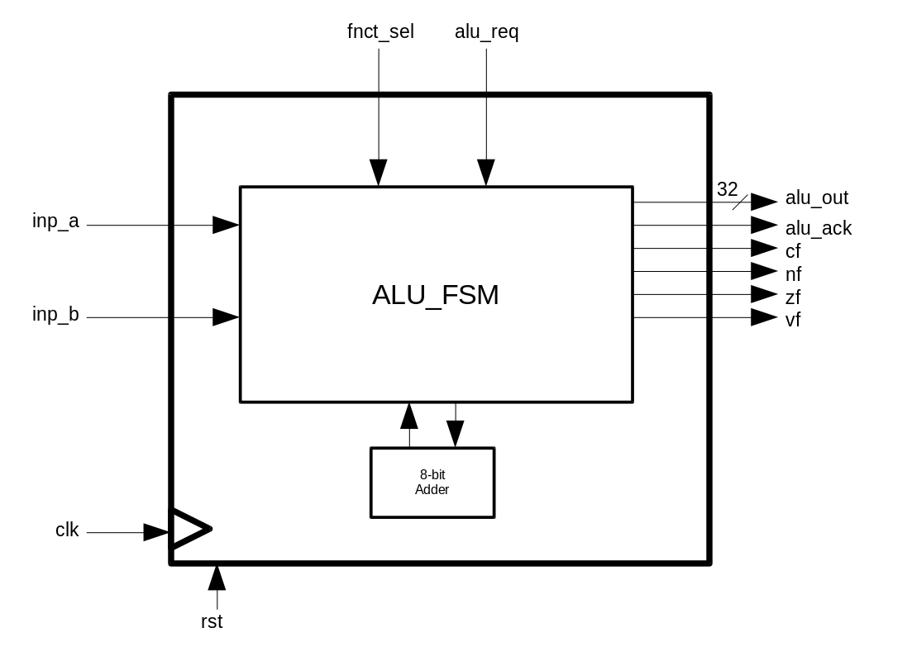

Input/ Outputs:

Name (Abbrev.) - (Size in bits): | Direction: | Description:
Clock (clk) – (1) | Input | Input from system clock
Reset (rst) – (1) | Input | Input from system reset
Input A (inp_a) - (32) | Input | This is Reg1 in the instruction parameters, it will be the input for shifts and checks
Input B (inp_b) - (32) | Input | This is Reg2 in the instruction parameters, it does not connect to the shifters and checks.
Function Select (fnct_sel) - (6) | Input | This is how the system chooses what function is being executed.
ALU Request (alu_req) – (1) | Input | This is the request signal to begin an ALU operation.
Output (out) - (32) | Output | This is the Reg3 of the instruction parameters, this is the result of any function in the ALU.
Carry Flag (cf) - (1) | Output | This is asserted when the carry out of the adder goes high.
Negative Flag (nf) - (1) | Output | This is asserted when the result of a calculation or check is negative.
Zero Flag (zf) - (1) | Output | This is asserted when the result of a calculation or check is zero.
Overflow Flag (vf) - (1) | Output | This is asserted when the result of a calculation overflows.
ALU Acknowledge (alu_ack) – (1) | Output | This is asserted when the calculation is complete

States:

0 →Idle
1 →ADD
2 →SUB
3 →AND
4 →OR
5 → XOR
6 → SFL
7 → SFR
8 → Check
9 → Byte 00
A → Byte 01
B → Byte 10
C → Byte 11
D → Ack.
E → Delay

