Global Implementation

Block Diagram:
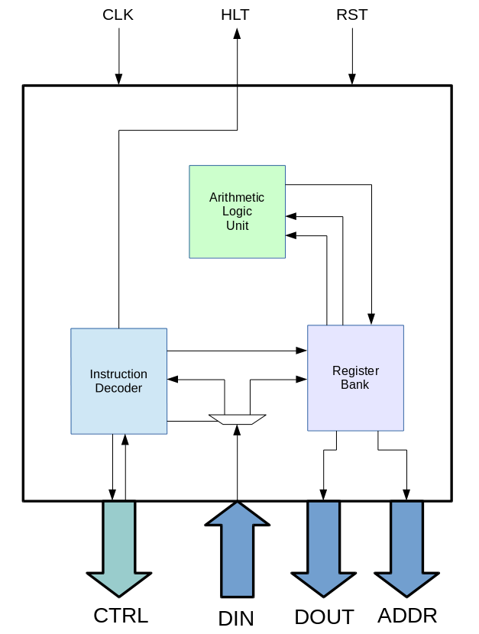

Internal Modules:

Name (Abbrev.): | Description:
Register Bank - (RB) | This module consists of the 16 general purpose 32-bit registers, the 32-bit program counter register and the associated management circuitry for the registers.
Arithmetic Logic Unit - (ALU) | This module consists of all the arithmetic and logic functions the processor can perform, it also contains logic to determine whether or not a value entered is equal to, greater than or less than zero. It takes in one or two 32-bit words as inputs and outputs one 32-bit word as it's output.
Instruction Decoder - (ID) | This module consists of the the logic that decodes and executes instructions, it takes in a 32-bit instruction and outputs all the control signals necessary.
Data Input Mux - (DIB) | This module consists of the logic controls where the data input bus feeds to, either the register bank or the instruction decoder.

Inter-module Communication:

This system will use a request response communication system with the ID as the master and all other modules as slaves.

The protocol for this system is once the ID issues a request or operation, the system will not continue it's execution until the associated module returns it's acknowledge signal. For example with an ADD instruction, once the ID feeds in the selected function, the carry in and the two input words, it will not continue with execution until the ALU returns an acknowledge signal to signify that it is safe to transfer the result to a register.

For further information refer to the respective .odt files for each block.

