Instruction Decoder Implementation

Description:

The instruction decoder is the conductor of the system, based on the instructions it receives it sends out the appropriate signals to the appropriate modules. It takes in a 32-bit instruction, and has multiple output signals including a 16-bit immediate value bus straight to the register bank, it then takes in feedback signals, such as acknowledge signals, so it knows when a module has completed it's action and the ALU check flags. The instruction decoder will be implemented via state machine.

Flow Chart:
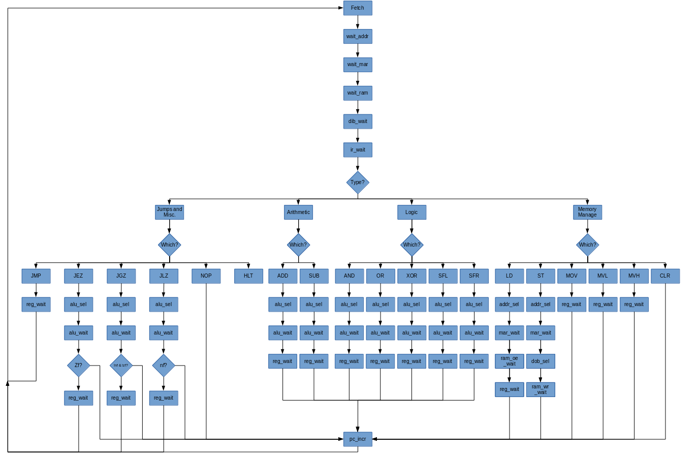
Inputs/ Outputs:

Name (Abbrev.) - (Size) | Direction: | Description:
Clock (clk) – (1) | Input | Input from system clock
Reset (rst) – (1) | Input | Input from system reset
Instruction Register Input (ir_en) - (32) | Input | This is the input from the data input bus carrying the instruction.
Carry Flag (cf) - (1) | Input | This is the carry flag from the ALU, it goes high when the carry out goes high.
Negative Flag (nf) - (1) | Input | This is the negative flag from the ALU, it goes high when the result of the ALU is negative.
Zero Flag (zf) - (1) | Input | This is the zero flag from the ALU, it goes high when the result of the ALU is zero.
Overflow Flag (vf) - (1) | Input | This is the overflow flag from the ALU, it goes high if the result of the ALU overflows.
ALU Acknowledge (alu_ack) - (1) | Input | This is the ALU acknowledge signal from the ALU, it let's the instruction decoder know that the ALU has finished it's operation.
Register Write Ack. (reg_wr_ack) - (1) | Input | This is the register acknowledge signal from the register bank, it let's the instruction decoder know that the selected register has been successfully written to.
MAR Write Ack. (mar_wr_ack) - (1) | Input | This is the MAR acknowledge signal from the RAM, it let's the instruction decoder know that the MAR has been successfully written to.
RAM Write Ack. (mar_wr_ack) - (1) | Input | This is the RAM write acknowledge signal from the RAM, it let's the instruction decoder know that the RAM has been successfully written to.
RAM Read Ack. (mar_oe_ack) - (1) | Input | This is the RAM read acknowledge signal from the RAM, it let's the instruction decoder know that the RAM has successfully outputted to the data bus.
Data Input Bus Ack. (dib_ack) – (1) | Input | This is the DIB read acknowledge from the DIB mux, it let's the instruction decoder know that the data from the DIB is available on it's output.
ALU Request (alu_req) – (1) | Output | This is the request signal to activate an ALU function.
Immediate Value Out (imme_out) - (16) | Output | This is the 16-bit data bus that carries the immediate value from the MVL/MVH commands to the register bank.
ALU Funct. Select (alu_fnct_sel) - (6) | Output | This is the address bus that the instruction decoder uses to tell the ALU which function to output.
ALU Input A Select (alu_a_sel) - (8) | Output | This is the address bus that the instruction decoder uses to tell the register bank which register to output onto the input A of the ALU.
ALU Input B Select (alu_b_sel) - (8) | Output | This is the address bus that the instruction decoder uses to tell the register bank which register to output onto the input B of the ALU.
Address Output Select (addr_sel) - (8) | Output | This is the address bus that the instruction decoder uses to tell the register bank which register to output onto the address bus.
Data Output Bus Select (dob_sel) - (8) | Output | This is the address bus that the instruction decoder uses to tell the register bank which register to output onto the data output bus.
Reg. To Reg. Select (rtr_sel) - (8) | Output | This is the address bus that the instruction decoder uses to tell the register bank which register is the output register in the MOV command
High/Low Half Select (hl_sel) - (2) | Output | This is the control bus that the instruction decoder uses to select whether the upper, lower or both halfs of the selected register are being written to.
RB Input Select (rb_ip_sel) - (3) | Output | This is the control bus that the instruction decoder uses to select which input feeds into the register bank.
RB Input Reg. Select (rb_ip_reg_sel) - (8) | Output | This is the address bus that the instruction decoder uses to tell the register bank which register is going to be written to.
RB Reg. Clear Select (rb_reg_clr_sel) - (8) | Output | This is the address bus that the instruction decoder uses to tell the register bank which register is going to be cleared.
Data Input Bus Select (dib_sel) - (1) | Output | This is the control signal to direct the data input bus to the instruction decoder, for instructions, or to the register bank, with data.
Register Write (reg_wr) - (1) | Output | This is the register write signal that requests the selected register to write.
Register Clear (reg_clr) - (1) | Output | This is the register clear signal that clears the selected register.
PC Increment (pc_incr) - (1) | Output | This is the increment signal for the program counter located in the register bank.
MAR Write (mar_wr) - (1) | Output | This is the MAR write signal which requests the MAR to write.
RAM Write (ram_wr) - (1) | Output | This is the RAM write signal which requests the RAM to write.
RAM Read (ram_oe) - (1) | Output | This is the RAM read signal which requests the RAM to read.
Halt (halt) – (1) | Output | This is the signal that halts the external oscillator.

Block Diagram:

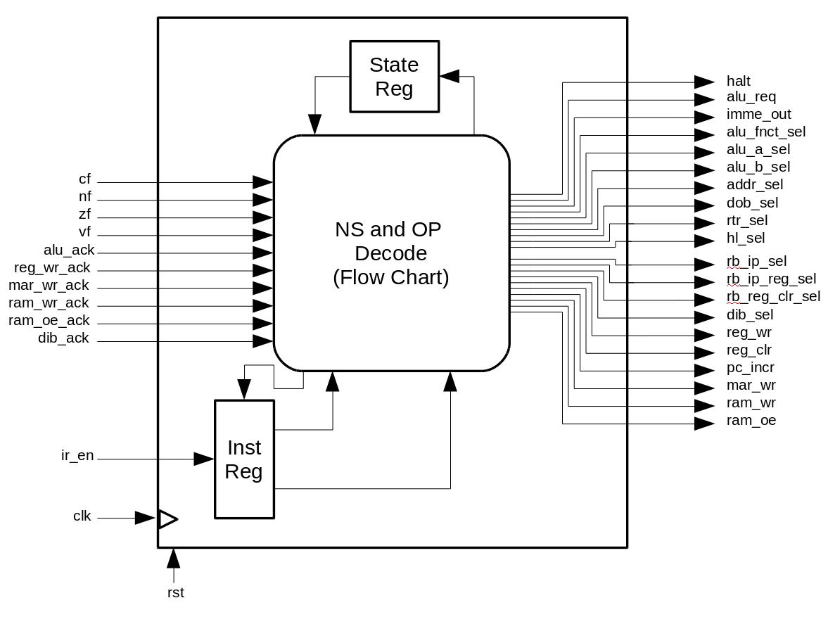
States:

0 → Fetch
1 → Wait Addr.
2 → Wait MAR
3 → Wait RAM OE
4 → DIB Wait
5 → IR Wait
6 → JMP Misc
7 → Arith
8 → Logic
9 → Mem Man
A → NOP
B → JMP
C → JEZ
D → JGZ
E → JLZ
F → HLT
10 → ADD
11 → SUB
12 → AND
13 → OR
14 → XOR
15 → SFL
16 → SFR
17 → LD
18 → ST
19 → MOV
1A → MVL
1B → MVH
1C →CLR
1D → ALU Sel
1E → Addr Sel
1F→ DOB Sel
20 → Reg Wait
21 → ALU Wait
22 → MAR Wait
23 → RAM OE Wait
24 → RAM WR Wait
25 → PC Plus
26 → PC Wait

