Register Bank Implementation

Description:

The register bank controls all of the interactions with the general purpose and special function registers. It controls which inputs are fed to the registers, which register will be written to or cleared, it also controls which half of the register that will be written to, the register bank will return an acknowledge signal from the selected register once a write operation has completed. It also controls which register will be outputted to what bus, the system has been set up to allow for each output bus to be used simultaneously.

Block Diagram:
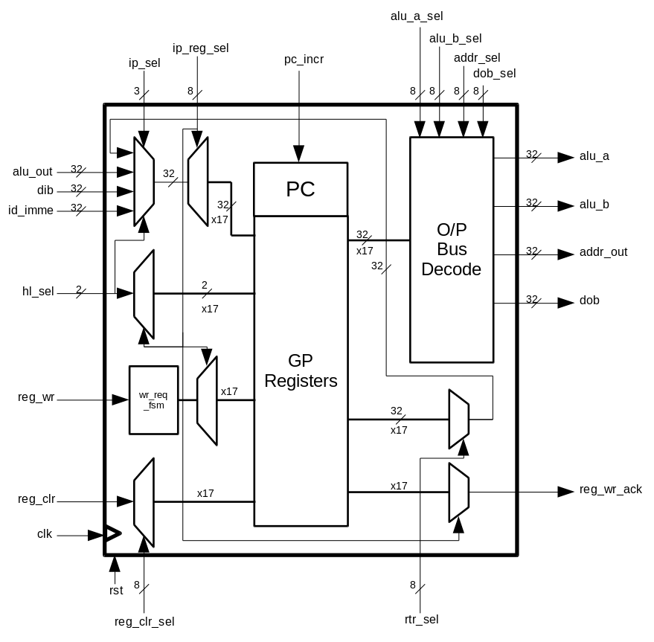

Input/ Outputs:

Name (Abbrev.) - (Size): | Direction: | Description:
Clock (clk) – (1) | Input | Input from system clock
Reset (rst) – (1) | Input | Input from system reset
ALU Output (alu_out) - (32) | Input | This is the output from the ALU that feeds back into the bank after a calculation is finished.
Data Input Bus (dib) - (32) | Input | This is the input bus from the RAM or other external devices.
Instruction Decoder Value (id_imme) - (16) | Input | This is the immediate data value that will be entered into either the lower or upper half of a register.
ALU Input A Select (alu_a_sel) - (8) | Input | This is the address that selects which register will be used for the input A of the ALU.
ALU Input B Select (alu_b_sel) - (8) | Input | This is the address that selects which register will be used for the input B of the ALU.
Address Output Select (addr_sel) - (8) | Input | This is the address that selects which register will be used as the output onto the address bus.
Data Output Bus Select (dob_sel) - (8) | Input | This is the address that selects which register will be used as the output to the data bus.
Reg. To Reg. Output Select (rtr_sel) - (8) | Input | This is the address that selects which register will be used at the output between two registers.
High or Low Half Select (hl_sel) - (2) | Input | This is the address that selects which half of the register that will be written to, upper, lower or both.
Input Select (ip_sel) - (3) | Input | This is the address that selects which input bus will be used as the input to the registers.
Input Register Select (ip_reg_sel) - (8) | Input | This is the address that selects which register will be inputted to.
Register Clear Select (reg_clr_sel) - (8) | Input | This is the address that selects which register will be cleared.
Register Write Request (reg_wr) - (1) | Input | This is the write request for the selected input register.
Register Clear (reg_clr) - (1) | Input | This is the clear signal for the selected register.
Program Counter Increment (pc_incr) - (1) | Input | This is the signal to tell the program counter to increment by 1.
ALU Input A (alu_a) - (32) | Output | This is the output bus to the input A of the ALU.
ALU Input B (alu_b) - (32) | Output | This is the output bus to the input B of the ALU.
Address Output (addr_out) - (32) | Output | This is the output bus to the address bus.
Data Output Bus (dob) - (32) | Output | This is the output bus to the data output bus.
Register Write Ack. (reg_wr_ack) - (1) | Output | This is the write acknowledge from the selected register to let the instruction decoder know that the write has been completed.

