ALU Design

- 8-bit ALU with 2's complement
- Using : 2x 74LS86 → XOR gates
2x 74LS283 → 4-bit adders
1x 74LS645 → Octal bus transceivers
- Micro-instructions → ALI, ALO, CYI

Diagram:

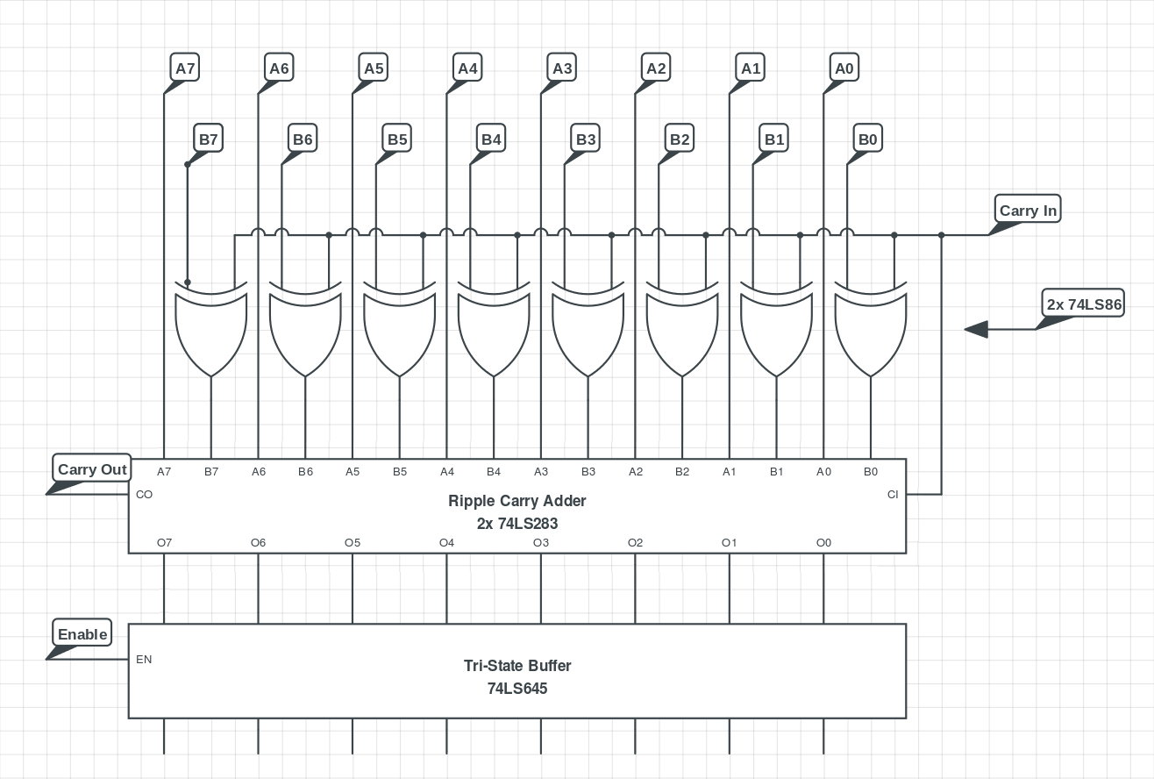
Build:

