A/B Registers

- Both 8-bit Registers
- Both have separate outputs to ALU
- Using: 4x 74LS175 → Quad D flip-flop
4x 74LS346 → Octal bus transceiver
- Micro-instructions → AI, AO, AC, BI, BO, BC

Design:

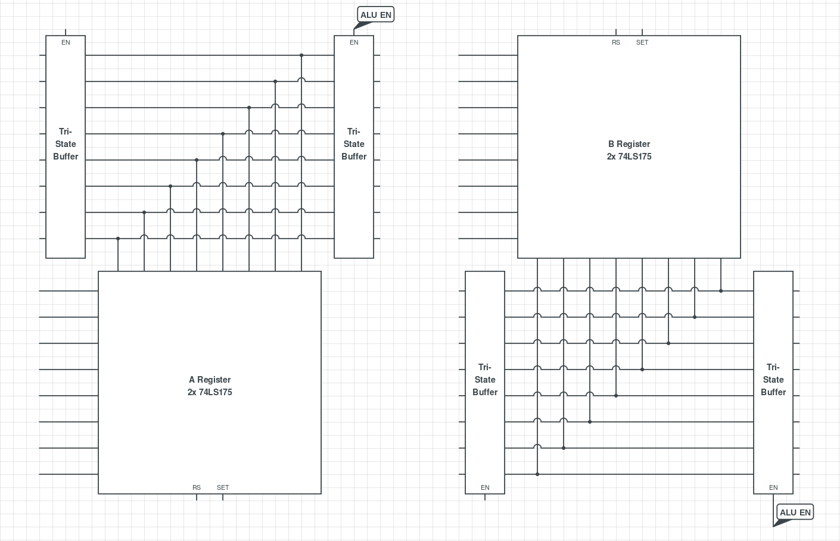

Build:

A Register:

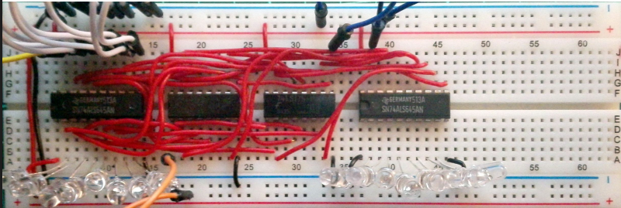
B Register:

