Clock Design

- Frequency range: 0.1Hz → 10Hz
- Two modes: Astable
Monostable
- Using: 3x NE555 → Timer IC
2x 74LS00 → Quad NAND gates
- Micro-instructions → HLT

Design:

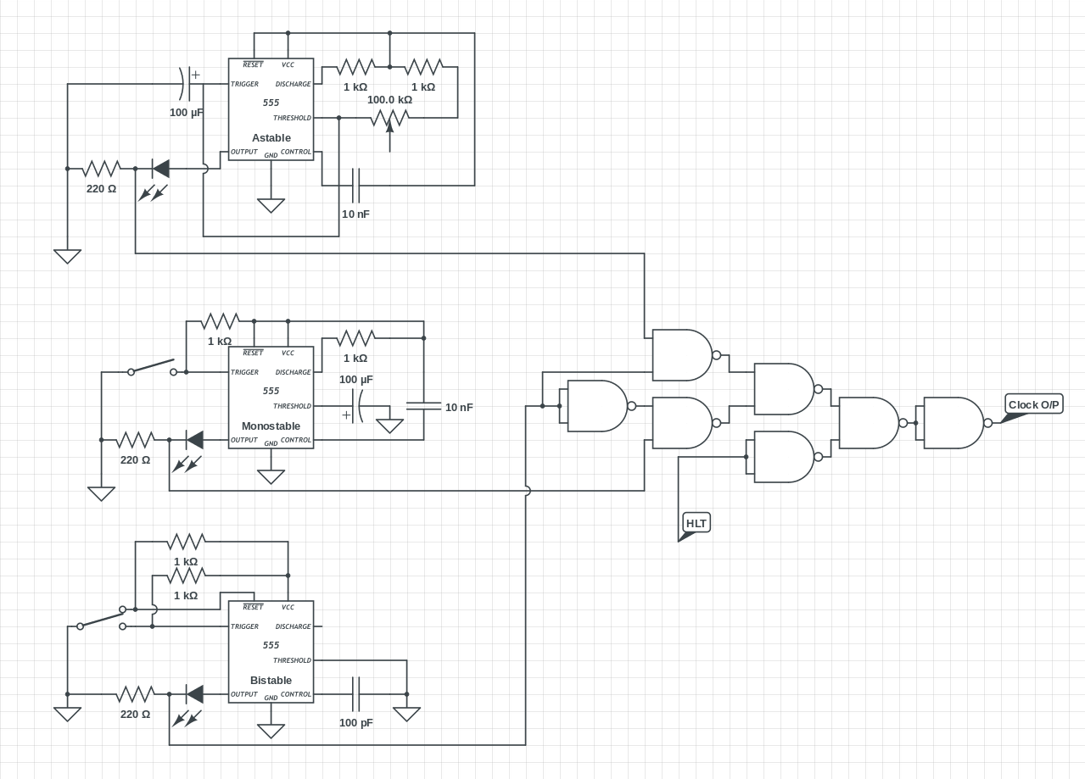

Build:

