I/O Design

- 8-bit I/O Register
- 4 seven segments displays for 2's complement
- Input DIP switch
- Using: 2x 74LS175 → Quad D flip-flop
1x AT28C16 → 2kB parallel EEPRIM
1x 74LS139 → 2-to-4 Decoder
1x 74LS76 → Dual JK flip-flop
1x NE555 → Timer IC
- Micro-instructions → OI, OO, OC, 2C

Design:

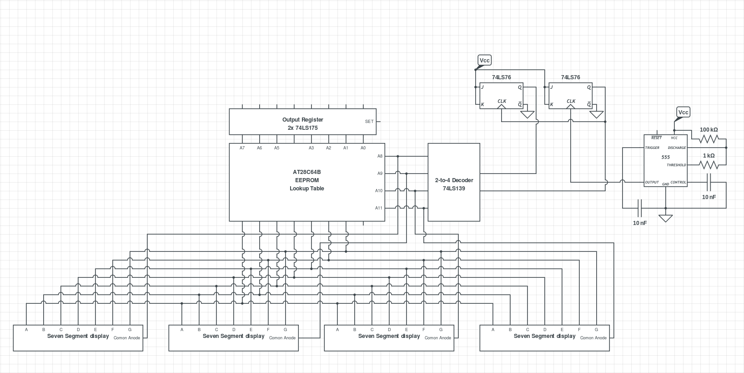

Build:

