Null Register Design

- 8-bit register will all I/P tied low
- Using: 2x 74LS175 → Quad D flip-flop
1x 74LS645 → Octal bus transceiver
- Micro-instructions → NO

Design:

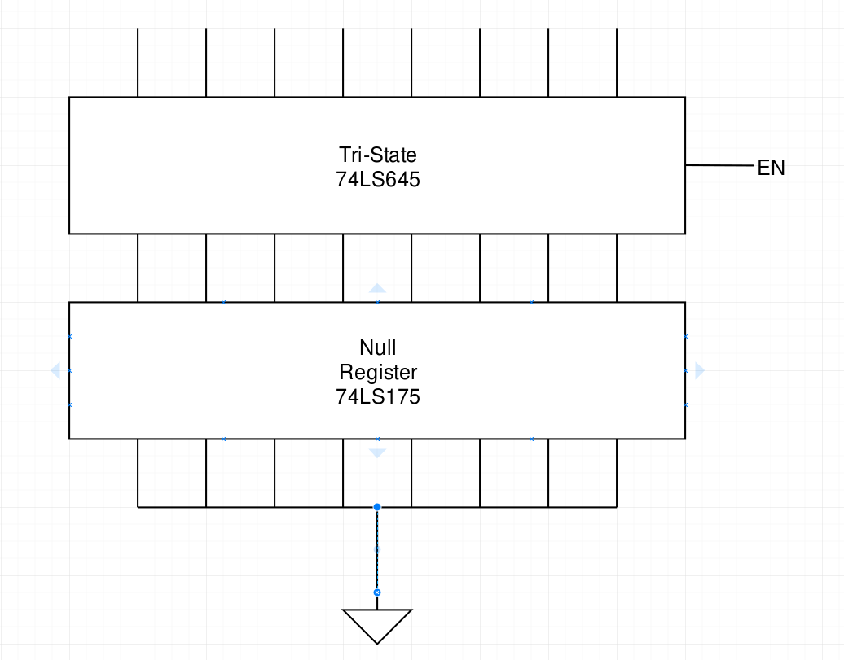
Build:

