Program Counter Design

- Using: 2x 74LS93 → 4-bit Counter
1x 74LS645 → Octal bus transceivers
- Micro-instructions → PI,PO,PE

Diagram:

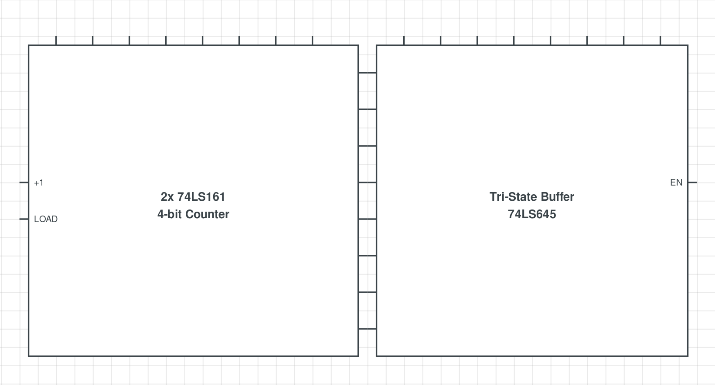
Build:

