RAM Design

- 256 Bytes
- Two modes: → Run
→ Programmable
- Can hand program using two DIP switches, one for addresses, one for data
- Using: 1x CY62256NLL-70PXC → 32kb of SRAM, 70ns response time
2x 74LS175 → Quad D flip-flop
3x 74LS157 → 2-to-1 data select
1x 74LS645 → Octal bus transceiver
- Micro-instructions → RI, RO, MI

Design:

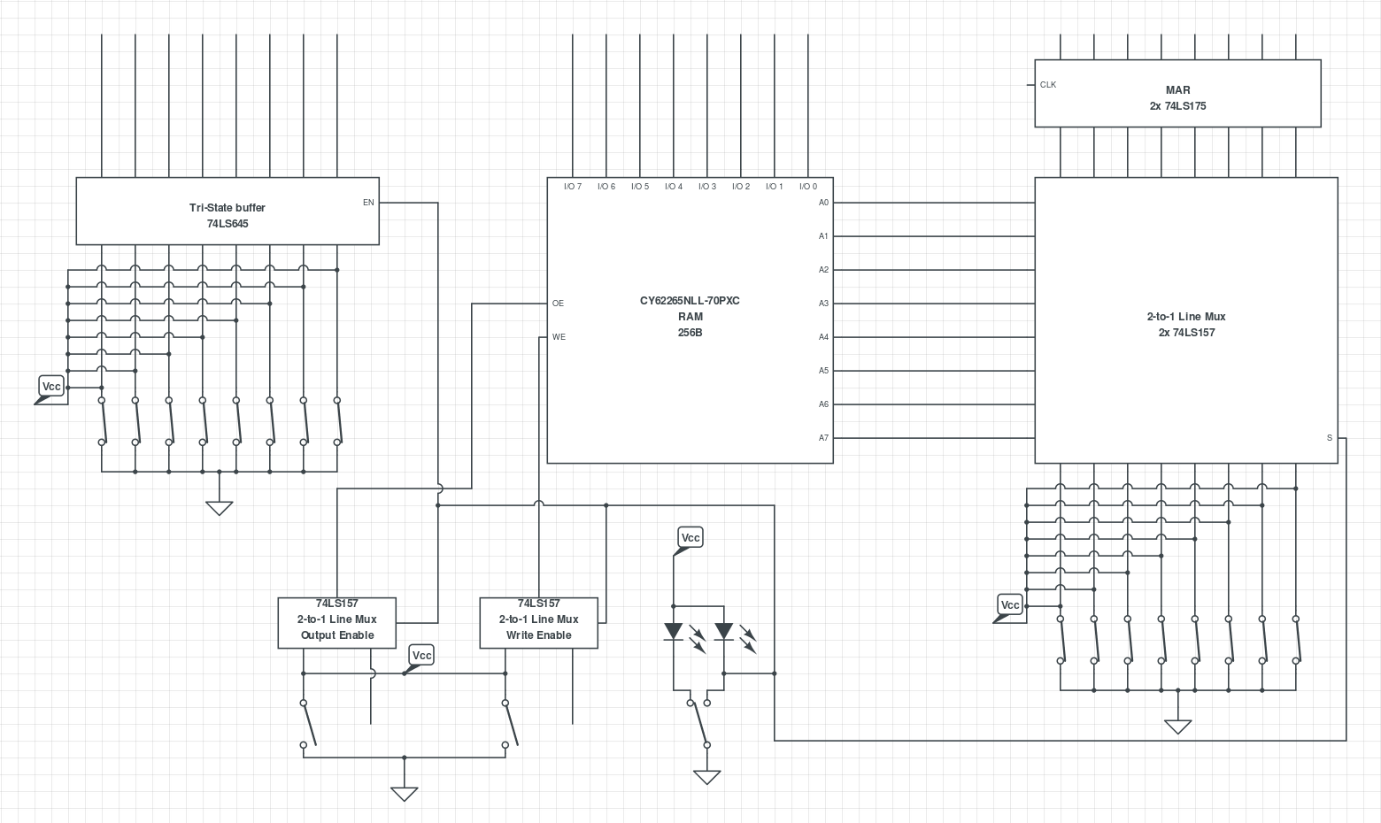

Build:

