Collection of atypical structures found in this work, with a case by case explanation of why they were included as valid SL-RNAs.

* **Outlier1**: Unique_SL-8, Unique_SL-9, Unique_SL-10 and Unique_SL-72Esquemático

  Descripción generada automáticamente con confianza media

The first expected hairpin is recognizable but the 3’ region joins with parts of the second, leaving the SM-like site in the third hairpin loop. These sequences were selected they resemble the untrimmed reference sequences AJ292365.1 and AJ292377.1 for *E. multilocularis* and *E. granulosus* respectively.

* **Outlier2**: Unique_SL-33

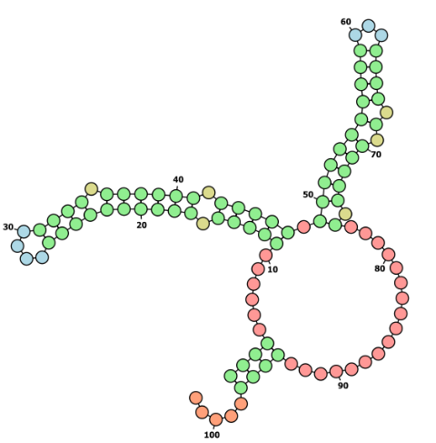

A portion of the terminal regions of the SL join, closing the structure. It was selected because our testing suggests this is a common occurrence when the 3’ terminal hairpin is not recovered fully (see **Supplementary File 4**).

* **Outlier3**: Unique_SL-11Gráfico, Gráfico de dispersión

  Descripción generada automáticamente

The first expected hairpin is recognizable but the 3’ region joins with parts of the second, leaving the SM site in the third hairpin loop. These sequences were selected because they resemble the untrimmed reference sequences AJ292365.1 and AJ292377.1 for *E. multilocularis* and *E. granulosus* respectively.

* **Outlier4**: Unique_SL-12Gráfico, Gráfico de dispersión

  Descripción generada automáticamente

The first expected hairpin is recognizable but the 3’ region joins with parts of the second, leaving the SM site in the third hairpin loop. These sequences were selected because of the untrimmed reference sequences AJ292365.1 and AJ292377.1 for *E. multilocularis* and *E. granulosus* respectively.

* **Outlier5**: Unique_SL-43

The normally unpaired region of the leader sequence forms a hairpin with the Maximum Expected Accuracy (MEA) method. This SL was reported on our previous work (Calvelo et al., 2023)and is present on *H. microstoma* transcriptome in approximately 15% of the processed reads, and therefore included in the analysis.

* **Outlier6**: Unique_SL-50Gráfico, Gráfico de dispersión

  Descripción generada automáticamente

The main hairpin of Schistomidae SLs, reason why it was included in the analysis, but the 3’ has a weak tendency to form an internal loop, surrounding the SM-like site.

* **Outlier7**: Unique_SL-60Forma

  Descripción generada automáticamente con confianza media

While the 3’ hairpin is present in some form, a portion of the terminal regions of the SL join, closing the structure. It was selected because our testing suggests this is a common occurrence when the 3’ terminal hairpin is not recovered fully (see **Supplementary File 4**).

* **Outlier8:** Unique_SL-61Gráfico, Gráfico de dispersión

  Descripción generada automáticamente

A portion of the terminal regions of the SL join, closing the structure. It was selected because our testing suggests this is a common occurrence when the 3’ terminal hairpin is not recovered fully (see **Supplementary File 4**).

* **Outlier9**: Unique_SL-64Imagen que contiene Forma

  Descripción generada automáticamente

A portion of the terminal regions of the SL join, closing the structure. It was selected because our testing suggests this is a common occurrence when the 3’ terminal hairpin is not recovered fully (see **Supplementary File 4**).

Calvelo, J., Brehm, K., Iriarte, A., & Koziol, U. (2023). Trans-splicing in the cestode Hymenolepis microstoma is constitutive across the life cycle and depends on gene structure and composition. *International Journal for Parasitology*, *53*(2), 103–117. https://doi.org/10.1016/j.ijpara.2022.11.006