**Swarm Intelligence for Next Generation Healthcare**

(a Co-ordinated AI Approach)

Report Submitted

By

**Jaya Chandra Terli 223200017**

**Naga Sai Aditya Chakrapani 224200071**

Computational Intelligence in Automation

**Apl. Prof. Dr.-Ing. habil. Mohit Kumar**

[](https://www.uni-rostock.de/)

Table of Contents

List of Figures iii

Abstract 1

Keywords 1

1. Introduction & Motivation 2

2. Background 2

2.1 Origin and Biological Inspiration 2

2.3 Comparison with Traditional AI and Centralized Systems 3

2.4 Technical Algorithms Based on Swarm Intelligence 4

3. Swarm Learning: Bridging SI and Machine Learning 5

3.1 Why SI is Suitable for Healthcare 5

4. Challenges in Clinical Environments 6

4.1 Staff Turnover and Evolving Roles 6

4.2 Inconsistent and Non-Structured Data Practices 6

4.3 Workflow Fragmentation Across Departments 6

4.4 Data Sharing Across Institutions 6

4.5 Loss of Context Over Time 7

5. New Strategies via SI/SL 7

5.1 Strategy-1: Adaptive AI Models for Enhanced Clinical Workflows 7

5.2 Strategy-2: Leveraging Swarm Learning for Collaborative Digital Twins 8

6. Case Studies 9

6.1. Case Study: Dynamic Patient Visit Segmentation using Gaussian Mixture Models (GMM) 9

6.2. Case Study: Anonymization in Medical Imaging Technologies (CT, PET, MRI) 11

7. Limitations and Ethical Considerations 12

8. Conclusion 12

9. Data availability 12

10. References 13

## List of Figures

Fig. 1. Core Principles of Swarm Intelligence 3

Fig. 2. Swarm Intelligence Algorithms used in healthcare datasets [3] 5

Fig. 3. Medical application of chatbots [10] 7

Fig. 4. Combining embodied AI with LLM-powered DTs to construct AI agents [2] 8

Fig. 5. Visit Group Segmentation using Gaussian Mixture Model 10

Fig. 6. CT scan Anonymisation (comparison of Gradient Images) 12

## Abstract

In modern healthcare, particularly in dynamic clinical settings where personnel rotate frequently and data management systems are continually upgraded, maintaining consistency in patient care and data handling remains a persistent challenge. Traditional centralized approaches to artificial intelligence often fail to account for the heterogeneity, decentralization, and human variability that characterize real-world medical institutions. Swarm Intelligence (SI), inspired by the collective behavior of decentralized, self-organizing systems found in nature, offers a compelling framework for addressing these issues.

This report explores the concept of Swarm Intelligence and its specific instantiation in Swarm Learning (SL), an emerging AI paradigm that enables decentralized training of machine learning models across multiple institutions without sharing raw data. We discuss real-world challenges in clinical settings, including those observed at the University of Medicine Rostock, and propose two novel strategies leveraging the latest SI/SL trends. Further, we examine two detailed case studies: a data-driven study based on firsthand observations in a clinical environment at the neurology centre at University of Rostock, and a case study on advanced methods for anonymizing 3D medical imaging data (MRI, CT, PET). We emphasize the usefulness of these case studies within coordinated AI systems for next-generation healthcare and illustrate how they can be integrated as components of SI/SL frameworks.

## Keywords

Swarm Intelligence, Swarm Learning, Decentralized AI, Healthcare Automation, Clinical Data Management, Patient Privacy, Federated Learning, Medical Imaging Anonymization, Adaptive AI Models, Digital Twins, Hospital Workflow Optimization, Multi-institutional Collaboration, Data-driven Segmentation, Gaussian Mixture Models, Blockchain in Healthcare, Medical Data Security, Coordinated AI Systems.

## 1. Introduction & Motivation

The modern healthcare landscape is increasingly complex, shaped by rapid technological advancements, expanding volumes of medical data, and a diverse, ever-changing workforce. Clinical environments are dynamic, with frequent staff rotations, fragmented institutional memory, and organically evolving data systems. These factors make it challenging to maintain continuity in patient care, consistency in data interpretation, and robustness in clinical decision-making.

Traditional, centralized approaches to Artificial Intelligence (AI) often struggle to adapt to this complexity. They rely on unified datasets and stable infrastructures, which do not reflect the decentralization, heterogeneity, and human variability found in real-world hospitals and clinics. As a result, their effectiveness is limited outside controlled settings or standardized datasets.

**Swarm Intelligence** (SI), inspired by the collective behavior of social organisms such as ants, bees, and birds, offers a new paradigm for healthcare AI [4]. SI emphasizes adaptability, distributed control, and emergent behavior, making it well-suited for environments that require real-time responsiveness and resilience. **Swarm Learning** (SL) applies these principles to machine learning, enabling decentralized institutions to collaboratively train AI models while preserving patient privacy and data sovereignty. [5]

This report explores how SI and SL can transform healthcare AI architecture. By leveraging local expertise, enabling real-time knowledge sharing, and supporting decentralized decision-making, swarm-based systems can enhance diagnostic accuracy, clinical efficiency, and institutional adaptability. These approaches also address limitations in current Electronic Health Record (EHR) systems by embedding intelligence into system design, allowing for evolution alongside changing workflows and personnel.

The following sections introduce the foundational concepts of Swarm Intelligence and Swarm Learning, examine their applications in healthcare—including diagnostics, hospital care management, and clinical response—and analyse their potential to drive the next generation of resilient, adaptive, and intelligent healthcare systems.

## 2. Background

### 2.1 Origin and Biological Inspiration

The concept of Swarm Intelligence (SI) is profoundly rooted in the observation of collective behaviors in nature, mirroring the intricate and often breathtaking coordination displayed by decentralized, self-organizing biological systems. Far from being a mere metaphor, SI draws direct inspiration from the elegant solutions that evolutionary processes have honed over millennia, transforming the seemingly chaotic movements of individual organisms into remarkably efficient and intelligent group behaviors.

**Key characteristics extracted from these biological phenomena include:**

* **Stigmergy:** This refers to indirect communication among agents through changes made to their local environment. A classic example is ants laying pheromone trails to mark paths to food. These chemical cues, left by one ant, influence the decisions of subsequent ants, leading to the collective discovery of optimal routes without direct interaction or complex signalling**.** [9]
* **Local Decision-Making:** Individual agents in a swarm operate based on simple rules applied to their immediate surroundings. They lack global knowledge of the system or a comprehensive master plan. For example, a bird in a flock might only respond to the movements of its few nearest neighbour’s. This localized interaction scales effectively to large populations.
* **Emergent Behavior:** Complex, intelligent, and often adaptive group behaviors arise from the aggregation of these simple, local interactions. No single ant "knows" the shortest path, but the collective behavior of the colony reveals it. Similarly, no single bird directs the flock, yet the murmuration moves as if guided by a single mind.

The overarching principles that define Swarm Intelligence are:

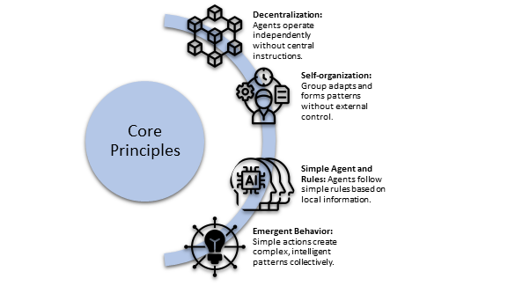

Fig. . Core Principles of Swarm Intelligence

### 2.3 Comparison with Traditional AI and Centralized Systems

Traditional AI often relies on centralized data collection and processing, which fundamentally contrasts with SI:

* **Data Sharing:** Centralized AI typically requires aggregating vast amounts of raw data, posing significant challenges for privacy (e.g., GDPR) and security in sensitive environments like healthcare. SI, especially in Swarm Learning, circumvents this by training models locally and only exchanging aggregated model updates, not raw patient data.
* **Decision-Making Architecture:** Centralized systems depend on a single, powerful entity making decisions based on a global data view. SI, conversely, distributes decision-making, with intelligence emerging from the collective of many simpler, local interactions.
* **Scalability & Resilience:** Centralized systems can face bottlenecks and single points of failure. SI's distributed nature offers inherent scalability and fault-tolerance, making it more resilient to individual failures and adaptable to dynamic, heterogeneous environments where data is inherently fragmented.

### 2.4 Technical Algorithms Based on Swarm Intelligence

The biological inspirations of SI have led to powerful computational models [3]:

* **Particle Swarm Optimization (PSO):** Inspired by bird flocking, PSO is a population-based algorithm where "particles" (candidate solutions) move through a search space, adjusting their paths based on their own best-found position and the best position found by the entire "swarm." It's widely used for function optimization.
* **Ant Colony Optimization (ACO):** Directly modelled on ant foraging, ACO algorithms find optimal paths by simulating pheromone trails. "Artificial ants" explore routes, depositing virtual pheromone, which guides subsequent ants towards more efficient solutions. Effective for routing and scheduling.
* **Artificial Bee Colony (ABC) Algorithms:** Mimics the intelligent foraging of honeybees. It divides bees into employed (exploiting known sources), onlooker (selecting sources based on information), and scout (searching for new sources), used for various optimization tasks.
* **Firefly Algorithm:** Based on the flashing behavior of fireflies, where brighter (better) fireflies attract less bright ones. It's applied to optimization problems by moving agents towards better solutions.

Fig. 2. shows various Swarm Intelligence algorithms used in healthcare datasets, which undoubtedly demonstrates that PSO (Particle Swarm Optimization) and the variants of PSO are the most popular algorithms used in medical applications.

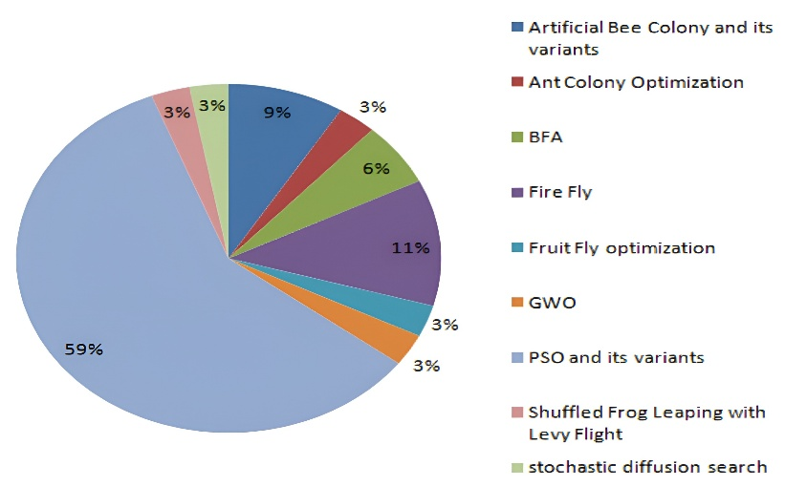

Fig. . Swarm Intelligence Algorithms used in healthcare datasets [3]

## 3. Swarm Learning: Bridging SI and Machine Learning

Swarm Learning (SL) is an innovative AI paradigm that fuses:

* **Federated Learning:** Enables collaborative machine learning model training across multiple decentralized institutions without sharing their raw data. [12]
* **Blockchain Technology:** Provides a secure, immutable, and transparent ledger for recording and verifying the exchange of model updates, enhancing trust and data integrity. [11]
* **Swarm Intelligence Principles:** Dictates the decentralized coordination, self-organization, and emergent intelligence of the participating nodes.

SL's core is a privacy-preserving decentralized model training. Hospitals train local models on their private datasets. Only the learned parameters (model updates) are securely shared and aggregated, allowing a powerful global AI model to emerge without any institution exposing sensitive patient data.

### 3.1 Why SI is Suitable for Healthcare

Swarm Intelligence (particularly Swarm Learning) is uniquely suited for healthcare due to its ability to address key challenges:

* **Heterogeneous Data Sources:** It manages diverse data formats across institutions by processing information locally, avoiding the need for centralized standardization.
* **Fault-Tolerance and Adaptability:** Inherently robust, SI systems can function effectively despite disruptions (e.g., staff turnover, system glitches) and adapt to dynamic clinical environments.
* **Continuous Learning Across Multiple Institutions without Data Sharing:** This is crucial for building accurate, generalizable AI models by leveraging collective data from diverse patient populations, all while strictly adhering to privacy regulations and data sovereignty.

## 4. Challenges in Clinical Environments

Healthcare institutions—be they large hospitals or smaller specialized clinics—are inherently complex, decentralized, and human-driven systems. While technological advances have transformed parts of the medical landscape, the day-to-day operation still relies heavily on staff intuition, fragmented information systems, and shifting personnel. This section highlights key challenges that limit the efficient use of AI and coordinated data-driven workflows in real-world clinical settings.

To provide practical context, we have selected several focused challenges based on firsthand observations and experiences at the University of Medicine Rostock. These examples illustrate the specific obstacles faced in clinical environments and inform the strategies discussed in subsequent sections.

### 4.1 Staff Turnover and Evolving Roles

One of the most prominent challenges in clinics is the **frequent rotation or turnover of medical personnel**. Nurses, doctors, interns, and administrative staff often change every one to two years, depending on contracts, specialization rotations, or institutional policy. As a result, there is a continuous **loss of tacit knowledge**—intuitive practices, informal naming schemes (e.g., visit tags like “Baseln”, “BL”, “Fo1”, “FUP1”, etc.), and undocumented routines that are well understood internally but never formally standardized.

### 4.2 Inconsistent and Non-Structured Data Practices

Although Electronic Health Records (EHRs) and hospital information systems exist, they are often adapted locally over time by different personnel, leading to **inconsistent naming conventions**, **unlinked data tables**, and **workflow-specific hacks**. For instance, patient visits might be labelled inconsistently, or clinical measurements might be logged in free-text fields instead of structured formats. This makes retrospective data use for AI training or even basic auditing difficult and labour-intensive.

### 4.3 Workflow Fragmentation Across Departments

Patient care journeys—from admission, diagnosis, treatment, to follow-up—are typically handled by different departments, each with their own **sub-systems** and **documentation styles**. The lack of a unified logic across these departments creates bottlenecks when trying to automate or model care pathways, especially in long-term treatment cases.

### 4.4 Data Sharing Across Institutions

With growing interest in collaborative AI and multi-centre studies, the **inability to securely and effectively share patient data across branches or institutions** poses a major obstacle. Legal restrictions (e.g., GDPR), lack of interoperability between hospital systems, and absence of standardized schemas make it difficult to build or train generalizable AI models. In smaller or specialized clinics, this issue becomes even more pronounced due to limited IT infrastructure and personnel.

### 4.5 Loss of Context Over Time

A long-term patient record may span multiple years, often outliving the employment of the staff who originally managed it. Comments in patient files, once meaningful to a nurse or doctor, become **ambiguous or obsolete**. Without semantic understanding or metadata about who entered what and why, AI systems—or even future humans—struggle to interpret them accurately. This temporal decay of data quality poses a serious challenge to longitudinal care and learning-based system.

## 5. New Strategies via SI/SL

The inherent challenges within clinical environments, such as fragmented data, personnel turnover, and the need for robust privacy, underscore the necessity for adaptive and co-ordinated AI solutions. Swarm Intelligence (SI) and Swarm Learning (SL) offer a compelling framework to address these complexities, moving beyond traditional centralized AI models to foster more resilient and intelligent healthcare systems.

### 5.1 Strategy-1: Adaptive AI Models for Enhanced Clinical Workflows

Leveraging the principles of SI and SL, AI models can be designed to dynamically adapt to evolving data landscapes and diverse team structures within healthcare institutions. This adaptability can manifest in several key areas:

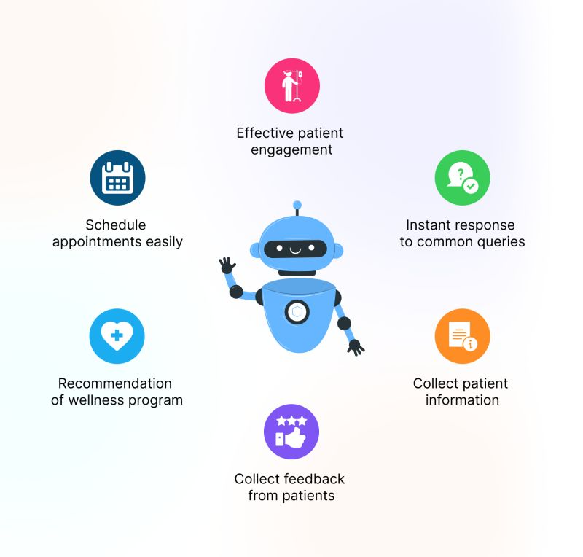

Fig. . Medical application of chatbots [10]

* **Intelligent Data Interaction:** Integrating AI-driven chatbots into existing data management applications can streamline patient interactions and administrative tasks. These tools can provide instant responses, direct patients to appropriate resources, and even assist clinicians by drafting notes and patient instructions, thereby reducing the cognitive burden associated with extensive documentation. Furthermore, advanced AI, including Large Language Models, can be adapted for clinical documentation, reporting, and efficient medical information retrieval. [10]
* **Ensuring Data Consistency and Quality:** AI models can play a crucial role in standardizing data entry and minimizing discrepancies during the recording process. By employing Natural Language Processing (NLP), unstructured clinical notes, discharge summaries, and other documents can be transformed into structured, analysable formats. AI can also enhance data hygiene by identifying and removing duplicate records, ensuring a cleaner and more reliable patient master index. Swarm Learning's inherent ability to robustly handle heterogeneous (non-IID) data from various sources and acquisition methods further supports the integration of diverse datasets without requiring strict upfront standardization, leading to more generalizable models.[6]
* **Workflow Adaptation and Anomaly Detection:** AI models can be developed to learn the operational patterns and working styles of healthcare personnel involved in patient care workflows. By analysing historical data and real-time inputs, these models could predict health risks, identify quality gaps, and forecast outcomes.More critically, they could detect major deviations from standard procedures or historically effective methods, raising alerts to ensure adherence to best practices and maintain consistency in care delivery. Swarm intelligence frameworks, such as the Internet of Medical Things (IoMT), already enable continuous patient monitoring and support real-time decision-making, providing a foundation for such adaptive systems. [7,8]

### 5.2 Strategy-2: Leveraging Swarm Learning for Collaborative Digital Twins

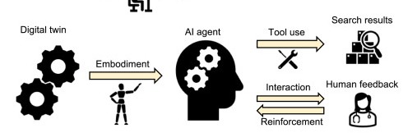A potential new application of Swarm Learning involves the development and networking of "digital twins" unique to individual healthcare institutions or departments. A digital twin, in this context, would be a virtual replica of a physical entity (e.g., a clinic, a hospital department, or even a patient's care pathway) that continuously learns and evolves with human interactions and real-world data. [2]

Fig. . Combining embodied AI with LLM-powered DTs to construct AI agents [2]

* **Networked Digital Twins:** Swarm Learning's decentralized architecture is ideally suited for creating a network of such digital twins, enabling collaborative intelligence across various scales—from regional clusters to national and even global networks. Each digital twin, acting as a node in the swarm, would train its local AI model using its proprietary data, ensuring sensitive patient information remains localized. Only the learned model parameters or insights would be securely shared and aggregated across the swarm, facilitated by blockchain technology for trusted collaboration and privacy preservation.
* **Scalable and Efficient Collaboration:** This networked approach would allow institutions of varying sizes to contribute to and benefit from a collective intelligence. Smaller clinics, for instance, could leverage the robust models trained on vast, diverse datasets from larger institutions, improving their diagnostic accuracy and treatment planning. The decentralized nature of SL minimizes communication overhead and boost’s fault tolerance and scalability, making it an efficient solution for large-scale, multi-institutional collaboration. Simplified Peer-to-Peer Swarm Learning (P2P-SL) frameworks are also being developed to enhance accessibility for resource-constrained environments by reducing reliance on complex infrastructures like blockchain, further democratizing advanced machine learning in healthcare. This collaborative ecosystem would accelerate medical research, enable personalized medicine, and facilitate the early detection of widespread health issues like pandemics by continuously monitoring health data across a broad network.

## 6. Case Studies

### 6.1. Case Study: Dynamic Patient Visit Segmentation using Gaussian Mixture Models (GMM)

**Context:** Segmenting patient events by visit is a critical challenge in large-scale dementia studies, such as those conducted at the Neurology Clinic DZNE (University of Medicine, Rostock).

Patient event data—including blood tests, lab results, and diagnoses—is recorded continuously and often spans multiple visits. Traditional fixed-threshold approaches, which rely on preset time windows to define visits, are arbitrary and frequently inadequate for patients with irregular or complex event patterns. Rather than relying on generic examples from other studies, we selected a real-world case scenario from DZNE to illustrate the practical challenges and solutions in visit segmentation. In the context of next-generation healthcare and coordinated AI systems, precise visit segmentation is vital for accurate label assignment, tracking disease progression, conducting survival analysis, and ensuring effective model training.

**Methodology: Data-Driven Segmentation with Gaussian Mixture Models**

This case study employs a Gaussian Mixture Model (GMM) to dynamically segment patient visits based on temporal gaps between consecutive healthcare events. The premise is that intra-visit gaps are typically short, while inter-visit gaps are significantly longer.

The specialized GMM logic analyses the distribution of these inter-event gaps, fitting a two-component GMM (representing "short" and "long" gaps). It then calculates the intersection point of these two distributions, which serves as a data-driven threshold (see example Fig.1.). Then a simple segmentation filter applies this threshold to assign a unique visit-id to each event, effectively clustering events into distinct visits.

**Key Steps:**

1. **Calculate Inter-Event Gaps:** Compute time differences (in days) between consecutive events for a patient.
2. **GMM Fitting:** Train a 2-component GMM on these gap durations to identify properties of short vs. long gaps.
3. **Threshold Determination:** Calculate the mathematical intersection of the two fitted Gaussian probability density functions to establish a dynamic threshold.
4. 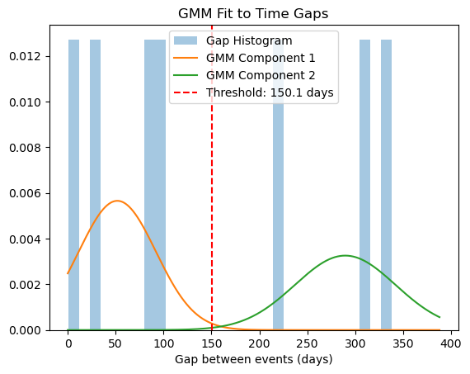**Visit Assignment:** Group events into visits; a new visit begins if the gap exceeds the determined threshold.

Fig. . Visit Group Segmentation using Gaussian Mixture Model

**Research Value & Future Usage within a Coordinated AI Framework**

This GMM-based segmentation offers significant research value and opens avenues for future applications within a "Coordinated AI Approach" or "Swarm Intelligence" system for healthcare.

Particularly the approach here can act as a specialized, intelligent "agent" within a larger healthcare AI swarm. It provides foundational, accurately segmented data that allows other specialized AI agents (e.g., Clinical NLP for extracting insights within visits, Resource Optimization for predicting demand based on visit patterns, Patient Engagement for identifying care gaps) to operate with greater precision and context.

Employing Gaussian Mixture Models for dynamic patient visit segmentation offers a data-driven improvement over traditional methods, providing a more accurate representation of patient care. This approach holds substantial research value by enabling deeper insights into patient journeys and serves as a crucial, structured input for advanced AI applications. In the evolving landscape of "AI & Healthcare" this GMM-based segmentation is an intelligent component that underpins more precise predictions, optimized resource utilization, and ultimately, contributes to a more effective and research-informed healthcare delivery system.

### 6.2. Case Study: Anonymization in Medical Imaging Technologies (CT, PET, MRI)

**Context:** The challenge of patient privacy from computer recognizable scan data of the medical modalities.

In the last decade, facial detection algorithms have achieved remarkable accuracy, enabling identification of individuals even in poor imaging conditions. While these state-of-the-art models are trained on massive 2D datasets, in a different setting they pose serious privacy risks when applied to 3D medical data from CT, PET, and MRI modalities. Medical imaging can reconstruct recognizable facial features through 3D rendering. Even when these features aren't clearly visible to human observers, motivated attackers could combine processing techniques, deep learning models, and publicly available social media images to access sensitive medical data. This vulnerability persists even after applying traditional anonymization methods that only remove personal identifying information from metadata.

**Methodology: Surface-Based Facial Region Detection and Selective Anonymization**

This case study examines the anonymization approach developed in the total-body-anonymization repository [1, 13]. The methodology addresses privacy vulnerabilities through a systematic pipeline that detects and obscures facial regions while preserving diagnostic quality

**The process operates in three key steps:**

1. **Surface Detection:** Project 3D volumes into 2D offset images using modality-specific thresholding (Otsu for CT, mean-based for PET) to highlight facial contours.
2. **Face Identification:** Apply MTCNN (Multi-task Convolutional Neural Networks) for robust face detection, with Haar cascades as fallback, constrained to anatomically plausible regions.
3. **Selective Anonymization:** Blur or pixelate detected facial regions following natural contours, ensuring privacy without compromising non-facial diagnostic information**.**

The effectiveness of this approach is demonstrated through gradient image analysis of a CT scan before and after anonymization (see Fig.2.). The gradient images reveal surface contours and facial features that could potentially be used for identification. As shown in the comparative analysis, the original gradient image clearly displays recognizable facial features including nose, eye sockets, and overall facial structure. After applying the anonymization algorithm, these identifying features are effectively obscured while maintaining the overall anatomical structure necessary for medical diagnosis.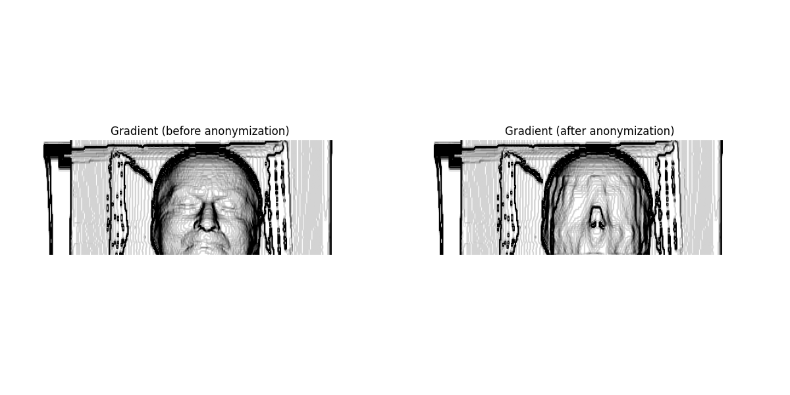

Fig. . CT scan Anonymisation (comparison of Gradient Images)

The innovation lies in the 3D-aware anonymization that considers the volumetric nature of medical data rather than treating it as simple 2D images. By using surface projection and gradient-based enhancement, the method can accurately identify facial features that might be reconstructed from medical scans, addressing the core vulnerability that traditional anonymization methods miss.

**Research Value & Future Usage within a Coordinated AI Framework**

This anonymization method is an important tool for privacy protection in coordinated healthcare AI systems. By keeping patient identities safe in 3D medical images, it allows hospitals and clinics to share and analyse imaging data without risking privacy. In a Swarm Intelligence or Swarm Learning setup, this approach acts as a privacy safeguard—making sure data is ready for shared learning and analysis while still useful for diagnosis. Using this method helps meet data protection rules and opens up new possibilities for secure, large-scale medical research and AI-powered healthcare.

## 7. Limitations and Ethical Considerations

While Swarm Intelligence and Swarm Learning offer promising solutions for healthcare, there are important limitations and ethical concerns. Ensuring patient privacy and data protection is critical, especially when sharing information across institutions [14]. Implementing these systems requires robust infrastructure and technical expertise, which may not be available everywhere [15]. Additionally, the interpretability of complex AI models remains a challenge, and transparent decision-making is essential for clinical trust and accountability.

## 8. Conclusion

Swarm Intelligence and Swarm Learning present a promising direction for next-generation healthcare, offering adaptive, decentralized, and privacy-preserving solutions to real clinical challenges. By leveraging coordinated AI agents and collaborative learning, these approaches can improve data quality, workflow efficiency, and patient outcomes. The case studies demonstrate practical applications in visit segmentation and medical image anonymization, highlighting their value within a broader AI ecosystem. Continued research and careful implementation will be key to realizing the full potential of SI/SL in healthcare, ensuring systems remain ethical, interpretable, and beneficial for both clinicians and patients.

## 9. Data availability

The patient event data used for the GMM visit segmentation and the CT scan data for anonymization, as described in the case studies, were sourced internally from the Neurology Clinic DZNE at the University of Medicine, Rostock. These datasets were provided exclusively for educational purposes. The code implementations for both case studies are openly available on GitHub (<https://github.com/J-Chandra-py/CIA_report>).

## 10. References

1. aaron-rohn. (2024). Total Body Anonymization. GitHub repository. <https://github.com/aaron-rohn/total-body-anonymization>
2. Concepts and applications of digital twins in healthcare and medicine, Zhang, Kang et al., Patterns, Volume 5, Issue 8, 101028.
3. Nayar, Nandini & Ahuja, Sachin & Jain, Dr. Shaily. (2019). Swarm intelligence and data mining: a review of literature and applications in healthcare. ICAICR '19: Proceedings of the Third International Conference on Advanced Informatics for Computing Research. 1-7. 10.1145/3339311.3339323.
4. Tabor, F. (2025, January 26). *Swarm Intelligence*. Retrieved from Francesca Tabor’s website: <https://www.francescatabor.com/articles/2025/1/26/swarm-intelligence>.
5. HewlettPackard, “*swarm-learning*,” GitHub repository, n.d. [Online]. Available: <https://github.com/HewlettPackard/swarm-learning>.
6. Warnat-Herresthal, S., Schultze, H., Shastry, K. L., et al. (2021). Swarm Learning for decentralized and confidential clinical machine learning. Nature, 594, 265–270. https://doi.org/10.1038/s41586-021-03583-3.
7. Patil, S., Singh, R., & Mehendale, N. (2025). Introducing a Simplified Peer-to-Peer Swarm Learning (P2P-SL) Framework for Healthcare AI. *arXiv preprint* arXiv:2504.16732. <https://arxiv.org/abs/2504.16732>
8. Sodhro, A. H., Pirbhulal, S., & de Albuquerque, V. H. C. (2019). Artificial Intelligence-Driven Mechanism for Edge Computing-Based Industrial Applications. *IEEE Transactions on Industrial Informatics*, 15(7), 4235–4243. <https://doi.org/10.1109/TII.2019.2904325>.
9. Theraulaz, Guy & Bonabeau, Eric. (1999). A Brief History of Stigmergy. Artificial life. 5. 97-116. 10.1162/106454699568700.
10. Ramamurthy, S. (n.d.). What is a medical chatbot and how does it work? [LinkedIn Post]. <https://www.linkedin.com/posts/col-dr-surendra-ramamurthy-45bb3517_what-is-a-medical-chatbot-and-how-does-it-activity-7092712355242942464-NQo1>
11. Bhalerao, R., Puranik, P., Nair, R., & Rajan, V. (2022). *Demystifying Swarm Learning: A New Paradigm of Blockchain-based Decentralized Federated Learning*. arXiv. <https://www.researchgate.net/publication/357875068_Demystifying_Swarm_Learning_A_New_Paradigm_of_Blockchain-based_Decentralized_Federated_Learning>.
12. Kairouz, P., McMahan, H. B., Avent, B., Bellet, A., Bennis, M., Bhagoji, A. N., Bonawitz, K., Charles, Z., Cormode, G., Cummings, R., D'Oliveira, R. G. L., Eichner, H., El Rouayheb, S., Evans, D., Gardner, J., Garrett, Z., Gascon, A., Ghazi, B., Gibbons, P. B., ... Zhao, S. (2021). Advances and Open Problems in Federated Learning. *Foundations and Trends in Machine Learning*, *14*(1-2), 1-210. <https://doi.org/10.1561/2200000083>
13. Selfridge AR, Spencer BA, Abdelhafez YG, Nakagawa K, Tupin JD, Badawi RD. Facial Anonymization and Privacy Concerns in Total-Body PET/CT. J Nucl Med. 2023 Aug;64(8):1304-1309. doi: 10.2967/jnumed.122.265280. Epub 2023 Jun 2. PMID: 37268426; PMCID: PMC10394314.
14. Guerra-Manzanares, Alejandro & Lopez, L. & Maniatakos, Michail & Shamout, Farah. (2023). Privacy-preserving machine learning for healthcare: open challenges and future perspectives. 10.48550/arXiv.2303.15563.
15. Ali, Md & Ahsan, Md Manjurul & Tasnim, Lamia & Afrin, Sadia & Biswas, Koushik & Hossain, Md & Ahmed, Md & Hasan, Ronok & Islam, Md & Raman, Shivakumar. (2024). Federated Learning in Healthcare: Model Misconducts, Security, Challenges, Applications, and Future Research Directions -- A Systematic Review. 10.48550/arXiv.2405.13832.