INTRODUCTION TO PROLOG

# SOURCE CODE:

## KB1:

woman(mia).

woman(jody).

woman(yolanda).

playsAirGuitar(jody).

party.

### OUTPUT:

# 

## KB2:

happy(yolanda).

listens2music(mia).

Listens2music(yolanda):-happy(yolanda).

playsAirGuitar(mia):-listens2music(mia).

playsAirGuitar(Yolanda):-listens2music(yolanda).

### OUTPUT:

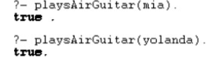

## KB3:

likes(dan,sally).

likes(sally,dan).

likes(john,brittney).

married(X,Y) :- likes(X,Y) , likes(Y,X).

friends(X,Y) :- likes(X,Y) ; likes(Y,X).

### OUTPUT:

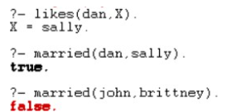

## KB4:

food(burger).

food(sandwich).

food(pizza).

lunch(sandwich).

dinner(pizza).

meal(X):-food(X).

### OUTPUT:

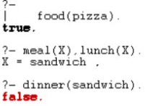

## KB5:

owns(jack,car(bmw)).

owns(john,car(chevy)).

owns(olivia,car(civic)).

owns(jane,car(chevy)).

sedan(car(bmw)).

sedan(car(civic)).

truck(car(chevy)).

### OUTPUT:

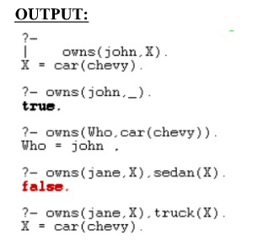

## KB6:

Find minimum maximum of two numbers

find_max(X,Y,X):-X=Y,!.

find_max(X,Y,Y):-X>=Y.

find_min(X,Y,X):-X=>Y,!.

find_min(X,Y,Y):-X<=Y.

### OUTPUT:

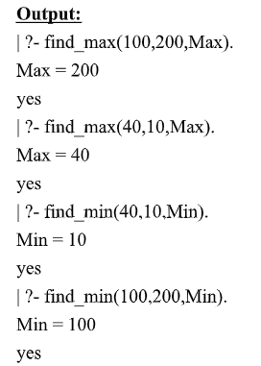

## KB7:

likes(mary,food).

likes(mary,wine).

likes(john,wine).

likes(john,mary).

### likes(john, X) :- likes(mary, X).

likes(john, Y) :- likes(Y, wine).

likes(john, Z) :- likes(Z, Z).

### OUTPUT:

