|  |  |  |  |
| --- | --- | --- | --- |
| Test | Expected outcome | Actual Outcome | Fix |
| Start button | Collect first players info & setup questions array | Collects the wrong players info | Index call for player was 1 above (arrays start at 0) |
| Choose category button | Displays a question from the chosen category randomly and has the possible answers delayed | Question was displayed correctly however answer A didn't display the option | Add the appropriate to string to the A part |
| A button | Set the choice to A | Sets the choice to A | N/A |
| B button | Set the choice to B | Sets the choice to B | N/A |
| C button | Set the choice to C | Sets the choice to C | N/A |
| D button | Set the choice to D | Sets the choice to D | N/A |
| Submit button | Compares the choice to the correct answer and adds 100 to the total for that player if correct  Displays if correct and the score and then moves onto the next player | Compares the choice to the correct answer and adds 100 to the total for BOTH PLAYERS if correct  Displays if correct and the score and then moves onto the next player | Fix the total adding up so it adds to the correct total for the player |
| 50/50 | Shows two options including the correct option so that there is a 50/50 chance | Only showed the button for the correct answer | Alter the mathematical logic behind it as the rand int Is important to the randomly selected second option |
| Ask the public | States which option the majority of the public chose and is usually correct | States the option which is correct | N/A |
| A label | Shows the correct corresponding option | Shows the correct corresponding option | N/A |
| B label | Shows the correct corresponding option | Shows the correct corresponding option | N/A |
| C label | Shows the correct corresponding option | Shows the correct corresponding option | N/A |
| D label | Shows the correct corresponding option | Shows the correct corresponding option | N/A |

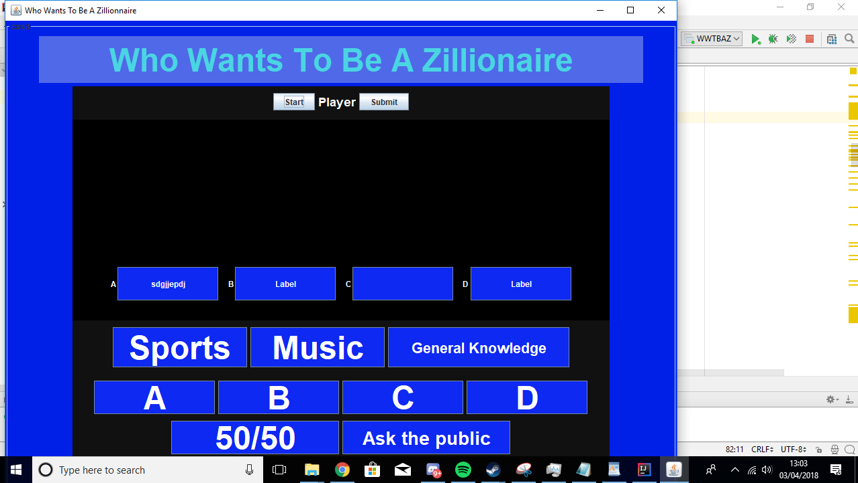

The screenshot above is the default screen

The screenshot below displays the question and the player at the top

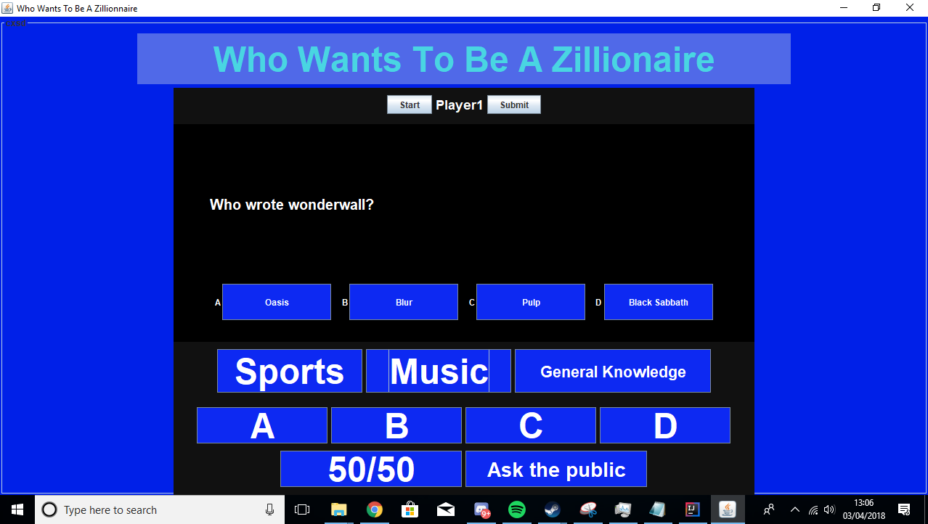

The screenshot below shows the use of fifty fifty

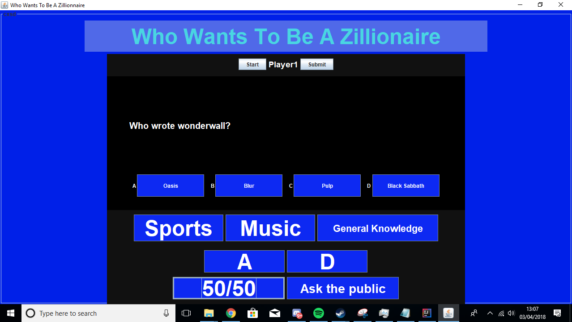

The next screenshot shows the use of ask the public

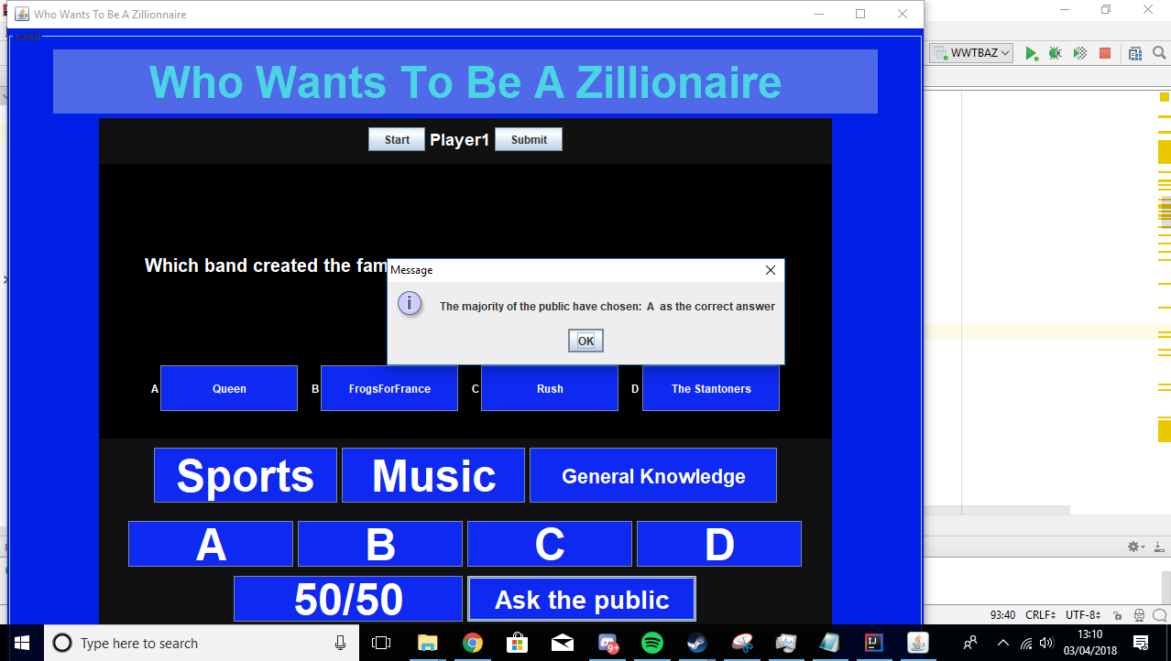

The screenshot below shows the question changing category and the player changing player 2

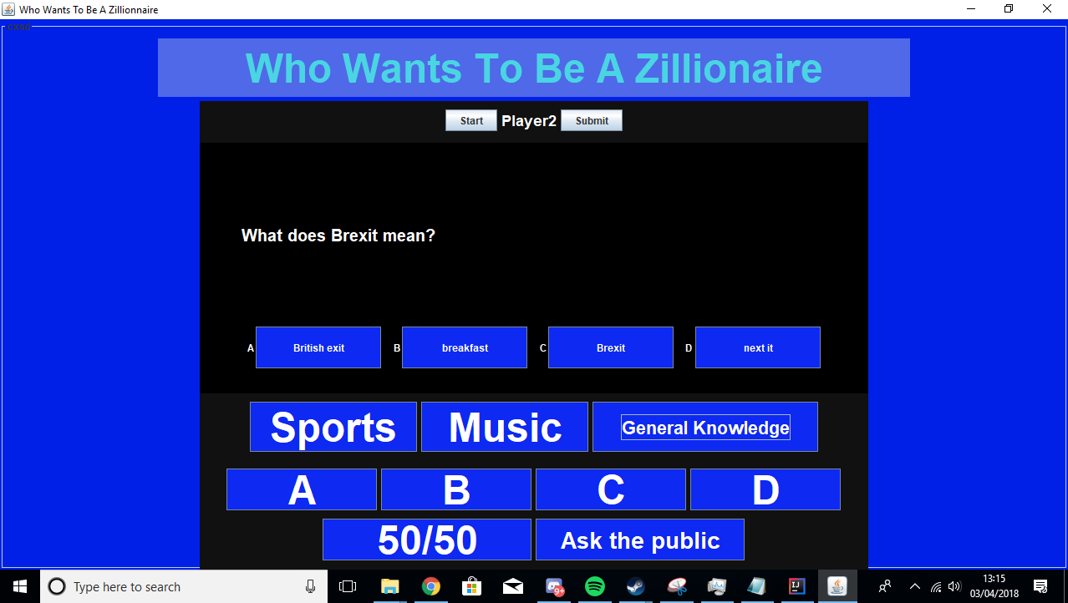

The screenshot below shows a player answering incorrectly

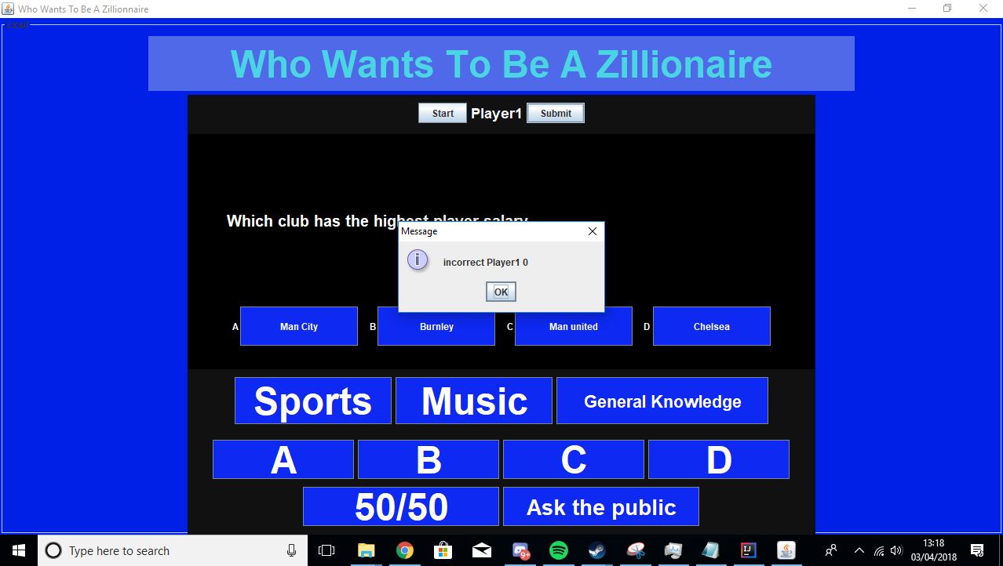

The screen shot below shows the player winning the game(application closes after box)

