🡺 Your name: **Jason Jun** Student No.: **126683200** UserID: **­­­­jjun10@mySeneca.ca**

**Part 1: Compression (40 points)**

🡺 your dictionary of compression token to string characters, one entry per line.

#and

*came

+itsy

3rain

!spider

@the

%up

(out

🡺 the compressed rhyme with the token substitutions,   
 i.e. the compressed text (not the sorted analysis list of words)

@+b+!crawled %@water sp(

down *@3#washed @!(

(*@sun #dried %all @3

#@+b+!went %@sp(again

🡺 how many characters are in your dictionary + compressed text? What is that number as percentage of the original’s 187? (see above example)

In (dictionary + compressed) text, there are 134 characters (37 + 86 = 123) .

The percentage of the original is 65.8% ([123 / 187] *100 = 65.8).

🡺 **Now test your compression dictionary.** Reverse the process to see if your compression dictionary is accurate. Process dictionary items from the bottom up: find the compression character in the compressed data and replace it with the original string. **Paste the decompressed version below** – *even if it is not perfect*. **What modifications, if any, does the compression dictionary need to return the compressed data back into its original state?**

the itsy bitsy spider crawled up the water spout

down came the rain and washed the spider out

out came the sun and dried up all the rain

and the itsy bitsy spider went up the spout again.

There was no need for any extra modifications.

**Part 2:**

**🡺** Paste the image of the Windows Explorer .zip archive information.

Use the Snipping Tool ( + “snip”) to copy only the information seen above.

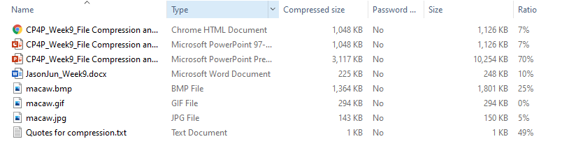

🡺 Files with the **lowest** ratios were compressed the **least**. Ratio indicates % of space saved.  
Which file types compressed the least? Why would that be? (10 pts)

GIF file type compressed the least because when GIF type files are being compressed, the horizontal redundancy gets removed. Hence, if there are more vertical detail or noise, the GIF types files will be less compressed. In this situation, the GIF file within the file had lots of vertical details.

🡺 Files with the **highest** ratios were compressed the **most**.   
Which file types compressed the most? Why would that be? (10 pts)

Microsoft PowerPoint Presentation was compressed the most. This could mean that compared to other files, the PowerPoint Presentation file had lost more data than the others when the files were compressed. Also, it could mean that the PowerPoint Presentation had more images or medias than other files. When compressed, the images and other media sources would have lower quality than the original ones.

**Part 3: Backup**

🡺 paste a screen shot of your backup results. (use the Screen Snip tool) **(10 points)**

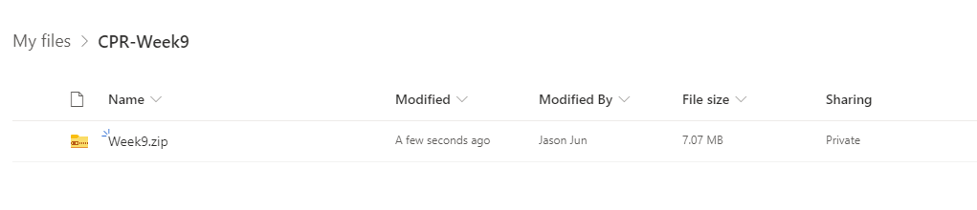

🡺 What is (or what should have been) your backup routine? How do you ensure your backup is current?

My routine is backing up the work on a cloud and on a USB drive. I ensure that the backup is current by updating the backup files every time I modify them, by replacing the old file with the currently saved version. Also, there is an updated filed on my computer always, until the computer stops working.

🡺 How does your backup routine address the three characteristics of a real backup and fulfill the 3-2-1 backup check?

My backup routine fulfills the 3-2-1 backup check because firstly, I have at least three copies of the file (drive, USB, and hard drive). Then I have the file backed up on different devices, which are my USB and my hard drive. Finally, the cloud I have used to backup would be the last location I would have my files, in case both USB and hard drive fails to work.

🡺 Now that you have a backup *but no laptop*, how will you access and work with the current version of your backed up files? What is your restore/recovery strategy?

With the backups I have created on USB and on cloud, I would use library computers or borrow a friend’s laptop and bring back the file through the USB and cloud and continue working on the work. Since my backup is stored in cloud as well, I can access it through my smartphone and tablet.

🡺 How long would this all take…and what if you a had a big assignment due tomorrow?

It would take 30 minutes to go through all the process of backing the big assignment on the cloud and my USB drive. The process of moving the file would not take long, but depending on the internet, it might take long to transfer the files to different backups. I could go to library or borrow a computer from my friend to work on the assignment, but since I have my smartphone and tablet, I can bring up the assignment from my cloud and continue working on it. Therefore, I would not hand in the assignment late.