**Exercises**

1. Regex

**THREE CATEGORIES OF TECHNIQUES FOR NLP**

1. Rules and heuristics.
2. Machine learning.
3. Deep learning.

**NLP TASKS**

1. Text classification(Healthcare domain, hate speech detection
2. Text similarity.
3. Information extraction.
4. Information retrival.(bots:FAQ, Flow-based,
5. Language modelling.(statistical, neural model).
6. Text summarization.
7. Topic modelling.

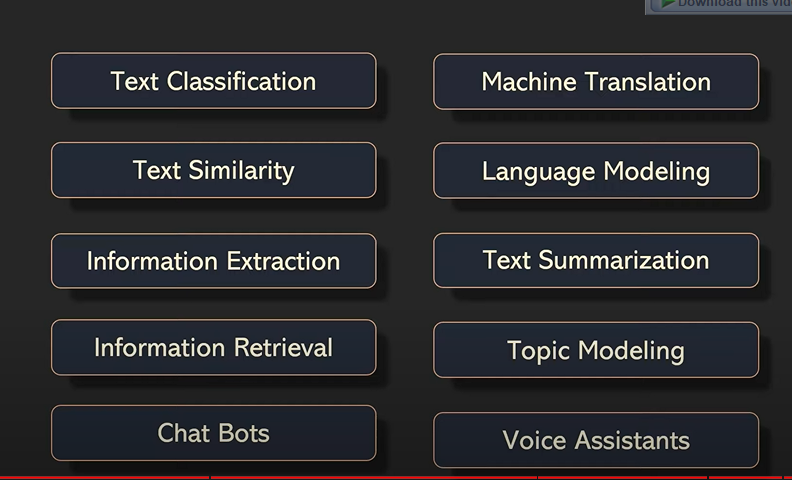

**NLP PIPELINE**

An end to end NLP project consists of many steps. These steps together forms an NLP pipeline. The pipeline has various stages such as data acquistion, data clearning, pre-processing, model building, deployment, monitor and update etc.

steps in nlp pipeline.

