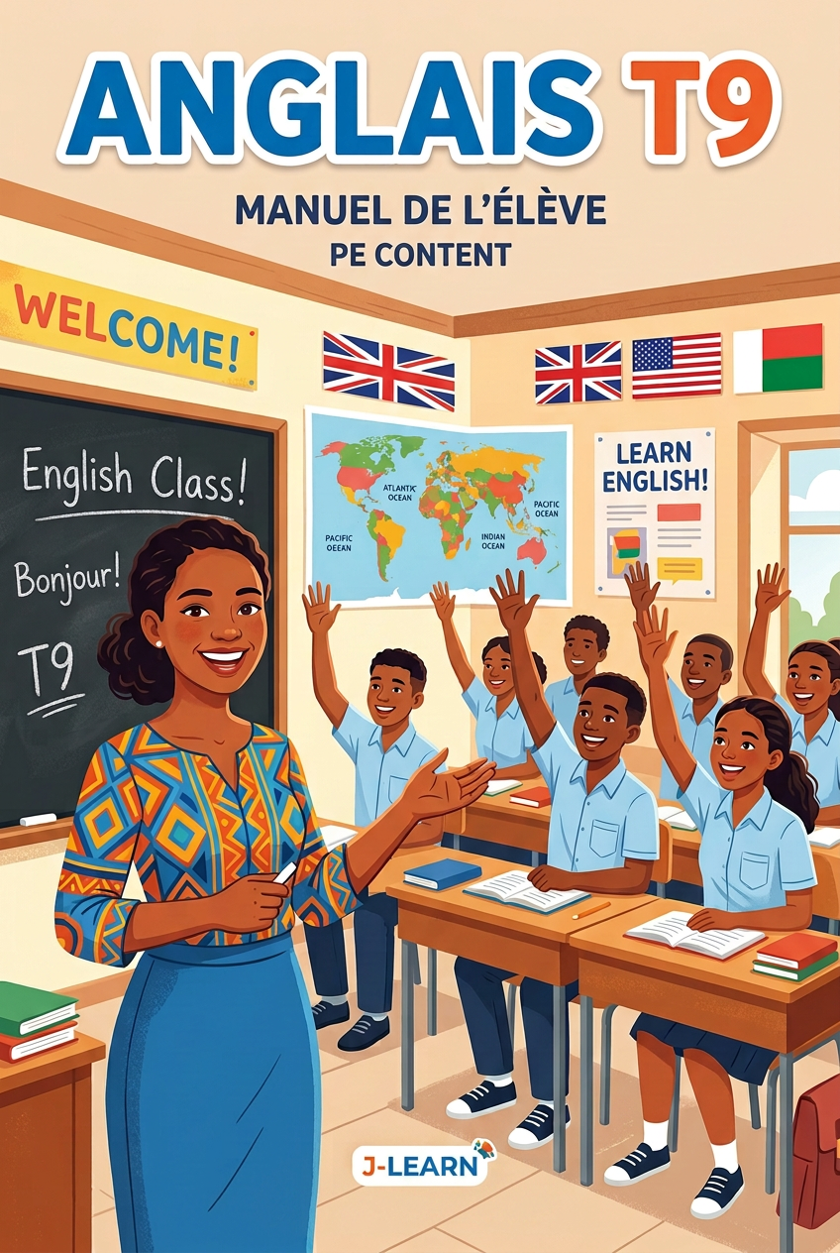

FOREWORD
This book follows the official T9 English syllabus (Programme d’études T9) and its Pedagogical Resources Booklet.
T9 is the last year of basic education — the exam year! The students report what people said, tell long stories with the past continuous, compare the past and the present with “used to”, talk about jobs with the present perfect, write a CV and a job application letter, and defend the environment with the if clauses. English is a real instrument of communication now.
Every session has three big steps: I. Review — II. New lesson — III. Evaluation. The teacher writes the duration of each step in the sheet.
Every preparation sheet is followed by a one-page “Lesson of the day”: the summary the students copy in their copy-books.
Important — the words in brackets: the small grey words in brackets, like Hello [hèlôou], only help you SAY the word. When the students copy the lesson in their copy-books, they must NOT copy the words in brackets.
Six annexes close the book: the picture dictionary, the songs, the pronunciation guide, the flashcards, the conjugation guide and the phonetics guide.
Dialogues, songs and reading texts can be listened to with a phone: scan the QR code or open the link at the bottom of the page. In Annex 2, the traditional songs also have a YouTube link for the video version.

HOW TO USE THIS BOOK
The three big steps of a session
• I. Review — quick questions on the last lesson.
• II. New lesson — six small steps: Warm-up, Presentation, Observation, Analysis, Synthesis, Practice.
• III. Evaluation — the students work alone.
• The duration boxes are empty (………): the teacher writes his/her own timing.
The two kinds of lesson pages
• LESSON OF THE DAY — one page after every preparation sheet: the board summary of that session. The students copy it in their copy-books — WITHOUT the grey words in brackets [ ].
• LESSON — UNIT — one big page at the end of the unit: it gathers all the sessions. Perfect for the revision and the test!
The four skills of T9
• ORAL COMMUNICATION — listen (pre / while / post-listening) and speak.
• READING — read real texts, ads and letters, and find the gist and the details.
• WRITING — write dialogues, paragraphs, a CV and a letter.
• LANGUAGE AND CULTURE — make links between English, Malagasy and French.
The colours of the book
■ Red — title of the lesson.
■ Green — sub-titles of the lesson.
■ Blue + bold — key words to remember. The small grey words in brackets help you say the word: Hello [hèlôou] — never copy them!
■ Pink — answer keys.

The audio
• Scan the QR code with a phone, or open the link: you can listen and download the MP3 file.
• E.A. means “Expected Answer”.

CONTENTS
OVERVIEW OF THE YEAR

… The units and the six annexes are being added block by block …

OVERVIEW OF THE YEAR
Unit | Title | Sessions | + Revision + Test
1 | Personal Communication | 10 (S1–S10) | S11, S12
2 | Classroom Communication | 4 (S13–S16) | S17, S18
3 | Our Time | 8 (S19–S26) | S27, S28
4 | Food | 10 (S29–S38) | S39, S40
5 | Family | 8 (S41–S48) | S49, S50
6 | Healthy Life | 10 (S51–S60) | S61, S62
7 | Job and Mass Media | 10 (S63–S72) | S73, S74
8 | Environment | 10 (S75–S84) | S85, S86

Total: 70 lesson sessions + 8 revisions + 8 test papers = 86 sessions. T9 is the exam year: every unit ends with a test paper in the exam format.

