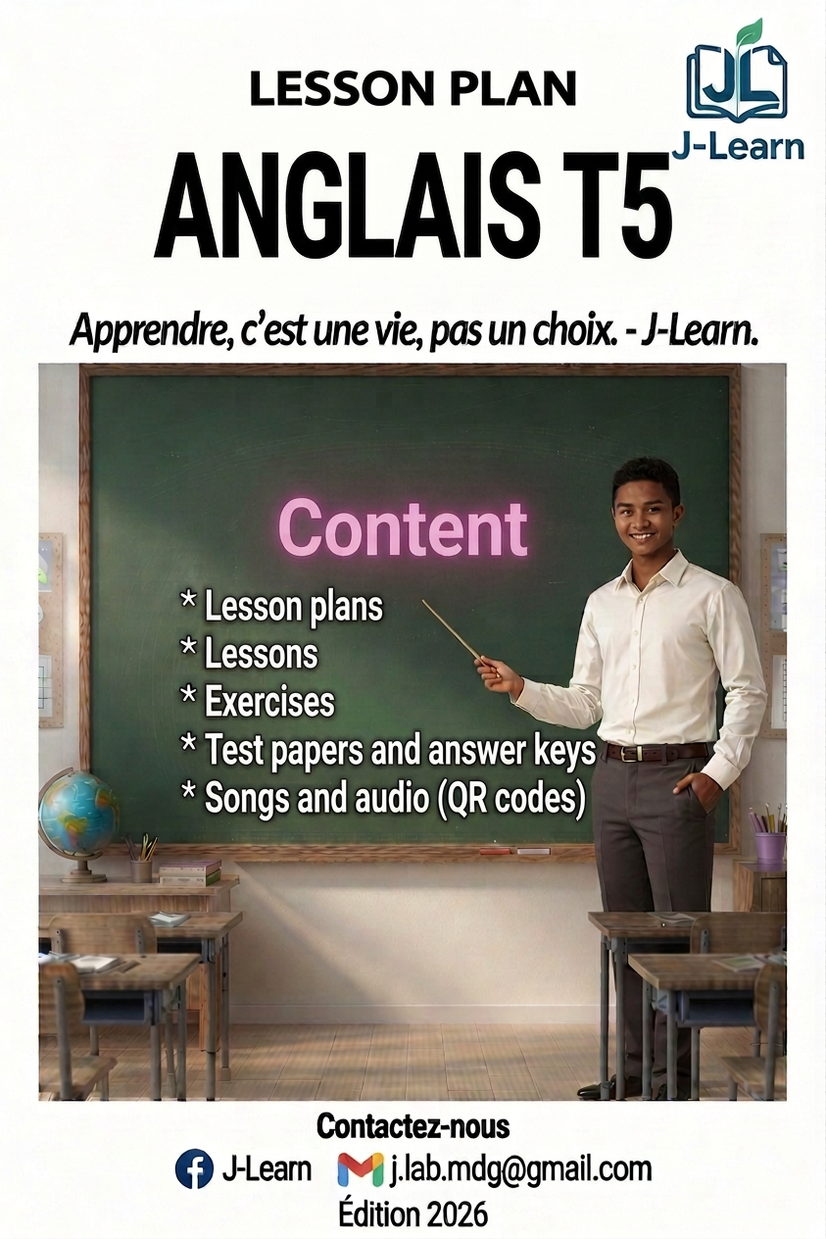

FOREWORD
This book follows the official T5 English syllabus of the Ministry of National Education of Madagascar (Programme d’études T5) and its Pedagogical Resources Booklet.
In T5, the pupils continue English: they speak more, they start to read the words and sentences they know, and they play, sing and act in English.
Every session has three big steps: I. Review — II. New lesson — III. Evaluation. The teacher writes the duration of each step in the sheet.
Every unit has: one opening page, the preparation sheets, one lesson with pictures and pronunciation help, exercises with an answer key, one revision session, one test paper, and one “I can…” page for the pupil.
Songs, rhymes and dialogues can be listened to with a phone: scan the QR code or open the link at the bottom of the page.

HOW TO USE THIS BOOK
The three big steps of a session
I. Review — quick questions on the last lesson.
II. New lesson — six small steps: Warm-up, Presentation, Observation, Analysis, Synthesis, Practice.
III. Evaluation — the pupils work alone.
The duration boxes are empty (………): the teacher writes his/her own timing.
The colours of the book
■ Red — title of the lesson.
■ Green — sub-titles of the lesson.
■ Blue + bold — key words to remember. The small grey words in brackets help you say the word: Hello [hèlôou].
■ Pink — answer keys.

The audio
Scan the QR code with a phone, or open the link: you can listen and download the MP3 file. E.A. means “Expected Answer”.

CONTENTS
UNIT 1 — SOCIALISING (Sessions 1–5)
Session 1 — The parts of the day
Session 2 — Greetings and wishes
Session 3 — Saying goodbye
Session 4 — Revision
Session 5 — T5 Test paper

UNIT 2 — INTRODUCING ONESELF (Sessions 6–9)
Session 6 — Where are you from? Where do you live?
Session 7 — I introduce myself
Session 8 — Revision
Session 9 — T5 Test paper

UNIT 3 — CLASSROOM LANGUAGE (Sessions 10–13)
Session 10 — The classroom commands
Session 11 — I read and give the commands
Session 12 — Revision
Session 13 — T5 Test paper

UNIT 4 — PARTS OF THE BODY (Sessions 14–17)
Session 14 — The parts of the body
Session 15 — This is my… — What am I doing?
Session 16 — Revision
Session 17 — T5 Test paper

UNIT 5 — MY BIRTHDAY IS ON… (Sessions 18–24)
Session 18 — Reading the numbers 1 to 20
Session 19 — The twelve months of the year
Session 20 — Reading the months, my favourite month
Session 21 — Counting from 21 to 40
Session 22 — Reading 21 to 40, my birthday is on…
Session 23 — Revision
Session 24 — T5 Test paper

UNIT 6 — MY DREAM CLASSROOM (Sessions 25–29)
Session 25 — Counting from 40 to 70, more or less!
Session 26 — Reading the numbers 40 to 70
Session 27 — My dream classroom
Session 28 — Revision
Session 29 — T5 Test paper

UNIT 7 — MEALS (Sessions 30–33)
Session 30 — Everyday food
Session 31 — What did you have for breakfast?
Session 32 — Revision
Session 33 — T5 Test paper

UNIT 8 — IN MY HOUSE (Sessions 34–39)
Session 34 — The rooms of the house
Session 35 — The furniture and the objects
Session 36 — Reading the house words
Session 37 — I describe a house
Session 38 — Revision
Session 39 — T5 Test paper

UNIT 9 — MY FAMILY (Sessions 40–45)
Session 40 — The family tree
Session 41 — Reading the family words, my family tree
Session 42 — Who is this? — the gallery walk
Session 43 — We are a family! (role play)
Session 44 — Revision
Session 45 — T5 Test paper

UNIT 10 — WILD ANIMALS (Sessions 46–49)
Session 46 — The wild animals
Session 47 — Counting to 100, how many animals?
Session 48 — Revision
Session 49 — T5 Test paper

ANNEXES
Annex 1 — Picture dictionary
Annex 2 — Songs and rhymes
Annex 3 — Pronunciation guide
Annex 4 — Flashcards to cut out

OVERVIEW OF THE YEAR
Unit | Title | Sessions | + Revision + Test
1 | Socialising | 3 (S1–S3) | S4, S5
2 | Introducing Oneself | 2 (S6–S7) | S8, S9
3 | Classroom Language | 2 (S10–S11) | S12, S13
4 | Parts of the Body | 2 (S14–S15) | S16, S17
5 | My Birthday | 5 (S18–S22) | S23, S24
6 | My Dream Classroom | 3 (S25–S27) | S28, S29
7 | Meals | 2 (S30–S31) | S32, S33
8 | In My House | 4 (S34–S37) | S38, S39
9 | My Family | 4 (S40–S43) | S44, S45
10 | Wild Animals | 2 (S46–S47) | S48, S49

Total: 29 lesson sessions + 10 revisions + 10 test papers = 49 sessions (1 hour of English per week).

UNIT 1 — SOCIALISING

Good morning! Have a nice day!
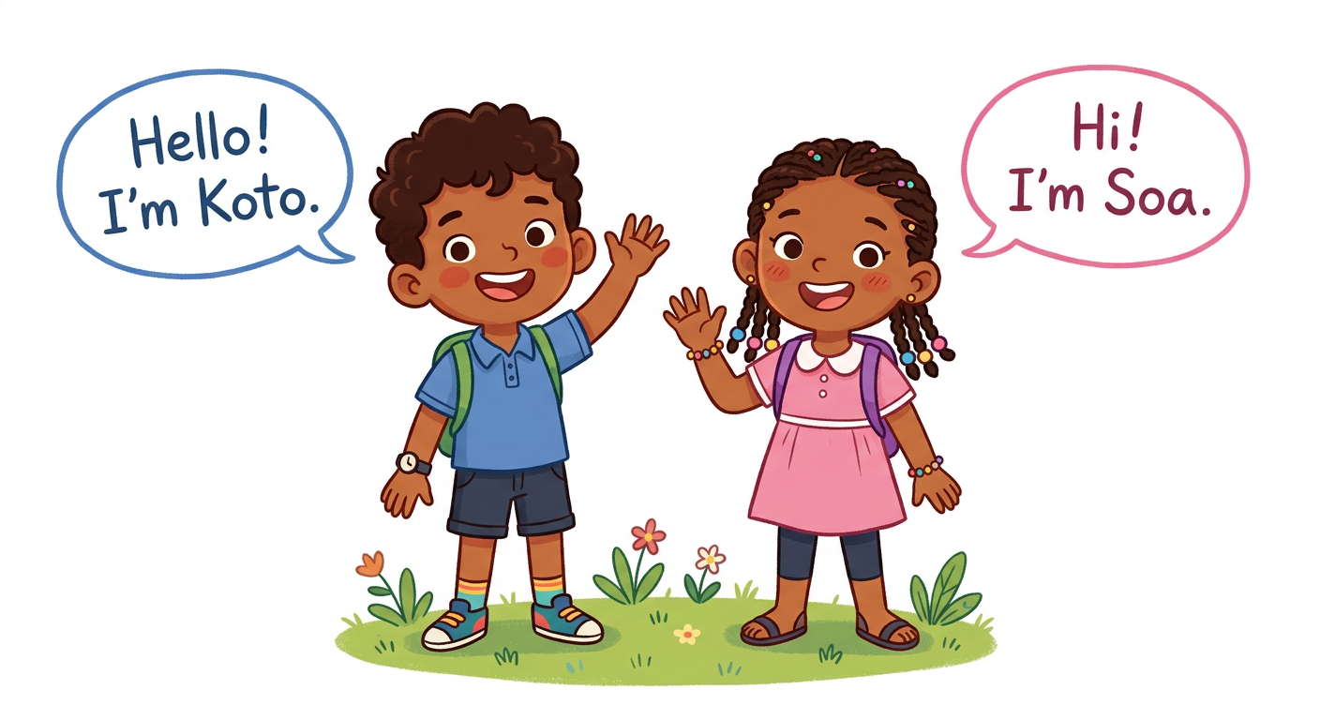
In this unit, I will learn to:
• say the four parts of the day;
• greet with Good morning, Good afternoon, Good evening;
• wish: Good night!, Enjoy your meal!, Have a nice day!;
• say goodbye: See you!, See you next time!
Values: self-confidence, perseverance.
DO YOU REMEMBER? (English T4)
Hello again! Koto and Soa are one year older — and you too!
1. Greet a friend: Hello! How are you?
2. Answer: I’m fine, thank you.

LISTEN! Scan the code or open the link to listen and download.
 | 🎧 The parts of the day — listen and repeat  https://drive.google.com/uc?export=download&id=1pNh-HroJV7wai1XYvm-y0z02ciw3_L8N

SESSION 1 / 49
The parts of the day
LESSON PREPARATION SHEET
Subject: English  Theme: UNIT 1 — SOCIALISING  Title: The parts of the day  Specific learning outcome: By the end of the lesson, learners will be able to say the four parts of the day clearly and say the “Parts of the day” rhyme.  Values: self-confidence, perseverance  Documentation: T4 English Syllabus (MEN — DCRP); T4 Pedagogical Resources Booklet  Materials: pictures of the parts of the day, 8 cards for the memory game, audio (QR code) | Date: ……………………  Class: T4  Session n°: 1 / 3  Duration: ……………………

Steps and Duration | Procedure |  | Technique and Strategy | Materials | Remarks
Steps and Duration | Teacher | Learners | Technique and Strategy | Materials | Remarks
I. Review  Duration: ……… | (Review of T4.) Answer these questions:  1. Greet a friend in English.  2. How are you?  3. Count from 1 to 10. | Answer.  E.A.: 1. Hello! / Good morning!  2. I’m fine, thank you.  3. one … ten. | Individual work | ----
II. NEW LESSON — Duration: ………
1. Warm-up | (The teacher mimes waking up and stretching.) When do we wake up? (The teacher mimes sleeping.) And when do we sleep? | Look. Answer in their own words. | Miming | ----
2. Presentation | Today we are going to learn a new lesson called: « The parts of the day ». By the end of this lesson, you will be able to say the four parts of the day in English. | Listen. | Whole-class work | ----
3. Observation | Look at the four pictures on the blackboard. Listen: morning… afternoon… evening… night. | Look. Listen. | “Visual aids” | Pictures of the parts of the day
4. Analysis | Repeat each word: all the class, then one row, then one pupil.  I say a word: point to the right picture.  When does the sun come up?  When do the stars come out? | Repeat. Point. Answer.  E.A.: the right picture is pointed to.  E.A.: In the morning.  E.A.: At night. | Repetition drill / “Visual aids” | Pictures
5. Synthesis | So, the four parts of the day are: morning, afternoon, evening, night.  Now the rhyme! Listen three times: “It’s the morning. The sun is coming up. It’s the morning. It’s time to wake up!…” (the four verses) | Listen. Repeat verse by verse after the teacher: together three times, then alone. | Modelling / Rhyme | Audio (QR code)
6. Practice | Memory game with 8 cards: 4 picture cards and 4 word cards. Pupil A turns two cards. If the picture and the word match, pupil A says the word and plays again. If not, pupil B plays.  Then I show a time on the clock: say the part of the day. | Play. Say.  E.A.: the pairs are found and named: morning, afternoon, evening, night. | “Memory game” / In pairs | 8 cards, a clock
III. Evaluation  Duration: ……… | 1. Say the four parts of the day.  2. Say the rhyme with the class.  3. I show a picture: say the part of the day. | Say.  E.A.: morning, afternoon, evening, night — the rhyme is said correctly. | Individual work | Pictures

SESSION 2 / 49
Greetings and wishes
LESSON PREPARATION SHEET
Subject: English  Theme: UNIT 1 — SOCIALISING  Title: Greetings and wishes  Specific learning outcome: By the end of the lesson, learners will be able to greet at the right time of the day and use the wishes: Good night!, Enjoy your meal!, Have a nice day!  Values: self-confidence, perseverance  Documentation: T4 English Syllabus (MEN — DCRP); T4 Pedagogical Resources Booklet  Materials: a clock, cards with pictures (sleeping / eating / going out), audio (QR code) | Date: ……………………  Class: T4  Session n°: 2 / 3  Duration: ……………………

Steps and Duration | Procedure |  | Technique and Strategy | Materials | Remarks
Steps and Duration | Teacher | Learners | Technique and Strategy | Materials | Remarks
I. Review  Duration: ……… | Answer these questions:  1. Say the four parts of the day.  2. Say the “Parts of the day” rhyme.  3. When do we sleep? | Answer.  E.A.: 1. morning, afternoon, evening, night.  2. The rhyme is said.  3. At night. | Individual work | ----
II. NEW LESSON — Duration: ………
1. Warm-up | In T4 we said “Good morning”. But what do we say in the afternoon? Let’s find out today! | Listen. Guess. | Whole-class work | ----
2. Presentation | Today we are going to learn a new lesson called: « Greetings and wishes ». By the end of this lesson, you will be able to greet at the right time and wish something nice to a friend. | Listen. | Whole-class work | ----
3. Observation | Listen and look at the clock: Good morning… Good afternoon… Good evening. Now the wishes: before we sleep — Good night!; before we eat — Enjoy your meal!; when a friend goes out — Have a nice day! | Look. Listen. | Modelling / “Visual aids” | A clock, pictures
4. Analysis | Repeat each greeting and each wish: the class, one row, one pupil.  I show a time on the clock: say the right greeting.  Your friend goes to bed. What do you say?  Your friend starts to eat. What do you say? | Repeat. Answer.  E.A.: the greeting matches the time.  E.A.: Good night!  E.A.: Enjoy your meal! | Repetition drill | A clock
5. Synthesis | So: Good morning (in the morning), Good afternoon (in the afternoon), Good evening (in the evening). The wishes: Good night!, Enjoy your meal!, Have a nice day! | Listen. Repeat. | Whole-class work | Blackboard
6. Practice | Card game in pairs: pupil A shows the picture side of a card (a person sleeping / eating / going out). Pupil B says the right wish. If it is right, next card; if not, A says the answer. Then change roles.  Group game: I whisper a wish to a pupil; the pupil mimes it; the group guesses the wish. | Play. Mime. Guess.  E.A.: Good night! / Enjoy your meal! / Have a nice day! match the pictures and the mimes. | Game (cards, miming) / In pairs | Cards with pictures
III. Evaluation  Duration: ……… | 1. I show three times on the clock: greet.  2. I show three pictures: say the wish.  3. Say the three wishes of today. | Answer.  E.A.: Good morning / afternoon / evening — Good night! / Enjoy your meal! / Have a nice day! | Individual work | A clock, cards

SESSION 3 / 49
Saying goodbye
LESSON PREPARATION SHEET
Subject: English  Theme: UNIT 1 — SOCIALISING  Title: Saying goodbye  Specific learning outcome: By the end of the lesson, learners will be able to say goodbye with “See you!” and “See you next time!”, recognise the greetings and wishes they hear, and read the learned words fluently.  Values: self-confidence, perseverance  Documentation: T4 English Syllabus (MEN — DCRP); T4 Pedagogical Resources Booklet  Materials: pictures of different situations, word cards, audio (QR code) | Date: ……………………  Class: T4  Session n°: 3 / 3  Duration: ……………………

Steps and Duration | Procedure |  | Technique and Strategy | Materials | Remarks
Steps and Duration | Teacher | Learners | Technique and Strategy | Materials | Remarks
I. Review  Duration: ……… | Answer these questions:  1. Greet me: it is the morning / the evening.  2. Your friend eats. What do you say?  3. Say the four parts of the day. | Answer.  E.A.: 1. Good morning! / Good evening!  2. Enjoy your meal!  3. morning, afternoon, evening, night. | Individual work | A clock
II. NEW LESSON — Duration: ………
1. Warm-up | (The teacher waves the hand and walks to the door.) What am I saying? In T4 we said “Goodbye!”. Today, a new way! | Look. Answer: Goodbye! Bye-bye! | Miming | ----
2. Presentation | Today we are going to learn a new lesson called: « Saying goodbye ». By the end of this lesson, you will be able to say “See you!” and “See you next time!” and read all the words of the unit. | Listen. | Whole-class work | ----
3. Observation | (The teacher waves and says:) See you! … See you next time! Listen and watch my gesture. | Look. Listen. | Modelling | ----
4. Analysis | Repeat: the class, one row, one pupil.  When do we say “See you!”?  Speed chat: two lines face to face. Say “See you!” — the friend answers “See you!”. Slide one step, change the words: “See you next time!”, “Bye-bye!”. | Repeat. Answer. Chat.  E.A.: when we leave a friend.  E.A.: the goodbye expressions are exchanged correctly. | Repetition drill / “Speed chat” | ----
5. Synthesis | So, to say goodbye we say: See you! or See you next time! And we know the greetings (Good morning / afternoon / evening) and the wishes (Good night!, Enjoy your meal!, Have a nice day!). | Listen. | Whole-class work | Blackboard
6. Practice | Listening: I say a sentence (Enjoy your meal! — Good night! — See you!); tick the right picture in your copy-book.  Reading: read the words on the blackboard fluently, without mistakes: all together, by rows, then alone.  In pairs: read the words to your friend; listen and correct each other kindly (peer correction). | Tick. Read. Correct.  E.A.: the pictures match the sentences; the words are read fluently: Good morning, See you!, Have a nice day!… | “Peer correction” / Repetition drill | Pictures, word cards
III. Evaluation  Duration: ……… | 1. Say goodbye to me in two ways.  2. I say a wish: point to the right picture.  3. Read three words on the blackboard. | Answer. Point. Read.  E.A.: See you! / See you next time! — the picture matches — the words are read correctly. | Individual work | Pictures, blackboard

LESSON — UNIT 1
SOCIALISING
1. The parts of the day
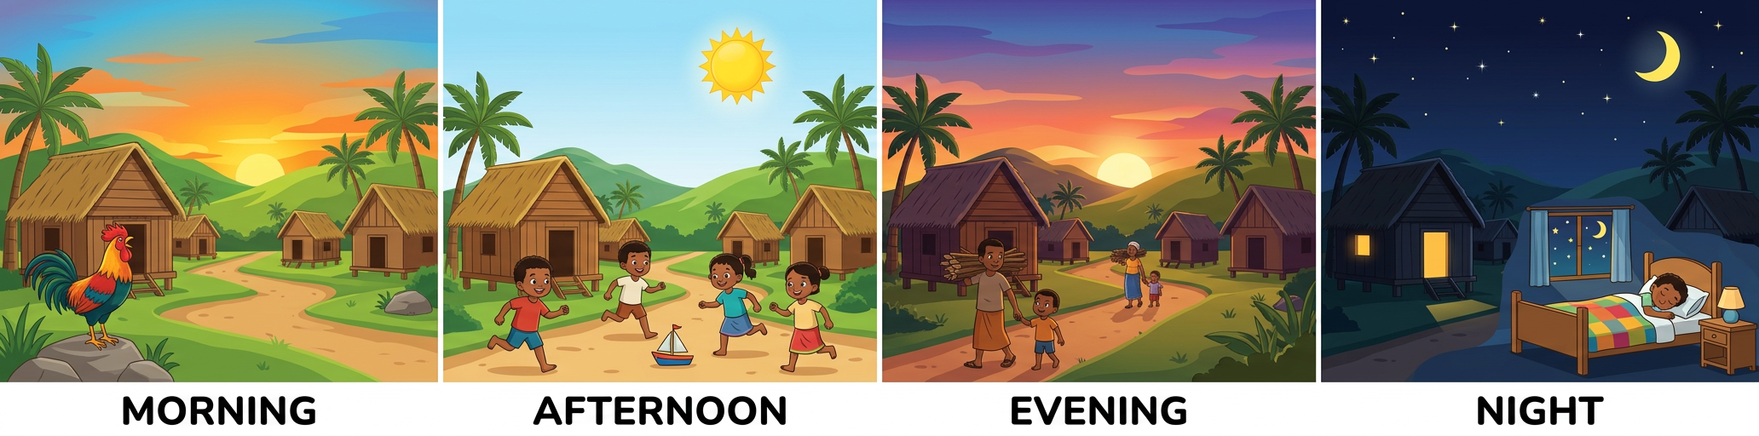
morning  [môrning] | afternoon  [afteurnoune] | evening  [ivning] | night  [naïte]

2. The rhyme
THE “PARTS OF THE DAY” RHYME ♪
It’s the morning. The sun is coming up.
It’s the morning. It’s time to wake up!
It’s the afternoon! I smile to the sun.
It’s the afternoon! Isn’t it fun?
It’s the evening, the end of the day.
It’s the evening! The sun has gone away.
It’s the night. The stars begin to peep.
It’s the night. It’s time to go to sleep.

3. Greetings
In the morning: Good morning! [goud môrning]
In the afternoon: Good afternoon! [goud afteurnoune]
In the evening: Good evening! [goud ivning]
SAY IT RIGHT! afterNOON — the strong part is at the END: af-teur-NOUNE.

4. Wishes
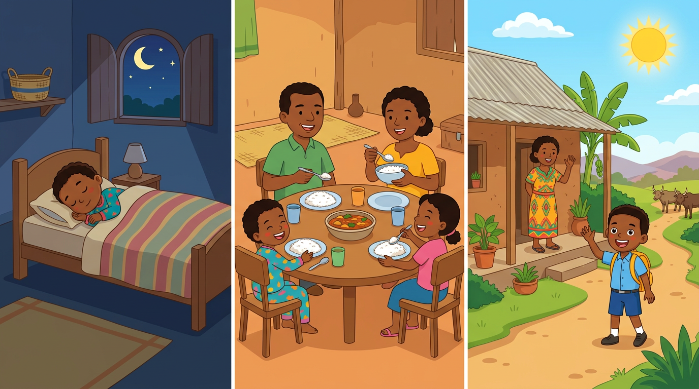
Before we sleep: Good night! [goud naïte]
Before we eat: Enjoy your meal! [inndjoï iôr mile]
A friend goes out: Have a nice day! [hav e naïs déi]
5. Saying goodbye
See you! [si iou] See you next time! [si iou nèkst taïme]
LISTEN! Scan the code or open the link to listen and download.
🎧 The parts of the day — listen and repeat
https://drive.google.com/uc?export=download&id=1pNh-HroJV7wai1XYvm-y0z02ciw3_L8N
 | 🎧 The rhyme — listen and say  https://drive.google.com/uc?export=download&id=1oE_Ayk2uxTUJNE7D857cohiq4xtrAU2Z
 | 🎧 Wishes and goodbye — listen and repeat  https://drive.google.com/uc?export=download&id=19M0ETNiwy2kByihjjsEXvD3C96-VmbEW

EXERCISES
Exercise 1 (4 points). The teacher points to the four pictures; say the parts of the day.

Exercise 2 (6 points). Say the right greeting or wish:
1. It is 8 o’clock in the morning. → ……
2. It is the afternoon. → ……
3. It is the evening. → ……
4. Your friend goes to bed. → ……
5. Your friend starts to eat. → ……
6. Your friend goes out for the day. → ……
Exercise 3 (4 points). Listen and tick the right picture: the teacher says four sentences (Good night! / Enjoy your meal! / See you! / Good morning!).

Exercise 4 (6 points). Say the “Parts of the day” rhyme with the actions.

Total: 20 points
ANSWER KEY
Exercise 1: morning, afternoon, evening, night (1 point each).
Exercise 2: 1. Good morning! 2. Good afternoon! 3. Good evening! 4. Good night! 5. Enjoy your meal! 6. Have a nice day!
Exercise 3: the four pictures match the sentences (1 point each).
Exercise 4: the four verses are said with the actions (1.5 points each).

SESSION 4 / 49
REVISION — UNIT 1: SOCIALISING
Remember:
morning  [môrning] | afternoon  [afteurnoune] | evening  [ivning] | night  [naïte]

Now answer:
1. Say the four parts of the day.
E.A.: morning, afternoon, evening, night.
2. Greet at the right time: morning / afternoon / evening.
E.A.: Good morning! Good afternoon! Good evening!
3. Say the three wishes.
E.A.: Good night! Enjoy your meal! Have a nice day!
4. Say goodbye in two ways.
E.A.: See you! See you next time!
5. Say the “Parts of the day” rhyme.
E.A.: the four verses are said.
6. Read the words of the unit on the blackboard.
E.A.: the words are read fluently, without mistakes.

SESSION 5 / 49
T5 TEST PAPER — UNIT 1: SOCIALISING
Duration: ……… Total: 20 points
Exercise 1 (4 points). The teacher points to four pictures; say the parts of the day.

Exercise 2 (6 points). Say the right greeting or wish (the teacher shows the clock or a picture, six times).

Exercise 3 (4 points). Listen and tick the right picture (four sentences).

Exercise 4 (6 points). Say the rhyme (4 points) and read two words on the blackboard (2 points).

ANSWER KEY
Exercise 1: morning, afternoon, evening, night (1 point each).
Exercise 2: the greeting/wish matches the clock or the picture (1 point each).
Exercise 3: the four pictures match the sentences (1 point each).
Exercise 4: the rhyme is said (4 points); the words are read correctly (1 point each).

UNIT 1 — I CAN…

Tick ✔ what you can do:
☐ I can say: morning, afternoon, evening, night.
☐ I can greet: Good morning / afternoon / evening!
☐ I can wish: Good night! Enjoy your meal! Have a nice day!
☐ I can say goodbye: See you! See you next time!
☐ I can say the “Parts of the day” rhyme.
☐ I can read the words of the unit.

Well done! See you in Unit 2: INTRODUCING ONESELF!

UNIT 2 — INTRODUCING ONESELF

Where are you from?
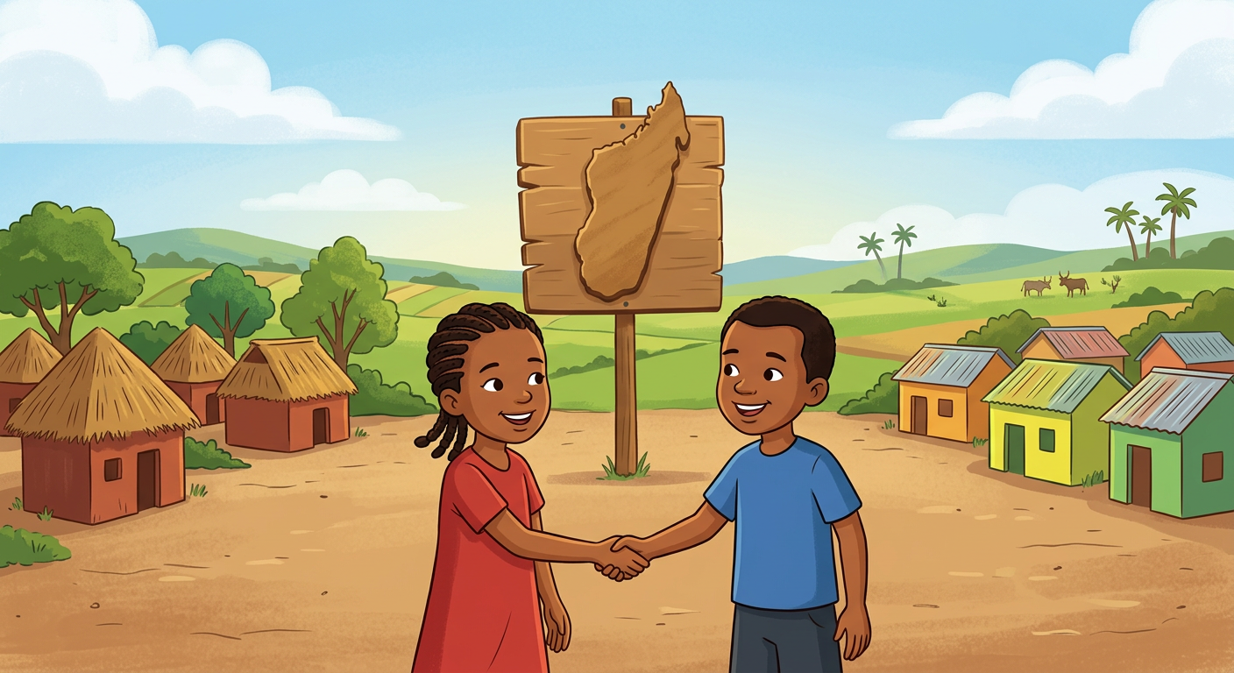
In this unit, I will learn to:
• ask and answer: Where are you from? — I’m from …;
• ask and answer: Where do you live? — I live in …;
• introduce myself: name, age, where I am from, where I live.
Values: respect, unity.
DO YOU REMEMBER? (Unit 1 + T4)
1. What’s your name? — My name is …
2. How old are you? — I’m …
3. Greet at the right time of the day.

LISTEN! Scan the code or open the link to listen and download.
 | 🎧 Where are you from? — listen and repeat  https://drive.google.com/uc?export=download&id=1Wu9GgUtjxwcjPtP9LiUXYwurxdGf_Gf2

SESSION 6 / 49
Where are you from? Where do you live?
LESSON PREPARATION SHEET
Subject: English  Theme: UNIT 2 — INTRODUCING ONESELF  Title: Where are you from? Where do you live?  Specific learning outcome: By the end of the lesson, learners will be able to ask and answer “Where are you from?” and “Where do you live?” with the right sentence intonation.  Values: respect, unity  Documentation: T4 English Syllabus (MEN — DCRP); T4 Pedagogical Resources Booklet  Materials: 7 numbered papers with village names, a small ball, audio (QR code) | Date: ……………………  Class: T4  Session n°: 1 / 2  Duration: ……………………

Steps and Duration | Procedure |  | Technique and Strategy | Materials | Remarks
Steps and Duration | Teacher | Learners | Technique and Strategy | Materials | Remarks
I. Review  Duration: ……… | Answer these questions:  1. Say the four parts of the day.  2. Greet me: it is the afternoon.  3. Say a wish to a friend. | Answer.  E.A.: 1. morning, afternoon, evening, night.  2. Good afternoon!  3. Have a nice day! / Good night! / Enjoy your meal! | Individual work | ----
II. NEW LESSON — Duration: ………
1. Warm-up | Sing the “What’s your name?” song from T4: “Hello, what’s your name? My name is… Nice to meet you. Nice to meet you too.” | Sing together. | Singing | ----
2. Presentation | Today we are going to learn a new lesson called: « Where are you from? Where do you live? ». By the end of this lesson, you will be able to say where you are from and where you live. | Listen. | Whole-class work | ----
3. Observation | Listen: Where are you from? — I’m from Madagascar. Where do you live? — I live in Ampasimbe. Listen to the music of the question: the voice goes down at the end. | Listen. | Modelling | Audio (QR code)
4. Analysis | Repeat the questions and the answers: the class, one row, one pupil.  Lottery game (from the syllabus): seven pupils draw a number (1 to 7); each number is a village name (Tanambao, Sambaina, Morombe, Ambalavola, Ampasika, Sambava, Ankazobe). I ask: Where are you from? The pupil answers with the village of the number.  Then the same with: Where do you live? — I live in … | Repeat. Play. Answer.  E.A.: I’m from Tanambao. / I live in Sambava. — the intonation is right. | Repetition drill / Game (lottery) | 7 numbered papers
5. Synthesis | So: Where are you from? — I’m from … (my home place). Where do you live? — I live in … (the place where I live now). | Listen. Repeat. | Whole-class work | Blackboard
6. Practice | Ball game in a circle (outside or in class): the pupil with the ball asks: “Hello, where do you live?”, throws the ball; the catcher answers: “Hello, I live in…”, then asks “And you? Where do you live?” and throws again.  Change the question: Where are you from? | Ask. Throw. Answer.  E.A.: — Where do you live? — I live in … / — Where are you from? — I’m from … | Game (ball) / Circle | A small ball
III. Evaluation  Duration: ……… | 1. Where are you from?  2. Where do you live?  3. Ask me one of the two questions. | Answer. Ask.  E.A.: I’m from … — I live in … — the question is asked with the right intonation. | Individual work | ----

SESSION 7 / 49
I introduce myself
LESSON PREPARATION SHEET
Subject: English  Theme: UNIT 2 — INTRODUCING ONESELF  Title: I introduce myself  Specific learning outcome: By the end of the lesson, learners will be able to read the dialogues fluently and introduce themselves confidently: name, age, where they are from, where they live.  Values: respect, unity  Documentation: T4 English Syllabus (MEN — DCRP); T4 Pedagogical Resources Booklet  Materials: dialogues on the blackboard, copy-books, a plastic bottle | Date: ……………………  Class: T4  Session n°: 2 / 2  Duration: ……………………

Steps and Duration | Procedure |  | Technique and Strategy | Materials | Remarks
Steps and Duration | Teacher | Learners | Technique and Strategy | Materials | Remarks
I. Review  Duration: ……… | Answer these questions:  1. Where are you from?  2. Where do you live?  3. Ask your friend one question. | Answer. Ask.  E.A.: 1. I’m from …  2. I live in …  3. Where are you from? / Where do you live? | Individual work | ----
II. NEW LESSON — Duration: ………
1. Warm-up | Listen to the two dialogues on the audio: Tiana and Andry; Jery and Liva. | Listen. | Whole-class work | Audio (QR code)
2. Presentation | Today we are going to read the dialogues and introduce ourselves. By the end of this lesson, you will be able to say who you are, all in English! | Listen. | Whole-class work | ----
3. Observation | Look at the dialogues on the blackboard. Listen to me reading them, sentence by sentence. | Look. Listen. | Modelling | Blackboard
4. Analysis | Read the dialogues after me: all together, by rows, then alone.  In pairs: read dialogue B and REPLACE the places with your own places.  Listen and correct each other kindly (peer correction). Then read aloud for the class.  True or false (in the copy-book): I say “Koto, where do you live?” — Koto answers “I live in Ankora.” In your copy-book: “Koto: I live in Anosy.” True or false? | Read. Replace. Correct. Circle.  E.A.: the dialogue is read with the real places; false — Koto lives in Ankora. | “Peer correction” / In pairs | Copy-books
5. Synthesis | So, to introduce myself I say: My name is … I’m … (age). I’m from … I live in … Nice to meet you! | Listen. Repeat the model. | Repetition drill | Blackboard
6. Practice | Spin-the-bottle game (from the syllabus), in groups of 10 in a circle: spin the bottle. The pupil the bottle points to introduces himself/herself: name, age, where from, where he/she lives, and finishes with “Nice to meet you!”  The others answer: “Nice to meet you, too!” Spin again! | Play. Introduce yourself.  E.A.: My name is … I’m 9. I’m from … I live in … Nice to meet you! — Nice to meet you, too! | Game (bottle) / Group work | A plastic bottle
III. Evaluation  Duration: ……… | 1. Introduce yourself in four sentences.  2. Read two lines of the dialogue.  3. I say a sentence about a pupil: true or false? | Introduce yourself. Read. Answer.  E.A.: My name is … I’m … I’m from … I live in … — the reading is fluent — true/false is right. | Individual work | Blackboard

LESSON — UNIT 2
INTRODUCING ONESELF
1. The song (do you remember?)
THE “WHAT’S YOUR NAME?” SONG ♪ (from T4)
Hello, what’s your name?
My name is… (2x)
Nice to meet you.
Nice to meet you too.

2. Where are you from? Where do you live?
The question: Where are you from? [ouèr âr iou frome]
The answer: I’m from Madagascar. [aïm frome madagaskar]
The question: Where do you live? [ouèr dou iou live]
The answer: I live in Ampasimbe. [aï live ine ampasimbé]
3. The dialogues
THE DIALOGUES (from the syllabus)
Dialogue A
Tiana : Andry, where are you from?
Andry : I’m from Madagascar. And you?
Tiana : I’m from Madagascar, too.

Dialogue B
Jery : Liva, where do you live?
Liva : I live in Ampasimbe. And you Jery, where do you live?
Jery : I live in Mahatazana.

4. I introduce myself
My name is … I’m … (age). I’m from … I live in … Nice to meet you!
LISTEN! Scan the code or open the link to listen and download.
🎧 Where are you from? + the dialogues — listen and repeat
https://drive.google.com/uc?export=download&id=1Wu9GgUtjxwcjPtP9LiUXYwurxdGf_Gf2

EXERCISES
Exercise 1 (4 points). Answer the teacher’s questions: Where are you from? Where do you live? (two questions, asked twice)

Exercise 2 (4 points). Read dialogue A with a friend, each one a role.

Exercise 3 (4 points). True or false? (The teacher reads; circle in the copy-book.)
1. Andry is from Madagascar.
2. Tiana is from France.
3. Liva lives in Ampasimbe.
4. Jery lives in Ampasimbe.
Exercise 4 (8 points). Introduce yourself in four sentences: name, age, from, live.

Total: 20 points
ANSWER KEY
Exercise 1: I’m from … / I live in … (1 point each answer).
Exercise 2: the dialogue is read fluently, with the right roles (4 points).
Exercise 3: 1. true 2. false 3. true 4. false (1 point each)
Exercise 4: My name is … (2) I’m … (2) I’m from … (2) I live in … (2).

SESSION 8 / 49
REVISION — UNIT 2: INTRODUCING ONESELF
Remember the two questions and the two answers:
Where are you from? [ouèr âr iou frome] → I’m from … [aïm frome]
Where do you live? [ouèr dou iou live] → I live in … [aï live ine]
Now answer:
1. Where are you from?
E.A.: I’m from …
2. Where do you live?
E.A.: I live in …
3. Read dialogue B with a friend, with YOUR places.
E.A.: the dialogue is read with the pupils’ real places.
4. Introduce yourself in four sentences.
E.A.: My name is … I’m … I’m from … I live in …
5. Sing the “What’s your name?” song.
E.A.: the song is sung.

SESSION 9 / 49
T5 TEST PAPER — UNIT 2: INTRODUCING ONESELF
Duration: ……… Total: 20 points
Exercise 1 (4 points). Answer: Where are you from? Where do you live?

Exercise 2 (4 points). Ask the teacher the two questions.

Exercise 3 (4 points). True or false? (The teacher reads four sentences about the dialogues.)

Exercise 4 (8 points). Introduce yourself in four sentences and finish with “Nice to meet you!”.

ANSWER KEY
Exercise 1: I’m from … / I live in … (2 points each).
Exercise 2: Where are you from? / Where do you live? with the right intonation (2 points each).
Exercise 3: true/false match the dialogues (1 point each).
Exercise 4: My name is … (2) I’m … (2) I’m from … (2) I live in … + Nice to meet you! (2).

UNIT 2 — I CAN…

Tick ✔ what you can do:
☐ I can ask: Where are you from? Where do you live?
☐ I can answer: I’m from … I live in …
☐ I can read the dialogues.
☐ I can introduce myself in four sentences.

Well done! See you in Unit 3: CLASSROOM LANGUAGE!

UNIT 3 — CLASSROOM LANGUAGE

Open your copybook!
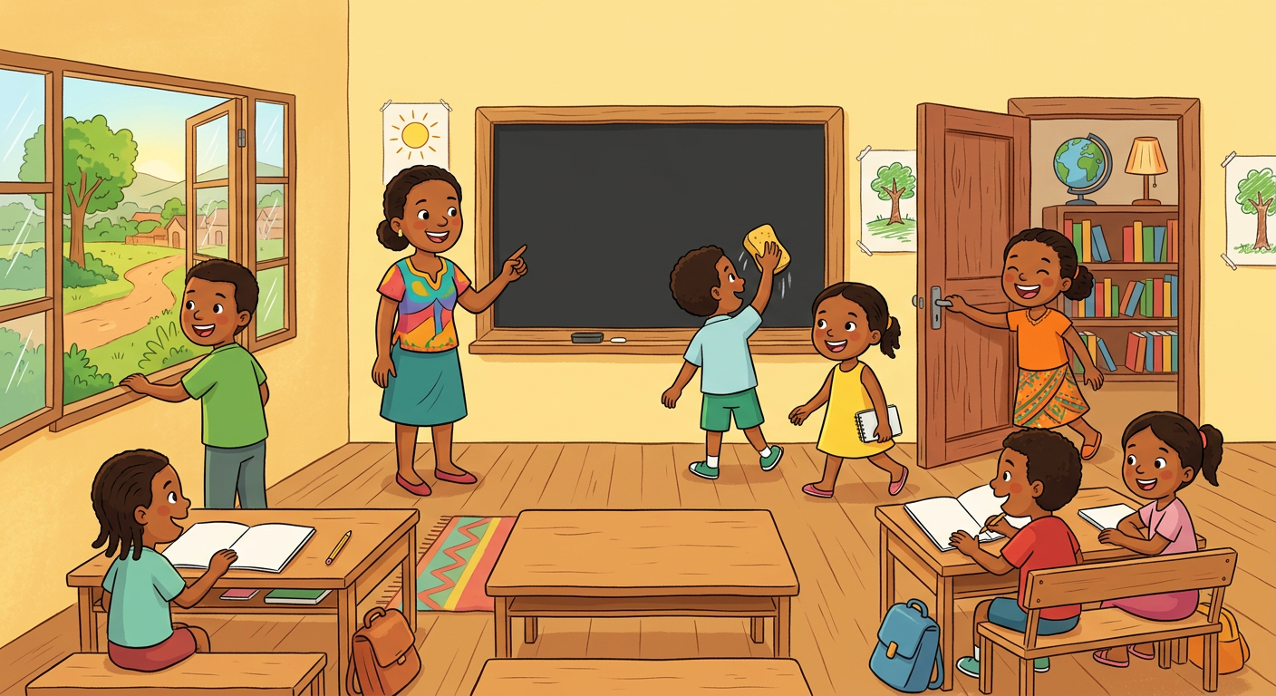
In this unit, I will learn to:
• understand and follow the classroom commands;
• give the commands to my friends;
• read the commands and match them with pictures.
Values: care for others, tolerance.
DO YOU REMEMBER? (T4)
In T4 we learned: Stand up! Sit down! Listen! Repeat! Look!
Play “Simon says” with these commands to warm up!

LISTEN! Scan the code or open the link to listen and download.
 | 🎧 Classroom commands — listen and act  https://drive.google.com/uc?export=download&id=1k4mXIALWcMYHQ9AMSpFzhNucvSruYH6m

SESSION 10 / 49
The classroom commands
LESSON PREPARATION SHEET
Subject: English  Theme: UNIT 3 — CLASSROOM LANGUAGE  Title: The classroom commands  Specific learning outcome: By the end of the lesson, learners will be able to understand the classroom commands and act them out correctly.  Values: care for others, tolerance  Documentation: T4 English Syllabus (MEN — DCRP); T4 Pedagogical Resources Booklet  Materials: the classroom (door, windows, blackboard), copybooks, audio (QR code) | Date: ……………………  Class: T4  Session n°: 1 / 2  Duration: ……………………

Steps and Duration | Procedure |  | Technique and Strategy | Materials | Remarks
Steps and Duration | Teacher | Learners | Technique and Strategy | Materials | Remarks
I. Review  Duration: ……… | (Commands from T4.) Do what I say:  1. Stand up! — Sit down!  2. Look at the blackboard!  3. Listen and repeat: “See you!” | Act. Repeat.  E.A.: the commands are followed.  E.A.: “See you!” is repeated. | Whole-class work | ----
II. NEW LESSON — Duration: ………
1. Warm-up | (The teacher opens the door and says nothing, then looks at the class.) What did I do? Today, the classroom speaks English! | Look. Answer in their own words. | Miming | The classroom
2. Presentation | Today we are going to learn a new lesson called: « The classroom commands ». By the end of this lesson, you will be able to understand and follow the commands in English. | Listen. | Whole-class work | ----
3. Observation | Watch and listen. (The teacher says each command and DOES it:) Go to the blackboard! Clean the blackboard! Open the door! Close the door! Open your copybook! Close your copybook! Open the windows! Close the windows! Go to the library! Go to the cafeteria! Have a break! | Look. Listen. | Modelling / Miming | The classroom, a copybook
4. Analysis | Repeat each command with the gesture: the class, one row, one pupil.  I say a command: one pupil does it.  I do an action: say the command.  What is the opposite of “Open the door!”? | Repeat. Act. Say.  E.A.: the actions match the commands.  E.A.: Close the door! | Repetition drill / T.P.R. (act it out) | The classroom
5. Synthesis | So, in the classroom we can say: Go to…! Clean…! Open…! Close…! Have a break! The command starts with the action word. | Listen. Repeat. | Whole-class work | Blackboard
6. Practice | Game “Teacher says” (like Simon says): if I say “Teacher says: open your copybook!”, do it. If I only say “Open your copybook!”, do NOT move!  Speed round: faster and faster! | Play. Act.  E.A.: the pupils act only after “Teacher says”; the actions are right. | Game (“Teacher says”) | The classroom
III. Evaluation  Duration: ……… | 1. I say three commands: act them out.  2. I mime two actions: say the commands.  3. Give one command to the class. | Act. Say. Command.  E.A.: the actions and the commands match: Open the windows! / Go to the blackboard!… | Individual work | The classroom

SESSION 11 / 49
I read and give the commands
LESSON PREPARATION SHEET
Subject: English  Theme: UNIT 3 — CLASSROOM LANGUAGE  Title: I read and give the commands  Specific learning outcome: By the end of the lesson, learners will be able to read the commands, match them with pictures and give the commands to their friends.  Values: care for others, tolerance  Documentation: T4 English Syllabus (MEN — DCRP); T4 Pedagogical Resources Booklet  Materials: command cards (words), picture cards, the classroom | Date: ……………………  Class: T4  Session n°: 2 / 2  Duration: ……………………

Steps and Duration | Procedure |  | Technique and Strategy | Materials | Remarks
Steps and Duration | Teacher | Learners | Technique and Strategy | Materials | Remarks
I. Review  Duration: ……… | Do what I say:  1. Open your copybook!  2. Close the windows!  3. What do I say before the pause? (mime resting) | Act. Answer.  E.A.: the actions are done.  3. Have a break! | Whole-class work | The classroom
II. NEW LESSON — Duration: ………
1. Warm-up | Quick game of “Teacher says” with the commands of the last session. | Play. | Game | ----
2. Presentation | Today you will READ the commands and GIVE the commands yourselves. You are the teachers today! | Listen. | Whole-class work | ----
3. Observation | Look at the commands written on the blackboard. Listen to me reading them, one by one, finger under the words. | Look. Listen. Follow with the eyes. | Modelling | Blackboard
4. Analysis | Read the commands after me: all together, by rows, then alone.  Matching: on one side the pictures, on the other side the command cards. Come and match a picture with its command, then read it.  Which word says the action in “Clean the blackboard!”? | Read. Match.  E.A.: the pictures and the commands match; the command is read.  E.A.: “Clean”. | Matching / “Visual aids” | Picture cards, command cards
5. Synthesis | So, we can read the commands and we know: the first word is the action (Go, Clean, Open, Close, Have). | Listen. | Whole-class work | Blackboard
6. Practice | In pairs: pupil A picks a command card, reads it aloud; pupil B does the action. Then change roles.  Group game: one pupil is “the teacher” and gives three commands to the group; the group acts. Everyone has a turn to be the teacher! | Read. Act. Command.  E.A.: the commands are read and given clearly; the actions are right: Go to the library!… | In pairs / Group work | Command cards
III. Evaluation  Duration: ……… | 1. Read two command cards.  2. Give two commands to the class.  3. Match three pictures with three commands. | Read. Command. Match.  E.A.: the reading is fluent; the commands are given clearly; the matching is right. | Individual work | Cards

LESSON — UNIT 3
CLASSROOM LANGUAGE
1. The commands
Go to the blackboard!  [gôou tou ze blakbôrd] | Clean the blackboard!  [kline ze blakbôrd]
Open the door!  [ôoupeune ze dôr] | Close the door!  [klôouz ze dôr]
Open your copybook!  [ôoupeune iôr kopibouk] | Close your copybook!  [klôouz iôr kopibouk]
Open the windows!  [ôoupeune ze ouindôouz] | Close the windows!  [klôouz ze ouindôouz]
Go to the library!  [gôou tou ze laïbreri] | Go to the cafeteria!  [gôou tou ze kafétiria]
Have a break!
[hav e bréik]

2. How does a command work?
The command starts with the action word: Go — Clean — Open — Close — Have.
Opposites: Open the door! ⇄ Close the door!
3. Be polite!
With a friend, you can add please [pliz]: Open the door, please!
LISTEN! Scan the code or open the link to listen and download.
🎧 Classroom commands — listen and act
https://drive.google.com/uc?export=download&id=1k4mXIALWcMYHQ9AMSpFzhNucvSruYH6m

EXERCISES
Exercise 1 (5 points). The teacher says five commands: act them out.

Exercise 2 (5 points). The teacher mimes five actions: say the commands.

Exercise 3 (5 points). Match the pictures with the commands and read them.

Exercise 4 (5 points). Say the opposites:
1. Open the door! → ……
2. Close your copybook! → ……
3. Open the windows! → ……
4. Close the door! → ……
5. Open your copybook! → ……
Total: 20 points
ANSWER KEY
Exercise 1: the five actions match the commands (1 point each).
Exercise 2: the five commands match the mimes (1 point each).
Exercise 3: the pictures and the commands match; the reading is right (1 point each).
Exercise 4: 1. Close the door! 2. Open your copybook! 3. Close the windows! 4. Open the door! 5. Close your copybook!

SESSION 12 / 49
REVISION — UNIT 3: CLASSROOM LANGUAGE
Remember the commands:
Go to the blackboard!  [gôou tou ze blakbôrd] | Clean the blackboard!  [kline ze blakbôrd]
Open the door!  [ôoupeune ze dôr] | Close the door!  [klôouz ze dôr]
Open your copybook!  [ôoupeune iôr kopibouk] | Close your copybook!  [klôouz iôr kopibouk]
Open the windows!  [ôoupeune ze ouindôouz] | Close the windows!  [klôouz ze ouindôouz]
Go to the library!  [gôou tou ze laïbreri] | Go to the cafeteria!  [gôou tou ze kafétiria]
Have a break!
[hav e bréik]

Now answer:
1. The teacher says five commands: act them out.
E.A.: the actions are right.
2. Give three commands to a friend.
E.A.: Go to the blackboard! / Open the door! / Have a break!…
3. Say the opposite: Open the windows!
E.A.: Close the windows!
4. Read four command cards.
E.A.: the commands are read fluently.
5. Play one round of “Teacher says” with your group.
E.A.: the game is played; the actions follow only “Teacher says”.

SESSION 13 / 49
T5 TEST PAPER — UNIT 3: CLASSROOM LANGUAGE
Duration: ……… Total: 20 points
Exercise 1 (5 points). The teacher says five commands: act them out.

Exercise 2 (5 points). The teacher mimes five actions: say the commands.

Exercise 3 (5 points). Read five command cards.

Exercise 4 (5 points). Say the opposite of five commands said by the teacher.

ANSWER KEY
Exercise 1: the actions match the commands (1 point each).
Exercise 2: the commands match the mimes (1 point each).
Exercise 3: the reading is fluent and correct (1 point each).
Exercise 4: Open ⇄ Close correctly used (1 point each).

UNIT 3 — I CAN…

Tick ✔ what you can do:
☐ I can understand the classroom commands.
☐ I can act out the commands.
☐ I can give the commands to my friends.
☐ I can read the commands.

Well done! See you in Unit 4: PARTS OF THE BODY!

UNIT 4 — PARTS OF THE BODY

Show me your hands!
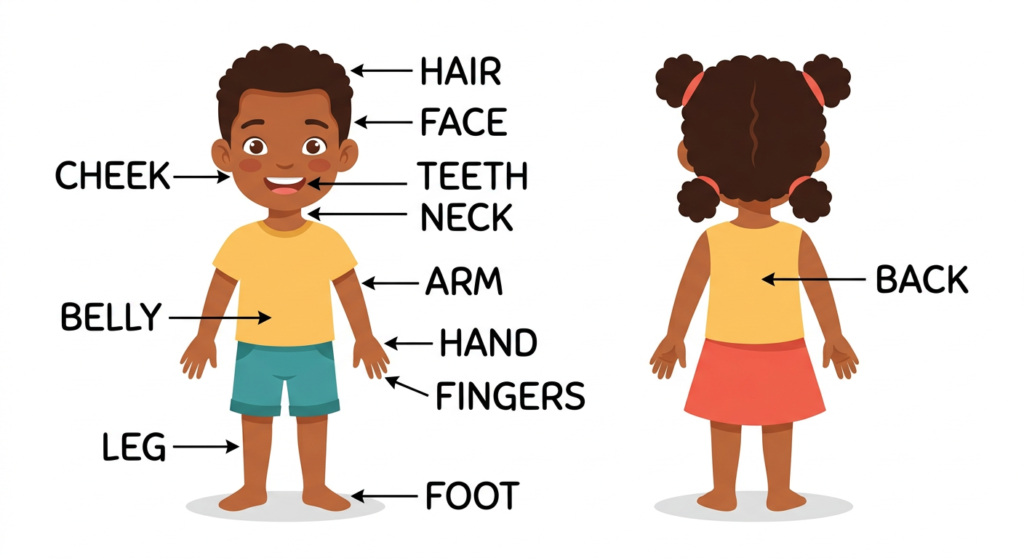
In this unit, I will learn to:
• say twelve new parts of the body;
• read the names of the body parts;
• say and act the “One little finger” rhyme;
• answer: What am I doing? — You are touching your …
Values: unity, love of effort.
DO YOU REMEMBER? (T4)
In T4 we learned: head, eyes, nose, ears, mouth, shoulders, knees and toes.
Sing “Head, shoulders, knees and toes” to warm up!

LISTEN! Scan the code or open the link to listen and download.
 | 🎧 One little finger — listen and act  https://drive.google.com/uc?export=download&id=17OUhSkIGUafhyZsqLvSWWwVUlXlHDaoL

SESSION 14 / 49
The parts of the body
LESSON PREPARATION SHEET
Subject: English  Theme: UNIT 4 — PARTS OF THE BODY  Title: The parts of the body  Specific learning outcome: By the end of the lesson, learners will be able to say the twelve new parts of the body clearly, read them on the picture and act the “One little finger” rhyme.  Values: unity, love of effort  Documentation: T4 English Syllabus (MEN — DCRP); T4 Pedagogical Resources Booklet  Materials: big picture of the body with labels, audio (QR code) | Date: ……………………  Class: T4  Session n°: 1 / 2  Duration: ……………………

Steps and Duration | Procedure |  | Technique and Strategy | Materials | Remarks
Steps and Duration | Teacher | Learners | Technique and Strategy | Materials | Remarks
I. Review  Duration: ……… | (Review of T4.) Answer these questions:  1. Touch your head / your nose / your ears.  2. Sing “Head, shoulders, knees and toes”.  3. Open your copybook! (Unit 3) | Act. Sing.  E.A.: the right parts are touched.  E.A.: the song is sung; the copybook is opened. | Whole-class work | ----
II. NEW LESSON — Duration: ………
1. Warm-up | (The teacher points to his/her hair.) Do you know this word in English? Today, twelve new parts of the body! | Look. Guess. | Miming | ----
2. Presentation | Today we are going to learn a new lesson called: « The parts of the body ». By the end of this lesson, you will be able to say and read twelve new parts of the body. | Listen. | Whole-class work | ----
3. Observation | Look at the big picture. Listen: hair, face, cheeks, neck, teeth, back, belly, arms, hands, fingers, legs, feet. (The teacher points to each part on the picture and on his/her own body.) | Look. Listen. | “Visual aids” / Audio | Big picture, audio (QR code)
4. Analysis | Repeat each word and touch the part: the class, one row, one pupil.  Read the names of the body parts on the picture.  In pairs: pupil A says “Point to the… (back, legs, feet…)”; pupil B points to the part. Then change roles. | Repeat. Touch. Read. Point.  E.A.: the words are read; the right parts are pointed to. | Repetition drill / In pairs | Big picture with labels
5. Synthesis | So, the new parts of the body are: hair, face, cheeks, neck, teeth, back, belly, arms, hands, fingers, legs, feet.  Careful! One foot → two feet. One tooth → many teeth. | Listen. Repeat. | Whole-class work | Blackboard
6. Practice | The rhyme! Listen to “One little finger” and watch my actions: tap, tap, tap — up — down — put it on your hair…  Say the rhyme with the actions, verse by verse, then all together. | Listen. Act. Say the rhyme.  E.A.: the rhyme is said with the right actions on hair, cheek, hand, leg, foot. | Rhyme / T.P.R. (act it out) | Audio (QR code)
III. Evaluation  Duration: ……… | 1. I point to six parts on the picture: say the words.  2. Read three words on the blackboard.  3. Say one verse of the rhyme with the actions. | Say. Read. Act.  E.A.: the parts are named clearly; the words are read without mistakes. | Individual work | Big picture

SESSION 15 / 49
This is my… — What am I doing?
LESSON PREPARATION SHEET
Subject: English  Theme: UNIT 4 — PARTS OF THE BODY  Title: This is my… — What am I doing?  Specific learning outcome: By the end of the lesson, learners will be able to answer “Show me your…” with “This is my…” and say “You are touching your…” in the game.  Values: unity, love of effort  Documentation: T4 English Syllabus (MEN — DCRP); T4 Pedagogical Resources Booklet  Materials: the picture of the body, audio (QR code) | Date: ……………………  Class: T4  Session n°: 2 / 2  Duration: ……………………

Steps and Duration | Procedure |  | Technique and Strategy | Materials | Remarks
Steps and Duration | Teacher | Learners | Technique and Strategy | Materials | Remarks
I. Review  Duration: ……… | Answer these questions:  1. I point to my cheek / my neck / my belly: what is it?  2. Say the “One little finger” rhyme.  3. What is the plural of “foot”? | Answer.  E.A.: 1. cheek, neck, belly.  2. The rhyme is said.  3. feet. | Individual work | ----
II. NEW LESSON — Duration: ………
1. Warm-up | Quick rhyme: “One little finger” with the actions, faster and faster! | Say the rhyme. Act. | Rhyme | ----
2. Presentation | Today we are going to speak about OUR body. By the end of this lesson, you will be able to say “This is my…” and “You are touching your…”. | Listen. | Whole-class work | ----
3. Observation | Listen. (The teacher says:) Show me your hand! (and a pupil shows the hand:) This is my hand. (The teacher touches his/her nose:) I’m touching my nose. | Look. Listen. | Modelling | ----
4. Analysis | Repeat the model sentences: the class, one row, one pupil.  In pairs: pupil A says “Show me your (eye, nose, ear, hand, teeth…)”; pupil B shows the part and says “This is my (eye…)” / “These are my (teeth…)”. Change roles.  Now repeat my gesture and my words: “I’m touching my eyes.” “I’m touching my nose.” | Repeat. Show. Say.  E.A.: This is my hand. / These are my teeth. / I’m touching my nose. | Repetition drill / In pairs | ----
5. Synthesis | So: Show me your hand! → This is my hand. For two parts: These are my hands. And for the action: I’m touching my nose. / You are touching your nose. | Listen. Repeat. | Whole-class work | Blackboard
6. Practice | Game “What am I doing?”: I touch a part of my body and ask “What am I doing?”  Then one pupil comes to the front, touches a part, and asks the class: “What am I doing?” | Answer. Play.  E.A.: You are touching your… (hair, cheek, back, belly…). | Game / Whole-class work | ----
III. Evaluation  Duration: ……… | 1. Show me your fingers / your teeth!  2. I touch my neck: what am I doing?  3. Read four body words on the blackboard. | Show. Answer. Read.  E.A.: These are my fingers / my teeth. — You are touching your neck. — the words are read without mistakes. | Individual work | Blackboard

LESSON — UNIT 4
PARTS OF THE BODY
1. Twelve new words
hair  [hèr] | face  [féiss] | cheeks  [tchiks] | neck  [nèk]
teeth  [tiss] | back  [bak] | belly  [bèli] | arms  [ârmz]
hands  [handz] | fingers  [finngueurz] | legs  [lègz] | feet  [fite]

2. One or two?
one foot → two feet one tooth → many teeth
3. The rhyme
THE “ONE LITTLE FINGER” RHYME ♪
Chorus:
One little finger, one little finger,
one little finger, tap, tap, tap!
Point your finger up, up.
Point your finger down, down.
Put it on your hair, hair. (Chorus)
Put it on your cheek, cheek. (Chorus)
Put it on your hand, hand. (Chorus)
Put it on your leg, leg. (Chorus)
Put it on your foot, foot.
Put it on your leg, leg. Put it on your hand, hand.
Put it on your cheek, cheek. Put it on your hair, hair.
Now let’s wave goodbye, goodbye!

4. Speaking about my body
Show me your hand! → This is my hand. [ziss iz maï hande]
Show me your teeth! → These are my teeth. [ziz âr maï tiss]
What am I doing? → You are touching your nose. [iou âr teutchinng iôr nôouz]
LISTEN! Scan the code or open the link to listen and download.
 | 🎧 The parts of the body — listen and repeat  https://drive.google.com/uc?export=download&id=1S_ddCrOf1ILZoAUnkidm_y1Gr-m4KvJP
🎧 One little finger — listen and act
https://drive.google.com/uc?export=download&id=17OUhSkIGUafhyZsqLvSWWwVUlXlHDaoL

EXERCISES
Exercise 1 (6 points). The teacher points to six parts of the body on the picture: say the words.

Exercise 2 (4 points). Show and say:
1. Show me your hand! → ……
2. Show me your teeth! → ……
3. Show me your fingers! → ……
4. Show me your cheek! → ……
Exercise 3 (4 points). The teacher touches four parts: say “You are touching your …”.

Exercise 4 (6 points). Say the “One little finger” rhyme with the actions (4 points) and read two body words (2 points).

Total: 20 points
ANSWER KEY
Exercise 1: the six parts are named clearly (1 point each).
Exercise 2: 1. This is my hand. 2. These are my teeth. 3. These are my fingers. 4. This is my cheek.
Exercise 3: You are touching your … (1 point each).
Exercise 4: the rhyme is said with the actions; the words are read correctly.

SESSION 16 / 49
REVISION — UNIT 4: PARTS OF THE BODY
Remember the twelve words:
hair  [hèr] | face  [féiss] | cheeks  [tchiks] | neck  [nèk]
teeth  [tiss] | back  [bak] | belly  [bèli] | arms  [ârmz]
hands  [handz] | fingers  [finngueurz] | legs  [lègz] | feet  [fite]

Now answer:
1. The teacher points to six parts on the picture: say the words.
E.A.: hair, face, cheeks, neck, teeth, back, belly, arms, hands, fingers, legs, feet.
2. Show me your hands! Show me your teeth!
E.A.: These are my hands. These are my teeth.
3. The teacher touches a part: what is he/she doing?
E.A.: You are touching your …
4. Say the “One little finger” rhyme with the actions.
E.A.: the rhyme is said with the actions.
5. Read six body words on the blackboard.
E.A.: the words are read fluently, without mistakes.
6. Puzzle game (in groups): put the pieces of the body picture together and name each part.
E.A.: the puzzle is done; the parts are named.

SESSION 17 / 49
T5 TEST PAPER — UNIT 4: PARTS OF THE BODY
Duration: ……… Total: 20 points
Exercise 1 (6 points). The teacher points to six parts on the picture: say the words.

Exercise 2 (4 points). Show and say: Show me your … (four parts).

Exercise 3 (4 points). The teacher touches four parts: say “You are touching your …”.

Exercise 4 (6 points). Say the rhyme with the actions (4 points) and read two body words (2 points).

ANSWER KEY
Exercise 1: the parts are named clearly (1 point each).
Exercise 2: This is my … / These are my … (1 point each).
Exercise 3: You are touching your … (1 point each).
Exercise 4: the rhyme is said with the actions; the reading is correct.

UNIT 4 — I CAN…

Tick ✔ what you can do:
☐ I can say twelve new parts of the body.
☐ I can read the names of the body parts.
☐ I can say: This is my … / These are my …
☐ I can say: You are touching your …
☐ I can say the “One little finger” rhyme.

Well done! See you in Unit 5: MY BIRTHDAY!

UNIT 5 — MY BIRTHDAY IS ON…

Happy birthday!
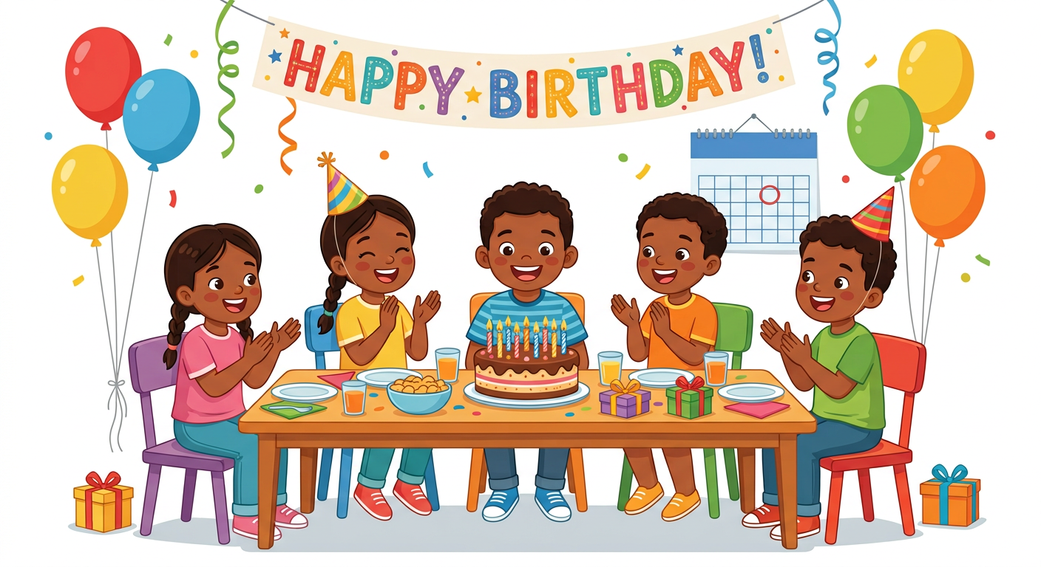
In this unit, I will learn to:
• read the numbers 1 to 20 and count to 40;
• say and read the 12 months of the year;
• say my favourite month;
• say my birthday: My birthday is on … It is a …
Values: self-confidence, mutual respect.
DO YOU REMEMBER? (T4)
In T4 we counted from 1 to 20: one, two, three… twenty.
Count to 20 with a friend: one says 1, the other says 2… Who says 20?

LISTEN! Scan the code or open the link to listen and download.
 | 🎧 The months of the year — listen and sing  https://drive.google.com/uc?export=download&id=1CyD5EY7e8HeRRKH-IC0t98IHLx3NNFpl

SESSION 18 / 49
Reading the numbers 1 to 20
LESSON PREPARATION SHEET
Subject: English  Theme: UNIT 5 — MY BIRTHDAY IS ON…  Title: Reading the numbers 1 to 20  Specific learning outcome: By the end of the lesson, learners will be able to read the numbers 1 to 20 written in words, fluently and with the right stress.  Values: self-confidence, mutual respect  Documentation: T4 English Syllabus (MEN — DCRP); T4 Pedagogical Resources Booklet  Materials: papers with the numbers 1 to 20 in words, blackboard, audio (QR code) | Date: ……………………  Class: T4  Session n°: 1 / 5  Duration: ……………………

Steps and Duration | Procedure |  | Technique and Strategy | Materials | Remarks
Steps and Duration | Teacher | Learners | Technique and Strategy | Materials | Remarks
I. Review  Duration: ……… | Answer these questions:  1. Count from 1 to 10.  2. Count from 11 to 20.  3. Show me your fingers! (Unit 4) | Answer. Show.  E.A.: one … ten; eleven … twenty.  E.A.: These are my fingers. | Individual work | ----
II. NEW LESSON — Duration: ………
1. Warm-up | Number ping-pong: I say a number, you say the next one. One! — … Five! — … Twelve! — … | Answer: two! six! thirteen! | Game | ----
2. Presentation | Today we are going to READ the numbers 1 to 20 written in words. By the end of this lesson, you will read them fluently, like little champions! | Listen. | Whole-class work | ----
3. Observation | Look at the words on the blackboard: one, two, three… twenty. Listen to me reading them. Listen to the strong part: thirTEEN, fourTEEN… but TWENty! | Look. Listen. | Modelling | Blackboard
4. Analysis | Read after me: all together, by rows, then alone.  I point to a word, you read it: eleven? sixteen? twenty?  Which words end with “-teen”? | Read. Answer.  E.A.: the words are read; thirteen, fourteen… nineteen end with -teen. | Repetition drill | Blackboard
5. Synthesis | So, we can read the numbers 1 to 20 in words. The numbers 13 to 19 end with -teen and the strong part is at the END. | Listen. | Whole-class work | Blackboard
6. Practice | In pairs (from the syllabus): take a paper with the numbers 1 to 20 in words. Pupil A reads the numbers in English; pupil B listens carefully and corrects the mistakes. Then change roles: B reads, A corrects. | Read. Listen. Correct each other kindly.  E.A.: the numbers are read fluently: one, two… twenty; the friends correct each other. | “Peer correction” / In pairs | Papers with the numbers in words
III. Evaluation  Duration: ……… | 1. Read five number words on the blackboard.  2. I say a number: point to the word.  3. Count from 1 to 20. | Read. Point. Count.  E.A.: the words are read without mistakes; the right words are pointed to. | Individual work | Blackboard

SESSION 19 / 49
The twelve months of the year
LESSON PREPARATION SHEET
Subject: English  Theme: UNIT 5 — MY BIRTHDAY IS ON…  Title: The twelve months of the year  Specific learning outcome: By the end of the lesson, learners will be able to say the twelve months of the year clearly and sing the “Months of the Year” song.  Values: self-confidence, mutual respect  Documentation: T4 English Syllabus (MEN — DCRP); T4 Pedagogical Resources Booklet  Materials: audio (QR code), blackboard | Date: ……………………  Class: T4  Session n°: 2 / 5  Duration: ……………………

Steps and Duration | Procedure |  | Technique and Strategy | Materials | Remarks
Steps and Duration | Teacher | Learners | Technique and Strategy | Materials | Remarks
I. Review  Duration: ……… | Answer these questions:  1. Read these words: seven, twelve, eighteen.  2. Count from 1 to 20.  3. What month is it now? | Read. Count. Answer in their own words.  E.A.: the words are read; the counting is right. | Individual work | Blackboard
II. NEW LESSON — Duration: ………
1. Warm-up | How many months are there in one year? Let’s count them on our fingers! | Count: twelve! | Whole-class work | ----
2. Presentation | Today we are going to learn a new lesson called: « The twelve months of the year ». By the end of this lesson, you will be able to say the twelve months and sing the song. | Listen. | Whole-class work | ----
3. Observation | Listen to the twelve months: January, February, March, April, May, June, July, August, September, October, November, December. | Listen. | Modelling / Audio | Audio (QR code)
4. Analysis | Listen again and repeat together, month by month, until the pronunciation is good.  Repeat by rows, then alone.  Now say the months in Malagasy, and compare: the English name and the Malagasy name are like cousins! (language transfer) | Repeat. Compare.  E.A.: the twelve months are pronounced clearly; the pupils see the months are alike. | Repetition drill / “Language transfer” | ----
5. Synthesis | So, the twelve months of the year are: January, February, March, April, May, June, July, August, September, October, November, December. | Listen. Repeat. | Whole-class work | Blackboard
6. Practice | The song! Listen to the “Months of the Year” song to the end.  Listen part by part and sing each part.  Sing the whole song from the beginning to the end. | Listen. Sing part by part. Sing the whole song.  E.A.: the song is sung: “January, February, March and April…”. | Song / Audio | Audio (QR code)
III. Evaluation  Duration: ……… | 1. Say the twelve months in order.  2. I say a month in Malagasy: say it in English.  3. Sing the song with the class. | Say. Sing.  E.A.: the months are said in order and clearly; the song is sung. | Individual work | ----

SESSION 20 / 49
Reading the months — My favourite month
LESSON PREPARATION SHEET
Subject: English  Theme: UNIT 5 — MY BIRTHDAY IS ON…  Title: Reading the months — My favourite month  Specific learning outcome: By the end of the lesson, learners will be able to read the twelve months fluently and say their favourite month.  Values: self-confidence, mutual respect  Documentation: T4 English Syllabus (MEN — DCRP); T4 Pedagogical Resources Booklet  Materials: 12 papers with the month names, big sheets, pencils | Date: ……………………  Class: T4  Session n°: 3 / 5  Duration: ……………………

Steps and Duration | Procedure |  | Technique and Strategy | Materials | Remarks
Steps and Duration | Teacher | Learners | Technique and Strategy | Materials | Remarks
I. Review  Duration: ……… | Answer these questions:  1. Say the twelve months in order.  2. Sing the “Months of the Year” song.  3. What month comes after June? | Answer. Sing.  E.A.: 1. January … December.  3. July. | Individual work | ----
II. NEW LESSON — Duration: ………
1. Warm-up | Quick song: sing the “Months of the Year” song, and clap on YOUR birth month! | Sing. Clap. | Song | ----
2. Presentation | Today we are going to READ the months and say our favourite month. By the end of this lesson, you will read the twelve months and say the month you like best. | Listen. | Whole-class work | ----
3. Observation | Look at the twelve months written on the blackboard. Listen to me reading them. Careful with the strong part: JAnuary, FEbruary, sepTEMber, ocTOber, noVEMber, deCEMber! | Look. Listen. | Modelling | Blackboard
4. Analysis | Read the months after me: all together, by rows, then alone.  Group game (from the syllabus): the class makes 12 groups. Each group takes a paper with one month and draws a picture for this month (example: June → a picture of Independence Day!). The class looks at the drawing and reads the month.  Now listen: My favourite month is December. “Favourite” = the one I like best. What is YOUR favourite month? | Read. Draw. Guess. Answer.  E.A.: the months are read; My favourite month is … | Group work / Modelling | 12 papers, big sheets, pencils
5. Synthesis | So: What is your favourite month? — My favourite month is (December). And when a friend answers, we say “Great!” or “Good!” — we respect the choice of our friend. | Listen. Repeat. | Whole-class work | Blackboard
6. Practice | Chain game: ask your neighbour “What is your favourite month?”; the neighbour answers “My favourite month is …”; you say “Great!” — then the neighbour asks the next pupil. | Ask. Answer. Respect the choice.  E.A.: — What is your favourite month? — My favourite month is … — Great! / Good! | Chain game | ----
III. Evaluation  Duration: ……… | 1. Read six months on the blackboard.  2. What is your favourite month?  3. Ask me my favourite month. | Read. Answer. Ask.  E.A.: the months are read fluently; My favourite month is …; the question is asked. | Individual work | Blackboard

SESSION 21 / 49
Counting from 21 to 40
LESSON PREPARATION SHEET
Subject: English  Theme: UNIT 5 — MY BIRTHDAY IS ON…  Title: Counting from 21 to 40  Specific learning outcome: By the end of the lesson, learners will be able to count from 21 to 40 and recognise the numbers thirty and forty.  Values: self-confidence, mutual respect  Documentation: T4 English Syllabus (MEN — DCRP); T4 Pedagogical Resources Booklet  Materials: two big cards with 30 and 40, copy-books | Date: ……………………  Class: T4  Session n°: 4 / 5  Duration: ……………………

Steps and Duration | Procedure |  | Technique and Strategy | Materials | Remarks
Steps and Duration | Teacher | Learners | Technique and Strategy | Materials | Remarks
I. Review  Duration: ……… | Answer these questions:  1. Count from 1 to 20.  2. Read: fifteen, nineteen, twenty.  3. What is your favourite month? | Count. Read. Answer.  E.A.: the counting and the reading are right; My favourite month is … | Individual work | Blackboard
II. NEW LESSON — Duration: ………
1. Warm-up | Count from 1 to 20 in English. Now count from 21 to 29 in French. Ready for the same numbers in English? It works the same way! | Count. | “Transfer” | ----
2. Presentation | Today we are going to count from 21 to 40. By the end of this lesson, you will count to forty! | Listen. | Whole-class work | ----
3. Observation | Look at this big card: 30. Listen: “thirty”. Look at this card: 40. Listen: “forty”. Now listen: twenty-one, twenty-two, twenty-three… twenty-nine, thirty! | Look. Listen. | “Visual aids” / Modelling | Big cards 30 and 40
4. Analysis | Repeat after me: thirty / forty — the class, one row, one pupil.  I say a number: point to the right card (thirty or forty).  Count with me: twenty-one… thirty. Thirty-one… forty.  Dictation: I say numbers between 21 and 40; write them in figures in your copy-book. | Repeat. Point. Count. Write.  E.A.: the cards are pointed to; the numbers are written: 25, 32, 40… | Repetition drill / Dictation | Cards, copy-books
5. Synthesis | So: 21 = twenty-one, 30 = thirty, 40 = forty. After twenty we say twenty-one, twenty-two… like in French! | Listen. Repeat. | Whole-class work | Blackboard
6. Practice | Hide-and-seek (from the syllabus), in the schoolyard: two teams, A and B. Team B hides. Team A counts to FORTY in English, then looks for the friends of team B. Then change roles! | Count to forty. Play.  E.A.: the team counts: one, two… thirty-nine, forty! before looking. | Game (hide-and-seek) / Two teams | The schoolyard
III. Evaluation  Duration: ……… | 1. Count from 21 to 40.  2. I show a card: thirty or forty?  3. Write in figures: twenty-five, thirty-eight. | Count. Answer. Write.  E.A.: the counting is right; 25 and 38 are written. | Individual work | Cards, copy-books

SESSION 22 / 49
Reading 21 to 40 — My birthday is on…
LESSON PREPARATION SHEET
Subject: English  Theme: UNIT 5 — MY BIRTHDAY IS ON…  Title: Reading 21 to 40 — My birthday is on…  Specific learning outcome: By the end of the lesson, learners will be able to read the numbers 21 to 40 in words and say the date of their birthday with the calendar.  Values: self-confidence, mutual respect  Documentation: T4 English Syllabus (MEN — DCRP); T4 Pedagogical Resources Booklet  Materials: cards with figures and words 21-40, a calendar, audio (QR code) | Date: ……………………  Class: T4  Session n°: 5 / 5  Duration: ……………………

Steps and Duration | Procedure |  | Technique and Strategy | Materials | Remarks
Steps and Duration | Teacher | Learners | Technique and Strategy | Materials | Remarks
I. Review  Duration: ……… | Answer these questions:  1. Count from 21 to 40.  2. Say the twelve months.  3. Read: thirty, forty. | Count. Say. Read.  E.A.: the counting, the months and the reading are right. | Individual work | Blackboard
II. NEW LESSON — Duration: ………
1. Warm-up | Card game (from the syllabus): each pupil takes one card face down on the table (a figure 21-40 OR a word twenty-one…forty). Find the friend with the SAME number and say your number together! | Take a card. Find the pair. Say the number. | Game (matching pairs) | Cards with figures and words
2. Presentation | Today we are going to read the numbers 21 to 40 and learn to say our BIRTHDAY. By the end of this lesson, you will say: My birthday is on … | Listen. | Whole-class work | ----
3. Observation | Look at the words on the blackboard: twenty-one… forty. Listen to me reading them.  Now listen (audio): When is your birthday? — My birthday is on October 22. It is a Monday. | Look. Listen. | Modelling / Audio | Blackboard, audio (QR code)
4. Analysis | Read the numbers after me: together, by rows, alone.  In pairs: pupil A reads and points to the words 21 to 40; pupil B listens and corrects. Change roles.  Look at the calendar: my birthday is on October 22. What day is it this year? (The teacher shows:) It is a Monday. | Read. Correct. Look at the calendar.  E.A.: the numbers are read; the day is found on the calendar. | “Peer correction” / “Visual aids” | Calendar, papers
5. Synthesis | So: When is your birthday? — My birthday is on (month + number): My birthday is on March 5. And with the calendar: It is a (Thursday). | Listen. Repeat. | Whole-class work | Blackboard, calendar
6. Practice | Everyone speaks! Each pupil says: “My birthday is on …”, looks at the calendar and adds: “It is a …”. I help the pupils who are not sure of their date. | Say the birthday. Look at the calendar. Say the day.  E.A.: My birthday is on (June 15). It is a (Sunday). | Individual speaking / “Visual aids” | Calendar
III. Evaluation  Duration: ……… | 1. Read four numbers in words (21-40).  2. When is your birthday?  3. Ask a friend: When is your birthday? | Read. Answer. Ask.  E.A.: the numbers are read; My birthday is on … It is a …; the question is asked. | Individual work | Calendar

LESSON — UNIT 5
MY BIRTHDAY IS ON…
1. The numbers 21 to 40
21  twenty-one | 22  twenty-two | 23  twenty-three | 24  twenty-four | 25  twenty-five
26  twenty-six | 27  twenty-seven | 28  twenty-eight | 29  twenty-nine | 30  thirty
31  thirty-one | 32  thirty-two | 33  thirty-three | 34  thirty-four | 35  thirty-five
36  thirty-six | 37  thirty-seven | 38  thirty-eight | 39  thirty-nine | 40  forty

SAY IT RIGHT! thirTEEN (13) — the strong part at the END. THIRty (30) — the strong part at the START!

2. The twelve months of the year
January  [djanioueri] | February  [fébioueri] | March  [mârtch] | April  [éiprol]
May  [méi] | June  [djoune] | July  [djoulaï] | August  [ôgueuste]
September  [sèptèmbeur] | October  [oktôoubeur] | November  [novèmbeur] | December  [dissèmbeur]

3. The song
THE “MONTHS OF THE YEAR” SONG ♪
January, February, March and April,
May, June, July and August,
September, October, November, December:
these are the months of the year!

4. My favourite month
The question: What is your favourite month? [ouate iz iôr féivrite monnss]
The answer: My favourite month is December. [maï féivrite monnss iz dissèmbeur]
We respect the choice: Great! [gréite] Good! [goud]
5. My birthday
The question: When is your birthday? [ouène iz iôr beurssdéi]
The answer: My birthday is on October 22. [maï beurssdéi iz one oktôoubeur touènti-tou]
With the calendar: It is a Monday. [ite iz e manndéi]
LISTEN! Scan the code or open the link to listen and download.
 | 🎧 Numbers 1 to 40 — listen and count  https://drive.google.com/uc?export=download&id=1g2bC2W2qoha6rmYqjGznnIBfHit3TUUN
🎧 The months of the year — listen and sing
https://drive.google.com/uc?export=download&id=1CyD5EY7e8HeRRKH-IC0t98IHLx3NNFpl
 | 🎧 My birthday — listen and repeat  https://drive.google.com/uc?export=download&id=1Z-mu6mXFzZGiTzrML0qmeEqKjV9PR72G

EXERCISES
Exercise 1 (5 points). Read these numbers: twelve — nineteen — twenty-four — thirty — forty.

Exercise 2 (5 points). Count from 21 to 40 without a mistake.

Exercise 3 (4 points). Say the months in order: which month comes after…?
1. after March? → ……
2. after July? → ……
3. after September? → ……
4. after December? → ……
Exercise 4 (6 points). Answer: What is your favourite month? (2 points) When is your birthday? (2 points) It is a …? (2 points)

Total: 20 points
ANSWER KEY
Exercise 1: the five numbers are read correctly (1 point each).
Exercise 2: twenty-one, twenty-two … thirty-nine, forty (5 points).
Exercise 3: 1. April 2. August 3. October 4. January.
Exercise 4: My favourite month is … — My birthday is on … — It is a …

SESSION 23 / 49
REVISION — UNIT 5: MY BIRTHDAY IS ON…
Remember the months:
January  [djanioueri] | February  [fébioueri] | March  [mârtch] | April  [éiprol]
May  [méi] | June  [djoune] | July  [djoulaï] | August  [ôgueuste]
September  [sèptèmbeur] | October  [oktôoubeur] | November  [novèmbeur] | December  [dissèmbeur]

Now answer:
1. Count from 1 to 40.
E.A.: one, two … thirty-nine, forty.
2. Read: seventeen, twenty-three, thirty-six, forty.
E.A.: the numbers are read without mistakes.
3. Sing the “Months of the Year” song.
E.A.: the song is sung.
4. Read the twelve months on the blackboard.
E.A.: the months are read fluently.
5. What is your favourite month?
E.A.: My favourite month is …
6. When is your birthday? What day is it this year?
E.A.: My birthday is on … It is a …

SESSION 24 / 49
T5 TEST PAPER — UNIT 5: MY BIRTHDAY IS ON…
Duration: ……… Total: 20 points
Exercise 1 (5 points). Read five numbers in words chosen by the teacher (between 1 and 40).

Exercise 2 (5 points). Count from 21 to 40.

Exercise 3 (5 points). Say the twelve months in order (3 points) and read two months on the blackboard (2 points).

Exercise 4 (5 points). Answer: What is your favourite month? When is your birthday? It is a …?

ANSWER KEY
Exercise 1: the numbers are read correctly (1 point each).
Exercise 2: twenty-one … forty without mistakes (5 points).
Exercise 3: January … December in order; the reading is correct.
Exercise 4: My favourite month is … (1) My birthday is on … (2) It is a … (2).

UNIT 5 — I CAN…

Tick ✔ what you can do:
☐ I can read the numbers 1 to 20 in words.
☐ I can count from 21 to 40.
☐ I can say and read the twelve months.
☐ I can sing the “Months of the Year” song.
☐ I can say my favourite month.
☐ I can say: My birthday is on … It is a …

Well done! See you in Unit 6: MY DREAM CLASSROOM!

UNIT 6 — MY DREAM CLASSROOM

There are twelve pupils!
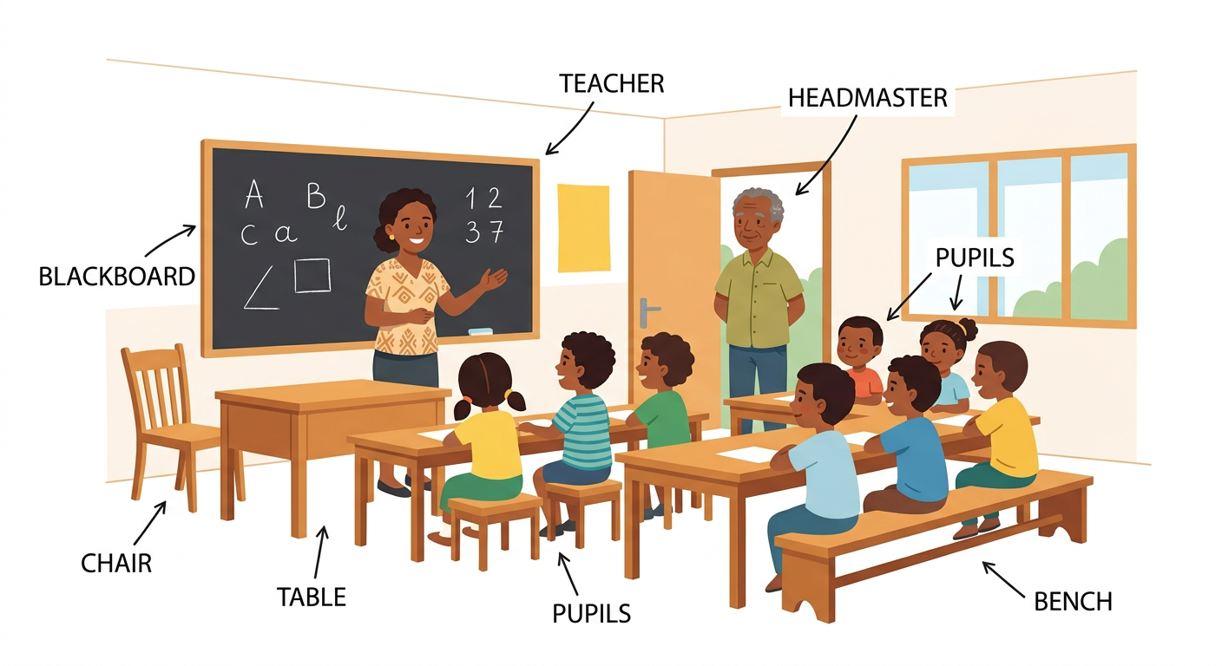
In this unit, I will learn to:
• count from 40 to 70 and read these numbers;
• play the “more or less” number game;
• say and read the classroom words;
• speak about my dream classroom with There is / There are.
Values: perseverance, unity.
DO YOU REMEMBER? (Unit 5)
Count from 21 to 40 with a friend.
Read: twenty-five, thirty, thirty-eight, forty.

LISTEN! Scan the code or open the link to listen and download.
 | 🎧 My dream classroom — listen and repeat  https://drive.google.com/uc?export=download&id=1qKWzzV4XRZUetQm8EVDT_vRAq7qR17r0

SESSION 25 / 49
Counting from 40 to 70 — more or less!
LESSON PREPARATION SHEET
Subject: English  Theme: UNIT 6 — MY DREAM CLASSROOM  Title: Counting from 40 to 70 — more or less!  Specific learning outcome: By the end of the lesson, learners will be able to count from 40 to 70, recognise fifty, sixty and seventy, and play the “more or less” game.  Values: perseverance, unity  Documentation: T4 English Syllabus (MEN — DCRP); T4 Pedagogical Resources Booklet  Materials: three big cards with 50, 60 and 70, copy-books, papers | Date: ……………………  Class: T4  Session n°: 1 / 3  Duration: ……………………

Steps and Duration | Procedure |  | Technique and Strategy | Materials | Remarks
Steps and Duration | Teacher | Learners | Technique and Strategy | Materials | Remarks
I. Review  Duration: ……… | Answer these questions:  1. Count from 1 to 40.  2. Read: thirty, forty.  3. When is your birthday? (Unit 5) | Count. Read. Answer.  E.A.: the counting and the reading are right; My birthday is on … | Individual work | Blackboard
II. NEW LESSON — Duration: ………
1. Warm-up | Count from 1 to 40 in English. Now count from 40 to 49 in French. In English it works the same way: forty-one, forty-two…! | Count. | “Transfer” | ----
2. Presentation | Today we are going to count from 40 to 70. By the end of this lesson, you will count to seventy and play a new number game! | Listen. | Whole-class work | ----
3. Observation | Look at these big cards: 50 … “fifty”. 60 … “sixty”. 70 … “seventy”. Listen and look. (The teacher repeats several times.) | Look. Listen. | “Visual aids” / Modelling | Big cards 50, 60, 70
4. Analysis | Repeat after me: fifty / sixty / seventy — the class, one row, one pupil.  Point to fifty! Point to seventy! Point to sixty!  Count with me: forty-one… fifty. Fifty-one… sixty. Sixty-one… seventy.  Dictation: I say numbers between 41 and 70; write them in figures in your copy-book. | Repeat. Point. Count. Write.  E.A.: the cards are pointed to; the numbers are written: 47, 58, 63… | Repetition drill / Dictation | Cards, copy-books
5. Synthesis | So: 50 = fifty, 60 = sixty, 70 = seventy. After forty we count forty-one, forty-two… like before! | Listen. Repeat. | Whole-class work | Blackboard
6. Practice | Game “More or less” (from the syllabus): one pupil writes a secret number between 40 and 70 on a paper. The class guesses. If the guess is too high, the pupil says “less!” with the gesture (hand down). If it is too low: “more!” (hand up). Who finds the number? | Write a secret number. Guess. Say “more” / “less” with the gestures.  E.A.: fifty-five? — less! — forty-eight? — more! — fifty-two? — yes! | Game (“more or less”) | Papers
III. Evaluation  Duration: ……… | 1. Count from 40 to 70.  2. I show a card: fifty, sixty or seventy?  3. Write in figures: forty-six, sixty-three. | Count. Answer. Write.  E.A.: the counting is right; 46 and 63 are written. | Individual work | Cards, copy-books

SESSION 26 / 49
Reading the numbers 40 to 70
LESSON PREPARATION SHEET
Subject: English  Theme: UNIT 6 — MY DREAM CLASSROOM  Title: Reading the numbers 40 to 70  Specific learning outcome: By the end of the lesson, learners will be able to read the numbers 40 to 70 written in words, fluently and with the right stress.  Values: perseverance, unity  Documentation: T4 English Syllabus (MEN — DCRP); T4 Pedagogical Resources Booklet  Materials: cards with figures and words 40-70, blackboard | Date: ……………………  Class: T4  Session n°: 2 / 3  Duration: ……………………

Steps and Duration | Procedure |  | Technique and Strategy | Materials | Remarks
Steps and Duration | Teacher | Learners | Technique and Strategy | Materials | Remarks
I. Review  Duration: ……… | Answer these questions:  1. Count from 40 to 70.  2. I say a number (41-70): write it in figures.  3. Play one quick round of “more or less”. | Count. Write. Play.  E.A.: the counting and the writing are right. | Individual work | Copy-books
II. NEW LESSON — Duration: ………
1. Warm-up | Number ping-pong from 40: I say forty-four, you say forty-five! | Answer. | Game | ----
2. Presentation | Today we are going to READ the numbers 40 to 70 written in words. By the end of this lesson, you will read them fluently. | Listen. | Whole-class work | ----
3. Observation | Look at the words on the blackboard: forty, forty-one… seventy. Listen to me reading them. The strong part is at the START: FIFty, SIXty, SEventy! | Look. Listen. | Modelling | Blackboard
4. Analysis | Read after me: all together, by rows, then alone.  I point to a word, you read it: fifty-three? sixty-eight?  How do we write 55 in words? | Read. Answer.  E.A.: the words are read; fifty-five. | Repetition drill | Blackboard
5. Synthesis | So, we can read the numbers 40 to 70 in words: forty… fifty… sixty… seventy, and the small numbers with a dash: fifty-two, sixty-nine. | Listen. | Whole-class work | Blackboard
6. Practice | Card game (from the syllabus): each pupil comes to the front and takes one card face down on the table (a figure 40-70 OR a word). Look at your card, find the friend with the SAME number, and say your number together! | Take a card. Read it. Find the pair. Say the number.  E.A.: “58” and “fifty-eight” find each other and say: fifty-eight! | Game (matching pairs) | Cards with figures and words
III. Evaluation  Duration: ……… | 1. Read five number words on the blackboard (40-70).  2. I say a number: point to the word.  3. Count from 40 to 70. | Read. Point. Count.  E.A.: the words are read without mistakes; the right words are pointed to. | Individual work | Blackboard

SESSION 27 / 49
My dream classroom
LESSON PREPARATION SHEET
Subject: English  Theme: UNIT 6 — MY DREAM CLASSROOM  Title: My dream classroom  Specific learning outcome: By the end of the lesson, learners will be able to say and read the classroom words, and present their dream classroom with “There is / There are”.  Values: perseverance, unity  Documentation: T4 English Syllabus (MEN — DCRP); T4 Pedagogical Resources Booklet  Materials: big picture of a classroom, big sheets, pencils, small word papers, audio (QR code) | Date: ……………………  Class: T4  Session n°: 3 / 3  Duration: ……………………

Steps and Duration | Procedure |  | Technique and Strategy | Materials | Remarks
Steps and Duration | Teacher | Learners | Technique and Strategy | Materials | Remarks
I. Review  Duration: ……… | Answer these questions:  1. Count from 40 to 70.  2. Read: fifty-five, sixty-two, seventy.  3. Open your copybook! (Unit 3) | Count. Read. Act.  E.A.: the counting and the reading are right. | Individual work | Blackboard
II. NEW LESSON — Duration: ………
1. Warm-up | Close your eyes. Imagine the most beautiful classroom of the world… What is in it? Today you will DRAW it and SPEAK about it! | Imagine. | Whole-class work | ----
2. Presentation | Today we are going to learn a new lesson called: « My dream classroom ». By the end of this lesson, you will present your dream classroom in English. | Listen. | Whole-class work | ----
3. Observation | Look at the big picture of the classroom. Listen: “This is the classroom. This is the headmaster. This is the teacher. These are the pupils. This is a table. This is a chair. These are benches.” | Look. Listen. | “Visual aids” / Audio | Big picture, audio (QR code)
4. Analysis | Repeat the sentences: the class, one row, one pupil.  I say a word: point to it on the picture (headmaster! bench! blackboard!).  Read the words written on the picture.  Small papers game: take a paper, read the word aloud, and stick it on the right thing on the big picture. | Repeat. Point. Read. Stick.  E.A.: the words are pointed to, read and placed correctly. | Repetition drill / Matching | Small word papers, big picture
5. Synthesis | So, for ONE thing we say: There is … (There is a teacher.) For MANY things we say: There are … (There are twelve pupils.) | Listen. Repeat. | Whole-class work | Blackboard
6. Practice | Draw your dream classroom on a big sheet!  Answer my questions: Who is this? What is this? How many pupils are there?  Present your drawing to your friend: “This is my dream classroom. There is … There are …” | Draw. Answer. Present.  E.A.: This is my dream classroom. There is a teacher. There are twelve pupils. | Drawing / In pairs | Big sheets, pencils
III. Evaluation  Duration: ……… | 1. Read four classroom words.  2. Present your dream classroom in three sentences.  3. How many pupils are there in your drawing? | Read. Present. Answer.  E.A.: the words are read; There is … / There are … are used; There are … pupils. | Individual work | The drawings

LESSON — UNIT 6
MY DREAM CLASSROOM
1. The numbers 40 to 70
41  forty-one | 43  forty-three | 45  forty-five | 47  forty-seven | 50  fifty
52  fifty-two | 54  fifty-four | 56  fifty-six | 58  fifty-eight | 60  sixty
61  sixty-one | 63  sixty-three | 65  sixty-five | 68  sixty-eight | 70  seventy

2. The “more or less” game
Too high? Say less! [lèss] (hand down). Too low? Say more! [môr] (hand up).
3. The classroom words
classroom  [klâsroume] | headmaster  [hèdmâsteur] | teacher  [titcheur] | pupils  [pioupolz]
table  [téibol] | chair  [tchèr] | bench  [bèntch] | blackboard  [blakbôrd]

4. There is … / There are …
For ONE thing: There is a teacher. [zèr iz e titcheur]
For MANY things: There are twelve pupils. [zèr âr touèlv pioupolz]
The question: How many pupils are there? [haou mèni pioupolz âr zèr]
5. My dream classroom
This is my dream classroom. There is a teacher. There are twelve pupils. There is a big blackboard. There are many books.
LISTEN! Scan the code or open the link to listen and download.
 | 🎧 Numbers 40 to 70 — listen and count  https://drive.google.com/uc?export=download&id=1H6XO5Ih70kMQYfFV3DbHw6y4XyPlii2z
🎧 My dream classroom — listen and repeat
https://drive.google.com/uc?export=download&id=1qKWzzV4XRZUetQm8EVDT_vRAq7qR17r0

EXERCISES
Exercise 1 (5 points). Count from 40 to 70.

Exercise 2 (5 points). Read these numbers: forty-four — fifty — fifty-seven — sixty-three — seventy.

Exercise 3 (4 points). The teacher points to four things or persons on the classroom picture: say the words.

Exercise 4 (6 points). Complete with There is or There are:
1. …… a teacher in my classroom.
2. …… twenty benches.
3. …… a big blackboard.
4. …… fifty pupils.
Total: 20 points
ANSWER KEY
Exercise 1: forty-one … seventy without mistakes (5 points).
Exercise 2: the five numbers are read correctly (1 point each).
Exercise 3: teacher, headmaster, pupils, bench, table, chair, blackboard… (1 point each).
Exercise 4: 1. There is 2. There are 3. There is 4. There are (1.5 points each).

SESSION 28 / 49
REVISION — UNIT 6: MY DREAM CLASSROOM
Remember the classroom words:
classroom  [klâsroume] | headmaster  [hèdmâsteur] | teacher  [titcheur] | pupils  [pioupolz]
table  [téibol] | chair  [tchèr] | bench  [bèntch] | blackboard  [blakbôrd]

Now answer:
1. Count from 40 to 70.
E.A.: forty-one … seventy.
2. Read: forty-nine, fifty-five, sixty-one, seventy.
E.A.: the numbers are read without mistakes.
3. Play one round of “more or less” with a secret number.
E.A.: more! / less! are used with the gestures.
4. Read six classroom words on the blackboard.
E.A.: the words are read fluently.
5. Present your dream classroom in three sentences.
E.A.: This is my dream classroom. There is … There are …
6. How many pupils are there in your class today? Count them in English!
E.A.: There are … pupils.

SESSION 29 / 49
T5 TEST PAPER — UNIT 6: MY DREAM CLASSROOM
Duration: ……… Total: 20 points
Exercise 1 (5 points). Count from 40 to 70.

Exercise 2 (5 points). Read five numbers in words chosen by the teacher (40-70).

Exercise 3 (5 points). Read five classroom words on the blackboard.

Exercise 4 (5 points). Present your dream classroom in three sentences with There is / There are.

ANSWER KEY
Exercise 1: the counting is right (5 points).
Exercise 2: the numbers are read correctly (1 point each).
Exercise 3: the words are read correctly (1 point each).
Exercise 4: This is my dream classroom. There is … There are … (5 points).

UNIT 6 — I CAN…

Tick ✔ what you can do:
☐ I can count from 40 to 70.
☐ I can read the numbers 40 to 70.
☐ I can play “more or less”.
☐ I can say and read the classroom words.
☐ I can present my dream classroom with There is / There are.

Well done! See you in Unit 7: MEALS!

UNIT 7 — MEALS

What did you have for breakfast?
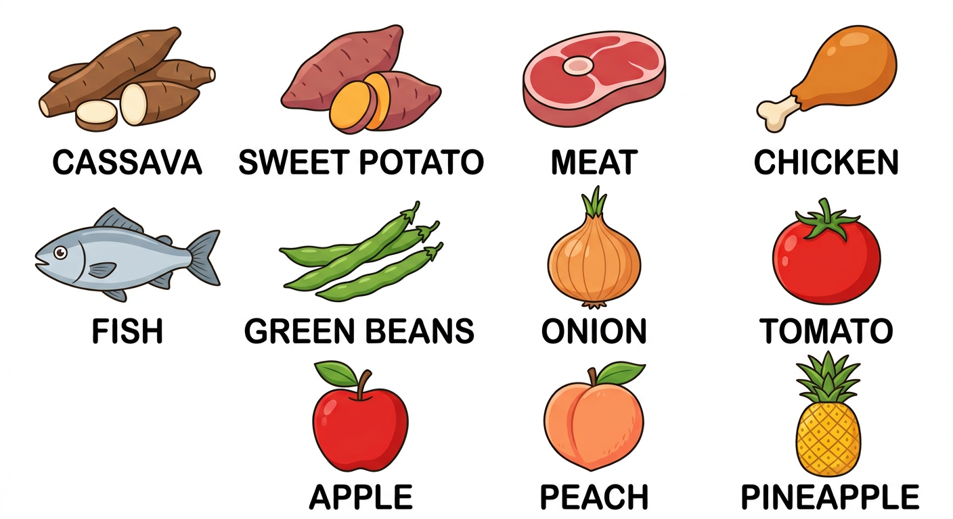
In this unit, I will learn to:
• say and read the names of everyday food;
• play the food board game;
• say what I ate: I had … for breakfast / lunch / dinner.
Values: mutual respect, working together.
DO YOU REMEMBER? (T4)
In T4 we learned: rice, bread, milk, water, tea, banana, orange, egg…
And the three meals: breakfast (morning), lunch (midday), dinner (evening).

LISTEN! Scan the code or open the link to listen and download.
 | 🎧 Meals — listen and repeat  https://drive.google.com/uc?export=download&id=1lY36Mkf5YKZyiAHOqcqdW9EIbykkZ8ZE

SESSION 30 / 49
Everyday food
LESSON PREPARATION SHEET
Subject: English  Theme: UNIT 7 — MEALS  Title: Everyday food  Specific learning outcome: By the end of the lesson, learners will be able to say, recognise, read and write the names of everyday food.  Values: mutual respect, working together  Documentation: T4 English Syllabus (MEN — DCRP); T4 Pedagogical Resources Booklet  Materials: real food or food pictures, blackboard, copy-books, audio (QR code) | Date: ……………………  Class: T4  Session n°: 1 / 2  Duration: ……………………

Steps and Duration | Procedure |  | Technique and Strategy | Materials | Remarks
Steps and Duration | Teacher | Learners | Technique and Strategy | Materials | Remarks
I. Review  Duration: ……… | (Review of T4.) Answer these questions:  1. Name three foods you know in English.  2. What are the three meals of the day?  3. Before we eat, what do we wish? (Unit 1) | Answer.  E.A.: 1. rice, bread, milk, banana…  2. breakfast, lunch, dinner.  3. Enjoy your meal! | Individual work | ----
II. NEW LESSON — Duration: ………
1. Warm-up | (The teacher shows a real cassava or a picture.) Mmm! Do you like this? Today we learn the food words in English! | Look. Answer in their own words. | “Visual aids” | Real food or pictures
2. Presentation | Today we are going to learn a new lesson called: « Everyday food ». By the end of this lesson, you will say and read the names of the food you eat every day. | Listen. | Whole-class work | ----
3. Observation | Look at the food (or the pictures) and listen: cassava, sweet potato, meat, chicken, fish… the vegetables: green beans, onion, tomato… the fruits: apple, peach, pineapple. | Look. Listen. | “Visual aids” / Audio | Food or pictures, audio (QR code)
4. Analysis | Repeat each word: the class, one row, one pupil.  I say a word: point to the right food or picture.  Read the words written on the blackboard.  Write the words in your copy-book. Then listen: I say a word — circle the word you hear. | Repeat. Point. Read. Write. Circle.  E.A.: the right foods are pointed to; the words are read and circled correctly. | Repetition drill / Dictation | Blackboard, copy-books
5. Synthesis | So, our everyday food: cassava, sweet potato, meat, chicken, fish; the vegetables: green beans, onion, tomato; the fruits: apple, peach, pineapple. | Listen. Repeat. | Whole-class work | Blackboard
6. Practice | Guessing game in pairs: pupil A mimes eating a food (a big pineapple? a small green bean?); pupil B guesses the food in English. Change roles. | Mime. Guess.  E.A.: pineapple! / fish! / sweet potato!… | Game (miming) / In pairs | ----
III. Evaluation  Duration: ……… | 1. I show five foods or pictures: say the words.  2. Read four food words on the blackboard.  3. I say a word: circle it in your copy-book. | Say. Read. Circle.  E.A.: the foods are named clearly; the words are read and circled without mistakes. | Individual work | Pictures, copy-books

SESSION 31 / 49
What did you have for breakfast?
LESSON PREPARATION SHEET
Subject: English  Theme: UNIT 7 — MEALS  Title: What did you have for breakfast?  Specific learning outcome: By the end of the lesson, learners will be able to ask and answer “What did you have for breakfast / lunch / dinner?” with “I had … for …”.  Values: mutual respect, working together  Documentation: T4 English Syllabus (MEN — DCRP); T4 Pedagogical Resources Booklet  Materials: the food board game, a die, small stones or beans, two puppets | Date: ……………………  Class: T4  Session n°: 2 / 2  Duration: ……………………

Steps and Duration | Procedure |  | Technique and Strategy | Materials | Remarks
Steps and Duration | Teacher | Learners | Technique and Strategy | Materials | Remarks
I. Review  Duration: ……… | Answer these questions:  1. Name the three vegetables and the three fruits of the lesson.  2. Read: cassava, chicken, pineapple.  3. What are the three meals of the day? | Answer. Read.  E.A.: green beans, onion, tomato — apple, peach, pineapple; breakfast, lunch, dinner. | Individual work | Blackboard
II. NEW LESSON — Duration: ………
1. Warm-up | Board game (from the syllabus), in groups: put your bean on START. Throw the die and move. If you stop on a food square, say the food name in English! Right answer: stay. Wrong answer: go back two squares. Careful with the special squares! | Play. Say the food names. | “Board game” / Group work | Board game, a die, beans
2. Presentation | Today we are going to say what we ATE. By the end of this lesson, you will ask and answer: What did you have for breakfast? — I had … for breakfast. | Listen. | Whole-class work | ----
3. Observation | First, tell me in your own words what you ate this morning.  Now watch the two puppets! (The teacher plays:) — What did you have for breakfast? — I had cassava for breakfast. — What did you have for breakfast? — I had rice for breakfast. | Answer. Look. Listen. | Role play (puppets) | Two puppets
4. Analysis | Repeat the question and the answer: the class, one row, one pupil.  Now YOU: what did you have for breakfast this morning?  And for lunch yesterday? And for dinner? | Repeat. Answer.  E.A.: I had (rice / cassava / tea…) for breakfast / lunch / dinner. | Repetition drill | ----
5. Synthesis | So: What did you have for breakfast / lunch / dinner? — I had … for breakfast / lunch / dinner. “Had” tells us it is FINISHED — we already ate it! | Listen. Repeat. | Whole-class work | Blackboard
6. Practice | Speed chat (from the syllabus): two lines face to face. Line A asks: “What did you have for breakfast?”; line B answers: “I had … for breakfast.” Slide one step to the left, change the question: lunch! dinner! Then the lines change roles. | Ask. Answer. Slide. Change roles.  E.A.: — What did you have for lunch? — I had rice and chicken for lunch. | “Speed chat” | ----
III. Evaluation  Duration: ……… | 1. What did you have for breakfast?  2. What did you have for dinner?  3. Ask me the question with “lunch”. | Answer. Ask.  E.A.: I had … for breakfast / dinner. — What did you have for lunch? | Individual work | ----

LESSON — UNIT 7
MEALS
1. Everyday food
cassava  [kassâva] | sweet potato  [souite potéitô] | meat  [mite] | chicken  [tchikène]
fish  [fich] | green beans  [grine binz] | onion  [onieune] | tomato  [tomâtô]
apple  [apol] | peach  [pitch] | pineapple  [païnapol] | rice  [raïss]

2. The food board game
Throw the die, move your bean, and say the food name of your square! Wrong answer? Go back two squares!
1  START! | 2  cassava | 3  chicken | 4  tomato
5  LOSE A TURN | 6  fish | 7  meat | 8  apple
9  GO BACK TO START | 10  sweet potato | 11  pineapple | 12  FINISH!

3. What did you have…?
The question: What did you have for breakfast? [ouate dide iou hav for brèkfeuste]
The answer: I had cassava for breakfast. [aï hade kassâva for brèkfeuste]
Also: for lunch [for leunntch] (midday) — for dinner [for dineur] (evening)
Careful! Today I have rice. Yesterday I had rice — it is finished!
LISTEN! Scan the code or open the link to listen and download.
🎧 Meals — listen and repeat
https://drive.google.com/uc?export=download&id=1lY36Mkf5YKZyiAHOqcqdW9EIbykkZ8ZE

EXERCISES
Exercise 1 (6 points). The teacher shows six foods or pictures: say the words.

Exercise 2 (4 points). Read: sweet potato — green beans — chicken — pineapple.

Exercise 3 (4 points). Sort the words: which are vegetables? which are fruits? (onion, apple, tomato, peach)

Exercise 4 (6 points). Answer with a full sentence:
1. What did you have for breakfast?
2. What did you have for lunch?
3. What did you have for dinner?
Total: 20 points
ANSWER KEY
Exercise 1: the six foods are named clearly (1 point each).
Exercise 2: the four words are read correctly (1 point each).
Exercise 3: vegetables: onion, tomato — fruits: apple, peach (1 point each).
Exercise 4: I had … for breakfast / lunch / dinner (2 points each).

SESSION 32 / 49
REVISION — UNIT 7: MEALS
Remember the food words:
cassava  [kassâva] | sweet potato  [souite potéitô] | meat  [mite] | chicken  [tchikène]
fish  [fich] | green beans  [grine binz] | onion  [onieune] | tomato  [tomâtô]
apple  [apol] | peach  [pitch] | pineapple  [païnapol] | rice  [raïss]

Now answer:
1. The teacher shows six foods or pictures: say the words.
E.A.: cassava, meat, fish, tomato, apple, pineapple…
2. Read six food words on the blackboard.
E.A.: the words are read fluently.
3. Name the three vegetables and the three fruits.
E.A.: green beans, onion, tomato — apple, peach, pineapple.
4. What did you have for breakfast? for lunch? for dinner?
E.A.: I had … for breakfast / lunch / dinner.
5. Play one round of the food board game with your group.
E.A.: the game is played; the food names are said.

SESSION 33 / 49
T5 TEST PAPER — UNIT 7: MEALS
Duration: ……… Total: 20 points
Exercise 1 (6 points). The teacher shows six foods or pictures: say the words.

Exercise 2 (4 points). Read four food words on the blackboard.

Exercise 3 (4 points). The teacher says four words: circle them in the copy-book.

Exercise 4 (6 points). Answer: What did you have for breakfast / lunch / dinner? (three full answers)

ANSWER KEY
Exercise 1: the foods are named clearly (1 point each).
Exercise 2: the words are read correctly (1 point each).
Exercise 3: the right words are circled (1 point each).
Exercise 4: I had … for breakfast / lunch / dinner (2 points each).

UNIT 7 — I CAN…

Tick ✔ what you can do:
☐ I can say the names of everyday food.
☐ I can read the food words.
☐ I can sort vegetables and fruits.
☐ I can say: I had … for breakfast / lunch / dinner.
☐ I can ask: What did you have for …?

Well done! See you in Unit 8: IN MY HOUSE!

UNIT 8 — IN MY HOUSE

Welcome to my house!
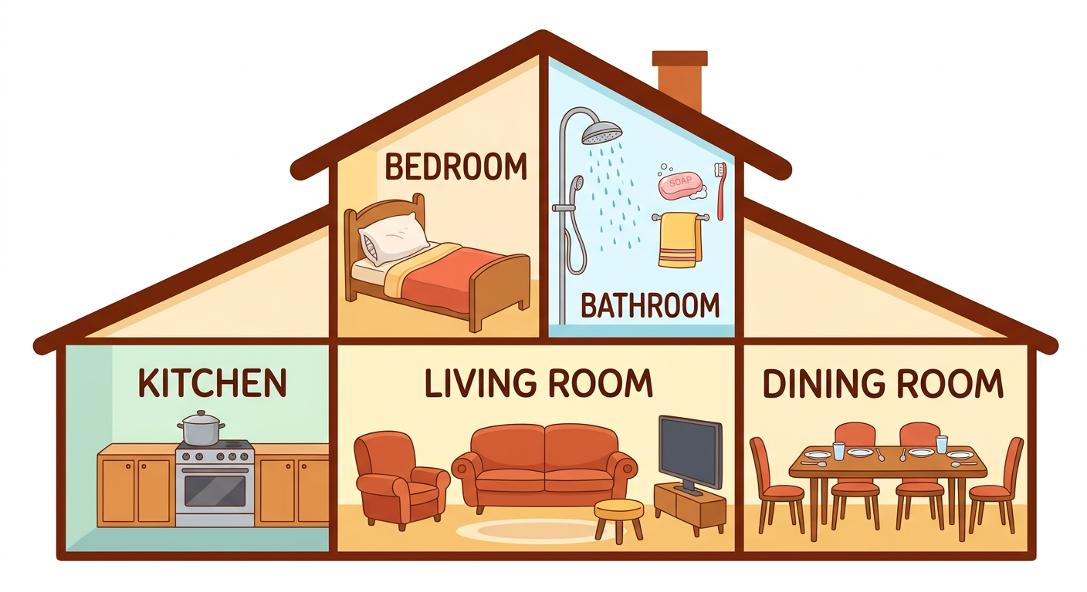
In this unit, I will learn to:
• say and read the five rooms of the house;
• say the furniture and the objects of each room;
• sing the “Welcome to my house” song;
• describe a house to my friend.
Values: mutual respect, working together.
DO YOU REMEMBER? (T4)
In T4 we learned the parts of the house: the door, the window, the roof, the wall.
Point to the door and the windows of the classroom!

LISTEN! Scan the code or open the link to listen and download.
 | 🎧 Welcome to my house — listen and sing  https://drive.google.com/uc?export=download&id=16kBQbrPY-eLZRH3ZfGkKS9NFti-m71xc

SESSION 34 / 49
The rooms of the house
LESSON PREPARATION SHEET
Subject: English  Theme: UNIT 8 — IN MY HOUSE  Title: The rooms of the house  Specific learning outcome: By the end of the lesson, learners will be able to say the five rooms of the house clearly and sing the “Welcome to my house” song.  Values: mutual respect, working together  Documentation: T4 English Syllabus (MEN — DCRP); T4 Pedagogical Resources Booklet  Materials: big picture of a house with its rooms, audio (QR code) | Date: ……………………  Class: T4  Session n°: 1 / 4  Duration: ……………………

Steps and Duration | Procedure |  | Technique and Strategy | Materials | Remarks
Steps and Duration | Teacher | Learners | Technique and Strategy | Materials | Remarks
I. Review  Duration: ……… | Answer these questions:  1. What did you have for breakfast? (Unit 7)  2. Name the parts of the house you know (T4).  3. Point to the door / the windows. | Answer. Point.  E.A.: I had …; door, window, roof, wall. | Individual work | ----
II. NEW LESSON — Duration: ………
1. Warm-up | Where do we sleep at home? Where do we cook? Today, the house speaks English! | Answer in their own words. | Whole-class work | ----
2. Presentation | Today we are going to learn a new lesson called: « The rooms of the house ». By the end of this lesson, you will say the five rooms and sing the song of the house. | Listen. | Whole-class work | ----
3. Observation | Look at the big picture of the house on the blackboard. Listen: the bedroom… the bathroom… the kitchen… the living room… the dining room. (The teacher points to each room.) | Look. Listen. | “Visual aids” | Big picture of the house
4. Analysis | Repeat each room: the class, one row, one pupil.  I say a room: point to it on the picture.  I say a word: draw a little person in the right room on your small picture.  Where do we sleep? Where do we cook? | Repeat. Point. Draw. Answer.  E.A.: the little person is in the right room; in the bedroom; in the kitchen. | Repetition drill / “Visual aids” | The picture
5. Synthesis | So, the five rooms of the house are: the bedroom, the bathroom, the kitchen, the living room, the dining room. | Listen. Repeat. | Whole-class work | Blackboard
6. Practice | The song! Listen to “Welcome to my house” to the end.  Sing part by part after me, with the gestures: I watch TV (mime), I take a shower (mime), I cook good food (mime)…  Sing the whole song! | Listen. Sing part by part. Sing the whole song with the gestures.  E.A.: the song is sung: “Welcome to my house, my family and me!…” | Song / T.P.R. (act it out) | Audio (QR code)
III. Evaluation  Duration: ……… | 1. Say the five rooms of the house.  2. I say a room: point to it on the picture.  3. Sing the song with the class. | Say. Point. Sing.  E.A.: bedroom, bathroom, kitchen, living room, dining room — the song is sung. | Individual work | The picture

SESSION 35 / 49
The furniture and the objects
LESSON PREPARATION SHEET
Subject: English  Theme: UNIT 8 — IN MY HOUSE  Title: The furniture and the objects  Specific learning outcome: By the end of the lesson, learners will be able to say the names of the furniture and the objects, and put each one in the right room.  Values: mutual respect, working together  Documentation: T4 English Syllabus (MEN — DCRP); T4 Pedagogical Resources Booklet  Materials: big house picture, small pictures of furniture and objects, tape or glue, audio (QR code) | Date: ……………………  Class: T4  Session n°: 2 / 4  Duration: ……………………

Steps and Duration | Procedure |  | Technique and Strategy | Materials | Remarks
Steps and Duration | Teacher | Learners | Technique and Strategy | Materials | Remarks
I. Review  Duration: ……… | Answer these questions:  1. Say the five rooms of the house.  2. Sing “Welcome to my house”.  3. Where do we have breakfast? | Answer. Sing.  E.A.: the five rooms; in the dining room. | Individual work | ----
II. NEW LESSON — Duration: ………
1. Warm-up | (The teacher mimes sleeping on a pillow.) What do I need to sleep? Today: the things of the house! | Look. Guess. | Miming | ----
2. Presentation | Today we are going to learn the furniture and the objects of the house. By the end of this lesson, you will say them and put them in the right room. | Listen. | Whole-class work | ----
3. Observation | Look at the small pictures and listen: in the bedroom — a bed, a pillow; in the bathroom — soap, a towel, a toothbrush; in the kitchen — a stove, a cooking pot; in the living room — a sofa, a stool, an armchair; in the dining room — a table, a chair, a plate, a spoon, a glass. | Look. Listen. | “Visual aids” / Audio | Small pictures, audio (QR code)
4. Analysis | Repeat each word: the class, one row, one pupil.  I show a small picture: say the word AND the room.  Come to the front, take a small picture, say the word, and stick it in the right room of the big house! | Repeat. Say. Stick.  E.A.: “A cooking pot — in the kitchen!” — the picture is stuck in the right room. | Repetition drill / Matching | Big picture, small pictures, tape
5. Synthesis | So, every thing has its room: the bed is in the bedroom, the stove is in the kitchen, the sofa is in the living room… | Listen. Repeat. | Whole-class work | Blackboard
6. Practice | Listening game: I say a word (towel! spoon! armchair!); point to the thing on the big picture.  In pairs: pupil A asks “Where is the (bed)?”; pupil B answers “The (bed) is in the (bedroom).” Change roles. | Point. Ask. Answer.  E.A.: — Where is the cooking pot? — The cooking pot is in the kitchen. | Game / In pairs | Big picture
III. Evaluation  Duration: ……… | 1. I show five small pictures: say the words.  2. Where is the pillow? Where is the glass?  3. Name two things of the bathroom. | Say. Answer.  E.A.: the words are said; The pillow is in the bedroom. The glass is in the dining room. — soap, towel, toothbrush. | Individual work | Small pictures

SESSION 36 / 49
Reading the house words
LESSON PREPARATION SHEET
Subject: English  Theme: UNIT 8 — IN MY HOUSE  Title: Reading the house words  Specific learning outcome: By the end of the lesson, learners will be able to read all the house words fluently and match them with the pictures.  Values: mutual respect, working together  Documentation: T4 English Syllabus (MEN — DCRP); T4 Pedagogical Resources Booklet  Materials: big house picture, word papers, tape or glue, blackboard | Date: ……………………  Class: T4  Session n°: 3 / 4  Duration: ……………………

Steps and Duration | Procedure |  | Technique and Strategy | Materials | Remarks
Steps and Duration | Teacher | Learners | Technique and Strategy | Materials | Remarks
I. Review  Duration: ……… | Answer these questions:  1. Say the five rooms.  2. Name two things of the kitchen and two things of the living room.  3. Where is the toothbrush? | Answer.  E.A.: the rooms; stove, cooking pot — sofa, armchair, stool; in the bathroom. | Individual work | ----
II. NEW LESSON — Duration: ………
1. Warm-up | Quick song: “Welcome to my house” with the gestures! | Sing. | Song | ----
2. Presentation | Today we are going to READ all the house words. By the end of this lesson, you will read them fluently, like champions! | Listen. | Whole-class work | ----
3. Observation | Look at the words written on the blackboard: bedroom, bathroom, kitchen… bed, pillow, soap… Listen to me reading them, finger under the words. | Look. Listen. Follow with the eyes. | Modelling | Blackboard
4. Analysis | Read the words after me: all together, by rows, then alone.  Which words have “room” inside? What does it tell us?  I point to a word: read it! | Read. Answer.  E.A.: bedroom, bathroom, living room, dining room — they are rooms of the house! | Repetition drill | Blackboard
5. Synthesis | So, we can read all the house words: the rooms and the things inside them. | Listen. | Whole-class work | Blackboard
6. Practice | Word papers game (from the syllabus): each pupil takes a paper with one word, reads it ALOUD, and sticks it under the right picture on the big house.  The class checks: is the word in the right place? | Take a paper. Read aloud. Stick it. Check together.  E.A.: “towel!” — the paper is stuck under the towel in the bathroom. | Matching / Whole-class work | Word papers, big picture, tape
III. Evaluation  Duration: ……… | 1. Read six house words on the blackboard.  2. I show a picture: find and read the right word.  3. Read one line of the song. | Read. Find. Read.  E.A.: the words are read fluently, without mistakes. | Individual work | Blackboard, big picture

SESSION 37 / 49
I describe a house
LESSON PREPARATION SHEET
Subject: English  Theme: UNIT 8 — IN MY HOUSE  Title: I describe a house  Specific learning outcome: By the end of the lesson, learners will be able to draw a house with its rooms and furniture and describe it to a friend.  Values: mutual respect, working together  Documentation: T4 English Syllabus (MEN — DCRP); T4 Pedagogical Resources Booklet  Materials: big sheets, pencils | Date: ……………………  Class: T4  Session n°: 4 / 4  Duration: ……………………

Steps and Duration | Procedure |  | Technique and Strategy | Materials | Remarks
Steps and Duration | Teacher | Learners | Technique and Strategy | Materials | Remarks
I. Review  Duration: ……… | Answer these questions:  1. Read: kitchen, armchair, toothbrush.  2. Where is the sofa?  3. Sing one verse of the song. | Read. Answer. Sing.  E.A.: the words are read; The sofa is in the living room. | Individual work | Blackboard
II. NEW LESSON — Duration: ………
1. Warm-up | Remember your dream classroom (Unit 6)? Today: your house! You will draw it and present it. | Listen. | Whole-class work | ----
2. Presentation | Today we are going to describe a house. By the end of this lesson, you will present a house with its rooms and its furniture, all in English. | Listen. | Whole-class work | ----
3. Observation | Listen to my model: “This is my house. There is a kitchen. There is a living room. In the living room, there is a sofa. There are three chairs in the dining room.” | Listen. | Modelling | ----
4. Analysis | What did I use to present? (There is / There are — Unit 6!)  Repeat the model sentences: the class, one row, one pupil.  Draw a house with its rooms and its furniture on a big sheet. | Answer. Repeat. Draw.  E.A.: There is / There are; the drawing shows rooms and furniture. | Repetition drill / Drawing | Big sheets, pencils
5. Synthesis | So, to describe a house: This is my house. There is a (kitchen). In the (kitchen), there is a (stove). There are (four plates) in the (dining room). | Listen. Repeat. | Whole-class work | Blackboard
6. Practice | In pairs (from the syllabus): describe YOUR drawing to your friend. The friend listens and points to the rooms and the things on the drawing. Then change roles. | Describe. Listen. Point. Change roles.  E.A.: This is my house. There is a bedroom. In the bedroom, there is a bed and a pillow… | In pairs | The drawings
III. Evaluation  Duration: ……… | 1. Describe your house in four sentences.  2. Where is the bed in your drawing?  3. Read three house words. | Describe. Answer. Read.  E.A.: the house is described with There is / There are; The bed is in the bedroom. | Individual work | The drawings

LESSON — UNIT 8
IN MY HOUSE
1. The five rooms
bedroom  [bèdroume] | bathroom  [bâssroume] | kitchen  [kitchène] | living room  [livinng roume] | dining room  [daïninng roume]

2. The things of each room
bedroom | bed, pillow
bathroom | soap, towel, toothbrush
kitchen | stove, cooking pot
living room | sofa, stool, armchair
dining room | table, chair, plate, spoon, glass

bed  [bède] | pillow  [pilô] | soap  [sôoupe] | towel  [taouol] | toothbrush  [toussbreuch]
stove  [stôouv] | cooking pot  [koukinng pote] | sofa  [sôoufa] | stool  [stoule] | armchair  [ârmtchèr]
table  [téibol] | chair  [tchèr] | plate  [pléite] | spoon  [spoune] | glass  [glâss]

3. The song
THE “WELCOME TO MY HOUSE” SONG ♪
Welcome to my house,
my family and me!
In the living room, I watch TV. (2x)
In the bathroom, I take a shower.
In the kitchen, I cook good food.
In the dining room, I have breakfast.
In the bedroom, I go to sleep.

4. Where is…?
The question: Where is the bed? [ouèr iz ze bède]
The answer: The bed is in the bedroom. [ze bède iz ine ze bèdroume]
5. I describe my house
This is my house. There is a kitchen. In the living room, there is a sofa. There are three chairs in the dining room.
LISTEN! Scan the code or open the link to listen and download.
🎧 Welcome to my house — listen and sing
https://drive.google.com/uc?export=download&id=16kBQbrPY-eLZRH3ZfGkKS9NFti-m71xc
 | 🎧 The rooms and the things — listen and repeat  https://drive.google.com/uc?export=download&id=1zwWta9VGHmAJ8eP1GyK421LcPgDuEF-p

EXERCISES
Exercise 1 (5 points). Say the five rooms of the house.

Exercise 2 (5 points). Where is it? Answer with a full sentence:
1. the bed → ……
2. the cooking pot → ……
3. the soap → ……
4. the sofa → ……
5. the plate → ……
Exercise 3 (5 points). Read: bathroom — pillow — stove — armchair — toothbrush.

Exercise 4 (5 points). Sing the “Welcome to my house” song with the gestures.

Total: 20 points
ANSWER KEY
Exercise 1: bedroom, bathroom, kitchen, living room, dining room (1 point each).
Exercise 2: The bed is in the bedroom. The cooking pot is in the kitchen. The soap is in the bathroom. The sofa is in the living room. The plate is in the dining room.
Exercise 3: the five words are read correctly (1 point each).
Exercise 4: the song is sung with the gestures (5 points).

SESSION 38 / 49
REVISION — UNIT 8: IN MY HOUSE
Remember the rooms and the things:
bedroom | bed, pillow
bathroom | soap, towel, toothbrush
kitchen | stove, cooking pot
living room | sofa, stool, armchair
dining room | table, chair, plate, spoon, glass

Now answer:
1. Say the five rooms of the house.
E.A.: bedroom, bathroom, kitchen, living room, dining room.
2. Name two things of each room.
E.A.: bed/pillow — soap/towel — stove/cooking pot — sofa/armchair — table/plate…
3. Where is the towel? Where is the spoon?
E.A.: The towel is in the bathroom. The spoon is in the dining room.
4. Read eight house words on the blackboard.
E.A.: the words are read fluently.
5. Sing “Welcome to my house”.
E.A.: the song is sung with the gestures.
6. Describe your house in four sentences.
E.A.: This is my house. There is … There are …

SESSION 39 / 49
T5 TEST PAPER — UNIT 8: IN MY HOUSE
Duration: ……… Total: 20 points
Exercise 1 (5 points). Say the five rooms of the house.

Exercise 2 (5 points). The teacher names five things: say the room of each thing (full sentence).

Exercise 3 (5 points). Read five house words on the blackboard.

Exercise 4 (5 points). Describe a house in four sentences with There is / There are.

ANSWER KEY
Exercise 1: the five rooms are said (1 point each).
Exercise 2: The … is in the … (1 point each).
Exercise 3: the words are read correctly (1 point each).
Exercise 4: This is my house. There is … There are … (5 points).

UNIT 8 — I CAN…

Tick ✔ what you can do:
☐ I can say the five rooms of the house.
☐ I can say the furniture and the objects of each room.
☐ I can read the house words.
☐ I can say: The bed is in the bedroom.
☐ I can sing “Welcome to my house”.
☐ I can describe a house.

Well done! See you in Unit 9: MY FAMILY!

UNIT 9 — MY FAMILY

I love my family!
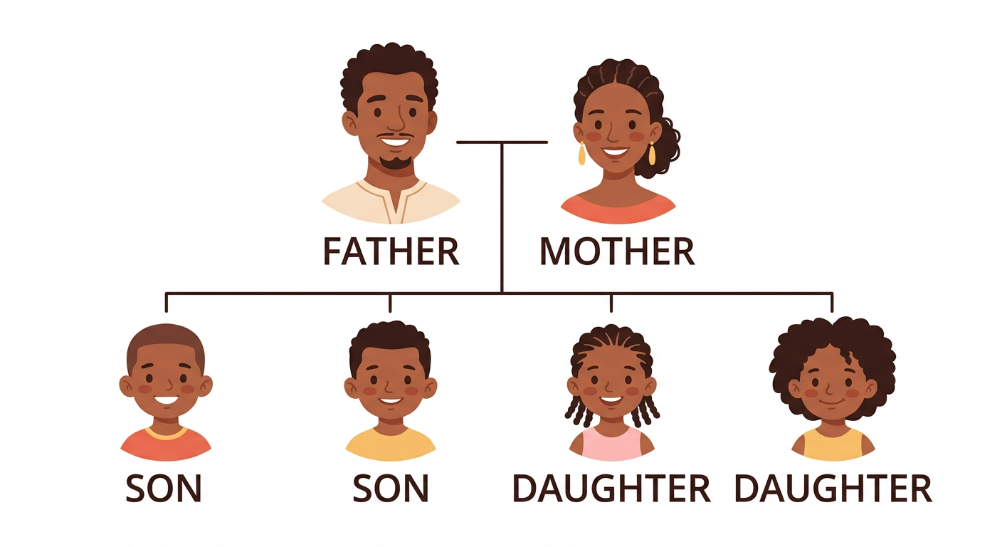
In this unit, I will learn to:
• say the family words: son, daughter, brother, sister…;
• ask and answer: Who’s this? What’s his/her name? How old is he/she?;
• read the family words and draw a family tree;
• present my family to the class.
Values: mutual respect, working together.
DO YOU REMEMBER? (T4)
In T4 we learned: mother, father, sister, brother — and the Family song.
This year we add: son, daughter — and we speak about ages and names!

LISTEN! Scan the code or open the link to listen and download.
 | 🎧 Who’s this? — listen and sing  https://drive.google.com/uc?export=download&id=162hgsy71DlffbSoHqI6ZG-V0QwtYfbJo

SESSION 40 / 49
The family tree
LESSON PREPARATION SHEET
Subject: English  Theme: UNIT 9 — MY FAMILY  Title: The family tree  Specific learning outcome: By the end of the lesson, learners will be able to sing the “Who’s this?” song and understand the family words with the family tree.  Values: mutual respect, working together  Documentation: T4 English Syllabus (MEN — DCRP); T4 Pedagogical Resources Booklet  Materials: a big family tree, audio (QR code) | Date: ……………………  Class: T4  Session n°: 1 / 4  Duration: ……………………

Steps and Duration | Procedure |  | Technique and Strategy | Materials | Remarks
Steps and Duration | Teacher | Learners | Technique and Strategy | Materials | Remarks
I. Review  Duration: ……… | (Review of T4.) Answer these questions:  1. Who lives in your house? (T4 words)  2. What is this? (a picture of a lion — teasing!) No — that is for Unit 10!  3. Count from 40 to 70. | Answer. Count.  E.A.: mother, father, sister, brother; the counting is right. | Individual work | ----
II. NEW LESSON — Duration: ………
1. Warm-up | The song! Listen to “Who’s this?” and sing it with the gestures (point to a friend for “brother”, another for “sister”). | Listen. Sing. | Song | Audio (QR code)
2. Presentation | Today we are going to learn a new lesson called: « The family tree ». By the end of this lesson, you will understand who is who in a family, in English. | Listen. | Whole-class work | ----
3. Observation | Look at the big family tree. First, tell me in your own words who these people are.  Now listen in English: Who’s this? This is the father. His name is Randria. He is 35 years old. Who’s this? This is the mother. Her name is Solo. She is 32 years old. And these are the children: two sons and two daughters. | Look. Explain. Listen. | “Visual aids” / Modelling | Big family tree
4. Analysis | Repeat the new words: son, daughter — the class, one row, one pupil.  For a boy we say HIS name, for a girl we say HER name. Repeat: His name is Randria. Her name is Solo.  Yes or no? (The teacher points to the mother:) Is this the father? | Repeat. Answer.  E.A.: No. This is the mother. | Repetition drill | Family tree
5. Synthesis | So: the father and the mother have children: the boys are the sons, the girls are the daughters. We ask: Who’s this? What’s his/her name? How old is he/she? | Listen. Repeat. | Whole-class work | Blackboard
6. Practice | I point to a person on the family tree: answer my questions!  Who’s this? What’s his name? How old is she? | Answer.  E.A.: This is the father. His name is Randria. She is 32 years old. | Question-answer / “Visual aids” | Family tree
III. Evaluation  Duration: ……… | 1. I point to three persons: who are they?  2. Is this the mother? (pointing to the father)  3. Sing the “Who’s this?” song. | Answer. Sing.  E.A.: This is the …; No. This is the father. — the song is sung. | Individual work | Family tree

SESSION 41 / 49
Reading the family words — my family tree
LESSON PREPARATION SHEET
Subject: English  Theme: UNIT 9 — MY FAMILY  Title: Reading the family words — my family tree  Specific learning outcome: By the end of the lesson, learners will be able to read the family words fluently and draw a family tree from instructions.  Values: mutual respect, working together  Documentation: T4 English Syllabus (MEN — DCRP); T4 Pedagogical Resources Booklet  Materials: blackboard, copy-books | Date: ……………………  Class: T4  Session n°: 2 / 4  Duration: ……………………

Steps and Duration | Procedure |  | Technique and Strategy | Materials | Remarks
Steps and Duration | Teacher | Learners | Technique and Strategy | Materials | Remarks
I. Review  Duration: ……… | Answer these questions:  1. What do we call the boy child? the girl child?  2. Who’s this? (pointing on the family tree)  3. Sing one verse of the song. | Answer. Sing.  E.A.: the son; the daughter; This is the … | Individual work | Family tree
II. NEW LESSON — Duration: ………
1. Warm-up | Quick song: “Who’s this?” with the gestures! | Sing. | Song | ----
2. Presentation | Today we are going to READ the family words and DRAW a family tree in the copy-book. | Listen. | Whole-class work | ----
3. Observation | Look at the words on the blackboard: father, mother, son, daughter, brother, sister. Listen to me reading them. | Look. Listen. | Modelling | Blackboard
4. Analysis | Read the words after me: all together, by rows, then alone.  I point to a word: read it!  Which words are for boys? Which words are for girls? | Read. Answer.  E.A.: father, son, brother — mother, daughter, sister. | Repetition drill | Blackboard
5. Synthesis | So, we can read all the family words. Now let’s use them to draw! | Listen. | Whole-class work | ----
6. Practice | Drawing dictation (from the syllabus): draw a family tree in your copy-book with MY instructions: “a father, a mother, two sons, two daughters”. Write the words under the persons.  Show your tree to your neighbour and read the words together. | Draw. Write. Read together.  E.A.: the tree shows the father, the mother, two sons, two daughters, with the words written and read. | Drawing dictation / In pairs | Copy-books
III. Evaluation  Duration: ……… | 1. Read the six family words.  2. Show the sons on your tree.  3. How many daughters are there on your tree? | Read. Show. Answer.  E.A.: the words are read fluently; There are two daughters. | Individual work | Copy-books

SESSION 42 / 49
Who is this? — the gallery walk
LESSON PREPARATION SHEET
Subject: English  Theme: UNIT 9 — MY FAMILY  Title: Who is this? — the gallery walk  Specific learning outcome: By the end of the lesson, learners will be able to present the members of their family from a picture: Who is this? — This is my… His/Her name is… He/She is…  Values: mutual respect, working together  Documentation: T4 English Syllabus (MEN — DCRP); T4 Pedagogical Resources Booklet  Materials: family pictures brought by the pupils, tape | Date: ……………………  Class: T4  Session n°: 3 / 4  Duration: ……………………

Steps and Duration | Procedure |  | Technique and Strategy | Materials | Remarks
Steps and Duration | Teacher | Learners | Technique and Strategy | Materials | Remarks
I. Review  Duration: ……… | Answer these questions:  1. Read: daughter, brother, mother.  2. Who’s this? What’s her name? (family tree)  3. For a boy: his or her? | Read. Answer.  E.A.: the words are read; This is …; his. | Individual work | Family tree
II. NEW LESSON — Duration: ………
1. Warm-up | Today, YOUR family comes to school… in pictures! Show your picture to your neighbour. | Show the picture. | In pairs | Family pictures
2. Presentation | Today we are going to present our families. By the end of this lesson, you will answer questions about YOUR family, with confidence! | Listen. | Whole-class work | ----
3. Observation | Listen to my model (with my picture): “This is my sister. Her name is Koly. She is 12.” | Listen. | Modelling | A picture
4. Analysis | Repeat the model: the class, one row, one pupil.  What do we say for a brother? (his!) And for a sister? (her!) | Repeat. Answer.  E.A.: This is my brother. His name is … / This is my sister. Her name is … | Repetition drill | ----
5. Synthesis | So: Who is this? — This is my (sister). Her name is (Koly). She is (12). Three little sentences and everyone knows your family! | Listen. Repeat. | Whole-class work | Blackboard
6. Practice | Gallery walk (from the syllabus): team A sticks the pictures on the wall and stands next to them. Team B walks, points to a person and asks: “Who is this?” The owner answers: “This is my sister. Her name is Koly. She is 12.”  Then the teams change roles! | Stick. Walk. Ask. Answer. Change roles.  E.A.: — Who is this? — This is my …. His/Her name is …. He/She is …. | “Gallery walk” / Two teams | Pictures, tape
III. Evaluation  Duration: ……… | 1. Present one person of your picture in three sentences.  2. Ask me “Who is this?” about my picture.  3. His or her? (a sister / a father) | Present. Ask. Answer.  E.A.: This is my … His/Her name is … He/She is … — her; his. | Individual work | Pictures

SESSION 43 / 49
We are a family! (role play)
LESSON PREPARATION SHEET
Subject: English  Theme: UNIT 9 — MY FAMILY  Title: We are a family! (role play)  Specific learning outcome: By the end of the lesson, learners will be able to present a whole family in a group role play, with names and ages.  Values: mutual respect, working together  Documentation: T4 English Syllabus (MEN — DCRP); T4 Pedagogical Resources Booklet  Materials: role papers (father, mother, brothers, sisters) | Date: ……………………  Class: T4  Session n°: 4 / 4  Duration: ……………………

Steps and Duration | Procedure |  | Technique and Strategy | Materials | Remarks
Steps and Duration | Teacher | Learners | Technique and Strategy | Materials | Remarks
I. Review  Duration: ……… | Answer these questions:  1. Present one member of your family.  2. Read: son, daughter, family.  3. Sing “Who’s this?”. | Present. Read. Sing.  E.A.: This is my … His/Her name is … | Individual work | ----
II. NEW LESSON — Duration: ………
1. Warm-up | Today, the class becomes… families! Make groups of five. | Make groups. | Group work | ----
2. Presentation | Today we are going to play a family. By the end of this lesson, your group will present its family to the class, all in English. | Listen. | Whole-class work | ----
3. Observation | Listen to my model (from the syllabus): “My name is Rija. This is my brother. His name is Koto. He is 12. This is my sister. Her name is Fara. She is 14. This is my father; his name is Rabe. He is 45. This is my mother; her name is Soa. She is 44.” | Listen. | Modelling | ----
4. Analysis | In your group, choose the roles: a father, a mother, brothers and sisters. Choose the names and the ages.  Prepare your presentation: one pupil presents ALL the family. | Choose roles, names, ages. Prepare. | “Role play” / Group work | Role papers
5. Synthesis | Remember the model: My name is … This is my (brother). His name is … He is … — and for the girls: her / she. | Listen. Repeat. | Whole-class work | Blackboard
6. Practice | Each group comes to the front and presents its family. The family members wave when they are presented!  The class claps and can ask one question: “Who is this?” | Present the family. Wave. Ask. Clap.  E.A.: My name is Rija. This is my brother. His name is Koto. He is 12. This is my mother; her name is Soa… | “Role play” / Group work | ----
III. Evaluation  Duration: ……… | 1. Present two members of your role-play family.  2. What’s the name of your “father”?  3. How old is your “sister”? | Present. Answer.  E.A.: This is my … His/Her name is … — His name is … — She is … years old. | Individual work | ----

LESSON — UNIT 9
MY FAMILY
1. The family words
father  [fâzeur] | mother  [meuzeur] | son  [seune] | daughter  [dôteur]
brother  [breuzeur] | sister  [sisteur] | family  [famili] | name  [néime]

2. The song
THE “WHO’S THIS?” SONG ♪
Who, who, who is this?
Brother, brother, it’s my brother!
Who, who, who is that?
Sister, sister, it’s my sister!
Brother and sister:
I love my brother. I love my sister.

3. The questions of the family
THE FAMILY TREE DIALOGUE (from the syllabus)
— Who’s this?
— This is the father.
— What’s his name?
— His name is Randria.
— How old is he?
— He is 35 years old.
— Who’s this?
— This is the mother.
— What’s her name?
— Her name is Solo.
— How old is she?
— She is 32 years old.

4. His or her?
For a boy or a man: his [hiz] — His name is Koto. He is 12.
For a girl or a woman: her [heur] — Her name is Fara. She is 14.
5. I present my family
My name is Rija. This is my brother. His name is Koto. He is 12. This is my mother; her name is Soa. She is 44.
LISTEN! Scan the code or open the link to listen and download.
🎧 Who’s this? + the family dialogue — listen and repeat
https://drive.google.com/uc?export=download&id=162hgsy71DlffbSoHqI6ZG-V0QwtYfbJo

EXERCISES
Exercise 1 (4 points). The teacher points to four persons on the family tree: who are they?

Exercise 2 (4 points). Read: father — daughter — brother — family.

Exercise 3 (6 points). His or her? He or she?
1. This is my sister. …… name is Lala.
2. This is my father. …… name is Rabe.
3. My brother? …… is 12.
4. My mother? …… is 40.
Exercise 4 (6 points). Present two members of your family (three sentences each).

Total: 20 points
ANSWER KEY
Exercise 1: This is the father / the mother / a son / a daughter (1 point each).
Exercise 2: the four words are read correctly (1 point each).
Exercise 3: 1. Her 2. His 3. He 4. She (1.5 points each).
Exercise 4: This is my … His/Her name is … He/She is … (3 points each).

SESSION 44 / 49
REVISION — UNIT 9: MY FAMILY
Remember the family words:
father  [fâzeur] | mother  [meuzeur] | son  [seune] | daughter  [dôteur]
brother  [breuzeur] | sister  [sisteur] | family  [famili] | name  [néime]

Now answer:
1. The teacher points on the family tree: who are they?
E.A.: This is the father / the mother / a son / a daughter.
2. Read the six family words.
E.A.: the words are read fluently.
3. Draw a family tree: a father, a mother, one son, two daughters.
E.A.: the tree is right, the words are written.
4. Answer: What’s his name? How old is she?
E.A.: His name is … She is … years old.
5. Present your family in four sentences.
E.A.: My name is … This is my … His/Her name is … He/She is …
6. Sing the “Who’s this?” song.
E.A.: the song is sung.

SESSION 45 / 49
T5 TEST PAPER — UNIT 9: MY FAMILY
Duration: ……… Total: 20 points
Exercise 1 (4 points). The teacher points to four persons on the family tree: who are they?

Exercise 2 (4 points). Read four family words on the blackboard.

Exercise 3 (4 points). Answer: What’s his name? What’s her name? How old is he? How old is she? (about the family tree)

Exercise 4 (8 points). Present your family (or your role-play family) in four sentences or more.

ANSWER KEY
Exercise 1: This is the … (1 point each).
Exercise 2: the words are read correctly (1 point each).
Exercise 3: His/Her name is … He/She is … years old (1 point each).
Exercise 4: My name is … This is my … His/Her name is … He/She is … (2 points per correct sentence).

UNIT 9 — I CAN…

Tick ✔ what you can do:
☐ I can say the family words: son, daughter, brother, sister…
☐ I can read the family words.
☐ I can ask: Who’s this? What’s his/her name? How old is he/she?
☐ I can use his/her and he/she.
☐ I can present my family.
☐ I can sing the “Who’s this?” song.

Well done! See you in Unit 10: WILD ANIMALS!

UNIT 10 — WILD ANIMALS

What is this? — This is a lion!
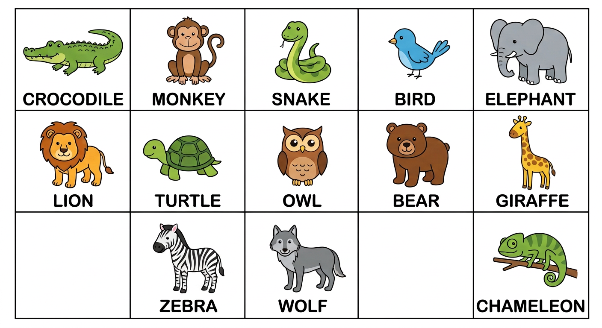
In this unit, I will learn to:
• say and read the names of thirteen wild animals;
• count from 71 to 100;
• answer: How many … are there? — There are …
Values: love of effort, striving for the best.
DO YOU REMEMBER? (T4)
In T4 we learned the farm animals and the pets: a cat, a dog, a zebu, a hen, a duck, a sheep, a pig…
This year: the WILD animals — the animals of the forest and the savanna!

LISTEN! Scan the code or open the link to listen and download.
 | 🎧 Wild animals — listen and repeat  https://drive.google.com/uc?export=download&id=1XR2r-mUSkfr0pryR6QyCF5OJ3aiv5pb_

SESSION 46 / 49
The wild animals
LESSON PREPARATION SHEET
Subject: English  Theme: UNIT 10 — WILD ANIMALS  Title: The wild animals  Specific learning outcome: By the end of the lesson, learners will be able to say and read the names of the wild animals, recognise them and answer “What is this?”.  Values: love of effort, striving for the best  Documentation: T4 English Syllabus (MEN — DCRP); T4 Pedagogical Resources Booklet  Materials: pictures of wild animals, true/false cards, copy-books, audio (QR code) | Date: ……………………  Class: T4  Session n°: 1 / 2  Duration: ……………………

Steps and Duration | Procedure |  | Technique and Strategy | Materials | Remarks
Steps and Duration | Teacher | Learners | Technique and Strategy | Materials | Remarks
I. Review  Duration: ……… | (Review of T4.) Answer these questions:  1. Name three farm animals or pets.  2. What is this? (a picture of a cat)  3. Present one member of your family. (Unit 9) | Answer.  E.A.: a cat, a dog, a zebu…; This is a cat; This is my … | Individual work | Pictures
II. NEW LESSON — Duration: ………
1. Warm-up | (The teacher mimes a big elephant with the trunk.) What animal am I? Today: the wild animals! | Look. Guess. | Miming | ----
2. Presentation | Today we are going to learn a new lesson called: « The wild animals ». By the end of this lesson, you will say and read thirteen animal names — like the chameleon of Madagascar! | Listen. | Whole-class work | ----
3. Observation | Look at the pictures and listen: a crocodile, a monkey, a snake, a bird, an elephant, a lion, a turtle, an owl, a bear, a giraffe, a zebra, a wolf, a chameleon. | Look. Listen. | “Visual aids” / Audio | Pictures, audio (QR code)
4. Analysis | Repeat each word until the pronunciation is good: the class, one row, one pupil.  Read the pairs on the blackboard (from the syllabus): snake – giraffe / bird – bear / lion – chameleon / owl – wolf.  In pairs, then in groups: read the words one after the other; listen and correct each other kindly. A mistake? Start the list again!  Listening: I say a word — circle it in your copy-book. Then swap copy-books with your neighbour and correct. | Repeat. Read. Correct each other. Circle. Swap and check.  E.A.: the words are read fluently; the right words are circled. | Repetition drill / “Peer correction” | Blackboard, copy-books
5. Synthesis | So, we know thirteen wild animals — and we can read their names! | Listen. | Whole-class work | Blackboard
6. Practice | True or false cards (from the syllabus): each group gets cards with a picture AND a name — some are right, some are WRONG (a picture of a bird with the word “Chameleon”!). Read the card, say TRUE or FALSE, and give the right name.  Read-and-draw: each group reads a word on the blackboard and draws the animal. The class looks and says the name!  Mime game: I whisper an animal to a pupil; the pupil mimes; the class guesses. | Read. Say true or false. Correct. Draw. Mime. Guess.  E.A.: False! This is a bird. — the drawings match the words — the mimes are guessed: a monkey! | Game (true/false, miming) / Group work | True/false cards, big sheets
III. Evaluation  Duration: ……… | 1. I show five pictures: say the animals.  2. Read four animal words.  3. What is this? (a picture of a turtle) | Say. Read. Answer.  E.A.: the animals are named clearly; the words are read; This is a turtle. | Individual work | Pictures

SESSION 47 / 49
Counting to 100 — How many animals are there?
LESSON PREPARATION SHEET
Subject: English  Theme: UNIT 10 — WILD ANIMALS  Title: Counting to 100 — How many animals are there?  Specific learning outcome: By the end of the lesson, learners will be able to count from 71 to 100 and answer “How many … are there?” with “There are …”.  Values: love of effort, striving for the best  Documentation: T4 English Syllabus (MEN — DCRP); T4 Pedagogical Resources Booklet  Materials: big cards with 80, 90 and 100, a small ball, pictures of many animals, audio (QR code) | Date: ……………………  Class: T4  Session n°: 2 / 2  Duration: ……………………

Steps and Duration | Procedure |  | Technique and Strategy | Materials | Remarks
Steps and Duration | Teacher | Learners | Technique and Strategy | Materials | Remarks
I. Review  Duration: ……… | Answer these questions:  1. Name five wild animals.  2. Read: crocodile, owl, zebra.  3. Count from 40 to 70. (Unit 6) | Answer. Read. Count.  E.A.: the animals are named; the words are read; the counting is right. | Individual work | Blackboard
II. NEW LESSON — Duration: ………
1. Warm-up | Count from 70 to 100 in Malagasy. Do you see? It works the same way in English: seventy, seventy-one, seventy-two… (language transfer) | Count. Compare. | “Transfer” | ----
2. Presentation | Today we are going to count to ONE HUNDRED — and count the wild animals! By the end of this lesson, you will say: There are 80 zebras! | Listen. | Whole-class work | ----
3. Observation | Look at these big cards: 80 … “eighty”. 90 … “ninety”. 100 … “one hundred”! Listen and look. (Repeat several times.) | Look. Listen. | “Visual aids” / Modelling | Big cards 80, 90, 100
4. Analysis | Repeat after me: eighty / ninety / one hundred — the class, one row, one pupil.  Point to eighty! Point to one hundred! Point to ninety!  Count with me: seventy-one… eighty… ninety… one hundred! | Repeat. Point. Count.  E.A.: the cards are pointed to; the counting is right. | Repetition drill | Cards
5. Synthesis | So: 80 = eighty, 90 = ninety, 100 = one hundred. And to count things: How many … are there? — There are … | Listen. Repeat. | Whole-class work | Blackboard
6. Practice | Ball game in the schoolyard (from the syllabus): I hold the ball and say a number, for example “72”. I throw the ball to a pupil: the pupil says the NEXT number in English. A mistake? We say the right number and start with a new number. Up to 100!  Counting the animals: look at my picture full of animals. “How many zebras are there?” — “There are 80 zebras.” Now in pairs, ask and answer with other animals and numbers — count the animals yourselves! | Play. Say the next number. Ask. Count. Answer.  E.A.: 72 → seventy-three! — How many birds are there? — There are one hundred birds. | Game (ball) / In pairs | A small ball, animal pictures
III. Evaluation  Duration: ……… | 1. Count from 71 to 100.  2. I show a card: eighty, ninety or one hundred?  3. How many … are there? (a picture) | Count. Answer.  E.A.: the counting is right; There are … (animals). | Individual work | Cards, pictures

LESSON — UNIT 10
WILD ANIMALS
1. Thirteen wild animals
a crocodile  [e krokodaïol] | a monkey  [e monnki] | a snake  [e snéike] | a bird  [e beurde]
an elephant  [ane élifannte] | a lion  [e laïeune] | a turtle  [e teurtol] | an owl  [ane aoul]
a bear  [e bèr] | a giraffe  [e djirâf] | a zebra  [e zibra] | a wolf  [e woulf]
a chameleon
[e kamilieune]

2. What is this?
The question: What is this? [ouate iz ziss]
The answer: This is a lion. [ziss iz e laïeune]
3. The numbers 71 to 100
71  seventy-one | 75  seventy-five | 79  seventy-nine | 80  eighty
82  eighty-two | 86  eighty-six | 89  eighty-nine | 90  ninety
91  ninety-one | 95  ninety-five | 99  ninety-nine | 100  one hundred

4. How many are there?
The question: How many zebras are there? [haou mèni zibraz âr zèr]
The answer: There are eighty zebras. [zèr âr éiti zibraz]
LISTEN! Scan the code or open the link to listen and download.
🎧 Wild animals — listen and repeat
https://drive.google.com/uc?export=download&id=1XR2r-mUSkfr0pryR6QyCF5OJ3aiv5pb_
 | 🎧 Numbers 71 to 100 — listen and count  https://drive.google.com/uc?export=download&id=1t46MXejhSLzzIcaAdDCvM5BS3HefnLl5

EXERCISES
Exercise 1 (5 points). The teacher shows five animal pictures: say the names.

Exercise 2 (5 points). Read: crocodile — elephant — giraffe — owl — chameleon.

Exercise 3 (4 points). True or false? (The teacher shows four cards with a picture and a name; correct the false ones.)

Exercise 4 (6 points). Count from 71 to 100 (4 points), then answer: How many … are there? (2 points)

Total: 20 points
ANSWER KEY
Exercise 1: the five animals are named clearly (1 point each).
Exercise 2: the five words are read correctly (1 point each).
Exercise 3: true/false is right; the false cards are corrected: “False! This is a …” (1 point each).
Exercise 4: seventy-one … one hundred; There are … (animals).

SESSION 48 / 49
REVISION — UNIT 10: WILD ANIMALS
Remember the animals:
a crocodile  [e krokodaïol] | a monkey  [e monnki] | a snake  [e snéike] | a bird  [e beurde]
an elephant  [ane élifannte] | a lion  [e laïeune] | a turtle  [e teurtol] | an owl  [ane aoul]
a bear  [e bèr] | a giraffe  [e djirâf] | a zebra  [e zibra] | a wolf  [e woulf]
a chameleon
[e kamilieune]

Now answer:
1. The teacher shows six pictures: say the animals.
E.A.: a crocodile, a monkey, a lion, an owl, a zebra, a chameleon…
2. Read six animal words on the blackboard.
E.A.: the words are read fluently.
3. What is this? (three pictures)
E.A.: This is a … / This is an elephant.
4. Count from 71 to 100.
E.A.: seventy-one … one hundred.
5. How many turtles are there? (a picture)
E.A.: There are … turtles.
6. Mime an animal for your group!
E.A.: the animal is guessed in English.

SESSION 49 / 49
T5 TEST PAPER — UNIT 10: WILD ANIMALS
Duration: ……… Total: 20 points
Exercise 1 (5 points). The teacher shows five animal pictures: say the names.

Exercise 2 (5 points). Read five animal words on the blackboard.

Exercise 3 (5 points). Count from 71 to 100.

Exercise 4 (5 points). Answer: What is this? (2 points) How many … are there? (3 points)

ANSWER KEY
Exercise 1: the animals are named clearly (1 point each).
Exercise 2: the words are read correctly (1 point each).
Exercise 3: seventy-one … one hundred (5 points).
Exercise 4: This is a … — There are … (animals).

UNIT 10 — I CAN…

Tick ✔ what you can do:
☐ I can say thirteen wild animals.
☐ I can read the animal words.
☐ I can answer: What is this? — This is a …
☐ I can count from 71 to 100.
☐ I can say: There are … (animals).

Well done! You finished the T5 English year! See you in T6!

ANNEXES

The treasure box of the year!
Annex 1 — Picture dictionary: all the words of the year
Annex 2 — Songs and rhymes: all the songs, with the audio
Annex 3 — Pronunciation guide: for the teacher
Annex 4 — Flashcards to cut out: for the games

ANNEX 1
PICTURE DICTIONARY
All the words of the year, unit by unit. Look at the picture, read the word, say it aloud!
SOCIALISING (Unit 1)

morning  [môrning] | afternoon  [afteurnoune] | evening  [ivning] | night  [naïte]

Good morning! [goud môrning] Good afternoon! [goud afteurnoune] Good evening! [goud ivning]
Good night! [goud naïte] Enjoy your meal! [inndjoï iôr mile] Have a nice day! [hav e naïss déi]
See you! [si iou] See you next time! [si iou nèxte taïme]
INTRODUCING ONESELF (Unit 2)

Where are you from? [ouèr âr iou frome] → I’m from Madagascar. [aïm frome madagaskar]
Where do you live? [ouèr dou iou live] → I live in … [aï live ine]
CLASSROOM LANGUAGE (Unit 3)

Go to the blackboard!  [gôou tou ze blakbôrd] | Clean the blackboard!  [kline ze blakbôrd]
Open the door!  [ôoupeune ze dôr] | Close the door!  [klôouz ze dôr]
Open your copybook!  [ôoupeune iôr kopibouk] | Close your copybook!  [klôouz iôr kopibouk]
Open the windows!  [ôoupeune ze ouindôouz] | Close the windows!  [klôouz ze ouindôouz]
Go to the library!  [gôou tou ze laïbreri] | Go to the cafeteria!  [gôou tou ze kafétiria]
Have a break!
[hav e bréik]

PARTS OF THE BODY (Unit 4)

hair  [hèr] | face  [féiss] | cheeks  [tchiks] | neck  [nèk]
teeth  [tiss] | back  [bak] | belly  [bèli] | arms  [ârmz]
hands  [handz] | fingers  [finngueurz] | legs  [lègz] | feet  [fite]

MY BIRTHDAY IS ON… (Unit 5)

January  [djanioueri] | February  [fébioueri] | March  [mârtch] | April  [éiprol]
May  [méi] | June  [djoune] | July  [djoulaï] | August  [ôgueuste]
September  [sèptèmbeur] | October  [oktôoubeur] | November  [novèmbeur] | December  [dissèmbeur]

When is your birthday? [ouène iz iôr beursdé] → My birthday is on June 12. [maï beursdé iz one djoune touèlfs]
MY DREAM CLASSROOM (Unit 6)

classroom  [klâsroume] | headmaster  [hèdmâsteur] | teacher  [titcheur] | pupils  [pioupolz]
table  [téibol] | chair  [tchèr] | bench  [bèntch] | blackboard  [blakbôrd]

How many benches are there? [haou mèni bèntchiz âr zèr] → There are 50 benches. [zèr âr fifti bèntchiz]
MEALS (Unit 7)

cassava  [kassâva] | sweet potato  [souite potéitô] | meat  [mite] | chicken  [tchikène]
fish  [fich] | green beans  [grine binz] | onion  [onieune] | tomato  [tomâtô]
apple  [apol] | peach  [pitch] | pineapple  [païnapol] | rice  [raïss]

What did you have for breakfast? [ouate dide iou hav for brèkfeuste] → I had cassava. [aï hade kassâva]
IN MY HOUSE (Unit 8)

The rooms:
bedroom  [bèdroume] | bathroom  [bâssroume] | kitchen  [kitchène] | living room  [livinng roume] | dining room  [daïninng roume]

The things:
bed  [bède] | pillow  [pilô] | soap  [sôoupe] | towel  [taouol] | toothbrush  [toussbreuch]
stove  [stôouv] | cooking pot  [koukinng pote] | sofa  [sôoufa] | stool  [stoule] | armchair  [ârmtchèr]
table  [téibol] | chair  [tchèr] | plate  [pléite] | spoon  [spoune] | glass  [glâss]

Where is the bed? [ouèr iz ze bède] → The bed is in the bedroom. [ze bède iz ine ze bèdroume]
MY FAMILY (Unit 9)

father  [fâzeur] | mother  [meuzeur] | son  [seune] | daughter  [dôteur]
brother  [breuzeur] | sister  [sisteur] | family  [famili] | name  [néime]

Who’s this? [houz zis] → This is my brother. [zis iz maï breuzeur]
What’s his name? [ouots hiz néime] → His name is Koto. [hiz néime iz koto]
WILD ANIMALS (Unit 10)

a crocodile  [e krokodaïol] | a monkey  [e monnki] | a snake  [e snéike] | a bird  [e beurde]
an elephant  [ane élifannte] | a lion  [e laïeune] | a turtle  [e teurtol] | an owl  [ane aoul]
a bear  [e bèr] | a giraffe  [e djirâf] | a zebra  [e zibra] | a wolf  [e woulf]
a chameleon
[e kamilieune]

What is this? [ouate iz zis] → This is a lion. [zis iz e laïeune]
THE BIG NUMBERS OF THE YEAR (Units 5, 6 and 10)

20 — twenty  [touènti] | 30 — thirty  [seurti] | 40 — forty  [fôrti]
50 — fifty  [fifti] | 60 — sixty  [siksti] | 70 — seventy  [sèvènti]
80 — eighty  [éiti] | 90 — ninety  [naïnti] | 100 — one hundred  [ouane heundrède]

ANNEX 2
SONGS AND RHYMES
All the songs and rhymes of the year. Scan the QR code or use the link to listen and download.
♪ THE “PARTS OF THE DAY” RHYME (Unit 1)

It’s the morning. The sun is coming up.
It’s the morning. It’s time to wake up!
It’s the afternoon! I smile to the sun.
It’s the afternoon! Isn’t it fun?
It’s the evening, the end of the day.
It’s the evening! The sun has gone away.
It’s the night. The stars begin to peep.
It’s the night. It’s time to go to sleep.

LISTEN! Scan the code or open the link to listen and download.
🎧 The “Parts of the day” rhyme — listen and say
https://drive.google.com/uc?export=download&id=1oE_Ayk2uxTUJNE7D857cohiq4xtrAU2Z

♪ THE “ONE LITTLE FINGER” RHYME (Unit 4)

One little finger, one little finger,
one little finger, tap, tap, tap!
Point your finger up, up. Point your finger down, down.
Put it on your hair, hair. (Chorus)
Put it on your cheek, cheek. (Chorus)
Put it on your hand, hand. (Chorus)
Put it on your leg, leg. (Chorus)
Put it on your foot, foot.
Now let’s wave goodbye, goodbye!
We act each verse with the finger on the right part of the body!
LISTEN! Scan the code or open the link to listen and download.
🎧 One little finger — listen and act
https://drive.google.com/uc?export=download&id=17OUhSkIGUafhyZsqLvSWWwVUlXlHDaoL

♪ THE “MONTHS OF THE YEAR” SONG (Unit 5)

January, February, March and April,
May, June, July and August,
September, October, November, December:
these are the months of the year!

LISTEN! Scan the code or open the link to listen and download.
🎧 The Months of the year song — listen and sing
https://drive.google.com/uc?export=download&id=1CyD5EY7e8HeRRKH-IC0t98IHLx3NNFpl

♪ THE “WELCOME TO MY HOUSE” SONG (Unit 8)

Welcome to my house,
my family and me!
In the living room, I watch TV. (2x)
In the bathroom, I take a shower.
In the kitchen, I cook good food.
In the dining room, I have breakfast.
In the bedroom, I go to sleep.

LISTEN! Scan the code or open the link to listen and download.
🎧 Welcome to my house — listen and sing
https://drive.google.com/uc?export=download&id=16kBQbrPY-eLZRH3ZfGkKS9NFti-m71xc

♪ THE “WHO’S THIS?” SONG (Unit 9)

Who, who, who is this?
Brother, brother, it’s my brother!
Who, who, who is that?
Sister, sister, it’s my sister!
Brother and sister:
I love my brother. I love my sister.

LISTEN! Scan the code or open the link to listen and download.
🎧 Who’s this? — listen and sing
https://drive.google.com/uc?export=download&id=162hgsy71DlffbSoHqI6ZG-V0QwtYfbJo

ANNEX 3
PRONUNCIATION GUIDE
For the teacher
In this book, every English word has a help between brackets, in italics and grey: it shows how to SAY the word, with sounds read as in French. Example:
bedroom [bèdroume] — we read “bèdroume” as in French.
This help is only a guide for the mouth: the true model is the AUDIO. Always play the audio (QR code or link) and repeat after it!
The special English sounds:
Written | How to say it | Examples
th → [z] / [s] | Put the tongue between the teeth and say a soft “z” or “s”. | this [zis], brother [breuzeur], birthday [beursdé], teeth [tiss]
h → [h] | Blow softly, like a small laugh. The “h” is not silent! | hair [hèr], house [haous], headmaster [hèdmâsteur]
r → [r] | A soft “r”, the tongue does not roll and does not touch the teeth. | rice [raïss], rooms [roumz], ruler
-ing → [ing] | A nasal “ng” at the end, like a small bell. | morning [môrning], evening [ivning], living room
ou / ow → [aou] | Two sounds together: “a” then “ou”. | how [haou], owl [aoul], towel [taouol]
o / oa → [ôou] | Two sounds together: “ô” then “ou”. | go [gôou], soap [sôoupe], stove [stôouv]
a → [éi] | Two sounds together: “é” then “i”. | name [néime], snake [snéike], plate [pléite]
i → [aï] | Two sounds together: “a” then “i”. | five [faïv], night [naïte], pineapple [païnapol]
u → [eu] | A short “eu”, the mouth relaxed. | mother [meuzeur], monkey [monnki], lunch [leunntch]
ee / ea → [i] | A long “i”, smile! | teeth [tiss], green beans [grine binz], teacher [titcheur]

Three golden rules:
1. Listen first, speak after: the pupils repeat AFTER the audio or the teacher.
2. Whole class → one row → one pupil: repeat in this order (repetition drill).
3. Praise every try: “Good!”, “Very good!”, “Well done!” — mistakes are welcome, they help us learn.

ANNEX 4
FLASHCARDS TO CUT OUT
For the teacher: photocopy these pages, paste them on cardboard, cut along the dashed lines. Use the cards for the games: point, mime, true or false, Kim’s game, “What is this?”…
THE BIG NUMBERS (Units 5, 6 and 10)

20  [touènti] | 30  [seurti] | 40  [fôrti] | 50  [fifti] | 60  [siksti]
70  [sèvènti] | 80  [éiti] | 90  [naïnti] | 100  [ouane heundrède]

twenty | thirty | forty | fifty | sixty
seventy | eighty | ninety | one hundred

THE MONTHS (Unit 5)

January  [djanioueri] | February  [fébioueri] | March  [mârtch]
April  [éiprol] | May  [méi] | June  [djoune]
July  [djoulaï] | August  [ôgueuste] | September  [sèptèmbeur]
October  [oktôoubeur] | November  [novèmbeur] | December  [dissèmbeur]

PARTS OF THE BODY (Unit 4)

hair  [hèr] | face  [féiss] | cheeks  [tchiks]
neck  [nèk] | teeth  [tiss] | back  [bak]
belly  [bèli] | arms  [ârmz] | hands  [handz]
fingers  [finngueurz] | legs  [lègz] | feet  [fite]

THE CLASSROOM (Unit 6)

classroom  [klâsroume] | headmaster  [hèdmâsteur]
teacher  [titcheur] | pupils  [pioupolz]
table  [téibol] | chair  [tchèr]
bench  [bèntch] | blackboard  [blakbôrd]

FOOD (Unit 7)

cassava  [kassâva] | sweet potato  [souite potéitô] | meat  [mite]
chicken  [tchikène] | fish  [fich] | green beans  [grine binz]
onion  [onieune] | tomato  [tomâtô] | apple  [apol]
peach  [pitch] | pineapple  [païnapol] | rice  [raïss]

THE ROOMS OF THE HOUSE (Unit 8)

bedroom  [bèdroume] | bathroom  [bâssroume]
kitchen  [kitchène] | living room  [livinng roume]
dining room
[daïninng roume]

THE FAMILY (Unit 9)

father  [fâzeur] | mother  [meuzeur] | son  [seune]
daughter  [dôteur] | brother  [breuzeur] | sister  [sisteur]

WILD ANIMALS (Unit 10)

crocodile  [krokodaïol] | monkey  [monnki] | snake  [snéike]
bird  [beurde] | elephant  [élifannte] | lion  [laïeune]
turtle  [teurtol] | owl  [aoul] | bear  [bèr]
giraffe  [djirâf] | zebra  [zibra] | wolf  [woulf]
chameleon
[kamilieune]

Tip: draw or paste a small picture on the back of each word card — the card becomes a picture card for “What is this?”.

THE END OF THE BOOK — NOT THE END OF ENGLISH!
Koto and Soa say:
“Goodbye, teacher! Goodbye, children! See you next year in T6!”
J-Learn collection — English T5
All the audio files of this book:
https://drive.google.com/drive/folders/1H3aOxLqwTFCfTIaze-MUfM96RRuSu4HM

