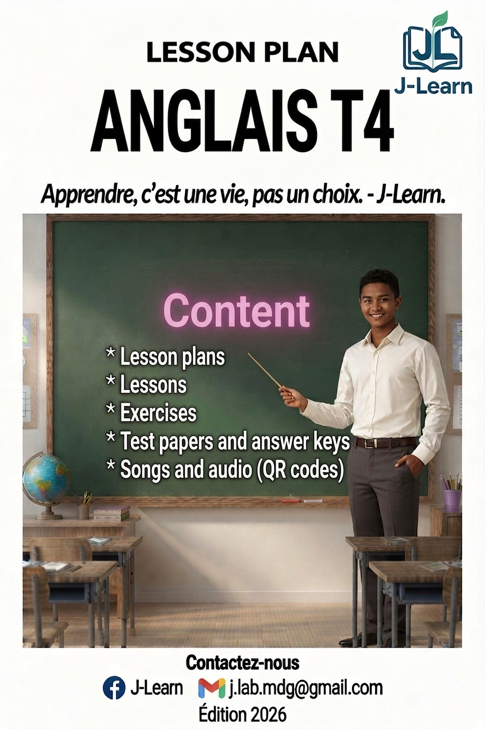

FOREWORD
This book follows the official T4 English syllabus of the Ministry of National Education of Madagascar (Programme d’études T4) and its Pedagogical Resources Booklet.
English starts in T4. This year, the pupils listen and speak: they greet, say their name, count, sing and play in English.
Every session has three big steps: I. Review — II. New lesson — III. Evaluation. The teacher writes the duration of each step in the sheet.
Every unit has: one opening page, the preparation sheets, one lesson with pictures and pronunciation help, exercises with an answer key, one revision session, one test paper, and one “I can…” page for the pupil.
Songs and dialogues can be listened to with a phone: scan the QR code or open the link at the bottom of the page.

HOW TO USE THIS BOOK
The PE rubric badges
In the official programme (PE), the contents of every unit are organised in three rubrics. This book shows them with three coloured badges above the sections of the lessons, and with the table “THIS UNIT IN THE OFFICIAL PROGRAMME (PE)” on the opening page of every unit.
■ 📗 VOCABULARY — the words and expressions of the official programme.
■ 🗣 LANGUAGE FUNCTIONS — what we do with the language: greeting, asking, offering…
■ ⚙ GRAMMAR — the rules and the structures.
The three big steps of a session
I. Review — quick questions on the last lesson.
II. New lesson — six small steps: Warm-up, Presentation, Observation, Analysis, Synthesis, Practice.
III. Evaluation — the pupils work alone.
The duration boxes are empty (………): the teacher writes his/her own timing.
The colours of the book
■ Red — title of the lesson.
■ Green — sub-titles of the lesson.
■ Blue + bold — key words to remember. The small grey words in brackets help you say the word: Hello [hèlôou].
■ Pink — answer keys.

The audio
Scan the QR code with a phone, or open the link: you can listen and download the MP3 file. E.A. means “Expected Answer”.

CONTENTS
UNIT 1 — SOCIALISING (Sessions 1–8)
Session 1 — Greetings
Session 2 — Saying goodbye
Session 3 — Introducing yourself: What’s your name?
Session 4 — Introducing yourself: How old are you?
Session 5 — Thanking
Session 6 — Apologizing
Session 7 — Revision
Session 8 — T4 Test paper

UNIT 2 — THE ALPHABET (Sessions 9–12)
Session 9 — The letters A to M
Session 10 — The letters N to Z, the Alphabet Song
Session 11 — Revision
Session 12 — T4 Test paper

UNIT 3 — NUMBERS (Sessions 13–17)
Session 13 — Numbers 1 to 10, the “One, two” rhyme
Session 14 — Numbers 11 to 20, the ball game
Session 15 — How many … are there?
Session 16 — Revision
Session 17 — T4 Test paper

UNIT 4 — CLASSROOM LANGUAGE (Sessions 18–21)
Session 18 — Classroom commands
Session 19 — Asking for permission
Session 20 — Revision
Session 21 — T4 Test paper

UNIT 5 — PARTS OF THE BODY (Sessions 22–25)
Session 22 — Parts of the body, the song
Session 23 — This is my head — What is this?
Session 24 — Revision
Session 25 — T4 Test paper

UNIT 6 — DAYS OF THE WEEK (Sessions 26–29)
Session 26 — The seven days, the song
Session 27 — The order of the days, my favourite day
Session 28 — Revision
Session 29 — T4 Test paper

UNIT 7 — SCHOOL ENVIRONMENT (Sessions 30–39)
Session 30 — School things (1)
Session 31 — School things (2)
Session 32 — What is this? — This is a book
Session 33 — The memory game (Kim’s game)
Session 34 — Colours (1): red, blue, black, green
Session 35 — Colours (2): find something red!
Session 36 — What do you need? — I need …
Session 37 — At the shop (role play)
Session 38 — Revision
Session 39 — T4 Test paper

UNIT 8 — MEALS (Sessions 40–43)
Session 40 — Food and drinks
Session 41 — Breakfast, lunch, dinner
Session 42 — Revision
Session 43 — T4 Test paper

UNIT 9 — HOUSE (Sessions 44–49)
Session 44 — Parts of the house (1)
Session 45 — Parts of the house (2)
Session 46 — Describing a house
Session 47 — My dream house
Session 48 — Revision
Session 49 — T4 Test paper

UNIT 10 — FAMILY (Sessions 50–53)
Session 50 — The members of the family, the Family song
Session 51 — Who is he? Who is she?
Session 52 — Revision
Session 53 — T4 Test paper

UNIT 11 — FARM ANIMALS AND PETS (Sessions 54–57)
Session 54 — Farm animals and pets
Session 55 — What is this? Draw me a cat!
Session 56 — Revision
Session 57 — T4 Test paper

ANNEXES — The treasure box of the year
Annex 1 — Picture dictionary
Annex 2 — Songs and rhymes
Annex 3 — Pronunciation guide
Annex 4 — Flashcards to cut out

OVERVIEW OF THE YEAR
Unit | Title | Sessions | + Revision + Test
1 | Socialising | 6 (S1–S6) | S7, S8
2 | The Alphabet | 2 (S9–S10) | S11, S12
3 | Numbers | 3 (S13–S15) | S16, S17
4 | Classroom Language | 2 (S18–S19) | S20, S21
5 | Parts of the Body | 2 (S22–S23) | S24, S25
6 | Days of the Week | 2 (S26–S27) | S28, S29
7 | School Environment | 8 (S30–S37) | S38, S39
8 | Meals | 2 (S40–S41) | S42, S43
9 | House | 4 (S44–S47) | S48, S49
10 | Family | 2 (S50–S51) | S52, S53
11 | Farm Animals and Pets | 2 (S54–S55) | S56, S57

Total: 35 lesson sessions + 11 revisions + 11 test papers = 57 sessions (1 hour of English per week).

UNIT 1 — SOCIALISING

Hello! Hi! Good morning!
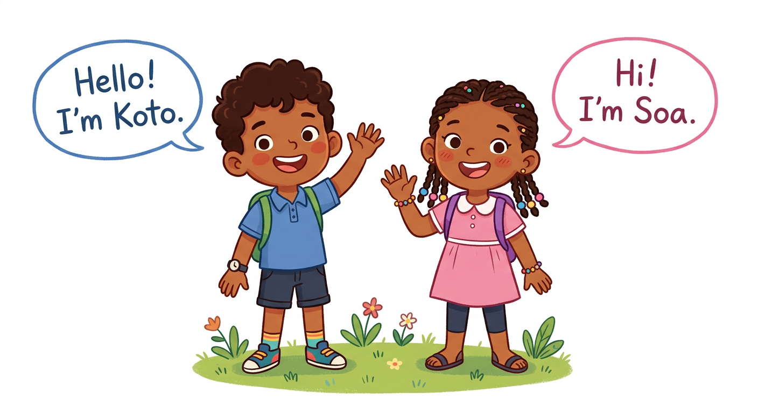
In this unit, I will learn to:
• greet my friends and say goodbye;
• say my name and my age;
• thank my friends and say sorry.
Values: respect, self-confidence.
THIS UNIT IN THE OFFICIAL PROGRAMME (PE)
📗 VOCABULARY | Hello, hi, good morning; goodbye; thank you; sorry.
🗣 LANGUAGE FUNCTIONS | Greeting; saying goodbye; introducing yourself; thanking; apologizing.
⚙ GRAMMAR | I am… / My name is…; How are you? — I’m fine, thank you.

MY FIRST ENGLISH WORDS!
English is spoken all over the world.
This year, you start English. Welcome!

LISTEN! Scan the code or open the link to listen and download.
 | 🎧 Greetings — listen and repeat  https://drive.google.com/uc?export=download&id=1Cj2Eo5iy6RFNWcsOS0vjvaDfvI2dHbTU

SESSION 1 / 57
Greetings
LESSON PREPARATION SHEET
Subject: English  Theme: UNIT 1 — SOCIALISING  Title: Greetings  Specific learning outcome: By the end of the lesson, learners will be able to greet a friend in English and answer the question “How are you?”.  Values: respect, self-confidence  Documentation: T4 English Syllabus (MEN — DCRP); T4 Pedagogical Resources Booklet  Materials: picture of two children greeting, blackboard | Date: ……………………  Class: T4  Session n°: 1 / 6  Duration: ……………………

Steps and Duration | Procedure |  | Technique and Strategy | Materials | Remarks
Steps and Duration | Teacher | Learners | Technique and Strategy | Materials | Remarks
I. Review  Duration: ……… | This is the first English lesson.  Greet the class. Then ask:  1. Wave your hand like me.  2. Do you know one English word? Say it. | Wave. Answer.  E.A.: pupils wave and say words they know (hello, OK, goal…). | Whole-class work | ----
II. NEW LESSON — Duration: ………
1. Warm-up | Koto waves his hand and says: “Hello!”. What does Koto say? | Listen. Answer.  E.A.: Hello! | Whole-class work | ----
2. Presentation | Today we are going to learn a new lesson called: « Greetings ». By the end of this lesson, you will be able to greet a friend in English and answer the question “How are you?”. | Listen. | Whole-class work | ----
3. Observation | Look at this picture of two children. | Look. | Whole-class work | Picture of two children greeting
4. Analysis | What do the children do with their hands?  What does the boy say?  What does the girl say?  When do we say “Good morning”? | Answer.  E.A.: They wave.  E.A.: Hello! I’m Koto.  E.A.: Hi! I’m Soa.  E.A.: In the morning. | Brainstorming / Whole-class work | Picture of two children greeting
5. Synthesis | So, to greet a friend, we say: “Hello!” or “Hi!”. In the morning, we say: “Good morning!”. To ask about a friend, we say: “How are you?”. The answer is: “I’m fine, thank you.” | Listen. | Whole-class work | Blackboard
6. Practice | Stand in two lines, face a friend.  Greet the friend in front of you: “Hello!” or “Hi!”.  Ask: “How are you?”. The friend answers: “I’m fine, thank you.”.  Move one step to the left. Start again with a new friend.  Then choose the right answer:  1. In the morning we say: Bye! / Good morning!  2. “How are you?” → I’m fine, thank you. / Hello!  3. A friend says “Hi!”. You say: Hi! / Sorry!  4. To greet, we say: Hello! / Goodbye! | Speak with a friend. Do the exercise.  E.A.: 1. Good morning! 2. I’m fine, thank you. 3. Hi! 4. Hello! | “Speed-chat” / In pairs | ----
III. Evaluation  Duration: ……… | Answer your teacher:  1. Hello!  2. Good morning!  3. How are you?  4. Greet your friend. | Answer.  E.A.: 1. Hello! / Hi! 2. Good morning! 3. I’m fine, thank you. 4. Hello! / Hi! / Good morning! | Individual work | ----

SESSION 2 / 57
Saying goodbye
LESSON PREPARATION SHEET
Subject: English  Theme: UNIT 1 — SOCIALISING  Title: Saying goodbye  Specific learning outcome: By the end of the lesson, learners will be able to say goodbye in English.  Values: respect, self-confidence  Documentation: T4 English Syllabus (MEN — DCRP); T4 Pedagogical Resources Booklet  Materials: blackboard | Date: ……………………  Class: T4  Session n°: 2 / 6  Duration: ……………………

Steps and Duration | Procedure |  | Technique and Strategy | Materials | Remarks
Steps and Duration | Teacher | Learners | Technique and Strategy | Materials | Remarks
I. Review  Duration: ……… | Answer these questions:  1. Greet your friend.  2. In the morning, what do we say?  3. How are you?  4. A friend says “Hello!”. What do you say? | Answer.  E.A.: 1. Hello! / Hi!  2. Good morning!  3. I’m fine, thank you.  4. Hello! / Hi! | Individual work | ----
II. NEW LESSON — Duration: ………
1. Warm-up | The lesson is finished. Soa goes home. She waves and says a word. What does she say? | Listen. Answer.  E.A.: Goodbye! / Bye! | Whole-class work | ----
2. Presentation | Today we are going to learn a new lesson called: « Saying goodbye ». By the end of this lesson, you will be able to say goodbye in English. | Listen. | Whole-class work | ----
3. Observation | Look at me. I walk to the door. I wave my hand and I say: “Goodbye!”. | Look. | Whole-class work | Classroom door
4. Analysis | What do I do with my hand?  What do I say?  When do we say “Goodbye”?  Do you know a short word for “Goodbye”? | Answer.  E.A.: You wave.  E.A.: Goodbye!  E.A.: When we leave. / When we go home.  E.A.: Bye! / Bye-bye! | Brainstorming / Whole-class work | Classroom door
5. Synthesis | So, when we leave, we say: “Goodbye!”. We can also say: “Bye!” or “Bye-bye!”. | Listen. | Whole-class work | Blackboard
6. Practice | Stand in two lines, face a friend.  Say the full chat: “Hello!” – “Hi!” – “How are you?” – “I’m fine, thank you.” – “Goodbye!” – “Bye-bye!”.  Move one step to the left. Start again and change the words.  Then choose the right answer:  1. We leave. We say: Hello! / Goodbye!  2. A friend says “Goodbye!”. You say: Bye! / Good morning!  3. The short word for Goodbye is: Bye! / Hi!  4. “Bye-bye!” means: goodbye / hello | Speak with a friend. Do the exercise.  E.A.: 1. Goodbye! 2. Bye! 3. Bye! 4. goodbye | “Speed-chat” / In pairs | ----
III. Evaluation  Duration: ……… | Answer your teacher:  1. Goodbye!  2. You go home. What do you say?  3. Say goodbye in two ways.  4. Say the full chat with me: hello → how are you → goodbye. | Answer.  E.A.: 1. Goodbye! / Bye! 2. Goodbye! / Bye-bye! 3. Bye! and Bye-bye! 4. Hello! – How are you? – I’m fine, thank you. – Goodbye! | Individual work | ----

SESSION 3 / 57
Introducing yourself: What’s your name?
LESSON PREPARATION SHEET
Subject: English  Theme: UNIT 1 — SOCIALISING  Title: Introducing yourself: What’s your name?  Specific learning outcome: By the end of the lesson, learners will be able to say their name and answer “Nice to meet you”.  Values: respect, self-confidence  Documentation: T4 English Syllabus (MEN — DCRP); T4 Pedagogical Resources Booklet  Materials: ball, “What’s your name?” song | Date: ……………………  Class: T4  Session n°: 3 / 6  Duration: ……………………

Steps and Duration | Procedure |  | Technique and Strategy | Materials | Remarks
Steps and Duration | Teacher | Learners | Technique and Strategy | Materials | Remarks
I. Review  Duration: ……… | Answer these questions:  1. Greet your friend.  2. How are you?  3. You go home. What do you say?  4. Say goodbye in two ways. | Answer.  E.A.: 1. Hello! / Hi! / Good morning!  2. I’m fine, thank you.  3. Goodbye! / Bye!  4. Bye! and Bye-bye! | Individual work | ----
II. NEW LESSON — Duration: ………
1. Warm-up | A new pupil comes to our school. You want to know him. What do you ask him? | Listen. Answer.  E.A.: His name. / Who are you? | Whole-class work | ----
2. Presentation | Today we are going to learn a new lesson called: « Introducing yourself: What’s your name? ». By the end of this lesson, you will be able to say your name and answer “Nice to meet you”. | Listen. | Whole-class work | ----
3. Observation | Listen to me. My name is …… (the teacher says his/her name). What’s your name, …… ? (the teacher asks 3 or 4 pupils). | Listen. | Whole-class work | ----
4. Analysis | What is my question?  What is the answer?  After the name, I say: “Nice to meet you”. What is the answer?  Now ask me: “What’s your name?”. | Answer.  E.A.: What’s your name?  E.A.: My name is ……  E.A.: Nice to meet you too.  E.A.: pupils ask the question, the teacher answers. | Brainstorming / Whole-class work | ----
5. Synthesis | So, to ask a name, we say: “What’s your name?”. The answer is: “My name is ……”. Then we say: “Nice to meet you.” and the friend answers: “Nice to meet you too.”. | Listen. | Whole-class work | Blackboard
6. Practice | Sing the “What’s your name?” song with me.  Ball game: I throw the ball to a pupil and the class sings: “Hello, hello, hello, what’s your name?”.  The pupil with the ball sings: “My name is ……, my name is ……”.  The class answers: “Nice to meet you, ……!”.  The pupil throws the ball to a friend. Start again. | Sing. Play. Answer.  E.A.: each pupil says “My name is ……” with his/her real name; the class answers “Nice to meet you” + the name. | Game / “Repetition drill” | Ball, “What’s your name?” song
III. Evaluation  Duration: ……… | Answer your teacher:  1. What’s your name?  2. Nice to meet you.  3. Ask your friend’s name.  4. Your friend answers. Say “Nice to meet you” with his/her name. | Answer.  E.A.: 1. My name is …… (real name) 2. Nice to meet you too. 3. What’s your name? 4. Nice to meet you, ……! | Individual work / In pairs | ----

SESSION 4 / 57
Introducing yourself: How old are you?
LESSON PREPARATION SHEET
Subject: English  Theme: UNIT 1 — SOCIALISING  Title: Introducing yourself: How old are you?  Specific learning outcome: By the end of the lesson, learners will be able to say their age in English.  Values: respect, self-confidence  Documentation: T4 English Syllabus (MEN — DCRP); T4 Pedagogical Resources Booklet  Materials: pictures of two children, blackboard | Date: ……………………  Class: T4  Session n°: 4 / 6  Duration: ……………………

Steps and Duration | Procedure |  | Technique and Strategy | Materials | Remarks
Steps and Duration | Teacher | Learners | Technique and Strategy | Materials | Remarks
I. Review  Duration: ……… | Answer these questions:  1. What’s your name?  2. Ask my name.  3. Nice to meet you.  4. Greet your friend and ask his/her name. | Answer.  E.A.: 1. My name is ……  2. What’s your name?  3. Nice to meet you too.  4. Hello! What’s your name? | Individual work | ----
II. NEW LESSON — Duration: ………
1. Warm-up | Look at Soa. She is not big, she is not small. Do you know her age? | Listen. Answer.  E.A.: No. / Eight? Nine? | Whole-class work | ----
2. Presentation | Today we are going to learn a new lesson called: « Introducing yourself: How old are you? ». By the end of this lesson, you will be able to say your age in English. | Listen. | Whole-class work | ----
3. Observation | Look at these two pictures of children. | Look. | Whole-class work | Pictures of two children
4. Analysis | The first child asks a question: “How old are you?”. What does he want to know?  The second child answers: “I’m 8”. What does it mean?  How do you ask the age of a friend?  How do you answer? | Answer.  E.A.: The age.  E.A.: He is 8 years old.  E.A.: How old are you?  E.A.: I’m …… (age). | Brainstorming / Whole-class work | Pictures of two children
5. Synthesis | So, to ask the age, we say: “How old are you?”. The answer is: “I’m ……” with the age: I’m 8. I’m 9. I’m 10. We can also say only the age: “8”, “9”, “10”. | Listen. | Whole-class work | Blackboard
6. Practice | Stand in two lines, face a friend.  Ask: “How old are you?”. The friend answers: “I’m ……”.  Change roles. Move one step to the left. Start again.  Then choose the right answer:  1. “How old are you?” asks about: the name / the age  2. The answer is: I’m 9. / My name is Soa.  3. “I’m 8” means: 8 years old / 8 pencils  4. To ask the age: How are you? / How old are you? | Speak with a friend. Do the exercise.  E.A.: 1. the age 2. I’m 9. 3. 8 years old 4. How old are you? | “Speed-chat” / In pairs | ----
III. Evaluation  Duration: ……… | Answer your teacher:  1. How old are you?  2. Ask the age of your friend.  3. What’s your name and how old are you?  4. Say the chat: greet → name → age. | Answer.  E.A.: 1. I’m …… (real age) 2. How old are you? 3. My name is ……, I’m …… 4. Hello! – What’s your name? – My name is …… – How old are you? – I’m …… | Individual work / In pairs | ----

SESSION 5 / 57
Thanking
LESSON PREPARATION SHEET
Subject: English  Theme: UNIT 1 — SOCIALISING  Title: Thanking  Specific learning outcome: By the end of the lesson, learners will be able to thank a friend and answer in English.  Values: respect, self-confidence  Documentation: T4 English Syllabus (MEN — DCRP); T4 Pedagogical Resources Booklet  Materials: pens, books | Date: ……………………  Class: T4  Session n°: 5 / 6  Duration: ……………………

Steps and Duration | Procedure |  | Technique and Strategy | Materials | Remarks
Steps and Duration | Teacher | Learners | Technique and Strategy | Materials | Remarks
I. Review  Duration: ……… | Answer these questions:  1. What’s your name?  2. How old are you?  3. Ask my name and my age.  4. Nice to meet you. | Answer.  E.A.: 1. My name is ……  2. I’m ……  3. What’s your name? How old are you?  4. Nice to meet you too. | Individual work | ----
II. NEW LESSON — Duration: ………
1. Warm-up | Soa gives a pencil to Koto. Koto is happy. What can Koto say? | Listen. Answer.  E.A.: Thank you. (Pupils may answer in their own words; the teacher gives the English word.) | Whole-class work | ----
2. Presentation | Today we are going to learn a new lesson called: « Thanking ». By the end of this lesson, you will be able to thank a friend and answer in English. | Listen. | Whole-class work | ----
3. Observation | Look at me. I give a pen to …… (a pupil). I say: “Thank you!” when he/she gives it back. | Look. | Whole-class work | Pen
4. Analysis | I take the pen. What do I say?  When do we say “Thank you!”?  A friend says “Thank you!”. What is the answer?  Now give your pen to a friend. What does he/she say? | Answer.  E.A.: Thank you!  E.A.: When a friend gives or helps.  E.A.: You’re welcome!  E.A.: Thank you! | Brainstorming / Whole-class work | Pen
5. Synthesis | So, when a friend gives something or helps us, we say: “Thank you!”. The friend answers: “You’re welcome!”. | Listen. | Whole-class work | Blackboard
6. Practice | Give your pen to your friend. The friend says: “Thank you!”. You answer: “You’re welcome!”. Change roles.  Then choose the right answer:  1. A friend gives you a book. You say: Thank you! / Sorry!  2. The answer to “Thank you!” is: You’re welcome! / Bye!  3. We say “Thank you!” when a friend: helps us / sleeps  4. “You’re welcome!” answers: Thank you! / How are you? | Play with a friend. Do the exercise.  E.A.: 1. Thank you! 2. You’re welcome! 3. helps us 4. Thank you! | “Simulation” / In pairs | Pens, books
III. Evaluation  Duration: ……… | Answer your teacher:  1. I give you a pencil. What do you say?  2. Thank you!  3. Play the scene with your friend: give → thank → answer.  4. When do we say “You’re welcome!”? | Answer.  E.A.: 1. Thank you! 2. You’re welcome! 3. “Thank you!” – “You’re welcome!” 4. After “Thank you!”. | Individual work / In pairs | ----

SESSION 6 / 57
Apologizing
LESSON PREPARATION SHEET
Subject: English  Theme: UNIT 1 — SOCIALISING  Title: Apologizing  Specific learning outcome: By the end of the lesson, learners will be able to say sorry and answer in English.  Values: respect, self-confidence  Documentation: T4 English Syllabus (MEN — DCRP); T4 Pedagogical Resources Booklet  Materials: blackboard | Date: ……………………  Class: T4  Session n°: 6 / 6  Duration: ……………………

Steps and Duration | Procedure |  | Technique and Strategy | Materials | Remarks
Steps and Duration | Teacher | Learners | Technique and Strategy | Materials | Remarks
I. Review  Duration: ……… | Answer these questions:  1. I give you a book. What do you say?  2. Thank you!  3. Greet your friend and ask his/her name.  4. How old are you? | Answer.  E.A.: 1. Thank you!  2. You’re welcome!  3. Hello! What’s your name?  4. I’m …… | Individual work | ----
II. NEW LESSON — Duration: ………
1. Warm-up | Koto runs. He bumps into Soa. It is not nice. What can Koto say? | Listen. Answer.  E.A.: Sorry. (Pupils may answer in their own words; the teacher gives the English word.) | Whole-class work | ----
2. Presentation | Today we are going to learn a new lesson called: « Apologizing ». By the end of this lesson, you will be able to say sorry and answer in English. | Listen. | Whole-class work | ----
3. Observation | Look at me and …… (a pupil). I bump into him/her softly. I say: “I’m sorry!”. He/she answers: “It’s OK!”. | Look. | Whole-class work | ----
4. Analysis | I bump into a friend. What do I say?  What is the short word for “I’m sorry”?  The friend answers. What does he/she say?  When do we say “Sorry”? | Answer.  E.A.: I’m sorry!  E.A.: Sorry!  E.A.: It’s OK!  E.A.: When we do something bad. / When we bump into a friend. | Brainstorming / Whole-class work | ----
5. Synthesis | So, when we do something bad, we say: “I’m sorry!” or “Sorry!”. The friend answers: “It’s OK!”. | Listen. | Whole-class work | Blackboard
6. Practice | Play the scene with a friend: bump softly → say “Sorry!” → answer “It’s OK!”. Change roles.  Then choose the right answer:  1. You bump into a friend. You say: Sorry! / Thank you!  2. The answer to “I’m sorry!” is: It’s OK! / You’re welcome!  3. The short word for “I’m sorry” is: Sorry! / Bye!  4. We say “Sorry!” when we: do something bad / sing | Play with a friend. Do the exercise.  E.A.: 1. Sorry! 2. It’s OK! 3. Sorry! 4. do something bad | “Simulation” / In pairs | ----
III. Evaluation  Duration: ……… | Answer your teacher:  1. You step on my foot. What do you say?  2. I’m sorry!  3. Play the scene with your friend: bump → sorry → answer.  4. Say all the words of Unit 1 that you remember. | Answer.  E.A.: 1. I’m sorry! / Sorry! 2. It’s OK! 3. “Sorry!” – “It’s OK!” 4. Hello, Hi, Good morning, How are you, I’m fine, Goodbye, Bye, My name is, Nice to meet you, How old are you, Thank you, You’re welcome, Sorry, It’s OK… | Individual work / In pairs | ----

LESSON — UNIT 1
SOCIALISING
🗣 LANGUAGE FUNCTIONS
1. Greetings
To greet a friend, we say: Hello! [hèlôou] or Hi! [haï]
In the morning, we say: Good morning! [goud môrning]
To ask about a friend: How are you? [haou âr iou]
The answer is: I’m fine, thank you. [aïm faïn, tenk iou]
🗣 LANGUAGE FUNCTIONS
2. Saying goodbye
When we leave, we say: Goodbye! [goudbaï] or Bye! [baï] or Bye-bye! [baï-baï]
🗣 LANGUAGE FUNCTIONS
3. Introducing yourself
To ask a name: What’s your name? [ouots iôr néim]
The answer: My name is …… [maï néim iz]
Then we say: Nice to meet you. [naïs tou mit iou]
The friend answers: Nice to meet you too. [naïs tou mit iou tou]
To ask the age: How old are you? [haou ôould âr iou]
The answer: I’m 8. [aïm éit] / I’m 9. / I’m 10.
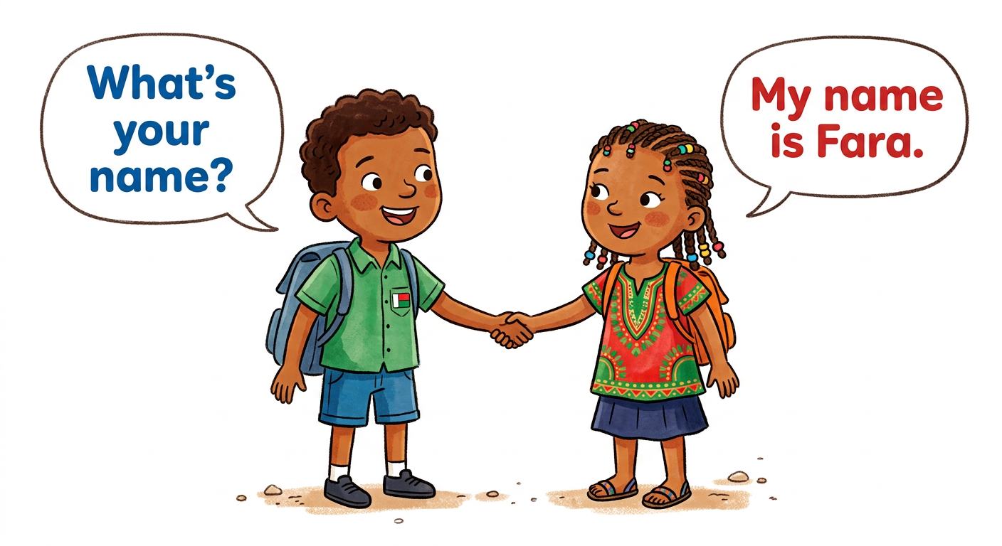
🗣 LANGUAGE FUNCTIONS
4. Thanking
A friend gives or helps. We say: Thank you! [tenk iou]
The friend answers: You’re welcome! [iôr ouèlkeum]
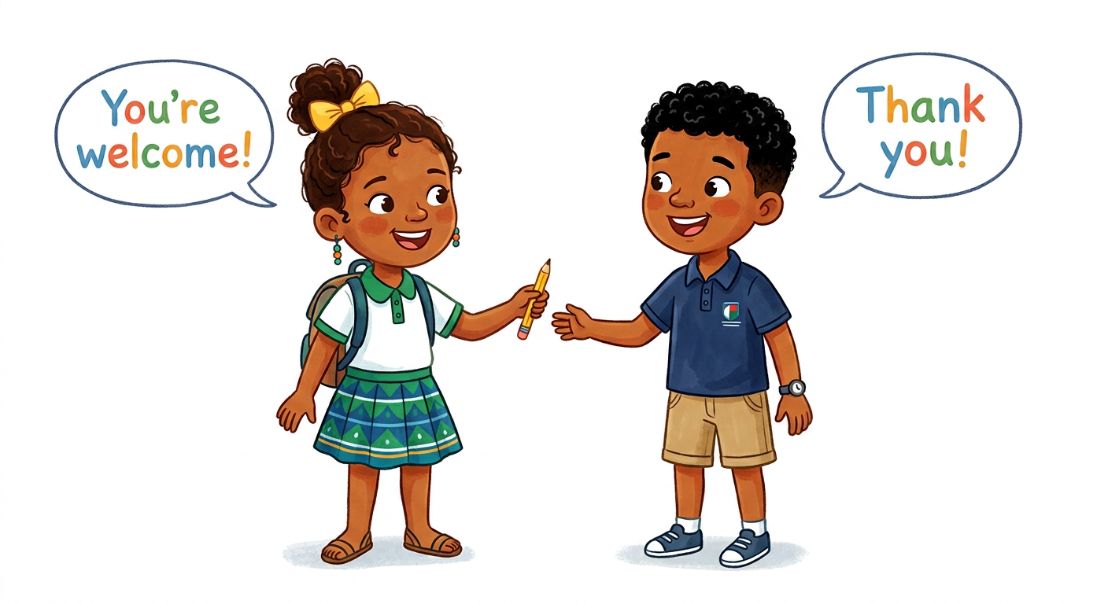
🗣 LANGUAGE FUNCTIONS
5. Apologizing
We do something bad. We say: I’m sorry! [aïm sori] or Sorry! [sori]
The friend answers: It’s OK! [its ôou-kéi]
LISTEN! Scan the code or open the link to listen and download.
🎧 Greetings — listen and repeat
https://drive.google.com/uc?export=download&id=1Cj2Eo5iy6RFNWcsOS0vjvaDfvI2dHbTU
 | 🎧 Saying goodbye — listen and repeat  https://drive.google.com/uc?export=download&id=1qhkZYU77a17c5VzOww2vzeRAp2cd6Seb
 | 🎧 What’s your name? — listen and repeat  https://drive.google.com/uc?export=download&id=1hxmqC72FkUDo5YmKeTHJwnhjWgalrSKr
 | 🎧 How old are you? — listen and repeat  https://drive.google.com/uc?export=download&id=1XyySqGahy3hQOoKHNAFlfkulmMm1v0DB
 | 🎧 Thank you! I’m sorry! — listen and repeat  https://drive.google.com/uc?export=download&id=1AjrG6fPVkbUTJYRpK5QLU4uYij6tCErH

EXERCISES
Exercise 1 (4 points). Match the sentence to the answer:
1. Hello! a. It’s OK!
2. How are you? b. You’re welcome!
3. Thank you! c. Hi!
4. I’m sorry! d. I’m fine, thank you.
Exercise 2 (4 points). Circle the right answer:
1. In the morning we say: Bye! / Good morning! / It’s OK!
2. To ask a name: How old are you? / What’s your name? / How are you?
3. We leave the class. We say: Goodbye! / Hello! / You’re welcome!
4. A friend gives you a book. You say: Sorry! / Thank you! / Nice to meet you.
Exercise 3 (6 points). Complete the chat with: name – fine – old – meet – Hi – Bye
Koto: Hello! How are you?
Fara: I’m ………, thank you.
Koto: What’s your ………?
Fara: My name is Fara. Nice to ……… you.
Koto: Nice to meet you too. How ……… are you?
Fara: I’m 9. Goodbye!
Koto: ………-bye!
Exercise 4 (6 points). Put the chat in the right order (write 1, 2, 3, 4):
…… Nice to meet you too.
…… What’s your name?
…… My name is Hery.
…… Nice to meet you.
Total: 20 points
ANSWER KEY
Exercise 1: 1–c ; 2–d ; 3–b ; 4–a
Exercise 2: 1. Good morning! 2. What’s your name? 3. Goodbye! 4. Thank you!
Exercise 3: fine ; name ; meet ; old ; Bye
Exercise 4: 4 – 1 – 2 – 3 (What’s your name? → My name is Hery. → Nice to meet you. → Nice to meet you too.)

SESSION 7 / 57
REVISION — UNIT 1: SOCIALISING
Remember the words of Unit 1:
We say… | When…
Hello! / Hi! / Good morning! | we meet a friend
How are you? — I’m fine, thank you. | we ask about a friend
Goodbye! / Bye! / Bye-bye! | we leave
What’s your name? — My name is …… | we ask a name
Nice to meet you. — Nice to meet you too. | we meet a new friend
How old are you? — I’m …… | we ask the age
Thank you! — You’re welcome! | a friend gives or helps
I’m sorry! / Sorry! — It’s OK! | we do something bad

Now answer:
1. Greet your friend.
E.A.: Hello! / Hi! / Good morning!
2. How are you?
E.A.: I’m fine, thank you.
3. What’s your name? How old are you?
E.A.: My name is ……, I’m ……
4. Your friend gives you a pen. What do you say? What does he answer?
E.A.: Thank you! — You’re welcome!
5. You bump into a friend. What do you say? What does he answer?
E.A.: I’m sorry! / Sorry! — It’s OK!
6. Say a full chat with your friend: greet → name → age → goodbye.
E.A.: Hello! – Hi! – What’s your name? – My name is …… – How old are you? – I’m …… – Goodbye! – Bye!

SESSION 8 / 57
T4 TEST PAPER — UNIT 1: SOCIALISING
Duration: ……… Total: 20 points
Exercise 1 (6 points). Match the sentence to the answer:
1. Good morning! a. I’m fine, thank you.
2. What’s your name? b. It’s OK!
3. How are you? c. Good morning!
4. Thank you! d. My name is Nivo.
5. Sorry! e. Nice to meet you too.
6. Nice to meet you. f. You’re welcome!
Exercise 2 (4 points). Circle the right answer:
1. You leave the class: Hello! / Goodbye! / It’s OK!
2. You ask the age: How old are you? / How are you? / What’s your name?
3. A friend helps you: Sorry! / Thank you! / Bye!
4. A friend says “Hi!”: Hi! / You’re welcome! / I’m 9.
Exercise 3 (6 points). Complete the chat with: meet – name – morning – fine – old – Goodbye
Lanto: Good ………! How are you?
Tiana: I’m ………, thank you.
Lanto: What’s your ………?
Tiana: My name is Tiana. Nice to ……… you.
Lanto: How ……… are you?
Tiana: I’m 9. ………! — Bye!
Exercise 4 (4 points). Act with your teacher: greet, say your name, say your age, say goodbye.

ANSWER KEY
Exercise 1: 1–c ; 2–d ; 3–a ; 4–f ; 5–b ; 6–e (1 point each)
Exercise 2: 1. Goodbye! 2. How old are you? 3. Thank you! 4. Hi! (1 point each)
Exercise 3: morning ; fine ; name ; meet ; old ; Goodbye (1 point each)
Exercise 4: the pupil says: Hello! / Good morning! — My name is …… — I’m …… — Goodbye! (1 point per sentence)

UNIT 1 — I CAN…

Tick ✔ what you can do:
☐ I can greet my friends: Hello! Hi! Good morning!
☐ I can answer: How are you? — I’m fine, thank you.
☐ I can say goodbye: Goodbye! Bye! Bye-bye!
☐ I can say my name and my age.
☐ I can say: Thank you! — You’re welcome!
☐ I can say: I’m sorry! — It’s OK!

Well done! See you in Unit 2: THE ALPHABET!

UNIT 2 — THE ALPHABET

A a B b C c
In this unit, I will learn to:
• say the 26 letters of the English alphabet;
• sing the Alphabet Song;
• spell my name.
Values: perseverance, self-confidence.
THIS UNIT IN THE OFFICIAL PROGRAMME (PE)
📗 VOCABULARY | The 26 letters of the English alphabet, A to Z.
🗣 LANGUAGE FUNCTIONS | Spelling your name; singing the Alphabet Song.
⚙ GRAMMAR | Capital letters and small letters.

DO YOU REMEMBER? (Unit 1)
1. Say hello to your friend.
2. Your friend says: “Thank you!”. What do you answer?

LISTEN! Scan the code or open the link to listen and download.
 | 🎧 Do you remember? — Koto and Soa say hello  https://drive.google.com/uc?export=download&id=1HJVRmEs4szOPI4Nozf54X4E6i8OizOlb

SESSION 9 / 57
The English alphabet: letters A to M
LESSON PREPARATION SHEET
Subject: English  Theme: UNIT 2 — THE ALPHABET  Title: The English alphabet: letters A to M  Specific learning outcome: By the end of the lesson, learners will be able to say the letters A to M correctly.  Values: perseverance, self-confidence  Documentation: T4 English Syllabus (MEN — DCRP); T4 Pedagogical Resources Booklet  Materials: alphabet chart, blackboard, individual slates, audio (QR code) | Date: ……………………  Class: T4  Session n°: 1 / 2  Duration: ……………………

Steps and Duration | Procedure |  | Technique and Strategy | Materials | Remarks
Steps and Duration | Teacher | Learners | Technique and Strategy | Materials | Remarks
I. Review  Duration: ……… | Answer these questions:  1. Say hello to a friend.  2. What do you say when you go home?  3. What do you say when a friend helps you?  4. Your friend says: “Thank you!”. What do you answer? | Answer.  E.A.: 1. Hello! / Hi! / Good morning!  2. Goodbye! / Bye!  3. Thank you!  4. You’re welcome! | Individual work | ----
II. NEW LESSON — Duration: ………
1. Warm-up | Listen. Koto sings: “A – B – C – D!”. What is Koto singing? | Listen. Answer.  E.A.: Letters. / The ABC. | Whole-class work | ----
2. Presentation | Today we are going to learn a new lesson called: « The English alphabet: letters A to M ». By the end of this lesson, you will be able to say the letters A to M correctly. | Listen. | Whole-class work | ----
3. Observation | Look at this alphabet chart. | Look. | Whole-class work | Alphabet chart
4. Analysis | How many letters are on the chart? Count them.  What is the first letter?  What letter comes after B?  Point to the letter M. What letter is it? | Answer.  E.A.: Twenty-six (26) letters.  E.A.: A.  E.A.: C.  E.A.: It is M. | Brainstorming / Whole-class work | Alphabet chart
5. Synthesis | So, the English alphabet has twenty-six letters. Today we learn the first thirteen letters: A, B, C, D, E, F, G, H, I, J, K, L, M. We say each letter with its English sound. | Listen. | Whole-class work | Blackboard
6. Practice | Say the missing letter:  1. A – B – … – D 2. E – … – G  3. H – I – … 4. K – … – M  Match the big letter to the small letter:  A D G M  g a m d | Do the exercise.  E.A.: 1. C 2. F 3. J 4. L  E.A.: A–a ; D–d ; G–g ; M–m | In pairs | Individual slate
III. Evaluation  Duration: ……… | Write the missing letters:  A, B, __, D, __, F, G, __, I, J, __, L, M  Say the letters from A to M. | Do the exercise.  E.A.: C, E, H, K  E.A.: A, B, C, D, E, F, G, H, I, J, K, L, M — each letter is said correctly. | Individual work | Notebook, slate

SESSION 10 / 57
The English alphabet: letters N to Z — the Alphabet Song
LESSON PREPARATION SHEET
Subject: English  Theme: UNIT 2 — THE ALPHABET  Title: The English alphabet: letters N to Z — the Alphabet Song  Specific learning outcome: By the end of the lesson, learners will be able to say the letters N to Z correctly, sing the Alphabet Song and spell their name.  Values: perseverance, self-confidence  Documentation: T4 English Syllabus (MEN — DCRP); T4 Pedagogical Resources Booklet  Materials: alphabet chart, blackboard, individual slates, audio (QR code) | Date: ……………………  Class: T4  Session n°: 2 / 2  Duration: ……………………

Steps and Duration | Procedure |  | Technique and Strategy | Materials | Remarks
Steps and Duration | Teacher | Learners | Technique and Strategy | Materials | Remarks
I. Review  Duration: ……… | Answer these questions:  1. How many letters are in the English alphabet?  2. What is the first letter?  3. What letter comes after J?  4. Say the letters from A to M. | Answer.  E.A.: 1. Twenty-six (26).  2. A.  3. K.  4. A, B, C, D, E, F, G, H, I, J, K, L, M. | Individual work | ----
II. NEW LESSON — Duration: ………
1. Warm-up | Soa knows thirteen letters: A to M. Does she know all the letters of the alphabet? | Listen. Answer.  E.A.: No. Some letters are missing. | Whole-class work | ----
2. Presentation | Today we are going to learn a new lesson called: « The English alphabet: letters N to Z — the Alphabet Song ». By the end of this lesson, you will be able to say the letters N to Z correctly, sing the Alphabet Song and spell your name. | Listen. | Whole-class work | ----
3. Observation | Look at the alphabet chart, after the letter M. | Look. | Whole-class work | Alphabet chart
4. Analysis | What letter comes after M?  What is the last letter of the alphabet?  Point to the letter W. What letter is it?  Count the letters from N to Z. How many are they? | Answer.  E.A.: N.  E.A.: Z.  E.A.: It is W.  E.A.: Thirteen (13) letters. | Brainstorming / Whole-class work | Alphabet chart
5. Synthesis | So, the letters N to Z are: N, O, P, Q, R, S, T, U, V, W, X, Y, Z. Now we know all the twenty-six letters. We can sing the Alphabet Song and spell names, letter by letter. | Listen. | Whole-class work | Blackboard
6. Practice | Sing each part of the Alphabet Song after your teacher:  Part 1: A B C D E F G  Part 2: H I J K L M N O P  Part 3: Q R S T U V  Part 4: W X Y and Z  Part 5: Now I know my ABC  Part 6: Next time won’t you sing with me?  Then spell with a friend:  — What’s your name? — My name is Mino.  — How do you spell it? — M-I-N-O. | Repeat. Sing. Spell.  E.A.: each pupil spells his/her name letter by letter (M-I-N-O, S-O-A…). | Whole-class work / In pairs | Blackboard, audio
III. Evaluation  Duration: ……… | Write the missing letters:  N, __, P, Q, __, S, T, __, V, W, __, Y, Z  Spell your name, letter by letter. | Do the exercise.  E.A.: O, R, U, X  E.A.: the name is spelt correctly, letter by letter. | Individual work | Notebook, slate

LESSON — UNIT 2
THE ALPHABET
📗 VOCABULARY
1. The English alphabet
The English alphabet [alfabèt] has twenty-six (26) letters [touènti-siks lèteuz].
Each letter has a big form [big fôm] and a small form [smôl fôm]. Example: A – a ; B – b.
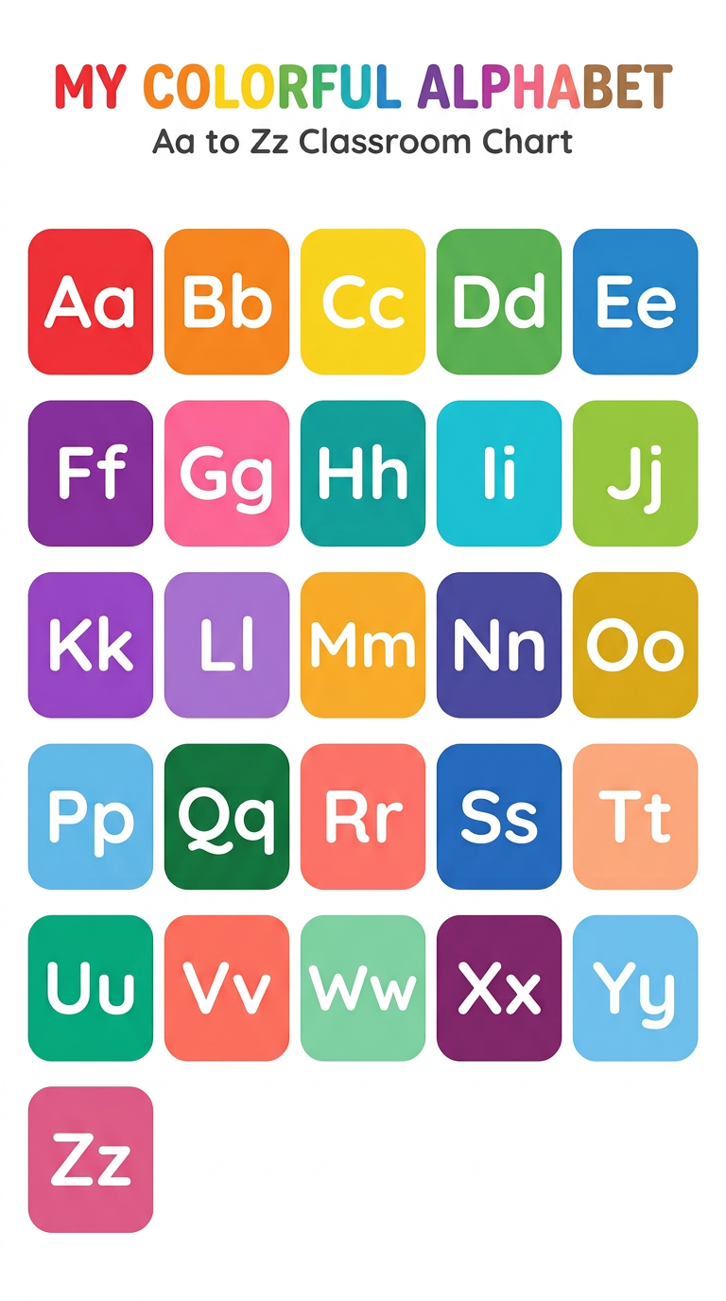
📗 VOCABULARY
2. The letters A to M
Aa  [éi] | Bb  [bi] | Cc  [si] | Dd  [di] | Ee  [i] | Ff  [èf] | Gg  [dji]
Hh  [éitch] | Ii  [aï] | Jj  [djéi] | Kk  [kéi] | Ll  [èl] | Mm  [èm]

📗 VOCABULARY
3. The letters N to Z
Nn  [èn] | Oo  [ôou] | Pp  [pi] | Qq  [kiou] | Rr  [âr] | Ss  [ès] | Tt  [ti]
Uu  [iou] | Vv  [vi] | Ww  [deubeliou] | Xx  [èks] | Yy  [ouaï] | Zz  [zèd]

4. The Alphabet Song
We sing all the letters with the Alphabet Song [alfabèt sông]:
A B C D E F G
H I J K L M N O P
Q R S T U V
W X Y and Z
Now I know my ABC
Next time won’t you sing with me?
In the song, we say Z [zi] — it rhymes with “me”.
🗣 LANGUAGE FUNCTIONS
5. I spell my name
To spell [spèl] a name, we say it letter by letter:
— What’s your name?
— My name is Mino.
— How do you spell it? [haou dou iou spèl it]
— M-I-N-O.
LISTEN! Scan the code or open the link to listen and download.
 | 🎧 The alphabet — listen and repeat  https://drive.google.com/uc?export=download&id=17j7jHre64NU9DgSNhOcE14KFIX-kPsU7
 | 🎧 The Alphabet Song — words (spoken)  https://drive.google.com/uc?export=download&id=1TUymYaapCRRUC11ceBbn49LIAKDuEKCP

6. I write the letters
Trace the letters with your pencil:
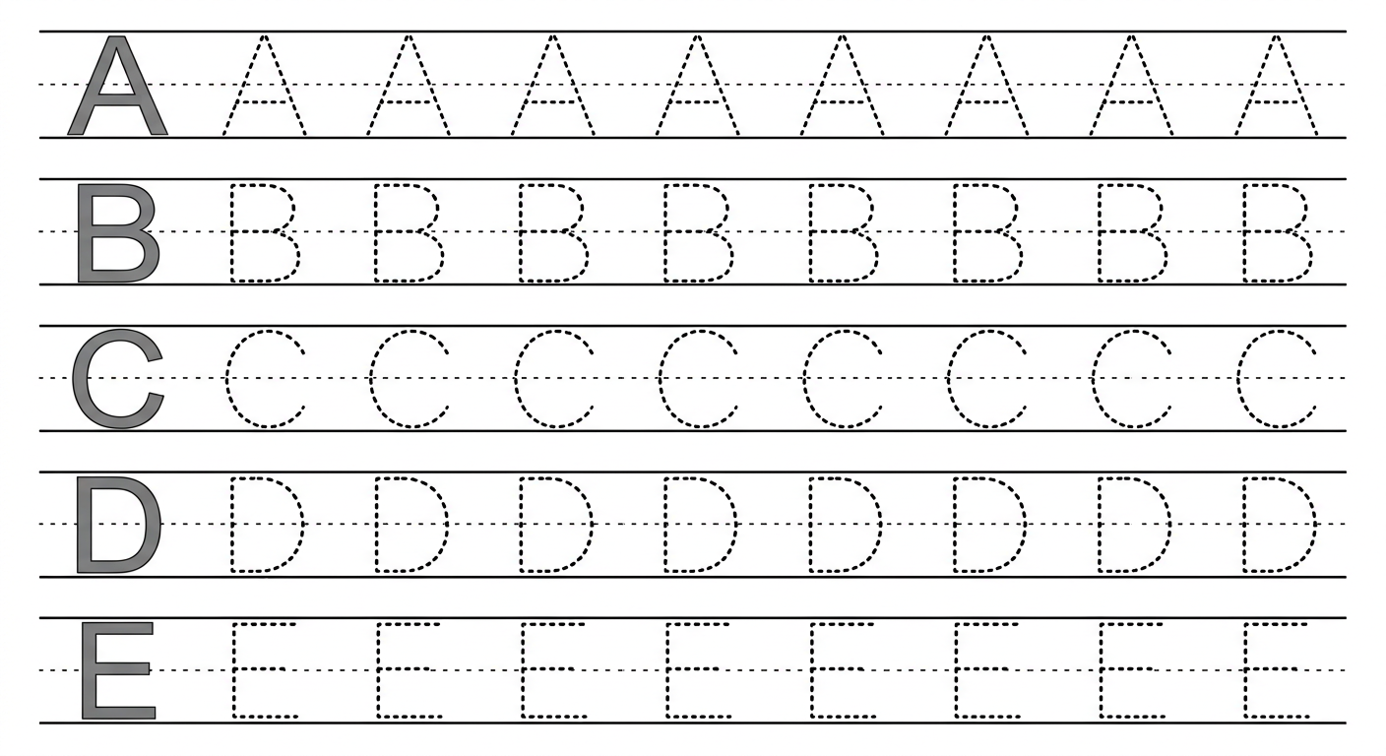

EXERCISES
Exercise 1 (6 points). Write the missing letters:
A, B, __, D, __, F, G, __, I, J, __, L, M, N, __, P, Q, __, S, T, __, V, W, __, Y, Z
Exercise 2 (4 points). Match the big letter to the small letter:
B E R W
r w b e
Exercise 3 (4 points). Circle the letter that comes after:
1. after C → B / D / E
2. after F → G / E / H
3. after M → L / N / O
4. after V → U / W / X
Exercise 4 (6 points). Complete the Alphabet Song:
A, B, C, D, E, F, __
H, I, J, K, L, M, N, O, __
Q, R, S, T, U, __
W, X, Y and __
Now I know my __ __ __
Next time won’t you __ with me?
Total: 20 points
ANSWER KEY
Exercise 1: C, E, H, K, O, R, U, X
Exercise 2: B–b ; E–e ; R–r ; W–w
Exercise 3: 1. D 2. G 3. N 4. W
Exercise 4: G ; P ; V ; Z ; A B C ; sing

SESSION 11 / 57
REVISION — UNIT 2: THE ALPHABET
Remember: the English alphabet has 26 letters.
Aa  [éi] | Bb  [bi] | Cc  [si] | Dd  [di] | Ee  [i] | Ff  [èf] | Gg  [dji]
Hh  [éitch] | Ii  [aï] | Jj  [djéi] | Kk  [kéi] | Ll  [èl] | Mm  [èm]
Nn  [èn] | Oo  [ôou] | Pp  [pi] | Qq  [kiou] | Rr  [âr] | Ss  [ès] | Tt  [ti]
Uu  [iou] | Vv  [vi] | Ww  [deubeliou] | Xx  [èks] | Yy  [ouaï] | Zz  [zèd]

Now answer:
1. How many letters are in the English alphabet?
E.A.: Twenty-six (26).
2. Say the letters from A to M.
E.A.: A, B, C, D, E, F, G, H, I, J, K, L, M.
3. Say the letters from N to Z.
E.A.: N, O, P, Q, R, S, T, U, V, W, X, Y, Z.
4. Sing the Alphabet Song.
E.A.: the letters are sung in the right order.
5. Spell your name.
E.A.: the name is spelt correctly, letter by letter (S-O-A…).

SESSION 12 / 57
T4 TEST PAPER — UNIT 2: THE ALPHABET
Duration: ……… Total: 20 points
Exercise 1 (8 points). Write the missing letters:
A, __, C, D, __, F, G, H, __, J, K, __, M,
N, O, __, Q, R, __, T, U, __, W, X, __, Z
Exercise 2 (4 points). Circle the letter that comes after:
1. after D → C / E / F
2. after H → I / G / J
3. after P → O / Q / R
4. after X → W / Y / Z
Exercise 3 (4 points). Match the big letter to the small letter:
D G Q Y
q y d g
Exercise 4 (4 points). Say with your teacher: sing the Alphabet Song and spell your name.

ANSWER KEY
Exercise 1: B, E, I, L, P, S, V, Y (1 point each)
Exercise 2: 1. E 2. I 3. Q 4. Y (1 point each)
Exercise 3: D–d ; G–g ; Q–q ; Y–y (1 point each)
Exercise 4: the song is sung in the right order (2 points); the name is spelt letter by letter (2 points)

UNIT 2 — I CAN…

Tick ✔ what you can do:
☐ I can say the letters A to M.
☐ I can say the letters N to Z.
☐ I can say all the alphabet, from A to Z.
☐ I can sing the Alphabet Song.
☐ I can spell my name.
☐ I can write the letters A, B, C, D, E.

Well done! See you in Unit 3: NUMBERS!

UNIT 3 — NUMBERS

1, 2, 3… twenty!
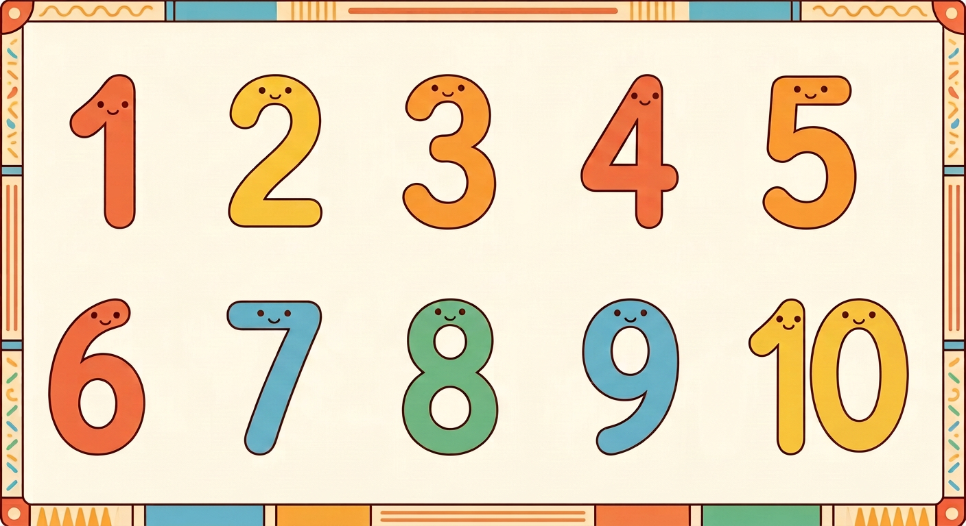
In this unit, I will learn to:
• count from 1 to 20 in English;
• say the “One, two” rhyme;
• ask and answer: How many … are there?
Values: self-confidence, perseverance.
THIS UNIT IN THE OFFICIAL PROGRAMME (PE)
📗 VOCABULARY | The numbers 1 to 20.
🗣 LANGUAGE FUNCTIONS | Counting objects; saying your age.
⚙ GRAMMAR | How many … are there? — There are…

DO YOU REMEMBER? (Unit 2)
1. Say the letters from A to E.
2. Spell your name, letter by letter.

LISTEN! Scan the code or open the link to listen and download.
 | 🎧 Numbers 1 to 20 — listen and repeat  https://drive.google.com/uc?export=download&id=1s99QLOuT7yDOPe0IV1cnA-TzyBya0WDB

SESSION 13 / 57
Numbers 1 to 10 — the “One, two” rhyme
LESSON PREPARATION SHEET
Subject: English  Theme: UNIT 3 — NUMBERS  Title: Numbers 1 to 10 — the “One, two” rhyme  Specific learning outcome: By the end of the lesson, learners will be able to say the numbers 1 to 10 correctly.  Values: self-confidence, perseverance  Documentation: T4 English Syllabus (MEN — DCRP); T4 Pedagogical Resources Booklet  Materials: number line on the board, small objects (pens, chalk), audio (QR code) | Date: ……………………  Class: T4  Session n°: 1 / 3  Duration: ……………………

Steps and Duration | Procedure |  | Technique and Strategy | Materials | Remarks
Steps and Duration | Teacher | Learners | Technique and Strategy | Materials | Remarks
I. Review  Duration: ……… | Answer these questions:  1. How many letters are in the English alphabet?  2. Say the letters from A to E.  3. Spell your name.  4. Sing the Alphabet Song. | Answer.  E.A.: 1. Twenty-six (26).  2. A, B, C, D, E.  3. The name is spelt letter by letter.  4. The song is sung in the right order. | Individual work | ----
II. NEW LESSON — Duration: ………
1. Warm-up | Koto has pencils. He counts them. Listen: “One, two, three…”. What is Koto doing? | Listen. Answer.  E.A.: He is counting. | Whole-class work | ----
2. Presentation | Today we are going to learn a new lesson called: « Numbers 1 to 10 ». By the end of this lesson, you will be able to say the numbers 1 to 10 correctly. | Listen. | Whole-class work | ----
3. Observation | Look at the number line on the board: 1, 2, 3, 4, 5, 6, 7, 8, 9, 10. Listen to the “One, two” rhyme to the end. | Look. Listen. | Whole-class work | Number line, audio
4. Analysis | How many numbers are on the board? Count in Malagasy first.  Listen to the rhyme part by part. Which numbers do you hear?  I point to a number. Say it after me: one, two, three…  What number comes after five? | Answer. Repeat.  E.A.: Ten numbers.  E.A.: one, two, three, four… ten.  E.A.: pupils repeat each number.  E.A.: Six. | Brainstorming / Repetition drill | Number line
5. Synthesis | So, the numbers 1 to 10 are: one, two, three, four, five, six, seven, eight, nine, ten. We can say them with the rhyme: “One, two, what do you do? Three, four, count some more! Five, six, clap your hands! Seven, eight, stand up straight! Nine, ten, once again!” | Listen. Repeat the rhyme part by part, with the actions. | Rhyme with actions | Blackboard, audio
6. Practice | Say the rhyme with the actions, group by group.  I point to a number on the line: say it.  Count these objects: (show 3 pens, 5 chalks, 7 pencils).  Say the missing number: 1, 2, …, 4 — 5, …, 7 — 8, 9, … | Say the rhyme. Count.  E.A.: three pens ; five chalks ; seven pencils.  E.A.: three ; six ; ten. | Game / Group work | Number line, objects
III. Evaluation  Duration: ……… | 1. Count from 1 to 10.  2. I show fingers: say the number.  3. Say the rhyme with the actions. | Answer.  E.A.: one, two, three, four, five, six, seven, eight, nine, ten — each number is said correctly. | Individual work | ----

SESSION 14 / 57
Numbers 11 to 20 — the ball game
LESSON PREPARATION SHEET
Subject: English  Theme: UNIT 3 — NUMBERS  Title: Numbers 11 to 20 — the ball game  Specific learning outcome: By the end of the lesson, learners will be able to say the numbers 11 to 20 correctly.  Values: self-confidence, perseverance  Documentation: T4 English Syllabus (MEN — DCRP); T4 Pedagogical Resources Booklet  Materials: number line 11–20 on the board, ball | Date: ……………………  Class: T4  Session n°: 2 / 3  Duration: ……………………

Steps and Duration | Procedure |  | Technique and Strategy | Materials | Remarks
Steps and Duration | Teacher | Learners | Technique and Strategy | Materials | Remarks
I. Review  Duration: ……… | Answer these questions:  1. Count from 1 to 10.  2. What number comes after seven?  3. I show fingers (4, 6, 9): say the number.  4. Say the “One, two” rhyme. | Answer.  E.A.: 1. one … ten.  2. Eight.  3. four ; six ; nine.  4. The rhyme is said with the actions. | Individual work | ----
II. NEW LESSON — Duration: ………
1. Warm-up | Soa counts her class: “… nine, ten…”. But there are more pupils! What numbers come after ten? | Listen. Answer.  E.A.: Eleven, twelve… (or in Malagasy; the teacher gives the English words). | Whole-class work | ----
2. Presentation | Today we are going to learn a new lesson called: « Numbers 11 to 20 ». By the end of this lesson, you will be able to say the numbers 11 to 20 correctly. | Listen. | Whole-class work | ----
3. Observation | Look at the number line on the board: 11, 12, 13, 14, 15, 16, 17, 18, 19, 20. Listen: eleven, twelve, thirteen… | Look. Listen. | Whole-class work | Number line 11–20
4. Analysis | I point to a number. Say it after me.  Which numbers end with the sound “-teen”?  What is the last number of the line?  A pupil points to a number: the class says it. | Repeat. Answer.  E.A.: thirteen, fourteen, fifteen, sixteen, seventeen, eighteen, nineteen.  E.A.: Twenty.  E.A.: pupils say the numbers pointed to. | Repetition drill / Whole-class work | Number line 11–20
5. Synthesis | So, the numbers 11 to 20 are: eleven, twelve, thirteen, fourteen, fifteen, sixteen, seventeen, eighteen, nineteen, twenty. Now we can count from 1 to 20. | Listen. Count together from 1 to 20. | Whole-class work | Blackboard
6. Practice | Go to the yard. Make a circle.  Ball game: I hold the ball and say “one”. I throw it to a pupil: he/she says “two” and throws it to a friend.  Continue up to “twenty”.  Start again from another number (e.g. “eleven”). | Play. Count.  E.A.: each pupil says the next number correctly, up to twenty. | Game (ball throw) | Ball
III. Evaluation  Duration: ……… | 1. Count from 11 to 20.  2. Count from 1 to 20.  3. Say the missing number: 11, 12, …, 14 — 15, …, 17 — 18, 19, … | Answer.  E.A.: thirteen ; sixteen ; twenty — each number is said correctly. | Individual work | ----

SESSION 15 / 57
How many … are there?
LESSON PREPARATION SHEET
Subject: English  Theme: UNIT 3 — NUMBERS  Title: How many … are there?  Specific learning outcome: By the end of the lesson, learners will be able to show quantities and ask and answer the question “How many … are there?”.  Values: self-confidence, perseverance  Documentation: T4 English Syllabus (MEN — DCRP); T4 Pedagogical Resources Booklet  Materials: pens, pencils, copybooks, slates (objects to count, 1 to 20) | Date: ……………………  Class: T4  Session n°: 3 / 3  Duration: ……………………

Steps and Duration | Procedure |  | Technique and Strategy | Materials | Remarks
Steps and Duration | Teacher | Learners | Technique and Strategy | Materials | Remarks
I. Review  Duration: ……… | Answer these questions:  1. Count from 1 to 20.  2. What number comes after twelve?  3. I show objects (5 pens): count them.  4. How old are you? | Answer.  E.A.: 1. one … twenty.  2. Thirteen.  3. one, two, three, four, five.  4. I’m …… (age). | Individual work | ----
II. NEW LESSON — Duration: ………
1. Warm-up | Look at my table: there are pens on it. Do you know how many? | Listen. Count. Answer.  E.A.: pupils count and give the number. | Whole-class work | Pens
2. Presentation | Today we are going to learn a new lesson called: « How many … are there? ». By the end of this lesson, you will be able to show quantities and ask and answer the question “How many … are there?”. | Listen. | Whole-class work | ----
3. Observation | Listen and look. I show 3 pens and I ask: “How many pens are there?”. I answer: “There are 3 pens.” I point to tables: “How many tables are there?” — “There are 4 tables.” | Look. Listen. | Modelling | Pens, tables
4. Analysis | What is my question?  What is the answer?  I say: “SHOW ME FIVE”. What do you do?  Now ask me the question with “pencils”. | Answer. Show.  E.A.: How many pens are there?  E.A.: There are 3 pens.  E.A.: pupils show five objects (pens, slates…).  E.A.: How many pencils are there? | Brainstorming / Modelling | Objects
5. Synthesis | So, to ask about a quantity, we say: “How many … are there?”. The answer is: “There are …” with the number: There are 3 pens. There are 4 tables. | Listen. | Whole-class work | Blackboard
6. Practice | Game “Show me!”: I say “Show me five!” — show five objects. “Show me two!” — show two objects.  Work in pairs: one shows objects and asks “How many … are there?”; the friend answers “There are …”. Change the number of objects. Change roles. | Play. Ask and answer in pairs.  E.A.: “How many pens are there?” — “There are 6 pens.” (the number matches the objects). | Game / In pairs | Objects 1 to 20
III. Evaluation  Duration: ……… | 1. I show 7 pencils: How many pencils are there?  2. Show me ten!  3. Ask your friend a question with “How many”.  4. How old are you? | Answer.  E.A.: 1. There are 7 pencils. 2. The pupil shows ten objects. 3. How many … are there? 4. I’m …… | Individual work / In pairs | Objects

LESSON — UNIT 3
NUMBERS
📗 VOCABULARY
1. Numbers 1 to 10
1  one  [ouane] | 2  two  [tou] | 3  three  [tsri] | 4  four  [fôr] | 5  five  [faïv]
6  six  [siks] | 7  seven  [sèvène] | 8  eight  [éit] | 9  nine  [naïn] | 10  ten  [tène]

2. The “One, two” rhyme
One, two, what do you do?
Three, four, count some more!
Five, six, clap your hands!
Seven, eight, stand up straight!
Nine, ten, once again!
📗 VOCABULARY
3. Numbers 11 to 20
11  eleven  [ilèvène] | 12  twelve  [touèlv] | 13  thirteen  [seurtine] | 14  fourteen  [fôrtine] | 15  fifteen  [fiftine]
16  sixteen  [sikstine] | 17  seventeen  [sèvènetine] | 18  eighteen  [éitine] | 19  nineteen  [naïntine] | 20  twenty  [touènti]

⚙ GRAMMAR
4. How many … are there?
To ask about a quantity: How many pens are there? [haou mèni pènz âr zèr]
The answer: There are 3 pens. [zèr âr tsri pènz]
Show a quantity: Show me five! [chôou mi faïv]
LISTEN! Scan the code or open the link to listen and download.
🎧 Numbers 1 to 20 — listen and repeat
https://drive.google.com/uc?export=download&id=1s99QLOuT7yDOPe0IV1cnA-TzyBya0WDB
 | 🎧 The “One, two” rhyme — listen and repeat  https://drive.google.com/uc?export=download&id=1HctvxUvAx6_baroHpwvV_KLb3HHL2uZb

EXERCISES
Exercise 1 (5 points). Say the missing number:
1. one, two, ……, four
2. five, ……, seven
3. ……, nine, ten
4. eleven, ……, thirteen
5. eighteen, nineteen, ……
Exercise 2 (5 points). Match the digit to the word:
3 7 12 15 20
twenty three fifteen seven twelve
Exercise 3 (5 points). Count and answer:
1. ✏✏✏✏ — How many pencils are there?
2. 🖊🖊 — How many pens are there?
3. 📕📕📕📕📕📕 — How many books are there?
4. Show me nine!
5. Show me sixteen!
Exercise 4 (5 points). Say the rhyme and do the actions.

Total: 20 points
ANSWER KEY
Exercise 1: three ; six ; eight ; twelve ; twenty
Exercise 2: 3–three ; 7–seven ; 12–twelve ; 15–fifteen ; 20–twenty
Exercise 3: 1. There are 4 pencils. 2. There are 2 pens. 3. There are 6 books. 4–5. The pupil shows 9, then 16 objects.
Exercise 4: the rhyme is said in the right order, with the actions.

SESSION 16 / 57
REVISION — UNIT 3: NUMBERS
Remember: we can count from 1 to 20 in English.
1  one  [ouane] | 2  two  [tou] | 3  three  [tsri] | 4  four  [fôr] | 5  five  [faïv]
6  six  [siks] | 7  seven  [sèvène] | 8  eight  [éit] | 9  nine  [naïn] | 10  ten  [tène]
11  eleven  [ilèvène] | 12  twelve  [touèlv] | 13  thirteen  [seurtine] | 14  fourteen  [fôrtine] | 15  fifteen  [fiftine]
16  sixteen  [sikstine] | 17  seventeen  [sèvènetine] | 18  eighteen  [éitine] | 19  nineteen  [naïntine] | 20  twenty  [touènti]

Now answer:
1. Count from 1 to 10.
E.A.: one, two, three, four, five, six, seven, eight, nine, ten.
2. Count from 11 to 20.
E.A.: eleven, twelve, thirteen, fourteen, fifteen, sixteen, seventeen, eighteen, nineteen, twenty.
3. Say the “One, two” rhyme with the actions.
E.A.: the rhyme is said in the right order.
4. I show 5 slates: How many slates are there?
E.A.: There are 5 slates.
5. Show me twelve!
E.A.: the pupil shows twelve objects.
6. How old are you?
E.A.: I’m …… (real age).

SESSION 17 / 57
T4 TEST PAPER — UNIT 3: NUMBERS
Duration: ……… Total: 20 points
Exercise 1 (6 points). Say the missing numbers:
one, ……, three, four, ……, six, seven, ……, nine, ten,
eleven, ……, thirteen, fourteen, ……, sixteen, seventeen, eighteen, ……, twenty
Exercise 2 (4 points). Match the digit to the word:
2 8 11 14
fourteen two eleven eight
Exercise 3 (6 points). Count and answer with “There are …”:
1. ✏✏✏ — How many pencils are there?
2. 📕📕📕📕📕 — How many books are there?
3. 🖊🖊🖊🖊🖊🖊🖊 — How many pens are there?
Exercise 4 (4 points). Say with your teacher: count from 1 to 20 and say the “One, two” rhyme.

ANSWER KEY
Exercise 1: two ; five ; eight ; twelve ; fifteen ; nineteen (1 point each)
Exercise 2: 2–two ; 8–eight ; 11–eleven ; 14–fourteen (1 point each)
Exercise 3: 1. There are 3 pencils. 2. There are 5 books. 3. There are 7 pens. (2 points each)
Exercise 4: counting 1–20 without mistake (2 points); the rhyme in the right order (2 points)

UNIT 3 — I CAN…

Tick ✔ what you can do:
☐ I can count from 1 to 10.
☐ I can count from 11 to 20.
☐ I can say the “One, two” rhyme.
☐ I can ask: How many … are there?
☐ I can answer: There are …
☐ I can show a quantity: Show me five!

Well done! See you in Unit 4: CLASSROOM LANGUAGE!

UNIT 4 — CLASSROOM LANGUAGE

Stand up! Sit down! Listen!
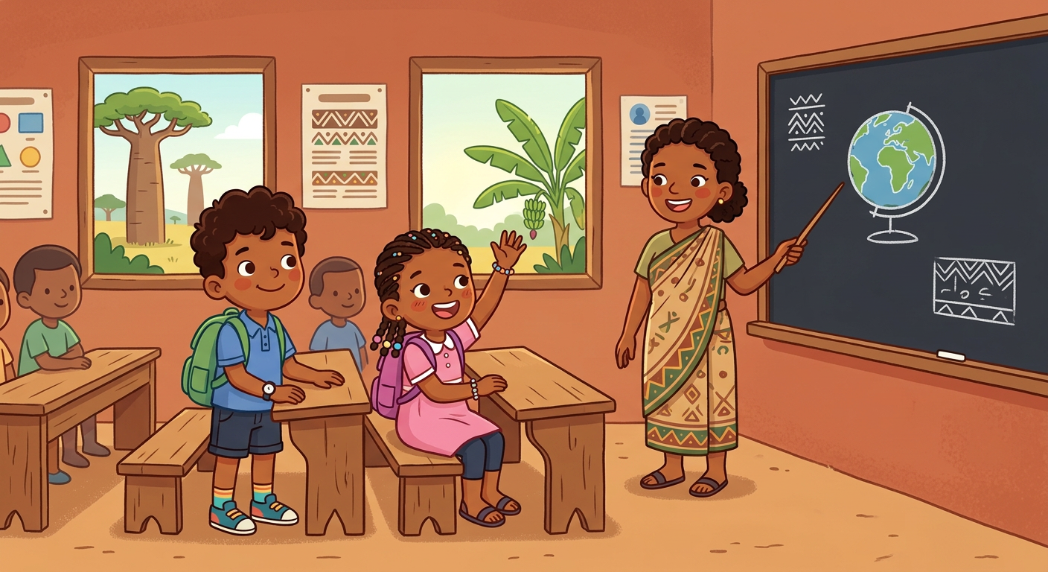
In this unit, I will learn to:
• understand and do the commands of the class;
• play “Simon says”;
• ask for permission: May I go out, please?
Values: responsibility, self-confidence.
THIS UNIT IN THE OFFICIAL PROGRAMME (PE)
📗 VOCABULARY | The commands of the class: stand up, sit down, listen, repeat…
🗣 LANGUAGE FUNCTIONS | Giving and following commands; asking for permission: May I go out, please?
⚙ GRAMMAR | The imperative; May I…?

DO YOU REMEMBER? (Unit 3)
1. Count from 1 to 10.
2. How many doors are there in the class?

LISTEN! Scan the code or open the link to listen and download.
 | 🎧 Classroom commands — listen and repeat  https://drive.google.com/uc?export=download&id=1oeU_-z2JGD7PNLX1ORtTxZmK9MhpjvAF

SESSION 18 / 57
Classroom commands
LESSON PREPARATION SHEET
Subject: English  Theme: UNIT 4 — CLASSROOM LANGUAGE  Title: Classroom commands  Specific learning outcome: By the end of the lesson, learners will be able to understand, say and do the classroom commands in English.  Values: responsibility, self-confidence  Documentation: T4 English Syllabus (MEN — DCRP); T4 Pedagogical Resources Booklet  Materials: Picture dictionary 1, page 50; audio (QR code) | Date: ……………………  Class: T4  Session n°: 1 / 2  Duration: ……………………

Steps and Duration | Procedure |  | Technique and Strategy | Materials | Remarks
Steps and Duration | Teacher | Learners | Technique and Strategy | Materials | Remarks
I. Review  Duration: ……… | Answer these questions:  1. Count from 1 to 20.  2. I show 4 pens: How many pens are there?  3. Show me six!  4. Say the “One, two” rhyme. | Answer.  E.A.: 1. one … twenty.  2. There are 4 pens.  3. The pupil shows six objects.  4. The rhyme is said with the actions. | Individual work | ----
II. NEW LESSON — Duration: ………
1. Warm-up | Look at me. (The teacher stands up, then sits down, then raises a hand, without a word.) What am I doing? | Look. Answer.  E.A.: You stand up. You sit down. You raise your hand. | Whole-class work | ----
2. Presentation | Today we are going to learn a new lesson called: « Classroom commands ». By the end of this lesson, you will be able to understand, say and do the classroom commands in English. | Listen. | Whole-class work | ----
3. Observation | Listen and look. I say each command and I do the action: “Stand up!” (I stand up). “Sit down!” (I sit down). “Look at the board!”, “Be quiet!”, “Listen to me, please!”, “Raise your hand!”, “Line up!”, “Come here!”, “Go back to your seat!” | Look. Listen. | Modelling with gestures | Picture dictionary 1, p. 50
4. Analysis | I do the action without a word: say the command.  (The teacher stands up.)  (The teacher puts a finger on the lips.)  (The teacher raises a hand.)  Now repeat each command after me, with the action. | Answer. Repeat with the action.  E.A.: Stand up!  E.A.: Be quiet!  E.A.: Raise your hand!  E.A.: pupils repeat and act. | Modelling with gestures / Repetition drill | ----
5. Synthesis | So, in the class we use commands: Stand up! Sit down! Look at the board! Be quiet! Stop talking! Listen to me, please! Raise your hand! Line up! Come here! Go back to your seat! We listen and we do the action. | Listen. | Whole-class work | Blackboard
6. Practice | Do what I say: “Stand up!” — “Sit down!” — “Raise your hand!” — “Be quiet!”…  Game “Simon says”: do the action ONLY if I say “Simon says” first.  “Simon says: stand up!” → stand up.  “Sit down!” (without Simon says) → do not move! | Listen. Do the actions. Play.  E.A.: pupils do the action only after “Simon says”; a pupil who moves at the wrong time sits out one round. | Game (“Simon says”) | ----
III. Evaluation  Duration: ……… | 1. I say three commands: do them.  2. I do an action: say the command.  3. Give a command to your friend. | Do. Say.  E.A.: the actions match the commands; the commands are said correctly (Stand up!, Sit down!, Come here!…). | Individual work / In pairs | ----

SESSION 19 / 57
Asking for permission
LESSON PREPARATION SHEET
Subject: English  Theme: UNIT 4 — CLASSROOM LANGUAGE  Title: Asking for permission  Specific learning outcome: By the end of the lesson, learners will be able to ask for permission to go out and reply in English.  Values: responsibility, self-confidence  Documentation: T4 English Syllabus (MEN — DCRP); T4 Pedagogical Resources Booklet  Materials: audio (QR code) | Date: ……………………  Class: T4  Session n°: 2 / 2  Duration: ……………………

Steps and Duration | Procedure |  | Technique and Strategy | Materials | Remarks
Steps and Duration | Teacher | Learners | Technique and Strategy | Materials | Remarks
I. Review  Duration: ……… | Do what I say:  1. Stand up! — Sit down!  2. Raise your hand!  3. I put a finger on my lips: say the command.  4. Play one round of “Simon says”. | Do. Say.  E.A.: 1–2. The actions are done.  3. Be quiet!  4. The rule is followed. | Whole-class work | ----
II. NEW LESSON — Duration: ………
1. Warm-up | Koto wants to go out of the class. He raises his hand. What must he say to the teacher? | Listen. Answer.  E.A.: He must ask the teacher. (Pupils may answer in their own words; the teacher gives the English sentence.) | Whole-class work | ----
2. Presentation | Today we are going to learn a new lesson called: « Asking for permission ». By the end of this lesson, you will be able to ask for permission to go out and reply in English. | Listen. | Whole-class work | ----
3. Observation | Listen and look. A pupil raises the hand and asks: “May I go out, please?”. I answer: “Yes, go ahead.” Another pupil asks: “May I go out, please?”. I answer: “No, not now.” | Look. Listen. | Modelling with gestures | ----
4. Analysis | What is the question of the pupil?  What are my two answers?  “Yes, go ahead.” — can the pupil go out?  “No, not now.” — can the pupil go out? | Answer.  E.A.: May I go out, please?  E.A.: Yes, go ahead. / No, not now.  E.A.: Yes.  E.A.: No. | Brainstorming / Whole-class work | ----
5. Synthesis | So, to ask for permission to go out, we raise the hand and we say: “May I go out, please?”. The teacher answers: “Yes, go ahead.” or “No, not now.” | Listen. | Whole-class work | Blackboard
6. Practice | Role play in pairs: one is the teacher, one is the pupil.  The pupil raises the hand: “May I go out, please?”.  The teacher answers: “Yes, go ahead.” or “No, not now.”.  Change roles.  Then choose the right answer:  1. To go out, I say: May I go out, please? / Stand up!  2. “Yes, go ahead.” means: I can go / I cannot go  3. “No, not now.” means: I can go / I cannot go | Play the roles. Do the exercise.  E.A.: 1. May I go out, please? 2. I can go 3. I cannot go | Role play / In pairs | ----
III. Evaluation  Duration: ……… | 1. You want to go out. What do you say?  2. May I go out, please? (answer yes)  3. May I go out, please? (answer no)  4. Play the scene with your friend. | Answer. Play.  E.A.: 1. May I go out, please? 2. Yes, go ahead. 3. No, not now. 4. The scene is played with the hand raised. | Individual work / In pairs | ----

LESSON — UNIT 4
CLASSROOM LANGUAGE
🗣 LANGUAGE FUNCTIONS
1. The commands of the class
• Stand up! [stand eup] → I stand.
• Sit down! [site daoun] → I sit.
• Look at the board! [louk at ze bôrd] → I look at the board.
• Be quiet! [bi kouaïeut] → I stop the noise.
• Stop talking! [stop tôking] → I stop talking.
• Listen to me, please! [lisseun tou mi, plize] → I listen.
• Raise your hand! [réiz iôr hand] → I raise my hand.
• Line up! [laïn eup] → I stand in a line.
• Come here! [kam hire] → I come to the teacher.
• Go back to your seat! [gôou bak tou iôr site] → I go to my seat.

2. The game “Simon says”
Do the action ONLY if you hear “Simon says” first.
“Simon says: stand up!” → stand up.
“Sit down!” (without Simon says) → do not move!
🗣 LANGUAGE FUNCTIONS
3. Asking for permission
I raise my hand and I say: May I go out, please? [méi aï gôou aout, plize]
The teacher says yes: Yes, go ahead. [yès, gôou euhèd]
The teacher says no: No, not now. [nôou, not naou]
LISTEN! Scan the code or open the link to listen and download.
🎧 Classroom commands — listen and repeat
https://drive.google.com/uc?export=download&id=1oeU_-z2JGD7PNLX1ORtTxZmK9MhpjvAF
 | 🎧 May I go out, please? — listen and repeat  https://drive.google.com/uc?export=download&id=1umZszJYwRUWDQ1EA63K5NdQCQ71GEMKE

EXERCISES
Exercise 1 (5 points). Do what your teacher says:
Stand up! — Raise your hand! — Be quiet! — Sit down! — Look at the board!
Exercise 2 (5 points). Say the command for each action:
1. The teacher wants you on your feet. → ……
2. The teacher wants no noise. → ……
3. The teacher wants a line. → ……
4. The teacher wants you near him/her. → ……
5. The teacher wants you at your place. → ……
Exercise 3 (5 points). Choose the right answer:
1. To go out, I say: May I go out, please? / Line up!
2. Before the question, I: raise my hand / run
3. “Yes, go ahead.” → I: go out / sit down
4. “No, not now.” → I: go out / stay in class
5. “Simon says: sit down!” → I: sit down / do not move
Exercise 4 (5 points). Play the scene with a friend: teacher and pupil, question and answer.

Total: 20 points
ANSWER KEY
Exercise 1: the five actions are done correctly (1 point each).
Exercise 2: 1. Stand up! 2. Be quiet! / Stop talking! 3. Line up! 4. Come here! 5. Go back to your seat!
Exercise 3: 1. May I go out, please? 2. raise my hand 3. go out 4. stay in class 5. sit down
Exercise 4: the question and one answer are said correctly, with the hand raised.

SESSION 20 / 57
REVISION — UNIT 4: CLASSROOM LANGUAGE
Remember the words of Unit 4:
We hear… | We do…
Stand up! / Sit down! | we stand / we sit
Look at the board! | we look at the board
Be quiet! / Stop talking! | we stop the noise
Listen to me, please! | we listen
Raise your hand! | we raise the hand
Line up! / Come here! / Go back to your seat! | we line up / we come / we go to our seat
May I go out, please? | we ask for permission
Yes, go ahead. / No, not now. | the answers of the teacher

Now answer:
1. Do what I say: Stand up! Raise your hand! Sit down!
E.A.: the actions are done correctly.
2. I put a finger on my lips: say the command.
E.A.: Be quiet! / Stop talking!
3. You want to go out. What do you say?
E.A.: May I go out, please?
4. Give two answers of the teacher.
E.A.: Yes, go ahead. / No, not now.
5. Play one round of “Simon says” with the class.
E.A.: the rule is followed.

SESSION 21 / 57
T4 TEST PAPER — UNIT 4: CLASSROOM LANGUAGE
Duration: ……… Total: 20 points
Exercise 1 (6 points). Do what your teacher says:
Stand up! — Look at the board! — Raise your hand! — Be quiet! — Line up! — Go back to your seat!
Exercise 2 (5 points). Say the command:
1. The teacher wants you on your feet. → ……
2. The teacher wants you to listen. → ……
3. The teacher wants you near him/her. → ……
4. The teacher wants no talking. → ……
5. The teacher wants you seated. → ……
Exercise 3 (5 points). Choose the right answer:
1. I want to go out: May I go out, please? / Come here!
2. First I: raise my hand / stand on the bench
3. “Yes, go ahead.”: I go out / I stay
4. “No, not now.”: I go out / I stay
5. “Simon says: raise your hand!”: I raise my hand / I do not move
Exercise 4 (4 points). Play the scene with your teacher: ask for permission; answer as a teacher.

ANSWER KEY
Exercise 1: the six actions are done correctly (1 point each).
Exercise 2: 1. Stand up! 2. Listen to me, please! 3. Come here! 4. Stop talking! / Be quiet! 5. Sit down! (1 point each)
Exercise 3: 1. May I go out, please? 2. raise my hand 3. I go out 4. I stay 5. I raise my hand (1 point each)
Exercise 4: question with the hand raised (2 points); one correct answer (2 points).

UNIT 4 — I CAN…

Tick ✔ what you can do:
☐ I can do the commands: Stand up! Sit down! …
☐ I can say the commands to a friend.
☐ I can play “Simon says”.
☐ I can ask: May I go out, please?
☐ I can understand: Yes, go ahead. / No, not now.

Well done! See you in Unit 5: PARTS OF THE BODY!

UNIT 5 — PARTS OF THE BODY

Head, shoulders, knees and toes!
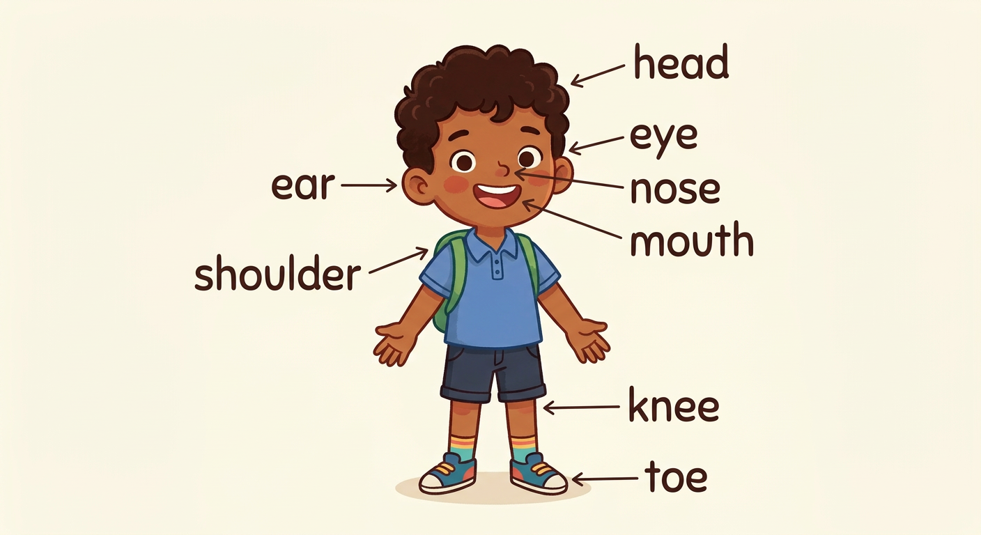
In this unit, I will learn to:
• say the parts of my body in English;
• sing “Head, shoulders, knees and toes”;
• say: This is my head. These are my ears.
Values: care of the body, self-confidence.
THIS UNIT IN THE OFFICIAL PROGRAMME (PE)
📗 VOCABULARY | The parts of the body: head, shoulders, knees, toes…
🗣 LANGUAGE FUNCTIONS | Showing and naming the parts of the body: Show me your…!
⚙ GRAMMAR | What is this? / What are these? — It is… / They are…

DO YOU REMEMBER? (Unit 4)
1. Do what your teacher says: Stand up! Sit down!
2. You want to go out. What do you say?

LISTEN! Scan the code or open the link to listen and download.
 | 🎧 Head, shoulders, knees and toes — the words  https://drive.google.com/uc?export=download&id=1LG-51ZLBhLnr3S9r7GpjIwVENCreY2OB

SESSION 22 / 57
Parts of the body — the song
LESSON PREPARATION SHEET
Subject: English  Theme: UNIT 5 — PARTS OF THE BODY  Title: Parts of the body — the song  Specific learning outcome: By the end of the lesson, learners will be able to say the parts of the body and sing “Head, shoulders, knees and toes” with the actions.  Values: care of the body, self-confidence  Documentation: T4 English Syllabus (MEN — DCRP); T4 Pedagogical Resources Booklet  Materials: song “Head, shoulders, knees and toes” (QR code), Picture dictionary 1, pages 8–9 | Date: ……………………  Class: T4  Session n°: 1 / 2  Duration: ……………………

Steps and Duration | Procedure |  | Technique and Strategy | Materials | Remarks
Steps and Duration | Teacher | Learners | Technique and Strategy | Materials | Remarks
I. Review  Duration: ……… | Answer these questions:  1. Do what I say: Stand up! Raise your hand! Sit down!  2. You want to go out. What do you say?  3. Count from 1 to 10. | Do. Answer.  E.A.: 1. The actions are done.  2. May I go out, please?  3. one … ten. | Individual work | ----
II. NEW LESSON — Duration: ………
1. Warm-up | Touch your head, like me. Touch your nose, like me. What are we touching? | Do. Answer.  E.A.: The head, the nose. (Pupils may answer in their own words; the teacher gives the English words.) | Whole-class work | ----
2. Presentation | Today we are going to learn a new lesson called: « Parts of the body — the song ». By the end of this lesson, you will be able to say the parts of the body and sing the song with the actions. | Listen. | Whole-class work | ----
3. Observation | Listen and look. I say each word and I touch the part of my body: head — shoulder — knee — toe — eye — ear — nose — mouth. | Look. Listen. | Modelling with gestures | Picture dictionary 1, p. 8–9
4. Analysis | Repeat each word after me and touch the part of your body.  I touch a part without a word: say it.  (The teacher touches the nose.)  (The teacher touches an ear.)  Now listen to the song “Head, shoulders, knees and toes” to the end. | Repeat. Touch. Answer. Listen.  E.A.: Nose!  E.A.: Ear! | Repetition drill with gestures | Audio (QR code)
5. Synthesis | So, the parts of the body are: head, shoulder, knee, toe, eye, ear, nose, mouth. We can sing them with the song, touching each part. | Listen. | Whole-class work | Blackboard
6. Practice | Sing the song part by part after me, touching each part of the body:  Part 1: Head, shoulders, knees and toes, knees and toes,  Part 2: Head, shoulders, knees and toes, knees and toes,  Part 3: And eyes and ears and mouth and nose,  Part 4: Head, shoulders, knees and toes, knees and toes.  Sing faster and faster! | Sing with the actions.  E.A.: each part of the body is touched at the right word. | Song with actions | Audio (QR code)
III. Evaluation  Duration: ……… | 1. Say the eight parts of the body.  2. I touch a part: say it.  3. Sing the song with the actions. | Answer. Sing.  E.A.: head, shoulder, knee, toe, eye, ear, nose, mouth — each word is said correctly. | Individual work | ----

SESSION 23 / 57
This is my head — What is this?
LESSON PREPARATION SHEET
Subject: English  Theme: UNIT 5 — PARTS OF THE BODY  Title: This is my head — What is this?  Specific learning outcome: By the end of the lesson, learners will be able to show a part of the body and say “This is my …” / “This is the …”.  Values: care of the body, self-confidence  Documentation: T4 English Syllabus (MEN — DCRP); T4 Pedagogical Resources Booklet  Materials: Picture dictionary 1, pages 8–9 | Date: ……………………  Class: T4  Session n°: 2 / 2  Duration: ……………………

Steps and Duration | Procedure |  | Technique and Strategy | Materials | Remarks
Steps and Duration | Teacher | Learners | Technique and Strategy | Materials | Remarks
I. Review  Duration: ……… | Answer these questions:  1. Say the eight parts of the body.  2. I touch a part (knee, ear): say it.  3. Sing the song with the actions. | Answer. Sing.  E.A.: 1. head, shoulder, knee, toe, eye, ear, nose, mouth.  2. Knee! Ear!  3. The song is sung with the actions. | Individual work | ----
II. NEW LESSON — Duration: ………
1. Warm-up | (The teacher points to his/her head.) Listen: “This is my head.” What am I showing? | Listen. Answer.  E.A.: Your head. | Whole-class work | ----
2. Presentation | Today we are going to learn a new lesson called: « This is my head — What is this? ». By the end of this lesson, you will be able to show a part of the body and say “This is my …”. | Listen. | Whole-class work | ----
3. Observation | Listen and look. “Show me your nose!” (a pupil shows the nose). “Point to your knee!” (a pupil points). I touch my mouth and I ask: “What is this?” — “This is the mouth.” I touch my ears: “What are these?” — “These are the ears.” | Look. Listen. Do. | Modelling with gestures | ----
4. Analysis | I say: “Show me your head!”. What do you do?  You show your head. What do you say?  I touch my nose and ask: “What is this?”. Answer.  For TWO parts (ears, eyes), what do we say? | Do. Answer.  E.A.: We show the head.  E.A.: This is my head.  E.A.: This is the nose.  E.A.: These are the ears. / These are the eyes. | Brainstorming / Modelling | ----
5. Synthesis | So: “Show me your …!” and “Point to your …!” are commands. To answer, we show the part and we say: “This is my …” or “This is the …”. For two parts, we say: “These are …”. | Listen. | Whole-class work | Blackboard
6. Practice | Work in pairs: one gives the command (“Show me your knee!”), the friend shows and says “This is my knee.”. Change roles.  Game “Simon says” with the body: “Simon says: touch your nose!”  Then answer:  1. (I touch my head) What is this?  2. (I touch my ears) What are these?  3. Show me your toes! | Play. Answer.  E.A.: 1. This is the head. 2. These are the ears. 3. The pupil shows the toes and says: These are my toes. | Game (“Simon says”) / In pairs | ----
III. Evaluation  Duration: ……… | 1. Show me your shoulder!  2. I touch my mouth: What is this?  3. I touch my eyes: What are these?  4. Give a command to your friend with “Point to …”. | Do. Answer.  E.A.: 1. This is my shoulder. 2. This is the mouth. 3. These are the eyes. 4. Point to your …! | Individual work / In pairs | ----

LESSON — UNIT 5
PARTS OF THE BODY
📗 VOCABULARY
1. My body
head  [hèd] | shoulder  [chôouldeur] | knee  [ni] | toe  [tôou]
eye  [aï] | ear  [ir] | nose  [nôouz] | mouth  [maous]

2. The song: Head, shoulders, knees and toes
Head, shoulders, knees and toes, knees and toes,
Head, shoulders, knees and toes, knees and toes,
And eyes and ears and mouth and nose,
Head, shoulders, knees and toes, knees and toes.
We sing and we touch each part of the body. Then we sing faster!
🗣 LANGUAGE FUNCTIONS
3. Show me your …!
The commands: Show me your nose! [chôou mi iôr nôouz] Point to your knee! [poïnte tou iôr ni]
The answer: This is my nose. [zis iz maï nôouz]
⚙ GRAMMAR
4. What is this? What are these?
For ONE part: What is this? [ouot iz zis] → This is the head. [zis iz ze hèd]
For TWO parts: What are these? [ouot âr ziz] → These are the ears. [ziz âr zi irz]
LISTEN! Scan the code or open the link to listen and download.
 | 🎧 Parts of the body — listen, repeat and touch  https://drive.google.com/uc?export=download&id=1NjFO-VaoL7BL2wvFGgUXq27vO0LoRwnO
🎧 Head, shoulders, knees and toes — the words
https://drive.google.com/uc?export=download&id=1LG-51ZLBhLnr3S9r7GpjIwVENCreY2OB

EXERCISES
Exercise 1 (8 points). Touch the part of the body your teacher says:
head — shoulder — knee — toe — eye — ear — nose — mouth
Exercise 2 (4 points). Answer the question:
1. (The teacher touches the head) What is this?
2. (The teacher touches the nose) What is this?
3. (The teacher touches the ears) What are these?
4. (The teacher touches the eyes) What are these?
Exercise 3 (4 points). Choose the right answer:
1. We see with the: eyes / ears
2. We hear with the: nose / ears
3. We eat with the: mouth / toe
4. We smell with the: nose / knee
Exercise 4 (4 points). Sing the song with the actions.

Total: 20 points
ANSWER KEY
Exercise 1: the eight parts are touched correctly (1 point each).
Exercise 2: 1. This is the head. 2. This is the nose. 3. These are the ears. 4. These are the eyes.
Exercise 3: 1. eyes 2. ears 3. mouth 4. nose
Exercise 4: the song is sung with the right actions.

SESSION 24 / 57
REVISION — UNIT 5: PARTS OF THE BODY
Remember the eight parts of the body:
head  [hèd] | shoulder  [chôouldeur] | knee  [ni] | toe  [tôou]
eye  [aï] | ear  [ir] | nose  [nôouz] | mouth  [maous]

Now answer:
1. Say the eight parts of the body and touch them.
E.A.: head, shoulder, knee, toe, eye, ear, nose, mouth.
2. Show me your knee!
E.A.: This is my knee.
3. I touch my mouth: What is this?
E.A.: This is the mouth.
4. I touch my ears: What are these?
E.A.: These are the ears.
5. Sing “Head, shoulders, knees and toes” with the actions.
E.A.: the song is sung with the right actions.
6. Play “Simon says” with the parts of the body.
E.A.: the rule is followed.

SESSION 25 / 57
T4 TEST PAPER — UNIT 5: PARTS OF THE BODY
Duration: ……… Total: 20 points
Exercise 1 (8 points). Touch the part of the body your teacher says:
head — shoulder — knee — toe — eye — ear — nose — mouth
Exercise 2 (4 points). The teacher touches a part; answer with “This is the …” or “These are the …”:
1. (head) 2. (nose) 3. (ears) 4. (eyes)
Exercise 3 (4 points). Choose the right answer:
1. Show me your …! → I show / I sing
2. For one part we say: This is… / These are…
3. For two parts we say: This is… / These are…
4. In the song we touch: the parts of the body / the door
Exercise 4 (4 points). Sing “Head, shoulders, knees and toes” with the actions.

ANSWER KEY
Exercise 1: the eight parts are touched correctly (1 point each).
Exercise 2: 1. This is the head. 2. This is the nose. 3. These are the ears. 4. These are the eyes. (1 point each)
Exercise 3: 1. I show 2. This is… 3. These are… 4. the parts of the body (1 point each)
Exercise 4: the song is sung in the right order, with the right actions (4 points).

UNIT 5 — I CAN…

Tick ✔ what you can do:
☐ I can say the eight parts of the body.
☐ I can touch the part my teacher says.
☐ I can say: This is my head.
☐ I can answer: What is this? — This is the …
☐ I can answer: What are these? — These are the …
☐ I can sing “Head, shoulders, knees and toes”.

Well done! See you in Unit 6: DAYS OF THE WEEK!

UNIT 6 — DAYS OF THE WEEK

Monday, Tuesday… Sunday!
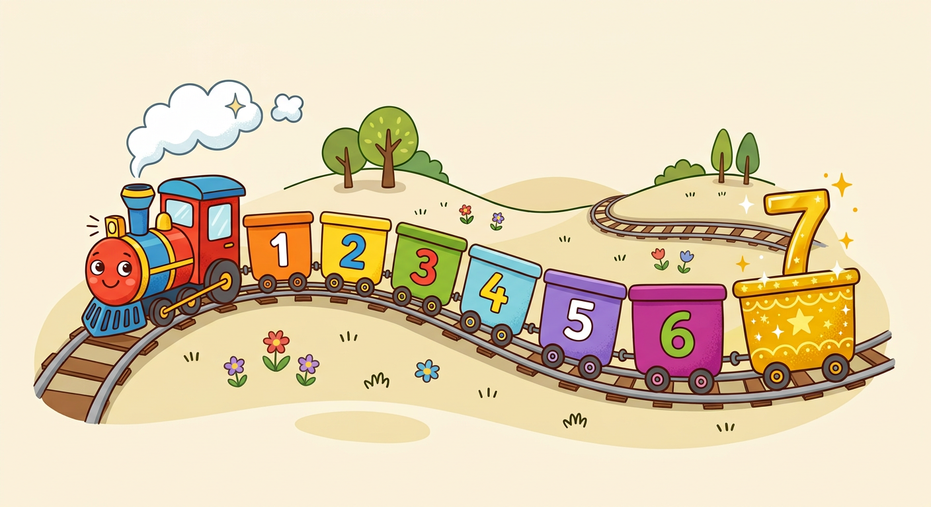
In this unit, I will learn to:
• say the seven days of the week;
• sing the “Days of the week” song;
• say my favourite day.
Values: solidarity, perseverance.
THIS UNIT IN THE OFFICIAL PROGRAMME (PE)
📗 VOCABULARY | The seven days of the week.
🗣 LANGUAGE FUNCTIONS | Saying the days; speaking about your favourite day.
⚙ GRAMMAR | What day is it today? — It is…

DO YOU REMEMBER? (Unit 5)
1. Touch your head! Touch your nose!
2. Sing “Head, shoulders, knees and toes”.

LISTEN! Scan the code or open the link to listen and download.
 | 🎧 The days of the week — listen and repeat  https://drive.google.com/uc?export=download&id=1SRePpIFR0s7XbU6Q3GZaAnMRrQbCf1nv

SESSION 26 / 57
The seven days of the week — the song
LESSON PREPARATION SHEET
Subject: English  Theme: UNIT 6 — DAYS OF THE WEEK  Title: The seven days of the week — the song  Specific learning outcome: By the end of the lesson, learners will be able to say the seven days of the week correctly and sing the “Days of the week” song.  Values: solidarity, perseverance  Documentation: T4 English Syllabus (MEN — DCRP); T4 Pedagogical Resources Booklet  Materials: song “The days of the week” (QR code), blackboard | Date: ……………………  Class: T4  Session n°: 1 / 2  Duration: ……………………

Steps and Duration | Procedure |  | Technique and Strategy | Materials | Remarks
Steps and Duration | Teacher | Learners | Technique and Strategy | Materials | Remarks
I. Review  Duration: ……… | Answer these questions:  1. Say the eight parts of the body.  2. I touch a part: say it.  3. Count from 1 to 7. | Answer.  E.A.: 1. head, shoulder, knee, toe, eye, ear, nose, mouth.  2. The part is named.  3. one, two, three, four, five, six, seven. | Individual work | ----
II. NEW LESSON — Duration: ………
1. Warm-up | Today we are at school. Tomorrow, no school! How many days are in one week? | Listen. Answer.  E.A.: Seven days. | Whole-class work | ----
2. Presentation | Today we are going to learn a new lesson called: « The seven days of the week ». By the end of this lesson, you will be able to say the seven days and sing the “Days of the week” song. | Listen. | Whole-class work | ----
3. Observation | Listen to the names of the days: Monday, Tuesday, Wednesday, Thursday, Friday, Saturday, Sunday. | Listen. | Modelling | Blackboard
4. Analysis | Listen again and repeat all together, day by day.  Repeat row by row (bench by bench).  How many days did we say?  What is the last day of the week? | Repeat. Answer.  E.A.: pupils repeat until the pronunciation is correct.  E.A.: Seven.  E.A.: Sunday. | Repetition drill | Blackboard
5. Synthesis | So, the seven days of the week are: Monday, Tuesday, Wednesday, Thursday, Friday, Saturday, Sunday. We can sing them with the “Days of the week” song. | Listen. | Whole-class work | Blackboard
6. Practice | Listen to the song. Then repeat it part by part:  Part 1: Monday, Tuesday, Wednesday, Thursday,  Part 2: Friday, Saturday,  Part 3: Sunday the last day, Sunday the last day.  Sing the parts alone, then sing the whole song from the beginning to the end.  Group game: seven groups, one day each. When your day is called, say it loudly and turn around once! | Listen. Sing. Play.  E.A.: the song is sung in the right order; each group reacts to its own day. | Song / Game (groups) | Audio (QR code)
III. Evaluation  Duration: ……… | 1. Say the seven days of the week.  2. What day comes after Monday?  3. Sing the song. | Answer. Sing.  E.A.: Monday, Tuesday, Wednesday, Thursday, Friday, Saturday, Sunday. — After Monday: Tuesday. | Individual work | ----

SESSION 27 / 57
The order of the days — my favourite day
LESSON PREPARATION SHEET
Subject: English  Theme: UNIT 6 — DAYS OF THE WEEK  Title: The order of the days — my favourite day  Specific learning outcome: By the end of the lesson, learners will be able to say the days in the right order and say their favourite day.  Values: solidarity, perseverance  Documentation: T4 English Syllabus (MEN — DCRP); T4 Pedagogical Resources Booklet  Materials: seven cards: number (1–7) on one side, day name on the other side | Date: ……………………  Class: T4  Session n°: 2 / 2  Duration: ……………………

Steps and Duration | Procedure |  | Technique and Strategy | Materials | Remarks
Steps and Duration | Teacher | Learners | Technique and Strategy | Materials | Remarks
I. Review  Duration: ……… | Answer these questions:  1. Say the seven days of the week.  2. How many days are in one week?  3. Sing the “Days of the week” song. | Answer. Sing.  E.A.: 1. Monday … Sunday.  2. Seven.  3. The song is sung in the right order. | Individual work | ----
II. NEW LESSON — Duration: ………
1. Warm-up | I mix the days: “Friday, Monday, Sunday…”. Is it the right order? | Listen. Answer.  E.A.: No! Monday is the first day. | Whole-class work | ----
2. Presentation | Today we are going to learn a new lesson called: « The order of the days — my favourite day ». By the end of this lesson, you will be able to say the days in the right order and say your favourite day. | Listen. | Whole-class work | ----
3. Observation | Look at the seven cards. On one side: a number (1 to 7). On the other side: a day. Card 1 → Monday. Card 7 → Sunday. | Look. | Whole-class work | Seven cards
4. Analysis | Card 1: what day is it?  Card 7: what day is it?  What number is Wednesday?  Listen: “My favourite day is Saturday.” — I love Saturday! And you? What is your favourite day? | Answer.  E.A.: Monday.  E.A.: Sunday.  E.A.: Three (3).  E.A.: My favourite day is … | Brainstorming / Modelling | Seven cards
5. Synthesis | So, the days have an order: 1 Monday, 2 Tuesday, 3 Wednesday, 4 Thursday, 5 Friday, 6 Saturday, 7 Sunday. To ask about the favourite day: “What is your favourite day?”. The answer: “My favourite day is …”. We respect the choice of a friend: we say “Great!” or “Good!”. | Listen. | Whole-class work | Blackboard
6. Practice | Card game in pairs: one shows the NUMBER side (the cards are mixed!); the friend says the day. Change roles.  Then say the seven days in the right order.  Survey: ask ten friends “What is your favourite day?”. Answer “Great!” or “Good!”.  Count the answers for each day on the board (Monday: 10, Tuesday: 12…). What is the favourite day of the class? | Play. Ask. Count.  E.A.: the day matches the number; “My favourite day is …”; “The class’s favourite day is …”. | Game (cards) / Survey | Seven cards
III. Evaluation  Duration: ……… | 1. Say the days in the right order.  2. I show card 5: what day is it?  3. What is your favourite day?  4. Ask your friend his/her favourite day. | Answer.  E.A.: 1. Monday … Sunday. 2. Friday. 3. My favourite day is … 4. What is your favourite day? — Great! | Individual work / In pairs | Seven cards

LESSON — UNIT 6
DAYS OF THE WEEK
📗 VOCABULARY
1. The seven days
1 | 2 | 3 | 4 | 5 | 6 | 7
Monday  [meundé] | Tuesday  [tiouzdé] | Wednesday  [ouènzdé] | Thursday  [seurzdé] | Friday  [fraïdé] | Saturday  [sateudé] | Sunday  [seundé]

One week [ouik] has seven days [sèvène déiz]. The first day is Monday [meundé]. The last day is Sunday [seundé].
2. The song: The days of the week
Monday, Tuesday,
Wednesday, Thursday,
Friday, Saturday,
Sunday the last day, Sunday the last day.
Monday, Tuesday,
Wednesday, Thursday,
Friday, Saturday.
(We sing it on a tune we know well.)
🗣 LANGUAGE FUNCTIONS
3. My favourite day
The question: What is your favourite day? [ouot iz iôr féivrite déi]
The answer: My favourite day is Saturday. [maï féivrite déi iz sateudé]
A friend answers: we say Great! [gréite] or Good! [goud] — we respect the choice of our friends.
LISTEN! Scan the code or open the link to listen and download.
🎧 The days of the week — listen and repeat
https://drive.google.com/uc?export=download&id=1SRePpIFR0s7XbU6Q3GZaAnMRrQbCf1nv
 | 🎧 The “Days of the week” song — the words  https://drive.google.com/uc?export=download&id=1rZSe5VDKzNmqlyoeImKdI1H1pWMBQyNK

EXERCISES
Exercise 1 (7 points). Say the days in the right order, from Monday to Sunday.

Exercise 2 (4 points). Say the missing day:
1. Monday, ……, Wednesday
2. Thursday, ……, Saturday
3. ……, Sunday
4. Wednesday, ……, Friday
Exercise 3 (5 points). Match the number to the day:
1 3 5 6 7
Saturday Monday Sunday Wednesday Friday
Exercise 4 (4 points). Answer:
1. What is your favourite day?
2. Ask your friend his/her favourite day. Answer “Great!” or “Good!”.
Total: 20 points
ANSWER KEY
Exercise 1: Monday, Tuesday, Wednesday, Thursday, Friday, Saturday, Sunday (1 point per day).
Exercise 2: 1. Tuesday 2. Friday 3. Saturday 4. Thursday
Exercise 3: 1–Monday ; 3–Wednesday ; 5–Friday ; 6–Saturday ; 7–Sunday
Exercise 4: 1. My favourite day is … 2. What is your favourite day? — Great! / Good!

SESSION 28 / 57
REVISION — UNIT 6: DAYS OF THE WEEK
Remember: one week has seven days.
1 | 2 | 3 | 4 | 5 | 6 | 7
Monday  [meundé] | Tuesday  [tiouzdé] | Wednesday  [ouènzdé] | Thursday  [seurzdé] | Friday  [fraïdé] | Saturday  [sateudé] | Sunday  [seundé]

Now answer:
1. Say the seven days in the right order.
E.A.: Monday, Tuesday, Wednesday, Thursday, Friday, Saturday, Sunday.
2. What is the first day? What is the last day?
E.A.: Monday. — Sunday.
3. What day comes after Wednesday?
E.A.: Thursday.
4. I show card 2, card 6: say the days.
E.A.: Tuesday. — Saturday.
5. What is your favourite day?
E.A.: My favourite day is …
6. Sing the “Days of the week” song.
E.A.: the song is sung in the right order.

SESSION 29 / 57
T4 TEST PAPER — UNIT 6: DAYS OF THE WEEK
Duration: ……… Total: 20 points
Exercise 1 (7 points). Say the seven days in the right order.

Exercise 2 (4 points). Say the missing day:
1. ……, Tuesday, Wednesday
2. Friday, ……, Sunday
3. Tuesday, ……, Thursday
4. Saturday, ……
Exercise 3 (5 points). The teacher shows a number card (1–7); say the day:
Card 1 — Card 4 — Card 5 — Card 6 — Card 7
Exercise 4 (4 points). Answer: What is your favourite day? Then ask your teacher the question.

ANSWER KEY
Exercise 1: Monday, Tuesday, Wednesday, Thursday, Friday, Saturday, Sunday (1 point per day).
Exercise 2: 1. Monday 2. Saturday 3. Wednesday 4. Sunday (1 point each)
Exercise 3: Monday ; Thursday ; Friday ; Saturday ; Sunday (1 point each)
Exercise 4: My favourite day is … (2 points) ; What is your favourite day? (2 points)

UNIT 6 — I CAN…

Tick ✔ what you can do:
☐ I can say the seven days of the week.
☐ I can say the days in the right order.
☐ I can say the day of a number card (1–7).
☐ I can sing the “Days of the week” song.
☐ I can say: My favourite day is …
☐ I can answer a friend: Great! Good!

Well done! See you in Unit 7: SCHOOL ENVIRONMENT!

UNIT 7 — SCHOOL ENVIRONMENT

My schoolbag, my pencil, my book!

In this unit, I will learn to:
• say the school things in English;
• answer: What is this? — This is a book;
• say the colours: red, blue, black, green;
• say what I need: I need one blue pen.
Values: self-confidence, respect.
THIS UNIT IN THE OFFICIAL PROGRAMME (PE)
📗 VOCABULARY | The school things; the colours.
🗣 LANGUAGE FUNCTIONS | Naming the school things; saying what you need: I need…
⚙ GRAMMAR | The article a: a pen, a book; What is this?

DO YOU REMEMBER? (Unit 6)
1. Say the seven days of the week.
2. What is your favourite day?

LISTEN! Scan the code or open the link to listen and download.
 | 🎧 School things — listen and repeat  https://drive.google.com/uc?export=download&id=1Ke_-Z2ijndvgIYnGdVhU3UNxem42MLLJ

SESSION 30 / 57
School things (1)
LESSON PREPARATION SHEET
Subject: English  Theme: UNIT 7 — SCHOOL ENVIRONMENT  Title: School things (1)  Specific learning outcome: By the end of the lesson, learners will be able to say the words: schoolbag, copy-book, book, pen, pencil, slate, chalk.  Values: self-confidence, respect  Documentation: T4 English Syllabus (MEN — DCRP); T4 Pedagogical Resources Booklet  Materials: real school things, Picture dictionary 1, pages 48–49 | Date: ……………………  Class: T4  Session n°: 1 / 8  Duration: ……………………

Steps and Duration | Procedure |  | Technique and Strategy | Materials | Remarks
Steps and Duration | Teacher | Learners | Technique and Strategy | Materials | Remarks
I. Review  Duration: ……… | Answer these questions:  1. Say the seven days of the week.  2. What is your favourite day?  3. Count from 1 to 10. | Answer.  E.A.: 1. Monday … Sunday.  2. My favourite day is …  3. one … ten. | Individual work | ----
II. NEW LESSON — Duration: ………
1. Warm-up | Look inside my schoolbag! (The teacher takes out a book, a pen…) What can you see? | Look. Answer.  E.A.: pupils name the objects in their own words; the teacher gives the English words. | Whole-class work | Schoolbag with objects
2. Presentation | Today we are going to learn a new lesson called: « School things (1) ». By the end of this lesson, you will be able to say: schoolbag, copy-book, book, pen, pencil, slate, chalk. | Listen. | Whole-class work | ----
3. Observation | Look at each object. Listen: “Repeat after me: a schoolbag… a copy-book… a book… a pen… a pencil… a slate… chalk.” | Look. Listen. | Modelling | Real school things
4. Analysis | Repeat each word all together, then group by group, then one by one.  Some words are like Malagasy words! Listen: boky → book; tsaoka → chalk; pensilihazo → pencil. Which English words do you recognise?  I show an object: say the word. | Repeat. Answer.  E.A.: book, chalk, pencil (close to the Malagasy words).  E.A.: the object is named correctly. | Repetition drill / “Language transfer” | Real school things, Picture dictionary p. 48–49
5. Synthesis | So, the first school things are: a schoolbag, a copy-book, a book, a pen, a pencil, a slate, chalk. We say “a” before the object: a pen, a book. | Listen. | Whole-class work | Blackboard
6. Practice | I show an object: the class says the word with “a”.  Work in pairs: one shows an object of the bench, the friend says the word. Change roles.  Put on the table what I say: “a pencil!” — “a book!” — “a slate!” | Say. Show.  E.A.: a schoolbag, a copy-book, a book, a pen, a pencil, a slate, chalk — with “a”. | In pairs / Whole-class work | Real school things
III. Evaluation  Duration: ……… | 1. I show five objects: say the words.  2. Show me a pencil! Show me a book!  3. Say all the words of today. | Say. Show.  E.A.: the seven words are said correctly, with “a”. | Individual work | Real school things

SESSION 31 / 57
School things (2)
LESSON PREPARATION SHEET
Subject: English  Theme: UNIT 7 — SCHOOL ENVIRONMENT  Title: School things (2)  Specific learning outcome: By the end of the lesson, learners will be able to say the words: pencil case, sharpener, ruler, rubber, sponge, glue, scissors, coloured pencils.  Values: self-confidence, respect  Documentation: T4 English Syllabus (MEN — DCRP); T4 Pedagogical Resources Booklet  Materials: real school things, Picture dictionary 1, pages 48–49 | Date: ……………………  Class: T4  Session n°: 2 / 8  Duration: ……………………

Steps and Duration | Procedure |  | Technique and Strategy | Materials | Remarks
Steps and Duration | Teacher | Learners | Technique and Strategy | Materials | Remarks
I. Review  Duration: ……… | Answer these questions:  1. I show objects (book, pen, slate): say the words.  2. Show me a pencil!  3. Which English word is like “boky”? | Answer. Show.  E.A.: 1. a book, a pen, a slate.  2. The pupil shows a pencil.  3. Book. | Individual work | School things
II. NEW LESSON — Duration: ………
1. Warm-up | Look at my pencil case. Many things are inside! Do you know their names in English? | Look. Answer.  E.A.: Not yet! (Pupils name some objects in their own words.) | Whole-class work | Pencil case
2. Presentation | Today we are going to learn a new lesson called: « School things (2) ». By the end of this lesson, you will be able to say: pencil case, sharpener, ruler, rubber, sponge, glue, scissors, coloured pencils. | Listen. | Whole-class work | ----
3. Observation | Look at each object. Listen: “Repeat after me: a pencil case… a sharpener… a ruler… a rubber… a sponge… glue… scissors… coloured pencils.” | Look. Listen. | Modelling | Real school things
4. Analysis | Repeat each word all together, then group by group, then one by one.  I show an object: say the word.  Which object cuts the paper?  Which object cleans the slate? | Repeat. Answer.  E.A.: the objects are named.  E.A.: Scissors.  E.A.: A sponge. | Repetition drill / Brainstorming | Real school things, Picture dictionary p. 48–49
5. Synthesis | So, the other school things are: a pencil case, a sharpener, a ruler, a rubber, a sponge, glue, scissors, coloured pencils. Now we know fifteen school things! | Listen. | Whole-class work | Blackboard
6. Practice | I show an object: the class says the word.  Work in pairs with the fifteen words: one shows, one says. Change roles.  Game: I say a word, touch the object on your bench as fast as you can! | Say. Play.  E.A.: a pencil case, a sharpener, a ruler, a rubber, a sponge, glue, scissors, coloured pencils. | Game / In pairs | Real school things
III. Evaluation  Duration: ……… | 1. I show six objects: say the words.  2. Show me a ruler! Show me scissors!  3. Say all the school things you know. | Say. Show.  E.A.: the words of the two lessons are said correctly. | Individual work | Real school things

SESSION 32 / 57
What is this? — This is a book
LESSON PREPARATION SHEET
Subject: English  Theme: UNIT 7 — SCHOOL ENVIRONMENT  Title: What is this? — This is a book  Specific learning outcome: By the end of the lesson, learners will be able to answer the question “What is this?” with “A …” or “This is a …”.  Values: self-confidence, respect  Documentation: T4 English Syllabus (MEN — DCRP); T4 Pedagogical Resources Booklet  Materials: real school things | Date: ……………………  Class: T4  Session n°: 3 / 8  Duration: ……………………

Steps and Duration | Procedure |  | Technique and Strategy | Materials | Remarks
Steps and Duration | Teacher | Learners | Technique and Strategy | Materials | Remarks
I. Review  Duration: ……… | Answer these questions:  1. I show objects: say the words.  2. Which object cuts the paper?  3. Say five school things. | Answer.  E.A.: 1. The objects are named.  2. Scissors.  3. Five words are said. | Individual work | School things
II. NEW LESSON — Duration: ………
1. Warm-up | (The teacher hides a book behind the back, then shows it.) I have a question for you: “What is this?” | Listen. Answer.  E.A.: A book! | Whole-class work | Book
2. Presentation | Today we are going to learn a new lesson called: « What is this? ». By the end of this lesson, you will be able to answer with “A …” or “This is a …”. | Listen. | Whole-class work | ----
3. Observation | Listen and look. I show a book: “What is this?” — “This is a book.” I show a pen: “What is this?” — “This is a pen.” | Look. Listen. | Modelling | School things
4. Analysis | What is my question?  What are the two ways to answer?  I show a slate: What is this?  I show a ruler: What is this? | Answer.  E.A.: What is this?  E.A.: “A book.” or “This is a book.”  E.A.: This is a slate.  E.A.: This is a ruler. | Brainstorming / Modelling | School things
5. Synthesis | So, the question is: “What is this?”. The answer is: “A …” or “This is a …”: This is a book. This is a pen. | Listen. | Whole-class work | Blackboard
6. Practice | Work in pairs: one shows an object and asks “What is this?”; the friend answers “This is a …”. Change roles.  Miming game in two teams: a pupil mimes an object (writing with a pen, cutting with scissors…); the team guesses: “A pen!” “Scissors!”.  One point for the right answer. The team with more points wins! | Ask and answer. Play.  E.A.: “What is this?” — “This is a …” ; the mimed object is guessed in English. | Game (miming) / In pairs | School things
III. Evaluation  Duration: ……… | 1. I show four objects: What is this?  2. Ask your friend with an object of your bench.  3. Mime an object for the class. | Answer. Play.  E.A.: This is a … (the four objects are named); the question is asked correctly. | Individual work / In pairs | School things

SESSION 33 / 57
The memory game (Kim’s game)
LESSON PREPARATION SHEET
Subject: English  Theme: UNIT 7 — SCHOOL ENVIRONMENT  Title: The memory game (Kim’s game)  Specific learning outcome: By the end of the lesson, learners will be able to use the school things vocabulary in a spontaneous scene.  Values: self-confidence, respect  Documentation: T4 English Syllabus (MEN — DCRP); T4 Pedagogical Resources Booklet  Materials: six to eight school things, one table | Date: ……………………  Class: T4  Session n°: 4 / 8  Duration: ……………………

Steps and Duration | Procedure |  | Technique and Strategy | Materials | Remarks
Steps and Duration | Teacher | Learners | Technique and Strategy | Materials | Remarks
I. Review  Duration: ……… | Answer these questions:  1. I show an object: What is this?  2. Say eight school things.  3. Mime an object; the class guesses. | Answer. Play.  E.A.: 1. This is a …  2. Eight words are said.  3. The object is guessed. | Individual work | School things
II. NEW LESSON — Duration: ………
1. Warm-up | Look at my table: there are six objects on it. Can you remember all of them? Let’s see! | Look. Answer.  E.A.: Yes! / We can try! | Whole-class work | Objects on the table
2. Presentation | Today we are going to play « the memory game ». By the end of this lesson, you will be able to use the words of the school things without help. | Listen. | Whole-class work | ----
3. Observation | Look at the objects on the table: a pen, a pencil, a rubber, a ruler, a book, chalk. Say them with me. Try to remember all of them! | Look. Say. Remember. | Whole-class work | Objects on the table
4. Analysis | Close your eyes! (The teacher takes one object away.) Open your eyes!  Look at the table. What is missing?  How do you know? | Play. Answer.  E.A.: The rubber! (the missing object, in English)  E.A.: We remember the objects. | Game | Objects on the table
5. Synthesis | So, we can play the memory game: we look, we close the eyes, one object goes away, and we say the missing object in English. | Listen. | Whole-class work | ----
6. Practice | Play again several times: change the objects, take away one object, sometimes two!  Then play in groups: one pupil is the teacher and takes an object away; the group says the missing object.  The pupil who answers first becomes the new “teacher”. | Play. Answer in English.  E.A.: the missing object is named correctly in English each time. | Game (Kim’s game) / Group work | Objects on the table
III. Evaluation  Duration: ……… | 1. Look at five objects. I take one away: what is missing?  2. Say the five objects of the table.  3. What is this? (I show the missing object.) | Answer.  E.A.: the missing object and the five words are said correctly; This is a … | Individual work | Objects on the table

SESSION 34 / 57
Colours (1): red, blue, black, green
LESSON PREPARATION SHEET
Subject: English  Theme: UNIT 7 — SCHOOL ENVIRONMENT  Title: Colours (1): red, blue, black, green  Specific learning outcome: By the end of the lesson, learners will be able to say the four colours and follow the commands “Take / Show me / Put your red pencil”.  Values: self-confidence, respect  Documentation: T4 English Syllabus (MEN — DCRP); T4 Pedagogical Resources Booklet  Materials: coloured pencils (red, blue, black, green), drawing copy-books | Date: ……………………  Class: T4  Session n°: 5 / 8  Duration: ……………………

Steps and Duration | Procedure |  | Technique and Strategy | Materials | Remarks
Steps and Duration | Teacher | Learners | Technique and Strategy | Materials | Remarks
I. Review  Duration: ……… | Answer these questions:  1. I show objects: What is this?  2. Play one round of the memory game.  3. Say the school things of your pencil case. | Answer. Play.  E.A.: 1. This is a …  2. The missing object is named.  3. The objects are named. | Individual work | School things
II. NEW LESSON — Duration: ………
1. Warm-up | Look at the coloured pencils. They are not the same! What is different? | Look. Answer.  E.A.: The colours. (Pupils answer in their own words; the teacher gives the English word: colours.) | Whole-class work | Coloured pencils
2. Presentation | Today we are going to learn a new lesson called: « Colours ». By the end of this lesson, you will be able to say: red, blue, black, green. | Listen. | Whole-class work | ----
3. Observation | Draw a schoolbag in your drawing copy-book. You will colour it!  Now listen and do: “Take your red pencil!” (I take my red pencil.) “Show me your red pencil!” “Put your red pencil on the table!” | Draw. Listen. Do. | Drawing / Modelling with gestures | Coloured pencils, copy-books
4. Analysis | Which pencil did we take first? Say the colour.  Now the same with: blue! black! green! (Take… Show me… Put…)  I show a pencil: say its colour. | Do. Answer.  E.A.: Red.  E.A.: pupils take, show and put each pencil.  E.A.: red / blue / black / green. | Modelling with gestures / Repetition drill | Coloured pencils
5. Synthesis | So, the four colours are: red, blue, black, green. To ask the colour: “What colour is …?” | Listen. | Whole-class work | Blackboard
6. Practice | Colour your schoolbag drawing with the colour YOU like.  Show your drawing and say the colour you chose.  I show a pencil or chalk: say the colour.  What colour is the schoolbag of your friend? | Colour. Show. Say.  E.A.: “Red!” / “My schoolbag is blue.” — the colour matches the drawing. | Drawing / Whole-class work | Coloured pencils, copy-books
III. Evaluation  Duration: ……… | 1. I show four pencils: say the colours.  2. Take your green pencil! Show me your black pencil!  3. What colour is your pen? | Say. Do.  E.A.: red, blue, black, green ; the commands are done ; the colour of the pen is said. | Individual work | Coloured pencils

SESSION 35 / 57
Colours (2): find something red!
LESSON PREPARATION SHEET
Subject: English  Theme: UNIT 7 — SCHOOL ENVIRONMENT  Title: Colours (2): find something red!  Specific learning outcome: By the end of the lesson, learners will be able to say the colour of the things around them.  Values: self-confidence, respect  Documentation: T4 English Syllabus (MEN — DCRP); T4 Pedagogical Resources Booklet  Materials: coloured pencils, chalk, things of the classroom | Date: ……………………  Class: T4  Session n°: 6 / 8  Duration: ……………………

Steps and Duration | Procedure |  | Technique and Strategy | Materials | Remarks
Steps and Duration | Teacher | Learners | Technique and Strategy | Materials | Remarks
I. Review  Duration: ……… | Answer these questions:  1. Say the four colours.  2. I show a pencil: say its colour.  3. Take your blue pencil! | Answer. Do.  E.A.: 1. red, blue, black, green.  2. The colour is said.  3. The command is done. | Individual work | Coloured pencils
II. NEW LESSON — Duration: ………
1. Warm-up | Look around the classroom. Can you see something red? | Look. Answer.  E.A.: pupils point to red things. | Whole-class work | ----
2. Presentation | Today we are going to play with the colours in the classroom. By the end of this lesson, you will be able to say the colour of the things around you. | Listen. | Whole-class work | ----
3. Observation | Listen and look. I point to a red dress: “red”. I point to a green wall: “green”. I point to a black slate: “black”. | Look. Listen. | Modelling | Things of the classroom
4. Analysis | Game: “Find something red and say: red!”  Now: find something blue! something black! something green!  What colour is the board?  What colour is your copy-book? | Find. Say.  E.A.: pupils point to a thing of the right colour and say the colour.  E.A.: Black.  E.A.: the colour is said. | Game / Whole-class work | Things of the classroom
5. Synthesis | So, everything has a colour! We can say the colour of the things around us: the board is black, the leaf is green… The question is: “What colour is …?” | Listen. | Whole-class work | Blackboard
6. Practice | Go to the schoolyard (or stay in class). Find and say: something red, something green, something blue, something black.  Work in pairs: one asks “What colour is the …?” (an object of the bench); the friend answers. Change roles. | Find. Ask and answer.  E.A.: “What colour is the pen?” — “Blue!” — the colour matches the object. | Game / In pairs | Things of the classroom or the yard
III. Evaluation  Duration: ……… | 1. Find something green!  2. What colour is the chalk?  3. What colour is your schoolbag?  4. Ask your friend a colour question. | Find. Answer.  E.A.: the colours are said correctly; the question “What colour is …?” is asked. | Individual work / In pairs | ----

SESSION 36 / 57
What do you need? — I need …
LESSON PREPARATION SHEET
Subject: English  Theme: UNIT 7 — SCHOOL ENVIRONMENT  Title: What do you need? — I need …  Specific learning outcome: By the end of the lesson, learners will be able to say the school things they need with “I need …”.  Values: self-confidence, respect  Documentation: T4 English Syllabus (MEN — DCRP); T4 Pedagogical Resources Booklet  Materials: school things | Date: ……………………  Class: T4  Session n°: 7 / 8  Duration: ……………………

Steps and Duration | Procedure |  | Technique and Strategy | Materials | Remarks
Steps and Duration | Teacher | Learners | Technique and Strategy | Materials | Remarks
I. Review  Duration: ……… | Answer these questions:  1. Say the four colours.  2. What colour is the board?  3. I show objects: say the words.  4. Count from 1 to 10. | Answer.  E.A.: 1. red, blue, black, green.  2. Black.  3. The objects are named.  4. one … ten. | Individual work | School things
II. NEW LESSON — Duration: ………
1. Warm-up | I want to write, but I have no pen! Listen: “I need one pen.” (A pupil gives a pen.) Thank you! | Listen. Give.  E.A.: a pupil gives a pen. | Whole-class work | Pen
2. Presentation | Today we are going to learn a new lesson called: « What do you need? ». By the end of this lesson, you will be able to say the things you need with “I need …”. | Listen. | Whole-class work | ----
3. Observation | Listen. “I need one pen.” “I need two pencils.” “I need one blue pen.” Then I ask a pupil: “What do you need?” | Listen. Answer. | Modelling | School things
4. Analysis | What do I say when I want something?  What is my question?  Answer me: What do you need? (to 3 or 4 pupils)  Can we add a number and a colour? Listen: “I need one blue pen.” | Answer.  E.A.: I need …  E.A.: What do you need?  E.A.: I need one pencil. / I need a rubber…  E.A.: Yes! number + colour + object. | Brainstorming / Modelling | School things
5. Synthesis | So, the question is: “What do you need?”. The answer is: “I need …” with the number, the colour and the object: I need one blue pen. I need two red pencils. | Listen. Repeat “I need …”. | Whole-class work | Blackboard
6. Practice | Work in pairs: one asks “What do you need?”; the friend answers “I need …” and the first one gives the object. Change roles.  Say it with a number and a colour: “I need one black pencil.”  Then choose the right answer:  1. I want a ruler. I say: I need a ruler. / This is a ruler.  2. The question is: What is this? / What do you need?  3. “I need two pens” = pens: 2 / 10 | Ask and answer. Do the exercise.  E.A.: 1. I need a ruler. 2. What do you need? 3. 2 | In pairs | School things
III. Evaluation  Duration: ……… | 1. You want a rubber. What do you say?  2. What do you need? (with number and colour)  3. Ask your friend the question. | Answer.  E.A.: 1. I need a rubber. 2. I need one blue pen… 3. What do you need? | Individual work / In pairs | ----

SESSION 37 / 57
At the shop (role play)
LESSON PREPARATION SHEET
Subject: English  Theme: UNIT 7 — SCHOOL ENVIRONMENT  Title: At the shop (role play)  Specific learning outcome: By the end of the lesson, learners will be able to buy school things in a role play, using “What do you need?” and “I need …”.  Values: self-confidence, respect  Documentation: T4 English Syllabus (MEN — DCRP); T4 Pedagogical Resources Booklet  Materials: one big table (the shop), school things, picture lists with numbers | Date: ……………………  Class: T4  Session n°: 8 / 8  Duration: ……………………

Steps and Duration | Procedure |  | Technique and Strategy | Materials | Remarks
Steps and Duration | Teacher | Learners | Technique and Strategy | Materials | Remarks
I. Review  Duration: ……… | Answer these questions:  1. You want a pencil. What do you say?  2. What is the question of the seller?  3. Say the four colours.  4. Count from 1 to 5. | Answer.  E.A.: 1. I need a pencil.  2. What do you need?  3. red, blue, black, green.  4. one … five. | Individual work | ----
II. NEW LESSON — Duration: ………
1. Warm-up | Look at this table: it is a shop! Pens, pencils, rulers… Today, we buy school things in English! | Look. Listen. | Whole-class work | The shop table
2. Presentation | Today we are going to play « At the shop ». By the end of this lesson, you will be able to buy school things in English with “I need …”. | Listen. | Whole-class work | ----
3. Observation | Listen and look. I am the seller, a pupil is the buyer. Seller: “What do you need?”. Buyer (with the picture list): “I need one blue pen.”. The seller gives the pen. Buyer: “Thank you!” — Seller: “You’re welcome!” | Look. Listen. | Modelling / Role play | The shop table, picture list
4. Analysis | What does the seller ask?  What does the buyer say?  What do we say at the end?  What is on the picture list? | Answer.  E.A.: What do you need?  E.A.: I need … (number + colour + object).  E.A.: Thank you! — You’re welcome!  E.A.: pictures of school things with the numbers to buy. | Brainstorming | Picture list
5. Synthesis | So, at the shop: the seller asks “What do you need?”; the buyer says “I need …” and reads the picture list; we finish with “Thank you!” — “You’re welcome!”. | Listen. | Whole-class work | Blackboard
6. Practice | Role play in pairs at the shop table: one seller, one buyer with a picture list.  The buyer asks all the things of the list: “I need two red pencils.”…  The seller listens and gives the right things.  Change roles. Change the lists. Everybody plays! | Play the roles.  E.A.: “What do you need?” — “I need one blue pen.” — the given objects match the list; “Thank you!” — “You’re welcome!”. | Role play / In pairs | The shop table, picture lists
III. Evaluation  Duration: ……… | 1. Play the buyer with this list: 1 pen, 2 pencils.  2. Play the seller: ask the question and give the things.  3. Finish the scene with the polite words. | Play.  E.A.: the scene is played with the question, “I need …”, the right objects and “Thank you!” — “You’re welcome!”. | Individual work / In pairs | The shop table

LESSON — UNIT 7
SCHOOL ENVIRONMENT
📗 VOCABULARY
1. My school things
a schoolbag  [e skoulbag] | a copy-book  [e kopibouk] | a book  [e bouk]
a pen  [e pène] | a pencil  [e pènsil] | coloured pencils  [keuleurd pènsilz]
a pencil case  [e pènsil kéis] | a sharpener  [e charpeneur] | a slate  [e sléit]
a sponge  [e speundj] | chalk  [tchôk] | a ruler  [e rouleur]
a rubber  [e reubeur] | glue  [glou] | scissors  [sizeurz]

We say a [e] before the object: a pen, a book, a ruler.
⚙ GRAMMAR
2. What is this?
The question: What is this? [ouot iz zis]
The answer: This is a book. [zis iz e bouk] or simply: A book. [e bouk]
📗 VOCABULARY
3. The colours
■ red  [rèd] | ■ blue  [blou] | ■ black  [blak] | ■ green  [grine]

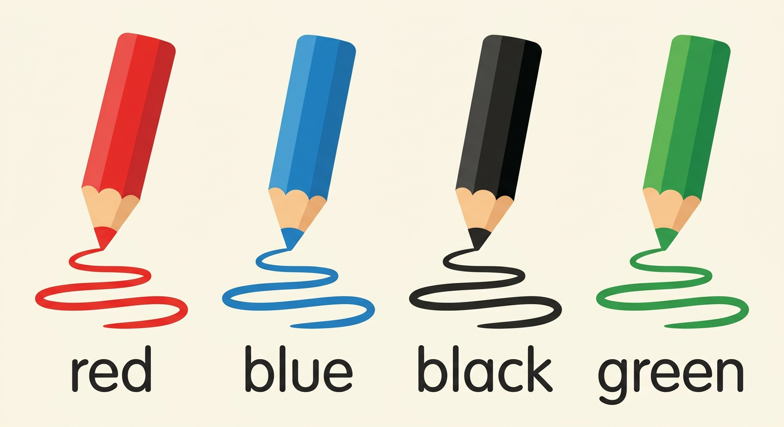
The question: What colour is the pen? [ouot keuleur iz ze pène] → It is blue. [it iz blou]
The game: Find something red and say: red!
🗣 LANGUAGE FUNCTIONS
4. I need …
The question: What do you need? [ouot dou iou nide]
The answer: I need one blue pen. [aï nide ouane blou pène] (number + colour + object)
At the shop, we finish with: Thank you! — You’re welcome!
LISTEN! Scan the code or open the link to listen and download.
🎧 School things — listen and repeat
https://drive.google.com/uc?export=download&id=1Ke_-Z2ijndvgIYnGdVhU3UNxem42MLLJ
 | 🎧 Colours — listen and repeat  https://drive.google.com/uc?export=download&id=1SfYtpKehemqRv37UbgrEOehq8bZFGHrD
 | 🎧 At the shop — listen and repeat  https://drive.google.com/uc?export=download&id=1jj4X8OACeOxSUxkNxS5oT1dQ7_FToj9v

EXERCISES
Exercise 1 (5 points). The teacher shows five objects; answer: What is this?

Exercise 2 (5 points). Say the right word:
1. It cuts the paper. → ……
2. It cleans the slate. → ……
3. We write on it with chalk. → ……
4. It makes the pencil sharp. → ……
5. The pencils live inside it. → ……
Exercise 3 (4 points). Say the colour:
1. What colour is the chalkboard?
2. What colour is the leaf of the tree?
3. What colour is your pen?
4. Find something red in the class!
Exercise 4 (6 points). At the shop! Say “I need …” with:
1. (1 pen, blue) 2. (2 pencils, red) 3. (1 ruler)
Then play the seller: ask the question.
Total: 20 points
ANSWER KEY
Exercise 1: This is a … (the five objects are named, 1 point each).
Exercise 2: 1. scissors 2. a sponge 3. a slate 4. a sharpener 5. a pencil case
Exercise 3: 1. It is black. 2. It is green. 3. the colour of the pen 4. a red thing is shown
Exercise 4: 1. I need one blue pen. 2. I need two red pencils. 3. I need a ruler. — What do you need? (the question, 3 points)

SESSION 38 / 57
REVISION — UNIT 7: SCHOOL ENVIRONMENT
Remember the words of Unit 7:
We say… | When…
a schoolbag, a book, a pen, a pencil… | the fifteen school things
What is this? — This is a book. | we ask about an object
red, blue, black, green | the four colours
What colour is …? — It is blue. | we ask the colour
What do you need? — I need … | we buy or ask for things
Thank you! — You’re welcome! | the polite words of the shop

Now answer:
1. Say ten school things.
E.A.: ten words are said with “a” (a pen, a book, a ruler…).
2. I show an object: What is this?
E.A.: This is a …
3. Say the four colours.
E.A.: red, blue, black, green.
4. What colour is the board?
E.A.: It is black.
5. You want two green pencils. What do you say?
E.A.: I need two green pencils.
6. Play the shop with your friend.
E.A.: the scene is played with the question and the polite words.

SESSION 39 / 57
T4 TEST PAPER — UNIT 7: SCHOOL ENVIRONMENT
Duration: ……… Total: 20 points
Exercise 1 (6 points). The teacher shows six objects; answer: What is this?

Exercise 2 (4 points). Say the right word:
1. It cuts the paper. → ……
2. We write on the board with it. → ……
3. It makes the pencil sharp. → ……
4. It cleans the slate. → ……
Exercise 3 (4 points). The teacher shows four coloured pencils; say the colours.

Exercise 4 (6 points). At the shop! Play the buyer with this list: 1 blue pen, 2 pencils, 1 rubber. Finish with the polite words.

ANSWER KEY
Exercise 1: This is a … (1 point per object).
Exercise 2: 1. scissors 2. chalk 3. a sharpener 4. a sponge (1 point each)
Exercise 3: red, blue, black, green (1 point each).
Exercise 4: I need one blue pen. I need two pencils. I need a rubber. (1,5 point each) + Thank you! — You’re welcome! (1,5 point)

UNIT 7 — I CAN…

Tick ✔ what you can do:
☐ I can say fifteen school things.
☐ I can answer: What is this? — This is a book.
☐ I can play the memory game in English.
☐ I can say the colours: red, blue, black, green.
☐ I can find something red and say: red!
☐ I can say: I need one blue pen.
☐ I can buy school things at the shop.

Well done! See you in Unit 8: MEALS!

UNIT 8 — MEALS

Rice, bread, milk… yum!

In this unit, I will learn to:
• say the food and the drinks in English;
• mime “to eat” and “to drink”;
• say the three meals: breakfast, lunch, dinner.
Values: respect, cooperation.
THIS UNIT IN THE OFFICIAL PROGRAMME (PE)
📗 VOCABULARY | Food and drinks; the three meals of the day.
🗣 LANGUAGE FUNCTIONS | Saying what you eat and drink.
⚙ GRAMMAR | I eat… / I drink… / I like…

DO YOU REMEMBER? (Unit 7)
1. I show an object: What is this?
2. Say the four colours.

LISTEN! Scan the code or open the link to listen and download.
 | 🎧 Food and drinks — listen and repeat  https://drive.google.com/uc?export=download&id=1DnO5-lncYNtG9Sah-o6eo7SpsdBmQvl_

SESSION 40 / 57
Food and drinks
LESSON PREPARATION SHEET
Subject: English  Theme: UNIT 8 — MEALS  Title: Food and drinks  Specific learning outcome: By the end of the lesson, learners will be able to say the food and drink words and mime “to eat” and “to drink”.  Values: respect, cooperation  Documentation: T4 English Syllabus (MEN — DCRP); T4 Pedagogical Resources Booklet  Materials: pictures of food and drinks, audio (QR code) | Date: ……………………  Class: T4  Session n°: 1 / 2  Duration: ……………………

Steps and Duration | Procedure |  | Technique and Strategy | Materials | Remarks
Steps and Duration | Teacher | Learners | Technique and Strategy | Materials | Remarks
I. Review  Duration: ……… | Answer these questions:  1. I show an object: What is this?  2. Say the four colours.  3. You want a pencil. What do you say? | Answer.  E.A.: 1. This is a …  2. red, blue, black, green.  3. I need a pencil. | Individual work | ----
II. NEW LESSON — Duration: ………
1. Warm-up | (The teacher mimes eating.) What am I doing? (The teacher mimes drinking.) And now? | Look. Answer.  E.A.: You eat. You drink. (Pupils answer in their own words; the teacher gives: to eat, to drink.) | Miming | ----
2. Presentation | Today we are going to learn a new lesson called: « Food and drinks ». By the end of this lesson, you will be able to say the food and drink words in English. | Listen. | Whole-class work | ----
3. Observation | Look at the pictures of food. Listen: rice… corn… bread… soup… a carrot… a potato… green leaves… a banana… an orange. Now the drinks: water… tea… coffee… milk… juice. | Look. Listen. | “Visual aids” | Pictures of food and drinks
4. Analysis | I say a word: point to the right picture.  I point to a picture: say the word.  Which words are DRINKS?  Mime: to eat! to drink! | Point. Say. Mime.  E.A.: the right picture is pointed to.  E.A.: the word matches the picture.  E.A.: water, tea, coffee, milk, juice.  E.A.: pupils mime eating and drinking. | “Visual aids” / Miming | Pictures
5. Synthesis | So, we EAT: rice, corn, bread, soup, a carrot, a potato, green leaves, a banana, an orange. We DRINK: water, tea, coffee, milk, juice. | Listen. Repeat. | Repetition drill | Blackboard
6. Practice | Listen and mime: “Rice!” (mime eating rice), “Juice!” (mime drinking)…  Game in two teams: a pupil mimes a food or a drink; the team guesses the word in English.  Then answer: eat or drink?  1. milk 2. bread 3. soup 4. water | Mime. Guess. Answer.  E.A.: 1. drink 2. eat 3. eat 4. drink | Game (miming) / Teams | Pictures
III. Evaluation  Duration: ……… | 1. I point to five pictures: say the words.  2. Say three things we drink.  3. Mime “to eat a banana”. | Say. Mime.  E.A.: the five words are said; water, tea, coffee, milk or juice; the miming is right. | Individual work | Pictures

SESSION 41 / 57
Breakfast, lunch, dinner
LESSON PREPARATION SHEET
Subject: English  Theme: UNIT 8 — MEALS  Title: Breakfast, lunch, dinner  Specific learning outcome: By the end of the lesson, learners will be able to say the three meals of the day and the everyday food.  Values: respect, cooperation  Documentation: T4 English Syllabus (MEN — DCRP); T4 Pedagogical Resources Booklet  Materials: three pictures of the meals of the day (local food), food cards | Date: ……………………  Class: T4  Session n°: 2 / 2  Duration: ……………………

Steps and Duration | Procedure |  | Technique and Strategy | Materials | Remarks
Steps and Duration | Teacher | Learners | Technique and Strategy | Materials | Remarks
I. Review  Duration: ……… | Answer these questions:  1. Say five things we eat.  2. Say three things we drink.  3. Mime “to drink tea”. | Answer. Mime.  E.A.: 1. rice, bread, corn, a banana, an orange…  2. water, milk, juice…  3. The miming is right. | Individual work | ----
II. NEW LESSON — Duration: ………
1. Warm-up | In the morning, before school, do you eat? And at midday? And in the evening? | Listen. Answer.  E.A.: Yes! (Pupils answer in their own words.) | Whole-class work | ----
2. Presentation | Today we are going to learn a new lesson called: « Breakfast, lunch, dinner ». By the end of this lesson, you will be able to say the three meals of the day. | Listen. | Whole-class work | ----
3. Observation | Look at the three pictures: the meal of the morning, the meal of midday, the meal of the evening. Listen: breakfast… lunch… dinner. | Look. Listen. | “Visual aids” | Three pictures of the meals
4. Analysis | I say a meal: point to the right picture.  The meal of the morning is …?  The meal of midday is …?  The meal of the evening is …? | Point. Answer.  E.A.: the right picture is pointed to.  E.A.: Breakfast.  E.A.: Lunch.  E.A.: Dinner. | “Visual aids” / Brainstorming | Three pictures
5. Synthesis | So, the three meals of the day are: breakfast in the morning, lunch at midday, dinner in the evening. | Listen. Repeat. | Repetition drill | Blackboard
6. Practice | Card game: a pupil draws a food card and mimes the food; the friends guess the word.  Then choose the right answer:  1. In the morning: lunch / breakfast  2. At midday: lunch / dinner  3. In the evening: dinner / breakfast  4. For breakfast I eat: rice / a schoolbag | Play. Answer.  E.A.: 1. breakfast 2. lunch 3. dinner 4. rice | Game (cards, miming) | Food cards
III. Evaluation  Duration: ……… | 1. Say the three meals of the day.  2. When do we eat breakfast?  3. Mime a food; the class guesses. | Answer. Mime.  E.A.: breakfast, lunch, dinner — in the morning — the food is guessed in English. | Individual work | Food cards

LESSON — UNIT 8
MEALS
📗 VOCABULARY
1. To eat
The action: to eat [tou ite] — we mime with the hand and the mouth.
rice  [raïs] | corn  [kôrn] | bread  [brèd]
soup  [soup] | a carrot  [e karotte] | a potato  [e potéitôou]
green leaves  [grine livz] | a banana  [e banâna] | an orange  [eune orindj]

📗 VOCABULARY
2. To drink
The action: to drink [tou drink] — we mime with the glass.
water  [ouôteur] | tea  [ti] | coffee  [kofi] | milk  [milk] | juice  [djous]

📗 VOCABULARY
3. The three meals of the day
In the morning: breakfast [brèkfeust]
At midday: lunch [leuntch]
In the evening: dinner [dineur]
We can say: For breakfast, I eat rice. I drink milk.
LISTEN! Scan the code or open the link to listen and download.
🎧 Food and drinks — listen and repeat
https://drive.google.com/uc?export=download&id=1DnO5-lncYNtG9Sah-o6eo7SpsdBmQvl_
 | 🎧 Breakfast, lunch, dinner — listen and repeat  https://drive.google.com/uc?export=download&id=1UEFxEPIvRKACM3wwxMb04lSrDAkbGFV4

EXERCISES
Exercise 1 (6 points). The teacher points to six pictures; say the words.

Exercise 2 (5 points). Eat or drink? Say the right action:
1. bread 2. juice 3. soup 4. milk 5. a carrot
Exercise 3 (5 points). Choose the right answer:
1. In the morning we eat: breakfast / dinner
2. At midday we eat: lunch / breakfast
3. In the evening we eat: dinner / lunch
4. We drink: water / bread
5. We eat: rice / tea
Exercise 4 (4 points). Mime two foods and two drinks; the class guesses.

Total: 20 points
ANSWER KEY
Exercise 1: the six words match the pictures (1 point each).
Exercise 2: 1. eat 2. drink 3. eat 4. drink 5. eat
Exercise 3: 1. breakfast 2. lunch 3. dinner 4. water 5. rice
Exercise 4: the mimed words are guessed in English (1 point each).

SESSION 42 / 57
REVISION — UNIT 8: MEALS
Remember: we EAT food, we DRINK drinks.
rice  [raïs] | corn  [kôrn] | bread  [brèd]
soup  [soup] | a carrot  [e karotte] | a potato  [e potéitôou]
green leaves  [grine livz] | a banana  [e banâna] | an orange  [eune orindj]

water  [ouôteur] | tea  [ti] | coffee  [kofi] | milk  [milk] | juice  [djous]

Now answer:
1. Say five things we eat.
E.A.: rice, corn, bread, soup, a carrot, a potato, green leaves, a banana, an orange (five of them).
2. Say the five drinks.
E.A.: water, tea, coffee, milk, juice.
3. Say the three meals of the day.
E.A.: breakfast, lunch, dinner.
4. When do we eat dinner?
E.A.: In the evening.
5. Mime “to eat” and “to drink”.
E.A.: the two actions are mimed.
6. What do you eat for breakfast?
E.A.: I eat … (rice, bread…). I drink … (milk, tea…).

SESSION 43 / 57
T4 TEST PAPER — UNIT 8: MEALS
Duration: ……… Total: 20 points
Exercise 1 (6 points). The teacher points to six pictures of food and drinks; say the words.

Exercise 2 (4 points). Eat or drink?
1. rice 2. water 3. an orange 4. coffee
Exercise 3 (6 points). Say the meal:
1. In the morning → ……
2. At midday → ……
3. In the evening → ……
Exercise 4 (4 points). Answer: What do you eat for breakfast? What do you drink?

ANSWER KEY
Exercise 1: the six words match the pictures (1 point each).
Exercise 2: 1. eat 2. drink 3. eat 4. drink (1 point each)
Exercise 3: 1. breakfast 2. lunch 3. dinner (2 points each)
Exercise 4: I eat … (2 points) ; I drink … (2 points).

UNIT 8 — I CAN…

Tick ✔ what you can do:
☐ I can say the food: rice, bread, corn…
☐ I can say the drinks: water, milk, juice…
☐ I can mime “to eat” and “to drink”.
☐ I can say: breakfast, lunch, dinner.
☐ I can say what I eat for breakfast.

Well done! See you in Unit 9: HOUSE!

UNIT 9 — HOUSE

Welcome to my house!
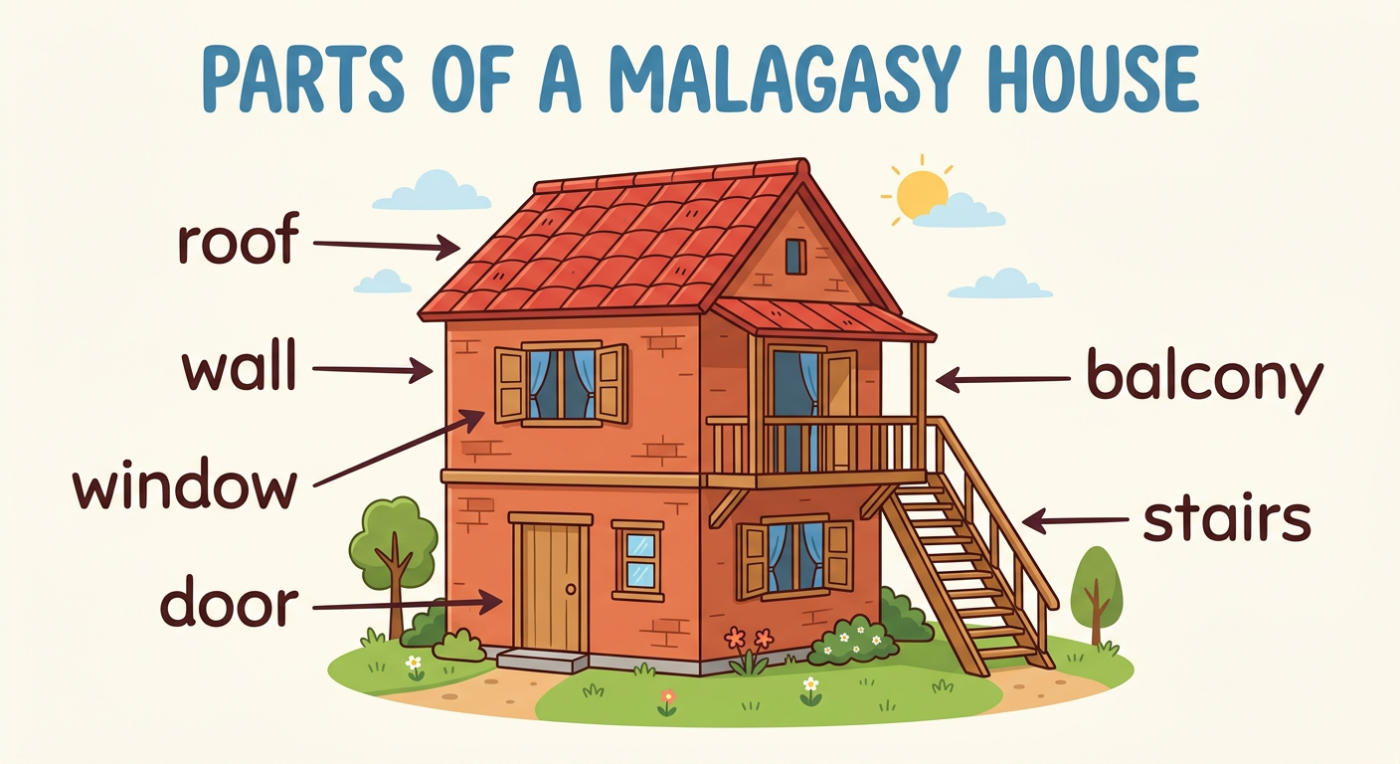
In this unit, I will learn to:
• say the parts of the house in English;
• point to the parts around me;
• describe my dream house.
Values: respect, cooperation.
THIS UNIT IN THE OFFICIAL PROGRAMME (PE)
📗 VOCABULARY | The parts of the house.
🗣 LANGUAGE FUNCTIONS | Pointing: Point to…!; describing a house.
⚙ GRAMMAR | This is the… — It is big / small.

DO YOU REMEMBER? (Unit 8)
1. Say the three meals of the day.
2. Say three things we drink.

LISTEN! Scan the code or open the link to listen and download.
 | 🎧 The house — listen and repeat  https://drive.google.com/uc?export=download&id=1L4rWJK7pOanJxBPUNfWRiXqNNneFhn8S

SESSION 44 / 57
Parts of the house (1)
LESSON PREPARATION SHEET
Subject: English  Theme: UNIT 9 — HOUSE  Title: Parts of the house (1)  Specific learning outcome: By the end of the lesson, learners will be able to say the words: window, door, wall, roof, room.  Values: respect, cooperation  Documentation: T4 English Syllabus (MEN — DCRP); T4 Pedagogical Resources Booklet  Materials: picture of a house, audio (QR code) | Date: ……………………  Class: T4  Session n°: 1 / 4  Duration: ……………………

Steps and Duration | Procedure |  | Technique and Strategy | Materials | Remarks
Steps and Duration | Teacher | Learners | Technique and Strategy | Materials | Remarks
I. Review  Duration: ……… | Answer these questions:  1. Say the three meals of the day.  2. Say three things we eat.  3. Eat or drink: milk? | Answer.  E.A.: 1. breakfast, lunch, dinner.  2. rice, bread, a banana…  3. Drink. | Individual work | ----
II. NEW LESSON — Duration: ………
1. Warm-up | Where do you sleep at night? At school? No! At …? | Listen. Answer.  E.A.: At home! / In the house! (Pupils answer in their own words; the teacher gives: house.) | Whole-class work | ----
2. Presentation | Today we are going to learn a new lesson called: « Parts of the house (1) ». By the end of this lesson, you will be able to say: window, door, wall, roof, room. | Listen. | Whole-class work | ----
3. Observation | Look at this picture of a house. Listen and look at what I point to: a window… a door… a wall… a roof… a room. | Look. Listen. | Picture study | Picture of a house
4. Analysis | Repeat each word after me.  I say a word: point to it on the picture.  I point to a part: say the word.  We enter the house by the …? | Repeat. Point. Say.  E.A.: the right part is pointed to.  E.A.: the word matches the part.  E.A.: Door. | Repetition drill / “Visual aids” | Picture of a house
5. Synthesis | So, the first parts of the house are: a window, a door, a wall, a roof, a room. | Listen. | Whole-class work | Blackboard
6. Practice | Look at OUR classroom: point to the door! point to a window! point to a wall!  Work in pairs: one says a part, the friend points to it on the picture or in the class. Change roles. | Point. Say.  E.A.: the parts are pointed to correctly and named: a window, a door, a wall, a roof, a room. | In pairs / “Realia” | The classroom, picture
III. Evaluation  Duration: ……… | 1. I point to five parts on the picture: say the words.  2. Point to the door of the class!  3. Say the five words of today. | Say. Point.  E.A.: the five words are said correctly. | Individual work | Picture of a house

SESSION 45 / 57
Parts of the house (2)
LESSON PREPARATION SHEET
Subject: English  Theme: UNIT 9 — HOUSE  Title: Parts of the house (2)  Specific learning outcome: By the end of the lesson, learners will be able to say the words: ceiling, light, balcony, stairs, and point to the parts around them.  Values: respect, cooperation  Documentation: T4 English Syllabus (MEN — DCRP); T4 Pedagogical Resources Booklet  Materials: picture of a house, the classroom and the school (“realia”) | Date: ……………………  Class: T4  Session n°: 2 / 4  Duration: ……………………

Steps and Duration | Procedure |  | Technique and Strategy | Materials | Remarks
Steps and Duration | Teacher | Learners | Technique and Strategy | Materials | Remarks
I. Review  Duration: ……… | Answer these questions:  1. I point on the picture: say the words.  2. Point to a wall of the class!  3. We enter the house by the …? | Answer. Point.  E.A.: 1. a window, a door, a wall, a roof, a room.  2. A wall is pointed to.  3. Door. | Individual work | Picture of a house
II. NEW LESSON — Duration: ………
1. Warm-up | Look UP! What is over our heads, inside the class? | Look. Answer.  E.A.: pupils point up; the teacher gives: the ceiling. | Whole-class work | The classroom
2. Presentation | Today we are going to learn a new lesson called: « Parts of the house (2) ». By the end of this lesson, you will be able to say: ceiling, light, balcony, stairs. | Listen. | Whole-class work | ----
3. Observation | Look at the picture and at the class. Listen: a ceiling… a light… a balcony… stairs. | Look. Listen. | Picture study / “Realia” | Picture, the classroom
4. Analysis | Repeat each word after me.  I say a word: point to it (picture, class or school).  What is over the room?  What do we use to go up? | Repeat. Point. Answer.  E.A.: the right part is pointed to.  E.A.: The ceiling.  E.A.: The stairs. | Repetition drill / “Realia” | Picture, the school
5. Synthesis | So, now we know nine parts of the house: a window, a door, a wall, a roof, a room, a ceiling, a light, a balcony, stairs. | Listen. | Whole-class work | Blackboard
6. Practice | Game: I say a part; point to it as fast as you can (picture, class or school yard).  Work in pairs with the nine words: one says, one points. Change roles.  Say the missing word: window, door, ……, roof — ceiling, ……, balcony | Point. Say.  E.A.: wall ; light — the nine parts are known. | Game / In pairs | Picture, the school
III. Evaluation  Duration: ……… | 1. I point to six parts: say the words.  2. Point to the ceiling! Point to the light!  3. Say the nine parts of the house. | Say. Point.  E.A.: the nine words are said correctly. | Individual work | Picture of a house

SESSION 46 / 57
Describing a house
LESSON PREPARATION SHEET
Subject: English  Theme: UNIT 9 — HOUSE  Title: Describing a house  Specific learning outcome: By the end of the lesson, learners will be able to understand and say a simple description of a house (colour, number of windows…).  Values: respect, cooperation  Documentation: T4 English Syllabus (MEN — DCRP); T4 Pedagogical Resources Booklet  Materials: drawing of the teacher’s house (e.g. green house, three windows, red wall) | Date: ……………………  Class: T4  Session n°: 3 / 4  Duration: ……………………

Steps and Duration | Procedure |  | Technique and Strategy | Materials | Remarks
Steps and Duration | Teacher | Learners | Technique and Strategy | Materials | Remarks
I. Review  Duration: ……… | Answer these questions:  1. Say the nine parts of the house.  2. Point to the ceiling!  3. Say the four colours.  4. Count from 1 to 5. | Answer.  E.A.: 1. The nine parts are said.  2. The ceiling is pointed to.  3. red, blue, black, green.  4. one … five. | Individual work | ----
II. NEW LESSON — Duration: ………
1. Warm-up | Look at my drawing! This is MY house. Do you want to know it? | Look. Answer.  E.A.: Yes! | Whole-class work | Drawing of a house
2. Presentation | Today we are going to learn a new lesson called: « Describing a house ». By the end of this lesson, you will be able to say a simple description of a house. | Listen. | Whole-class work | ----
3. Observation | Listen to my description: “This is my house. It is green. It has three windows. It has a red wall. It has one door.” | Look. Listen. | Modelling | Drawing of a house
4. Analysis | What colour is my house?  How many windows are there?  What colour is the wall?  What words do we use to describe? Listen again: “It is …” (colour), “It has …” (number + part). | Answer.  E.A.: It is green.  E.A.: Three windows.  E.A.: Red.  E.A.: It is… / It has… | Brainstorming / Modelling | Drawing of a house
5. Synthesis | So, to describe a house we say: “This is my house. It is …” with the colour, and “It has …” with the number and the part: It has three windows. | Listen. Repeat the model. | Repetition drill | Blackboard
6. Practice | Listen and say true or false (about my drawing):  1. It is green. 2. It has five windows.  3. It has a red wall. 4. It has two doors.  Then describe my drawing yourself, sentence by sentence. | Answer. Describe.  E.A.: 1. true 2. false 3. true 4. false — then: This is the house. It is green. It has three windows… | Whole-class work | Drawing of a house
III. Evaluation  Duration: ……… | 1. Describe the drawing: colour, windows, wall, door.  2. I describe a house: point to the right part.  3. Say one sentence with “It has …”. | Describe.  E.A.: It is … ; It has … windows ; It has a … wall — the sentences match the drawing. | Individual work | Drawing of a house

SESSION 47 / 57
My dream house
LESSON PREPARATION SHEET
Subject: English  Theme: UNIT 9 — HOUSE  Title: My dream house  Specific learning outcome: By the end of the lesson, learners will be able to draw their dream house and describe it in English.  Values: respect, cooperation  Documentation: T4 English Syllabus (MEN — DCRP); T4 Pedagogical Resources Booklet  Materials: drawing copy-books, coloured pencils | Date: ……………………  Class: T4  Session n°: 4 / 4  Duration: ……………………

Steps and Duration | Procedure |  | Technique and Strategy | Materials | Remarks
Steps and Duration | Teacher | Learners | Technique and Strategy | Materials | Remarks
I. Review  Duration: ……… | Answer these questions:  1. Describe this drawing (colour, windows).  2. Say the two describing words: It … / It … .  3. Say five parts of the house. | Answer.  E.A.: 1. It is … It has …  2. It is… / It has…  3. Five parts are said. | Individual work | Drawing of a house
II. NEW LESSON — Duration: ………
1. Warm-up | Close your eyes. Think of the house of your dreams… big? green? with a balcony? Today you draw it! | Listen. Imagine. | Whole-class work | ----
2. Presentation | Today we are going to draw and describe « My dream house ». By the end of this lesson, you will be able to describe your own house in English. | Listen. | Whole-class work | ----
3. Observation | Look at my model again: “This is my house. It is green. It has three windows. It has a red wall.” | Look. Listen. | Modelling | Drawing of a house
4. Analysis | What do you say first?  What do you say for the colour?  What do you say for the windows and the door? | Answer.  E.A.: This is my house.  E.A.: It is … (green, red…).  E.A.: It has … windows. It has one door. | Brainstorming | ----
5. Synthesis | So, to present our dream house: “This is my house. It is … It has … windows. It has a … wall. It has …” | Listen. | Whole-class work | Blackboard
6. Practice | Draw your dream house in your copy-book.  Colour it with the colours YOU like.  Then show your drawing to your friend and describe it: “This is my house. It is … It has …”.  Some pupils present their house to the class. | Draw. Colour. Describe.  E.A.: each description matches the drawing: This is my house. It is blue. It has two windows… | Drawing / In pairs | Copy-books, coloured pencils
III. Evaluation  Duration: ……… | 1. Show your drawing and say three sentences.  2. Answer: What colour is your house? How many windows are there? | Describe. Answer.  E.A.: This is my house. It is … It has … — It is … ; There are … windows. | Individual work | The drawings

LESSON — UNIT 9
HOUSE
📗 VOCABULARY
1. The parts of the house
a window  [e ouindôou] | a door  [e dôr] | a wall  [e ouôl]
a roof  [e rouf] | a room  [e roum] | a ceiling  [e siling]
a light  [e laïte] | a balcony  [e balkoni] | stairs  [stèrz]

🗣 LANGUAGE FUNCTIONS
2. Point to …!
The command: Point to the door! [poïnte tou ze dôr] — we point to the part.
🗣 LANGUAGE FUNCTIONS
3. I describe a house
First: This is my house. [zis iz maï haous]
The colour: It is green. [it iz grine]
The parts: It has three windows. [it haz tsri ouindôouz] It has a red wall. [it haz e rèd ouôl]
LISTEN! Scan the code or open the link to listen and download.
🎧 The house — listen and repeat
https://drive.google.com/uc?export=download&id=1L4rWJK7pOanJxBPUNfWRiXqNNneFhn8S
 | 🎧 I describe a house — listen and repeat  https://drive.google.com/uc?export=download&id=1Zm0X3I7ubdn6MusaDdByHuUcGaD2o6Ye

EXERCISES
Exercise 1 (6 points). The teacher points to six parts on the house picture; say the words.

Exercise 2 (4 points). Say the right word:
1. We enter by it. → ……
2. It is over the house. → ……
3. We look outside by it. → ……
4. We use them to go up. → ……
Exercise 3 (4 points). Point in the classroom:
Point to the door! — Point to a window! — Point to the ceiling! — Point to a wall!
Exercise 4 (6 points). Describe your dream house drawing: three sentences with “This is”, “It is”, “It has”.

Total: 20 points
ANSWER KEY
Exercise 1: the six words match the parts (1 point each).
Exercise 2: 1. a door 2. a roof 3. a window 4. stairs
Exercise 3: the four parts are pointed to (1 point each).
Exercise 4: This is my house. It is … It has … (2 points per correct sentence).

SESSION 48 / 57
REVISION — UNIT 9: HOUSE
Remember the nine parts of the house:
a window  [e ouindôou] | a door  [e dôr] | a wall  [e ouôl]
a roof  [e rouf] | a room  [e roum] | a ceiling  [e siling]
a light  [e laïte] | a balcony  [e balkoni] | stairs  [stèrz]

Now answer:
1. Say the nine parts of the house.
E.A.: a window, a door, a wall, a roof, a room, a ceiling, a light, a balcony, stairs.
2. Point to the door, a window, the ceiling of the class.
E.A.: the parts are pointed to.
3. What do we use to go up?
E.A.: The stairs.
4. Describe this house: (the teacher shows a drawing).
E.A.: This is the house. It is … It has … windows.
5. Describe YOUR dream house.
E.A.: This is my house. It is … It has …

SESSION 49 / 57
T4 TEST PAPER — UNIT 9: HOUSE
Duration: ……… Total: 20 points
Exercise 1 (6 points). The teacher points to six parts of the house; say the words.

Exercise 2 (4 points). Say the right word:
1. We enter by it. → ……
2. It is over the room, inside. → ……
3. It gives light at night. → ……
4. We use them to go up. → ……
Exercise 3 (4 points). True or false? (The teacher shows a drawing: a green house with three windows.)
1. It is green. 2. It is red. 3. It has three windows. 4. It has ten doors.
Exercise 4 (6 points). Describe your dream house: three sentences.

ANSWER KEY
Exercise 1: the six words match the parts (1 point each).
Exercise 2: 1. a door 2. a ceiling 3. a light 4. stairs (1 point each)
Exercise 3: 1. true 2. false 3. true 4. false (1 point each)
Exercise 4: This is my house. It is … It has … (2 points per correct sentence).

UNIT 9 — I CAN…

Tick ✔ what you can do:
☐ I can say the nine parts of the house.
☐ I can point to the parts around me.
☐ I can understand: Point to the door!
☐ I can say: This is my house. It is green.
☐ I can say: It has three windows.
☐ I can draw and describe my dream house.

Well done! See you in Unit 10: FAMILY!

UNIT 10 — FAMILY

This is my family!
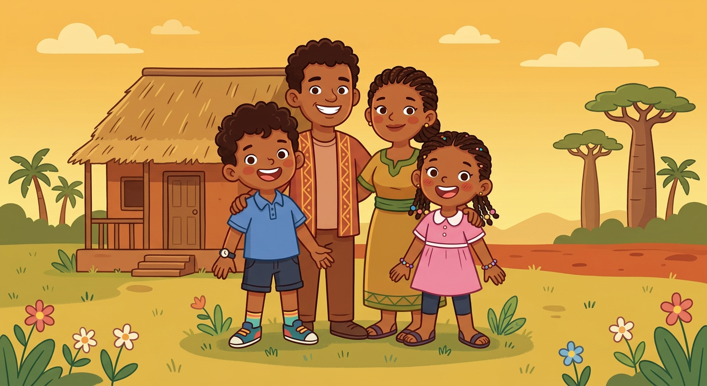
In this unit, I will learn to:
• say the members of the family in English;
• sing the Family song;
• ask and answer: Who is he? Who is she?
Values: respect, mutual help.
THIS UNIT IN THE OFFICIAL PROGRAMME (PE)
📗 VOCABULARY | The members of the family.
🗣 LANGUAGE FUNCTIONS | Presenting your family.
⚙ GRAMMAR | Who is he? Who is she? — He is… / She is…

DO YOU REMEMBER? (Unit 9)
1. Say five parts of the house.
2. Describe a house: It is … It has …

LISTEN! Scan the code or open the link to listen and download.
 | 🎧 The Family song — listen and sing  https://drive.google.com/uc?export=download&id=1FUKaZHPakDJD7b-KtEfiQOTQ5sblCDzt

SESSION 50 / 57
The members of the family
LESSON PREPARATION SHEET
Subject: English  Theme: UNIT 10 — FAMILY  Title: The members of the family  Specific learning outcome: By the end of the lesson, learners will be able to say the members of the family and sing the Family song.  Values: respect, mutual help  Documentation: T4 English Syllabus (MEN — DCRP); T4 Pedagogical Resources Booklet  Materials: family picture (father, mother, two children), family tree on the blackboard, audio (QR code) | Date: ……………………  Class: T4  Session n°: 1 / 2  Duration: ……………………

Steps and Duration | Procedure |  | Technique and Strategy | Materials | Remarks
Steps and Duration | Teacher | Learners | Technique and Strategy | Materials | Remarks
I. Review  Duration: ……… | Answer these questions:  1. Say five parts of the house.  2. Describe this drawing: It is … It has …  3. Point to the door! | Answer. Point.  E.A.: 1. Five parts are said.  2. It is … It has … windows.  3. The door is pointed to. | Individual work | Drawing of a house
II. NEW LESSON — Duration: ………
1. Warm-up | At home, who lives with you? Your dad? Your mum? Today we say them in English! | Listen. Answer in their own words. | Whole-class work | ----
2. Presentation | Today we are going to learn a new lesson called: « The members of the family ». By the end of this lesson, you will be able to say the members of the family in English. | Listen. | Whole-class work | ----
3. Observation | Look at this family picture: a father, a mother and two children. Look at the family tree on the blackboard. Listen: mother… father… sister… brother… children. | Look. Listen. | Picture study (family tree) | Family picture, blackboard
4. Analysis | Repeat each word after me: the class, one row, one pupil.  I point to the picture: who is this?  The girl is the …? The boy is the …?  The two children are: the sister and the …? | Repeat. Answer.  E.A.: the word matches the person.  E.A.: The sister. The brother.  E.A.: The brother. | Repetition drill / “Visual aids” | Family picture
5. Synthesis | So, the members of the family are: the father, the mother and the children: the sister and the brother.  Now, the Family song! Listen: “Sister, brother, father, mother / Who is she? Who is she? / She’s my sister, she’s my sister / Oh, I see! Oh, I see!” | Listen. Sing with the teacher. | Singing | Audio (QR code)
6. Practice | Sing the song again: the class, then one row, then in pairs. Change the member: brother, mother, father.  I point to the family picture: say the member. | Sing. Say.  E.A.: the song is sung; the members are named: mother, father, sister, brother, children. | Singing / “Visual aids” | Family picture
III. Evaluation  Duration: ……… | 1. Say the five family words.  2. I point to the picture: who is this?  3. Sing one verse of the Family song. | Say. Sing.  E.A.: mother, father, sister, brother, children — the verse is sung. | Individual work | Family picture

SESSION 51 / 57
Who is he? Who is she?
LESSON PREPARATION SHEET
Subject: English  Theme: UNIT 10 — FAMILY  Title: Who is he? Who is she?  Specific learning outcome: By the end of the lesson, learners will be able to ask and answer: Who is he? Who is she? — This is my …  Values: respect, mutual help  Documentation: T4 English Syllabus (MEN — DCRP); T4 Pedagogical Resources Booklet  Materials: family picture, pupils’ own family drawings | Date: ……………………  Class: T4  Session n°: 2 / 2  Duration: ……………………

Steps and Duration | Procedure |  | Technique and Strategy | Materials | Remarks
Steps and Duration | Teacher | Learners | Technique and Strategy | Materials | Remarks
I. Review  Duration: ……… | Answer these questions:  1. Say the five family words.  2. Sing one verse of the Family song.  3. The girl of the family is the …? | Answer. Sing.  E.A.: 1. mother, father, sister, brother, children.  2. The verse is sung.  3. The sister. | Individual work | ----
II. NEW LESSON — Duration: ………
1. Warm-up | Sing the Family song together! Listen to the question in the song: “Who is she?” | Sing. | Singing | Audio (QR code)
2. Presentation | Today we are going to learn a new lesson called: « Who is he? Who is she? ». By the end of this lesson, you will be able to ask and answer about the members of the family. | Listen. | Whole-class work | ----
3. Observation | Look at the family picture. Listen to the dialogue: “— Who is he? — This is my father.” “— Who is she? — This is my mother.” | Look. Listen. | Modelling (dialogue) | Family picture
4. Analysis | For a man or a boy, we ask: Who is …?  For a woman or a girl, we ask: Who is …?  And we answer: This is my …  I point to the father: ask me the question! | Answer. Ask.  E.A.: Who is he?  E.A.: Who is she?  E.A.: This is my father / mother / sister / brother.  E.A.: Who is he? | Brainstorming / Modelling | Family picture
5. Synthesis | So: for a boy or a man → Who is he? For a girl or a woman → Who is she? And we answer: This is my father, this is my mother, this is my sister, this is my brother. | Listen. Repeat the model. | Repetition drill | Blackboard
6. Practice | Speed-Chat! Two rows face to face. Pupils in row A point to the picture and ask: Who is he? / Who is she? Pupils in row B answer: This is my … After one minute, row A moves one step; new pairs, again!  Then change roles: row B asks, row A answers. | Ask. Answer. Move.  E.A.: — Who is he? — This is my father. / — Who is she? — This is my sister. | “Speed-Chat” / In pairs | Family picture
III. Evaluation  Duration: ……… | 1. I point to the picture: Who is he? Who is she?  2. Ask me a question about the picture.  3. Say the five family words. | Answer. Ask.  E.A.: This is my … — Who is he? / Who is she? — the five words are said. | Individual work | Family picture

LESSON — UNIT 10
FAMILY
📗 VOCABULARY
1. The members of the family
mother  [meuzeur] | father  [fâzeur] | sister  [sisteur] | brother  [breuzeur] | children  [tchildrène]

⚙ GRAMMAR
2. Who is he? Who is she?
For a boy or a man: Who is he? [hou iz hi]
For a girl or a woman: Who is she? [hou iz chi]
The answer: This is my father. [zis iz maï fâzeur] This is my sister. [zis iz maï sisteur]
3. The Family song
THE FAMILY SONG ♪ (tune of “Frère Jacques”)
Sister, brother, father, mother,
Who is she? Who is she?
She’s my sister, she’s my sister,
Oh, I see! Oh, I see!
Then we sing again with: brother (Who is he? — He’s my brother), mother (She’s my mother), father (He’s my father).

LISTEN! Scan the code or open the link to listen and download.
 | 🎧 The family — listen and repeat  https://drive.google.com/uc?export=download&id=1uhSmlL2W3LC0IInIOndrb-gCbay88dox
🎧 The Family song — listen and sing
https://drive.google.com/uc?export=download&id=1FUKaZHPakDJD7b-KtEfiQOTQ5sblCDzt

EXERCISES
Exercise 1 (5 points). The teacher points to the family picture; say the members.

Exercise 2 (4 points). He or she? Say the right question:
1. the father → Who is …?
2. the sister → Who is …?
3. the mother → Who is …?
4. the brother → Who is …?
Exercise 3 (5 points). Answer with “This is my …”: the teacher points to the picture five times.

Exercise 4 (6 points). Sing the Family song with two members (sister, brother).

Total: 20 points
ANSWER KEY
Exercise 1: mother, father, sister, brother, children (1 point each).
Exercise 2: 1. he 2. she 3. she 4. he (1 point each)
Exercise 3: This is my … + the right member (1 point each).
Exercise 4: the two verses are sung (3 points each).

SESSION 52 / 57
REVISION — UNIT 10: FAMILY
Remember the members of the family:
mother  [meuzeur] | father  [fâzeur] | sister  [sisteur] | brother  [breuzeur] | children  [tchildrène]

Now answer:
1. Say the five family words.
E.A.: mother, father, sister, brother, children.
2. For a girl, what is the question?
E.A.: Who is she?
3. For a boy, what is the question?
E.A.: Who is he?
4. The teacher points to the picture: answer.
E.A.: This is my father / mother / sister / brother.
5. Sing the Family song.
E.A.: the song is sung with the four members.
6. Speed-Chat: ask and answer with a friend.
E.A.: — Who is he? — This is my brother.

SESSION 53 / 57
T4 TEST PAPER — UNIT 10: FAMILY
Duration: ……… Total: 20 points
Exercise 1 (5 points). The teacher points to the family picture five times; say the members.

Exercise 2 (4 points). He or she?
1. the mother 2. the brother 3. the sister 4. the father
Exercise 3 (6 points). Answer the teacher’s questions: Who is he? Who is she? (three questions)

Exercise 4 (5 points). Sing one verse of the Family song.

ANSWER KEY
Exercise 1: mother, father, sister, brother, children (1 point each).
Exercise 2: 1. she 2. he 3. she 4. he (1 point each)
Exercise 3: This is my … + the right member (2 points each).
Exercise 4: the verse is sung correctly (5 points).

UNIT 10 — I CAN…

Tick ✔ what you can do:
☐ I can say: mother, father, sister, brother, children.
☐ I can ask: Who is he? Who is she?
☐ I can answer: This is my father.
☐ I can sing the Family song.

Well done! See you in Unit 11: FARM ANIMALS AND PETS!

UNIT 11 — FARM ANIMALS AND PETS

Cat, dog, zebu… and you?
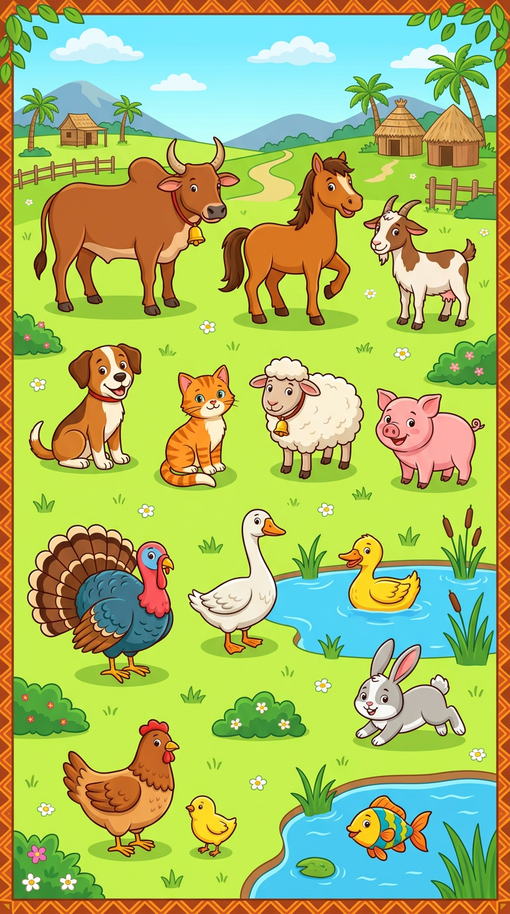
In this unit, I will learn to:
• say the farm animals and the pets in English;
• answer: What is this? — It is a cat;
• play the animal games: draw, mime, true or false.
Values: love of effort, looking for the best.
THIS UNIT IN THE OFFICIAL PROGRAMME (PE)
📗 VOCABULARY | The farm animals and the pets.
🗣 LANGUAGE FUNCTIONS | Naming the animals; asking a friend: Draw me a…!
⚙ GRAMMAR | What is this? — It is a…

DO YOU REMEMBER? (Unit 10)
1. Say the five family words.
2. Ask and answer: Who is he? — This is my …

LISTEN! Scan the code or open the link to listen and download.
 | 🎧 The animals — listen and repeat  https://drive.google.com/uc?export=download&id=1pOIvtk9r1K7LURxTa3vNAqEqphBeFSzw

SESSION 54 / 57
Farm animals and pets
LESSON PREPARATION SHEET
Subject: English  Theme: UNIT 11 — FARM ANIMALS AND PETS  Title: Farm animals and pets  Specific learning outcome: By the end of the lesson, learners will be able to say the names of the farm animals and the pets in English.  Values: love of effort, looking for the best  Documentation: T4 English Syllabus (MEN — DCRP); T4 Pedagogical Resources Booklet  Materials: big picture of the animals, animal cards, audio (QR code) | Date: ……………………  Class: T4  Session n°: 1 / 2  Duration: ……………………

Steps and Duration | Procedure |  | Technique and Strategy | Materials | Remarks
Steps and Duration | Teacher | Learners | Technique and Strategy | Materials | Remarks
I. Review  Duration: ……… | Answer these questions:  1. Say the five family words.  2. I point to the family picture: Who is she?  3. Sing one verse of the Family song. | Answer. Sing.  E.A.: 1. mother, father, sister, brother, children.  2. This is my …  3. The verse is sung. | Individual work | Family picture
II. NEW LESSON — Duration: ………
1. Warm-up | (The teacher imitates a cat: “Meow!”) What is it? (Then a dog: “Woof!”) And this? | Listen. Guess.  E.A.: pupils guess in their own words; the teacher gives: a cat! a dog! | Miming / Game | ----
2. Presentation | Today we are going to learn a new lesson called: « Farm animals and pets ». By the end of this lesson, you will be able to say the names of the animals in English. | Listen. | Whole-class work | ----
3. Observation | Look at the big picture. Listen: a cat… a dog… a zebu… a hen… a pig… a fish… a duck… a goose… a rabbit… a sheep… a goat… a horse… a chicken… a turkey. | Look. Listen. | “Visual aids” | Big picture of the animals
4. Analysis | Repeat each word after me: all the class, then one row, then one pupil alone.  I say an animal: point to it on the picture.  I point to an animal: say the name.  Which animals live in your home or your yard? | Repeat. Point. Say.  E.A.: the right animal is pointed to.  E.A.: the name matches the animal.  E.A.: a cat, a dog, a hen… (pupils answer). | Repetition drill / “Visual aids” | Big picture
5. Synthesis | So, the farm animals and the pets are: a cat, a dog, a zebu, a hen, a pig, a fish, a duck, a goose, a rabbit, a sheep, a goat, a horse, a chicken, a turkey. | Listen. Repeat. | Repetition drill | Blackboard
6. Practice | Game in groups: I show an animal card with a name said aloud — true or false? The group speaker answers and corrects.  Example: (picture of a cat) “This is a dog.” True or false? | Play. Answer.  E.A.: False! This is a cat. — the groups correct the wrong names. | Game (cards) / Group work | Animal cards
III. Evaluation  Duration: ……… | 1. I point to eight animals: say the names.  2. Say four animals of the yard.  3. The big animal with horns of Madagascar is the …? | Say.  E.A.: the eight names are said — a hen, a duck, a goose, a turkey… — a zebu. | Individual work | Big picture

SESSION 55 / 57
What is this? Draw me a cat!
LESSON PREPARATION SHEET
Subject: English  Theme: UNIT 11 — FARM ANIMALS AND PETS  Title: What is this? Draw me a cat!  Specific learning outcome: By the end of the lesson, learners will be able to answer “What is this?” about an animal and react to “Draw me a …!”.  Values: love of effort, looking for the best  Documentation: T4 English Syllabus (MEN — DCRP); T4 Pedagogical Resources Booklet  Materials: animal cards, slates, chalk | Date: ……………………  Class: T4  Session n°: 2 / 2  Duration: ……………………

Steps and Duration | Procedure |  | Technique and Strategy | Materials | Remarks
Steps and Duration | Teacher | Learners | Technique and Strategy | Materials | Remarks
I. Review  Duration: ……… | Answer these questions:  1. I point to six animals: say the names.  2. Say three pets.  3. True or false: (picture of a hen) “This is a hen.” | Answer.  E.A.: 1. The six names are said.  2. a cat, a dog, a fish, a rabbit.  3. True! | Individual work | Animal cards
II. NEW LESSON — Duration: ………
1. Warm-up | A pupil comes to the front and mimes an animal. What is it? | Mime. Guess.  E.A.: A cat! A horse! … | Miming / Game | ----
2. Presentation | Today we are going to learn a new lesson called: « What is this? Draw me a cat! ». By the end of this lesson, you will be able to ask and answer about the animals and draw the animal I say. | Listen. | Whole-class work | ----
3. Observation | Listen to the dialogue (I show a card): “— What is this? — It is a cat.” (Another card:) “— What is this? — It is a zebu.” Now listen to the command: “Draw me a cat!” (The teacher draws a cat on the blackboard.) | Look. Listen. | Modelling | Animal cards, blackboard
4. Analysis | What is the question for an animal?  What is the answer?  What do you do when I say “Draw me a dog!”?  I show a card: ask me the question! | Answer. Ask.  E.A.: What is this?  E.A.: It is a … (cat, dog…).  E.A.: We draw a dog.  E.A.: What is this? | Brainstorming / Modelling | Animal cards
5. Synthesis | So: the question is “What is this?”, the answer is “It is a …”. And with “Draw me a …!”, we draw the animal. | Listen. Repeat the model. | Repetition drill | Blackboard
6. Practice | Game 1 — Draw me a …! : “Draw me a cat!” Draw on your slate, then show your drawing.  Game 2 — Mime: a pupil mimes an animal; the class asks “What is this?” and guesses: “It is a …!”  Game 3 — in pairs with the cards: one asks, one answers. Change roles. | Draw. Mime. Ask. Answer.  E.A.: — What is this? — It is a cat. / The drawing matches the animal. | Games (drawing, miming) / In pairs | Slates, chalk, animal cards
III. Evaluation  Duration: ……… | 1. I show four cards: What is this?  2. Draw me a fish!  3. Say six animal names. | Answer. Draw.  E.A.: It is a … (four answers) — the fish is drawn — six names are said. | Individual work | Animal cards, slates

LESSON — UNIT 11
FARM ANIMALS AND PETS
📗 VOCABULARY
1. The animals
a cat  [e kate] | a dog  [e dog] | a zebu  [e zibou] | a hen  [e hène]
a pig  [e pig] | a fish  [e fich] | a duck  [e deuk] | a goose  [e gous]
a rabbit  [e rabite] | a sheep  [e chipe] | a goat  [e gôoute] | a horse  [e hôrs]
a chicken  [e tchikène] | a turkey  [e teurki]

⚙ GRAMMAR
2. What is this?
The question: What is this? [ouate iz zis]
The answer: It is a cat. [it iz e kate] It is a zebu. [it iz e zibou]
🗣 LANGUAGE FUNCTIONS
3. Draw me a …!
The command: Draw me a cat! [drô mi e kate] — we draw the animal on the slate.
LISTEN! Scan the code or open the link to listen and download.
🎧 The animals — listen and repeat
https://drive.google.com/uc?export=download&id=1pOIvtk9r1K7LURxTa3vNAqEqphBeFSzw
 | 🎧 What is this? Draw me a…! — listen and repeat  https://drive.google.com/uc?export=download&id=15Z-Mi5KkGxi3_lukg4wQQPVfnuRxYngh

EXERCISES
Exercise 1 (7 points). The teacher points to seven animals on the picture; say the names.

Exercise 2 (4 points). True or false? (The teacher shows a card and says a name.)
1. (a cat) “This is a cat.”
2. (a dog) “This is a hen.”
3. (a zebu) “This is a zebu.”
4. (a duck) “This is a horse.”
Exercise 3 (4 points). Answer: What is this? (four cards)

Exercise 4 (5 points). Draw me a hen! Then mime an animal for the class.

Total: 20 points
ANSWER KEY
Exercise 1: the seven names match the animals (1 point each).
Exercise 2: 1. true 2. false (It is a dog.) 3. true 4. false (It is a duck.) (1 point each)
Exercise 3: It is a … + the right animal (1 point each).
Exercise 4: the hen is drawn (3 points); the mimed animal is guessed (2 points).

SESSION 56 / 57
REVISION — UNIT 11: FARM ANIMALS AND PETS
Remember the fourteen animals:
a cat  [e kate] | a dog  [e dog] | a zebu  [e zibou] | a hen  [e hène]
a pig  [e pig] | a fish  [e fich] | a duck  [e deuk] | a goose  [e gous]
a rabbit  [e rabite] | a sheep  [e chipe] | a goat  [e gôoute] | a horse  [e hôrs]
a chicken  [e tchikène] | a turkey  [e teurki]

Now answer:
1. Say the fourteen animals.
E.A.: a cat, a dog, a zebu, a hen, a pig, a fish, a duck, a goose, a rabbit, a sheep, a goat, a horse, a chicken, a turkey.
2. The teacher shows a card: What is this?
E.A.: It is a …
3. True or false: (a goat) “This is a sheep.”
E.A.: False! It is a goat.
4. Draw me a zebu!
E.A.: the zebu is drawn on the slate.
5. Mime an animal; the class guesses.
E.A.: the class asks “What is this?” and answers “It is a …!”

SESSION 57 / 57
T4 TEST PAPER — UNIT 11: FARM ANIMALS AND PETS
Duration: ……… Total: 20 points
Exercise 1 (7 points). The teacher points to seven animals; say the names.

Exercise 2 (4 points). True or false? (The teacher shows four cards and says the names.)

Exercise 3 (5 points). Answer: What is this? (five cards)

Exercise 4 (4 points). Draw me a cat! Draw me a fish!

ANSWER KEY
Exercise 1: the seven names match the animals (1 point each).
Exercise 2: true / false + the correction: It is a … (1 point each).
Exercise 3: It is a … + the right animal (1 point each).
Exercise 4: the two animals are drawn (2 points each).

UNIT 11 — I CAN…

Tick ✔ what you can do:
☐ I can say the fourteen farm animals and pets.
☐ I can answer: What is this? — It is a cat.
☐ I can play: Draw me a …!
☐ I can mime an animal for my friends.
☐ I finished ALL the units of English T4! HURRAY!

CONGRATULATIONS! You finished the year! Koto and Soa are proud of you!

ANNEXES

The treasure box of the year!
Annex 1 — Picture dictionary: all the words of the year
Annex 2 — Songs and rhymes: all the songs, with the audio
Annex 3 — Pronunciation guide: for the teacher
Annex 4 — Flashcards to cut out: for the games

ANNEX 1
PICTURE DICTIONARY
All the words of the year, unit by unit. Look at the picture, read the word, say it aloud!
SOCIALISING (Unit 1)

Hello! [hèlôou] Hi! [haï] Good morning! [goud môrning]
How are you? [haou âr iou] → I’m fine, thank you. [aïm faïn, tenk iou]
Goodbye! [goudbaï] Bye-bye! [baï-baï]
What’s your name? [ouots iôr néim] → My name is … [maï néim iz]
How old are you? [haou ôould âr iou] → I’m 8. [aïm éit]
Thank you! [tenk iou] → You’re welcome! [iôr ouèlkeum]
I’m sorry! [aïm sori] → It’s OK! [its ôou-kéi]
THE ALPHABET (Unit 2)

NUMBERS 1 TO 20 (Unit 3)

1 — one  [ouane] | 2 — two  [tou] | 3 — three  [tsri] | 4 — four  [fôr]
5 — five  [faïv] | 6 — six  [siks] | 7 — seven  [sèvène] | 8 — eight  [éit]
9 — nine  [naïn] | 10 — ten  [tène] | 11 — eleven  [ilèvène] | 12 — twelve  [touèlv]
13 — thirteen  [seurtine] | 14 — fourteen  [fôrtine] | 15 — fifteen  [fiftine] | 16 — sixteen  [sikstine]
17 — seventeen  [sèvènetine] | 18 — eighteen  [éitine] | 19 — nineteen  [naïntine] | 20 — twenty  [touènti]

CLASSROOM LANGUAGE (Unit 4)

Stand up! [stand eup] Sit down! [site daoun] Be quiet! [bi kouaïeut]
Listen to me, please! [lisseun tou mi, plize] Look at the board! [louk at ze bôrd]
Raise your hand! [réiz iôr hand] Line up! [laïn eup] Come here! [kam hire]
May I go out, please? [méi aï gôou aout, plize] → Yes, go ahead. [yès, gôou euhèd]
PARTS OF THE BODY (Unit 5)

head  [hèd] | shoulder  [chôouldeur] | knee  [ni] | toe  [tôou]
eye  [aï] | ear  [ir] | nose  [nôouz] | mouth  [maous]

DAYS OF THE WEEK (Unit 6)

Monday  [meundé] | Tuesday  [tiouzdé] | Wednesday  [ouènzdé] | Thursday  [seurzdé]
Friday  [fraïdé] | Saturday  [sateudé] | Sunday  [seundé]

SCHOOL THINGS AND COLOURS (Unit 7)

a schoolbag  [e skoulbag] | a copy-book  [e kopibouk] | a book  [e bouk]
a pen  [e pène] | a pencil  [e pènsil] | coloured pencils  [keuleurd pènsilz]
a pencil case  [e pènsil kéis] | a sharpener  [e charpeneur] | a slate  [e sléit]
a sponge  [e speundj] | chalk  [tchôk] | a ruler  [e rouleur]
a rubber  [e reubeur] | glue  [glou] | scissors  [sizeurz]

red  [rèd] | blue  [blou] | black  [blak] | green  [grine]

What is this? [ouate iz zis] → This is a book. [zis iz e bouk]
What do you need? [ouate dou iou nide] → I need a pencil. [aï nide e pènsil]
MEALS (Unit 8)

We eat:
rice  [raïs] | corn  [kôrn] | bread  [brèd]
soup  [soup] | a carrot  [e karotte] | a potato  [e potéitôou]
green leaves  [grine livz] | a banana  [e banâna] | an orange  [eune orindj]

We drink:
water  [ouôteur] | tea  [ti] | coffee  [kofi] | milk  [milk] | juice  [djous]

The meals:
breakfast  [brèkfeust] | lunch  [leuntch] | dinner  [dineur]

HOUSE (Unit 9)

a window  [e ouindôou] | a door  [e dôr] | a wall  [e ouôl]
a roof  [e rouf] | a room  [e roum] | a ceiling  [e siling]
a light  [e laïte] | a balcony  [e balkoni] | stairs  [stèrz]

This is my house. [zis iz maï haous] It is green. [it iz grine] It has three windows. [it haz tsri ouindôouz]
FAMILY (Unit 10)

mother  [meuzeur] | father  [fâzeur] | sister  [sisteur] | brother  [breuzeur] | children  [tchildrène]

Who is he? [hou iz hi] Who is she? [hou iz chi] → This is my father. [zis iz maï fâzeur]
FARM ANIMALS AND PETS (Unit 11)

a cat  [e kate] | a dog  [e dog] | a zebu  [e zibou] | a hen  [e hène]
a pig  [e pig] | a fish  [e fich] | a duck  [e deuk] | a goose  [e gous]
a rabbit  [e rabite] | a sheep  [e chipe] | a goat  [e gôoute] | a horse  [e hôrs]
a chicken  [e tchikène] | a turkey  [e teurki]

What is this? [ouate iz zis] → It is a cat. [it iz e kate] Draw me a cat! [drô mi e kate]

ANNEX 2
SONGS AND RHYMES
All the songs and rhymes of the year. Scan the QR code or use the link to listen and download.
♪ THE ALPHABET SONG (Unit 2)

A B C D E F G
H I J K L M N O P
Q R S T U V
W X Y and Z
Now I know my ABC
Next time won’t you sing with me?

LISTEN! Scan the code or open the link to listen and download.
🎧 The Alphabet Song — listen and sing
https://drive.google.com/uc?export=download&id=1TUymYaapCRRUC11ceBbn49LIAKDuEKCP

♪ THE “ONE, TWO” RHYME (Unit 3)

One, two, what do you do?
Three, four, count some more!
Five, six, clap your hands!
Seven, eight, stand up straight!
Nine, ten, once again!

LISTEN! Scan the code or open the link to listen and download.
🎧 The “One, two” rhyme — listen and say
https://drive.google.com/uc?export=download&id=1HctvxUvAx6_baroHpwvV_KLb3HHL2uZb

♪ HEAD, SHOULDERS, KNEES AND TOES (Unit 5)

Head, shoulders, knees and toes, knees and toes,
Head, shoulders, knees and toes, knees and toes,
And eyes and ears and mouth and nose,
Head, shoulders, knees and toes, knees and toes.
We touch each part of the body at the right word. Sing faster and faster!
LISTEN! Scan the code or open the link to listen and download.
🎧 Head, shoulders, knees and toes — listen and sing
https://drive.google.com/uc?export=download&id=1LG-51ZLBhLnr3S9r7GpjIwVENCreY2OB

♪ THE DAYS OF THE WEEK SONG (Unit 6)

Monday, Tuesday,
Wednesday, Thursday,
Friday, Saturday,
Sunday the last day, Sunday the last day.
Monday, Tuesday,
Wednesday, Thursday,
Friday, Saturday.
(We sing it on a tune we know well.)
LISTEN! Scan the code or open the link to listen and download.
🎧 The Days of the week song — listen and sing
https://drive.google.com/uc?export=download&id=1rZSe5VDKzNmqlyoeImKdI1H1pWMBQyNK

♪ THE FAMILY SONG (Unit 10) — tune of “Frère Jacques”

Sister, brother, father, mother,
Who is she? Who is she?
She’s my sister, she’s my sister,
Oh, I see! Oh, I see!
Then we sing again with: brother (Who is he? — He’s my brother), mother (She’s my mother), father (He’s my father).
LISTEN! Scan the code or open the link to listen and download.
🎧 The Family song — listen and sing
https://drive.google.com/uc?export=download&id=1FUKaZHPakDJD7b-KtEfiQOTQ5sblCDzt

ANNEX 3
PRONUNCIATION GUIDE
For the teacher
In this book, every English word has a help between brackets, in italics and grey: it shows how to SAY the word, with sounds read as in French. Example:
book [bouk] — we read “bouk” as in French.
This help is only a guide for the mouth: the true model is the AUDIO. Always play the audio (QR code or link) and repeat after it!
The special English sounds:
Written | How to say it | Examples
th → [z] / [s] | Put the tongue between the teeth and say a soft “z” or “s”. | this [zis], three [tsri], thank you [tenk iou], birthday
h → [h] | Blow softly, like a small laugh. The “h” is not silent! | hello [hèlôou], house [haous], hen [hène], horse [hôrs]
r → [r] | A soft “r”, the tongue does not roll and does not touch the teeth. | red [rèd], rice [raïs], ruler [rouleur]
-ing → [ing] | A nasal “ng” at the end, like a small bell. | morning [môrning], ceiling [siling]
ou / ow → [aou] | Two sounds together: “a” then “ou”. | how [haou], house [haous], mouth [maous]
o / oa → [ôou] | Two sounds together: “ô” then “ou”. | hello [hèlôou], nose [nôouz], goat [gôoute]
a → [éi] | Two sounds together: “é” then “i”. | name [néim], eight [éit], slate [sléit]
i → [aï] | Two sounds together: “a” then “i”. | five [faïv], nine [naïn], light [laïte]
u → [eu] | A short “eu”, the mouth relaxed. | mother [meuzeur], duck [deuk], lunch [leuntch]
ee / ea → [i] | A long “i”, smile! | sheep [chipe], green [grine], tea [ti]

Three golden rules:
1. Listen first, speak after: the pupils repeat AFTER the audio or the teacher.
2. Whole class → one row → one pupil: repeat in this order (repetition drill).
3. Praise every try: “Good!”, “Very good!”, “Well done!” — mistakes are welcome, they help us learn.

ANNEX 4
FLASHCARDS TO CUT OUT
For the teacher: photocopy these pages, paste them on cardboard, cut along the dashed lines. Use the cards for the games: point, mime, true or false, Kim’s game, “What is this?”…
NUMBERS (Unit 3)

1  [ouane] | 2  [tou] | 3  [tsri] | 4  [fôr] | 5  [faïv]
6  [siks] | 7  [sèvène] | 8  [éit] | 9  [naïn] | 10  [tène]

one | two | three | four | five
six | seven | eight | nine | ten

COLOURS (Unit 7)

red  [rèd] | blue  [blou]
black  [blak] | green  [grine]

DAYS OF THE WEEK (Unit 6)

Monday  [meundé] | Tuesday  [tiouzdé]
Wednesday  [ouènzdé] | Thursday  [seurzdé]
Friday  [fraïdé] | Saturday  [sateudé]
Sunday
[seundé]

SCHOOL THINGS (Unit 7)

schoolbag  [skoulbag] | copy-book  [kopibouk] | book  [bouk]
pen  [pène] | pencil  [pènsil] | coloured pencils  [keuleurd pènsilz]
pencil case  [pènsil kéis] | sharpener  [charpeneur] | slate  [sléit]
sponge  [speundj] | chalk  [tchôk] | ruler  [rouleur]
rubber  [reubeur] | glue  [glou] | scissors  [sizeurz]

FOOD AND DRINKS (Unit 8)

rice  [raïs] | corn  [kôrn] | bread  [brèd]
soup  [soup] | carrot  [karotte] | potato  [potéitôou]
green leaves  [grine livz] | banana  [banâna] | orange  [orindj]
water  [ouôteur] | tea  [ti] | coffee  [kofi]
milk  [milk] | juice  [djous]

FAMILY (Unit 10)

mother  [meuzeur] | father  [fâzeur] | sister  [sisteur]
brother  [breuzeur] | children  [tchildrène]

FARM ANIMALS AND PETS (Unit 11)

cat  [kate] | dog  [dog] | zebu  [zibou]
hen  [hène] | pig  [pig] | fish  [fich]
duck  [deuk] | goose  [gous] | rabbit  [rabite]
sheep  [chipe] | goat  [gôoute] | horse  [hôrs]
chicken  [tchikène] | turkey  [teurki]

Tip: draw or paste a small picture on the back of each word card — the card becomes a picture card for “What is this?”.

THE END OF THE BOOK — NOT THE END OF ENGLISH!
Koto and Soa say:
“Goodbye, teacher! Goodbye, children! See you next year!”
J-Learn collection — English T4
All the audio files of this book:
https://drive.google.com/drive/folders/10CyXbCzIb0SV9hYk45iSbMVRZr9frxD6

