|  |
| --- |
| **Localization method to calibrate GPS sensor data using lidar sensor for autonomous driving** |

|  |
| --- |
| **\*Sang-Hyeon Lee, Won-Moook Jeong**  **Computer Science and Engineering, Mechatronics Engineering Koreatech**  **e-mail : *hgnaseel@gmail.com, jwonmook@gmail.com*** |

**Abstract**

The method of this paper is implemented so that the location can be tracked with the help of a nearby vehicle even when the GPS signal is completely blocked due to a device defect or the surrounding environment. The existing correction method is a method of correcting a signal within a predictable error range, but the proposed method is implemented by using a lidar sensor to track the posture with the help of a nearby vehicle.

I. Introduction

As the development of autonomous driving technology accelerates, the importance of positioning technology that recognizes the location of a vehicle is also increasing. The most classic and widely used GPS technology among positioning technologies used for autonomous driving has a disadvantage in that it is impossible to receive normal data in an environment with many obstacles such as indoors and high-rise buildings.

In this study, the disturbance/error of the GPS signal that may occur during autonomous driving was corrected by estimating the location using the information of the LiDAR installed in each autonomous vehicle.

The existing error correction method corrects the signal within a predictable error range, but in this paper, even when the GPS signal is completely blocked due to a device defect or the surrounding environment, the method uses a method to track the location with the help of a nearby vehicle.

II. Cognitive Algorithms

2.1 Recognition

StrongArm SA1110~~~~ 예를 들어 I/O, 메모리 및 비디오 칩들을 사용 가능하다[1].

2.2 Convex hull Algorithm

~~~~~는칩들, 예를

Sdfsdf

Sdfsdfs

Ⅲ. Implementation

Experiments were conducted with one leading vehicle and one rear vehicle. It was carried out by intentionally blocking the gps value of the rear vehicle, and the actual gps value of the rear vehicle was used only for experimental comparison.

The leading car used Hyundai Avante, and the rear car used Wego Robotics autonomous driving platform: ERP 42.

S/W was developed in Ubuntu 18.04 – ROS Melodic environment.

간에는 무선으로 연결이 되며 호스트 시스템에서 동적으로 클라이언트 시스템에게 IP주소를 할당하는 방법과 터치스크린을 이용하여 할당하는 방법이 있으며, 직접적으로 LCD를 통하여 IP 주소 할당 사항 등을 모니터링 할 수 있다.

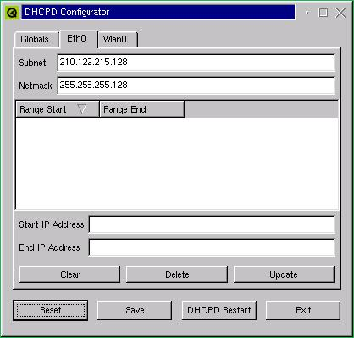

그림 4. 구현된 애플리케이션

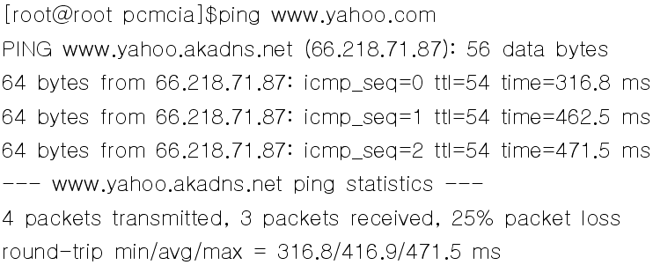

그림 5. 클라이언트에서 외부로 연결되는 모습

Ⅳ. Conclusion 및 향후 연구 방향

타겟 시스템에 임베디드 리눅스를 이식하기 위해서는 시스템의 특성과 구성 요소들의 이해가 상당히 중요하며, 이를 위해 우선적인 프로세서의 이해가 선행되어야 한다. 본 논문에서는 최근에 활발히 연구되고 있는 임베디드 시스템과 빠르게 보급되고 있는 무선 랜을 이용하여, 기존에 개발되어 사용되고 있는 라우터를 임베디드 운영체제의 한 종류인 임베디드 리눅스를 이용하여 구현하였다. 특히 LCD, Touch Screen, QT 애플리케이션을 이용하여 사용자 인터페이스 부분의 구현에 목적을 두었다.

참고문헌

[1] Kaiqi Liu, “Fast Dynamic Vehicle Detection in Road Scenarios Based on Pose Estimation with Convex-Hull Model”, MDPI, 2019.

[2] 이동 수단의 집단 제어를 위한 장치 및 방법,

https://patents.google.com/patent/KR101559886B1/ko

[3] 트럭 플래투닝(Truck Platooning)기술 상용화: 현황과 한계점,

https://lotis.or.kr/tia03v.do?cn_id=2017110900002&cn_type_cd=TIA&CN_TYPE_CD=TIA&MENU_ID=TIA00