Use Case Diagram

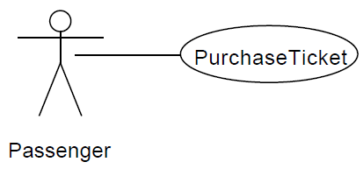- Used during requirements specification and analysis to represent **external behavior** (visible from the outside of the system)

- **Actor:** role/type of user of the system - A **Use Case:** class of functionality provided by the system

**Actor:** a model or role for an external entity which interacts (communicates) with the system

- May represent the role of:

* **Physical User** (managers, employees, customers…)
* **External system** (another system)
* 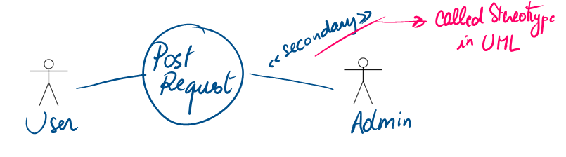**Physical environment** (e.g. weather – input to system through sensors)

- Has a unique name and an optional description

- Can be:

* 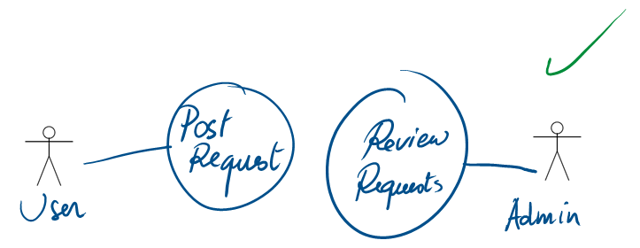**Primary**: solicits the execution of the use case (active role)
* **Secondary**: is solicited during the execution of the use case (passive)

Note: though this is good for simplifying large diagrams, we can also cut

it into 2 and include the link in the Detailed Text Description (DTD)

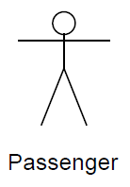- **Inheritance:** B inherits A ⬄ all what A can do, B can do too

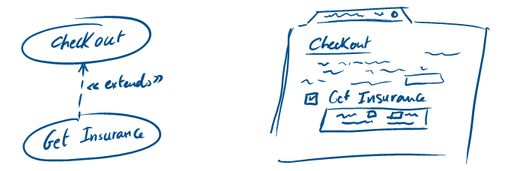**Relationships:**

**Extends:** case depends or is optional part or result of another

* X extends Y ⬄ X might be **optionally executed** from Y
* Arrow direction is from **extending to extended** use case

**Includes:** cases automatically/necessarily triggered in another one

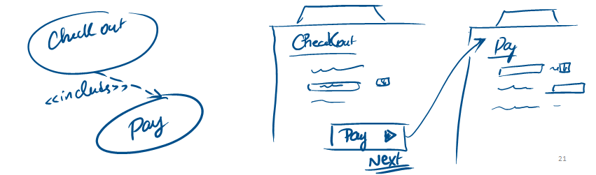

* X includes Y ⬄ X **requires/triggers** the execution of Y
* Arrow direction is from **including to included** use case

**Notes**:

* Different included and extended cases can be directed

on to more than one other use cases

* There can be **no link** between an actor and **extended** or **including** use cases

**Generalizes:** function that may occur in two or more different ways

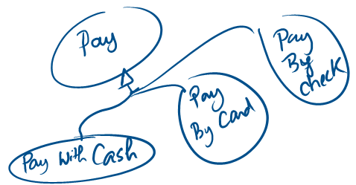

* X generalizes Y & Z ⬄ X **can be performed** as either Y or Z
* Typically represents a menu with submenus

**Relationships must not be over-used**

**Scenario:** each use case can be divided into multiple scenarios (ex: login success or failed)

**-** Each scenario has a sequence of **steps**

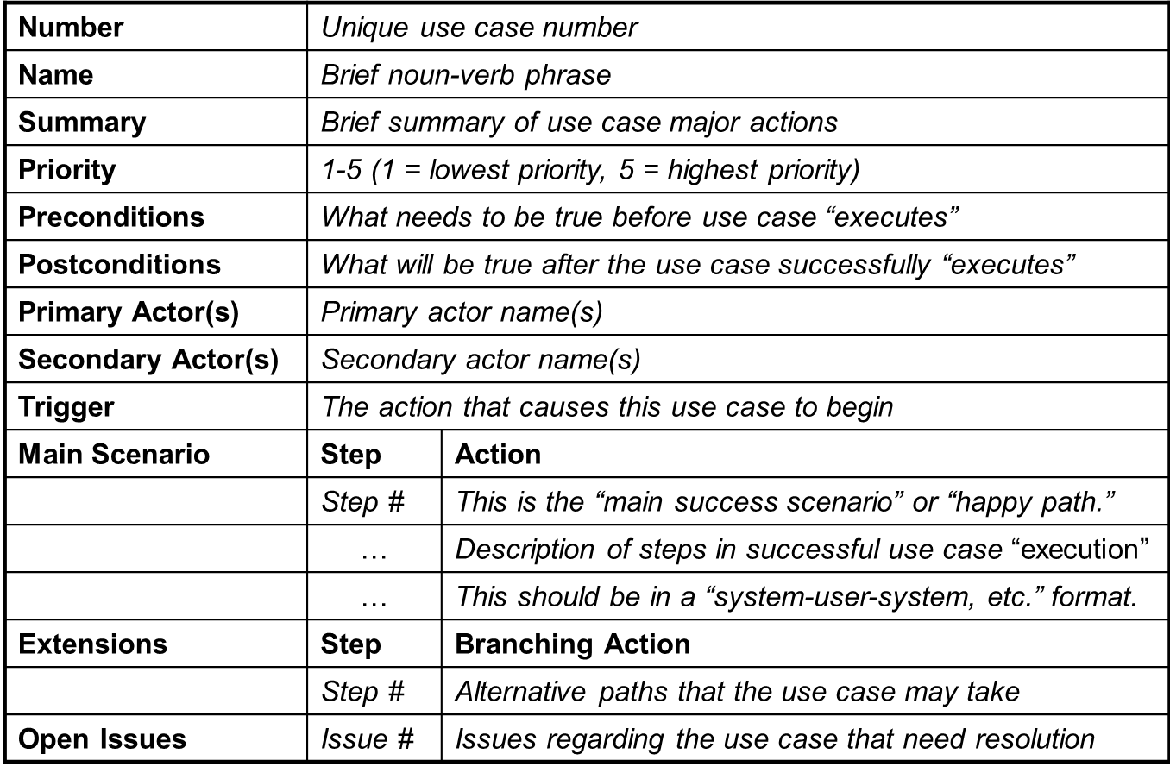**DTD:** Use cases can be described textually, with a focus on the event flow between actor and system:

**Note:** not all fields are mandatory; only include enough information to fully explain your case

Example on different **scenarios**:

