Class Diagram

**Won’t store data about employees working elsewhere**

- Describe classes and their relationships **Associations:**

**Many-to-One**

0503PossibleMultipAssoc

**Class**

**Attribute: type**

**Operation (inputs): outputs**

**Many-to-Many**

**One-to-One**

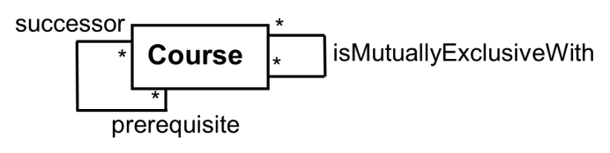-Can be directed from a class to itself:

**Generalization:**

0509AnimalDiscriminators**Specializing a superclass into two or more subclasses Aggregation:** When a class **has** instances of

another class

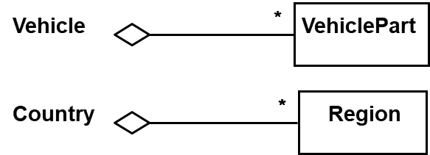

**Composition:** **Stronger aggregation**

**Note**: Avoid **unnecessary** hierarchies. Usually it’s

simpler to represent an entity as an instance of Removing aggregate destroys it’s parts

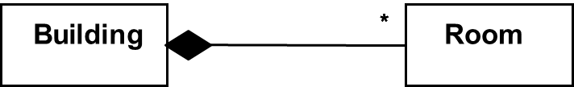another instead of its own class

**Note:** Include **abstract** classes & **interfaces** when needed