1. Find all the information about each products

db.products.find()



------------------------------------------------------------------------------

2. Find the product price which are between 400 to 800

db.products.find({$and : [{product_price:{$gt:400}}, {product_price:{$lt:800}}]})

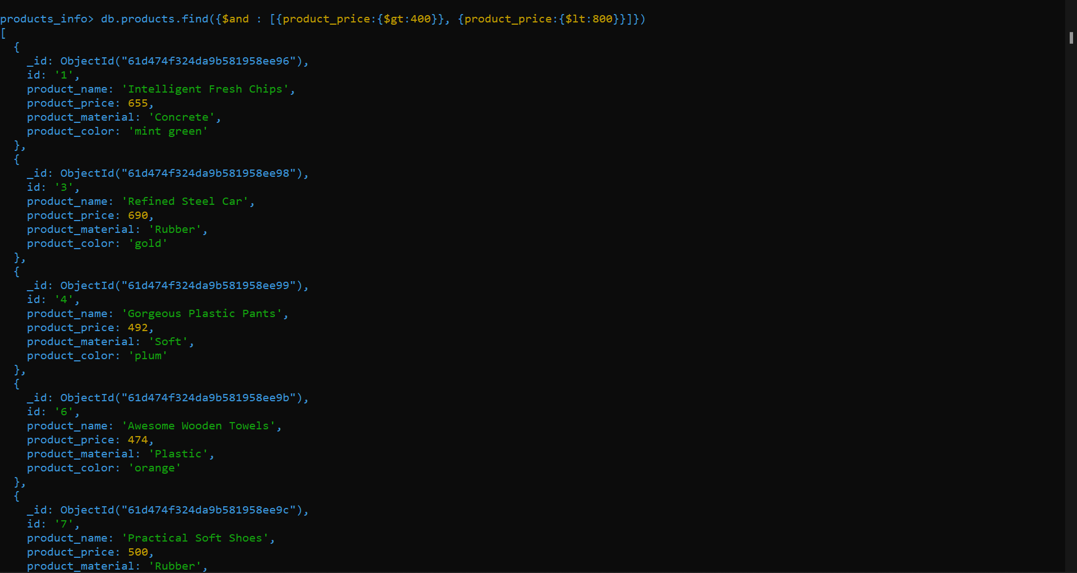

------------------------------------------------------------------------------

3. Find the product price which are not between 400 to 600

db.products.find({$or : [{product_price:{$gt:800}}, {product_price:{$lt:400}}]})

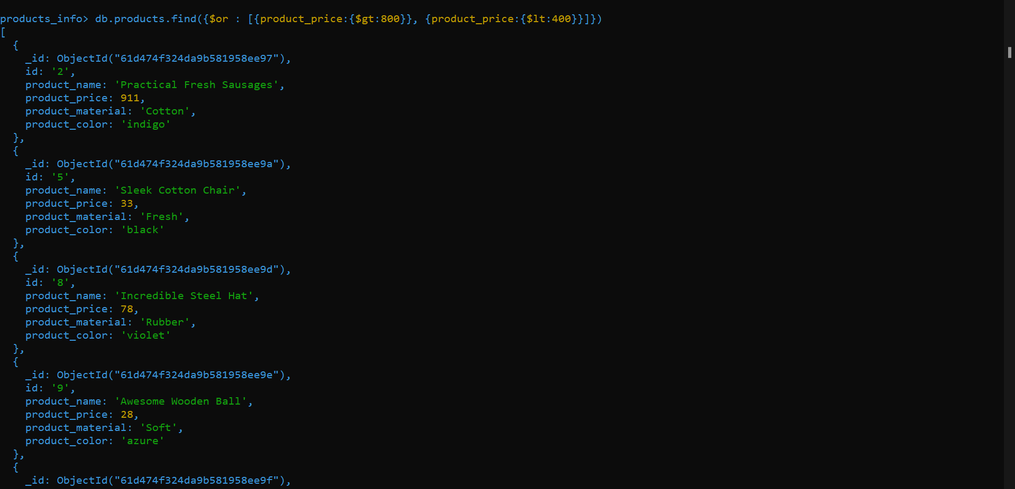

------------------------------------------------------------------------------

4. List the four product which are greater than 500 in price

db.products.find({product_price : {$gt:500}}).limit(4)

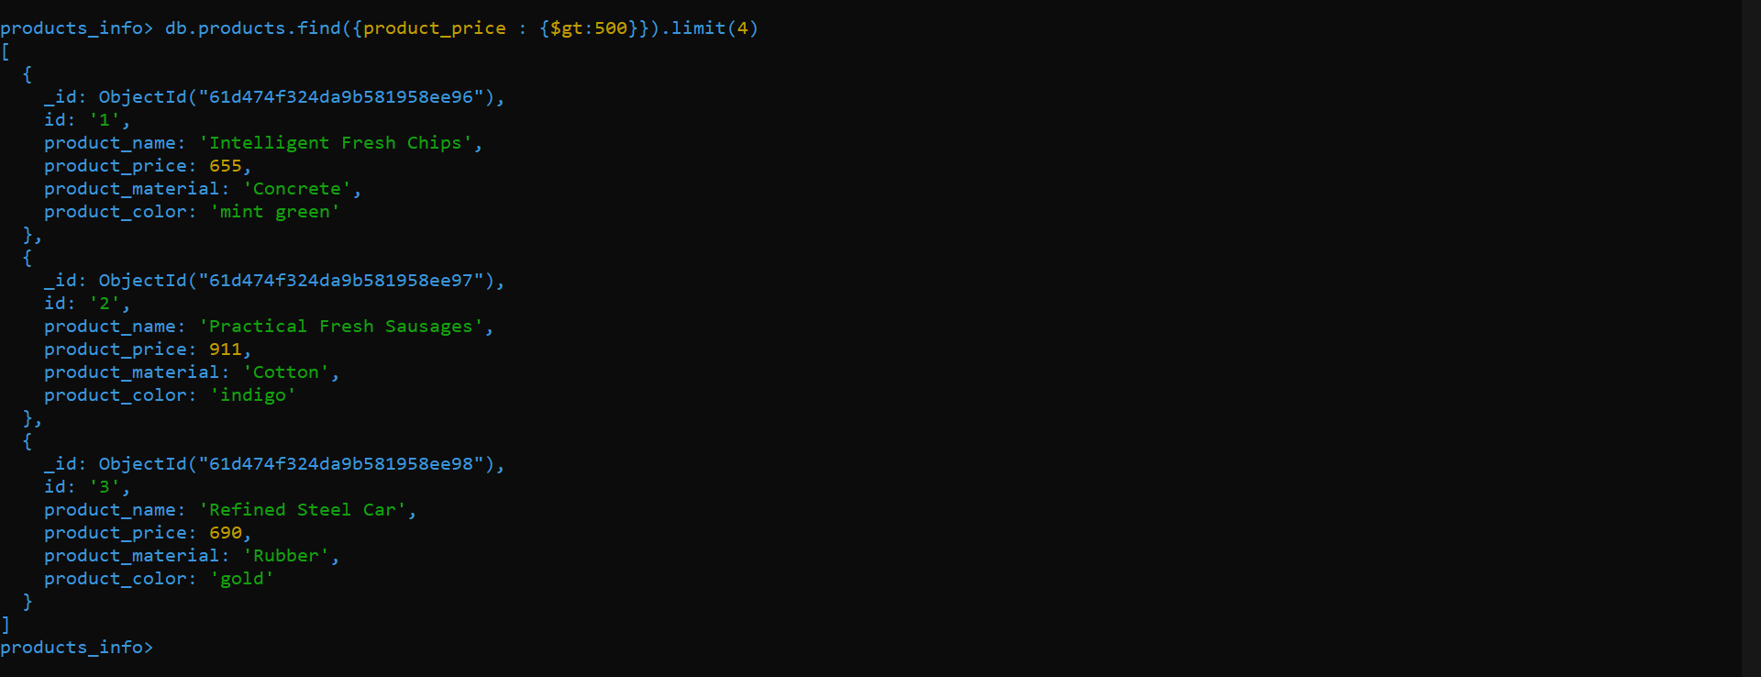

-------------------------------------------------------------------------------

5. Find the product name and product material of each products

db.products.find().forEach(doc => print(doc.id,'->','product_name ::', doc.product_name,' ','product_material::', doc.product_material))

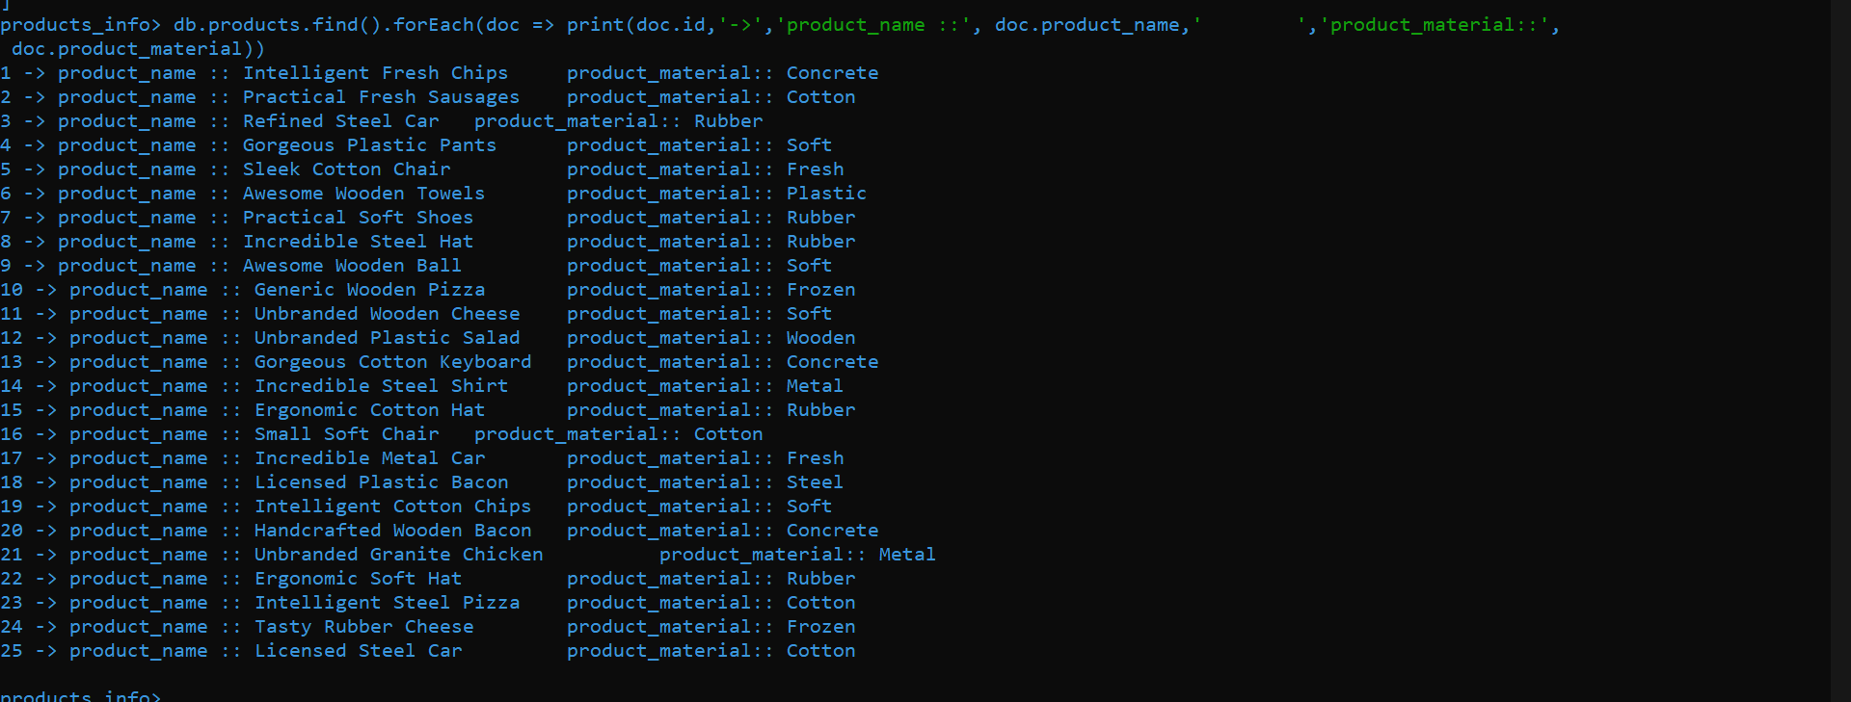

---------------------------------------------------------------------------------

6. Find the product with a row id of 10

db.products.find({id:"10"})

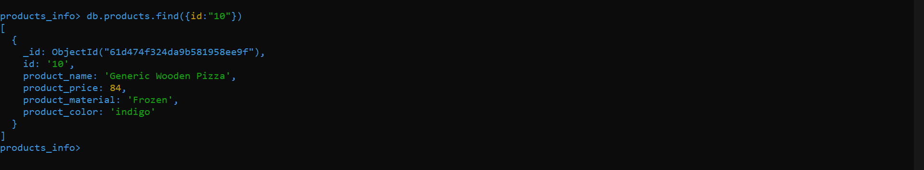

----------------------------------------------------------------------------------

7. Find only the product name and product material

db.products.find().forEach(doc => print(doc.id,'->','product_name ::', doc.product_name,' ','product_material::', doc.product_material))



----------------------------------------------------------------------------------

8. Find all products which contain the value of soft in product material

db.products.find({product_material : /.*Soft.*/})



----------------------------------------------------------------------------------

9. Find products which contain product color indigo and product price 492.00

db.products.find({$and : [{product_color : "indigo"}, {product_price : 492.00}]})



----------------------------------------------------------------------------------

10. Delete the products which product price value are same

db.products.aggregate([

{$group: {

_id: {product_price: "$product_price"},

uniqueIds: {$addToSet: "$_id"},

count: {$sum: 1}

}

},

{$match: {

count: {"$gt": 1}

}

}

])

