1. Create tables for the above list given

2. insert at least 5 rows of values in each table

CREATE database students;

use students;

create table users(student_name varchar(45), student_email varchar(40));

insert into users (student_name,student_email) values ('Akanksha', 'Akanksha@mail.com'),

('Arya', 'Arya@mail.com'),

('Vijay', 'Vijay@mail.com'),

('Surya', 'Surya@mail.com'),

('Prabha', 'Prabha@mail.com'),

('Aravind', 'Aravind@mail.com'),

('Kalpana', 'Kalpana@mail.com'),

('Pooja', 'Pooja@mail.com'),

('Anupama', 'Anupama@mail.com'),

('Rudhra','Rudhra@mail.com');

create table codekata(student_name varchar(45), problems_solved numeric);

insert into codekata(student_name, problems_solved) values

('Akanksha', 20),

('Arya', 40),

('Vijay', 44),

('Surya', 23),

('Prabha', 75),

('Aravind', 12),

('Kalpana', 42),

('Pooja', 56),

('Anupama', 1),

('Rudhra',98);

create table attendance(student_name varchar(45), att_percent numeric);

insert into attendance(student_name, att_percent) values

('Akanksha', 75),

('Arya', 89),

('Vijay', 67),

('Surya', 87),

('Prabha', 75),

('Aravind', 35),

('Kalpana', 50),

('Pooja', 78),

('Anupama', 10),

('Rudhra',100);

create table topics(topic_name varchar(45));

insert into topics(topic_name) values ("HTML"), ("CSS"), ("Bootstrap"), ("ReactJS"), ("MongoDB"), ("NOdeJS");

create table tasks(task_name varchar(45));

insert into tasks(task_name) values ("pancard task"), ("invitation card task"), ("Newspapaer task"), ("CRUD App"), ("Zen class DB"), ("payment task");

create table company_drives(student_name varchar(45), no_of_drives numeric);

insert into company_drives(student_name, no_of_drives) values

('Akanksha', 5),

('Arya', 5),

('Vijay', 3),

('Surya', 4),

('Prabha', 3),

('Aravind', 1),

('Kalpana', 2),

('Pooja', 3),

('Anupama', 0),

('Rudhra',5);

create table mentors(mentor_name varchar(50), students_assigned numeric);

insert into mentors(mentor_name, students_assigned) values ('Sai', 3), ('Vignesh', 2), ('Shekar', 2), ('VInay', 1), ('Suresh', 2);

create table courses(id numeric, course_name varchar(50));

insert into courses(id,course_name) values (1,"Front end"), (2,"Backend"), (3,"Python"), (4,"AI"), (5,"Machine learning"), (6,"Java"), (7,"C++");

create table student_activated_courses(id numeric,student_name varchar(50), student_activated_course varchar(50));

insert into student_activated_courses(id,student_name, student_activated_course) values (1,"Akanksha","Front end"), (2,"Arya","Backend"), (3,"Vijay","Python"), (4,"Prabha","AI"), (5,"Rudhra","Machine learning"), (6,"Pooja","Java"), (7,"Anupama","C++");

--------------------------------------------------------------------------------------

3. get number problems solved in codekata by combining the users

select sum(problems_solved) as Total_codekata_problems from codekata;

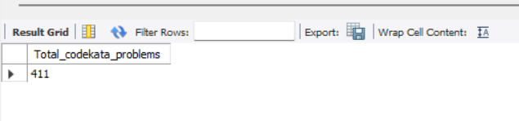

--------------------------------------------------------------------------------------

4. display the no of company drives attended by a user

select * from company_drives;

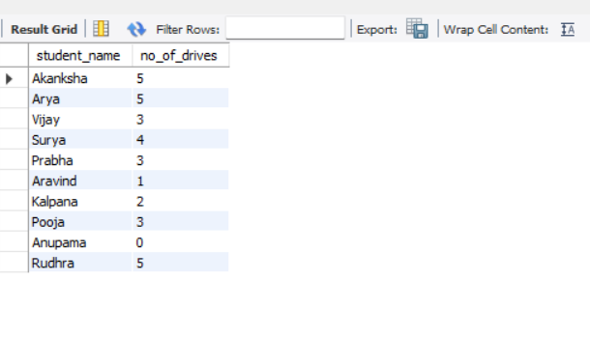

--------------------------------------------------------------------------------------

5. combine and display students_activated_courses and courses for a specific user grouping them based on the course

select student_name, course_name, student_activated_course

from courses inner join student_activated_courses

on courses.id = student_activated_courses.id

where course_name = student_activated_course;

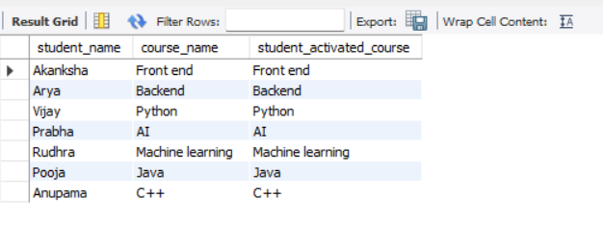

--------------------------------------------------------------------------------------

6. list all the mentors

select mentor_name from mentors;

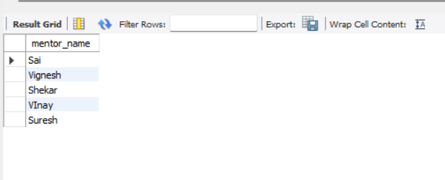

--------------------------------------------------------------------------------------

7. list the number of students that are assigned for a mentor

select * from mentors;

