**Database Concept:**

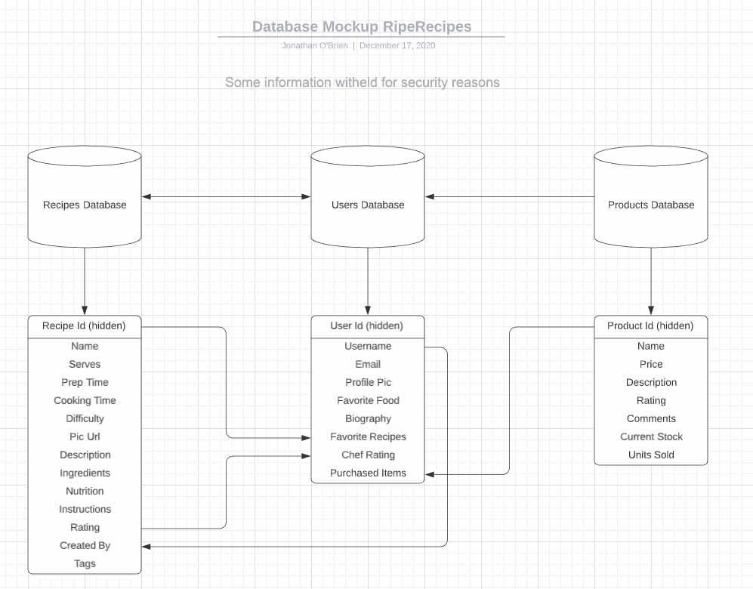

***Recipes will hold all information about a recipe, with the addition of who created it:***

* **Name**: String
* **Serves**: Integer
* **Prep Time**: String
* **Cooking Time**: Integer
* Translated into minutes
* **Difficulty**: String
* Predefined drop-down (“easy”, “medium” , “hard”)
* **Pic Url**: String
* **Description**: String
* **Ingredients**: String
* After each ingredient is pushed to “Staging area”, now each ingredient line can form a list of ingredients.
* **Nutrition**: String
* As these will be in separate boxes, we can add these as a list of items, now when rendering this back to the screen we can define what each item is.
* **Instructions**: String
* **Rating** = Integer
* A recipe will be assigned 3 on recipe creation, each new rating should first call the rating, then add the new rating to it and divide by (“num of ratings” + 1)
* **Num Of Ratings** = Integer
* **Created By** = String
* Auto assign the username of the user that creates the recipe.
* **Tags** = String
* A few keywords about the recipe, this will help in search functionality.

***Users database will hold the required information on website members, this database should be forward thinking to allow for potential future monetisation.***

* Name: String
* Email: String
* Favorite Food
* Possible future way to target members based on their likes. For example if a member likes Chinese food and we are trying to sell cooking utensils that fit that category of food. Then these users could be targeted specifically.
* Profile Pic: String
* Biography: String
* To add some content to a users profile page.
* Favorite Recipes: String
* Allows us to track what members like and do not like, this allows possible future email marketing if we can analyze the trends of user likes.
* Chef Rating: Integer
* This figure will be a sort of motivating aspect to the website, a user can add recipes to this website and then receive feedback on how good (or not) their recipes are based on other user feedback.
* Purchased Items:
* A simple list of items a member has purchased, this will also add to potential future marketing, allowing us to see what certain users have bought and offering similar products.

***The products database will hold all information on that product, as well as performance based metrics.***

* **Name**: String
* **Price**: Float (allow a decimal figure)
* **Description**: String
* **Rating**: Integer
* Rating based on feedback from users that have purchased the item.
* **Comments**: String
* Comments can be submitted after purchasing a product. These can then be displayed for others to see.
* **Current Stock**: Integer
* Allows us to keep track of how many units in stock, else we can auto remove product from being displayed.
* **Units Sold**: Integer
* Allows us to see how well or not a product is doing, this figure can lead into marketing plans such as special offers or email marketing.

**Website Logic**

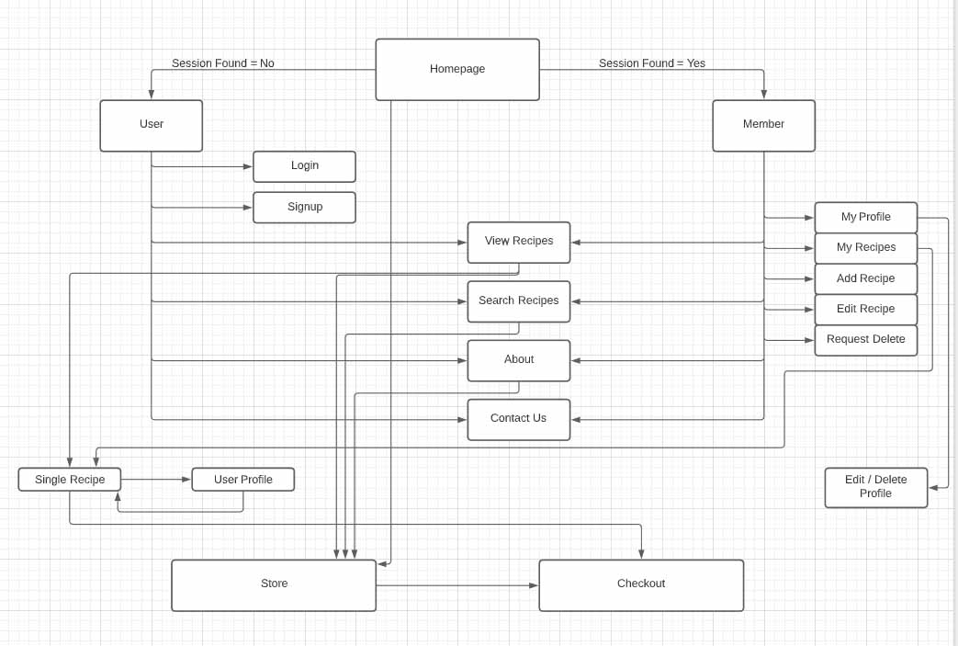

**Color Scheme & Typography:**

**Main Colors & Button Colors:**

**Main Color**:

RGB 245,41,135 #f06292 pink lighten-2

**Secondary Color**:

RGB 179,229,252 #b3e5fc light-blue lighten-4

**Tertiary Color:**

RGB 234,128,252 #ea80fc purple accent-1

**Positive / Submit**:

RGB 0,230,118 #00e676 green accent-3

**Negative / Cancel**:

RGB 244,67,54 #f44336 red

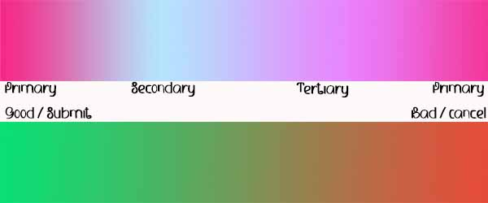

**Font Styles:**

