Installation de MRARegress

Precise version of R, R Studio, packages and hardware used
R version 4.3.2 (2023-10-31 ucrt) -- "Eye Holes" - Platform: x86_64-w64-mingw32/x64 (64-bit)
RStudio 2023.06.0 Build 421.
Modules required by "MRARegress":
Package | Version
BiocManager | 1.30.22
CVXR | 1.0-12
devtools | 2.4.5
dplyr | 1.1.4
glmnet | 4.1-8
magrittr | 2.0.3
minet | 3.58.0
randomForest | 4.7-1.1
RCy3 | 2.20.2
rootSolve | 1.8.2.4
stats | 4.3.2
stringr | 1.5.1
testthat | 3.2.1
upstartr | 0.1.2
utils | 4.3.2
"minet" requires the package "Biocmanager". Then, BiocManager::install("minet").
The software "Cytoscape" (version >= 3.6.1 required -- our version is 3.10.2) must be installed and running before using "DrawGraph", a module of "MRARegress" used to draw network graphs.
Modules required by "AdvancedMRA.R" (the program used to generate the results of this article):
Package | Version
CVXR | 1.0-12
data.table | 1.15.2
MRARegress | 1.0.0
RCy3 | 2.20.2
stringr | 1.5.1
upstartr | 0.1.2
Our Hardware:
PC Dell, core i7 - 14 cores, 2.4 GHz - RAM 64 GB.
Our code:
- "MRARegress", available from GitHub: https://github.com/J-P-BORG/MRARegress
- "AdvancedMRA.R", available from GitHub: https://github.com/J-P-BORG/MRA
- Data files, available from GitHub: https://github.com/J-P-BORG/MRARegress
then, folder "data".

Installation and Basic Testing
- Check the installed versions of R and RStudio. Update them if necessary.
- Check that the required modules (see previous paragraph) are installed and that the versions match, otherwise install and/or update them.
- Install the "MRARegress" package: devtools::install_github("J-P-Borg/MRARegress").
- Check that there is no error message. There may be warnings about replacing the previous import of certain objects.
- The "MRARegress" package should now appear in RStudio's package list (at the bottom right of the screen).
Two simple examples, to test installation :
library("MRARegress")
library("testthat")
1st example :
MatExp <- matrix(c(1:12), nrow=3)
MRARegress(MatExp)$r

The following results matrix should be displayed:
Q1 Q2 Q3
N1 -1.0000000 2.954545 -2.0454545
N2 0.3021978 -1.000000 0.7417582
N3 -0.3703704 1.296296 -1.0000000
2nd example :
Run "Cytoscape"

MatExp <- matrix(c(1,2,3, 11,21,31, 12,22,32, 13,23,33),nrow=3)
Ret <- MRARegress (MatExp, Relative=FALSE)
RetDG <- DrawGraph (Ret)
test_that("Simple network", {
expect_equal (RetDG$Variables[[2]], 3, tolerance=1E-4) # 3 nodes (DrawGraph succeeded)
})

The following line should be displayed:
Test passed

When entering "Ret$r", the following connectivity matrix should appear:
> Ret$r
Q1 Q2 Q3
N1 -1.0 2 -1.0
N2 0.5 -1 0.5
N3 -1.0 2 -1.0

When opening "Cytoscape", one must see:
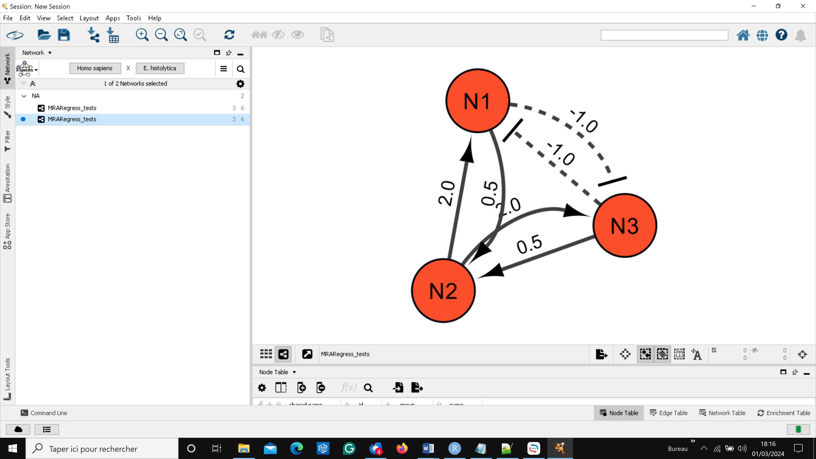

Connectivity matrix values are graphically represented.
In Cytoscape, users can manipulate nodes and arcs to enhance diagram clarity: click on a node to select it, then move it with the mouse. Select an arc by holding down the "alt" key. A red square is drawn next to this arc. Move this square to distort the arc. See "Cytoscape" documentation.

